**MASTERS PRE-UNIVERSITY COLLEGE, HASSAN 573201**

**BIOLOGY PRACTICE QUESTIONS**

**Topic: Locomotion and Movement**

1. **Actin binding sites are located on**

a) troponin b) tropomyosin c) meromyosin d) Both (b) & (c)

1. **Progressive degeneration of skeletal muscle, mostly due to genetic disorder occurs in**

a. Myasthenia gravis b. Muscular dystrophy

c. Arthritis d. Tetany

1. **Which is not true for red fibers?**
2. Muscles contain a red coloured oxygen storing pigment

b. Muscle contains plenty of mitochondria

c. These muscles are also called aerobic muscles

d. Amount of sarcoplasmic reticulum is high in it.

1. **Which set clearly identify striated muscles?**

a. Cylindrical, Syncytial and unbranched

b. Spindle, unbranched and uninucleated

c. Cylindrical, striped and uninucleated

d. Cylindrical, Striped and branched

1. **Acetabulum occurs in**

a. Pectoral girdle b. Pelvic girdle c. Vertebrae d. Cranium

1. **Which of the following human skeletal parts are correctly matched with their respective category?**

**Pairs of skeletal parts Category**

A. Humerus and ulna Appendicular skeleton

B. Malleus and stapes Ear ossicles

C. Sternum and ribs Axial skeleton

D. Clavicle and glenoid cavity Pelvic girdle

a. A and B only b. A, B and C only c. A, B and D only d. All of the above

1. **Sella tursica a depression enclosing the pituitary gland is found in**

a. Temporal bone b. Parietal bone c. Sphenoid bone d. Frontal bone

1. **The human skull has 22 bones with …. Cranial bones and ….. facial bones**
2. 10, 12 b. 14, 8 c. 12, 10 d. 8, 14
3. **The ATPase activity of the myosin head is dependent on:**
4. Magnesium ions b. Manganese ions c. Calcium ions d. Ferric ions
5. **Which of the following joints would allow no movement?**
6. Ball and socket joint b. Fibrous joints

c. Cartilaginous joints d. Synovial joints

1. **The neurotransmitter released by the nerve cell at the neuromuscular junction is:**
2. Acetylcholine b.Adrenaline c. Serotonin d. Dopamine
3. **Scapula is a large triangular bone situated in the dorsal part of the thorax between the:**

a. Second and fifth ribs b. Third and sixth ribs

c. Third and eighth ribs d. Second and seventh ribs

1. **Out of 'X' pairs of ribs in humans only 'Y' pairs are true ribs. Select the option that correctly represents values of X and Y and provides their explanation :**
2. X = 12, Y = 7 True ribs are attached dorsally to vertebral column and ventrally to the sternum
3. X = 12, Y = 5 True ribs are attached dorsally to vertebral column and sternum on the two ends
4. X = 24, Y = 7 True ribs are dorsally attached to vertebral column but are free on ventral side
5. X = 24, Y = 12 True ribs are dorsally attached to vertebral column but are free on ventral side
6. **Identify A, B, C, D and E in the given diagram of Human skull. Choose the correct option.**

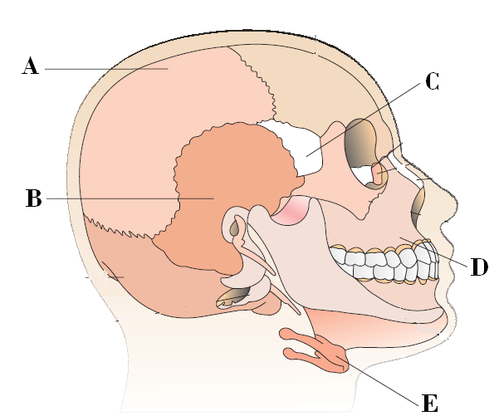

**Codes: A B C D E**

a. Parietal bone Temporal bone Sphenoid Maxillae Hyoid

b. Frontal bone Parietal bone Ethamoid Maxillae Hyoid

c. Parietal bone Temporal bone Ethamoid Zygomatic bones Hyoid

d. Occipital bone Frontal bone Sphenoid palantine bone Mandible

1. **What is sarcomere?**
2. Part between two H lines b. Part between two A band

c. Part between two I bands d. Part between two Z lines

1. **Osteoporosis, an age-related disease of skeletal system, may occur due to**
2. immune disorder affecting neuro-muscular junction leading to fatigue
3. high concentration of Ca++ and Na+
4. decreased level of estrogen
5. accumulation of uric acid leading to inflammation of joints
6. **The __________ is a membrane-bound structure located within the muscles cells. Its main function is to store calcium ions.**
7. Sarcoplasmic reticulum b. Fibrin c. Myosin d. None of the above
8. **Which is a high energy compound in muscles?**
9. Glucose b. Starch c. Glycogen d. Creatine phosphate
10. **Sutures present between various bones of skull are:**
11. Cartilaginous joints b. Synovial joints c. Hinge joints d. Fibrous joints
12. **Phalangeal formula of hand of man is:**
13. 1,2,2,2,2 b. 2,1,1,1,1, c. 2,3,3,3,3 d. 2,3,3,2,2
14. **Which one of the following options is incorrect?**

a. Hinge joint – between Humerus and Pectoral girdle

b. Pivot joint – between atlas, axis and occipital condyle

c. Gliding joint – between the carpals

d. Saddle joint – between carpel and metacarpals of thumb

1. **Spinal cord passes through:**
2. Foramen of Monro b. Foramen ovale c. Foramen magnum d. None of the above
3. **Haversian system is present in:**
4. Avian bones b. Reptilian bones c. Mammalian bones d. Bones of all animals
5. **Coxal pelvic girdle is formed by fusion of**
6. Ilium, ischium and pubis b. Scapula and clavicle

c. Ilium and Scapula d. Ilium, scapula, ischium

1. **Select the correct option regarding A, B and C.**

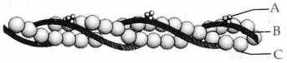

(a) A-Tropomyosin-runs close to F-actin throughout its length

(b) B-Troponin-complex protein distributed at regular interval of tropomyosin

(c) C-F actin - polymer of monomeric G-actin helically bound to each other

(d) None of these

1. **.Which of the following is a sesamoid bone?**

a) Pectoral girdle b) Pterygoid c) Pelves d) Patella

1. **Which one of the skull bones is moveble?**

a)Vomer b) Maxillary c) Mandible d) All of these

1. **Acromion process is found in**

a) Pectoral girdle b) Humerous c) Pelvic girdle d) None of these

1. **Number of cervical vertebrae in camels is….**
2. More than that of rabbit b. less than that of rabbit

c. same as that of whale d. More than that of horse

1. **Shortening of a sarcomere during muscle contraction is due to**

a) contraction of thin & thick filament

b) Sliding of both thin & thick filament

c) Sliding of thin filaments over thick filament

d) Sliding of thick filaments over thin filament

|  |  |  |  |
| --- | --- | --- | --- |
| **Sl.no** | **Key** | **Sl.no** | **Key** |
| **1** | C | **16** | C |
| **2** | B | **17** | A |
| **3** | D | **18** | D |
| **4** | A | **19** | D |
| **5** | B | **20** | C |
| **6** | B | **21** | A |
| **7** | C | **22** | C |
| **8** | D | **23** | C |
| **9** | C | **24** | A |
| **10** | B | **25** | C |
| **11** | A | **26** | D |
| **12** | D | **27** | C |
| **13** | A | **28** | A |
| **14** | A | **29** | C |
| **15** | **D** | **30** | C |
|  |  |  |  |
|  |  |  |  |
|  |  |  |  |
|  |  |  |  |
|  |  |  |  |
|  |  |  |  |
|  |  |  |  |
|  |  |  |  |
|  |  |  |  |
|  |  |
|  |  |