**MASTERS PRE-UNIVERSITY COLLEGE, HASSAN 573201.**

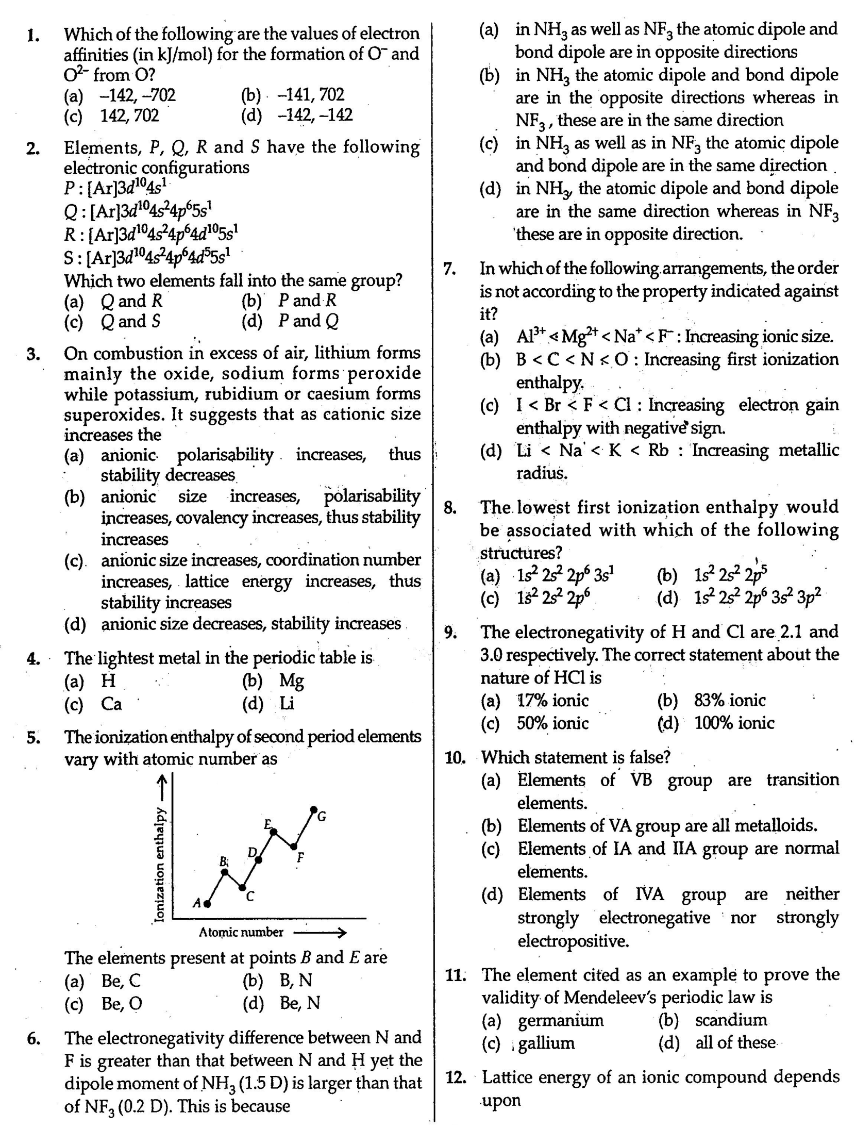 **CHEMISTRY: Topic:-Classification of Elements and Periodicity in Properties**

**`**`

