1. (a) By conservation of energy, 

⇒ 

1. (a) Initial K.E. of block when bullet strikes to it



Due to this K.E. block will rise to a height *h*.

Its potential energy = 

By the law of conservation of energy

 ∴

1. (c)

*m*1

40*m/s*

*m*2

At rest

*m*1+*m*2

30*m/s*

Initial momentum of the system = 

Final momentum of the system = 

By the law of conservation of momentum



⇒  ⇒ =

1. (b) Momentum and kinetic energy is conserved only in this case.
2. (c)

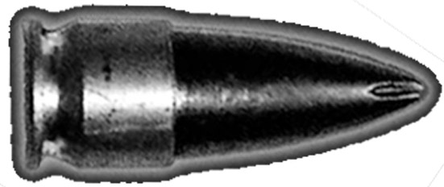

*M*

*m*

*x*



*v*

*V*

Let speed of the bullet = *v*

Speed of the system after the collision = *V*

By conservation of momentum 

⇒ 

So the initial K.E. acquired by the system

= 

This kinetic energy goes against friction work done by friction = 

By the law of conservation of energy

⇒ 

∴ 

*m*

*v*

*m*

Before collision

2*m*

*V*

At rest

After collision

1. (a)

Initial momentum = *mv*

Final momentum = 2*mV*

By the conservation of momentum, 

\*\*\*

K.E. of the system after the collision = 

∴ loss in K.E.

This loss in K.E. will increase the temperature

∴  ⇒ 

*V*

*m+M*



*v*

*M*

*m*



At rest

1. (d)

Initial kinetic energy of bullet = 

After inelastic collision system moves with velocity V

By the conservation of momentum

 ⇒ 

Kinetic energy of system = 

= 

Loss of kinetic energy = 

=

1. (d) According to Kepler's law 

If *N* is the frequencs then 

or ⇒ 

1. (d) Reading of spring balance 

If the lift falls freely then *a = g* ∴ *R* = 0

1. (c)  ∴ 

According to problem  and 

∴ 

⇒ 

1. (c) Apparent weight = actual weight – upthrust force



⇒ 

1. (b) . If mass and radius of the planet are twice then  will be half that of  *i.e.* 
2. (c) *U* = Loss in gravitational energy = gain in K.E.

So, 

1. (d) 
2. (c)  (approx.)

∴

1. (b)  ⇒ 

⇒ .

1. (b) ⇒and 

∴ . Given *V*2 = 1.5 *V*1

on solving we get *V1* = 16000 *volt* = 16 *kV.*

1. (c) Radius of circular path described by a charged particle in a magnetic field is given by ; where *K* = Kinetic energy of electron ⇒ 





By using *E* = *W*0 + *Kmax*

⇒ 

1. (c) Photoelectrons emits if energy of incident light > work function.
2. (c) *E* = *W0 + K*max⇒  and 

⇒  and 

⇒ ⇒ .

1. (b) *v*max*=* 4 × 108 *cm/sec* = 4 × 106 *m/sec*.

∴ 

\*\*\*

= 7.2 × 10–18 *J =* 45 *eV*.

Hence, stopping potential .

1. (b) **
2. (a) We know that  and 

Here for *n* =1, *E*1 = – 54.4 *eV*

Therefore  ⇒ *Z* = 2

Hence radius of first Bohr orbit 

1. (b) The electrostatic *P.E.* is zero when the electron and proton are far apart from each other. Work done in pulling electron and proton far away from each other



= 3.4 × 1.6 × 10–19*J.*-11-111

1. The Hydrogen atom before the transition was at rest. Therefore from conservation of momentum.





⇒ *v* = 4.352 *m/s* ≈ 4 *m/sec.*

1. (b) In 2 *sec* only 90% nuclei are left behind. Thus in next two second 90% of 900 or 810 nuclei will be left.
2. (b) Acceleration 

where  and  ⇒ 

Since both are in ground state *i.e.*, *n* = 1

so *a* ∝ *Z*3 ⇒ .

1. (b) By using 

For Hydrogen atom 

 .....(i)

For hydrogen like atom 

 ....(ii)

From equation (i) and (ii) 

1. (b) Transition from 4*E* to *E*

 ⇒  ...... (i)

Transition from  to *E*

 ⇒  ...... (i)

From equation (i) and (ii) 