**MASTERS PRE-UNIVERSITY COLLEGE, HASSAN 573201.**

**Subject: Physics Topic:-Rotational Dynamics**

1. **A constant power is supplied to a rotating disc. The relationship of angular velocity(w) of disc and number of rotations(n) made by the disc is governed by**

a) $wαn^{\frac{1}{3}}$ b) $wαn^{\frac{2}{3}}$ c) $wαn^{\frac{3}{2}}$ d) $wαn^{2}$

1. **A particle performing uniform circular motion has angular momentum L. If its angular frequency is doubled and its kinetic energy is halved, then the new angular momentum is**

a) $\frac{L}{4}$ b)2Lc)4L d) $\frac{L}{2}$

1. **A cubical block of side ‘L’ rests on a rough horizontal surface with coefficient of friction $μ.$ A horizontal force F is applied on the block as shown in figure. The minimum force required to topple the block is**

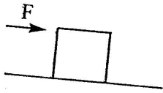

a)Infinitesimal b)mg/4 c)mg/2 d)mg(1- $μ$)

1. **A rope is wound several times on a solid cylinder of radius 0.1m and mass 10kg. The cylinder is free to rotate about its axis. If the rope is pulled with a force of 10N, the angular acceleration of the cylinder is**

a)10 rad s-2 b)5 rad S-2 c)20 rad S-2 d)15 rad S-2

1. 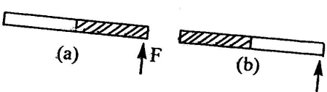**As shown in figure, a stick half of which is made of wood and other half of iron is pivoted as shown in fig. (a). It is pivoted at wooden end and force is applied to the other end of it at right angles to its length. (b) It is pivoted at iron end and the same force is applied to the other end at right angles to its length. Then angular acceleration produced is**

a)More in case b than in a b)more in case a then in b

c)equal in both the cases d)data insufficient.

1. **A wheel of radius 20cm can rotate about its centre. A string is wrapped over its rim and is pulled by a force of 10N tangential to pulley. If the angular acceleration produced is 4 radS-2, then the moment of inertia of the wheel in kgm2 is**

a)25 b)0.5 c)50 d)5

1. **The moment of inertia of a uniform disc about an axis passing through its centre and perpendicular to its plane is 2kg m2. It is rotating with an angular velocity 100 rads-1. A second identical disc rotating opposite to that of the first but with same angular velocity is joined to its coaxially. Now these two discs together continue to rotate about the same axis. Then the lose in KE in KJ is**

a)10 b)20 c)25 d)zero.

1. 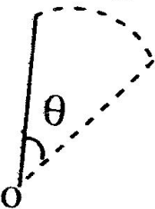**A rod is free to rotate about ‘O” as shown. It begins to rotate. When it has turned through an angle ‘ $θ'$. Its angular velocity ‘w’ is given as**

a) $\sqrt{\frac{6g}{l}sinθ}$ b) $\sqrt{\frac{6g}{l}sin\left(\frac{θ}{2}\right)}$ c) $\sqrt{\frac{6g}{l}}cos\frac{θ}{2}$ d) $\sqrt{\frac{6g}{l} }cosθ$

1. 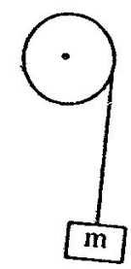**A block of mass 2kg hangs from the rim of a wheel of radius 0.5m. On releasing from rest, the block falls through 5m height in 2s.The M.I. of the wheel will be**

a)1kgm2 b)3.2kgm2 c)2.5kg2 d)1.5kgm2

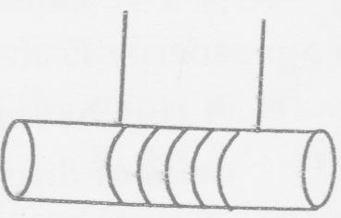**A cylinder of mass M and radius R starts falling under gravity at t=0 as shown in figure. If the mass of chord is negliglible , the tension in each string is**

a)Mg/6 b)Mg/4 c)Mg/2 d)Mg

1. **A particle of mass ‘m’ is projected with an initial velocity u at an angle ‘ $θ'$ to horizontal. The torque of gravity on projectile at maximum height about the point of projection is**

a) $\frac{mgu^{2}sin2θ}{2}$ b)mg $u^{2}$ sin2 $θ$ c) $\frac{mgu^{2}sinθ}{2}$ d) $\frac{1}{2}mu^{2}sin2θ$

1. 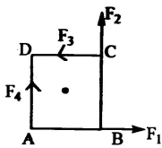**‘O’ is the center of a square ABCD, F1,F2,F3 and F4, are four forces acting along the sides AB,BC,CD and AD as shown in figure. What should be the maginitude of F4 so that the total torque about ‘O’ is zero?**

a)F1+F2+F3 b)F1+F2-F3 c)F1-F2-F3 d)

**Rolling Motion:-**

1. **A disc is at rest at the top of a rough inclined plane. It rolls without slipping. At the bottom inclined plane there is a vertical groove of radius ‘R”, In order to loop the groove, the minimum height of incline required is**

a) $\frac{15R}{4}$ b) $\frac{9R}{4}$ c) $\frac{5R}{2}$**d) $\frac{7R}{5}$**

1. **A solid sphere of mass 1.5kg rolls on a frictionless horizontal surface, its centre of mass moving at a speed of 5ms-1. Then it rolls up an incline of 30 $°$ to horizontal. The height attained by the sphere before it stops is (g=10sm-2)**

a)5m b)1.5m c)1.75m d)3.65m

1. **A solid cylinder of mass ‘m’ rolls without slipping down an inclined plane making an angle $θ$ with the horizontal. The frictional force between the cylinder and the incline is**

a) $mg sinθ$ b) $\frac{mgsinθ}{3}$ c) $mgcosθ$ d) $\frac{2mgsinθ}{3}$

1. 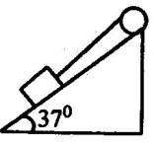**A block of mass 12kg is attached to a string wrapped around a wheel of radius 10cm. The acceleration of the block moving down the inclined plane is 2ms-2. The tension in the string is (1 of wheel =0.117kgm2)**

a)24.5N b)68.7N c)23.4N d)46.8N

**EQUILIBRIUM OF BODY & PARALLEL FORCES**

1. **The resultant of two unlike parallel forces is 5N and acts at a distance of 20cm and 40cm from them. The forces are**

a)2N, 5N b)5N,10N c)6N,10N d)8N,12N

1. **A uniform rod is 4m long and weighs 10kg. If it is supported on a knife edge at one metre from the end, what weight place at that end keeps the rod horizontal?**

a)8kg b)10kg c)12kg d)16kg

1. **A body and a man carry a uniform rod of length ‘L’ horizontally in such a way that the boy gets 1/3 of the load. If the boy is at one end of the rod, the distance of the man from the other end is**

a)L/6 b)L/5 c)L/4 d)L/3

**20. Seven identical circular planar discs, each of mass M and radius R are welded symmetrically as shown in the figure. The moment of inertia of the arrangement about the axis normal to the plane and passing through the point P is**

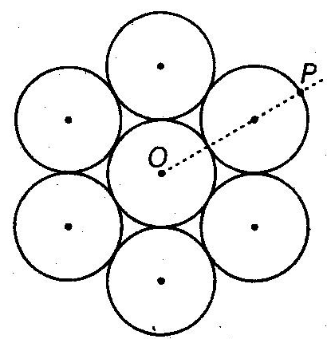

a) $\frac{19}{2}MR^{2}$ b) $\frac{55}{2}MR^{2}$ c) $\frac{73}{2}MR^{2}$ d) $\frac{181}{2}MR^{2}$

1. 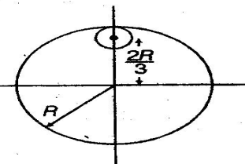**From a uniform circular disc of radius R and mass 9 M, a small disc of radius $\frac{R}{3}$ is removed as shown in the figure. The moment of inertia of the remaining disc about an axis perpendicular to the plane of the disc and passing through centre of disc is**

a)4MR2 b) c) d)

1. **A particle is moving with a uniform speed in a circular orbit of radius R in a central force inversely proportional to the nth power of R. If the period of rotation of the particle is T, then:**

a)T $α$ R3/2 for any n b) $TαR^{\frac{n}{2}+1}$ c) $TαR^{(n+1)/2}$ d) $TαR^{\frac{1}{2}}$

1. **The moment of inertia of a uniform cylinder of length $l$ and radius R about its perpendicular bisector is I. What is the ratio $l/R$ such that the moment of inertia is minimum?**

a) $\frac{\sqrt{3}}{2}$**b) $1$ c) $\frac{3}{\sqrt{2}}$ d) $\sqrt{\frac{3}{2}}$**

1. 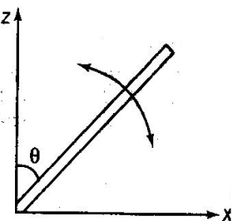**A slender uniform rod of mass M and length $l$ is pivoted at one end so that it can rotate in a vertical plane (seen the figure). There is negligible friction at the pivot. The free end is held vertically above the pivot and then released. The angular acceleration of the rod when it makes an angle $θ$ with the vertical, is**

a) $\frac{2g}{3l}sinθ$ b) $\frac{3g}{2l}cosθ$ c) $\frac{2g}{3l}cosθ$ d) $\frac{3g}{2l}sinθ$

1. 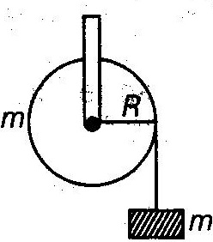**A mass m suporeted by a massless string wound around a uniform hollow cylinder of mass m and radius R. If the string does not slip on the cylinder, with what acceleration will the mass fall on release?**

a) $\frac{2g}{3}$ b) $\frac{g}{2}$ c) $\frac{5g}{6}$ d) $g$

1. **A pulley of radius 2 m is rotated about its axis by a force $F=\left(20t-5t^{2}\right)N$ (Where, t is measured in seconds) applied tangentially. If the moment of inertia of the pulley about its axis of rotation is 10 kg-m2, then the number of rotations made by the pully before its direction of motion is reserved, is**

a)more than 3 but less than 6 b)more than 6 but less than 9

c)more than 9 d) less than 3.

1. **Consider a uniform square plate of side a and mass m. The moment of inertia of this plate about an axis perpendicular to its plane and passing through one of its corners is**

a) $\frac{5}{6}ma^{2}$ b) $\frac{1}{12}ma^{2}$ c) $\frac{7}{12}ma^{2}$ d) $\frac{2}{3}ma^{2}$

1. **For the given uniform square lamina ABCD, whose center is O**

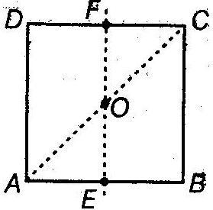

a) $\sqrt{2}I_{AC}=I_{EF}$ b) $I_{AD}=3I_{EF}$ c) $I_{Ac}=4I_{EF}$ d) $I_{AC}=\sqrt{2} I_{EF}$

1. **A round uniform body of radius R, mass M and moment of inertia I, rolls down (without slipping) an inclined plane making an angle $θ$ with the horizontal. The its acceleration is**

a) $\frac{gsinθ}{1+I/MR^{2}}$ b) $\frac{gsinθ}{1+MR^{2}/I}$ c) $\frac{gsinθ}{1-I/MR^{2}}$ d) $\frac{gsinθ}{1-MR^{2}/I.}$

1. **Four point masses, each of value m, are placed at the corners of a square ABCD of side $l$. The moment of inertia of this system about an axis passing through A and parallel to BD is**

a) $2ml^{2}$ b) $\sqrt{3}ml^{2}$ c) $3ml^{2}$ d) $ml^{2}$

1. **One solid sphere A and another hollow sphere B are of same mass and same outer radii. Their momemt of inertia about their diameters are respectively IA and IB such that**

a) $I_{A}=I_{B}$**b) $I_{A}>I_{B}$ c) $I_{A}<I_{B}$ d) $\frac{I_{A}}{I_{B}}=\frac{d_{A}}{d_{B}}$**