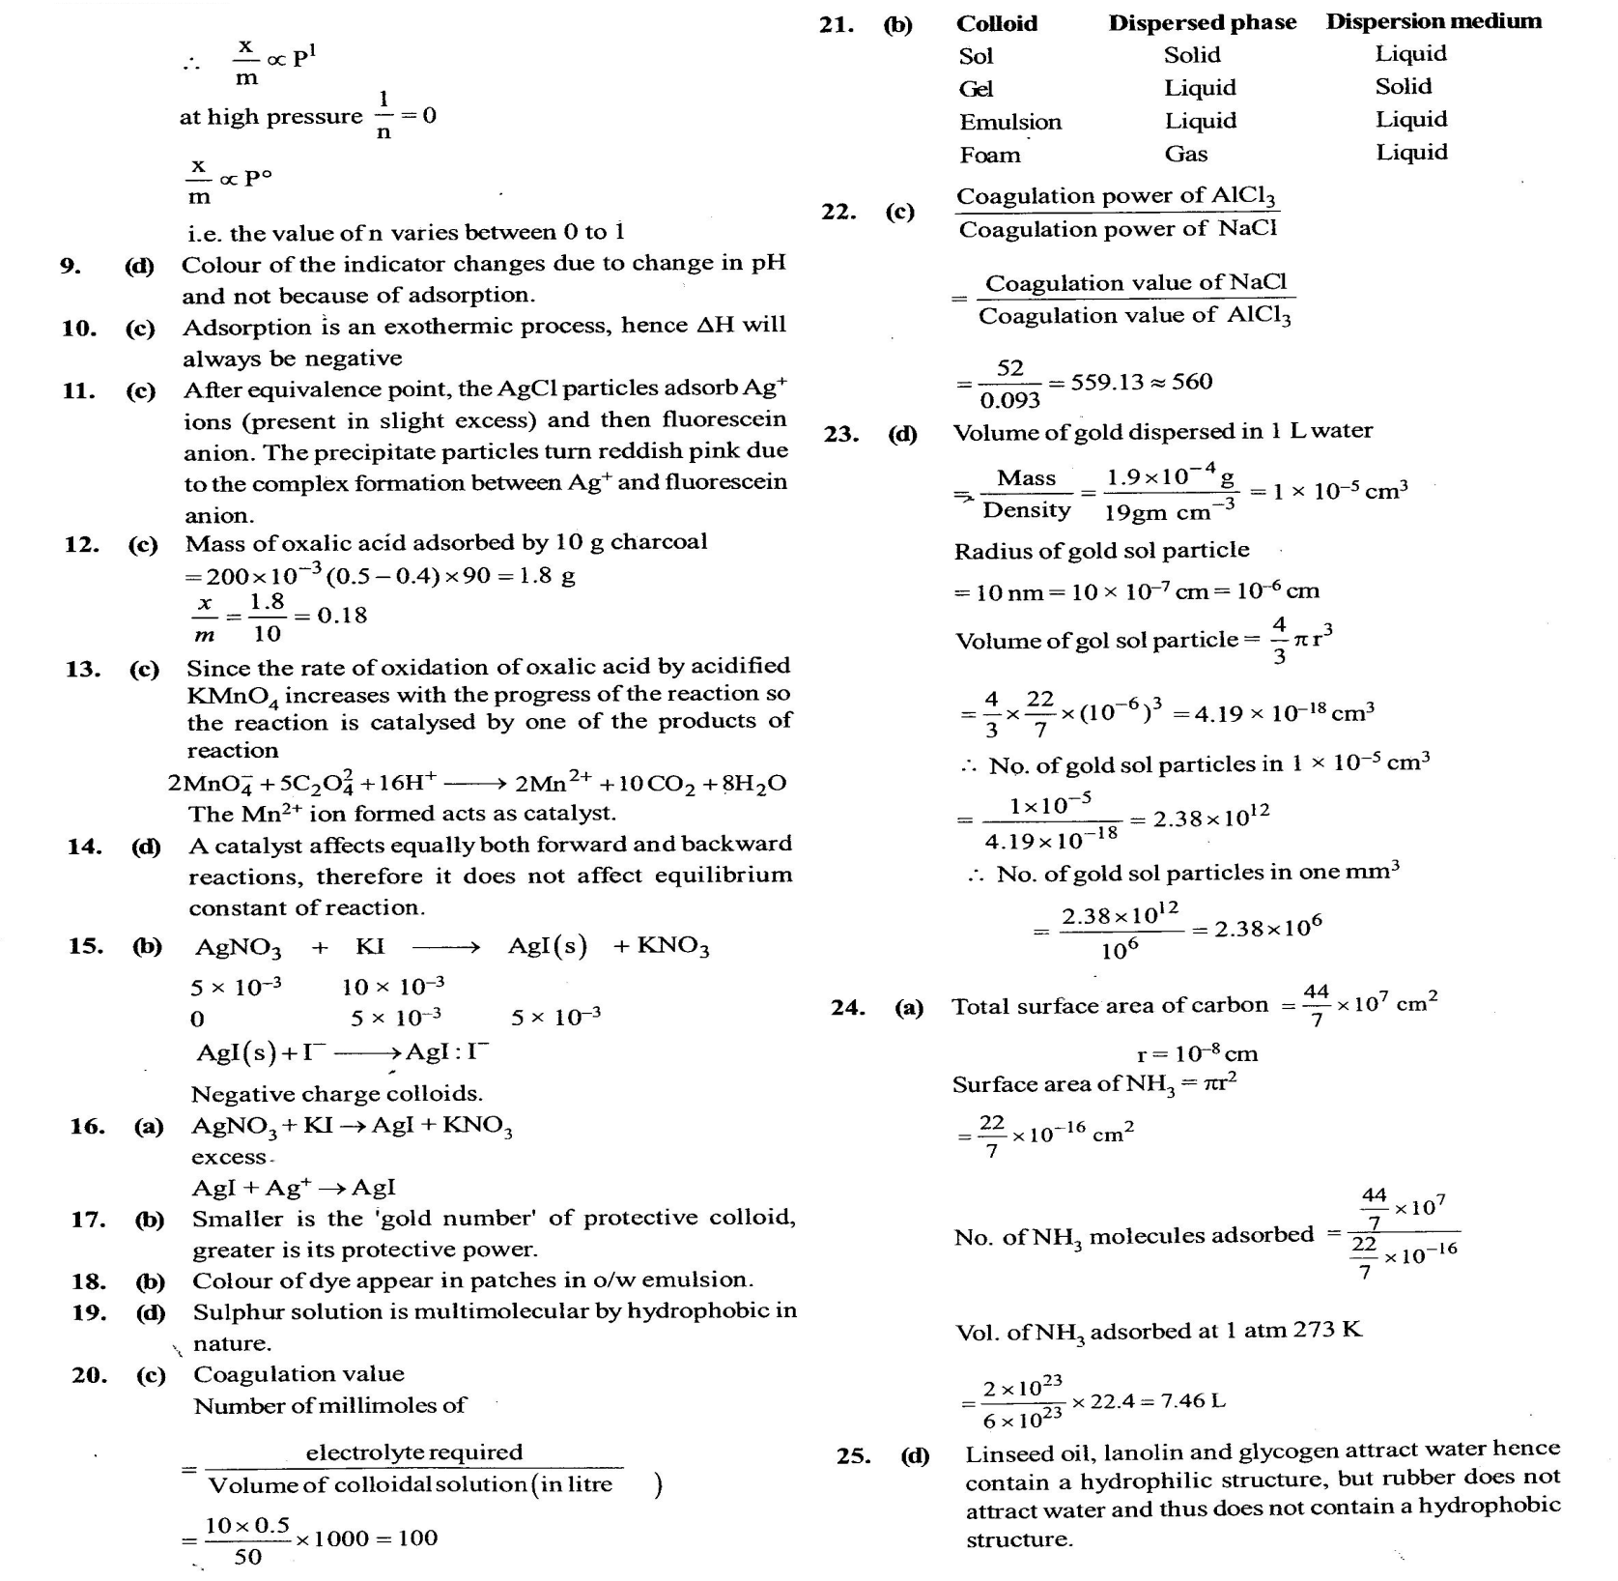

**MASTERS PRE-UNIVERSITY COLLEGE, HASSAN 573201.**

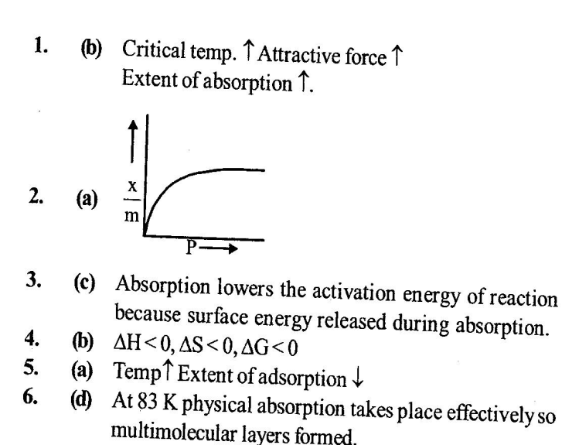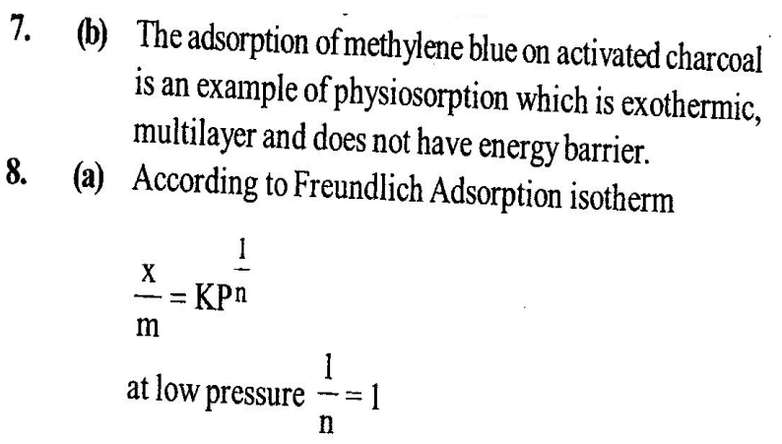 **CHEMISTRY: Topic:- Hints & solution Surface Chemistry**

