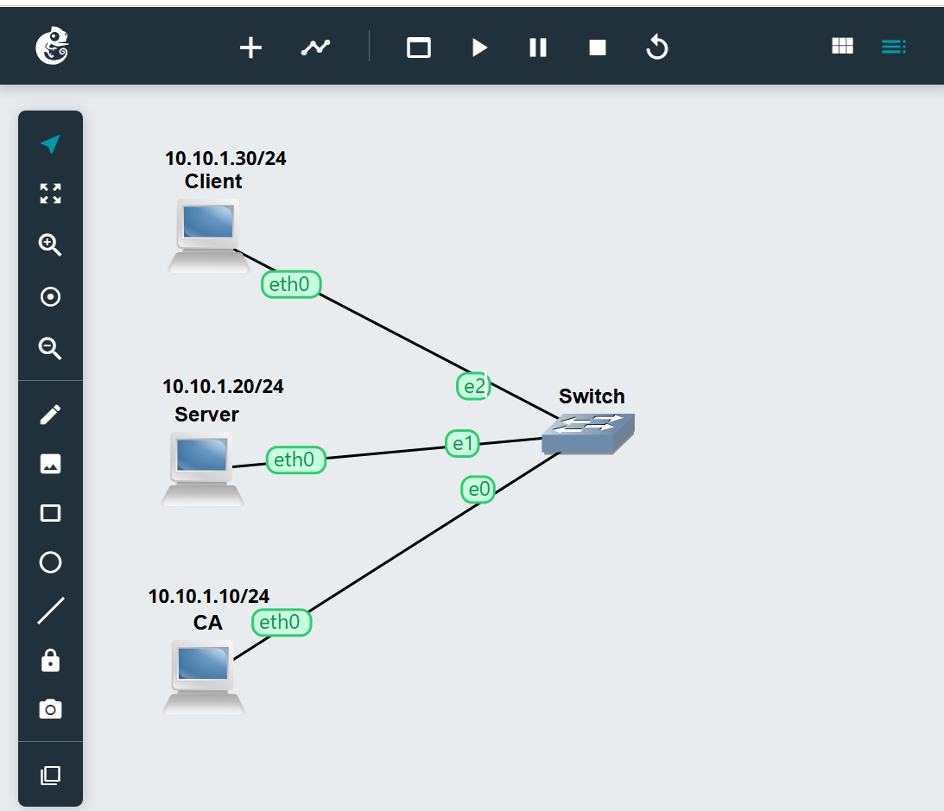
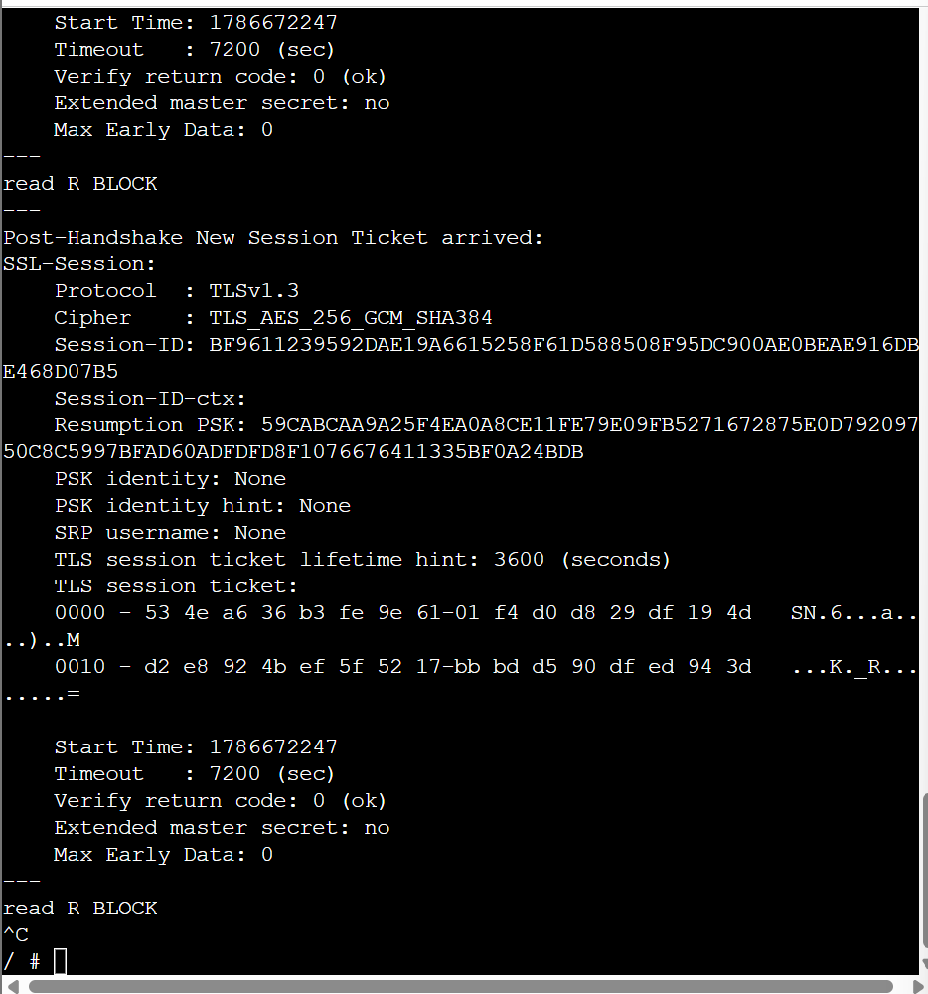
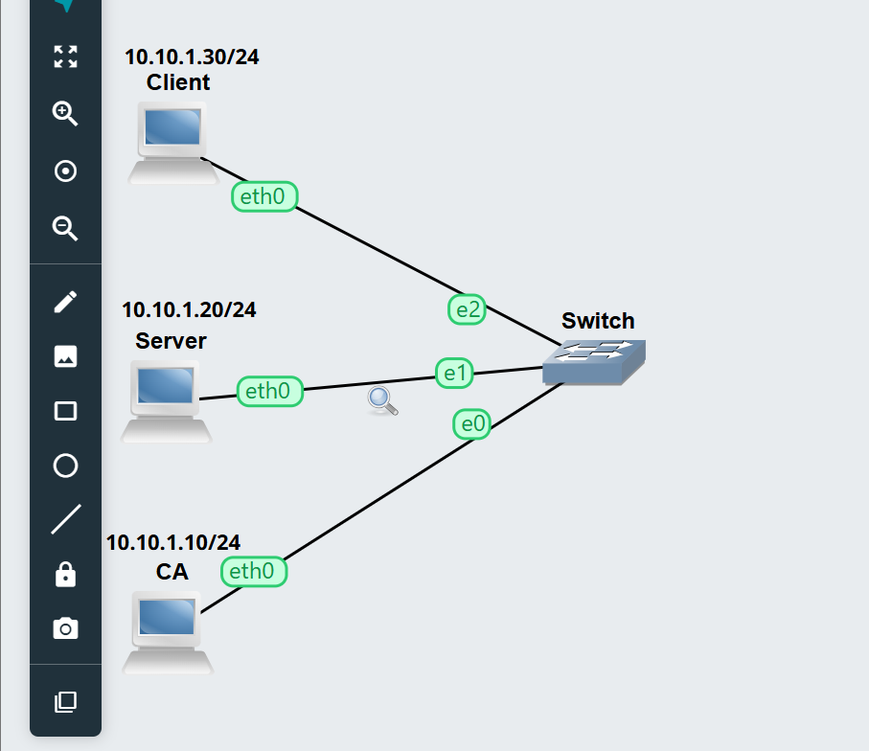
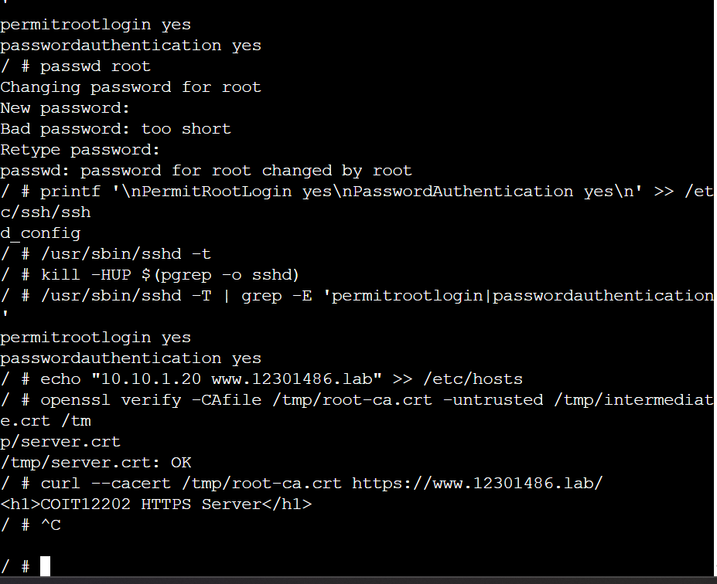

Q1. An intermediate CA serves as a different certificate authority amid the root CA and server certificate. The root CA provides a signature to the intermediate CA certificate, after which the latter can sign server certificates. This is considered to be a better practice as the private key of a root CA can be kept safe from prying eyes. If the intermediate CA is breached, it can be revoked without putting the root CA private key at risk.

Q2. The command openssl verify is used to verify if the server certificate is trustworthy via the chain of certificates leading to the trusted root certificate authority. The algorithm verifies the signatures and relationships in the certificate chain. Without the intermediate certificate, typically, it would not be possible for the client to create a full trust chain from the server's certificate up to the root certificate authority, making the verification of the certificates fail.

Q3. Once a secured connection is formed, HTTP application data becomes safe and protected through TLS encryption. The packet capture displays only handshake information, disclosing details of the connection itself as well as the certificates. However, when it comes to the actual request and response of HTTP being captured in packets, these pieces of information are encrypted.

Q4.A self-signed certificate is authenticated by the entity that created the certificate instead of a recognized certificate authority. Such certificates can be helpful while testing or developing and in private cases where they are trusted manually.

A CA-signed certificate is issued by a trusted certificate authority and is part of the certificate chain. Such certificates are better suited for use at production sites and services since they can be verified by clients through trusted certificate authorities.

