UMESH MAHAJAN
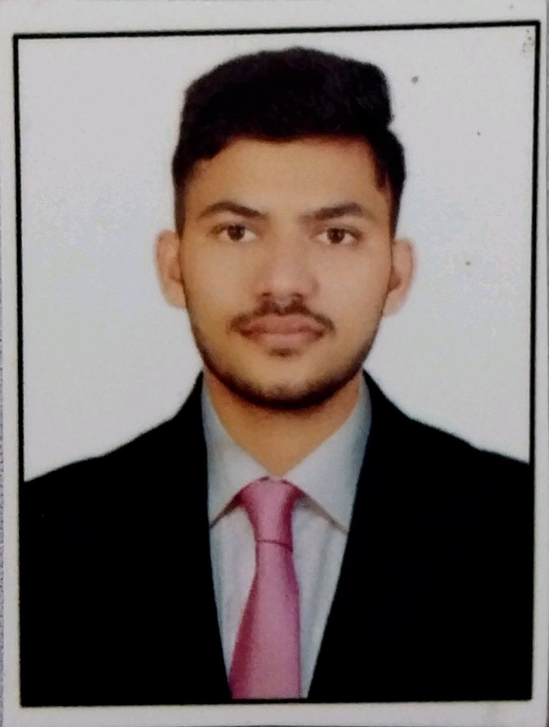
 Email: umeshmahajan196@gmail.com
 Mobile: 8780077096
 LinkedIn: linkedin.com/in/umesh-mahajan
 Github : github.com/umeshmali196
 Address:

CAREER OBJECTIVE :
Passionate about computer applications, programming, and problem-solving, focused on building strong practical technical skills.Committed to continuous learning and growth. Seeking an opportunity to learn continuously, apply my skills, and contribute effectively in a professional environment.

ACADEMIC PROFILE
Program | Institute | University/  Board | Passing year | Score
M.C.A.
B.C.A. | Vimal Tormal Poddar BCA College, Surat | VNSGU | 2025 | 68.88%
HSC | Sunrise Vidyalaya , Surat Gujarat | GSEB | 2022 | 70.28%
SSC | Suman Highschool No.11 , Surat Gujarat | GSEB | 2020 | 60.33%

TECHNICAL SKILLS :

Languages: C, C++, Java, HTML, CSS, JavaScript, PHP, Python,
Database Management: Oracle 10g, MySQL, SQLite , SQL
Tools & Platforms: VS Code, Git & GitHub, Canva, MS Office , XAMPP
Operating Systems: Windows, Linux (Ubuntu basics)
Concepts: DSA, OOPs, Python for Data Analytics & Data Science (Numpy , Pandas) ,
Data Visualization ( Matploatlib, Seaborn)
Frameworks: Android Studio , Flask , Django

PROJECTS :
- Project: FOODIFY – Online Food Ordering System
Description:
Developed a web-based food ordering system that allows users to browse food items, place orders, and manage order details through a simple and responsive interface.
Frontend Technologies: HTML, CSS, JavaScript, Bootstrap
Backend Technologies: PHP, MySQL
- Project: Cruise of the Global Fleet
Description:
Built a cruise management web application enabling users to explore cruise details and manage booking data through a structured frontend-to-backend workflow.

Frontend Technologies: HTML, CSS, JavaScript

Backend Technologies: JSP, Java, JDBC Connection , MySQL
Server: Apache Tomcat.

CERTIFICATIONS :
- Communication Skills, Personality Development And Etiquette - University of VNSGU
- Course on Computer Concepts (CCC) – AICES | A+ Grade

CO-CURRICULAR ACTIVITIES & ACHIEVEMENTS :
- Active participation in Cultural event – VNSGU University

SOFT SKILLS :
- Communication
- Analytical Thinking
- Problem-Solving Ability
- Teamwork & Coordination
- Adaptability, Willingness to Learn
- Time Management
STRENGTHS

- Quick Learner
- Positive Learning Attitude
- Strong work ethics and integrity
- Honest and responsible approach to work
- Disciplined

HOBBIES

- Practicing coding
- Sports / Fitness
- Online Learning
- Watch Movies / Webseries

DECLARATION :
I declare that the information provided above is true and accurate, and fairly represents my qualifications, skills, and academic background.
Date: ____________
Place: ____________

