Installation manual:

1. ***Node.js***

Name of Application: node.js

Website: <https://nodejs.org/en/>

Version: 6.9.4 LTS

Platform: Windows

Steps:

* Download the LTS version of node.js from the link given in website
* After downloading, double click on the setup (.msi) file, which will begin the installation of node.js
* Follow the instructions and node.js will be installed successfully on your system.

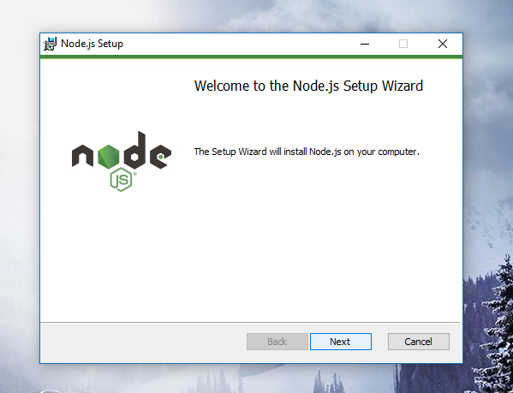

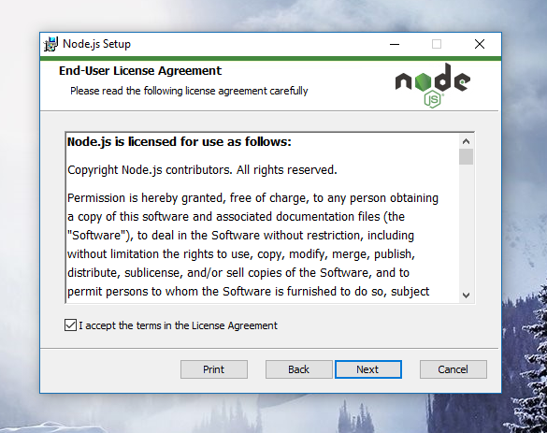

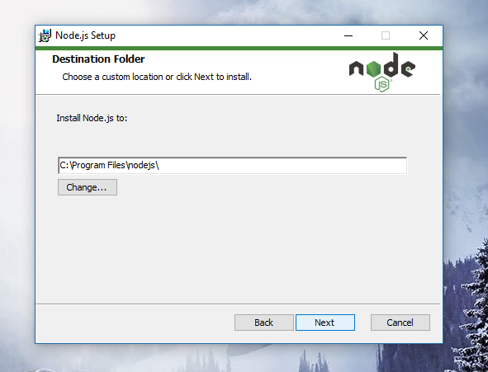

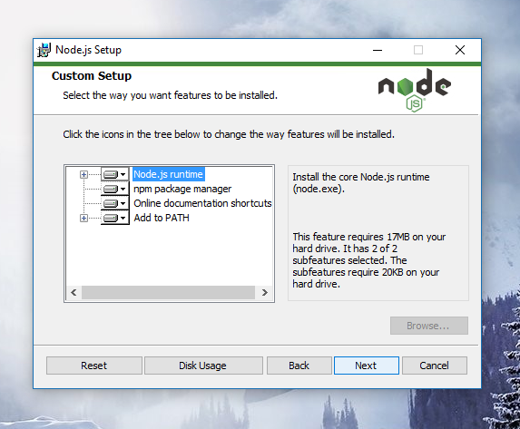

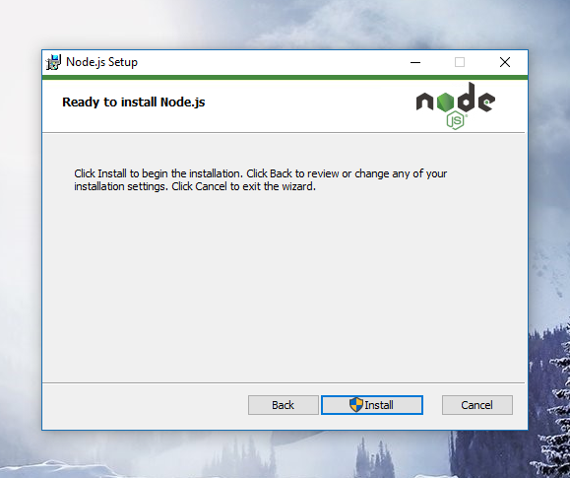

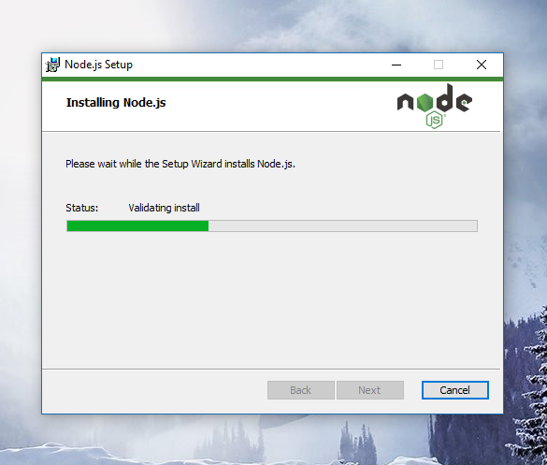

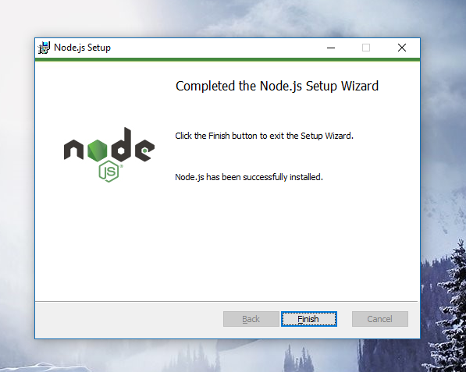

1. ***Mongo DB***

Name of Application: Mongo DB

Website: <https://www.mongodb.com/download-center#previous>

Version: 3.2

Platform: Windows

Steps:

* Download the appropriate version of Mongo DB by selecting the correct option from the dropdown menu.
* Click on the ‘Download (msi)’ which will begin the download of .msi package of mongodb
* After downloading, double click the .msi file to start the installation and select the ‘Complete’ option and click ‘Next’.
* Follow the instructions and this will install mongodb on your system.

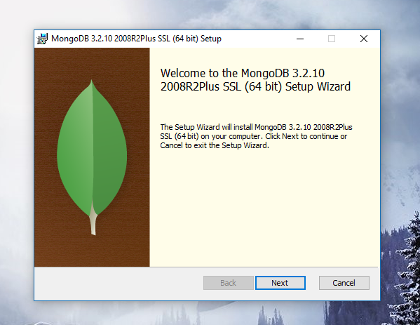

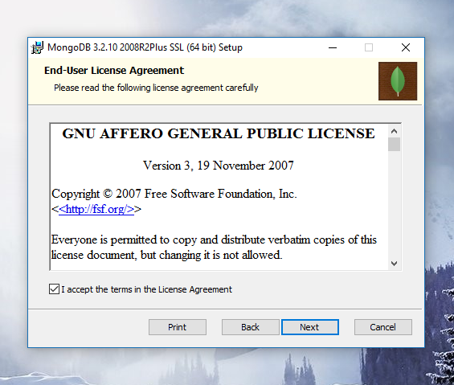

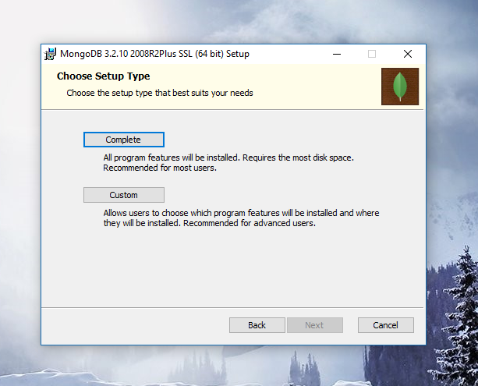

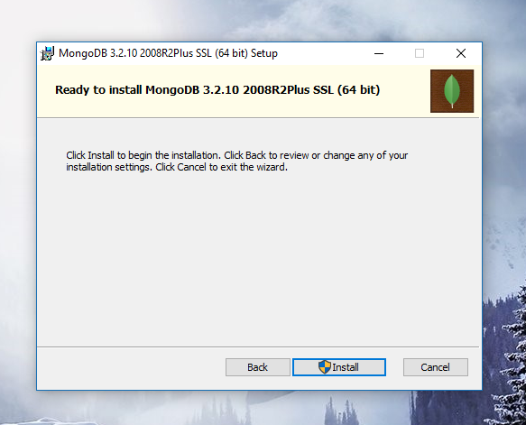

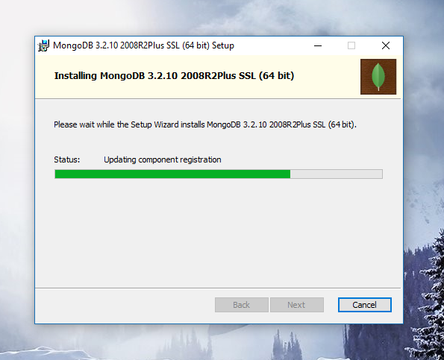

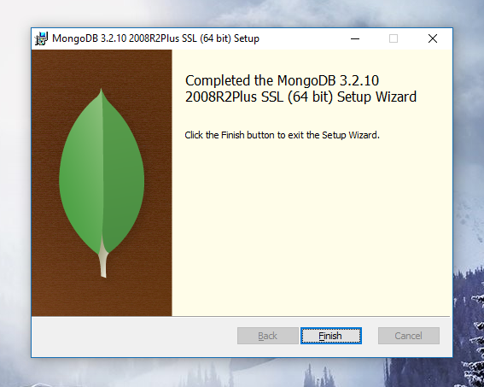

1. ***Git***

Name of Application: Git

Website: <https://git-scm.com/download/win>

Version: 2.11

Platform: Windows

Steps:

* Download the latest version of Git from the link given in website.
* After download is complete, double click on the .exe file to begin the installation process.
* Follow the instructions step by step and this will install Git on your system.

