
SIES GRADUATE SCHOOL OF TECHNOLOGY DEPARTMENT OF COMPUTER ENGINEERING

DATA ANALYTICS & Visualization (DAV) – REPORT FORMAT

Group and Project Details
Project Title: Supply Chain Efficiency Optimization Using Advanced Power BI Visualizations
Group No.:
Faculty Name: Prof. Reena G
Submission Date: 18/10/2026

Student Names and Roll Numbers (all group members):

Kshitij Mane 124A1076
Atharva Matale 124A1078
Trushna Mhatre 124A1080
Mayank Mishra 124A1082
Mohammed Fowz 124A1083
Shrivenkatesh Kannan 124A1097
Umeshraj Nadar 124A1099
Shruti Nagare 124A1100
Praveen Naidu 124A1102
Arohi Pathak 124A1116
Kapish Patil 124A1119
Bhardwaj Rai 124A1128

Abstract
Supply-chain managers need fast, visual answers on where deliveries run late and where profit is earned. This project builds an interactive Microsoft Power BI dashboard, “Supply Chain Efficiency Optimization”, on the DataCo order-item dataset (180,519 records, 43 attributes, January 2015 – January 2018). Data is loaded through Power Query, modelled as one fact table with a calendar table, and analysed with DAX measures for late-delivery rate, cancellation rate and delay days. Three report pages – Executive Overview, Delivery Performance and Cost & Profitability – use slicers and cross-filtering. Net sales are $33.05M, profit is $3.97M (a 12.0% margin) and 57.3% of delivered items arrive late. First Class shipments are late every time because the one-day promise is never met, whereas Standard Class is late only 39.8% of the time. Re-setting delivery promises could cut the late rate to about 32%.

Introduction and Problem Statement
Background and motivation
Modern retail and e-commerce supply chains must deliver the right product, at the right cost, on the promised date. Late deliveries damage customer trust, raise service costs and waste transport capacity, while discounts and product mix decide whether each order is profitable [2][3]. Operations teams, however, usually hold this information in large transactional files that are hard to read without visual analytics. A dashboard that links delivery performance with sales and profit lets managers find problem areas in seconds instead of hours.
Problem statement
The company’s order-item data (180,519 rows) shows what was sold and shipped but not, at a glance, which shipping modes, regions and product categories cause late deliveries or erode profit. The problem is to design and implement a Power BI solution that converts this data into an interactive, decision-ready view of supply-chain efficiency.
Objectives
  - Prepare, validate and model the DataCo order-item data for analysis in Power BI.
  - Define transparent KPIs with DAX – late-delivery rate, cancellation rate, average delay days, net sales, profit and profit margin.
  - Build a three-page interactive dashboard (Executive Overview, Delivery Performance, Cost & Profitability) with slicers and cross-filtering.
  - Identify the main drivers of late delivery and the concentration of sales and profit by region and product category.
  - Recommend operational improvements aligned with UN SDG 9 (Industry, Innovation and Infrastructure) and SDG 12 (Responsible Consumption and Production) [9].
Scope and expected outcome
Scope: descriptive and diagnostic analytics at order-item level for orders placed between 1 January 2015 and 31 January 2018. Expected outcome: a saved .pbix report, a validated set of KPIs, evidence-based insights and a what-if estimate of how much a change in delivery promises would reduce late deliveries.
Assumptions and constraints
  - Late delivery means actual shipping days exceed scheduled days (Delay_Days > 0). Cancelled shipments are excluded from the late-rate denominator because they have no realised delivery.
  - Monetary values are used as stored in the source data and are shown in US dollars; Implied_Cost and Profit follow the definitions in the prepared dataset and are not audited accounting figures.
  - The data contains no warehouse or transport-cost field, so warehouse-level and transport-cost analysis are out of scope.
  - Regional coverage differs between years (see Section 9), and 2018 contains January only; year-on-year comparisons are therefore treated with caution.

Existing System / Literature Review
Supply-chain visibility has traditionally been delivered through ERP and warehouse-system reports and spreadsheets. These show periodic, aggregated totals, are rebuilt manually and offer little filtering, so root causes of delay stay hidden [2][3]. Research on big-data analytics in logistics stresses that value comes from turning detailed operational data into descriptive, predictive and prescriptive insight [4]. The DataCo smart-supply-chain dataset [1] has mostly been used for model-building tasks such as predicting late-delivery risk or fraud; such models answer “will this order be late?” but rarely give managers an explorable picture of where and why performance fails. Good dashboard design – clear hierarchy, few visuals per page, consistent encoding and direct interaction – is what makes data actionable [5], and Power BI with DAX provides the modelling and visual layer for it [7][8].
Table 1: Existing approaches, their limitations and the gap addressed
Approach | Strength | Limitation | How this project addresses it
Spreadsheets / ERP static reports | Familiar; accurate totals | Manual, aggregated, no drill-down or cross-filtering | Interactive slicers and cross-filtering on 180,519 records
Predictive ML on DataCo data | Estimates late-delivery risk per order | Black-box output; no link to profit; not operations-friendly | Transparent DAX KPIs shown by mode, region and category
Generic BI templates | Quick to deploy | Not tied to a clear problem or definitions | KPI definitions, data-quality rules and SDG alignment documented
Separate delivery and finance views | Specialised detail | Hard to see trade-offs between service and profit | Delivery (page 2) and profit (page 3) share one model

Gap: few published uses of this dataset combine delivery performance and profitability in one transparent, interactive dashboard with documented measures. This project fills that gap and adds a what-if estimate of the impact of better delivery promises.

Dataset and Requirements
Table 2: Dataset summary
Item | Description
Dataset / source | DataCo smart supply-chain order data [1], supplied as the “Supply_Chain_PowerBI_Ready” package (Fact_OrderItems_PowerBI_Ready.csv / dataCo_dataset.csv)
Size and format | CSV, 180,519 rows × 43 columns (about 49 MB); one row per order item; 65,752 distinct orders
Period | Order dates 1 Jan 2015 – 31 Jan 2018 (37 months)
Coverage | 164 countries, 23 regions, 50 product categories, 4 shipping modes, 4 delivery statuses, 9 order statuses
Collection method | Transactional order and shipment records of a global retailer, enriched by joining the fact table with its category, geography, shipping-mode, delivery-status and date dimension tables
Permission / licence | Open research data published with the citation in [1]; used here for academic work with attribution

Table 3: Main attribute groups
Group | Attributes
Identifiers and keys | Order_Item_Id, Order_Id, Geo_Key, Category_Key, Mode_Key, Delivery_Status_Key, Order_Date_Key, Ship_Date_Key
Dates | Order_Date, Ship_Date and derived year, quarter, month, year-month and weekday fields for both
Financial | Quantity, Gross_Sales, Discount, Net_Sales, Implied_Cost, Profit
Delivery | Days_Real, Days_Scheduled (_x, _y), Delay_Days, Late_Risk, Is_Late, Is_Cancelled_Shipment, Is_Loss_Making, Stage_Order
Dimensions | Category, Country, Region, Shipping_Mode, Delivery_Status, Order_Status

Data quality (from validation_report.json and re-checked in Python): no duplicate rows, Order_Item_Id is unique, no missing dimension attributes, Net_Sales = Gross_Sales − Discount in every row, and no shipment is dated before its order. Delay_Days is blank for the 7,754 cancelled shipments only; these blanks are deliberately kept (not replaced by zero) because a cancelled order has no realised delay.
Functional requirements
  - FR1 – Import the CSV and validate data types and nulls in Power Query.
  - FR2 – Provide KPI measures: late rate, cancellation rate, average delay, average scheduled days, net sales, cost, profit and margin.
  - FR3 – Offer slicers for Region, Category and Shipping Mode that filter all visuals on the page.
  - FR4 – Show delivery performance by shipping mode and a detail table by region, mode and delivery status.
  - FR5 – Show profit by category and net sales by region.
  - FR6 – Allow users to click any visual element to cross-filter the others.
Non-functional requirements
  - Performance: visuals refresh within about a second for 180,519 rows (in-memory model).
  - Usability: 16:9 canvas (1920 × 1080), consistent “Frontier” theme, clear titles and subtitles.
  - Accuracy: every KPI reconciles with an independent calculation on the source CSV.
  - Maintainability: measures, not hard-coded values; a documented data-quality rule for blanks.
  - Portability: single .pbix file with the CSV path as the only external dependency.
Table 4: Software and hardware requirements
Category | Requirement
Software | Microsoft Power BI Desktop (Windows); Power Query (M) and DAX; Python 3 with pandas and matplotlib for verification and figures; Microsoft Word / PDF reader
Hardware | Windows 10/11 PC, 8 GB RAM recommended (4 GB minimum), multi-core CPU, 2 GB free disk space, 1920 × 1080 display
Inputs | Fact_OrderItems_PowerBI_Ready.csv (and, optionally, the original Dim_*.csv tables)
Outputs | Supply_Chain_Efficiency_Optimization.pbix (3 pages), KPI results, insights and recommendations
Constraints | One-table model with a stand-alone calendar table; no transport-cost or warehouse fields; coverage differs by region and year

Proposed Methodology and System Design
The proposed solution is a five-stage pipeline – source, ETL, data model, visualisation and outcome (Figure 1). It is organised into seven modules: (M1) data acquisition, (M2) ETL in Power Query, (M3) data modelling, (M4) DAX measure layer, (M5) report pages, (M6) interaction through slicers and cross-filtering, and (M7) validation and scenario analysis.
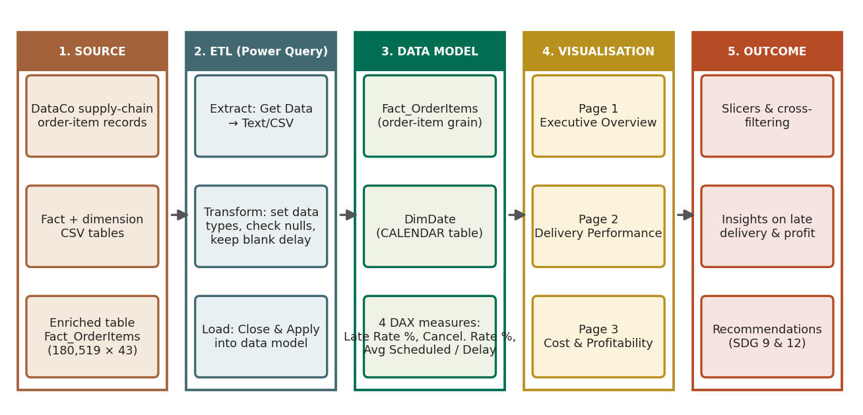
Figure 1: System architecture and workflow of the proposed Power BI solution
ETL (Extract, Transform, Load)
  - Extract: Home → Get data → Text/CSV loads Fact_OrderItems_PowerBI_Ready.csv (43 columns, Windows-1252 encoding).
  - Transform: promote headers; set types deliberately (keys and counts as whole numbers, Order_Date/Ship_Date as date-time, the *_Key and year-month fields as date, amounts as decimal, text columns as text); check column quality for errors and nulls; keep Delay_Days blank for cancelled shipments.
  - Load: Close & Apply loads the query as table Fact_OrderItems; a calendar table DimDate is added with DAX (CALENDAR + ADDCOLUMNS).
Fact / dimension design
The supplied package follows a star schema: a fact table Fact_OrderItems (one row per order item) with keys to the dimensions Dim_Category, Dim_Geography, Dim_ShippingMode, Dim_DeliveryStatus and Dim_Date. For a fast single-view dashboard the dimensions were pre-joined into one enriched table (a flattened star), so Category, Country, Region, Shipping_Mode, Delivery_Status and date attributes sit beside the facts. DimDate is kept as a stand-alone calendar table (Figure 2); the report uses the fact table’s own date fields with Power BI’s date hierarchy.
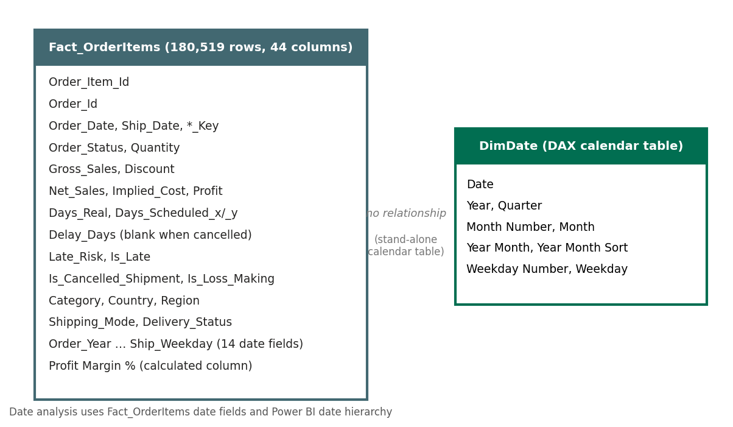
Figure 2: Model view: Fact_OrderItems and the stand-alone DimDate calendar table
Data mining
This project is descriptive and diagnostic analytics; no data-mining algorithm is trained. The pre-processing steps are the ETL rules above (type setting, null handling, duplicate and key checks). Predictive modelling of the supplied Late_Risk flag is listed as future scope.
Dashboard design
Three pages share a 1920 × 1080 canvas and the “Frontier” colour theme: Executive Overview (slicers + three summary visuals), Delivery Performance (KPI cards, two mode charts and a detail table) and Cost & Profitability (KPI cards and two column charts). Slicers sit on the Executive Overview page; every visual on every page can be clicked to cross-filter the rest.

Algorithm Design
The KPI logic is a single pass over the rows that survive the current filter context (slicer or cross-filter). The pseudocode below shows how each measure is evaluated; Figure 3 is the matching flowchart.
ALGORITHM ComputeKPIs(Fact, filters)
rows <- Fact WHERE all(filters) are true # filter context
items <- DISTINCTCOUNT(rows.Order_Item_Id)
delivered <- DISTINCTCOUNT(rows WHERE Is_Cancelled_Shipment = 0)
late_items <- DISTINCTCOUNT(rows WHERE Is_Late = 1)
cancelled <- DISTINCTCOUNT(rows WHERE Is_Cancelled_Shipment = 1)
LateRate <- late_items / delivered # DIVIDE() returns blank if delivered = 0
CancelRate <- cancelled / items
AvgDelay <- AVERAGE(rows.Delay_Days) # blanks (cancelled) are ignored
AvgSched <- AVERAGE(rows.Days_Scheduled_x)
Margin <- SUM(rows.Profit) / SUM(rows.Net_Sales)
FOR EACH group g IN visual axis (mode, region, category, year)
evaluate the measures on rows WHERE group = g
SORT groups by the chosen measure; RENDER visual

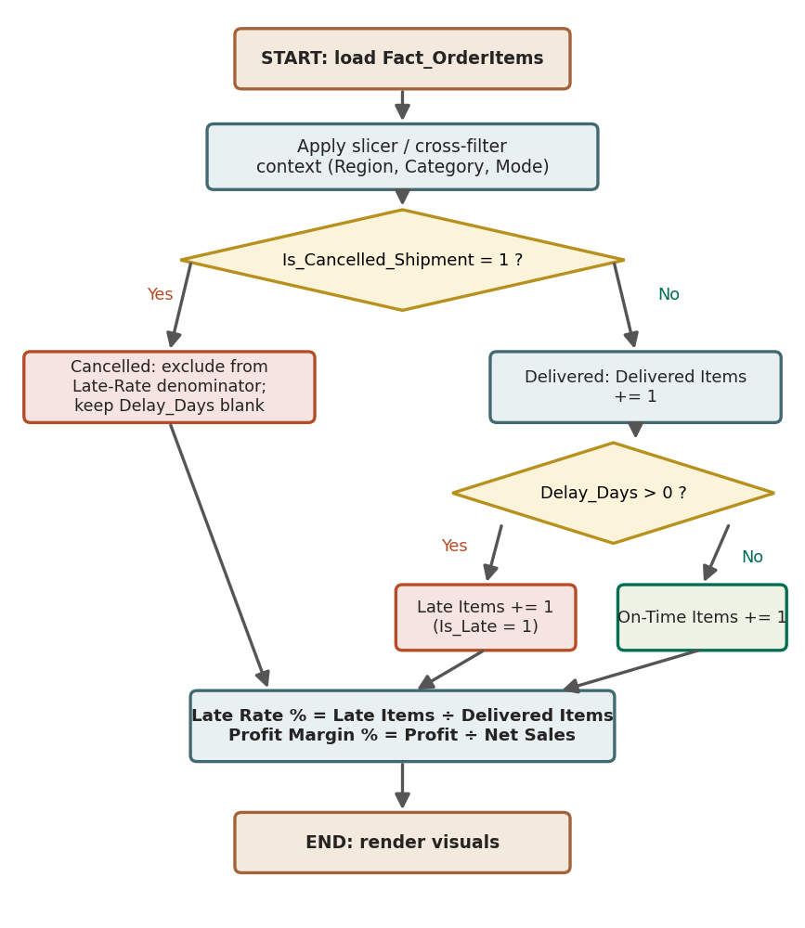
Figure 3: Flowchart of the KPI calculation logic
Data structures
Power BI stores each column in the in-memory VertiPaq engine as a compressed, dictionary-encoded column. Filters are applied as bitmaps over the row set; slicer selections are lists of values per column. Group-by visuals use temporary hash tables keyed by the axis field.
Complexity
For n = 180,519 rows and k groups on a visual axis, each measure needs one scan of the filtered rows, O(n); grouping adds O(n) hashing and sorting the k groups costs O(k log k) (k ≤ 50 here). Memory is O(n·c) for c columns but small in practice because columns are compressed (the whole report with data is about 8 MB, compared with 49 MB of CSV).
What-if scenario algorithm
FOR EACH delivered item i:
new_schedule[i] <- proposed promise for Shipping_Mode[i] # e.g. First Class 1 -> 2 days
late_new[i] <- 1 IF Days_Real[i] > new_schedule[i] ELSE 0
LateRate_new <- SUM(late_new) / delivered

Implementation
Table 5: Tools and environment
Tool / technology | Purpose
Power BI Desktop | Report authoring, data model, visuals, themes (Fluent 2 base theme with the “Frontier” colour theme)
Power Query (M) | CSV import, header promotion, type conversion
DAX | Calendar table and KPI measures
Python 3 (pandas, matplotlib) | Independent verification of KPIs, what-if scenario and extra figures
Prepared data package | Fact_OrderItems_PowerBI_Ready.csv, README and validation_report.json
Environment | Windows desktop; source file read from a local folder (…\Supply_Chain_PowerBI_Ready\)

Module-wise implementation
Table 6: Report visuals by page
Page | Visual | Fields / measures
1 Executive Overview | Title text box | “Supply Chain Efficiency — Executive Dashboard”
 | Slicers (3) | Region (tile grid), Category (list), Shipping_Mode (tiles)
 | Bar chart | Late Rate % by Shipping_Mode
 | Line chart | Sum of Net_Sales by Order_Year_Month (year level of date hierarchy)
 | Column chart (data labels) | Sum of Profit by Region
2 Delivery Performance | KPI cards (3) | Late Rate %, Cancellation Rate %, Average Delay Days
 | Clustered bar | Late Rate % by Shipping_Mode
 | Clustered column | Average Scheduled Days and Average Delay Days by Shipping_Mode
 | Table | Count of Order_Id, Region, Shipping_Mode, Delivery_Status, Sum of Delay_Days, Sum of Is_Late
3 Cost & Profitability | KPI cards (4) | Sum of Net_Sales, Sum of Implied_Cost, Sum of Profit, Profit Margin %
 | Column chart | Sum of Profit by Category
 | Column chart | Sum of Net_Sales by Region

Important code
Power Query (M) – import and typing (shortened):
let
Source = Csv.Document(File.Contents("…\Fact_OrderItems_PowerBI_Ready.csv"),
[Delimiter=",", Columns=43, Encoding=1252, QuoteStyle=QuoteStyle.None]),
Promoted = Table.PromoteHeaders(Source, [PromoteAllScalars=true]),
Typed = Table.TransformColumnTypes(Promoted,{{"Order_Item_Id", Int64.Type},
{"Order_Date", type datetime}, {"Net_Sales", type number},
{"Delay_Days", Int64.Type}, {"Is_Late", Int64.Type}, ... })
in Typed

DAX – measures used by the report:
Late Rate % =
DIVIDE (
CALCULATE ( DISTINCTCOUNT ( Fact_OrderItems[Order_Item_Id] ), Fact_OrderItems[Is_Late] = 1 ),
CALCULATE ( DISTINCTCOUNT ( Fact_OrderItems[Order_Item_Id] ), Fact_OrderItems[Is_Cancelled_Shipment] = 0 ) )

Cancellation Rate % =
DIVIDE (
CALCULATE ( DISTINCTCOUNT ( Fact_OrderItems[Order_Item_Id] ), Fact_OrderItems[Is_Cancelled_Shipment] = 1 ),
DISTINCTCOUNT ( Fact_OrderItems[Order_Item_Id] ) )

Average Scheduled Days = AVERAGE ( Fact_OrderItems[Days_Scheduled_x] )
Average Delay Days = AVERAGE ( Fact_OrderItems[Delay_Days] )
Profit Margin % = DIVIDE ( SUM ( Fact_OrderItems[Profit] ), SUM ( Fact_OrderItems[Net_Sales] ) )

DAX – calendar table (DimDate):
DimDate =
VAR StartDate = MIN ( MIN ( Fact_OrderItems[Order_Date] ), MIN ( Fact_OrderItems[Ship_Date] ) )
VAR EndDate = MAX ( MAX ( Fact_OrderItems[Order_Date] ), MAX ( Fact_OrderItems[Ship_Date] ) )
RETURN ADDCOLUMNS ( CALENDAR ( StartDate, EndDate ),
"Year", YEAR ( [Date] ), "Quarter", "Q" & FORMAT ( [Date], "Q" ),
"Month Number", MONTH ( [Date] ), "Month", FORMAT ( [Date], "MMMM" ),
"Year Month", FORMAT ( [Date], "YYYY-MM" ),
"Year Month Sort", YEAR ( [Date] ) * 100 + MONTH ( [Date] ),
"Weekday Number", WEEKDAY ( [Date], 2 ), "Weekday", FORMAT ( [Date], "dddd" ) )

Complete files: GitHub repository ____________________________________________ (add link before submission).
Setup and execution
  - Install Power BI Desktop and copy the project folder (CSV, .pbix) to a local drive.
  - Open Supply_Chain_Efficiency_Optimization.pbix. If Power BI cannot find the file, choose Transform data → Data source settings → Change Source and point to Fact_OrderItems_PowerBI_Ready.csv.
  - Click Refresh, then use the page tabs at the bottom to move between the three pages.
  - Use the Region, Category and Shipping Mode slicers on page 1, or click any bar, column or table row, to filter the other visuals; hold Ctrl for multi-select and click an empty area to clear the filter.

Testing and Validation
Testing combined data checks, measure reconciliation and interaction checks. Each KPI was recalculated independently from the source CSV with Python (pandas) and compared with the value the Power BI measure must return; interaction tests apply a slicer selection or cross-filter click and confirm that cards, charts and the table update consistently.
Table 7: Test cases and results
Test Case / Input | Expected Result | Actual Result | Status
T1 Data load  Import CSV | 180,519 rows; 43 source columns | 180,519 rows; 43 columns (+1 calculated column in the model) | Pass
T2 Key uniqueness  Distinct Order_Item_Id | Equals row count | 180,519 distinct = 180,519 rows | Pass
T3 Blank delays  Count of blank Delay_Days | 7,754 blanks, all cancelled, not zero-filled | 7,754 blanks; all rows have Is_Cancelled_Shipment = 1 | Pass
T4 Late Rate %  All data | 98,977 ÷ 172,765 = 57.29% | 57.29% | Pass
T5 Cancellation Rate %  All data | 7,754 ÷ 180,519 = 4.30% | 4.30% | Pass
T6 Average Delay Days  All data | Mean of 172,765 valid delays = 0.57 | 0.57 | Pass
T7 Sales cards  Net sales, cost, profit | Net $33.05M; cost $29.09M; profit $3.97M | $33.05M; $29.09M; $3.97M | Pass
T8 Profit Margin card  Sum of row-level margin column | A ratio near 12% | 21,743 (sum of 180,519 row margins) – meaningless | Fail
T9 Profit Margin card (fixed)  DIVIDE(SUM(Profit), SUM(Net_Sales)) | $3.97M ÷ $33.05M = 12.00% | 12.00% | Pass (after fix)
T10 Slicer test  Region = Western Europe, Mode = Standard Class | Late-rate bar shows only Standard Class (40.2%); profit by region shows $355K | Standard Class 40.2%; Western Europe profit $355K | Pass
T11 Cross-filter (page 2)  Click First Class | Late Rate 100.00%; cancellation 4.68%; avg delay 1.00; table total 27,814 items | 100.00%; 4.68%; 1.00; 27,814 | Pass
T12 Cross-filter (page 3)  Click Fishing category | Net sales $6.23M; profit $756K; margin 12.14% | $6.23M; $756K; 12.14% | Pass

Defect found: test T8 showed that the “Profit Margin %” field in the model is a row-level calculated column (Profit ÷ Net_Sales for each row); summing it on a card is meaningless. It was replaced by a measure that divides total profit by total net sales (T9). The average of row margins would also differ slightly (12.04%) because it weights small and large orders equally.

Results and Discussion
The figures below show the three report pages. Each page is shown in its default state and, where useful, with a filter applied to demonstrate the interactive behaviour. Dashboard images are renderings of the report pages built from the .pbix layout and the loaded data.
9.1 Executive Overview (page 1)
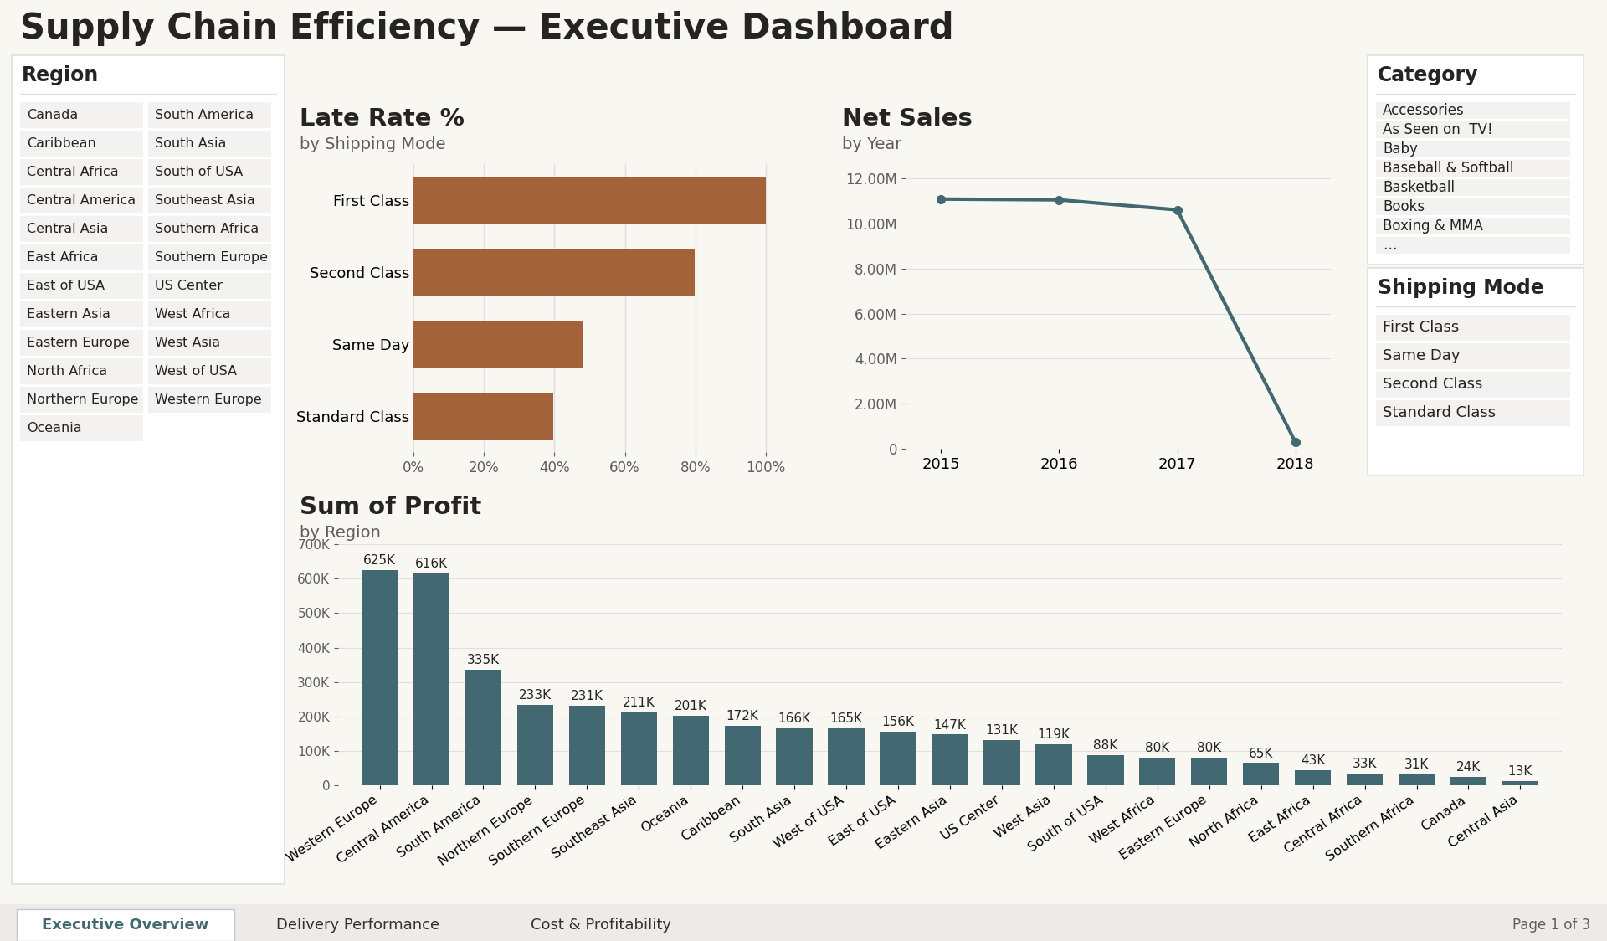
Figure 4: Executive Overview – all data (slicers: Region, Category, Shipping Mode)
Late Rate % varies strongly by shipping mode: First Class 100.0%, Second Class 79.8%, Same Day 47.9% and Standard Class 39.8%. Net sales per year are almost flat – $11.09M (2015), $11.06M (2016) and $10.61M (2017); 2018 contains January only ($0.30M). Western Europe and Central America earn the most profit ($625K and $616K), together 31.3% of total profit.
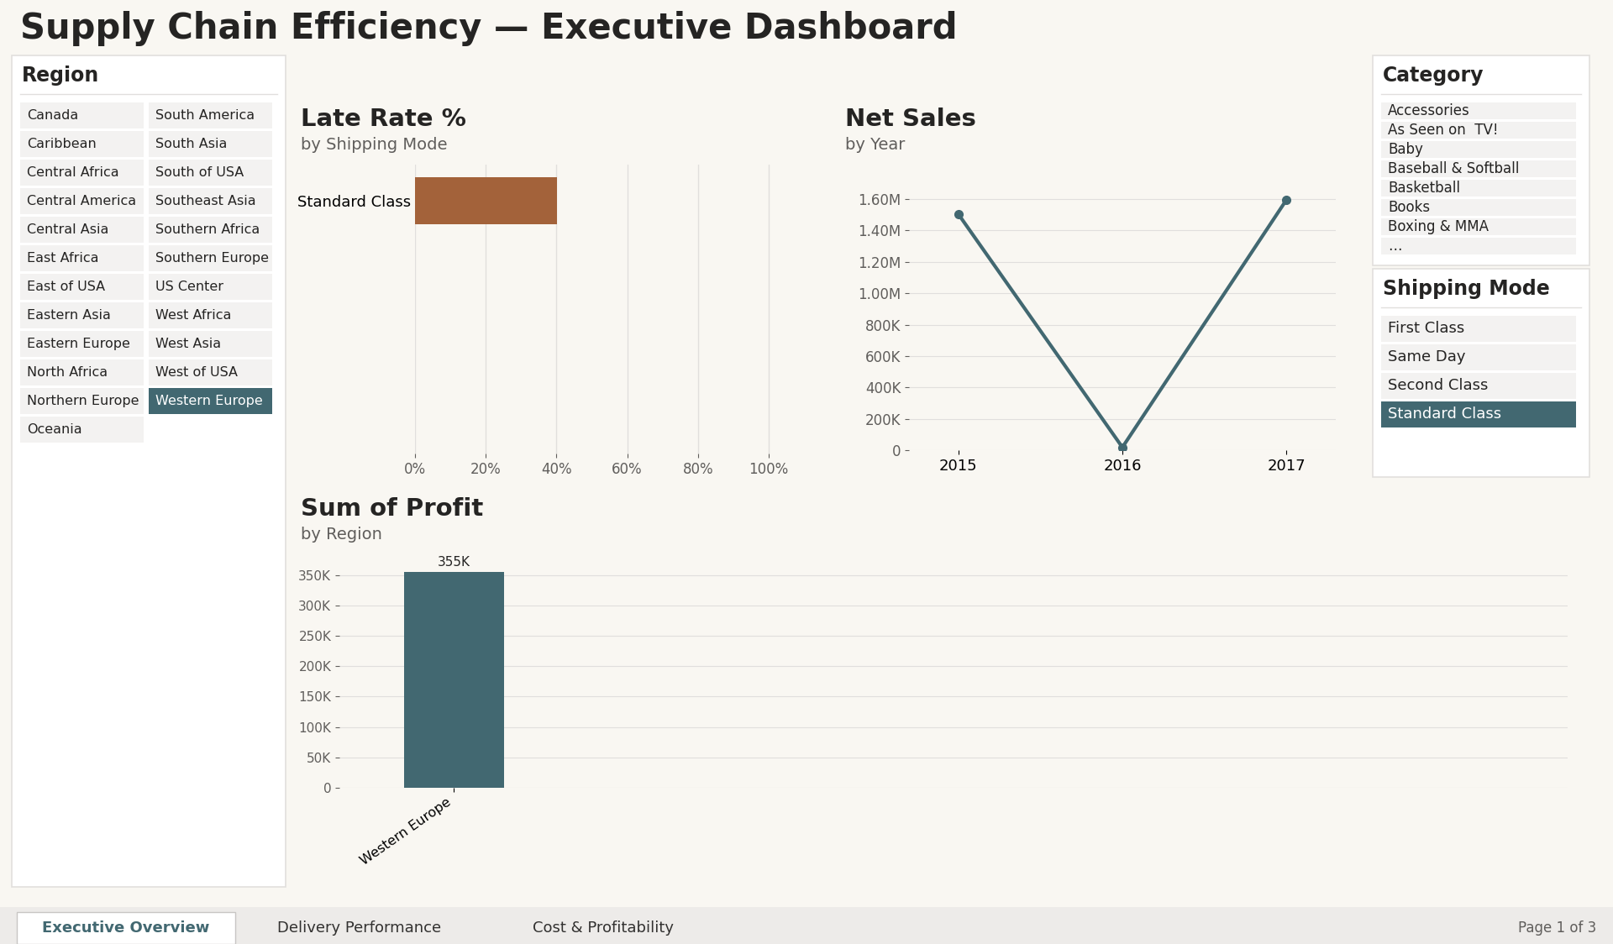
Figure 5: Executive Overview with filters applied: Region = Western Europe and Shipping Mode = Standard Class
Selecting a Region tile and a Shipping Mode tile filters every visual: the bar chart now shows only Standard Class (40.2% late), the line chart shows only Western Europe Standard Class sales, and the profit chart shows $355K for the selected region. The sales line falls to almost zero in 2016 because Western Europe has almost no orders in that year (Section 9.5).
9.2 Delivery Performance (page 2)
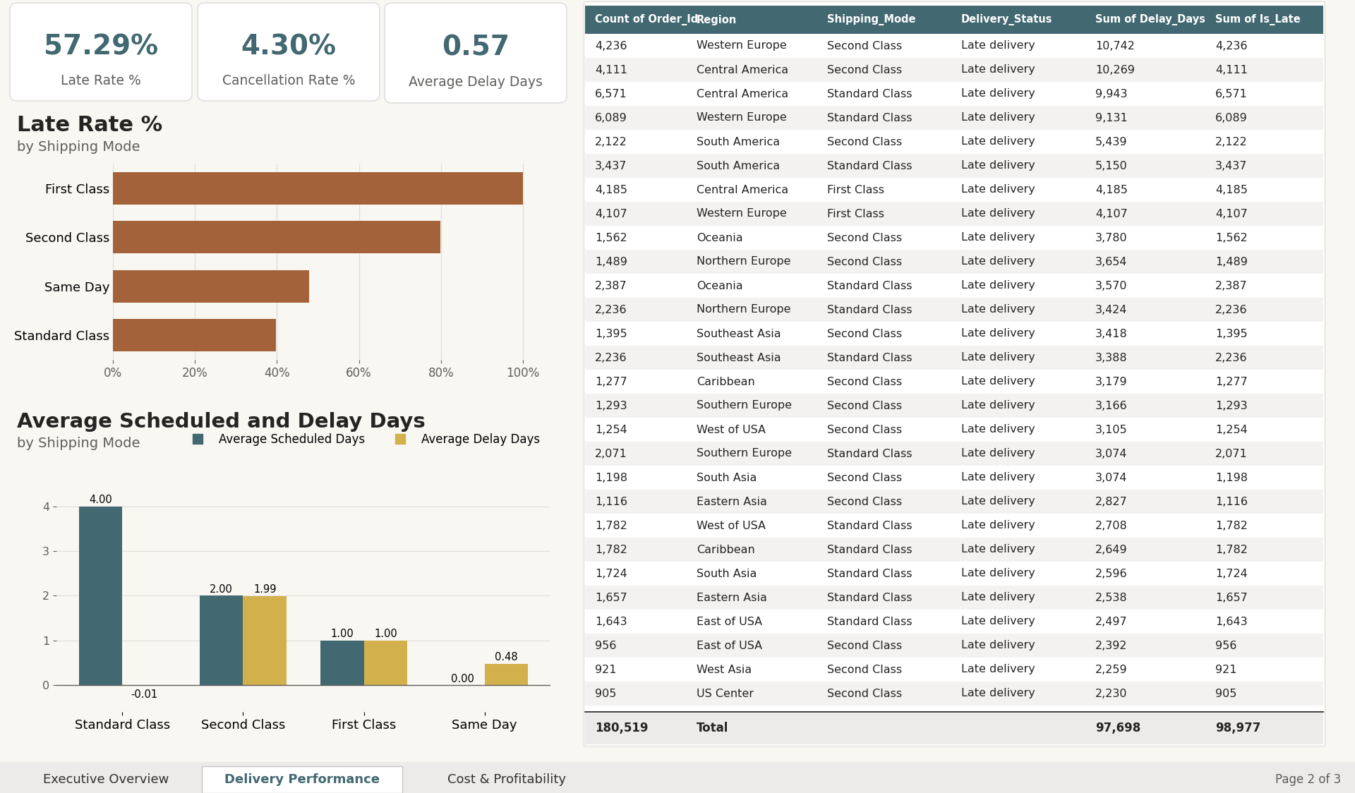
Figure 6: Delivery Performance – KPI cards, mode charts and detail table
Table 8: Delivery performance by shipping mode
Shipping mode | Items | Scheduled days | Actual days (avg) | Avg delay (days) | Late rate
Standard Class | 107,752 | 4 | 4.00 | -0.01 | 39.8%
Second Class | 35,216 | 2 | 3.99 | 1.99 | 79.8%
First Class | 27,814 | 1 | 2.00 | 1.00 | 100.0%
Same Day | 9,737 | 0 | 0.48 | 0.48 | 47.9%

Overall, 57.3% of delivered items are late (98,977 of 172,765), 4.30% of items are cancelled and the average valid delay is 0.57 days. The cause is structural: First Class promises one day but always takes two days, so every First Class item is late; Second Class promises two days but takes about four (80% late). Standard Class promises four days, delivers on average in 4.0 days and is on time or early 60% of the time. Late items are late by 1.6 days on average.
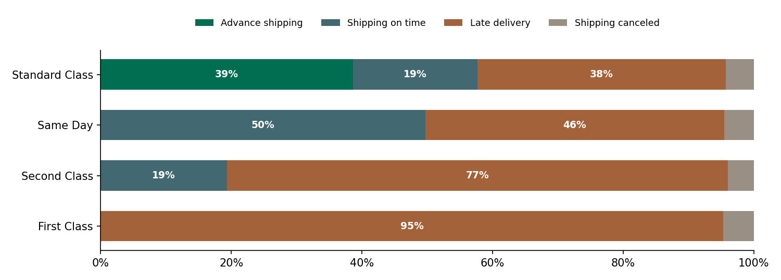
Figure 7: Delivery status mix by shipping mode (share of all items)
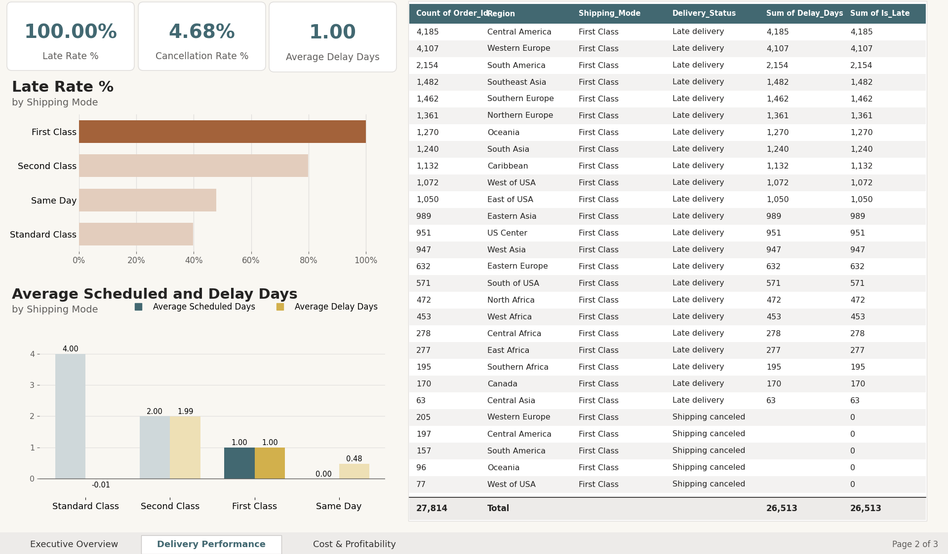
Figure 8: Delivery Performance after clicking the First Class bar (cross-filtering)
Clicking First Class dims the other bars and filters the cards and table: Late Rate becomes 100.00%, average delay 1.00 day and the table total falls to 27,814 items – a direct view of the problem the promise creates.
9.3 Cost & Profitability (page 3)
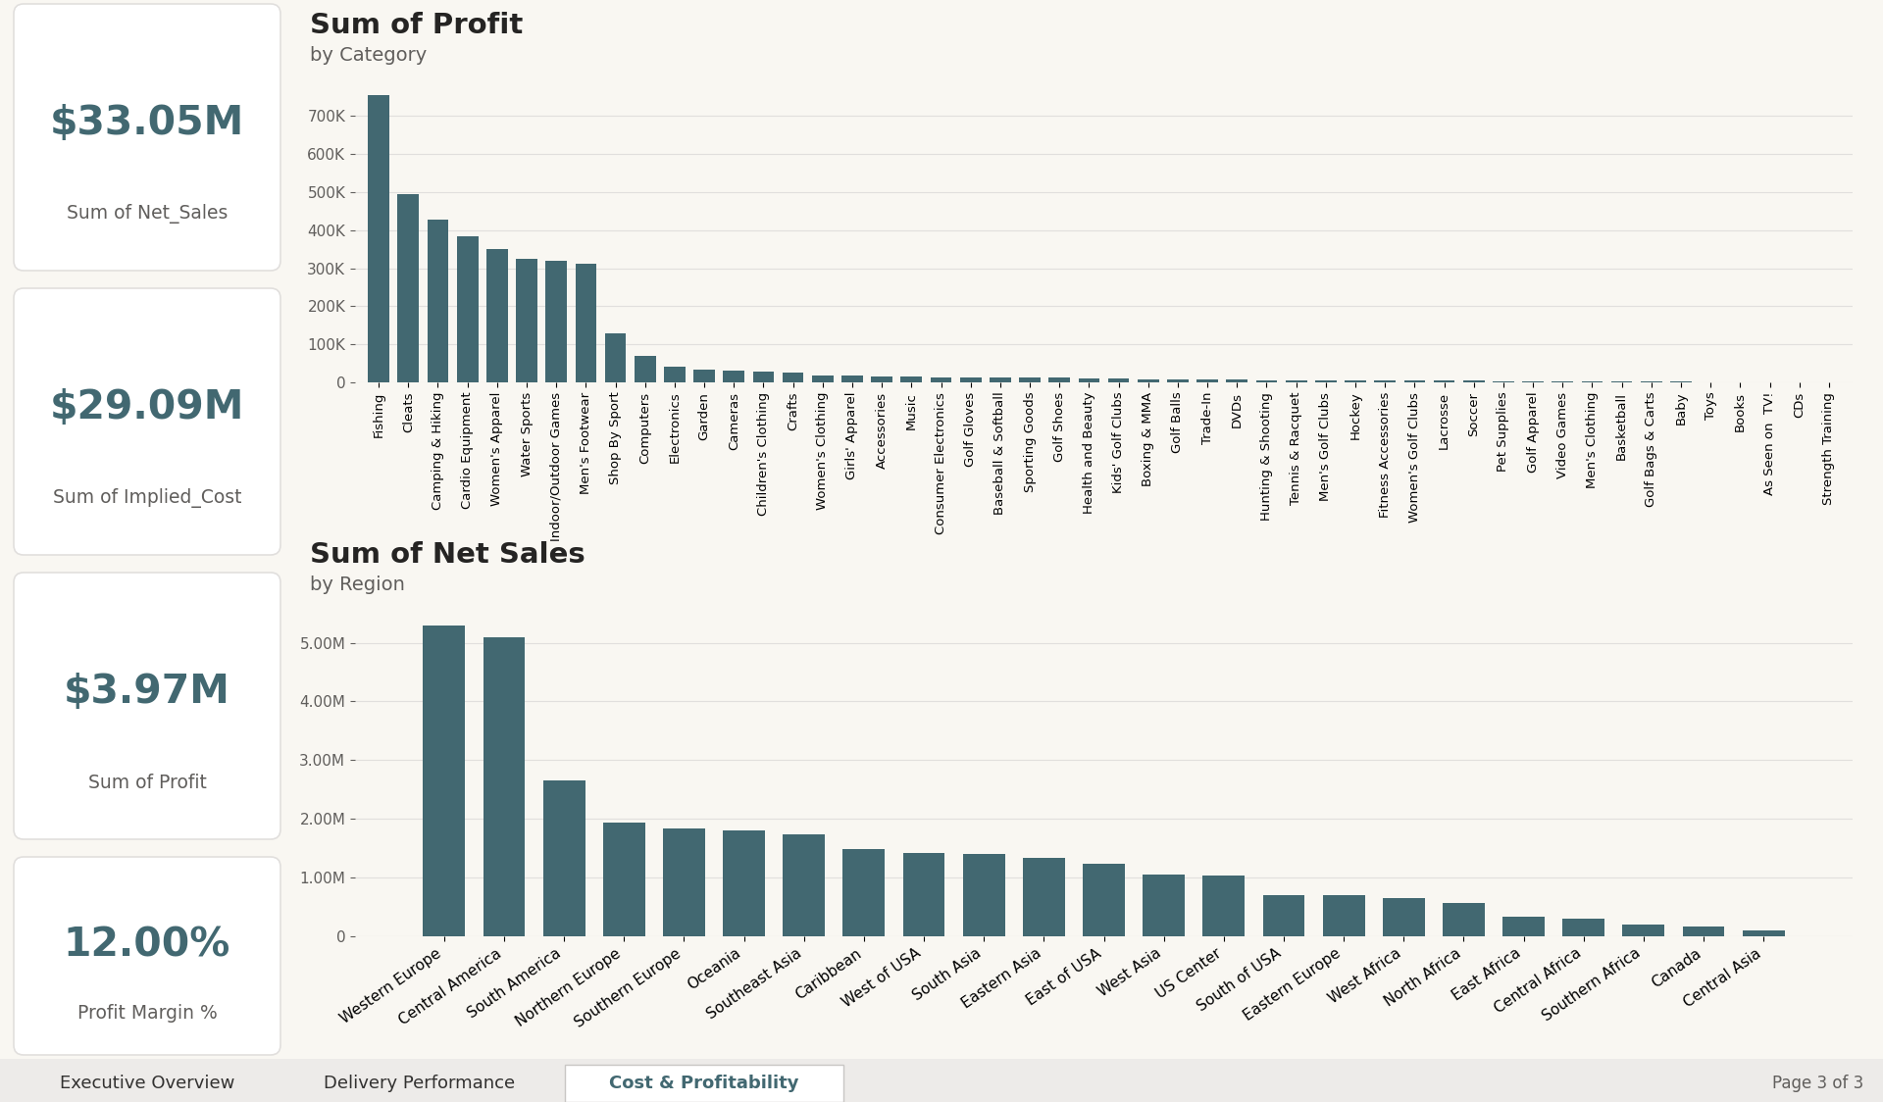
Figure 9: Cost & Profitability – cards, profit by category and net sales by region
Net sales are $33.05M and implied cost $29.09M, leaving profit of $3.97M and a margin of 12.0%. Discounts total $3.73M (10.1% of gross sales). Profit is concentrated: Fishing ($756K), Cleats ($495K) and Camping & Hiking ($427K) give 42% of profit, and the nine largest categories give 88%. Western Europe and Central America generate 31% of net sales. 33,784 items (18.7%) lose money; their losses of $3.88M offset $7.85M of gains.
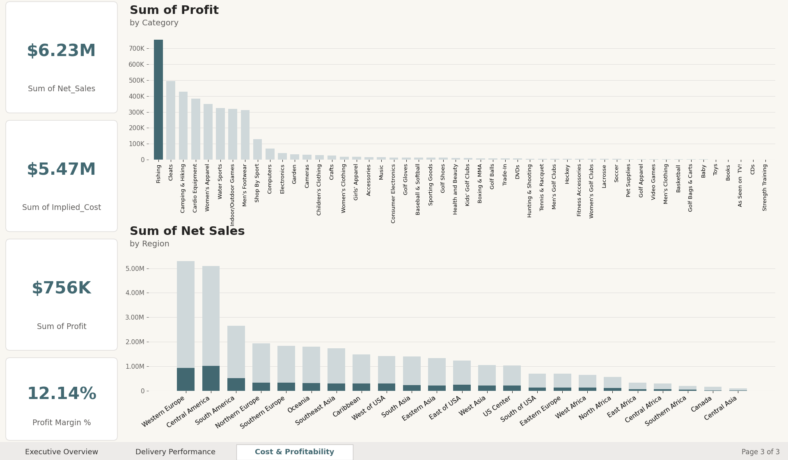
Figure 10: Cost & Profitability after selecting the Fishing category
With Fishing selected the cards show net sales of $6.23M, profit of $756K and a margin of 12.14%; the regional chart shows each region’s Fishing share in a darker colour. Weak spots are small categories such as Strength Training (0.7% margin), As Seen on TV! (3.9%) and Men’s Clothing (5.1%).
9.4 Scenario analysis: resetting delivery promises
Because lateness is driven by the promised days, the late rate was recalculated under revised promises using the actual days already observed (algorithm in Section 6). The effect is an estimate of reporting-level lateness, not a forecast of carrier behaviour.
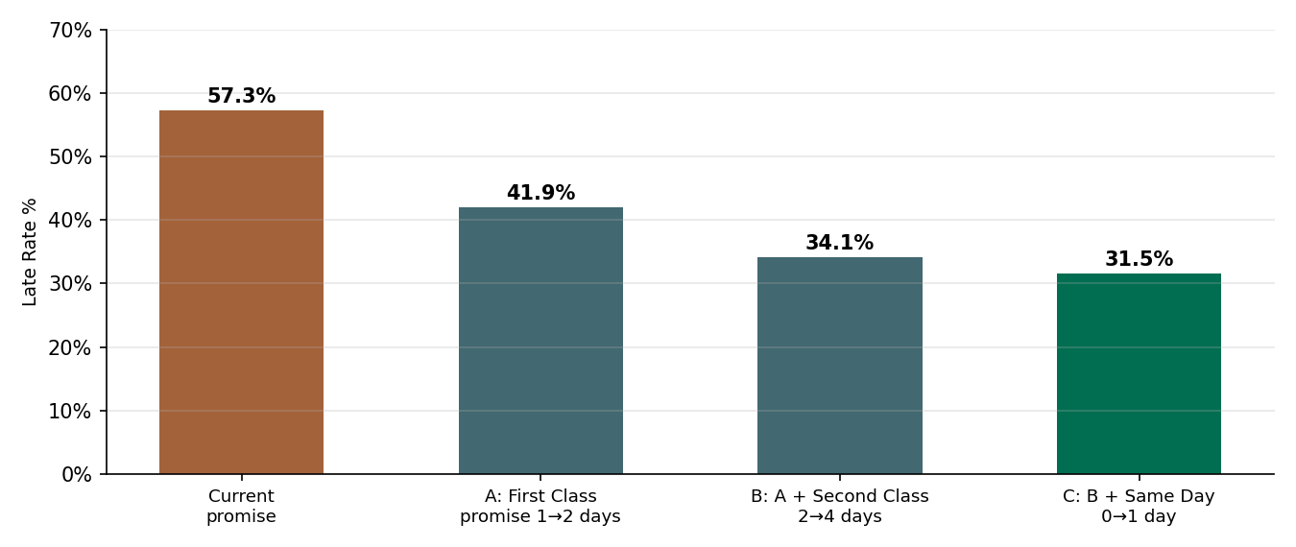
Figure 11: What-if: late rate under revised delivery promises
Aligning the First Class promise with its real two days cuts the late rate from 57.3% to 41.9%; also moving Second Class to four days gives 34.1%, and giving Same Day one day gives 31.5%. Honest, achievable promises would remove roughly 45% of today’s late items without changing physical performance, while faster real service for First Class and Second Class would be the longer-term goal.
9.5 Additional observations
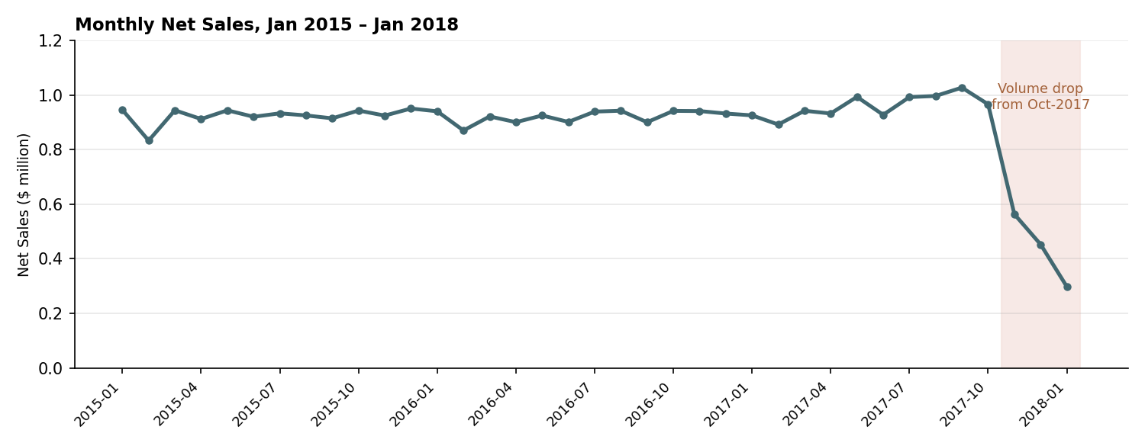
Figure 12: Monthly net sales, January 2015 – January 2018
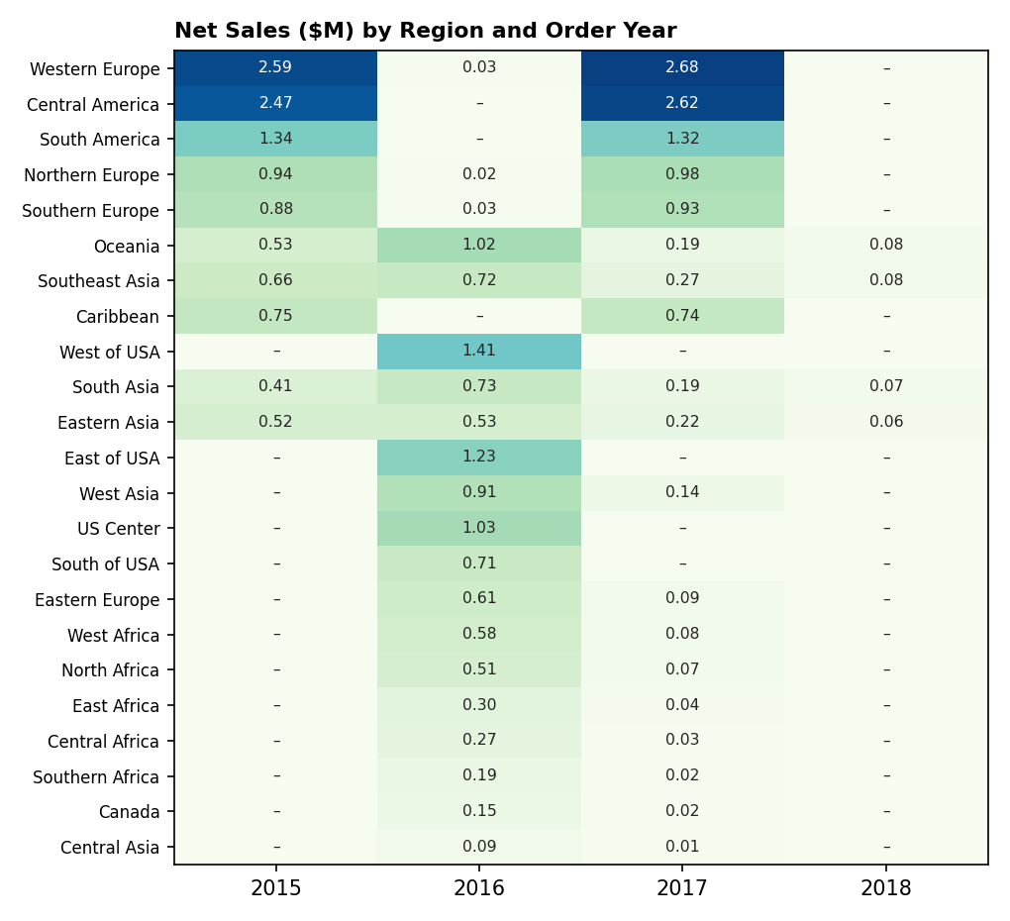
Figure 13: Net sales by region and order year ($ million; – means no orders)
Two unexpected patterns need care when interpreting the dashboard: (1) order volume drops sharply from October 2017 (5,189 items in September 2017 versus 2,255 in October), which looks like a data cut-off rather than a real demand fall; (2) regional coverage differs by year – the three US regions and several others appear only in 2016, while Western Europe, Central America and South America appear almost only in 2015 and 2017. Late-delivery rates, however, are similar across regions (51.6% in Canada to 60.1% in Central Africa), so region is not the main driver of lateness; shipping mode is.
9.6 Summary of key metrics and objective achievement
Table 9: Key metrics
Metric | Value
Order items / orders | 180,519 / 65,752
Gross sales / discounts | $36.78M / $3.73M
Net sales / implied cost | $33.05M / $29.09M
Profit / margin | $3.97M / 12.00%
Late rate (delivered items) | 57.29%
Cancellation rate | 4.30%
Average delay (valid) | 0.57 days
Loss-making items | 33,784 (18.7%)

Table 10: Objectives versus outcome
Objective | Status | Evidence
Prepare, validate and model the data | Achieved | Sections 4–5, tests T1–T3
Define transparent DAX KPIs | Achieved | Section 7 code; tests T4–T9
Three-page interactive dashboard | Achieved | Figures 4–10; tests T10–T12
Identify drivers of late delivery | Achieved | Shipping-mode promise gap, Section 9.2
Identify concentration of sales and profit | Achieved | Section 9.3
Recommendations for SDG 9 and 12 | Achieved | Section 11 (conclusion)

9.7 Limitations
  - Single-table model with a stand-alone calendar table; no relationship-based time intelligence.
  - Profit and Implied_Cost are dataset-defined; transport cost and warehouse data are absent.
  - Uneven regional coverage by year and a partial last quarter limit trend conclusions.
  - The scenario analysis re-labels promises using observed days and does not model carrier capacity or customer reaction.

Conclusion and Future Scope
The project delivers a three-page Power BI dashboard that turns 180,519 order-item records into clear, interactive insight on delivery performance, sales and profit. With $33.05M in net sales and $3.97M profit (12.0% margin), the supply chain is profitable, but 57.3% of delivered items are late. Shipping mode, not region, explains the problem: First Class is always late and Second Class is late 80% of the time because the promised days are shorter than the days actually taken. Profit is concentrated in a few categories (Fishing, Cleats, Camping & Hiking). All objectives were met and all KPIs reconcile with an independent calculation.
Recommendations (SDG 9 and SDG 12): (1) re-set First Class and Second Class delivery promises to match capability, or invest in faster real service (SDG 9 – resilient infrastructure and innovation); (2) shift volume towards Standard Class where promises are reliably met; (3) review discounts and pricing in low-margin categories to cut loss-making items and waste (SDG 12 – responsible production and consumption); (4) fix data coverage and the October 2017 cut-off before trend decisions.
Limitations: one-table model, dataset-defined profit, missing transport and warehouse data, uneven regional coverage.
Future scope: add transport-cost and warehouse fields; build a proper star schema with relationships to DimDate and the dimension tables; add drill-through pages, tooltips and a what-if parameter for promise days; train a predictive model on the Late_Risk flag; publish to Power BI Service with scheduled refresh and row-level security.

References
[1] F. Constante, F. Silva and A. Pereira, “DataCo SMART SUPPLY CHAIN FOR BIG DATA ANALYSIS,” Mendeley Data, V5, 2019. doi: 10.17632/8gx2fvg2k6.5
[2] S. Chopra and P. Meindl, Supply Chain Management: Strategy, Planning, and Operation, 6th ed. Pearson, 2016.
[3] M. Christopher, Logistics & Supply Chain Management, 5th ed. Pearson, 2016.
[4] G. Wang, A. Gunasekaran, E. W. T. Ngai and T. Papadopoulos, “Big data analytics in logistics and supply chain management: Certain investigations for research and applications,” Int. J. Production Economics, vol. 176, pp. 98–110, 2016.
[5] S. Few, Information Dashboard Design: The Effective Visual Communication of Data. O’Reilly Media, 2006.
[6] R. Kimball and M. Ross, The Data Warehouse Toolkit, 3rd ed. Wiley, 2013.
[7] M. Russo and A. Ferrari, The Definitive Guide to DAX, 2nd ed. Microsoft Press, 2019.
[8] Microsoft, “Power BI documentation,” Microsoft Learn. https://learn.microsoft.com/power-bi/
[9] United Nations, “Transforming our world: the 2030 Agenda for Sustainable Development,” A/RES/70/1, 2015.

