

**ENGINEERING CLINICS**

**Project:** Iot Based Smart Cart with Inventory management

**Abstract:** The project depicts an IoT-based Smart Cart with advanced inventory management features. It uses an ESP32 microcontroller with built-in WiFi. An IP address displayed on the LCD screen connects users to a billing page with real-time updates. Items tagged with RFID, like tea, rice, biscuits, and soap, are scanned, updating the LCD and webpage. The cart calculates the total and sends an SMS bill to the customer's phone. Stock-out notifications are sent to the owner's phone if any item quantity reaches five. The shopkeeper can log in to access sales data and restock accordingly. This smart cart speeds up shopping, smoothens inventory management, and boosts sales through data-driven strategies.

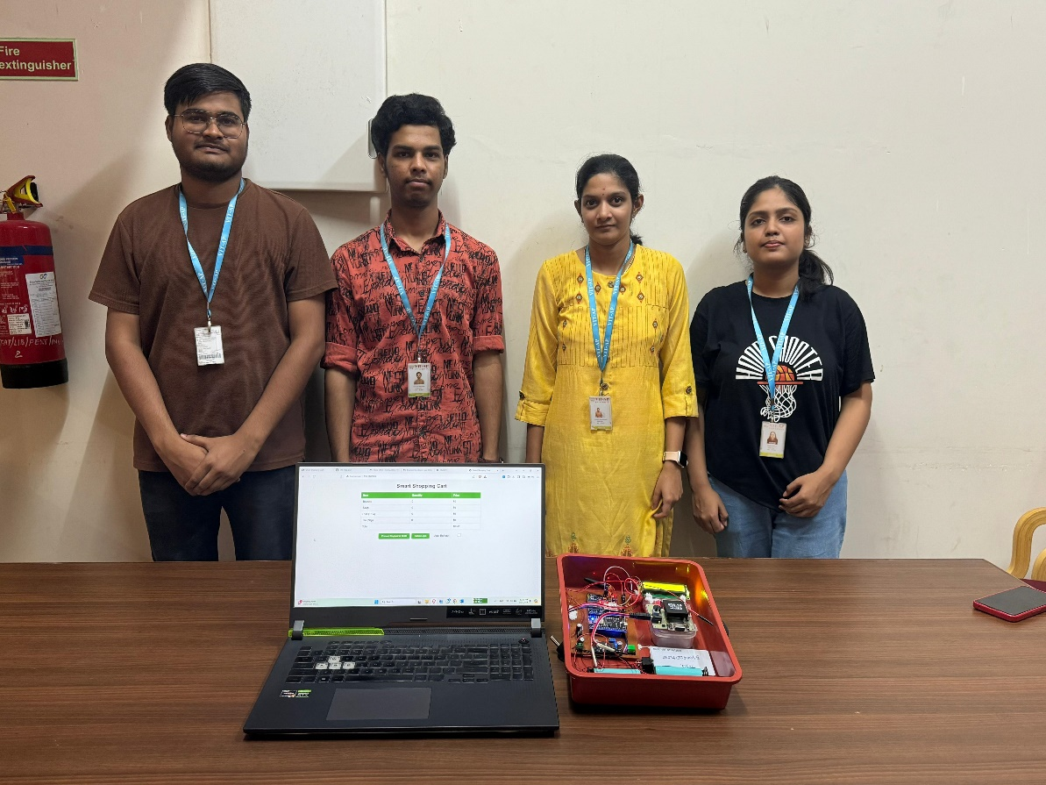

**Project Guide:** Dr. Chiranjeev Kumar Shahu

**Project Members:**

1. NUPOOR KUMARI – 22MIC7141

2. UMESH MEENA – 22MIC7179

3. MULLAPUDI BHUVANESWARI – 22MIS7159

4. NALLA SAI SHIVAMANI – 22MIC7163

5. AMITABHA NATH - 22BCE8048

6. KOYILADA PREM - 22BCE9667