Incidence, onset and material dependency of central venous catheter-related thrombosis in critically ill surgical patients: a prospective observational single-center study

Sebastian Gibb, MD1,✉, Sebastian Engelhardt1, Falk von Dincklage, MD1, and Sven-Olaf Kuhn, MD1

**Purpose**: Catheter-related thrombosis (CRT) is a major complication of central venous catheters (CVCs). However, the incidence, onset, and dependence of CRT on CVC material and/or type in critically ill surgical patients is unknown. Therefore, we here investigated incidence, onset, and dependence of CRT on a variety of risk factors including CVC material and type in critically ill surgical patients.

**Methods**: In this prospective observational single-center study we included all critically ill patients with CVCs that were treated in our surgical intensive care unit during a six-month period. All CVCs were examined for CRT every other day using ultrasound, starting within 24 hours of placement. The primary outcome was the time of onset of CRT depending on the type of CVC. CRT risk factors were analyzed using multiple Cox proportional hazards regression models.

**Results**: We included 95 first-time CVCs in the internal jugular vein. The median time to CRT varied from one day to five days for different types of CVCs. Within one day, 37 to 64% of CVCs and within one week, 64 to 100% of CVCs developed a CRT. All but one of the observed CRT were asymptomatic and caused no complications. Multiple regression analyses of CRT risk factors showed that beside cancer and omitting prophylactic anticoagulation, also some CVC types were associated with a higher risk for CRT.

**Conclusion**: Almost all CVCs in critically ill surgical patients developed an asymptomatic CRT in the first days after catheterization. Depending on the type of CVC the median CRT-free period varied considerably.

**Keywords**: Central venous catheter, Catheter-related thrombosis, Ultrasound, Intensive care medicine

**Take-home message**: Thrombosis is one of the most common complications of central venous catheters (CVC) and is caused by a variety of factors. The incidence of catheter-related thrombosis (CRT) is even higher in surgical than in medical critically ill patients. The median CRT-free period varies from one to five days depending on the type of CVC. In general, these thromboses are asymptomatic and don’t require treatment. However, the differences in CVC material and the resulting CRTs have been neglected in clinical research and need to be further investigated.

1 Department of Anesthesiology and Intensive Care Medicine, University Medicine Greifswald, Ferdinand-Sauerbruch-Straße, D-17475 Greifswald, Germany.

✉ Correspondence: [Sebastian Gibb, MD <mail@sebastiangibb.de>](mailto:mail@sebastiangibb.de)

# Introduction

Central venous catheters (CVCs) are commonly used during surgery and in critically ill patients [1]. Catheter-related thrombosis (CRT) is a major complication of central venous access and an important risk factor for pulmonary embolism (PE) and central line-associated bloodstream infections (CLABSI)[1, 2].

The majority of CRTs are asymptomatic and patients with CVCs are rarely screened for CRT in routine clinical practice. The incidence of CRT in previous studies varies widely between medical and surgical patients, ranging from 6 to 56% [2–6]. A recently published study used a daily ultrasound assessment on mostly critically ill medical patients and found a median time to CRT of four days with an incidence of 16.9% [4]. Perioperative hypercoagulability in surgical patients may explain the higher incidence of CRT with more than 50%. However, despite the much higher incidence the onset of CRT in surgical patients is still unknown.

Patient-related risk factors for CRT, such as cancer or previous vein thrombosis, are well-known [1, 7]. In contrast, catheter-related risk factors other than insertion site and catheter diameter have rarely been studied. Only one small study, almost 30 years old, looked at the effect of catheter material and found a lower incidence of CRT for polyurethane/siliconized catheters compared with polyvinyl chloride/polyethylene [8].

Therefore, we conducted a prospective observational single-center study to determine the incidence, onset, and dependence of CRT on CVC material and/or manufacturer in postoperative critically ill patients.

# Methods

## Study design and population

In this prospective observational single-center study, we evaluated the occurrence of CRT in critically ill patients with CVCs treated in our surgical intensive care unit (ICU) at a university hospital during a six-month period from March 2022 to August 2022.

We enrolled all adult patients (≥ 18 years) who required a CVC for at least 48 hours. All CVCs were placed in the operating theatre or ICU using an ultrasound-guided insertion approach and maximum barrier precautions according to local guidelines. Skin antisepsis was performed with octenidine dihydrochlordie, 1-propanol, 2-propanol (octeniderm colourless, Schülke & Mayr GmbH, Norderstedt, Germany). The choice of the appropriate CVC type, site and side was made by the clinicians performing the placement. They were asked to complete a questionnaire documenting the manufacturer, the LOT (identification) number, the number of attempts, any complications and their level of expertise in CVC placement. If the patient had a blood sample taken on the day of the screening we ordered white blood cells counts (WBC), C-reactive peptide (CRP) and D-dimer.

The study was approved by the ethics committee of the University Medicine Greifswald (reference number: BB 006/22).

## Ultrasound assessment

CVCs were ultrasound scanned for CRT every other day, starting within 24 hours of placement. We used a linear probe with a frequency of 8-12 MHz. All patients were examined in the supine position. CRT was diagnosed when an echogenic structure attached to the CVC was detected, which was non-compressible and showed pathological color Doppler. To determine the size of the thrombosis, we measured the largest dimension (height) in the short-axis and the longest dimension (length) in the long-axis view. If the length was longer than the probe/scan window we set the length to 60 mm. A picture or video was taken if a thrombosis was found for the first time. We didn’t look at arterial catheters or catheters for renal replacement or extracorporeal membrane oxygenation therapy. To ensure consistent and high image quality the ultrasound examination was always performed by one of the authors (SE), who was trained in point-of-care ultrasound and intensive care medicine and had more than two years’ experience. The recorded images and videos were then reviewed by a second independent intensivist (SG) with more than seven years’ experience in point-of-care ultrasound. Neither was involved in the placement of CVCs or the management of the critically ill patients. The results of these non-routine investigations were not reported to the treating clinicians so as not to alter usual care.

## Catheter types

Due to supply constraints, controlled randomisation was not feasible and different types of CVCs from different manufacturers were used. We observed three different types of Arrow CVCs (Teleflex Medical GmbH, Germany), namely the classic polyurethane CVCs with three and five lumens (referred to as Arrow3 and Arrow5), and the chlorhexidine acetate and silver sulfadiazine coated polyurethane catheters Arrowg+ard Blue (1st generation) with four lumens (referred to as Arrow4). Further we observed the three-lumen Certofix protect Trio catheter (B. Braun SE, Germany), consisting of a thermoplastic polyurethane, embedded Barium Sulphate as contrast agent and an antimicrobial coating containing polyhexamethylene biguanide (Polyhexanide or PHMB, referred to as Braun3), and the five-lumen multicath CVC (VYGON GmbH & Co. KG, Germany; referred to as Vygon5), made of polyurethane without any special coating.

## Outcome

The primary outcome was the time of onset of CRT for each type of CVC. As the reported CRT rates were very inhomogeneous, we designed our study as an exploratory observational study over a six-month period and did not estimate a sample size. Secondary outcomes were (1) difference in CRT-free time according to the type of CVC and (2) risk factors for CRT.

## Statistical analysis

All data processing and all statistical analyses were performed using R version 4.3.1 [9].

Prior to the analyses, all laboratory values were *log* transformed to approximate normal distributions. CRT-free time was modelled using Kaplan-Meier estimates, and comparisons between different CVC types were made using the Gehan-Wilcoxon test with the Peto and Peto modification for different censoring patterns as implemented in the *survival* R package [10, 11]. Multivariable Cox proportional hazards regression models were used to estimate hazard ratios of CRT as provided by the *survival* R package [10–12]. Adjustment was done for sex, CVC type, side, admission type, perioperative placement, sepsis, cancer, previous deep vein, thrombosis (DVT), and anticoagulation. The proportional hazard assumption was tested with the chi-square test for independence of the scaled Schoenfeld residuals and transformed time for each covariate (see Supplementary Information, Table S1 and Fig. S5). A *p*-value less than 0.05 was considered a statistically significant difference. Benjamini-Hochberg procedure was used to correct for multiple testing [13]. Summary tables, the CONSORT and the forest plots were generated using the packages *gtsummary*, *consort*, and *survminer*, respectively [14–17]. All data and analyses are available at <https://github.com/umg-minai/crt> [18].

# Results

## Baseline characteristics

During the six-month study period 215 CVCs from 192 consecutive critically ill patients were eligible for inclusion.

120 CVCs were excluded (see Fig. 1). Initially, we decided to include only the first CVC of each patient and excluded 23 consecutive CVCs. As catheter entry into the femoral or the subclavian vein was often difficult to visualize with ultrasound, we focused on the internal jugular vein (IJV) and excluded 16 and 49 CVCs, respectively. In addition, we had to exclude a total of six CVCs because of the very small number of catheters of this type (e.g. one CVC Arrow, 5 lumen with Arrowg+ard Blue (1st generation) coating) or because they were inserted in an external hospital and we were unable to verify the time of insertion. As direct oral anticoagulants (DOACs) are an inhomogeneous group and uncommon in our ICU, we examined only one patient with a DOAC and decided to exclude this CVC as well. We also had to exclude 25 CVCs due to missing or unreadable LOT information. Finally, we retained 95 first-time CVCs and patients for our analysis (see Table 1).

30 Arrow5, 25 Vygon5, 19 Arrow3, 14 Arrow4, and seven Braun3 CVCs were used. Most of them were placed in the right IJV (82 (86%)). A skin incision was made prior to CVC insertion in just over half of the cases. Two thirds of all CVCs were inserted by experienced practitioners who had inserted more than 50 CVCs. About the same number of CVCs were inserted in the ICU and outside the operating room. We examined the catheters by ultrasound 24 (19, 29) hours after insertion.

About 80% of the patients admitted to our ICU had previously undergone surgery. One third had sepsis and about 40% had cancer. Only 7 (7.4%) patients had a history of vein thrombosis.

Patients received prophylactic anticoagulation with low-molecular-weight heparins in two thirds of cases, and unfractionated heparin in only a few. However, almost a third had no anti-thrombotic prophylaxis at the time of CVC placement.

In general, the patients had an elevated WBC (median (IQR): 12.8 (9.4, 17.4), [Gpt/L]), CRP (145 (98, 206), [mg/L]), and D-dimer (4.1 (2.3, 7.8), [mg/L]) on the first day after CVC insertion.

## Analysis of CRT-free time

The median CRT-free time to the first diagnosed CRT was one day for Arrow4, Braun3 and Vygon5. Arrow3 and Arrow5 had longer median CRT-free periods of three and five days, respectively (see Table 2). Due to catheter removal or ICU discharge, we were only able to perform follow-up ultrasound examinations for 3 (1, 7) days.

Specifically, we found CRTs in 37% of all Arrow5, 42% of all Arrow3, 43% of all Braun3, 64% of all Vygon5, and 64% of all Arrow4 CVCs at the first examination (within 24 hours; see also Fig. 2). Within one week of catheterization 64 to 100% of CVCs developed a CRT.

The height and length of the thrombosis remained largely constant over time. On day one, the median (IQR) height and length were 2.1 (1.5, 2.6) mm and 19.7 (13.1, 28.1) mm, respectively. However, the median (IQR) largest dimension of the thrombosis was almost identical across all examinations: 2.2 (1.5, 3.1) mm and 21.5 (11.9, 29.0) mm, respectively (see Supplementary Information, Fig. S1 to S4).

A statistical comparison between the CVC type with the lowest CRT rate, Arrow5, and those with the highest CRT rate, gives an unadjusted *p*-value of 0.11 for Arrow4 and 0.04 for Vygon5. Adjusting the *p*-values for all ten possible comparisons of CVC types gives a *p*-value of 1 for Arrow4 and 0.44 for Vygon5 (see the Supplementary Information, Fig. S8 and S9).

## Complications

Despite the high CRT rate none of the patients had a PE or CLABSI. However, one symptomatic thrombosis was observed and one CVC was removed because of suspected infection. Lumen occlusion was reported in four CVCs.

## Analysis of CRT risk factors

In addition to the univariate analyses we applied multiple regression analyses to determine the impact of different variables (see Fig. 3). All variables with missing values were omitted to maintain the sample size. However, the results don’t vary much even when all variables are included (see Supplementary Information for a regression with half the number of samples but all the variables, Table S4).

As shown in the forest plot (see Fig. 3), the Arrow4 and Vygon5 CVC types were significantly associated with higher rates of CRT. Their hazard ratios were 4.9 and 3.1, respectively. In addition to CVC type, no prophylactic anticoagulation prior to CVC placement was another significant risk factor for CRT, with a hazard ratio of 2.1. Cancer was also significantly associated with CRT (hazard ratio 2.1), but is an inhomogeneous disease category. In our cases, cancer was always diagnosed before the CVC insertion. Nevertheless, we didn’t stratify our regression model for cancer because the chi-square values for the (un)stratified models were very similar (5.6 vs 6.2). We tested and rejected stratification for sex for the same reason (5.6 vs 6.4). However, men had a significant less risk of CRT (hazard ratio 0.56) than women. Neither age, side, sepsis, previous DVT, nor WBC on day one were associated with a higher rate of CRT. Because it is very unlikely that any of the covariates studied, except for laboratory measurements, would change over the short observation period, we didn’t look for any time-dependence.

# Discussion

In this prospective observational study, we found asymptomatic CRT in 70 of 95 CVCs (73.7%) in the IJV of critically ill patients within four weeks after catheterisation. This incidence of CRT is much higher than previously reported 28 to 56% for IJV CVCs in general surgical ICU or cardiac surgery patients [2, 6, 19]. To our knowledge, the time of thrombosis onset has not been previously studied in surgical patients. The median (IQR) time from CVC insertion to CRT diagnosis for all CVCs was 3 (1, 7) days, which is comparable to the previously reported 4 (2, 7) days for CRT onset in critically ill medical patients [4]. While CRT developed slowly in critically ill medical patients with only 12% of CRTs observed on day one, we found CRT in up to 64.3% of CVCs in critically ill surgical patients within the first 24 hours, depending on the type of CVC. This underscores the importance of clinically reviewing the indication for a CVC critically in the first place, reviewing it on a daily basis, and removing the CVC as early as possible.

Depending on the type of CVC the median time to CRT varies from one day for Arrow4 and Vygon5 to five days for Arrow5 and Braun3. Causes are difficult to discuss due to differences in manufacturer and material. Previously, different incidences of PE due to CRT have been reported in patients with polyvinyl chloride or polyvinyl catheters compared to those with polyurethane or siliconized catheters, favouring the latter [8]. We studied two different types of Arrow CVCs, the classic polyurethane and the chlorhexidine acetate and silver sulfadiazine coated polyurethane Arrowg+ard Blue (1st generation) catheters. Others have reported a lower CRT rate with a chlorhexidine gluconate gel dressing alone [5]. In contrast we have seen a higher CRT rate with the chlorhexidine acetate coated CVCs. While chlorhexidine should reduce CLABSI it may result in more CRT, which is itself a major risk factor for CLABSI.

Most CRTs are directly associated with vascular endothelial injury. We believe that the most important factors in the development of CRT are the initial endothelial trauma and the hypercoagulability due to perioperative inflammatory stress. Venous stasis due to obstruction, catheter-to-vessel ratio and volume status may play a minor role in the first days but may be more important in the long term. This may explain the higher incidence and earlier onset of CRT compared to medical patients in other studies.

The American College of Chest Physicians guideline “Antithrombotic therapy for venous thrombotic embolism (VTE)” defines a large VTE as greater than 7 mm in diameter and greater than 50 mm in length [20]. Only one of the thromboses we found was longer than 50 mm and three (4.3% had a maximum height of more than 7 mm, respectively. Due to the irregular, non-circular shape of the CRT, which is often placed on one side of the CVC, the maximum height does not necessarily correspond to the diameter. Compared to critically ill medical patients, CRTs were similar in size, with a higher proportion of thicker CRTs (30% over 7 mm) and 0.5% were longer than 50 mm [4].

Although CRT size and progression were neither our primary nor secondary outcome, and we did not measure the size every day unless it was obviously different from the previous image, most CRTs were stable in size. This is in line with the results previously reported [4].

Despite the high incidence of CRT we didn’t observe any negative outcome. Thus, our results confirm the guideline recommendation to leave catheters with CRT in place [20, 21]. Removal for thrombosis and reinsertion of a new CVC does not seem necessary and is not recommended [1, 20, 21]. However, the need for therapeutic anticoagulation in asymptomatic incidental should be debated.

The benefit of anticoagulation in CRT is support by our results, as prophylactic anticoagulation at the time of catheter placement appears to be associated with a lower rate of CRT. Especially in patients with cancer prophylactic anticoagulation could reduce CRT [21, 22]. Interestingly, this was not found in some previous studies [2, 4, 23]. However, as mentioned above, except one, all of our and most of the reported CRTs are asymptomatic [2, 4, 6, 21, 23]. That’s why prophylactic or therapeutic anticoagulation should be weighed against the potential harm of major bleeding and other risks of anticoagulation [22].

## Limitations

As this was an exploratory observational study and we were limited by supply shortages, the number of catheters per type and manufacturer varied widely. The lack of randomisation may also have biased the results. We had to exclude more than half of all CVCs because of poor ultrasound accessibility, lack of LOT information, or small number of catheter types. However, assigning CVCs with missing LOT information to each manufacturer’s main type increases the sample size from 95 to 120, with very similar results (see Supplementary Information, Table S3). Depending on the vessel, the sensitivity and specificity of ultrasound for the diagnosis of DVT are 87 to 94% and 85 to 97%, respectively. Serial ultrasound, as in our study, increases sensitivity and specificity up 97.9% and 99.8%, respectively [24, 25]. Nevertheless, the true accuracy of ultrasonography in the diagnosis of CRT in the IJV is not known.

Although we focused on the IJV, our ultrasound access was limited to the proximal part of the CVC. This may led to an underestimation of the incidence of CRT.

When the patient was discharged from the ICU, we stopped the ultrasound examination, which may also underestimate the incidence of CRT.

Cancer is a well-known risk factor for CRT [1, 3, 7, 22]. However, cancer includes different types of malignancies, but due to our relatively small sample size, we were not able to perform a subgroup analysis by the type of cancer. We did not record the type and duration of the surgery, which may also influence the incidence of CRT.

While our data suggest that women had a higher risk of CRT, the numbers of different CVCs in both sex subgroups are too heterogeneous and the subgroups are too small for any meaningful conclusion. A recent meta-analysis found no association between sex and CRT [7].

Due to missing information and its exploratory nature, our study is underpowered to draw conclusions about the effect of multiple insertion attempts and the operator experience. However, in the reduced sample size we found no difference (see Supplementary Information, Table S4) which is in line with previous studies showing that the number of insertion attempts and operator experience may be unrelated to CRT [19, 23].

# Conclusion

The incidence of CRT is much higher in surgical than in medical critically ill patients. Depending on the type of CVC the median CRT-free period varies from one to five days. Possible explanations include vascular trauma and perioperative inflammation. In general, these thromboses are asymptomatic and don’t require treatment. However, the differences in CVC material and the resulting CRTs have been neglected in clinical research and need to be further investigated.

# Acknowledgement

We thank Katrin Singer (Teleflex/Arrow), Androniki Graf (B. Braun), Johannes Haga Jäger (B. Braun), Silvia Metz (B. Braun), Stephan Schopka (B. Braun) and Tobias Neels (Vygon) for information on CVC materials and properties. We would also thank Marcus Vollmer for helpful discussions on survival analysis and for proofreading the manuscript.

## Author Contributions

Conceptualization: Sebastian Gibb and Sven-Olaf Kuhn; Data curation: Sebastian Engelhardt and Sebastian Gibb; Formal analysis: Sebastian Gibb; Investigation: Sebastian Engelhardt; Supervision: Sebastian Gibb and Sven-Olaf Kuhn; Validation: Sebastian Gibb and Sven-Olaf Kuhn; Writing - original draft: Sebastian Gibb; Writing - review & editing: Falk von Dincklage, Sebastian Engelhardt, Sebastian Gibb, and Sven-Olaf Kuhn All authors have read and agreed to the published version of the manuscript.

## Competing interests

All authors state no conflict of interest.

## Ethical approval

Research involving human subjects complied with all relevant national regulations and institutional policies, as well as the tenets of the Helsinki Declaration (as revised in 2013), and was approved by the ethics committee of the University Medicine Greifswald (reference number: BB 006/22).

## Data and software availability

All data and analyses are available at <https://github.com/umg-minai/crt> [18].

# References

1. Geerts W (2014) Central venous catheterrelated thrombosis. Hematology 2014:306–311. <https://doi.org/10.1182/asheducation-2014.1.306>

2. Malinoski D, Ewing T, Bhakta A, et al (2013) Which central venous catheters have the highest rate of catheter-associated deep venous thrombosis. Journal of Trauma and Acute Care Surgery 74:454–462. <https://doi.org/10.1097/ta.0b013e31827a0b2f>

3. Haggstrom L, Parmar G, Brungs D (2020) Central venous catheter thrombosis in cancer: A multi-centre retrospective study investigating risk factors and contemporary trends in management. Clinical Medicine Insights: Oncology 14:117955492095309. <https://doi.org/10.1177/1179554920953097>

4. Wu C, Zhang M, Gu W, et al (2023) Daily point-of-care ultrasound-assessment of central venous catheter-related thrombosis in critically ill patients: A prospective multicenter study. Intens Care Med 49:401–410. <https://doi.org/10.1007/s00134-023-07006-x>

5. Yamashita T, Takamori A, Nakagawachi A, et al (2020) Early prophylaxis of central venous catheter-related thrombosis using 1% chlorhexidine gluconate and chlorhexidine-gel-impregnated dressings: A retrospective cohort study. Sci Rep 10: <https://doi.org/10.1038/s41598-020-72709-w>

6. Wu X, Studer W, Skarvan K, Seeberger MD (1999) High incidence of intravenous thrombi after short-term central venous catheterization of the internal jugular vein. J Clin Anesth 11:482–485. <https://doi.org/10.1016/s0952-8180(99)00093-8>

7. Liu GD, Ma WJ, Liu HX, et al (2022) Risk factors associated with catheter-related venous thrombosis: A meta-analysis. Public Health 205:45–54. <https://doi.org/10.1016/j.puhe.2022.01.018>

8. Monreal M, Raventos A, Lerma R, et al (1994) Pulmonary embolism in patients with upper extremity DVT associated to venous central lines - a prospective study. Thromb Haemostasis 72:548–550. <https://doi.org/10.1055/s-0038-1648912>

9. R Core Team (2023) [R: A language and environment for statistical computing](https://www.R-project.org/). R Foundation for Statistical Computing, Vienna, Austria

10. Terry M. Therneau, Patricia M. Grambsch (2000) Modeling survival data: Extending the Cox model. Springer, New York

11. Therneau TM (2023) [Survival: Survival analysis](https://github.com/therneau/survival)

12. Cox DR (1972) Regression models and life-tables. J R Stat Soc Series B 34:187–202. <https://doi.org/10.1111/j.2517-6161.1972.tb00899.x>

13. Benjamini Y, Hochberg Y (1995) Controlling the false discovery rate: A practical and powerful approach to multiple testing. J R Stat Soc Series B 57:289–300. <https://doi.org/10.1111/j.2517-6161.1995.tb02031.x>

14. Sjoberg DD, Whiting K, Curry M, et al (2021) Reproducible summary tables with the gtsummary package. The R Journal 13:570–580. <https://doi.org/10.32614/RJ-2021-053>

15. Sjoberg DD, Larmarange J, Curry M, et al (2023) [Gtsummary: Presentation-ready data summary and analytic result tables](https://github.com/ddsjoberg/gtsummary)

16. Dayim A (2023) [Consort: Create consort diagram](https://github.com/adayim/consort/)

17. Kassambara A, Kosinski M, Biecek P (2021) [Survminer: Drawing survival curves using ggplot2](https://rpkgs.datanovia.com/survminer/index.html)

18. Gibb S (2023) CRT data and analyses. <https://doi.org/10.5281/zenodo.10396907>

19. Timsit JF, Farkas JC, Boyer JM, et al (1998) Central vein catheter-related thrombosis in intensive care patients: Incidence, risks factors, and relationship with catheter-related sepsis. Chest 114:207–213. <https://doi.org/10.1378/chest.114.1.207>

20. Kearon C, Akl EA, Comerota AJ, et al (2012) Antithrombotic therapy for VTE disease. Chest 141:e419S–e496S. <https://doi.org/10.1378/chest.11-2301>

21. Wall C, Moore J, Thachil J (2015) Catheter-related thrombosis: A practical approach. Journal of the Intensive Care Society 17:160–167. <https://doi.org/10.1177/1751143715618683>

22. Kahale LA, Tsolakian IG, Hakoum MB, et al (2018) Anticoagulation for people with cancer and central venous catheters. Cochrane Db Syst Rev 2019: <https://doi.org/10.1002/14651858.cd006468.pub6>

23. Leung A, Heal C, Banks J, et al (2016) The incidence of peripheral catheter related thrombosis in surgical patients. Thrombosis 2016:1–6. <https://doi.org/10.1155/2016/6043427>

24. Patel P, Braun C, Patel P, et al (2020) Diagnosis of deep vein thrombosis of the upper extremity: A systematic review and meta-analysis of test accuracy. Blood Advances 4:2516–2522. <https://doi.org/10.1182/bloodadvances.2019001409>

25. Bhatt M, Braun C, Patel P, et al (2020) Diagnosis of deep vein thrombosis of the lower extremity: A systematic review and meta-analysis of test accuracy. Blood Advances 4:1250–1264. <https://doi.org/10.1182/bloodadvances.2019000960>

# Tables

**Table 1:** Baseline characteristics of all analysed central venous catheters in the internal jugular vein. Values are given as median (lower quartile - upper quartile) or n (percent). BMI, body mass index; CRT, catheters-related thrombosis; DVT, deep vein thrombosis; LMWH, low molecular weight heparin; OR, operating room; UFH, unfractionated heparin.

| **Characteristic** | **Overall**, N = 95 | **CRT**, N = 70 | **CRT-free**, N = 25 | **p-value** |
| --- | --- | --- | --- | --- |
| Sex (male) | 56 (59%) | 39 (56%) | 17 (68%) | 0.3 |
| Age | 70 (62, 77) | 71 (61, 77) | 70 (67, 79) | 0.4 |
| BMI | 26.3 (23.3, 30.1) | 26.1 (23.4, 30.5) | 27.4 (23.8, 30.0) | 0.8 |
| (Missing) | 8 | 6 | 2 |  |
| Type (Manufacturer/Lumens) |  |  |  | 0.6 |
| Arrow/3 Lumens | 19 (20%) | 12 (17%) | 7 (28%) |  |
| Arrow/4 Lumens | 14 (15%) | 11 (16%) | 3 (12%) |  |
| Arrow/5 Lumens | 30 (32%) | 23 (33%) | 7 (28%) |  |
| Braun/3 Lumens | 7 (7.4%) | 4 (5.7%) | 3 (12%) |  |
| Vygon/5 Lumens | 25 (26%) | 20 (29%) | 5 (20%) |  |
| Side of insertion (left) | 13 (14%) | 10 (14%) | 3 (12%) | >0.9 |
| Incision | 61 (65%) | 44 (64%) | 17 (68%) | 0.7 |
| (Missing) | 1 | 1 | 0 |  |
| More than one insertion attempt | 13 (14%) | 9 (13%) | 4 (17%) | 0.7 |
| (Missing) | 1 | 0 | 1 |  |
| Experience (number of CVCs in the past) |  |  |  | 0.6 |
| <25 | 23 (24%) | 17 (25%) | 6 (24%) |  |
| 25-50 | 18 (19%) | 15 (22%) | 3 (12%) |  |
| >50 | 53 (56%) | 37 (54%) | 16 (64%) |  |
| (Missing) | 1 | 1 | 0 |  |
| Placement in the OR | 58 (61%) | 43 (61%) | 15 (60%) | 0.9 |
| Time to first exam [hours] | 24 (19, 29) | 24 (19, 29) | 24 (20, 30) | 0.6 |
| Follow-up time [days] | 3 (1, 7) | 4 (3, 9) | 3 (1, 5) | 0.044 |
| Admission type |  |  |  | 0.6 |
| Surgical | 76 (80%) | 57 (81%) | 19 (76%) |  |
| Medical | 19 (20%) | 13 (19%) | 6 (24%) |  |
| Speciality |  |  |  | 0.10 |
| General surgery | 46 (48%) | 39 (56%) | 7 (28%) |  |
| Gynecology | 3 (3.2%) | 2 (2.9%) | 1 (4.0%) |  |
| Medical | 7 (7.4%) | 4 (5.7%) | 3 (12%) |  |
| Neurology | 4 (4.2%) | 3 (4.3%) | 1 (4.0%) |  |
| Neurosurgery | 10 (11%) | 5 (7.1%) | 5 (20%) |  |
| Orthopedics | 5 (5.3%) | 3 (4.3%) | 2 (8.0%) |  |
| Thoracic surgery | 2 (2.1%) | 2 (2.9%) | 0 (0%) |  |
| Trauma surgery | 5 (5.3%) | 5 (7.1%) | 0 (0%) |  |
| Urology | 4 (4.2%) | 2 (2.9%) | 2 (8.0%) |  |
| Vascular surgery | 9 (9.5%) | 5 (7.1%) | 4 (16%) |  |
| Sepsis | 27 (28%) | 21 (30%) | 6 (24%) | 0.6 |
| Cancer | 38 (40%) | 32 (46%) | 6 (24%) | 0.057 |
| History of vein thrombosis | 7 (7.4%) | 4 (5.7%) | 3 (12%) | 0.4 |
| Smoking | 35 (37%) | 28 (40%) | 7 (28%) | 0.3 |
| Type of anticoagulation drug |  |  |  | 0.3 |
| LMWH | 59 (62%) | 43 (61%) | 16 (64%) |  |
| None | 30 (32%) | 24 (34%) | 6 (24%) |  |
| UFH | 6 (6.3%) | 3 (4.3%) | 3 (12%) |  |
| Complications |  |  |  | 0.8 |
| None | 89 (94%) | 64 (91%) | 25 (100%) |  |
| Closed lumen | 4 (4.2%) | 4 (5.7%) | 0 (0%) |  |
| Removal, suspected infection | 1 (1.1%) | 1 (1.4%) | 0 (0%) |  |
| Symptomatic thrombosis | 1 (1.1%) | 1 (1.4%) | 0 (0%) |  |
| WBC day 1 [Gpt/L] | 12.8 (9.4, 17.4) | 13.5 (9.7, 19.2) | 10.3 (8.7, 15.0) | 0.13 |
| CRP day 1 [mg/L] | 145 (98, 206) | 156 (94, 235) | 136 (101, 171) | 0.6 |
| (Missing) | 23 | 16 | 7 |  |
| D-dimer day 1 [mg/L] | 4.1 (2.3, 7.8) | 4.3 (2.3, 8.2) | 3.8 (2.4, 5.4) | 0.5 |
| (Missing) | 11 | 6 | 5 |  |

**Table 2:** Median CRT-free time for all central venous catheters in the internal jugular vein and for their different types. Values are given as median (lower quartile - upper quartile). CRT, catheters-related thrombosis.

| **Characteristic** | **Median CRT-free time** |
| --- | --- |
| Overall | 3.0 (1.0, 3.0) |
| Type (Manufacturer/Lumens) |  |
| Arrow/3 Lumens | 3.0 (1.0, —) |
| Arrow/4 Lumens | 1.0 (1.0, —) |
| Arrow/5 Lumens | 5.0 (1.0, 11) |
| Braun/3 Lumens | 5.0 (1.0, —) |
| Vygon/5 Lumens | 1.0 (1.0, 3.0) |

# Figures

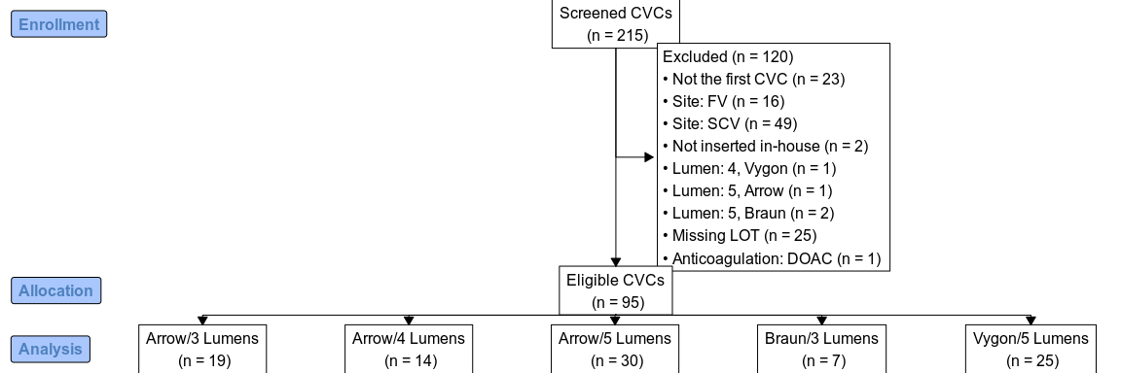

**Fig. 1:** The flowchart shows the inclusion and exclusion criteria. CVC, central venous catheter; DOAC, direct oral anticoagulants; FV, femoral vein; SCV, subclavian vein.

## 

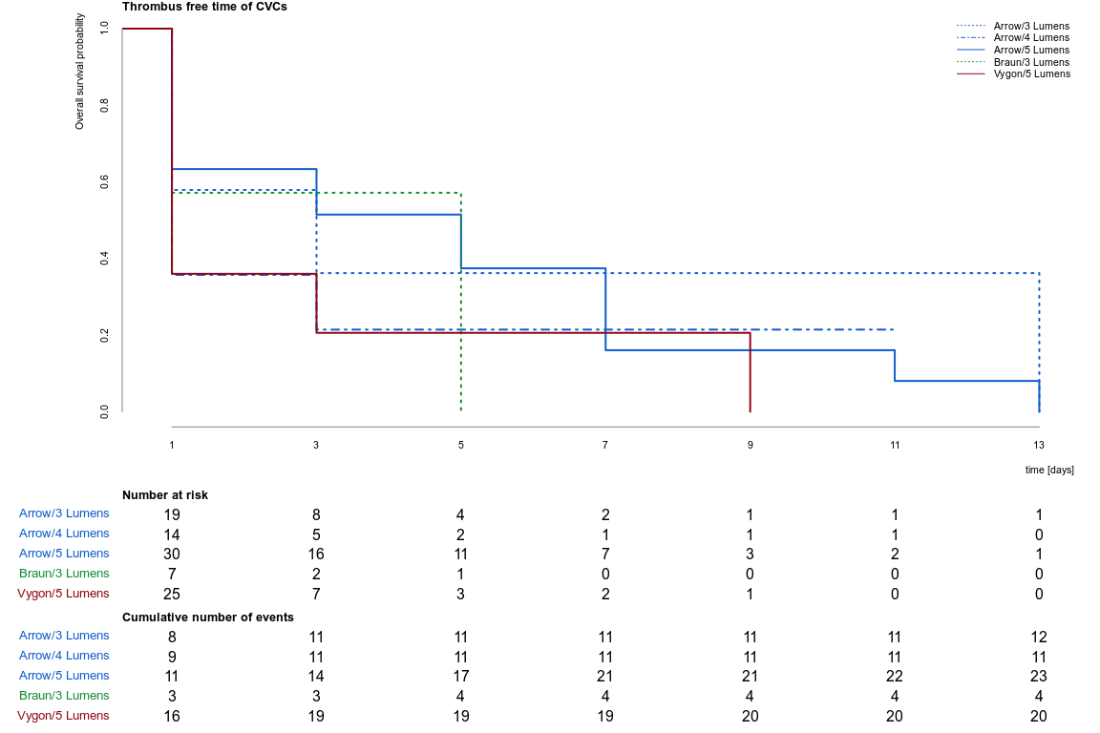

**Fig. 2:** Survival plot showing CRT-free time for all analysed central venous catheters. Confidence intervals overlap and have not been drawn for ease of visualization.

## 

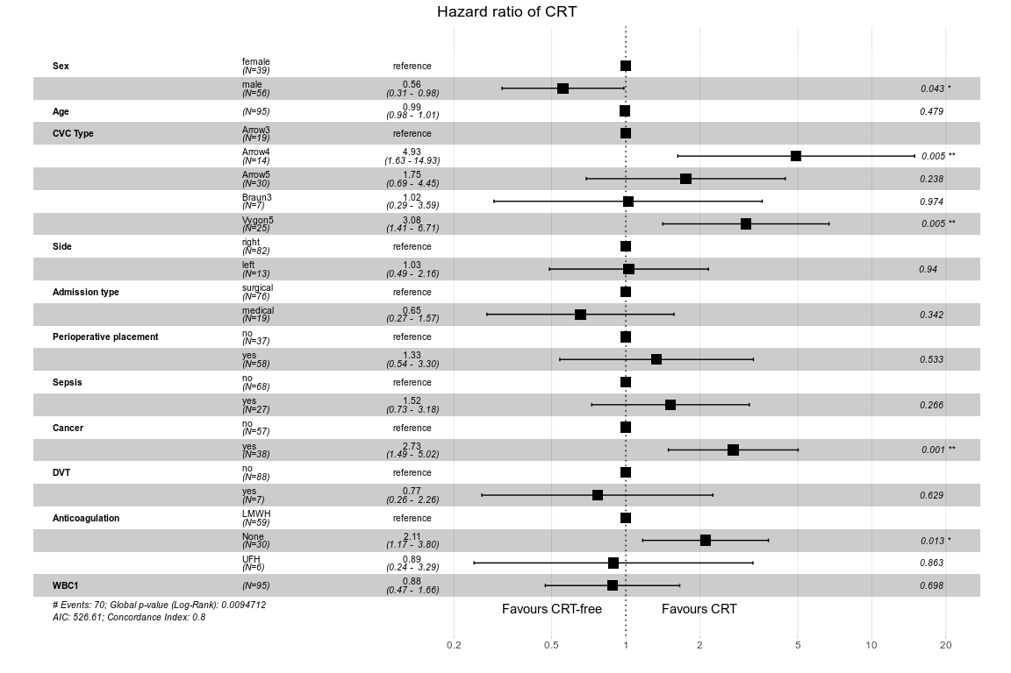

**Fig. 3:** Hazard ratios of CRT adjusted for different covariates. CRT, catheter-related thrombosis; CVC, central venous catheter; DVT, deep vein thrombosis; LMWH, low-molecular-weight heparins; UFH, unfractionated heparin; WBC1, white blood cell count on day one.