**MODULE: 9 ReactJs Intro**

* What is React js ?
* Answer :   React is a User Interface (UI) library . JavaScript library created by Facebook. React is a tool for building UI components.
* It is mainly used for building the user interface or the frontend of our application
* What is NPM in React Js?
* Answer :   
  In React.js, NPM (Node Package Manager) is a package manager for JavaScript that is commonly used to manage and install dependencies in a React project.
* NPM allows developers to easily share and distribute code packages (libraries, modules, and tools) that can be used in their projects.
* What is Role of Node Js in react Js?
* Answer :  NodeJS is a framework of JavaScript which is mainly used for working with the backend of our application or building the backend using JavaScript.
* Node.js **handles requests and authentication from the browser**, make database calls, etc. It makes API calls and processes in-browser data.
* Node is  used for creating networking and server-side apps

* What is CLI command In React Js?
* Answer :   CLI commands are currently only used to create a passable version of a react application using the command line.
* CLI is a command line program that accepts text input to execute operating system functions.
* What is Components in React Js?
* Answer : Components are independent and reusable bits of code. They serve the same purpose as JavaScript functions, but work in isolation and return HTML.
* Components come in two types, Class components and Function components.
* What is Header and Content Components in React Js?
* Answer : In React.js, the concepts of "Header" and "Content" components are not predefined. They are typically used as generic terms to describe different parts or sections of a user interface in a React application.

For example, you might create separate components for the header and content of a webpage

**Header Component:**

* The "Header" component in a React application is often used to represent the top section of a webpage or application. It may include elements such as the navigation bar, logo, user authentication status, or any other information that is consistently displayed at the top of the page.

**Content Component:**

* The "Content" component is typically used to encapsulate the main content area of a webpage or application. It may include different sections, components, or modules that make up the primary user interface content.
* How to install React Js on Windows, Linux Operating System? How to Install NPM and How to check version of NPM?
* Answer :
* Step :1node.js & npm Install
* Step :2To Check version of npm , open cmd and write this command **npm –v** for check npm version.
* How to check version of React Js?
* Answer :

To Check version of React , open cmd and write this command npm v reactfor check react version.

* How to change in components of React Js?
* Answer : setState() enqueues changes to the component state and tells React that this component and its children need to be re-rendered with the updated state.
* How to Create a List View in React Js?
* Answer :

Creating a list view in React.js involves using the map function to iterate over an array of data and render individual list items.

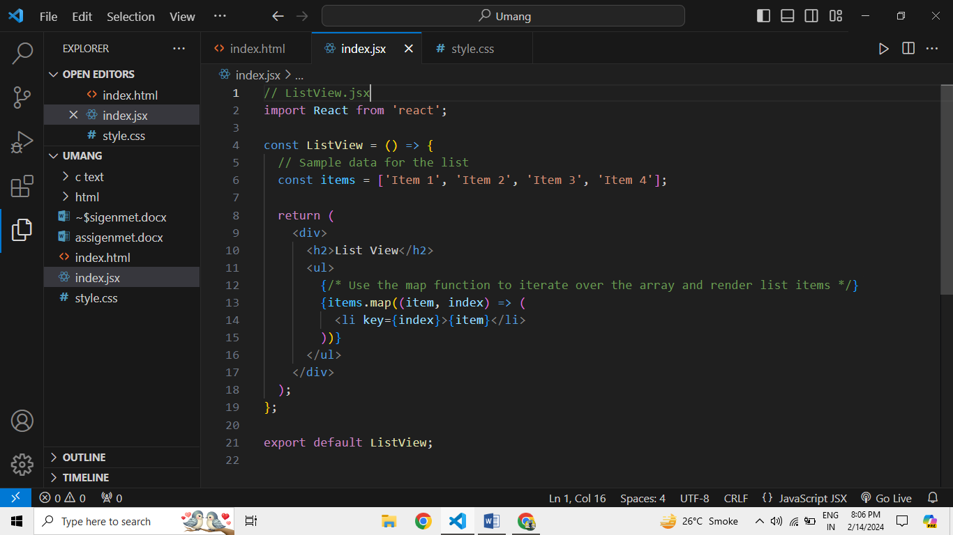

* **Assinment Task :**
* Create Increment decrement state change by button click?

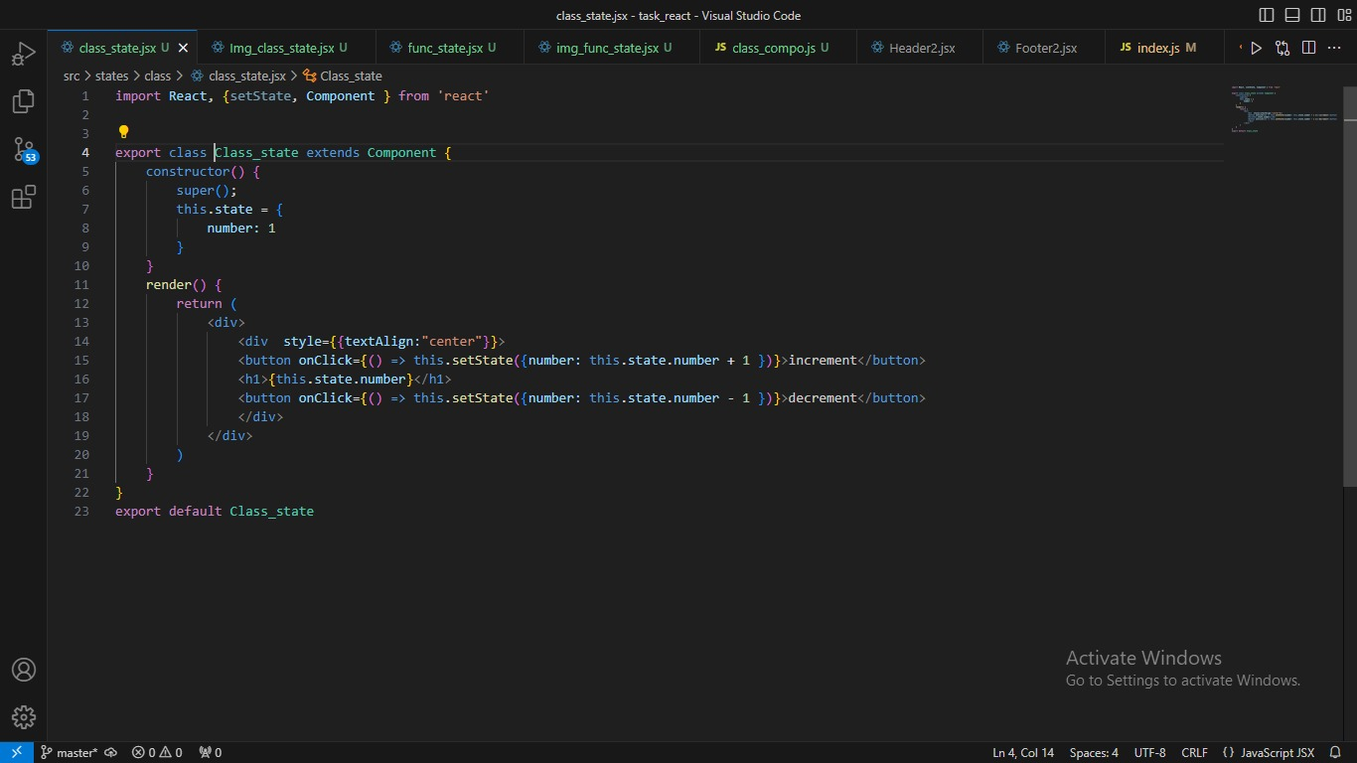

* Create Shopping site home page with Styled- component

**Git Link [: https://github.com/umg026/Amzon_Clone](:  https://github.com/umg026/Amzon_Clone)**

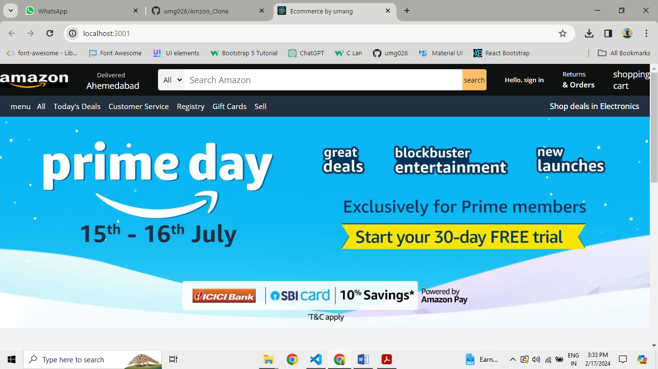 **Preview :**