Municipality Permit Chatbot System (MPCS)

Deployment and Operations Guide (Runbook)

University of Maryland Global Campus (UMGC) SWEN 670

Document Revision: 1.1

Software Version: #2

**Prepared by UMGC ChatBot Team**:

Rusty Baker

Sepribo Taylor-Harry

Matthew Slaymaker

Nathaniel Muesing

Subhash Gandhi Vallala

Joshua Piersol

PAGE INTENTIONALLY LEFT BLANK

Contents

1 Introduction 4

1.2 Purpose 4

1.2 Revision history 4

1.3 Intended audience and reading suggestions. 5

1.4 Technical project stakeholders. 5

1.5 References. 5

1.6 Definitions, acronyms and abbreviations 6

2 Server Configurations 6

2.1 Server 1 (Database) 6

2.1.1 Roles, Features, and Packages 7

2.2 Server 2 (Web Application) 9

2.2.1 Prerequisites, Features, and Packages 10

3 Software Installation 11

3.1 Server 1 (Database) 11

3.1.1 Prerequisites 11

3.1.2 Installation Steps 11

3.1.2 Configuration 12

3.1.3 Configured Values 13

3.1.4 Administer MongoDB 14

3.2 Server 2 (Web Application) 16

3.2.1 Prerequisites 16

3.2.2 Installation Steps 16

3.2.3 Configuration: 17

4 Testing the Installation 21

5 Troubleshooting 22

**Error! Hyperlink reference not valid.Error! Hyperlink reference not valid.Error! Hyperlink reference not valid.Error! Hyperlink reference not valid.Error! Hyperlink reference not valid.Error! Hyperlink reference not valid.Error! Hyperlink reference not valid.Error! Hyperlink reference not valid.Error! Hyperlink reference not valid.Error! Hyperlink reference not valid.Error! Hyperlink reference not valid.Error! Hyperlink reference not valid.Error! Hyperlink reference not valid.Error! Hyperlink reference not valid.Error! Hyperlink reference not valid.Error! Hyperlink reference not valid.Error! Hyperlink reference not valid.Error! Hyperlink reference not valid.Error! Hyperlink reference not valid.Error! Hyperlink reference not valid.Error! Hyperlink reference not valid.Error! Hyperlink reference not valid.Error! Hyperlink reference not valid.Error! Hyperlink reference not valid.**

**Tables of Figures**

Figure 1: How to get an update through Windows Update 8

Figure 2: How to get an update through Microsoft Download Center 9

Figure 3: How to check that you have the npm client installed 10

Figure 4: How to download MongoDB Community Edition 11

Figure 5: Mongo DB as Service Configuration 13

Figure 6: How to Start MongoDB Service 14

Figure 7: Running the MongoDB Instance 15

Figure 8: How to Stop MongoDB Service 15

Figure 9: Installing Node.js from nodejs.org 16

Figure 10: Launching Angular Workspace Application 18

Figure 11: Location of Angular.json Configuration File 19

Figure 12: Angular Command Line Console 20

Figure 13: Application Browser using different Port 20

**Error! Hyperlink reference not valid.**

**List of Tables**

Table 1: Revision History 4

Table 2: Technical project stakeholders 5

Table 3: Referenced documents 5

Table 4: Definitions, acronyms and abbreviations 6

Table 5: MongoDB configured values 13

**Error! Hyperlink reference not valid.Error! Hyperlink reference not valid.Error! Hyperlink reference not valid.Error! Hyperlink reference not valid.Error! Hyperlink reference not valid.**

# 1 Introduction

## Purpose

The purpose of this Installation and Deployment Guide is to describe in technical terms the steps necessary to install the software and make it operational.

## 1.2 Revision history

The Revision history table shows the date, changes, and authors who have worked on this document.

Table 1

Revision History

|  |  |  |  |
| --- | --- | --- | --- |
| Version/Change | Version date | Description of changes | Author |
| 1.0 | 7/23/2020 | Initial Revision | Sepribo Taylor-Harry, Rusty Baker, Joshua Piersol |
| 1.1 | 8/3/2020 | Incorporated Stakeholder feedback | Sepribo Taylor-Harry |

## 1.3 Intended audience and reading suggestions.

This Installation and Deployment Guide is intended to be used by technical stakeholders of the project who will be responsible for planning, performing, or maintaining the installation or deployment, such as the Systems Administrator, Analysts, or Developers.

It is intended that stakeholders and software support personnel can read this document and coordinate their efforts in the installation/deployment of the application.

## 1.4 Technical project stakeholders.

This section provides a list of all known stakeholders with interest in the project.

Table 2

Technical project stakeholders

|  |  |  |
| --- | --- | --- |
| Name | E-mail address | Role |
| Professor Assadullah | mir.assadullah@faculty.umgc.edu | Stakeholder |
| Rusty Baker | rusty.j.b2016@gmail.com | Project Manager |
| Nathaniel Muesing | nkmuesing@gmail.com | Lead Developer |
| Sepribo Taylor-Harry | seprtayl@gmail.com | Lead DevOps |
| Matthew Slaymaker | slaymakerm@wmpenn.edu | Lead Testing |
| Subhash Gandhi Vallala | sgvallala@gmail.com | Lead Quality Assurance |
| Joshua Piersol | joshpwork@yahoo.com | Lead Systems |

## 1.5 References.

Table 3

Referenced documents

|  |  |  |
| --- | --- | --- |
| Reference No. | Document | Author(s) |
| REF-1 | [Install MongoDB Community Edition on Windows](https://docs.mongodb.com/manual/tutorial/install-mongodb-on-windows/) | MongoDB |
| REF-2 | [Setting up the local environment and workspace](https://angular.io/guide/setup-local) | Angular |
| REF-3 | [Download the Node.js source code](https://nodejs.org/en/download/) | Node.js |
| REF-4 | [The ol package](https://openlayers.org/download/) | OpenLayers |
| REF-5 | [Getting started with Watson Assistant](https://cloud.ibm.com/docs/assistant?topic=assistant-getting-started" \l "getting-started) | IBM Watson |

## 1.6 Definitions, acronyms and abbreviations

Table 4

Definitions, acronyms and abbreviations

|  |  |
| --- | --- |
| Term | Definition |
| Administrator | Anyone provided administrative rights in the Municipality Permit Chatbot System (MPCS) by the client. |
| Angular CLI | A command-line interface tool used to initialize, develop, scaffold, and maintain Angular applications. |
| DB | Database |
| IE | Internet Explorer |
| HTML | Hypertext Markup Language |
| CSS | Cascading Style Sheets |
| LTS | Long Term Support |
| npm | Node Package Manager |
| MSI | Microsoft Installer (file extension) |
| IP | Internet Protocol |
| UI | User Interface |
| API | Application Programming Interface |

# 2 Server Configurations

## 2.1 Server 1 (Database)

Installation of MongoDB 4.2 Community Edition is supported on the following operating systems and 64-bits versions:

* Windows Server 2019
* Windows 10 / Windows Server 2016
* Windows 8.1 / Windows Server 2012 R2
* Windows 8 / Windows Server 2012
* Windows 7 / Windows Server 2008 R2

### 2.1.1 Roles, Features, and Packages

#### Packages

The following software packages must be installed on the operating system before installation of the software:

1. Users on Windows versions previous to Windows 10 must install the following update before installing MongoDB:
   * Update for Universal C Runtime for Windows

**How to obtain the Update:**

*Method 1: Windows Update*

* + - This update is available from Windows Update. For more information about how to run Windows Update for a specific version, see [How to get an update through Windows Update](https://support.microsoft.com/en-us/help/3067639/how-to-get-an-update-through-windows-update).

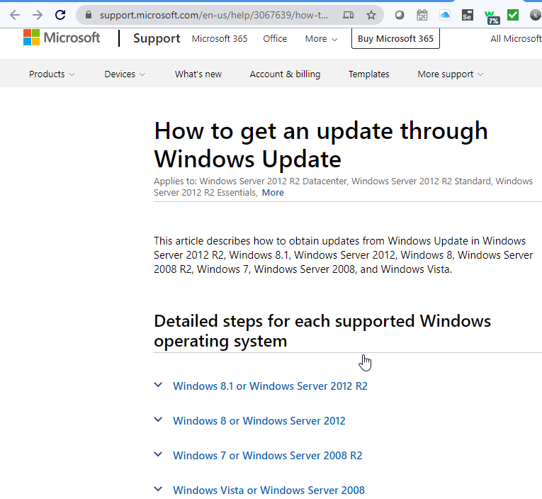

Figure 1: How to get an update through Windows Update

*Method 2: Microsoft Download Center*

* + - The following files for each operating systems and 64-bits versions are available for download from the [Microsoft Download Center](https://support.microsoft.com/en-us/help/2999226/update-for-universal-c-runtime-in-windows" \l ":~:text=About%20this%20update&text=This%20update%20allows%20Windows%20desktop,Software%20Development%20Kit%20(SDK).).

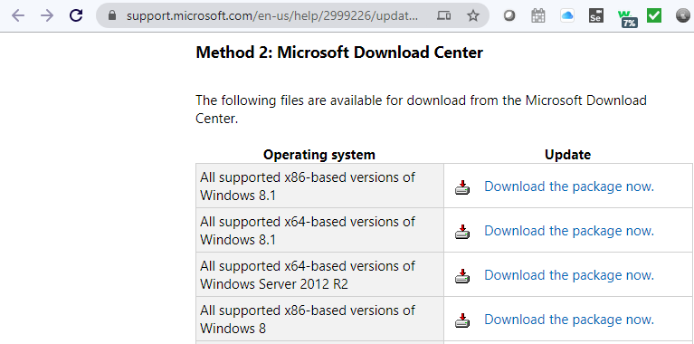

Figure 2: How to get an update through Microsoft Download Center

**How to install the Update:**

To start the download, click the Download button and then do one of the following, or select another language from Change Language and then click Change.

* + Click Run to start the installation immediately.
  + Click Save to copy the download to your computer for installation at a later time.

1. Users on Windows 10, Server 2016, and Server 2019 do not need this update.

## 2.2 Server 2 (Web Application)

Installation of Angular is supported on the following Web browsers and versions:

* Google Chrome (Version 84.0.4147.89 or prior)
* Firefox (Version 78.0.2 or prior) and extended support release (ESR) (Version 78.0.2 or prior)
* Edge 2 (Version 84.0.522.40 or prior)
* IE 11, 10*, 9* ("compatibility view" mode not supported) *deprecated in v10
* Safari 2 (Version 13.1 or prior)

### 2.2.1 Prerequisites, Features, and Packages

#### Prerequisites

To use the Angular framework, one should be familiar with the following programming languages:

* JavaScript
* HTML
* CSS

#### Packages

The following software packages must be installed on the operating system prior to installation of the software (installation steps are described in section 3.2.2):

* Node.js – Angular requires a current, active LTS, or maintenance LTS version of Node.js.
* npm package manager – Angular, the Angular CLI, and Angular applications depend on npm packages for many features and functions.

Note: This guide uses the npm client command line interface, which is installed with Node.js by default when installing the Angular CLI. To check that you have the npm client installed, run npm -v in a terminal window.

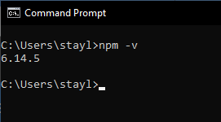

Figure 3: How to check that you have the npm client installed

# 3 Software Installation

## 3.1 Server 1 (Database)

### 3.1.1 Prerequisites

1. All steps in section 2 "Server Configurations" have been performed.

### 3.1.2 Installation Steps

Follow these steps to install MongoDB Community Edition using the MongoDB Installer wizard. The installation process installs both the MongoDB binaries as well as the default configuration file <install directory>\bin\mongod.cfg.

1. Download the MongoDB Community .msi installer from the following link: [MongoDB Download Center](https://www.mongodb.com/try/download/community?tck=docs_server)

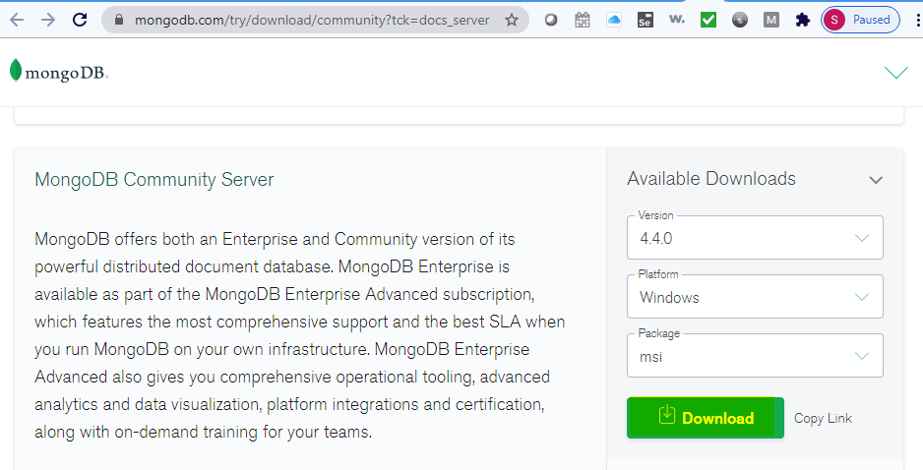

Figure 4: How to download MongoDB Community Edition

* 1. In the Version dropdown, select the version of MongoDB to download.
  2. In the Platform dropdown, select Windows.
  3. In the Package dropdown, select msi.
  4. Click Download.

1. Run the MongoDB installer. From the Windows Explorer/File Explorer:
   1. Go to the directory where you downloaded the MongoDB installer (.msi file). By default, this is your Downloads directory.
   2. Double-click the .msi file.
2. Follow the MongoDB Community Edition installation wizard. The wizard steps you through the installation of MongoDB and MongoDB Compass.
   1. Choose Setup Type:

You can choose either the **Complete** (recommended for most users) or **Custom** setup type. The Complete setup option installs MongoDB and the MongoDB tools to the default location. The Custom setup option allows you to specify which executables are installed and where.

### 3.1.2 Configuration

#### 3.1.2.1 MongoDB as Service:

The following steps configures MongoDB as a Windows service.

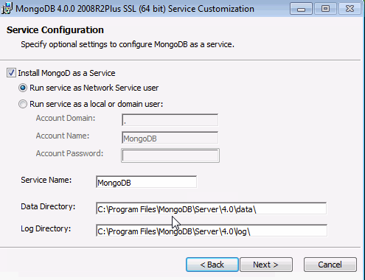

Figure 5: Mongo DB as Service Configuration

* Select **Install MongoDB as a Service** MongoDB as a service.
* Select either:
  + **Run the service as Network Service user** (Default): This is a Windows user account that is built-in to Windows

or

* + **Run the service as a local or domain user:** For an existing local user account, or an existing domain user.

### 3.1.3 Configured Values

Use the table below to make note of the values for your installation environment for future reference.

Table 5

MongoDB configured values

|  |  |
| --- | --- |
| Information | Value |
| Account Domain | For an existing domain user, specify an Account Domain |
| Account Name | For an existing domain or local user account, specify an Account Name for the user |
| Account Password | For an existing domain or local user account, specify an Account Password for the user |
| Service Name | Specify the service name. Default name is MongoDB |
| Data Directory | Specify the data directory, which corresponds to the --dbpath. |
| Log Directory | Specify the Log directory, which corresponds to the --logpath. |

### 3.1.4 Administer MongoDB

By default, the MongoDB service is started upon successful installation.

#### 3.1.4.2 Start MongoDB Community Edition as a Windows Service:

To start/restart the MongoDB service, use the Services console:

* From the Services console, locate the MongoDB service.
* Right-click on the MongoDB service and click Start.

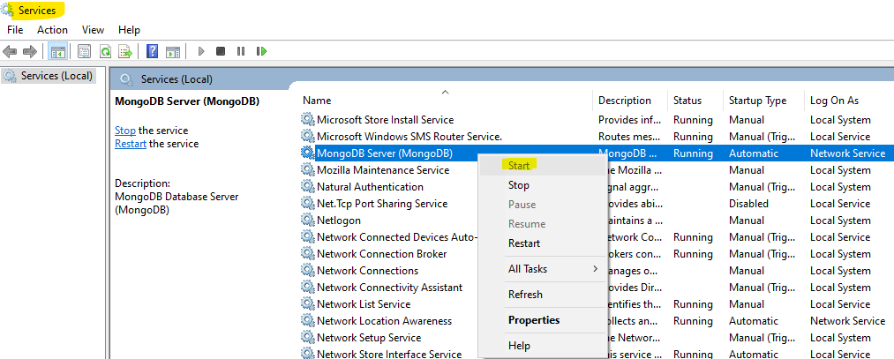

Figure 6: How to Start MongoDB Service

* To begin using MongoDB, connect a mongo.exe shell to the running MongoDB instance by opening a Command Interpreter with Administrative privileges and run:

"C:\Program Files\MongoDB\Server\4.2\bin\mongo.exe"

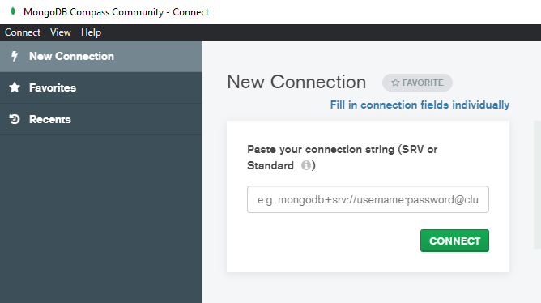

Figure 7: Running the MongoDB Instance

#### 3.1.4.2 Stop MongoDB Community Edition as a Windows Service:

To stop/pause the MongoDB service, use the Services console:

* From the Services console, locate the MongoDB service.
* Right-click on the MongoDB service and click Stop (or Pause).

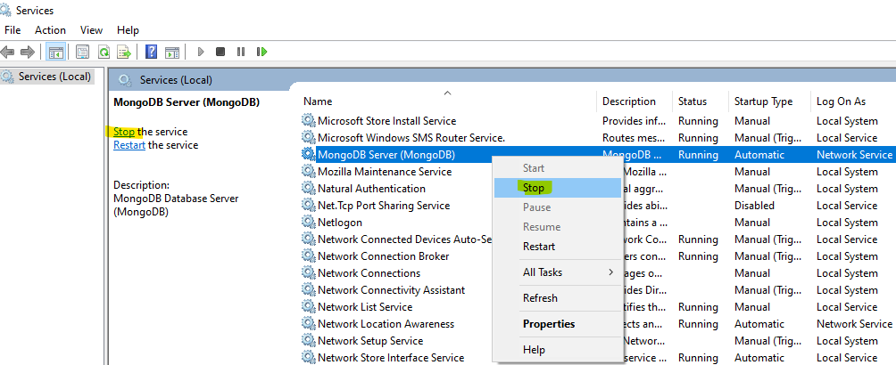

Figure 8: How to Stop MongoDB Service

#### 3.1.4.3 Remove MongoDB Community Edition as a Windows Service:

To remove the MongoDB service:

* First use the Services console to stop the service.
* Then open a [Windows command prompt/interpreter](https://docs.microsoft.com/en-us/windows-server/administration/windows-commands/cmd) (cmd.exe) as an Administrator, and

run the following command: "sc.exe delete MongoDB"

## 3.2 Server 2 (Web Application)

### 3.2.1 Prerequisites

1. All steps in section 2 "Server Configurations" have been performed.
2. All steps in section 3.1 "Software Installation, Server 1 (Database)" have been performed.

### 3.2.2 Installation Steps

1. Node.js is an open source development platform used to create scalable network applications.

To install navigate to [nodejs.org](https://nodejs.org/en/download/) and select the windows msi installer:

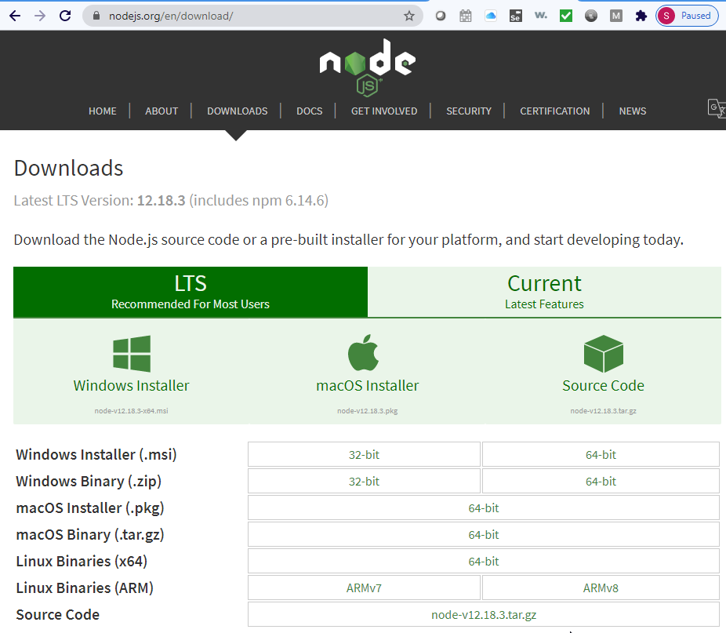

Figure 9: Installing Node.js from nodejs.org

1. Use the command line interface (CLI) to install npm. To download the latest version of npm on the command line, run the following command:



1. Angular CLI is used to create projects, generate application and library code, and perform a variety of ongoing development tasks such as testing, bundling, and deployment.

To install the Angular CLI, open a terminal window and run the following commands: 

1. OpenLayers is the API used to generate map details and take in user input for zoning. User input is taken in as a series of coordinates used to determine zone borders.

To install the OpenLayers package, open a terminal window then navigate to the Angular project’s file directory and run the following command:



### 3.2.3 Configuration:

#### Run (serving) your project

1. First, navigate inside your project's folder and run the following commands:



The <github_repo> command navigate to the angular project.

The ng serve command launches the server, watches your files, and rebuilds the app as you make changes to those files.

The --open (or just -o) option automatically opens your browser to http://localhost:4200/.

1. If your installation and setup was successful, you can now navigate to the http://localhost:4200/ address to view your front-end application.

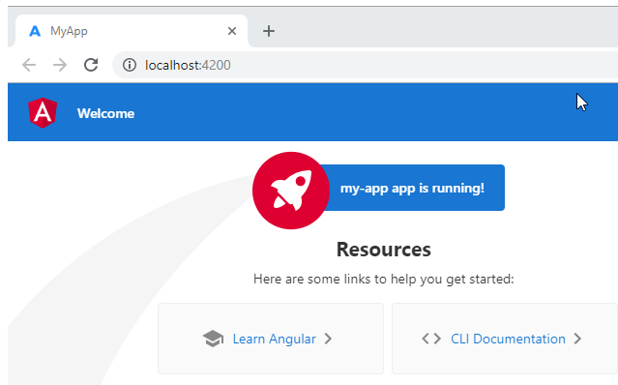

Figure 10: Launching Angular Workspace Application

*How to change default port to 80*

By default, every project uses the same port (4200), but you can change this port to say 80 by following the below command:

1. Edit the angular.json file in the root directory of your application. This contains the configuration for the Angular CLI development environment.

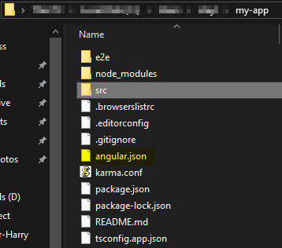

Figure 11: Location of Angular.json Configuration File

1. Drill down into “projects > my-app > architect > serve”, you’ll see something like this:



1. This block contains some configuration for the ng serve command. You can specify the port by adding a port attribute in the options block, like this:



1. Now my-app is built to run off port 80. To validate, run the app:



1. You’ll notice the last line on the console shows the new port number:

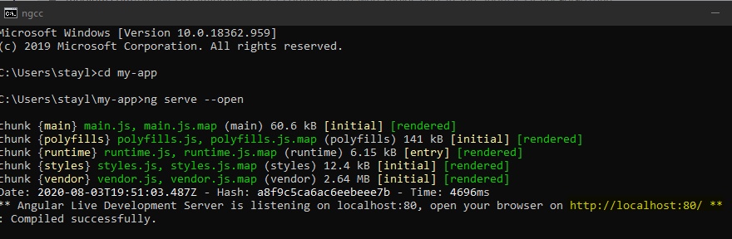

Figure 12: Angular Command Line Console

1. Load the browser to <http://localhost:80>:

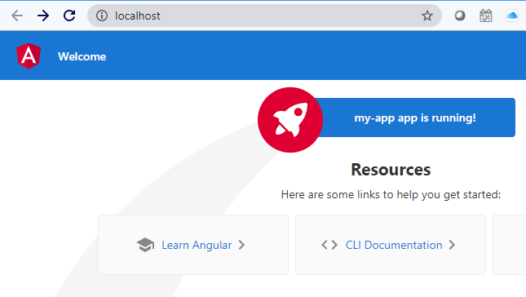

Figure 13: Application Browser using different Port

# Testing the Installation

Before notifying users that the software is available, run the following checks to confirm that the software was installed and configured correctly:

1. To start the application, navigate to the workspace folder, such as my-app and run the following command:



1. Navigate your web browser to the <Host Name:Port> noted in section 3.2.3.
2. Click your project, if your application is functioning correctly, a first-time sign-in page should display for the city official configuration client.
3. Ensure you can navigate to each screen as seen in the technical design document.
4. Ensure the Watson conversation chatbot UI is accessible and interactive. If the Watson conversation chatbot UI is inaccessible, refer to section 5 for troubleshooting steps.
5. Once connected, fill out information to create zones and related permits to confirm the chatbot can communicate and perform basic tasks such as answering questions.
6. Close the Web Browser when completed, and use the following command in terminal to end an ongoing process:



# 5 Troubleshooting

1. ng serve error: I receive an error message when trying to serve (run) the web application via command line.

Actions: You have to be inside an angular-cli project in order to use the serve command after install of angular-cli.

1. An unhandled exception occurred: Workspace config file cannot be loaded

Action: See error exception in command line, and review the angular-errors.log.

1. Cannot connect to application: Unhandled Promise rejection: No provider for HttpClient!

Action: This error tells you, that you have not imported the angular HttpClient Module into your (root) module. To resolve the problem, you need to import the missing module into your module. In most cases, that module would be in your app directory in the GitHub repository.

1. Port Already in Use: Port 4200 is already in use.

Action: Use '--port' to specify a different port. For example, “ng serve – port <new port number> –open. You can also use the command “lsof -t -i tcp:4200 | xargs kill -9” to list out any processes that are using port 4200 and force quit them (aka -9).

1. Log location:
   1. Angular (web application): the web application log by default is located in the following directory: "C:\Users\<user1>\AppData\Local\Temp\ng-N4Pal4\angular-errors.log".
   2. MongoDB (database server): the backend database log by default is located in the following directory: “C:\Program Files\MongoDB\Server\4.4\Log”.