**NASA HUD**

**User Manual**

**Version 4.0**

**04/26/2020**

**Prepared by: NASA HUD Team 2**

Ali Alnaqeeb

Laura Tamshen

Ryan Cohan

Matthew Elliott

Jonathan Johnson

**Table of Contents**

Contents

Revision History 3

**Introduction** 4

**Overview** 4

**Conventions** 5

**Acronyms** 5

**Getting Started** 5

**Selecting a Procedure** 5

**Selecting a Role** 5

**Navigating the Steps** 6

**Navigating the Figures** 6

**Warnings** 7

**Getting Help** 8

**User Access Considerations** 9

**Accessing the System** 9

**Error Messages** 9

**Special Considerations** 10

**Support** 10

**Supporting Information** 10

# Revision History

|  |  |  |  |
| --- | --- | --- | --- |
| **Version Number** | **Date** | **Author/Owner** | **Description of Change** |
| 1.0 | 03/22/2020 | Laura Tamshen | Initial draft |
| 2.0 | 03/24/2020 | Laura Tamshen | Added screenshots |
| 3.0 | 04/05/2020 | Ali Alnaqeeb | Incorporated feedback and content from other documents |
| 4.0 | 04/24/2020 | Ryan Cohan | Various updates |

# **Introduction**

This User Manual provides the information necessary for users of EVA procedures to effectively use the NASA HUD.

Our customers at National Aeronautics and Space Administration (NASA) are requesting the development of a Heads-Up Display (HUD) system that can be utilized for NASA’s Extra-Vehicular Activity/Intra-Vehicular Activity (EVA/IVA). The display has a 4-inch screen size with 480x800 pixel resolution. The astronaut procedure steps will be shown on this display. This HUD will also be programmed so that it can interact with voice commands. The voice commands that will control this software are “Maestro next step” and “Maestro previous step” as well as “Maestro show image [image number]” to enlarge. The user of the software will be able to select which actor he/she will be acting as, which - since procedures are a compilation of many different steps for many different actors – dictates which steps will be displayed on the HUD.

The intended audience for this document is astronauts and ground control personnel who oversee EVA procedures.

# **Overview**

Currently, the employees at NASA create spacewalk procedures knows as EVAs. Typically, these procedures include two astronauts that are located outside of two stations known as EV1 and EV2. In addition, there is a robotics operator inside the spacecraft and Mission Control on the ground assisting in the walk.

There are situations in which EV1 is focused on a task where all the steps can be done independent of EV2’s actions. There are other times when their steps are heavily intertwined. The same goes for robotics operators and Mission Control steps. The customers at NASA have a need to programmatically parse procedures, map each step to its respective actor, and display this on a hands-free screen (i.e. HUD).

The HUD has a 4-inch screen size with 480x800 pixel resolution. The astronaut procedure steps will be shown on this display. This HUD will also be programmed so that it can interact with voice commands.

The design for the Maestro HUD application is a standard two-tier web application consisting of a forward-facing web tier and a backend application tier. The web layer will serve as the user interface, serving the JavaScript, HTML, and CSS necessary to render the UI and HUD. The application tier will consist of a node/express server responsible for handling HTTPS requests from the client. This layer will serve the data to the web tier.

# **Conventions**

This document provides screen shots using mock data and corresponding text to describe how to use the NASA HUD.

The term ‘user’ is used throughout this document to refer to a person who is interacting with NASA HUD.

# **Acronyms**

**HUD** – Heads Up Display

**EVA** – Extra Vehicular Activity

# **Getting Started**

## **Selecting a Procedure**

After powering up the HUD, the Procedure Select screen will display.

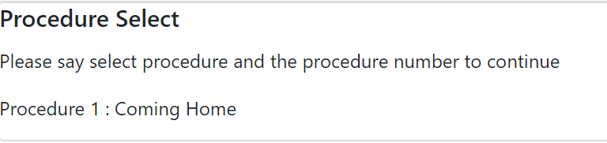

**Figure 1 - Procedure Select screen**

The user will then select the desired procedure using a voice command beginning with the keyword “Maestro”. For example: “Maestro select procedure 1”. After the procedure is selected the Role Select screen will display.

## **Selecting a Role**

The user may now select the desired role using a voice command. For example: “Maestro select role 2”. The HUD will then display the first step in the selected procedure for that role.

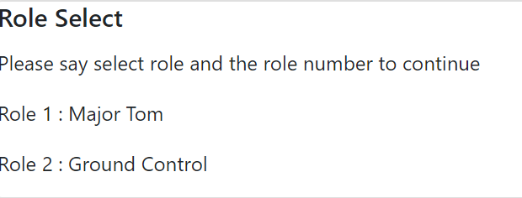

**Figure 2 - Select Role**

## **Navigating the Steps**

When ready to proceed to the next step, the user will use the voice command “Maestro next step” at which point the HUD will display the next sequential step in the procedure.

Navigation to the previous step is accomplished by another voice command: “Maestro previous step”.

After the final step is displayed, “Procedure Complete” will show on the HUD for five seconds after which the user will be brought back to the initial Select Procedure screen.

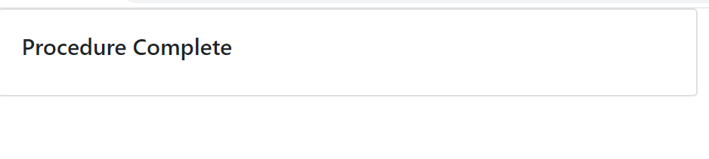

**Figure 3 - Procedure Complete screen**

## **Navigating the Figures**

Some steps have associated figures. In this case, thumbnails of the figures will be displayed on the HUD to the right of the step text. The user may navigate to any of the figures using the following voice commands:

|  |  |
| --- | --- |
| Voice Command | Action |
| Maestro show image [image number] | The selected image displays on the HUD. |
| Maestro previous image page | The next page of images display. |
| Maestro next image page | The previous page of images display. |
| Maestro back to step | The display returns to the step that was in progress before the image commands were issued. |

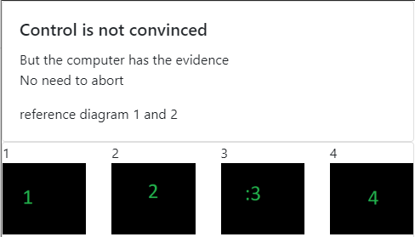

Figure 4 - Figure Thumbnails

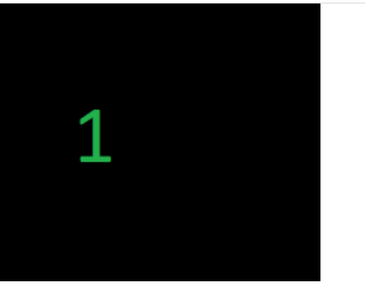

Figure 5 - Show Image 1

## **Warnings**

Procedures may also contain warnings. Warnings may display for the entire procedure, a set of procedure steps, or a single procedure step. A yellow box at the top of the HUD (above the step text) will display any associated warnings.

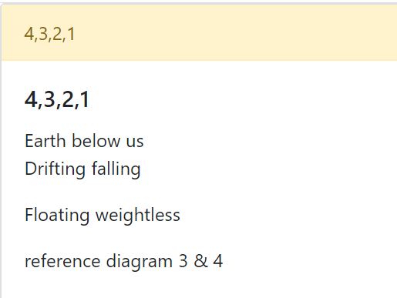

Figure 6 - Warning display

# **Getting Help**

At any point, the user may get a list of maestro commands by saying “Maestro help”. The below screen will display:

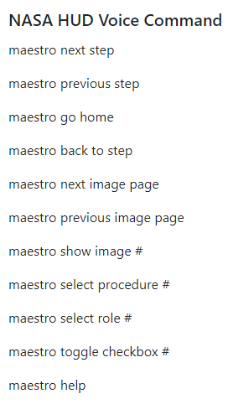

# **User Access Considerations**

All users of the NASA HUD system will have full access to the application.

# **Accessing the System**

The system may be accessed here: <https://app-nasa-hud-master.herokuapp.com/>

There is no login/password required.

# **Error Messages**

Should invalid input data be encountered when reading the procedure, the following errors may be encountered.

* Get Files
  + Authorization failed
    - Code 403
  + Request malformed
    - Code 400
  + Invalid or missing parameter
    - Code 422
  + Internal server error
    - Code 5xx
* Lint
  + Authorization failed
    - Code 403
  + Request malformed
    - Code 400
  + Invalid or missing parameter
    - Code 422
  + Internal server error
    - Code 5xx
  + File linting unsuccessful
    - Code 422
  + File not found
    - Code 404
* Get Roles
  + Authorization failed
    - Code 403
  + Request malformed
    - Code 400
  + Invalid or missing parameter
    - Code 422
  + Internal server error
    - Code 5xx
  + File not found
    - Code 404
* Get Tasks
  + Authorization failed
    - Code 403
  + Request malformed
    - Code 400
  + Invalid or missing parameter
    - Code 422
  + Internal server error
    - Code 5xx
  + File not found
    - Code 404
  + Role not found
    - Code 404

# **Special Considerations**

As mentioned in the Project Plan, there is a risk that the yaml file with the actual instructions may not be available to the front-end code by the end of the project. If this occurs, mock data will be supplied to the front end for demonstration purposes.

# **Support**

Support from NASA Team 2 will be available until April 26, 2020. At that point the application and all associated documentation will be turned over to the stakeholders.

# **Supporting Information**

NA