**DevSecOps User Guide**

**Spring 2022**

**Version 1.0**

**University of Maryland Global Campus**

**SWEN 670**

Prepared by Andrew Nicolette and Robert Wren

For Approval by Dr. Mir Assadullah

# **Revision History**

|  |  |  |  |
| --- | --- | --- | --- |
| **Date** | **Version** | **Description** | **Author(s)** |
| 03/01/2022 | 1.0 | Initial User Guide | Andrew Nicolette Robert Wren |
|  |  |  |  |
|  |  |  |  |
|  |  |  |  |
|  |  |  |  |

# **Table of Contents**

**Revision History** 2

**Table of Contents** 3

**1** **Introduction** 4

1.1 References 4

**2** **DevSecOps Guide** 5

2.1 Accessing the Repo 5

2.2 Committing and Merging to Development 6

2.3 View GitHub Actions Status (Development Branch) 8

2.4 Merge Development Branch to Main 9

2.5 View GitHub Actions Status (Main Branch) 10

2.6 Verification in Google Play 12

**3** **CaPPMS Guide** 13

3.1 Home 13

3.2 About 14

3.3 Submit Project Idea 15

3.4 Project List 17

3.5 Project List – Guest User 17

3.6 Authorized User 20

3.7 Previous Projects 25

3.8 FAQ List 26

3.9 Log In 30

# **Introduction**

The format of this document involves two sections. The first section guides the user on how to trigger and leverage the built DevSecOps pipeline, while the second is more focused on the CaPPMS site that is used to manage Capstone Projects at UMGC

First, DevSecOps involves the entire team to engage in automation, communication, and collaboration. In the context for development teams, this means business analysis, quality assurance practices, and deployment methodologies are considered by the entire team. The whole team ensures testable requirements and testable code throughout the lifecycle for smooth integration with the CI/CD pipeline services downstream.

Second, the CaPPMS site is used for managing UMGC Software Engineering Capstone projects. Any user is able to submit a project idea to be reviewed by UMGC personnel. UMGC personnel have the ability to approve projects or delete them. Furthermore, they are also able to complete projects to be added to the Previous Projects page. This user guide aims to provide readers information about how to use the site and perform every available functionality.

References

Worku, A., Setiawan, M., Johnson, R. (2021, September 26). Captsone Project Management System (CaPPMS) & User Guide. University of Maryland Global Campus.

# **DevSecOps Guide**

This section guides and assists users in triggering the pipeline in both the development branch and the main branch. It contains instructions and descriptions on each step of the process along with screenshots showing the users different scenarios that might occur throughout the lifecycle.

## Accessing the Repo

The Spring 2022 Version Control Repository can be accessed at the following URL: <https://github.com/umgc/spring2022>

Here is the starting point for the users to make changes to the repository and trigger the pipeline to run their automated tests, builds, and deployments.

## Committing and Merging to Development

Once you make changes, you can **commit** them to the **Feature Branch**, essentially creating a snapshot of the state of the repository that you can reference in the future.

To save your changes to the **remote**, you’ll have to **push** your **commits** to the origin remote. By doing so, your changes are shared with the rest of the team. In addition, if you happen to lose your data on your local computer, you can still access changes you’ve **pushed** to the **remote**.

Once you have merged the **Developer Branch** into your own branch with a **merge commit,** you can attempt to merge your **Feature Branch** into the **Developer Branch.**

Create a **pull request** and add any comments about the merge that the reviewer might want to know.

## View GitHub Actions Status (Development Branch)

Once a pull request is instantiated, a GitHub actions workflow is triggered. The workflow is also triggered by any pushes to the development branches directly, but users would administrator privileges to do so because of the protection on the branch.

The development branch generally contains operational code and serves as a staging environment in which any new features will be tested to establish their effects before being allowed to merge into the Main Branch. Here the automated pipeline will run unit tests and make sure it can build without errors. The user should see all green checkmarks denoting everything passed and was successful.

## Merge Development Branch to Main

Once the lead developer on the team feels the development branch is in a good state, a **pull request** can be initiated to merge the code from the development branch to the master/main branch. The administrators of the repository will work with the lead developers to address if there are any conflicts and will validate that the CI/CD pipeline checks have all passed and been approved.

## View GitHub Actions Status (Main Branch)

Once a pull request is instantiated to the main branch, a separate GitHub actions workflow is triggered. The workflow is also triggered by any pushes to the development branches directly but users would administrator privileges to do so because of the protection on the branch.

The main branch contains operational code that can be released as a working version of the project. Here the automated pipeline will do more compared to the one that ran previously in the development branch. It will continue to run automated tests and prepare the build artifact but also publish a new working version to Google Play. The user should see all green checkmarks denoting everything passed and was successful.

Assuming all the previous checks were successful, the app bundle will be added to a new release based on the track associated by the developers and DevOps personnel. For beginning stages internal, alpha, and beta testing is recommended before sending directly to production.

## Verification in Google Play

Once successful, the user should navigate over to the Google Play console and verify the application was successfully uploaded and a new release has been created.

Once verified, they can review the release and submit for review such that their new changes can be seen in whatever track they are publishing to.

# **CaPPMS Guide**

The CaPPMS site can be reached at the following URL: <https://umgc-cappms.azurewebsites.net/>

## Home

The default home page contains a navigation bar at the top of the page. Navigation items include Home, About, Project List, Previous Projects, FAQ List, and Log in. Image 1 below shows the home page:

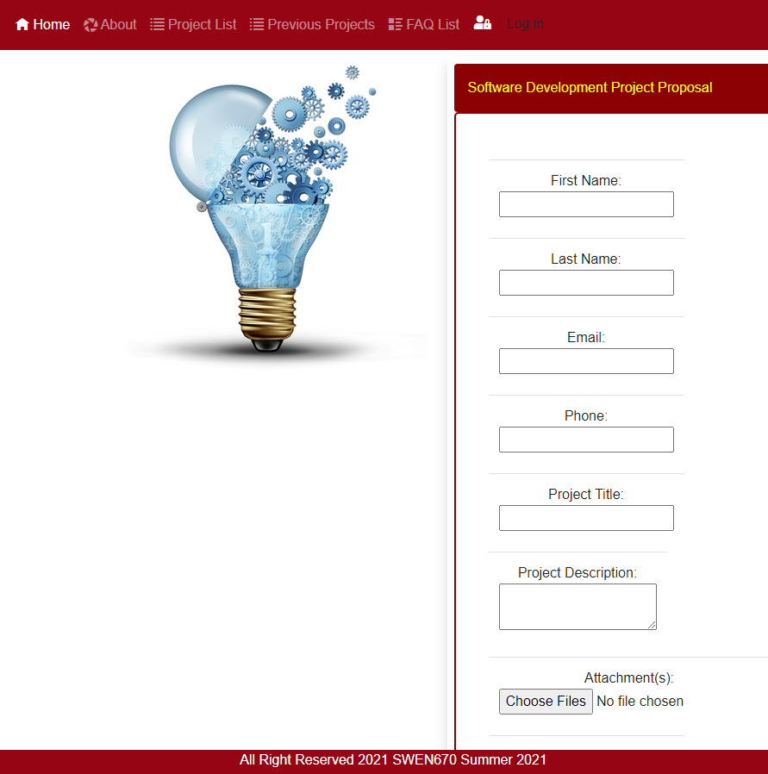

## About

The about page is a static page that contains information about the site.

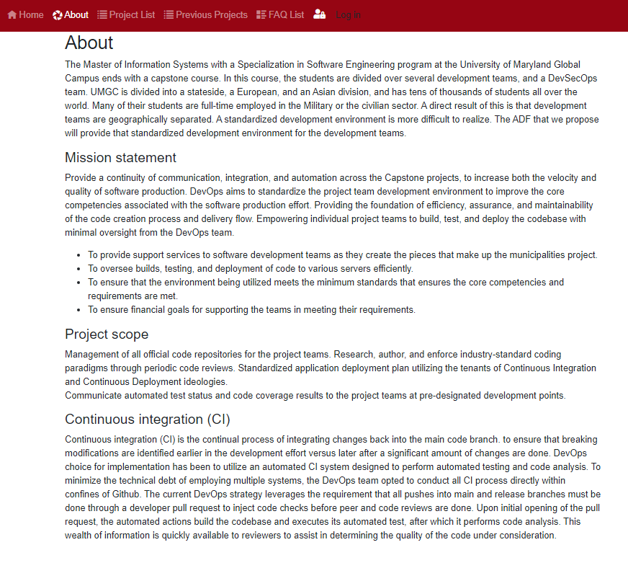

## Submit Project Idea

Once on the home page, a project idea can be submitted by filling out the project information in the Software Development Project Proposal section. The following input is requested:

* First Name – The submitter’s first name.
* Last Name – The submitter’s last name.
* Email – The submitter’s email address.
* Phone – The submitter’s phone number.
* Project Title – The name of the project idea.
* Project Description – A detailed description of the project idea.
* Attachments – Documentation supporting the project idea. Can also include specific documentation including the Project Plan, SRS, TDD, etc…
* Website – The project idea’s website.
* GitHub – The GitHub repository where the project is located.

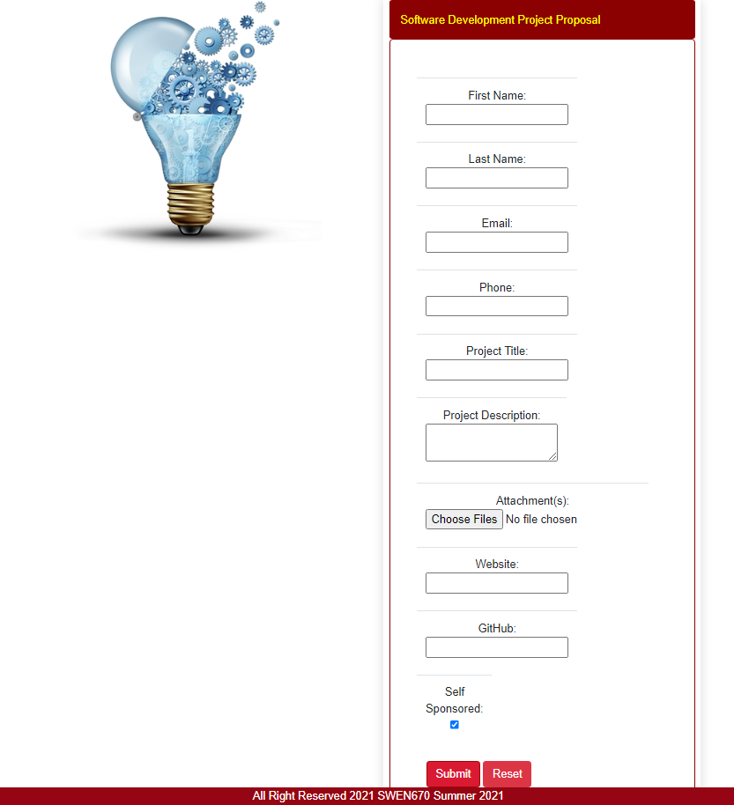

If the Self Sponsored checkbox is checked, the Sponsor information will be populated with the submitter’s information. If the Self Sponsored checkbox is unchecked, additional input is requested. The additional input is listed below:

* Sponsor First Name – The sponsor’s first name.
* Sponsor Last Name – The sponsor’s last name.
* Sponsor Email – The sponsor’s email address.
* Sponsor Phone – The sponsor’s phone number.

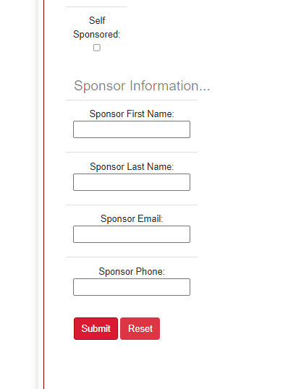

Once all information has been filled out, the project idea information can be submitted. After pressing the submit button, the “Uploading…” box will appear. Depending on the size of the attachments being uploaded, this process can either be quick or take quite a bit.

## Project List

The Project List page contains a table holding all submitted project ideas and detailed information about each project. This page is displayed differently depending on if the user has logged into the site or if the user is just a guest user. For both types of users, the project’s title, description, status, submitter information, sponsor information, links, and attachments can be viewed. The authorized user can edit these values, whereas the guest user only has read-only permissions. Any user can post a comment on a project but only authorized users can delete comments. Authorized users also have additional capabilities including deleting a project idea, deleting a comment, updating a project idea, deleting attachments, adding attachments, and exporting the project idea information.

## Project List – Guest User

When a user has not logged in, they are viewed as a guest user. The guest user can view the project idea table.

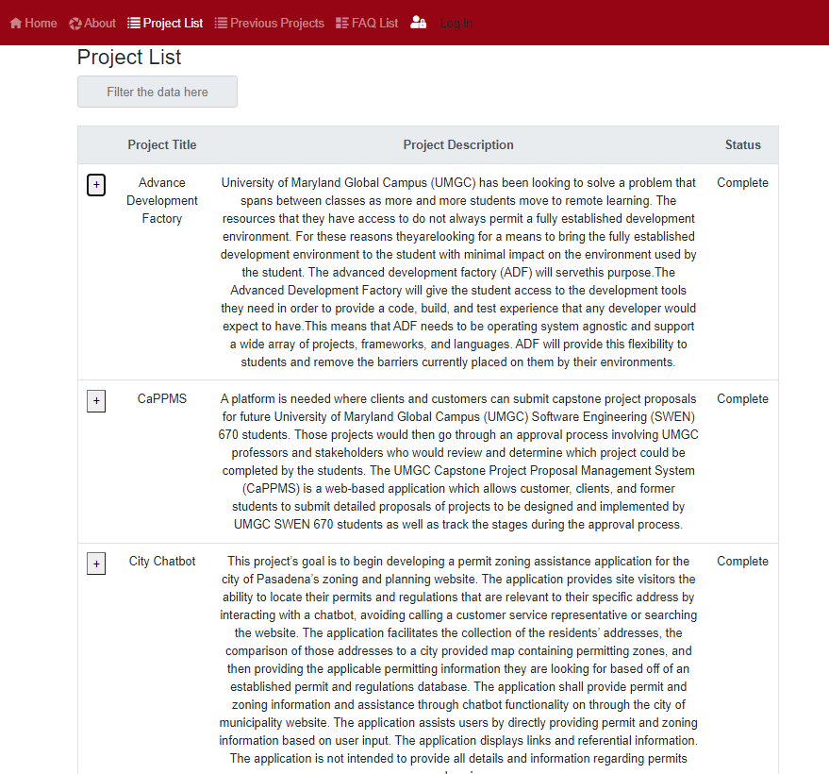

To the left of each row, there is a + button. By pressing the + button on a project idea, the detailed information of that project can be viewed.

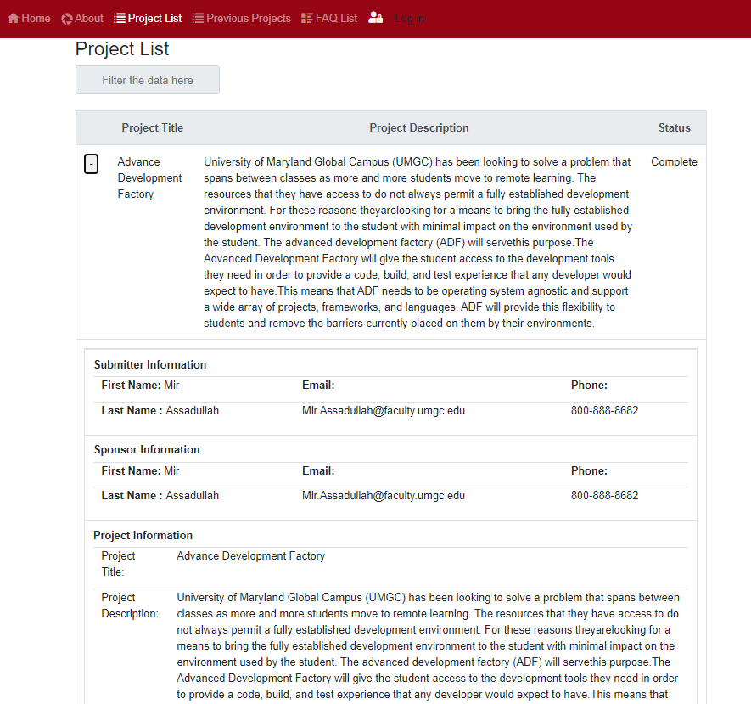

Finally, the guest user can filter the project list based on any given keyword by entering text in the “Filter the data here” text box. The filter text box filters based on any keyword that is located in any of the column’s values. Therefore, the user can even filter based on projects with a completed status or approved status, if desired.

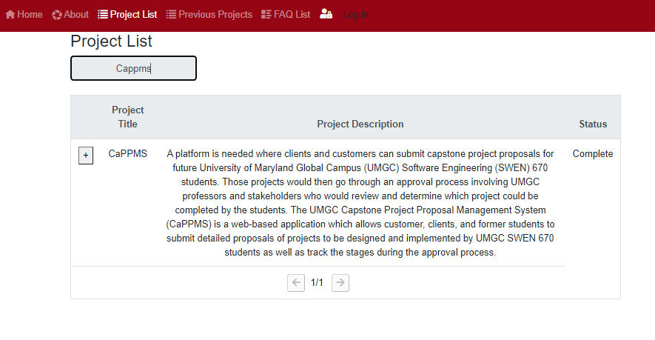

## Authorized User

When a user has logged in, they are viewed as an authorized user. The authorized user is granted more privileges and is able to make changes to the project information. The authorized user can do everything the guest user can do with some additional capabilities.

Update Project – The authorized user is able to edit Submitter Information, Sponsor Information, Project Information, and Team Links. To do this, change any of the text boxes and then scroll down and press Update button to save the changes made.

**Export Project -** The authorized user can click the Export button and an exported file be created and contain a list of the project’s information.

**Delete Project –** The authorized user can delete a project entirely. To do this, the authorized user can press the Delete button to delete the project. After pressing the delete button, the authorized user will need to confirm the project deletion by pressing the Confirm button on the pop-up dialog.

**Approve Project -** The authorized user can approve a newly submitted project. To do this, select a project with the status of “New”. Scroll down and press the Approve button to approve the project.

Once a project is approved, a GitHub repository gets created under the UMGC organization. The new repository will correspond to the project name and the description of the repository with correspond to the description in the CaPPMS interface. Two branches will be created. The default branch called “Development” and another one called “Main”. Also, two branch protection policies get created that require approval from administrators or codeowners for every merge into those two branches. Last, the user interface changes, and the project can then be marked as complete. To complete a project, select a project that is marked Approved in the Status column. Scroll down and press the Complete Project button.

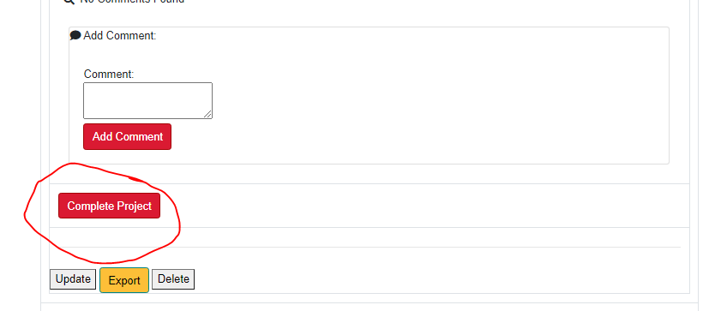

## Previous Projects

Every time a project is marked complete in the Project List page, it is automatically added to the Previous Projects page. The Previous Projects page is populated with completed projects in descending chronological order. Each project is grouped by the semester it was completed and contains the downloadable project files, along with the links that have been provided when the project was completed. If the user did not specify a specific link, it will not appear in the Previous Projects page.

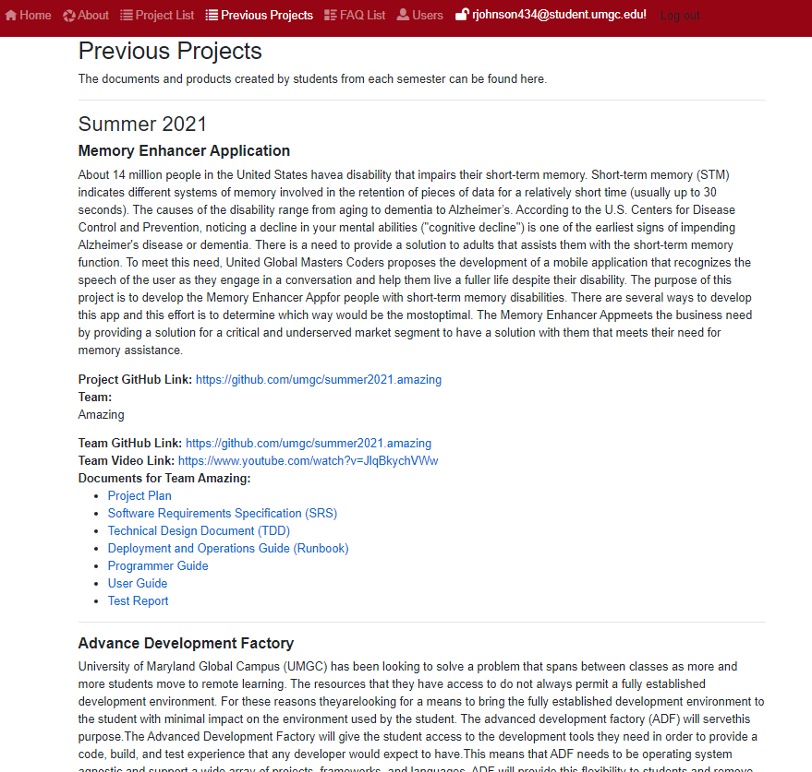

One important thing to note, the user can go back and update the links and project information by editing a completed project on the Project List page.

## FAQ List

The FAQ List page contains questions that have been asked by users along with their answers. The FAQ List page looks different depending on the type of user who is accessing this page. If the user is a guest user who has not logged in, they are able to browse the questions that have been asked and answered already. The guest user can also submit a new question. Finally, the guest user can also search existing questions.

**Guest User**

First, the guest user can browse existing topics, questions, and their answers. To do this, press the plus button to the left of a FAQ topic. After doing so, a list of questions related to the topic will appear. To view the answer to a specific question, the user can press the plus button next to the question.

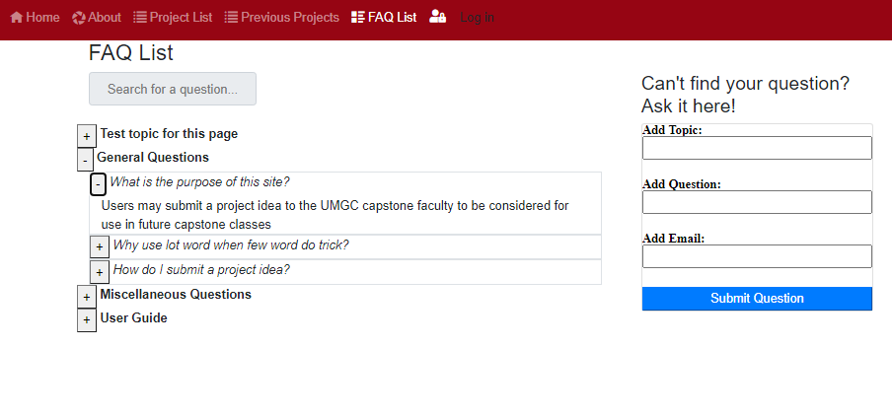

The guest user can also submit a question. To do so, the user can add their topic to the Add Topic text box. The user can then add their question to the Add Question text box and their name in the Add Email text box. After filling out the information, the user can press the Submit Question button.

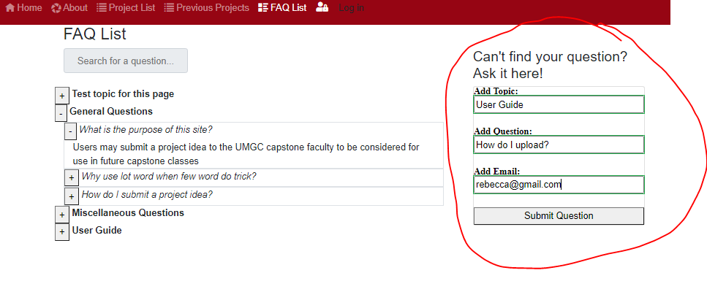

After a question is submitted, a pop-up window appears where the user can confirm that their question has been submitted.

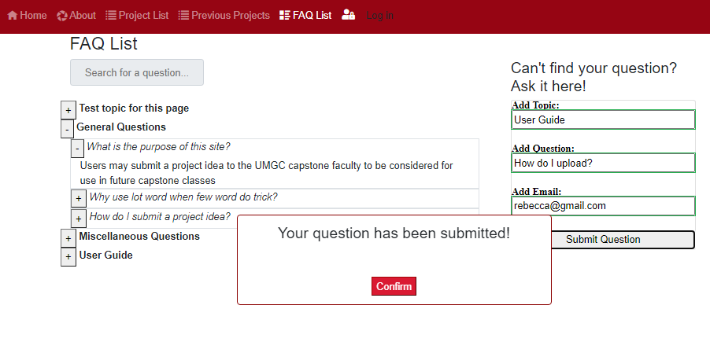

The question is then sent to be reviewed for approval by an authorized user.

The guest user can also search any question or answer in the FAQ List. To search, the user can enter any keyword in the “Search for a question…” text box and the list of questions updates depending on which ones contain the keyword.

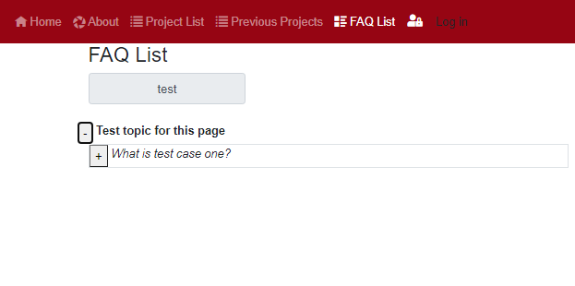

**Admin User**

When a guest user has submitted a question, the question submitted is listed on the left-hand side under the Unanswered Questions section.

The authorized user can press the button containing one of the question submitted to reveal a pop-up window where they can reply to the question, update the question topic or question contents, and even delete the question altogether.

To reply, enter the answer in the Reply button and press the Update button. A pop-up window will appear where the user can confirm the change.

After confirming the change, the question is added to the FAQ List and is removed from the Unanswered Question list.

## Log In

To Log In to the site, the user can press the Log In button on the top navigation bar. The system automatically logs in using the UMGC credentials already logged in. Only users who have been giving access to the site can use their credentials to log in to the site.