Municipality Permit Chatbot System (MPCS)

User Guide

Version 1.0 ● 05 August 2020

Prepared by: Rusty Baker, Sepribo Taylor-Harry, Subhash Gandhi Vallala, Joshua Piersol Matthew Slaymaker, Nathaniel Muesing

SWEN 670 University of Maryland Global Campus

**Trademarks**

The Municipality Permit Chatbot System (MPCS) is not a registered trademark. All other trademarks or registered trademarks are the property of their respective owners.

**Disclaimer**

The information provided in this document is provided “as is” without software warranty of any kind. In no event shall the University of Maryland Global Campus or the individuals listed on the cover page be liable for any damages whatsoever including direct, incidental, accidental, consequential, loss of business interests or special damages, even if the University of Maryland Global Campus or its suppliers have been forewarned of the likelihood of such damages.

**Document Lifetime**

The University of Maryland Global Campus may occasionally update this documentation between releases of the software. If you are using this document as a guide, please ensure that you have the most up-to-date document revision to ensure proper guidance. Please refer to https://github.com/umgc/umgc.city_chatbot for the most current revision.

**Where to get help**

For instance, with the Chatbot, please refer to the following link:

https://www.ibm.com/cloud/architecture/content/course/integrate-ibm-watson-assistant-and-watson-discovery/integrate-ibm-watson-assistant-and-watson-discovery/

**Product information**

Documentation, release notes, software updates, and information about MPCS products can be found at the following website at https://github.com/umgc/umgc.city_chatbot.

**Product Licensing**

MPCS is to be open-source software, requiring no use of licensing information.

Revision History

|  |  |  |  |
| --- | --- | --- | --- |
| **Date** | **Version** | **Author** | **Description** |
| 08/04/2020 | 1.0 | Rusty Baker | Initial Release |
|  |  |  |  |
|  |  |  |  |
|  |  |  |  |

**Table of Contents**

**Introduction** 7

**Overview** 7

**Scope** 7

**System Organization** 7

**Describing the System** 8

**Key Features** 8

**Environment** 8

**Installing and Starting the System** 9

**Access Control** 9

**Installing The System** 9

**Starting The System** 9

**Step by Step Instructions** 10

**Account Registration** 10

***Registration Error Handling*** 12

**Home Screen** 13

**User Screen** 14

***Adding A User*** 14

***Removing A User*** 15

***Editing A User*** 16

***User Error Handling*** 16

**Regulations** 16

***Adding A Regulation*** 17

***Editing A Regulation*** 19

***Deleting A Regulation*** 19

***Regulation Error Handling*** 20

**PERMITS** 20

***Adding A Permit*** 21

***Editing A Permit*** 23

***Deleting A Permit*** 23

***Permit Error Handling*** 24

**Zones** 24

***Adding A Permit*** 25

***Editing A Zone*** 27

***Deleting A Zone*** 28

**Chatbot Functionality** 29

List of Figures

**Figure 1**. MPCS Client-Side Login Screen 10

**Figure 2.** MPCS Client-Side Registration Screen 11

**Figure 3.** MPCS Client-Side login Screen with successful registration prompt 12

**Figure 4** MPCS Client-Side Registration Screen Error Handling 12

**Figure 5**. MPCS Client-Side Home Screen 13

**Figure 6.** MPCS Client-Side User Screen 14

**Figure 7.** MPCS Client-Side Add User Screen 15

**Figure 8.** MPCS Client-Side User Deletion Confirmation 15

**Figure 9.** MPCS Client-Side Add User Error Handling 16

**Figure 10.** MPCS Client-Side Regulation Screen 17

**Figure 11**. MPCS Client-Side Add Regulation Screen 18

**Figure 12.** MPCS Client-Side Regulation Screen With Inputted Regulation 18

**Figure 13.** MPCS Client-Side Regulation Deletion Confirmation 19

**Figure 14.** MPCS Client-Side Regulation Error Handling 20

**Figure 15.** MPCS Client-Side Permits Screen 21

**Figure 16**. MPCS Client-Side Add Permit Screen 22

**Figure 17.** MPCS Client-Side Add Permit Screen 22

**Figure 18.** MPCS Client-Side Permit Deletion Confirmation 23

**Figure 19.** MPCS Client-Side Permit Error Handling 24

**Figure 20.** MPCS Client-Side Permit Error Handling 25

**Figure 21.** MPCS Client-Side Add Zone Screen 26

**Figure 22.** MPCS Client-Side Add Zone Screen 27

**Figure 23.** MPCS Client-Side Zone Deletion Confirmation 28

**Figure 24** MPCS Chatbot Used By Residents 29

# **Introduction**

## **Overview**

The purpose of the MPCS software application is to assist end-users, comprising of city officials in the creation, editing, and navigation of municipal regulations and permits. Furthermore, the MPCS is a web-based application with two characteristics: a chatbot used by city residents and a client-side used by city officials that will reside on the metropolitan city website (e.g., Pasadena). The chatbot interface used by a city resident, guides residents with what permits or regulations are required based on their specified location and zone. The client-side application provides City Officials with the capability to set zones, add regulations, and add permits specific to the set zones.

## **Scope**

The purpose of this User Guide (UG) is to provide users of the MPCS with an understanding of how the software functions and what methods of functionality are existent. Furthermore, this document will predominately be directed to the users using the MPCS on the client-side web-based (e.g., officials of the municipal website) portal of creating zones, permits, and regulations. Users using the chatbot system will be addressed; however, there is limited guidance required in using the chatbot interface.

## **System Organization**

The system and software to which this document is to be utilized with are specified as or applicable to:

**Municipal Permit Chatbot System (MPCS)**

Version: 1.0

Release: 1.0

# **Describing the System**

## **Key Features**

Key features associated with the MPCS Client-Side software consists of the following:

* Account Registration/Login
* Adding, Editing, and Deleting Regulation Information
* Adding, Editing, and Deleting Permit Information
* Adding, Editing, and Deleting Users
* Adding, editing, or removing City Zones (Point to Draw Tool).
* Logging Out

Key features associated with the MPCS Chatbot software consists of:

* Chatting with City Resident
* Identifying which Zone the Resident resides in
* Supplying City Resident with permit link specific to regulation specific to the zone
* Supply City Resident with a regulation link specific to regulation specific to the zone

## **Environment**

The hardware, software, and other resources required by the end-user to install and run the software consist of the following:

* Database infrastructure to support the MPCS Client-side
* Installation and running of the software is done virtually requiring no physical hardware (aside from servers)

# **Installing and Starting the System**

## **Access Control**

MPCS currently lacks the characteristics of having an administrator for the MPCS. It is the municipal website administrator’s responsibility for ensuring proper access has been given to City Officials for the use of the MPCS client-side. This software is to be installed locally and will require modification for remote functionality.

## **Installing The System**

The software necessary in order to run this tool is listed as follows: MongoDB, Node, express, and Angular. Please refer to the Municipality Permit Chatbot System (MPCS) Deployment and Operations Guide (Runbook) Document Revision 1.2 Software Version 1 for the software installation process for all software involved with the MPCS.

## **Starting The System**

Once the software listed within “Installing The System” is installed, the following procedures will have to be executed in order to run the software in a local environment. Within the angular project directory, the following code will have to be executed in the terminal window “ng serve -o”

Within the Node software, the following command will have to be executed within the city-official-backend directory: nodemon server. Furthermore, monogDB will have to be started by selecting the “mongod.exe” and setting the default directory to “c:/data/db”

# **Step by Step Instructions**

This section provides instructions specific to the features outlined in the “Key Features” section. Additionally, this section will provide users with an understanding of what to expect when executing the software.

## **Account Registration**

Before accessing the MPCS Client-side software, the user will have to register and create a user account. To begin the registration process of creating an account for the MPCS Client-S, one will have to click “Register,” which resides next to the “Login” button on the Login Screen, as shown in Figure 1.

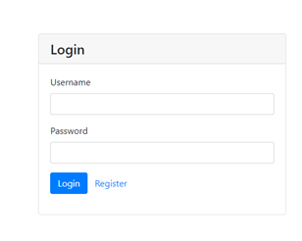

**Figure 1**. MPCS Client-Side Login Screen

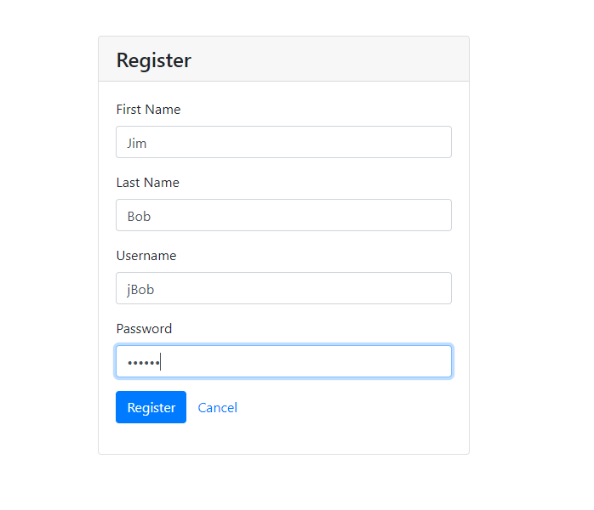

**Figure 2.** MPCS Client-Side Registration Screen

Figure 2 outlines the “Registration Screen,” which provides users with the ability to create a user account via the input of their First Name, Last Name, Username, and Password. To fulfill the registration process and save the inputted information, the user must select the “Save” button. Once saved, the screen will transition to the initial login screen and provide the user with a prompt indicating if the registration was successful, as shown in Figure 3.

**Note:** Registration fields of First Name, Last Name, Username, and password must be filled out in order to create an account for the user. Refer to the “Registration Error Handling” subsection for more information.

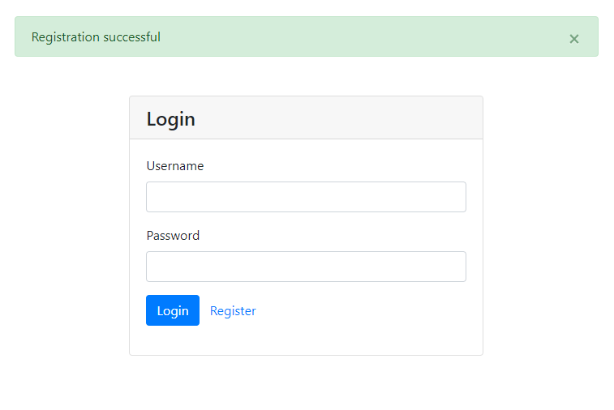

**Figure 3.** MPCS Client-Side login Screen with successful registration prompt

### ***Registration Error Handling***

Error handling associated with registration is only in the case of the “Register” screen. All inputs are necessary, requiring information to be inputted by that of the user. If information is not placed within the field, then an error will be produced, resulting within the highlighting of the field in red, as shown in Figure 4.

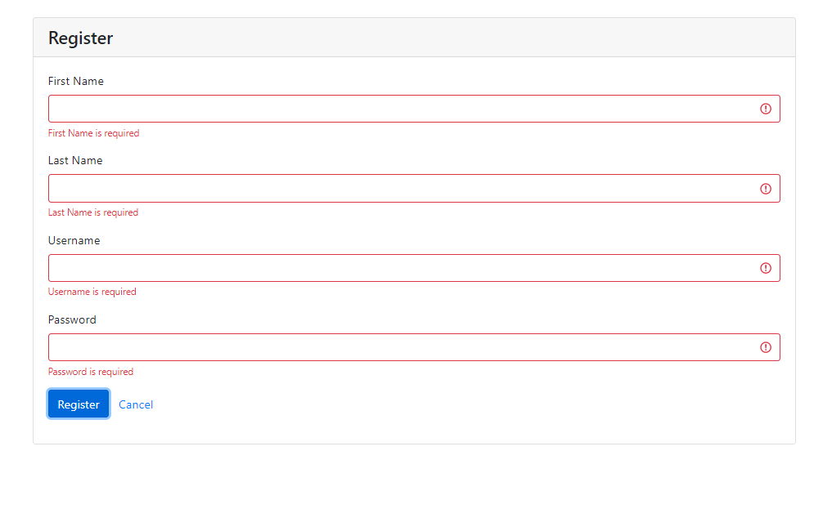

**Figure 4** MPCS Client-Side Registration Screen Error Handling

## **Home Screen**

The “Home Screen: can be accessed upon successful login of the MPCS Client-side software. The home screens provide the user with an initial starting point and direct access point to other features offered by that of the MPCS Client-side software, as shown in Figure 5. At the top of the home screen, there is a stationary list of screens that are to be displayed at all times, providing users the ability to quickly accessing other components of the software. Similarly, the home screen can be accessed by selecting the text “Home” in the upper right-hand corner of the screen.

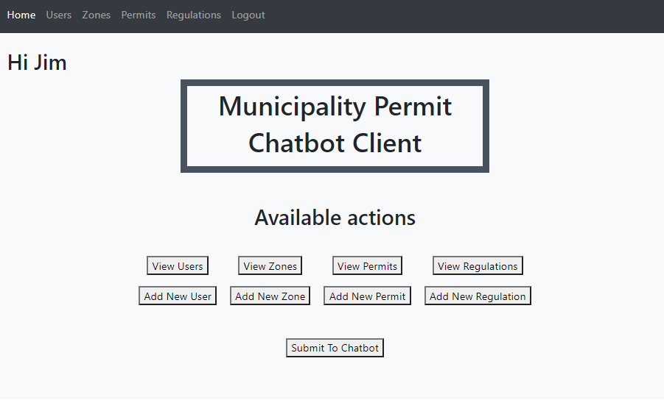

**Figure 5**. MPCS Client-Side Home Screen

## **User Screen**

Accessing the “Users” can be done through either the initial home screen or by selecting the text “User” on the running bar on the topic of the screen, as shown in Figure 6. Furthermore, the “Users” screen will provide the user with the principal possibility of adding, editing or deleting a user.

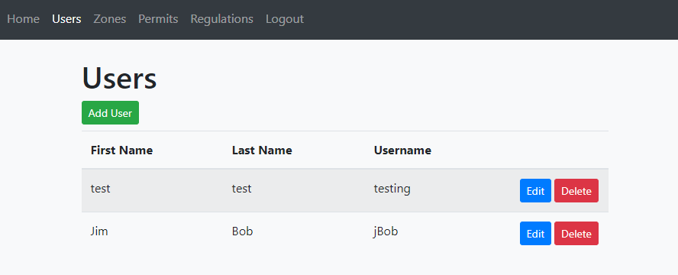 **Figure 6.** MPCS Client-Side User Screen

### ***Adding A User***

Adding a user to the MPCS Client-Side software can be done via the home screen, by selecting the “Add User” button as shown in Figure 5, or by selecting the green “Add User” button within the user screen as shown in Figure 6. Once the “Add User” button is selected, the screen will transition to the “Add User Screen,” shown in Figure 7. The add user screen provides users with the ability to add a name, username, and password. In order to finalize the process of adding a user, one will have to select the blue “Save” button. Once “Save” is selected, the screen will transition back to Figure 6 and display the newly added username with corresponding name information.

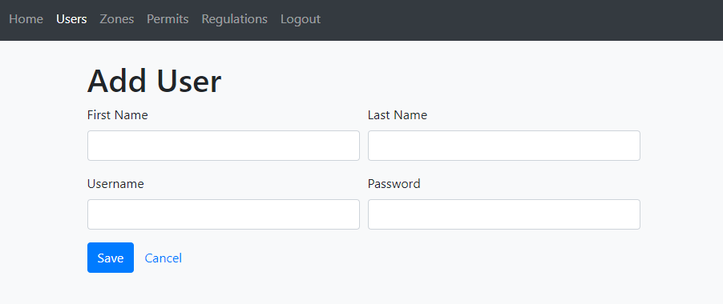

**Figure 7.** MPCS Client-Side Add User Screen

**Note:** User Screen fields of First Name, Last Name, Username, and password must be filled out in order to create an account for the user. See “User Error Handling” for more information.

### ***Removing A User***

To remove a user from the list of registered users, the user will have to access the “User Screen” and select the red button labeled “Delete,” as shown in Figure 6. Upon selection of the “Delete” button, a confirmation prompt will appear to the user requesting concurrence in the deletion process, as shown in Figure 8. To delete the user, the user should select the blue “OK” button, which will result in the removal of the user from the list. If the user selects “Cancel”, then the process will be aborted.

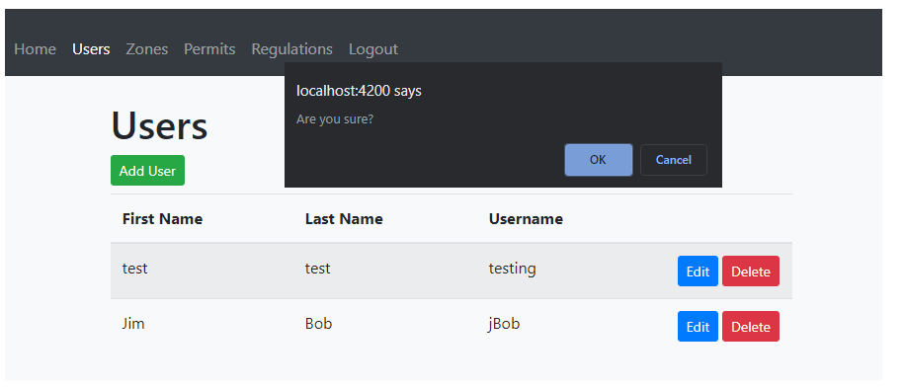

**Figure 8.** MPCS Client-Side User Deletion Confirmation

### ***Editing A User***

To edit a user from the list of registered users, the user will have to access the “User Screen” and select the blue button labeled “Edit,” as shown in Figure 6.

### ***User Error Handling***

Error handling associated with adding users is only in the case of the “Add User” screen. All inputs are necessary, requiring information to be inputted by that of the user. If information is not placed within the field, then an error will be produced, resulting within the highlighting of the field in red, as shown in Figures 9.

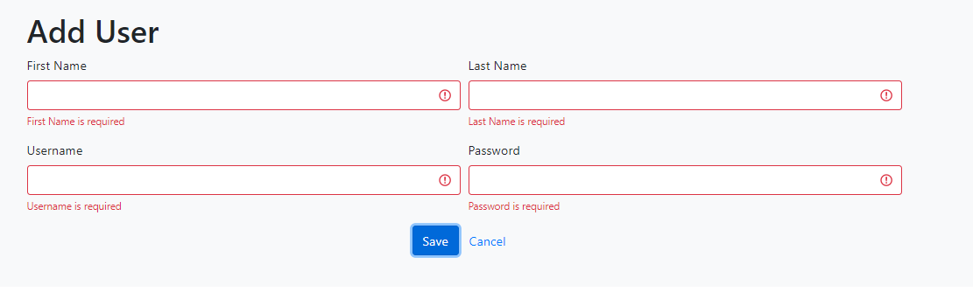

**Figure 9.** MPCS Client-Side Add User Error Handling

## **Regulations**

This section will outline the instructions of adding a regulation, editing a regulation, and then deleting a regulation within the MPCS Client-Side software. The “Regulations” screen outlines the key screen showing all regulations inputted and saved by that of the user, as shown in Figure 10. The “Regulations” screen can be accessed by selecting the “Regulations” button at the top of the software tool., or the user can select the “View Regulations” on the home screen, as shown in Figure 5. Furthermore, the “Regulations” screen will provide the user with the principal possibility of adding, editing or deleting a regulation.

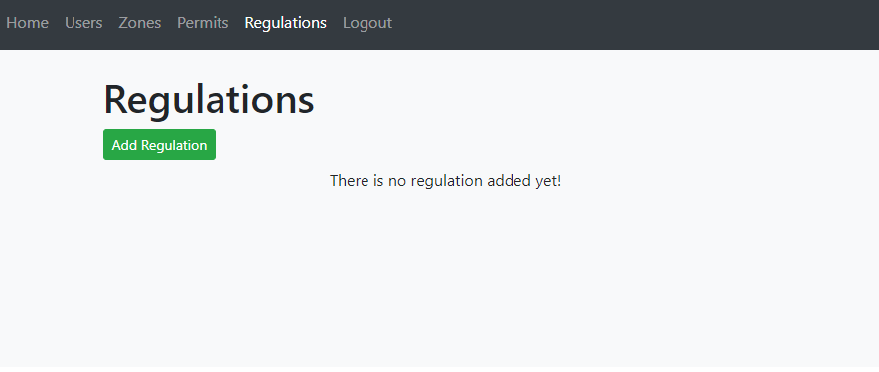

**Figure 10.** MPCS Client-Side Regulation Screen

### ***Adding A Regulation***

In order to add a regulation within the MPCS software, the user will have to select the green “Add Regulation” button, as shown in Figure 10, or selecting the grey “Add New Regulation” button as located in Figure 5. Upon selection of either button, the screen will transition to the “Add Regulation” screen, as shown in Figure 11. The add regulation screen provides users with the ability to add a code/designation, regulation URL (specific to that URL), and keywords identifying the regulation (e.g., Plumbing, Electrical). To save and process the regulation, the user will have to select the blue “Save” button.

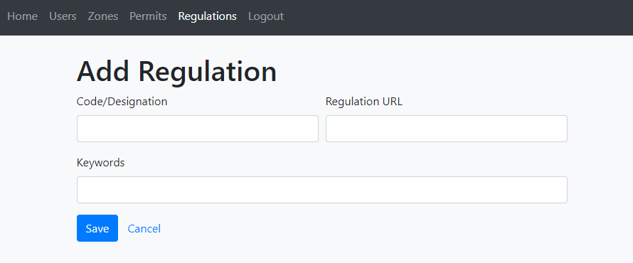

**Figure 11**. MPCS Client-Side Add Regulation Screen

Upon selection of the save previously mentioned, the “Add Regulation” screen will transition back to the “Regulations” screen, ultimately displaying the newly added regulation within a listed view, as shown in Figure 12.

**Note:** User Screen fields of First Name, Last Name, Username, and password must be filled out in order to create an account for the user. Refer to the “Regulation Error Handling” subsection for more information.

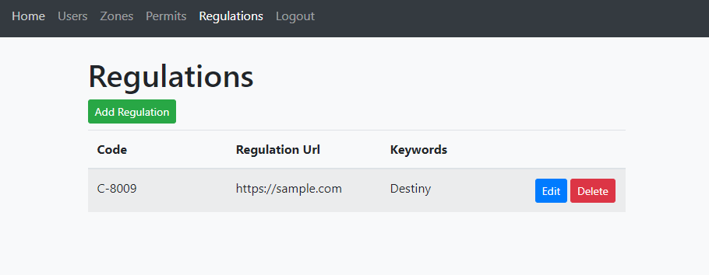

**Figure 12.** MPCS Client-Side Regulation Screen With Inputted Regulation

### ***Editing A Regulation***

To edit an existing regulation, the user will have to access the “Regulations” screen either via the Home Screen or via the line bar. To edit a listed regulation, the user will have to select the blue “Edit” button, as shown in Figure 12. Once selected, the screen will transition back to the “Add Regulation” screen, as shown in Figure 11. To finalize editing a regulation, the user will have to ensure all information is updated and then select the blue “Save” button, which will subsequently transition the screen back to the “Regulations” screen.

### ***Deleting A Regulation***

To delete a regulation that is listed within the “Regulations” screen, the user will have to select the red “Delete” button next to the corresponding regulation that is to be deleted, as shown in Figure 12. Before deleting the regulation, the software will display a confirmation prompt to the requesting concurrence in the deletion process. To delete the regulation, the user should select the blue “OK” button, which will result in the removal of the regulation, as shown in Figure 13. If the user selects “Cancel” then the process will be aborted.

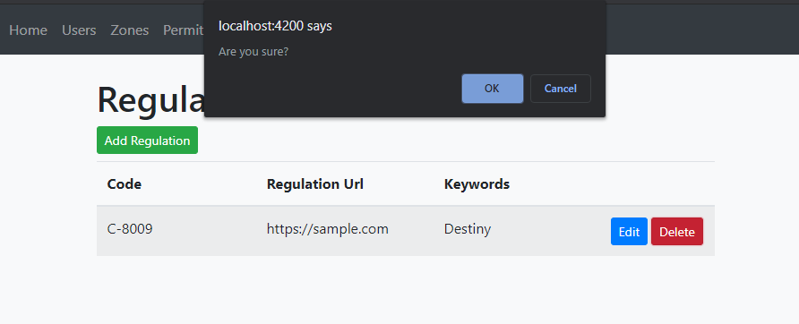

**Figure 13.** MPCS Client-Side Regulation Deletion Confirmation

### ***Regulation Error Handling***

Error handling associated with regulations is only in the case of the “Add Regulation” screen. All inputs are necessary, requiring information to be inputted by that of the user. If information is not placed within the field, then an error will be produced, resulting within the highlighting of the field in red, as shown in Figure 11.

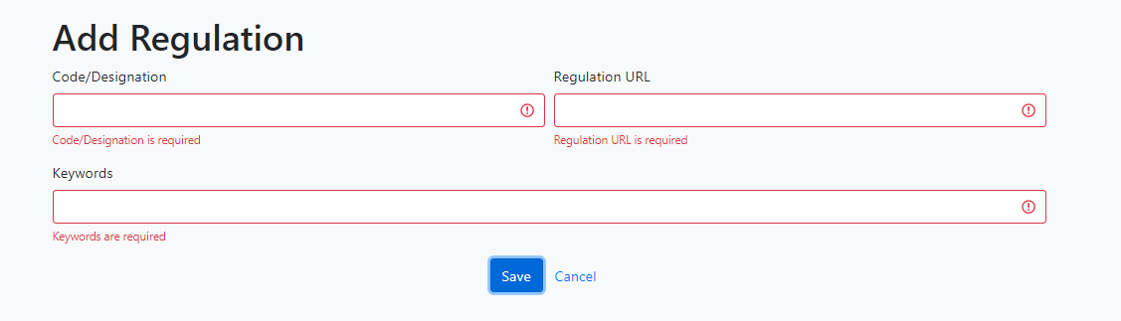***Figure 14.*** *MPCS Client-Side Regulation Error Handling*

## **PERMITS**

This section will outline the instructions of adding permits, editing permits, and then deleting permits within the MPCS Client-Side software. The “Permits” screen outlines the key screen showing all permits inputted and saved by that of the user, as shown in Figure 15. The “Permits” screen can be accessed by selecting the “Permits” button at the top of the software tool., or the user can select the “View Permits” on the home screen, as shown in Figure 5. Furthermore, the “Permits” screen will provide the user with the principal possibility of adding, editing or deleting permits.

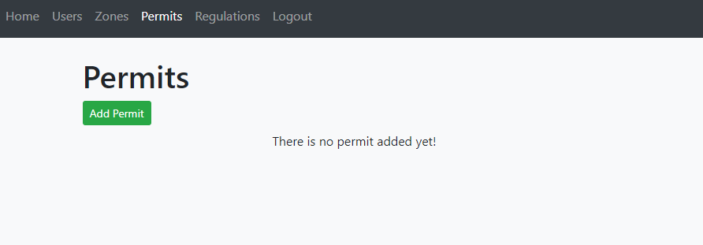

***Figure 15.*** *MPCS Client-Side Permits Screen*

### ***Adding A Permit***

In order to add a permit within the MPCS software, the user will have to select the green “Add Permit” button, as shown in Figure 15, or selecting the grey “Add New Permit” button as located in Figure 5. Upon selection of either button, the screen will transition to the “Add Permit” screen, as shown in Figure 16. The add permits screen provides users with the ability to add a code or designation, permit URL (specific to that URL), application URL, and keywords identifying the permit (e.g., Building, Zoning). To save and process the permit, the user will have to select the blue “Save” button.

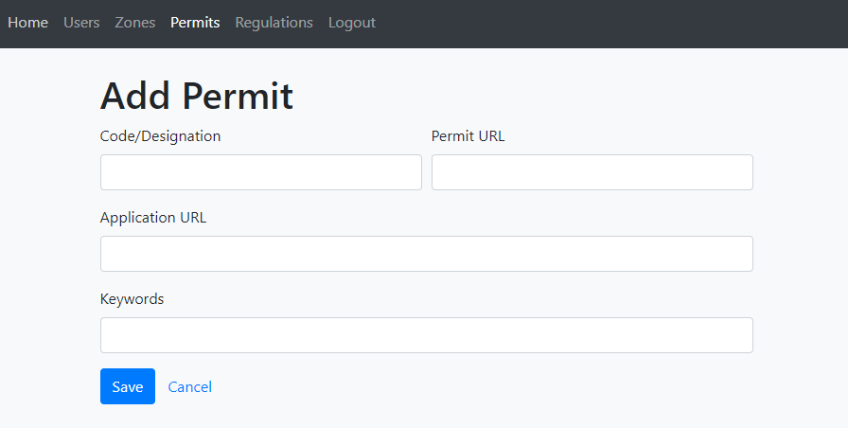

**Figure 16**. MPCS Client-Side Add Permit Screen

Upon selection of the save previously mentioned, the “Add Permit” screen will transition back to the “Permits” screen, ultimately displaying the newly added permit within a listed view, as shown in Figure 17.

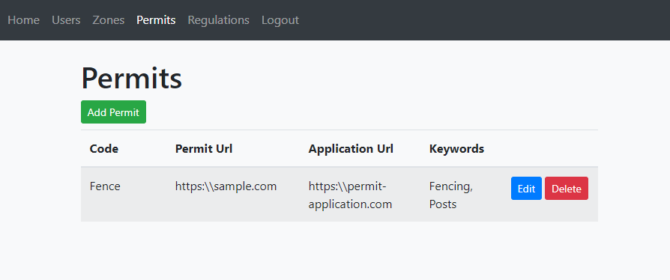

**Figure 17.** MPCS Client-Side Add Permit Screen

**Note:** User Screen fields of First Name, Last Name, Username, and password must be filled out in order to create an account for the user. Refer to the “Permit Error Handling” subsection for more information.

### ***Editing A Permit***

To edit an existing permit, the user will have to access the “Permits” screen either via the Home Screen or via the line bar at the top of the screen. To edit a listed regulation, the user will have to select the blue “Edit” button, as shown in Figure 17. Once selected, the screen will transition back to the “Add Permit” screen, as shown in Figure 16. To finalize editing a permit, the user will have to ensure all information is updated and then select the blue “Save” button, which will subsequently transition the screen back to the “Permits” screen.

### ***Deleting A Permit***

To delete a permit that is listed within the “Permits” screen, the user will have to select the red “Delete” button next to the corresponding permit that is to be deleted, as shown in Figure 17. Before deleting the permit, the software will display a confirmation prompt to the requesting concurrence in the deletion process, as shown in Figure 18. To delete the permit, the user should select the blue “OK” button, which will result in the removal of the regulation. If the user selects “Cancel” then the process will be aborted.

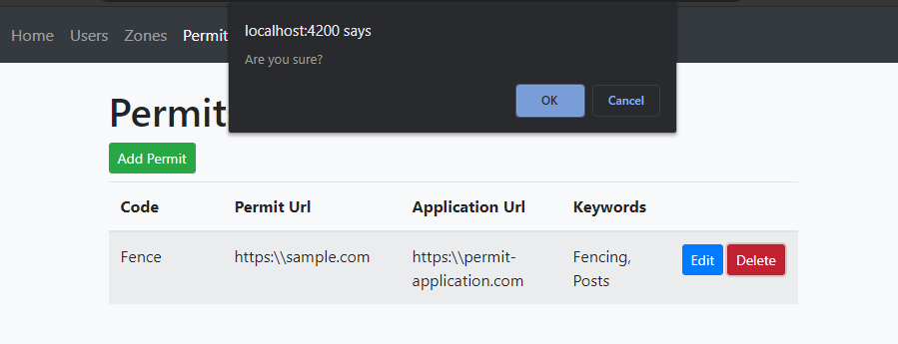

**Figure 18.** MPCS Client-Side Permit Deletion Confirmation

### ***Permit Error Handling***

Error handling associated with permits is only in the case of the “Add Permit” screen. All inputs are necessary, requiring information to be inputted by that of the user. If information is not placed within the field, then an error will be produced, resulting within the highlighting of the field in red, as shown in Figure 19.

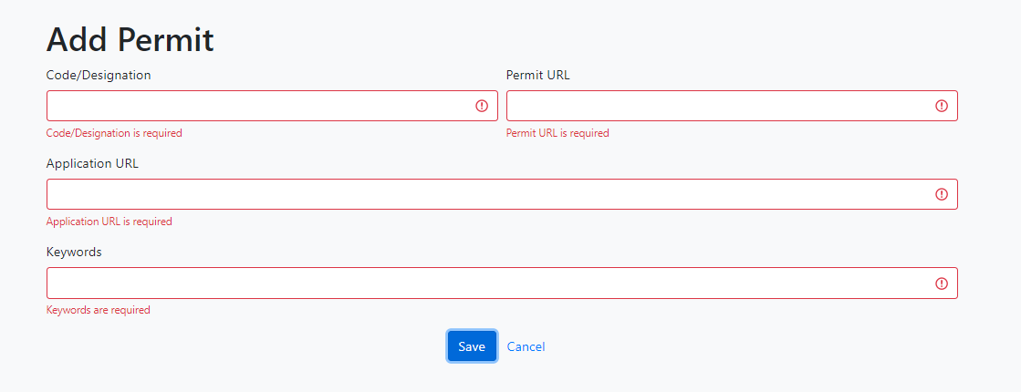***Figure 19.*** *MPCS Client-Side Permit Error Handling*

## **Zones**

This section will outline the instructions of adding zones, editing zones, and then deleting zones within the MPCS Client-Side software. The “Zones” screen outlines the key screen showing all zones inputted and saved by that of the user, as shown in Figure 20. The “Zones” screen can be accessed by selecting the “Zones” button at the top of the software tool., or the user can select the “View Zones” on the home screen, as shown in Figure 5. Furthermore, the Zones screen will provide the user with the principal possibility of adding, editing or deleting a zone.

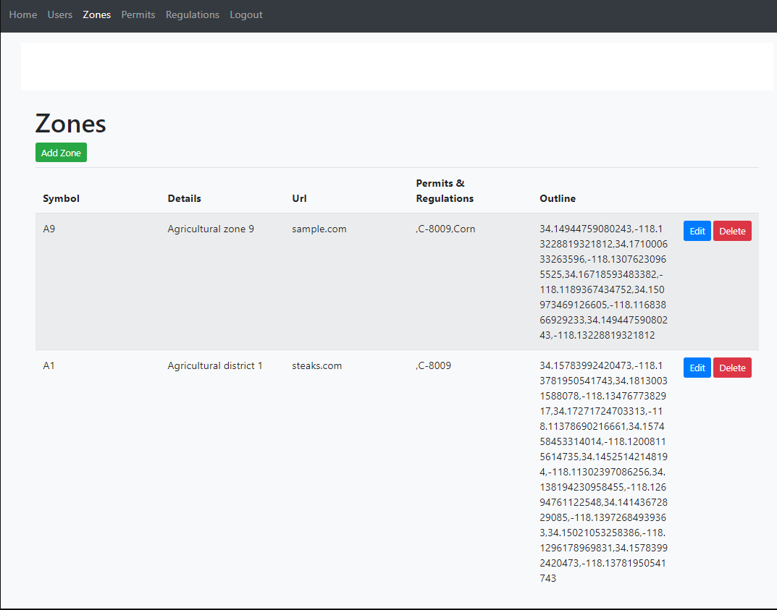

**Figure 20.** MPCS Client-Side Permit Error Handling

### ***Adding A Permit***

In order to add a zone within the MPCS software, the user will have to select the green “Add Zone” button, as shown in Figure 20, or selecting the grey “Add New Zone” button as located in Figure 5. The “Add Zone” screen provides the user with the ability to manually drawing a zone one a map in addition to specifying permits and regulations specific to the draw zone, as shown in Figure 21. Drawing zones on the map should be done with a point-to-point characteristic, implying that there is curved lines are not possible. Additional information that the user has in adding to a specific zone consists of a zone symbol, zone URL, and zone details.

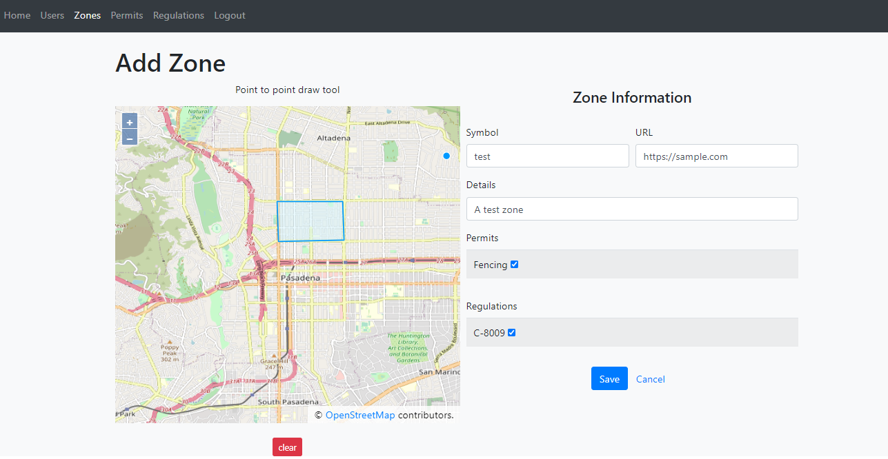

**Figure 21.** MPCS Client-Side Add Zone Screen

To save a zone and finalize the zone creation process, the user will have to select the blue “Save” button, as shown in Figure 21. Upon selecting the “Save” button within the “Add Zone” screen, the screen will transition back to the Zons screen and provide a prompt to the user indicating if the zone creation was successful, as shown in Figure 22.

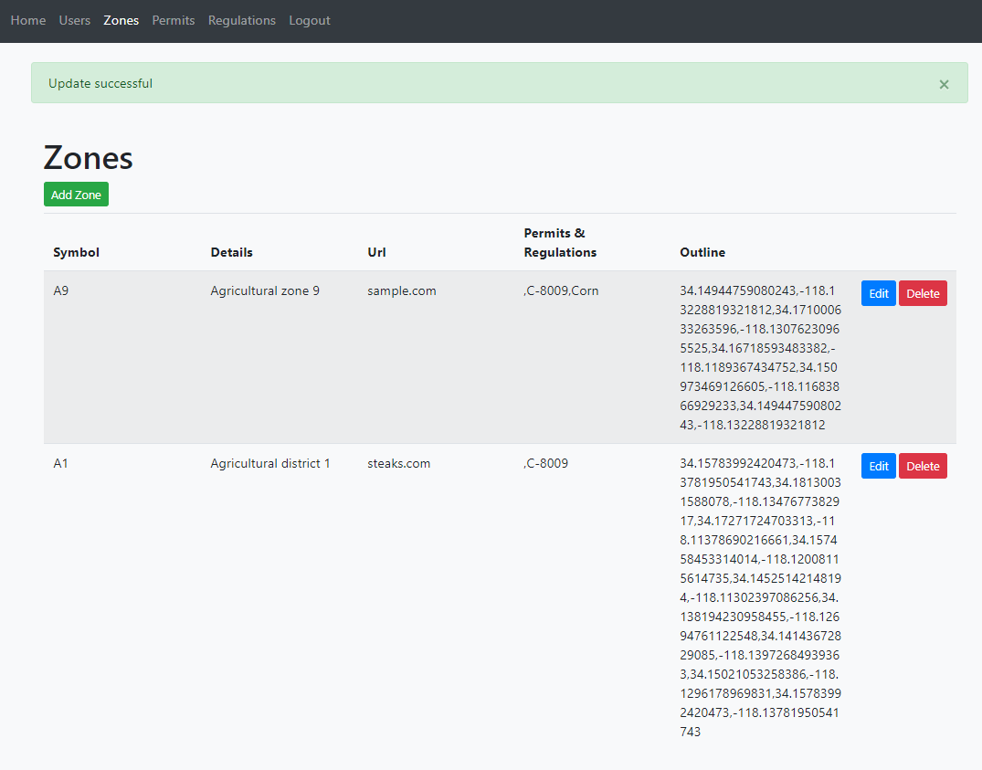

**Figure 22.** MPCS Client-Side Add Zone Screen

### ***Editing A Zone***

To edit an existing zone, the user will have to access the “Zones” screen either via the Home Screen or via the line bar at the top of the screen. To edit a listed zone, the user will have to select the blue “Edit” button, as shown in Figure 22. Once selected, the screen will transition back to the “Add Zone” screen, as shown in Figure 21. To finalize editing a zone, the user will have to ensure all information is updated and then select the blue “Save” button, which will subsequently transition the screen back to the “Zones” screen.

### ***Deleting A Zone***

To delete a zone that is listed within the “Zone” screen, the user will have to select the red “Delete” button next to the corresponding regulation that is to be deleted, as shown in Figure 22. Before deleting the zone, the software will display a confirmation prompt to the requesting concurrence in the deletion process, as shown in Figure 23. To delete the zone, the user should select the blue “OK” button, which will result in the removal of the regulation. If the user selects “Cancel” then the process will be aborted.

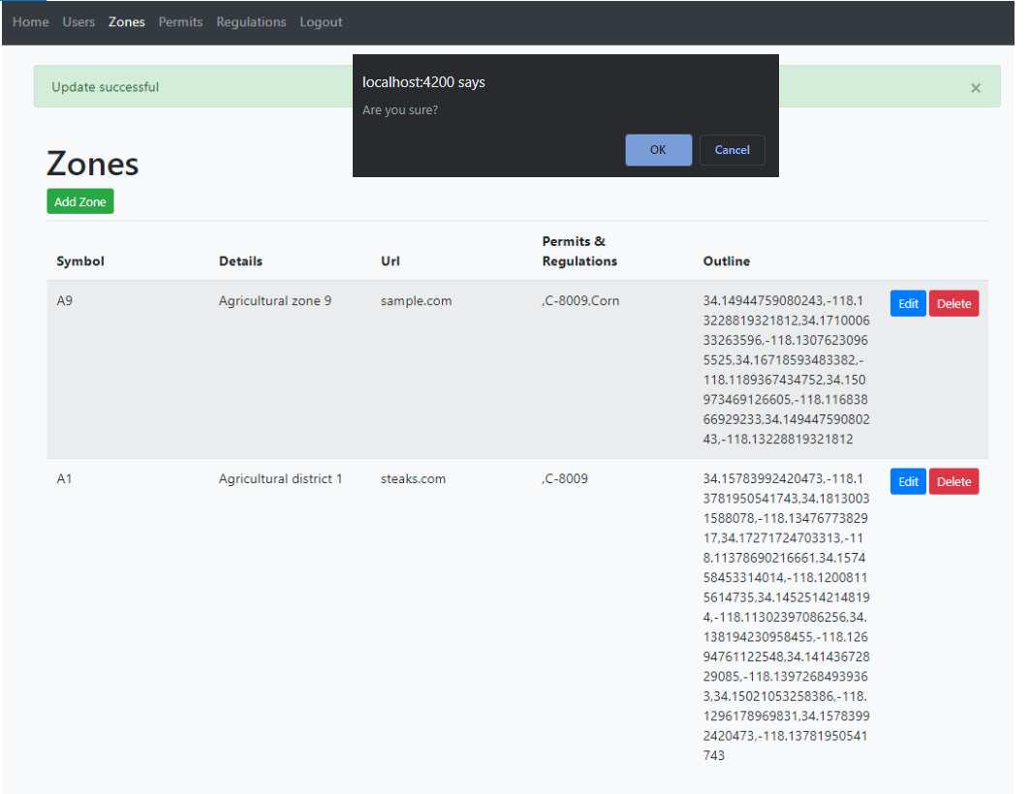

**Figure 23.** MPCS Client-Side Zone Deletion Confirmation

## **Chatbot Functionality**

The Chatbot used by the city-resident has a simplistic design that provides the user with an interface for communication. Figure 24 depicts an image of the MPCS chatbox that will be hosted on the Municipal city website. Similar to that of a real person, the city resident has the capability of questioning the Chatbot. In the essence of the MPCS software, once the Chatbot has the necessary information, it will supply the resident with a link derived from the MPCS Client-side software that was previously discussed in previous sections. By selecting the supplied link, the city resident will have direct access to the questioned regulation or permit based upon their current location.

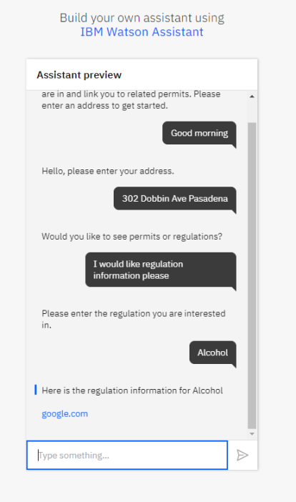

**Figure 24** MPCS Chatbot Used By Residents