Presented by Team Mesmerize

Presley Muwan, Karen Crumb, Kevin Bell, Teresa Balbi, Sami Salim, Daniel Avery, Christian Cruz Jimenez  
  
UMGC SWEN 670

project plan

MEMORY MAGIC APP

Project name: Memory Magic Application.

Date: September 14, 2021

Project Manager: Presley Muwan

Phase: Project Planning

Revision History

|  |  |  |  |
| --- | --- | --- | --- |
| Revision Number | Date | Description | Approved By |
| 1.0 | 06/11/2021 | Initial Release | Presley Muwan |
| 1.1 | 09/14/2021 | Revision | Teresa Balbi |
| 1.2 |  | Milestone 2 | Presley Muwan |

Table of Contents

1 General Information 4

1.1 Background 4

1.2 Statement of Need 4

1.3 Vision Statement 4

2 Project Assignment 5

2.1 Project Scope 8

2.1.1 Project Objectives 8

2.1.2 Project Requirements 8

2.2 Project Assumptions 10

2.3 Product Approval/Acceptance Criteria 11

2.4 Project Cost 11

2.5 Acronyms and Abbreviations 13

3 Risk Analysis 13

3.1 Risk Framework 13

3.2 Risk Assessment 15

3.3 Application Risks and Vulnerabilities 15

3.4 Risk Matrix 17

3.5 Risk Register 18

4 Organization of the project 19

4.1 Communication 20

4.2 Explanation of the methodology 20

4.3 Project Staffing 21

4.4 Roles and responsibilities 21

4.5 Responsibility Assigned Matrix 23

4.6 Project Tools 24

4.7 Project Storage 25

4.8 Deliverables 26

4.9 Project Schedule/WBS 27

5 Software Test Plan 28

6 Appendices 29

6.1 Project Schedule/WBS 29

6.2 Credits 30

6.3 References 31

# General Information

## Background

Short-Term Memory (STM), also known as active memory, can be explained as the brain's ability to store small amounts of information while keeping it readily available for a short period of time, normally 20-30 seconds in length and/or seven items, plus or minus two (Cherry, 2021). STM plays a critical function in shaping a human's ability to interact with the world. However, a few factors can influence STM, such as dementia, Alzheimer's, and age. In the United States, about 16 million people over 65 years old have shown signs of STM loss, and about 15% of them may develop dementia or Alzheimer's disease (Small, 2002). To assist individuals with STM issues, United Global Masters Coders recommends the development of a mobile application that recognizes users' speech, allows them to create reminders, and customize phrases to facilitate their lives despite STM concerns.

## Statement of Need

The purpose of this project is to combine Team Mesmerize own features and the best features developed by Team Amazing, Team Bravo, and Team Charlie to create a complete Memory Magic App for people with STM concerns. To meet the business need, the Memory Magic App will satisfy the demand for this underserved market by providing an efficient solution for individuals with STM issues.

## Vision Statement

The vision for United Global Masters Coders is to combine Team Mesmerize cloud support, security feature, and support for languages with the best features from Team Amazing, Team Bravo, and Team Charlie to develop the finest personal speech recognition application for individuals suffering from STM issues.

# Project Assignment

The project shall use the SMART tool, which stands for Specific, Measurable, Achievable, Realistic, and Time. Table 1 has divided the meaning of SMART, making it easier for the reader to grasp its matrix and system.

* **Measurable** will track project goals and assess the effectiveness of the short-term memory aid mobile application.
* **Achievable** will work hard to meet the project's success criteria.
* **Realistic** means that the aims and objectives are achievable and that the objectives' outcomes may lower the total project plan.
* **Time** is the most practical option for addressing the problem within a deadline/milestone (Project-Managment.com, 2019).

Overall, the SMART tool is comparable to project management in that it establishes guidelines to meet the following goals: scope, money, and time.

**Table 1**

*SMART Goals*

|  |  |
| --- | --- |
| **SMART Goals** | **Description** |
| Specific | Memory Magic app shall do the following things:   * Ask for the user's permission to use device’s microphone. * Speech to text converter. * Save the notes with the date. * The user shall edit or delete notes. * The user shall type a note, have an option to search notes via the search bar, save personal details such as events, search keywords using voice commands, or search bar. * The user shall use start and stop as trigger words for a start, stop. Recall can look at notes using keywords. * UI shall have large icons for easy viewing. * The App shall support different languages. * Cloud support – enabling cloud storage, so the users don't worry if they lose their devices or need to access notes from another device. * Security feature – users can use the biometric features on the personal mobile devices to ensure privacy. * The application shall keep track of event dates and times and remind the users, within a one-hour interval, when the event is due. |
| Measurable | To create the mobile application, Memory Magic shall use Scrum Methodology. A prototype/ progress shall fulfill the high-level criteria at the end of each Sprint/Weekly meeting. |
| Achievable | The Team has completed each job and role for the Team after assessing the PM and team members. For example, memory magic comprises three Software Developers, two Dev Tester, one UI/UX Designer, one Business analyst, and a Project Manager. Understanding each position allows each team member to work concurrently to implement the solution efficiently. A software developer, for example, sets a functional feature need. Before going to the next set of requirements, the Team's tester should test that feature and confirm it operates correctly.  Similarly, PMs define tasks, schedules, and plans to keep the Team on track. Business analysts strive to collaborate with everyone, including members and consumers, to ensure the project's success. Roles can also be interchangeable. For example, Dev testers can pick up on tickets and work on them. The application shall integrate with NLU web services developed by the Tongue Twisters team. |
| Realistic | Dr. Mir Assadullah launched the project, PM and the Team came up with the app's initial requirement. After completing the Software Engineering Project courses after the semester, the Memory Magic mobile application shall satisfy the demand for this underserved market by providing an efficient solution for individuals with STM issues. |
| Time | The memory Magic team's Project manager has established a milestone for each step. The project can be divided into three phases: planning, design, engineering, and implementation. Its goal is to ensure that the finished product is satisfactory before giving it to the client. The mobile application shall be available after the semester's eleven weeks. |

## Project Scope

The Memory Magic's Project Plan scope includes the Planning Phase, Design & Engineering Phase, and Execution Phase.

### Project Objectives

The planning phase is when the Memory Magic team shall gather the vision statement, business needs statement, object, and objective requirements, a Project Management and Business Analyst (BA) Statement of Work (SOW) shall be established. A communication strategy within the Team is formed. Next, software developers and testers write code to create prototypes that meet the requirements during the design and engineering phases. Finally, the execution step involves finalizing a finished product, deploying an app, and delivering it to the client.

### Project Requirements

The Project requirements consist of functional and non-functional requirements.

Functional Requirements:

* The application shall have large icons to make them easier to find by those with memory issues. The system shall check if all necessary permissions to resources are granted.
* The application shall listen for the start phrase and transcribe the user's speech. The application shall allow the users to edit and update text.
* The application shall allow the user to add a new note as well as delete it.
* The application shall allow the user to sort a list of notes by date and group the notes by subject category.
* The application shall have a search option in which the user can enter keywords or dates.
* The application shall have a context sensitive help area.
* The application shall have a storage setting that the user may use to set up cloud storage with their google account.
* The application shall allow users to use the biometric features in their personal mobile devices to ensure privacy.
* The application shall have a language settings option.
* The default option shall be English.
* The application shall keep track of event dates and times and remind the users, within a one-hour interval, when the event is due.
* The application shall use Time Ago instead of absolute date/times.
* The application shall provide a Calendar and Daily Checklist
* The application shall support voice interaction with user
* The application shall include caregiver instructions and onboarding options
* Settings shall me made possible to allow either caregiver or user to set up the application

Nonfunctional Requirements:

* UI responses to user interaction shall not exceed 2 seconds.
* All external communication shall be encrypted.
* All data shall be encrypted (in transit and at rest).
* The system shall comply with 508 specifications and HIPPA Privacy Rules to ensure that the application is secure and easy to use by individuals with a disability.
* Users who enable cloud storage shall access their backed-up notes from any device connected to the internet.
* Users shall have the option to back up their notes on google cloud.
* The application may provide games to stimulate memory
* The application may allow caregiver to develop a scrapbook and include photos and music
* The application may provide a profile screen with user’s personal information

Work within the PM's scoping strategy is as follows:

* Agile project methodology shall be used for the project.
* The Flutter and Dart SDKs shall be available for free download as open source from the internet.
* The overview information for tracking team progress and assigning team member duties shall be visible in the MS Project and Github platform.
* The code shall be distributed on Github in branches so that team members may readily access it.
* The code shall be merged into main branches and compiled for submission by DevSecOps (DSO).
* Testing shall be placed concurrently with development to ensure that the minimum attainable criteria are met.

## Project Assumptions

The following are the project assumptions:

* Memory Magic shall strive to meet the original outline need, which is dependent on the approach of software developers and researchers to identify the best solution.
* The PM shall allocate tasks to team members depending on their roles.
* Milestone deliverables date shall not change.
* The PM and BA shall check the project's health weekly to stay on track.

## Product Approval/Acceptance Criteria

This document shall detail the project Milestones in specified deliverable dates. This project shall have four Milestones that Team Mesmerize should complete and Dr. Mir Assadullah shall rate each Milestone deliverable.

Milestone 1, which comprises the Project Plan and Software Requirements Specifications, shall be altered if future development does not meet the professor's requirements or an approval/acceptance response is not received.

In the Agile methodology employed by Team Mesmerize, changes to the project are inevitable. When the changes are identified, the development team determines the scope of the change, including various factors such as risks involved and level of efforts. Once the initial analysis is completed, the team works with the Project Manager to communicate the related changes to The Tongue Twisters Team and DevSecOps team to see any potential changes to their integrations. The information obtained is presented to the stakeholders to prioritize the change. Once the changes are agreed upon, all related documents are updated to represent the change, including the history. Finally, the potential changes are communicated to all the teams.

Microsoft teams and emails are primarily used for communication to make sure all the teams are in sync.

## Project Cost

The estimated costs for this project is shown in Table 2. The prices are calculated on the cost of labor, as the project does not anticipate costs related to software and/or hardware. Hourly rates for each role shown below:

* Project Manager: $63.00 per hour
* Business Analyst: $40.00 per hour
* Lead Developer: $55.00 per hour
* UI/UX Designer: $45.00 per hour
* Developer (2): $45.00 per hour
* Tester (2) $35.00 per hour

Table 2 exemplifies each role, compensation for labor per hour, total number of hours expected for each role, and the total estimated cost for labor for each role. Labor is estimated based on a three-hour workday, five days a week on a 12 week-long project.   
**Table 2**

*Project Costs*

|  |  |  |  |
| --- | --- | --- | --- |
| **Role** | **Compensation for Labor per hour** | **Total Number of Hours Expected (3 hours per day x 5 days week x 12 weeks)** | **Total Estimated Costs per Role** |
| Project Manager | $63.00 | 180 Hours | $11,340.00 |
| Business Analyst | $40.00 | 180 Hours | $7,200.00 |
| Lead Developer | $55.00 | 180 Hours | $9,900.00 |
| UI/UX Designer | $45.00 | 180 Hours | $8,100.00 |
| Developer | $45.00 | 180 Hours per Developer | $8,100.00 – Per Developer ($8,100.00 x 2 = 16,200.00) |
| Tester | $35.00 | 180 Hours per Tester | $6,300.00 – Per Tester ($6,300.00 x 2 = 12,600.00) |

*Note.* Compensation for Labor per hour found on salary.com for each role.

Total of hours expected was estimated based on members availability.

Total estimated cost per role was calculated by multiplying hourly rate per total number of hours expected.

*Total cost for the project is estimated to be $65,340.00 for labor (adding the total estimated cost per role for each role). There is not an anticipated expected cost for software and hardware to be associated with this project.

## Acronyms and Abbreviations

See the most used acronyms/abbreviations and their definitions below:

**Table 3**

*Acronyms, Abbreviations, and Definitions*

|  |  |
| --- | --- |
| **Acronyms and Abbreviations** | **Definitions** |
| PM | Project Manager |
| BA | Business Analyst |
| DSO | DevSecOps |
| STM | Short Term Memory Loss |
| WBS | Work Breakdown Structure |
| UI | User Interface |
| NLP | Natural Language Processing |
| NLU | Natural Language Understanding |
| RT | Regression Testing |
| OS | Operating System |
| LEO | UMGC online platform class |
| SMART | Specific, Measurable, Achievable, Relevant/Realistic, and Time-bound are the acronyms for SMART tools. It is used to establish the aims and objectives of a project. |

# Risk Analysis

## Risk Framework

This Risk Analysis will follow the framework indicated in this section to keep a consistent process through the life of the project. Keeping consistency when addressing risk is vital to anticipate adverse events that could negatively impact the project. Being able to develop alternative solutions to reach your objectives under all circumstances is the most important challenge in risk management (Gisclard-Biondi, 2021). The framework presented below is based on the lifecycle of risk management.

**Figure 1**

*Risk Lifecycle Framework*

Each step of the lifecycle framework will have a specific purpose to assist the project team in the risk assessment. The five steps of the framework are explained in more detail below:

1. Risk Identification
   * + - * Identify risks early in the project
         * List the different risks identified
         * Define their characteristics
     1. Risk Assessment
        + - Assess the risk level based on the possible impact
          - Consider the probability of occurrence
          - Assign degree of importance and priorities
     2. Treatment
        + - Develop and assign a risk mitigation plan based on control strategies
          - Avoid the risk
          - If the risk can't be avoided, mitigate the adverse effect produced
     3. Monitoring
        + - Monitor the risks throughout the project lifecycle
          - Update the Risk Register regularly
     4. Reporting
        + - Keep and save the analysis record to make it available for future projects

## Risk Assessment

The purpose of this risk assessment is to identify, evaluate, prioritize, and develop a mitigation plan for the possible risks associated with the project. The objective is to create a collaborative effort to reduce or eliminate future risks in the project as soon as possible by creating awareness of what could happen and how the objective of the project could be affected. Each risk identified will be prioritized based on the possible impact on the scope and outcome of the project to provide the team members an understanding of what risk the project could take and/or which one should be avoided. To assist with the analysis of this assessment, a risk matrix and a risk register will be created to facilitate the identification and understanding of possible risks. This assessment will be updated throughout the life of the project if necessary.

## Application Risks and Vulnerabilities

This section of the risk assessment will consider the risks, vulnerabilities, and threads related to the Magic Memory application. The two main focus of this assessment will be to identify the risk associated with the probability of losing a part of the system and the vulnerabilities of the system that could allow intrusion into the system's information and integrity. Table 4 will discuss some of the application risks and vulnerabilities.   
**Table 4**

*Application Risk and Vulnerability*

|  |  |  |  |
| --- | --- | --- | --- |
| Risk ID | Risk Summary | Vulnerability | Threat |
| 1 | Misalignments in the operating system (OS) and/or firmware of the device | The application's security features are not aligned with the updates and patches on the device OS | Information exposure |
| 2 | Reliability of the voice recognition engine. | Incorrect voice recognitions could compromise the main features of the application | Application crashes / Application functionality |
| 3 | Application dependencies from external services could limit the application features | The application could not function as designed if the external services are compromised | Service denial / Loss of availability |
| 4 | Improper application configuration | Improper configuration could prevent the application to function as designed and could compromise key features | Loss of availability |
| 5 | The application has different behaviors depending on the platform being used | Platform dependency could present improper results and/or outputs not expected by the user | Variation in outputs / Cross platform availability |
| 6 | Ability to protect and secure the notes saved into the system | The user could have sensitive, confidential, or Personal Identifiable Information (PII) information on the notes that could be exposed to unauthorized persons | Application integrity / Data loss |
| 7 | Inconsistencies between the recording speech and the note transcriptions | Inconsistent transcriptions of the notes could compromise some features of the application | Data Inconsistency |

## Risk Matrix

The risk assessment matrix helps to identify and evaluate the threats and risks of a specific situation (Yahnke 2018). To provide a better understanding of the likelihood that an event will occur, and the severity/impact of the consequences, a risk matrix and a risk register will be developed in the following sections.

The risk matrix is organized as follows:

* The likelihood/probability of occurrence in the "Y" axis
* The risk impact of the event on the "X" axis

**Table 5**

*Risk Matrix*

|  |  |  |  |  |  |  |
| --- | --- | --- | --- | --- | --- | --- |
| Impact | | | | | | |
|  | | Negligible | Minor | Moderate | Significant | Severe |
| Likelihood | Very Likely | **5** | **10** | **15** | **20** | **25** |
| Likely | **4** | **8** | **12** | **16** | **20** |
| Possible | **3** | **6** | **9** | **12** | **15** |
| Rare | **2** | **4** | **6** | **8** | **10** |
| Unlikely | **1** | **2** | **3** | **4** | **5** |

## Risk Register

This risk register will identify and analyze the probable threats in the life of this project. The intention is to help the project team understand the importance of each identified risk and enable them to address the risk efficiently. The risk register will identify the risk and provide a description, assign a probability of occurrence, assign a risk owner, and a mitigation action plan.

**Table 6**

*Risk Register*

|  |  |  |  |  |
| --- | --- | --- | --- | --- |
| Risk ID | Risk Description | Probability of Occurrence | Risk Owner | Mitigation Plan |
| R1 | Project scope, purpose, and need are not well defined | Possible - 9 | PM | Identify and understand the project scope and the customer's need at the beginning of the project and throughout the life of the project. |
| R2 | Insufficient team knowledge to deliver the required product | Unlikely - 2 | PM | Identify the strength and weaknesses of the team members and assign tasks accordingly. |
| R3 | Misunderstanding and incomplete requirements | Rare - 4 | PM | Assign multiple checkpoints during the project life to vet the work with stakeholders. |
| R4 | Milestones are not reached | Possible - 6 | PM | Hold weekly meeting touchpoints with the Team and discuss work plans for the week. |
| R5 | Missing or incorrect tools to develop the product | Rare - 4 | PM/Developer | Identify the required tools and equipment at the beginning of the project and plan accordingly with stakeholders. |
| R6 | Team members availability | Unlikely - 2 | PM/Team Members | Maintain good communication with the team members and identify member's availability on a routine basis. |
| R7 | System development and integration complexity | Possible - 9 | Developers | Identify system complexity at the early stages of the project and discuss it with the Team. Set priorities for each complexity. |

The risk register shall be used every time a possible risk is identified. If the risk has been identified in the risk register, the owner should be aware of the situation and the mitigation plan should be executed. If the risk has not been identified in the risk register, a risk assessment shall be conducted, and the risk register shall be updated with the new assessment.

# Organization of the project

Team Mesmerize will sort project tasks using the Agile methodology and apply the lightweight framework of Scrum. There will be short sprints to complete tasks and meetings twice a week. The Team will otherwise communicate through Microsoft Teams so that all required tasks are understood between all team members. GitHub will be used to keep track of the development of the project, and other documentation will be saved in Microsoft Teams files.

## Communication

The project team will communicate mostly through Microsoft Teams and email. Microsoft Teams gives the project team the ability to communicate in multiple ways such as group chat, personal messages, meetings, and file sharing. Project team members will be signed into their Microsoft Teams account during working hours so they will be able to receive notification from team members as they are delivered. All team members will utilize Microsoft Teams and respond to all messages so the Team will meet all milestone goals.

The Team will have teleconference meetings every Monday and Thursday through Microsoft Teams to discuss current progress, and what is required going forward. Team Mesmerize will also have Microsoft Teams teleconference meetings with the product owner and other shareholders the Saturday after each milestone to understand what is required for the next milestone and an opportunity to openly communicate.

The PM will set up a GitHub project folder, and Microsoft Teams folder where work can be updated, but only one member can edit individual files at a time. There will be clear communication of what is being updated, and permission will be requested to edit information created by another member.

## Explanation of the methodology

The Scrum framework of the Agile methodology differs from traditional methodologies. Work will be broken into goals that can be completed in time-boxed sprints of two weeks. The Team will hold daily scrum meetings for less than 15-minutes, which will allow them to review the progress of the sprint. When a sprint is completed, information is collected and reviewed to know what should be prioritized in the next sprint.

## Project Staffing

Team Mesmerize has a capable staff that includes a PM, a business analyst, a lead developer, two developers, a tester, and a UI/UX developer. All team members have well-rounded skills and will support each other with their responsibilities. Figure 2 shows Tam Mesmerize organization structure.

**Figure 2**

*Team Organization*

## Roles and responsibilities

Each member's responsibilities for the project are listed on Table 7. Even though each member is responsible for their specified roles, they can assist other members at any given time to ensure the successful completion of the project.

**Table 7**

*Roles and Responsibilities*

|  |  |  |
| --- | --- | --- |
| **Role** | **Member(s)** | **Responsibilities** |
| Project Owner | Dr. Mir Assadullah | Ensures the project team knows the intended purpose of the application and the audience who will use it. They will communicate with the PM to make sure they are not misguided during the process. |
| Project Manager | Presley Muwan | Plans and monitors the project to ensure its successful completion. Assists team members in their roles and leads them in understanding their responsibilities. |
| Business Analyst | Teresa Balbi | Uses research and data analytics to ensure the project meets the requirements for successful completion. |
| Lead Developer | Karen Crumb | Works closely with the development team to build the application and divides up the responsibilities. Leads development meetings to review the code and ensure the application is functioning properly. Directly shares progress with the PM and the project team. |
| Developer | Daniel Avery  Sami Salim | Responsible for coding, designing, developing, and debugging the application for mobile use. |
| Tester | Christian Cruz Jimenez  Leelakrishnan Subramaniam | Evaluates the developers' project work and create manual and automated tests to ensure the project has no bugs and functions properly based on the requirements. |
| UI/UX Designer | Kevin Bell | Creates design mockups based on the requirements and research of intended users. Develops designs that are visually pleasing and show simplicity. |

## Responsibility Assigned Matrix

The RACI matrix below shows the project deliverables and milestones in the left column; the project team and leadership stakeholders are shown in the top row. The matrix on Table 8 will show who is responsible (R) and accountable (A) for, consulted (C) about, and informed (I) of each deliverable or task of the four milestones. The matrix is color coded to differentiate between the four responsibilities, project team, and leadership.

**Table 8**

*RACI Matrix*

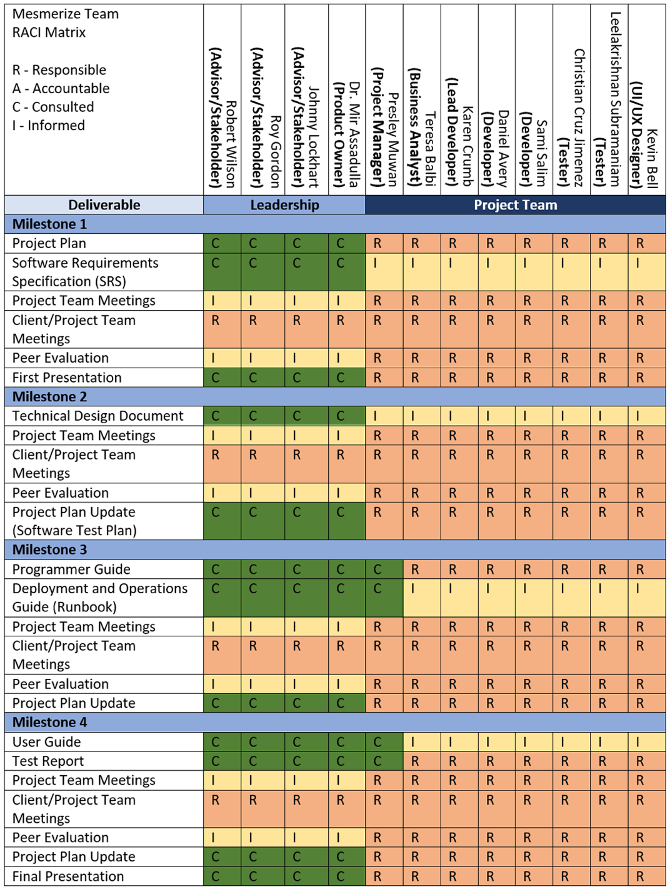

## Project Tools

Table 9 details the tools used to complete this project.

**Table 9**

*Project Tools*

|  |  |
| --- | --- |
| **Tool** | **Description** |
| Adobe XD | Adobe XD is a vector-based experience design platform that will be used to design visual elements of the application before it is coded. |
| Android Studio | An integrated development environment (IDE) built for the development of applications for Android devices. |
| App Store | An Apple mobile application store for iOS operating systems. |
| Dart | A programming language used to develop the application at an accelerated pace. Dart is like other languages like Java and C# which will be an easy adjustment for the developers. |
| Flutter | An open-source UI software development kit developed by Google used to build iOS and Android applications. Flutter uses Dart as its language for cross-platform development. |
| GitHub | A repository hosting service that allows the Team to organize, share and edit the code for the project from anywhere. |
| Google Play Store | A Google mobile application store for Android devices. |
| Microsoft Teams | A workplace integration platform developed by Microsoft that allows the Team to communicate through chat, videoconferencing, and file sharing. |
| Microsoft Word | A word processor created by Microsoft will allow the project team to prepare documentation to be shared to create a proper plan for each phase of the project. |

## 

## Project Storage

The project documents will be stored using the files created within Microsoft Teams. This will give Team Mesmerize the information needed to develop the application through code which will be stored in the GitHub repository.

## Deliverables

Team Mesmerize will need to complete four milestones to successfully deliver the application to the product owner. Deliverable milestones are shown on Table 10. Milestone One will contain the Project Plan and Software Requirements Specification (SRS), which will explain the requirements and resources needed to complete the project. Milestone Two will contain the Technical Design Document and a Software Test Plan that will be added to the Project Plan. Milestone Three will consist of a Programmer Guide, Deployment and Operations Guide (Runbook), and an updated Project Plan. Milestone Four will contain a User Guide, Test Report, and updated Project Plan. The final version of the application will be presented to the product owner and stakeholders.

**Table 10**

*Deliverables*

|  |  |  |
| --- | --- | --- |
| **Deliverable** | **Description** | **Due Date** |
| **Milestone 1** |  | **August 31, 2021** |
| Project Plan | A document that describes what is required to successfully execute, monitor, control, and close the project. |  |
| Software Requirements Specification (SRS) | A document that specifies what is required to develop the application and how it should be done. |  |
| **Milestone 2** |  | **September 14, 2021** |
| Technical Design Document | A document that describes the minute details of the entire application design. |  |
| Project Plan Update (Software Test Plan) | An updated Project Plan, which include adding the Software Test Plan. |  |
| **Milestone 3** |  | **October 19, 2021** |
| Programmer Guide | A guide intended for future programmers working with the software developed by the Team. |  |
| Deployment and Operations Guide (Runbook) | This Runbook should guide deployment and operation of the application. |  |
| Project Plan Update | Any necessary changes made to the Project Plan. |  |
| **Milestone 4** |  | **November 2, 2021** |
| User Guide | A guide intended for future users of the application as an aid to working the application successfully. |  |
| Test Report | A summary of testing results, activities, and objectives. |  |
| Project Plan Update | Any necessary changes made to the Project Plan. |  |
| Completed Functioning Application | Memory Magic Application is complete and provides a working software. |  |

## Project Schedule/WBS

The project schedule has a complete list of the project milestones, activities, and deliverables. It is a WBS deliverable-oriented breakdown of the project to give the PM and project Team a visual of the timelines and deadlines to complete each phase of the project on time. The WBS will be represented as a Gantt chart. The WBS (Gantt chart) is displayed in Appendix 6.1.

# Software Test Plan

## Goal

The goal of this test plan is to ensure that all promised deliverables have been met and that the features that have been specified within are created to specification. All members of the team have a unique role in ensuring that delivery meets certain quality standards.

Having already defined the features, this test plan is the main focus of quality control and quality assurance. The reputation of the application relies heavily on core features working exactly as intended - and by providing tests that exemplify that, we can proceed to the next stage of the Software Development lifecycle.

## Roles and Responsibilities

Daniel, Sami, Karen (Developers) - The developers are responsible for creating unit tests for their work. All publicly exposed functions shall be unit tested to an accuracy of 80% code coverage, as determined by the code linter enabled by the DevSecOps Team.

Kevin, Christian (QC) - The quality control agents are at the heart of the integrity of the deliverables. They are responsible for developing and writing ALL types of tests as needed and detailed below.

Presley (Project Manager) -Ensures that the deliverables are on schedule and assists with technical knowledge with all team members as needed.

Teresa (Business Analyst) - This individual shall act as the go between the technical minded folks and the outside stakeholders – to ensure that they are receiving feedback that their product demands are being met.

DevSecOps - DevSecOps team shall be responsible for enabling static analysis on the Github repository.

## Test Matrix

The following Test Matrix shall be utilized to confirm that the proper tests have been implemented and that all features are working as intended.

### Unit Tests

|  |  |  |
| --- | --- | --- |
|  | **iPhone** | **Android** |
| **General Tests:** |  |  |
| 1. **Application Opens Up**   Success case: Wait for the “Speak” button to appear which means that the application has successfully opened. |  |  |
| 1. **From any page, click Calendar**   Success case: Wait for anticipated elements to appear. |  |  |
| 1. **From any page, click on Settings**   Success case: Wait for anticipated elements to appear. |  |  |
| 1. **From any page, click on Notes**   Success case: Wait for anticipated elements to appear. |  |  |
| 1. **From any page, click on Home**   Success case: Wait for anticipated elements to appear. |  |  |
| 1. **From any page, click on Bell**   Success case: Wait for anticipated elements to appear. |  |  |
| 1. **From any page, click on Mic**   Success case: Wait for anticipated elements to appear. |  |  |
| **Home Screen:** |  |  |
| 1. Click on “Speak”   **Success case: Mic screen will appear.** |  |  |
| 1. Click on “Text”   Success case: Enter a note by text screen will appear. |  |  |
| **Mic Screen:** |  |  |
| 1. Click on “Press to Record (Mic)”   Success case: Speak dialog appears. |  |  |
| **Menu Screen:**   1. Click on sync to cloud   Success case: Enter state for enabling sync to cloud. |  |  |
| 1. Click on trigger   Success case: Wait for anticipated elements to appear. |  |  |
| 1. Click on general setting   Success case: Wait for anticipated elements to appear. |  |  |
| 1. **Click on help**   Success case: Wait for anticipated elements to appear. |  |  |
| **Note Screen:** |  |  |
| 1. Search for note – no results   Success case: No results appear. |  |  |
| 1. Search for a note - results   Success case: Searched for note will appear. |  |  |
| 1. Modify text after search note   Success case: Note is updated. |  |  |
| 1. Click on “Add A Note”   Success case: Wait for anticipated elements to appear. |  |  |
| **Delete a Note Screen** |  |  |
| 1. Click on Delete Note   Success case: Note is deleted from datastore. |  |  |
| 1. Click on Cancel |  |  |
| **Edit a note Screen** |  |  |
| 1. Click on Save Changes   Success case: Note is saved in datastore. |  |  |
| 1. Click on Cancel Changes   Success case: Note is not saved in datastore. |  |  |
| **Trigger Screen** |  |  |
| 1. Change all inputs and save   Success case: Triggers are saved in datastore. |  |  |
| 1. Change all inputs and cancel   Success case: Triggers are not saved in datastore. |  |  |
| **Sync to Cloud Screen** |  |  |
| 1. Mock login to google cloud   Success case: After mock response, user is linked to google cloud |  |  |
| **General Setting Screen** |  |  |
| 1. days to keep notes and save   Success case: Settings are updated for the user |  |  |
| 1. Change font size notes   Success case: Settings are updated for the user |  |  |
| 1. Change font size menu |  |  |
| Success case: Settings are updated for the user |  |  |
| 1. Change language from English to Arabic   Success case: Settings are updated for the user |  |  |
| 1. Change language from English to Arabic back to English, then save   Success case: Settings are updated for the user |  |  |
| **Security Setting Screen** |  |  |
| 1. Setup fingerprint   Success case: Settings are updated for the user |  |  |
| 1. Reset fingerprint |  |  |
| Success case: Settings are updated for the user |  |  |
| 1. Press Cancel Button   Success case: State is unchanged |  |  |
| **Calendar Screen** |  |  |
| 1. Click a calendar event   Success case: Wait for anticipated elements to appear. |  |  |

### Integration Tests

`

|  |  |  |
| --- | --- | --- |
|  | **iPhone** | **Android** |
| **Integration with NLU (Team B):** |  |  |
| 1. Application handles successful response from NLU API.   Success case: Obtain desired response. |  |  |
| 1. Application handles all non-success responses from NLU API.   Success case: Error is handled gracefully |  |  |
| **Integration with Google Drive:** |  |  |
| 1. Application handles successful link with Google API   Success case: Profile is linked |  |  |
| 1. Application handles unsuccessful link with Google API   Success case: Error is handled gracefully |  |  |

### E2E

Full-system, end-to-end (E2E) smoke tests shall be created for common use cases to ensure intended functionality as well as serve as a safeguard in the case of regression of a feature that has already been integrated into the system.

After development of the application, the Quality Control team shall put together a list of E2E tests that demonstrate full functionality of a feature set that a typical user would take to interact with the application.

## Static Analysis

Static analysis shall be completed on the application to ensure that any glaring issues shall be rectified before ultimate delivery of the application.

This includes but is not limited to the Static Analysis features that may be available on Github.com, as well as any third-party tools the team deems necessary to ensure that the code is free of any major errors or bad syntax that may lead to exploits.

# Appendices

## Project Schedule/WBS

**Figure 3**

*Project Schedule*

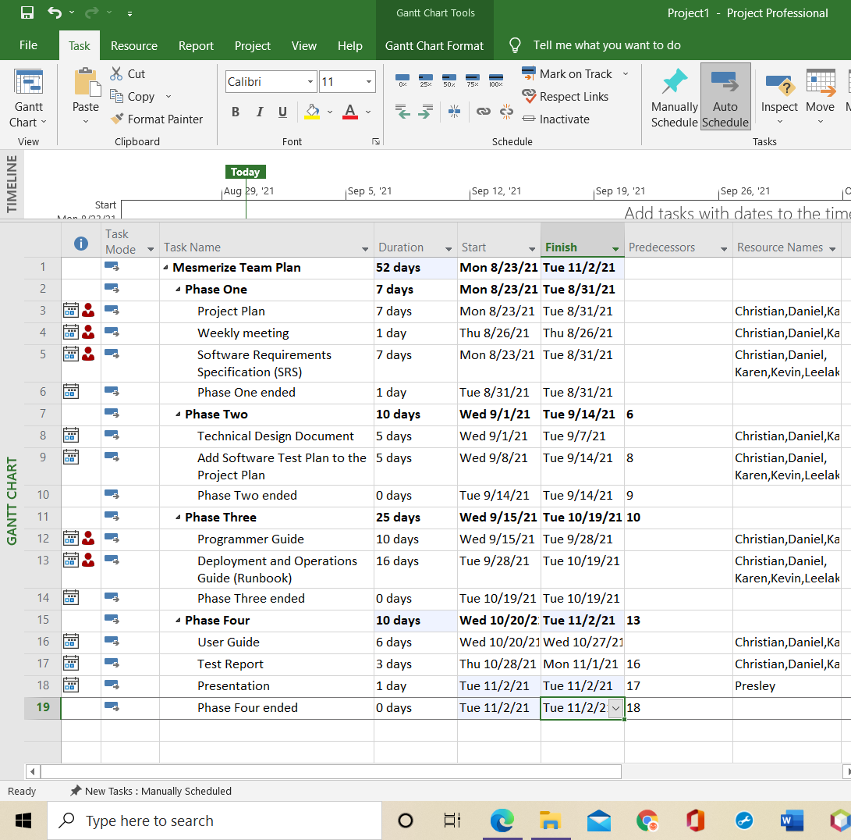

**Figure 4**

*Members Schedule*

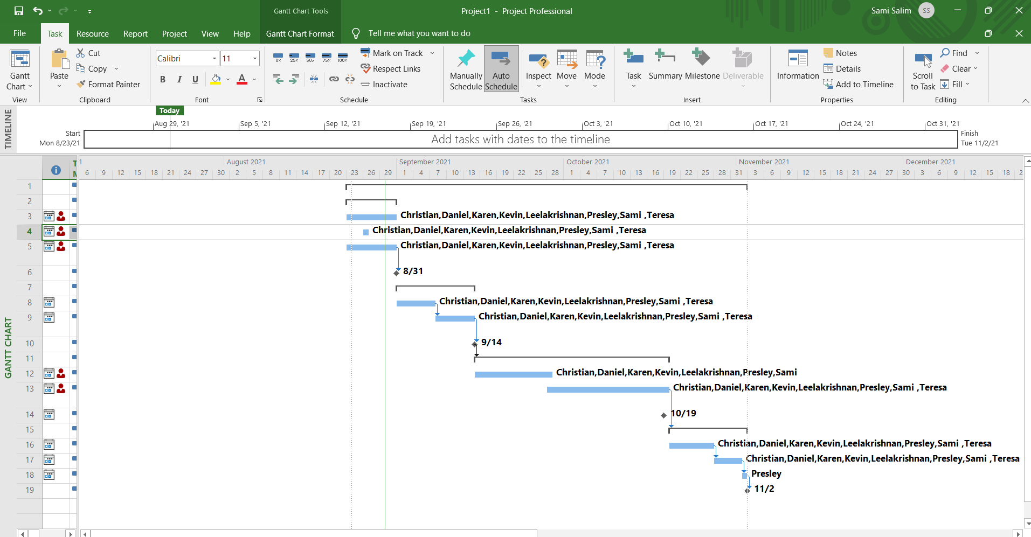

## Credits

Below are the members that contributed or will contribute to the development of this application:

* Dr. Mir Mohammed Assadullah
* Roy Gordon
* Johnny Lockhart
* Jeroen Soeurt
* Michelle Monfort
* Robert Wilson
* Ayodeji Famudehin
* Chauntika Broggin
* Christian Ahmed
* Mitchell Olshansky
* Mod Drammeh
* Nicholas Ballo
* Shawn Kelly
* Raul Benavides
* Maddison Dunning
* Alec Baileys
* Benjamin Cushing
* Elshaday Mesfin
* Tyler Puschinsky
* Michael Le
* Debashis Jena
* Austin Johnson
* Prince Antwi Aboagye
* Didimus Kimbi
* Damion Sevilla
* Rebecca Johnson
* Addisu Worku
* Matthew Setiawan
* Obinna Okonkwo
* Andrew Rohn
* Joseph Kalfus
* Firehiwot Chari
* Eskedar Endashw
* Malik Webster
* Leela Subramanian
* Presley Muwan
* Christian Cruz Jimenez
* Daniel Avery
* Karen Crumb
* Kevin Bell
* Sami Salim
* Teresa Balbi
* Endalkachew Girma

## References

References

American Psychological Association. (2019) *The publication manual of the American Psychological Association*. 7th ed. Washington, D.C. American Psychological Association.

Atlassian. (n.d.). Agile tools for software teams. In *Jira Software*. Retrieved from https://www.atlassian.com/software/jira/agile

Baars, W. (2006). *Project management handbook*. Hague, Netherlands: Data Archiving and Networked Services. Retrieved from https://learn.umgc.edu/d2l/le/content/609389/viewContent/22442926/View

Baileys, A., Benavides, R., Cushing, B., Dunning, M., Mesfin, E., & Puschinsky, T. (2021, June 19). Project plan: Harkify. *University of Maryland Global Campus*.

Brown, M. (2020, March 24). Capstone project guide. In *SWEN 670*. Retrieved from https://learn.umgc.edu/d2l/le/content/609389/viewContent/22442920/View

Cherry, K. (2021, April 25). What is short-term memory?. In *Verywell Mind*. Retrieved from https://www.verywellmind.com/what-is-short-term-memory-2795348

Developers. (2021, August 26). Everything you need to build on Android. In *Android Studio*. Retrieved from https://developer.android.com/studio/features

Famudehin, A., Broggin, C., Ahmed, C., Olshansky, M., Drammeh, M., Ballo, N., & Kelly, S. (2021, July 24). Project Plan: Memory enhancer application. *University of Maryland Global Campus*.

Get pay right. (n.d.). In *Salary.com*. Retrieved from https://www.salary.com/

Gisclard-Biondi, H. (2021). The Risk Management Lifecycle Explained: 5 Steps to Managing Risks. *Appvizer.* Retrieved from https://www.appvizer.com/magazine/operations/project-management/risk-management-lifecycle

Hello world. (2020, July 24). In *GitHub Guides*. Retrieved from https://guides.github.com/activities/hello-world/

Le, M., Jena, D., Johnson, A., Aboagye, P. A., Kimbi, D., & Sevilla, D. (2021, August 6). Project plan: Mnemosyne, Disability Mobile Application. *University of Maryland Global Campus*.

Rae, M. (2020, October 26). What is Adobe XD and what is it used for?. In *Adobe.com*. Retrieved from https://www.adobe.com/products/xd/learn/get-started/what-is-adobe-xd-used-for.html

Small, G. W. (2002, June 22). What we need to know about age related memory loss. *BMJ*, *324*(7352), 1502-1505. Retrieved from https://www.ncbi.nlm.nih.gov/pmc/articles/PMC1123445/

SWEN 670 9040 Software Engineering Project (2218). (n.d.). In *University of Maryland Global Campus*. Retrieved from https://learn.umgc.edu/d2l/home/609389

Szeja, R. (2021, March 26). Is Flutter a programming language?. In *Netguru*. Retrieved from https://www.netguru.com/blog/is-flutter-a-programming-language

Weir, M. (2020, November 18). What is Microsoft Teams? Here's what you need to know about the workplace communication

tool. In *Insider*. Retrieved from https://www.businessinsider.com/what-is-microsoft-teams

Yahnke, K. (2018). How to Use a Risk Assessment Matrix. *i-Sight.* Retrieved from https://i-sight.com/resources/risk-assessment-matrix/