Presented by Team Mesmerize

Presley Muwan, Karen Crumb, Kevin Bell, Teresa Balbi, Sami Salim, Daniel Avery, Leelakrishnan Subramaniam, Christian Cruz Jimenez  
  
UMGC SWEN 670

project plan

MEMORY MAGIC APP

Project name: Memory Magic Application.

Date: August 30, 2021

Project Manager: Presley Muwan

Phase: Project Planning

Revision History

|  |  |  |  |
| --- | --- | --- | --- |
| Revision Number | Date | Description | Approved By |
| 1.0 | 06/11/2021 | Initial Release | Presley Muwan |

Table of Contents

1 General Information 4

1.1 Background 4

1.2 Statement of Need 4

1.3 Vision Statement 4

2 Project Assignment 4

2.1 Project Scope 7

2.1.1 Project Objectives 7

2.1.2 Project Requirements 7

2.2 Project Assumptions 8

2.3 Product Approval/Acceptance Criteria 8

2.4 Project COST 8

2.5 Acronyms and Abbreviations 9

3 Risk Analysis 9

3.1 Risk Framework 9

3.2 Risk Assessment 10

3.3 Application Risks and Vulnerabilities 11

3.4 Risk Matrix 12

3.5 Risk Register 12

4 Organization of the project 13

4.1 Communication 13

4.2 Explanation of the methodology 14

4.3 Project Staffing 14

4.4 Roles and responsibilities 14

4.5 Responsibility Assigned Matrix 16

4.6 Project Tools 17

4.7 Project Storage 17

4.8 Deliverables 17

4.9 Project Schedule/WBS 18

5 Software Test Plan 18

6 Appendices 18

6.1 6.1 Project Schedule/WBS 19

6.2 References 20

# General Information

## Background

Short-Term Memory (STM), also known as active memory, can be explained as the brain's ability to store small amounts of information while keeping it readily available for a short period of time, normally 20-30 seconds in length and/or seven items, plus or minus two (Cherry, 2021). STM plays a critical function in shaping a human's ability to interact with the world. However, a few factors can influence STM, such as dementia, Alzheimer's, and age. In the United States, about 16 million people over 65 years old have shown signs of STM loss, and about 15% of them may develop dementia or Alzheimer's disease (Small, 2002). To assist individuals with STM issues, United Global Masters Coders recommends the development of a mobile application that recognizes users' speech, allows them to create reminders, and customize phrases to facilitate their lives despite STM concerns.

## Statement of Need

The purpose of this project is to combine Team Mesmerize own features and the best features developed by Team Amazing, Team Bravo, and Team Charlie to create a complete Memory Magic App for people with STM concerns. To meet the business need, the Memory Magic App will satisfy the demand for this underserved market by providing an efficient solution for individuals with STM issues.

## Vision Statement

The vision for United Global Masters Coders is to combine Team Mesmerize cloud support, security feature, and support for Spanish with the best features from Team Amazing, Team Bravo, and Team Charlie to develop the finest personal speech recognition application for individuals suffering from STM issues.

# Project Assignment

The project shall use the SMART tool, which stands for Specific, Measurable, Achievable, Realistic, and Time. The table has divided the meaning of SMART, making it easier for the reader to grasp its matrix and system.

**Measurable** will track project goals and assess the effectiveness of the short-term memory aid mobile application.

**Achievable** will work hard to meet the project's success criteria.

**Realistic** means that the aims and objectives are achievable and that the objectives' outcomes may lower the total project plan.

**Time** is the most practical option for addressing the problem within a deadline/milestone (Project-Managment.com, 2019).

Overall, the SMART tool is comparable to project management in that it establishes guidelines to meet the following goals: scope, money, and time.

Table 1 – SMART Goals

|  |  |
| --- | --- |
| Specific | Memory Magic app shall do the following things:   * Ask for the user's permission to record voice. * Speech to text converter. * Save the notes with the date. * The user shall edit or delete notes. * The user shall type a note, have an option to search notes via the search bar, save personal details such as phone numbers or medications, search keywords using voice commands, or search bar. * The user shall use start and stop as trigger words for a start, stop. Recall can look at notes using keywords. * UI shall have large icons for easy viewing. * The App shall support Spanish language speakers. * Cloud support – enabling cloud storage, so the users don't worry if they lose their devices or need to access notes from another device. * Security feature – users can opt to create security passphrases required to access their notes, ensuring privacy. * The application shall keep track of event dates and times and remind the users, within a one-hour interval, when the event is due. |
| Measurable | To create the mobile application, Memory Magic shall use Scrum Methodology. A prototype/ progress shall fulfill the high-level criteria at the end of each Sprint/Weekly meeting. |
| Achievable | The Team has completed each job and role for the Team after assessing the PM and team members. For example, memory magic comprises three Software Developers, two Dev Tester, one UI/UX Designer, one Business analyst, and a Project Manager. Understanding each position allows each team member to work concurrently to implement the solution efficiently. A software developer, for example, sets a functional feature need. Before going to the next set of requirements, the Team's tester should test that feature and confirm it operates correctly.  Similarly, PMs define tasks, schedules, and plans to keep the Team on track. Business analysts strive to collaborate with everyone, including members and consumers, to ensure the project's success. Roles can also be interchangeable. For example, Dev testers can pick up on tickets and work on them. The application shall integrate with NLU web services developed by the Tongue Twisters team. |
| Realistic | Dr. Mir Assadullah launched the project, and PM and the Team came up with the app's initial requirement. After completing the Software Engineering Project courses after the semester, the Memory Magic mobile application shall satisfy the demand for this underserved market by providing an efficient solution for individuals with STM issues. |
| Time | The memory Magic team's Project manager has established a milestone for each step. The project can be divided into three phases: planning, design, engineering, and implementation. Its goal is to ensure that the finished product is satisfactory before giving it to the client. The mobile application shall be available after the semester's eleven weeks. |

## Project Scope

The Memory Magic's Project Plan scope includes the Planning Phase, Design & Engineering Phase, and Execution Phase.

### Project Objectives

The planning phase is when the Memory Magic team shall gather the vision statement, business needs statement, object, and objective requirements, a Project Management and Business Analyst (BA) Statement of Work (SOW) shall be established. A communication strategy within the Team is formed. Next, software developers and testers write code to create prototypes that meet the requirements during the design and engineering phases. Finally, the execution step involves finalizing a finished product, deploying an app, and delivering it to the client.

### Project Requirements

The Project requirements consist of functional and non-functional requirements.

Functional Requirements:

* The application shall have large icons to make them easier to find by those with memory issues. The system shall check if all necessary permissions to resources are granted.
* The application shall listen for the start phrase and transcribe the user's speech. The application shall allow the users to edit and update text.
* The application shall allow the user to add a new note as well as delete it.
* The application shall allow the user to sort a list of notes by date and group the notes by subject category.
* The application shall have a search option in which the user can enter keywords or dates. The application shall have a help area that shall be linked from any screen in the application.
* The application shall have a storage setting that the user may use to set up cloud storage with their google account.
* The application shall have a setting to save a Passphrase, which shall be required to access the user notes, ensuring privacy.
* The application shall have a language settings option.
* The default option shall be English, with the alternate option as Spanish, which helps Spanish language speakers.
* The application shall keep track of event dates and times and remind the users, within a one-hour interval, when the event is due.
* Nonfunctional Requirements:
* · UI responses to user interaction shall not exceed 3 seconds.
* All external communication shall be encrypted.
* The application shall not require user authentication but shall have an option for the users to secure their notes with a passphrase.
* The system shall comply with 508 specifications to ensure that it is easy to use by individuals with a disability.
* Users who enable cloud storage shall access their backed-up notes from any device connected to the internet.
* The users shall have the option to back up their notes on google cloud.

Work within the PM's scoping strategy is as follows:

* Agile project methodology shall be used for the project.
* The Flutter and Dart SDKs shall be available for free download as open-source from the internet.
* The overview information for tracking team progress and assigning team member duties shall be visible in the MS Project and Github platform.
* The code shall be distributed on Github in branches so that team members may readily access it.
* The code shall be merged into main branches and compiled for submission by DevSecOps (DSO).
* Testing shall be placed concurrently with development to ensure that the minimum attainable criteria are met.

## Project Assumptions

The following are the project assumptions:

* Memory Magic shall strive to meet the original outline need, which is dependent on the approach of software developers and researchers to identify the best solution.
* The PM shall allocate tasks to team members depending on their roles.
* Milestone deliverables date shall not change.
* The PM and BA shall check the project's health weekly to stay on track.

## Product Approval/Acceptance Criteria

This document shall detail the project Milestones in specified deliverable dates. This project shall have four Milestones that Memory Magic Team should complete. The following individuals: Dr. Mir Assadullah shall rate each Milestone deliverable. Milestone 1, which comprises the Project Plan and Software Requirements Specifications, shall be altered if future development does not meet the professor's requirements or an approval/acceptance response is not received.

In the Agile methodology employed by the memory magic team, changes to the project are inevitable. When the changes are identified, the development team determines the scope of the change, including various factors such as risks involved and level of efforts. Once the initial analysis is completed, the team works with the Project Manager to communicate the related changes to The Tongue Twisters Team and DevSecOps team to see any potential changes to their integrations. The information obtained is presented to the stakeholders to prioritize the change. Once the changes are agreed upon, all related documents are updated to represent the change, including the history. Finally, the potential changes are communicated to all the teams. Microsoft teams and emails are primarily used for communication to make sure all the teams are in sync.

## Project COST

The memory Magic team might not spend any money on the software to develop the app, and the project does not require any hardware acquisition or installation. The estimated costs are shown below in Table 2. The prices are calculated on the cost of labor alone, approximately 3 hours a day, 5 days a week, for 12 weeks (hourly rate shown in bulleted list*).

* Project Manager: $63.00hr
* Business Analyst: $40.00hr
* Lead Developer: $55.00hr
* Developer (3): $45.00hr
* Tester (2) $35hr

*Hourly rates found on salary.com

Table 2: Project Costs

Labor is estimated based on a 3hr workday, 5 days a week on a 12 week-long project.

|  |  |
| --- | --- |
| Category | Total Estimated Costs |
| Labor | $65,340 |
| Software | $0 |
| Hardware | $0 |

## Acronyms and Abbreviations

|  |  |
| --- | --- |
| Acronyms and Abbreviations | Definitions |
| PM | Project Manager |
| BA | Business Analyst |
| DSO | DevSecOps |
| STM | Short Term Memory Loss |
| WBS | Work Breakdown Structure |
| UI | User Interface |
| NLP | Natural Language Processing |
| NLU | Natural Language Understanding |
| RT | Regression Testing |
| OS | Operating System |
| LEO | UMGC online platform class |
| SMART | Specific, Measurable, Achievable, Relevant/Realistic, and Time-bound are the acronyms for SMART tools. It is used to establish the aims and objectives of a project. |

# Risk Analysis

## Risk Framework

This Risk Analysis will follow the framework indicated in this section to keep a consistent process through the life of the project. Keeping consistency when addressing risk is vital to anticipate adverse events that could negatively impact the project. Being able to develop alternative solutions to reach your objectives under all circumstances is the most important challenge in risk management (Gisclard-Biondi, 2021). The framework presented below is based on the lifecycle of risk management.

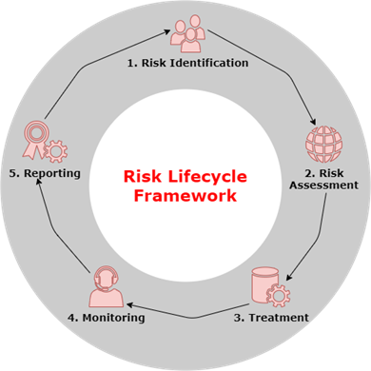

* + - 1. Risk Identification
         * Identify risks early in the project
         * List the different risks identified
         * Define their characteristics
    1. Risk Assessment
       - * Assess the risk level based on the possible impact
         * Consider the probability of occurrence
         * Assign degree of importance and priorities
    2. Treatment
       - * Develop and assign a risk mitigation plan based on control strategies
         * Avoid the risk
         * If the risk can't be avoided, mitigate the adverse effect produced
    3. Monitoring
       - * Monitor the risks throughout the project lifecycle
         * Update the Risk Register regularly
    4. Reporting
       - * Keep and save the analysis record to make it available for future projects

## Risk Assessment

The purpose of this risk assessment is to identify, evaluate, prioritize, and develop a mitigation plan for the possible risks associated with the project. The objective is to create a collaborative effort to reduce or eliminate future risks in the project at soon as possible by creating awareness of what could happen and how the objective of the project could be affected. Each risk identified will be prioritized based on the possible impact on the scope and outcome of the project to provide the team members a visualization of what risk the project could take and which one should be avoided. To assist with the analysis of this assessment, a risk matrix, and a risk register will be created to facilitate the identification and understanding of possible risks. This assessment will be updated throughout the life of the project if necessary.

## Application Risks and Vulnerabilities

This section of the risk assessment will consider the risks, vulnerabilities, and threads related to the Magic Memory application. The two main focuses of this assessment will be to identify the risk associated with the probability of losing a part of the system and the vulnerabilities of the system that could allow intrusion into the system's information and integrity. The table below will discuss some of the application risks and vulnerabilities.

Application risk and vulnerabilities

|  |  |  |  |
| --- | --- | --- | --- |
| Risk ID | Risk Summary | Vulnerability | Threat |
| 1 | Misalignments in the operating system (OS) and/or firmware of the device | The application's security features are not aligned with the updates and patches on the device OS | Information exposure |
| 2 | Reliability of the voice recognition engine. | Incorrect voice recognitions could compromise the main features of the application | Application crashes / Application functionality |
| 3 | Application dependencies from external services could limit the application features | The application could not function as designed if the external services are compromised | Service denial / Loss of availability |
| 4 | Improper application configuration | Improper configuration could prevent the application to function as designed and could compromise key features | Loss of availability |
| 5 | The application has different behaviors depending on the platform being used | Platform dependency could present improper results and/or outputs not expected by the user | Variation in outputs / Cross platform availability |
| 6 | Ability to protect and secure the notes saved into the system | The user could have sensitive, confidential, or Personal Identifiable Information (PII) information on the notes that could be exposed to unauthorized persons | Application integrity / Data loss |
| 7 | Inconsistencies between the recording speech and the note transcriptions | Inconsistent transcriptions of the notes could compromise some features of the application | Data Inconsistency |

## Risk Matrix

The risk assessment matrix helps to identify and evaluate the threats and risks of a specific situation (Yahnke 2018). To provide a better understanding of the likelihood that an event will occur and the severity/impact of the consequences, a risk matrix, and a risk register will be developed in the following sections.

The risk matrix is organized as follow:  
 The likelihood or probability of occurrence in the "Y" axis  
 The risk impact of the event on the "X" axis

Risk Matrix

|  |  |  |  |  |  |  |
| --- | --- | --- | --- | --- | --- | --- |
| Impact | | | | | | |
|  | | Negligible | Minor | Moderate | Significant | Severe |
| Likelihood | Very Likely | **5** | **10** | **15** | **20** | **25** |
| Likely | **4** | **8** | **12** | **16** | **20** |
| Possible | **3** | **6** | **9** | **12** | **15** |
| Rare | **2** | **4** | **6** | **8** | **10** |
| Unlikely | **1** | **2** | **3** | **4** | **5** |

## Risk Register

This risk register will identify and analyze the probable threats in the life of this project. The intention is to help the project team to understand the importance of each identified risk and enable them to address the risk efficiently. The risk register will identify the risk and provide a description, assign a probability of occurrence, assign a risk owner, and a mitigation action plan.

Risk Register

|  |  |  |  |  |
| --- | --- | --- | --- | --- |
| Risk ID | Risk Description | Probability of Occurrence | Risk Owner | Mitigation Plan |
| R1 | Project scope, purpose, and need are not well defined | Possible - 9 | PM | Identify and understand the project scope and the customer's need at the beginning of the project and throughout the life of the project. |
| R2 | Insufficient team knowledge to deliver the required product | Unlikely - 2 | PM | Identify the strength and weaknesses of the team members and assign tasks accordingly. |
| R3 | Misunderstanding and incomplete requirements | Rare - 4 | PM | Assign multiple checkpoints during the project life to vet the work with stakeholders. |
| R4 | Milestones are not reached | Possible - 6 | PM | Hold weekly meeting touchpoints with the Team and discuss work plans for the week. |
| R5 | Missing or incorrect tools to develop the product | Rare - 4 | PM/Developer | Identify the required tools and equipment at the beginning of the project and plan accordingly with stakeholders. |
| R6 | Team members availability | Unlikely - 2 | PM/Team Members | Maintain good communication with the team members and identify member's availability on a routine basis. |
| R7 | System development and integration complexity | Possible - 9 | Developers | Identify system complexity at the early stages of the project and discuss it with the Team. Set priorities for each complexity. |

The risk register shall be used every time a possible risk is identified. If the risk has been identified in the risk register, the owner should be aware of the situation and the mitigation plan should be executed. If the risk has not been identified in the risk register, a risk assessment shall be conducted and the risk register shall be updated with the new assessment.

# Organization of the project

Team Mesmerize will sort project tasks using the Agile methodology and apply the lightweight framework of Scrum. There will be short sprints to complete tasks and meetings twice a week. The Team will otherwise communicate through Microsoft Teams so that all required tasks are understood between all team members. GitHub will be used to keep track of the development of the project, and other documentation will be saved in Microsoft Teams files.

## Communication

The project team will communicate mostly through Microsoft Teams and email. Microsoft Teams gives the project team the ability to communicate in multiple ways such as group chat, personal messages, meetings, and file sharing. Project team members will be signed into their Microsoft Teams account during working hours so they will be able to receive notification from team members as they are delivered. All team members will utilize Microsoft Teams and respond to all messages so the Team will meet all milestone goals.

The Team will have teleconference meetings every Monday and Thursday through Microsoft Teams to discuss current progress and what is required going forward. Since team members are not limited to one responsibility, this is a good time to communicate where assistance may be needed from others to complete tasks. Team Mesmerize will also have Microsoft Teams teleconference meetings with the product owner and other shareholders the Saturday after each milestone to understand what is required for the next milestone and an opportunity to openly communicate.

The PM will set up a GitHub project folder, and Microsoft Teams folder where work can be updated, but only one member can edit individual files at a time. There will be clear communication of what is being updated, and permission will be requested to edit information created by another member.

## Explanation of the methodology

The Scrum framework of the Agile methodology differs from traditional methodologies. Work will be broken into goals that can be completed in time-boxed sprints of two weeks. The Team will hold daily scrum meetings for less than 15-minutes, which will allow them to review the progress of the sprint. When a sprint is completed, information is collected and reviewed to know what should be prioritized in the next sprint.

## Project Staffing

Team Mesmerize has a capable staff that includes a PM, a business analyst, a lead developer, two developers, a tester, and a UI/UX developer. All team members have well-rounded skills and will support each other with their responsibilities.

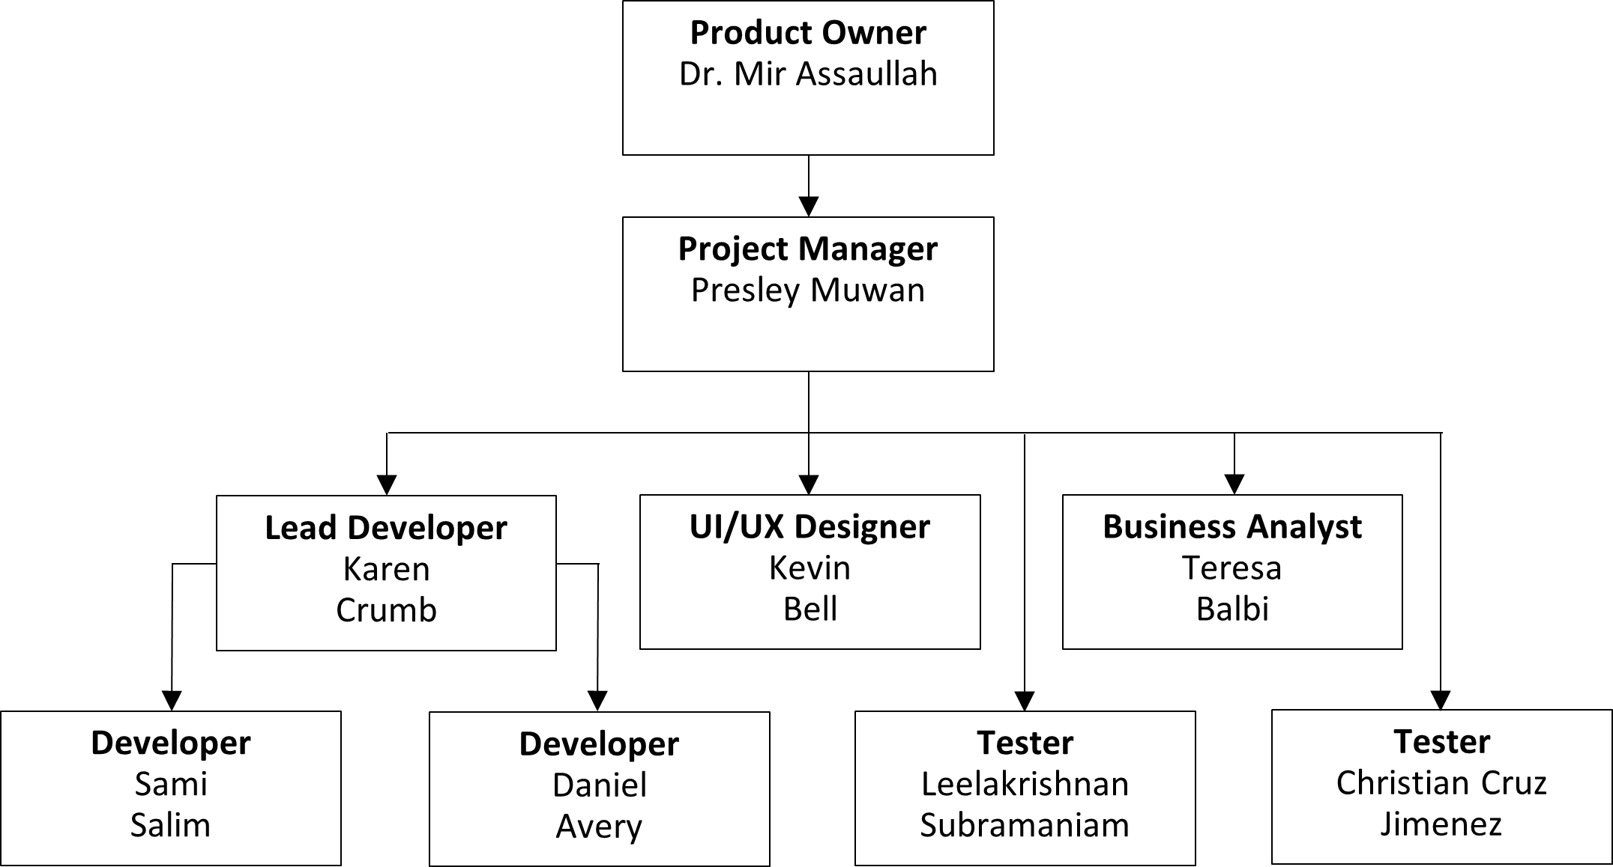

## Roles and responsibilities

Each member's responsibilities for the project are listed below. Even though each member is responsible for their specified roles, they can assist other members at any given time to ensure the successful completion of the project.

|  |  |  |
| --- | --- | --- |
| **Role** | **Member(s)** | **Responsibilities** |
| Project Owner | Dr. Mir Assadullah | Ensures the project team knows the intended purpose of the application and the audience who will use it. They will communicate with the PM to make sure they are not misguided during the process. |
| Project Manager | Presley Muwan | Plans and monitors the project to ensure its successful completion. Assists team members in their roles and leads them in understanding their responsibilities. |
| Business Analyst | Teresa Balbi | Uses research and data analytics to ensure the project meets the requirements for successful completion. |
| Lead Developer | Karen Crumb | Works closely with the development team to build the application and divides up the responsibilities. Leads development meetings to review the code and ensure the application is functioning properly. Directly shares progress with the PM and the project team. |
| Developer | Daniel Avery  Sami Salim | Responsible for coding, designing, developing, and debugging the application for mobile use. |
| Tester | Christian Cruz Jimenez  Leelakrishnan Subramaniam | Evaluates the developers' project work and create manual and automated tests to ensure the project has no bugs and functions properly based on the requirements. |
| UI/UX Designer | Kevin Bell | Creates design mockups based on the requirements and research of intended users. Develops designs that are visually pleasing and show simplicity. |

## Responsibility Assigned Matrix

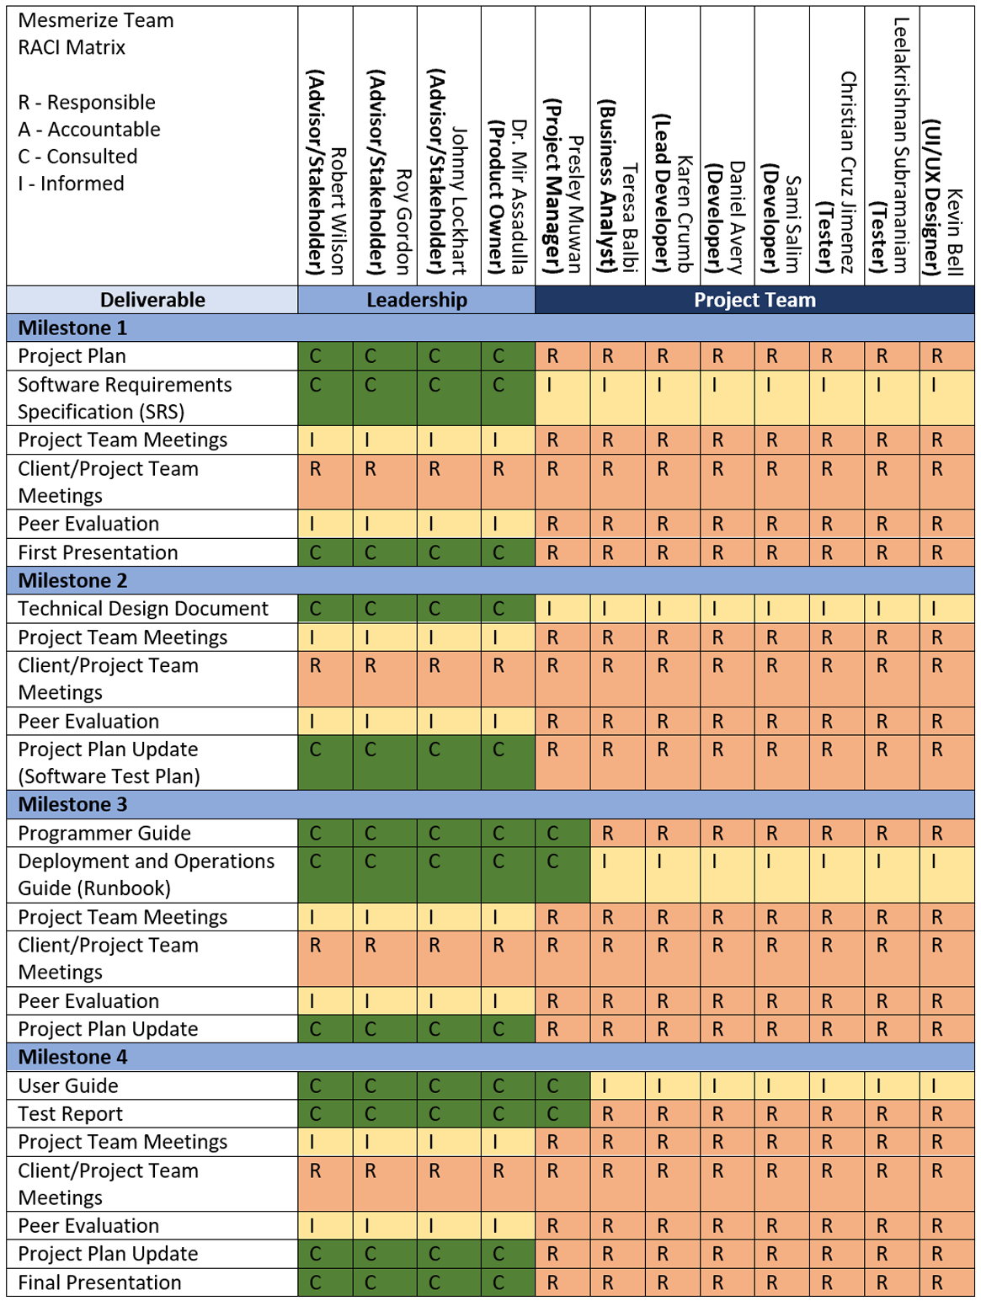

## Project Tools

The table below details the tools used to complete this project.

|  |  |
| --- | --- |
| **Tool** | **Description** |
| Adobe XD | Adobe XD is a vector-based experience design platform that will be used to design visual elements of the application before it is coded. |
| Android Studio | An integrated development environment (IDE) built for the development of applications for Android devices. |
| App Store | An Apple mobile application store for iOS operating systems. |
| Dart | A programming language used to develop the application at an accelerated pace. Dart is like other languages like Java and C# which will be an easy adjustment for the developers. |
| Flutter | An open-source UI software development kit developed by Google used to build iOS and Android applications. Flutter uses Dart as its language for cross-platform development. |
| GitHub | A repository hosting service that allows the Team to organize, share and edit the code for the project from anywhere. |
| Google Play Store | A Google mobile application store for Android devices. |
| Microsoft Teams | A workplace integration platform developed by Microsoft that allows the Team to communicate through chat, videoconferencing, and file sharing. |
| Microsoft Word | A word processor created by Microsoft will allow the project team to prepare documentation to be shared to create a proper plan for each phase of the project. |

## Project Storage

The project documents will be stored using the files created within Microsoft Teams. This will give the Team the information needed to develop the application through code which will be stored in the GitHub repository.

## Deliverables

Team Mesmerize will need to complete four milestones to successfully deliver the application to the product owner. Milestone One will contain the Project Plan and Software Requirements Specification (SRS), which will explain the requirements and resources needed to complete the project. Milestone Two will contain the Technical Design Document and a Software Test Plan that will be added to the Project Plan. Milestone Three will consist of a Programmer Guide, Deployment and Operations Guide (Runbook), and an updated Project Plan. Milestone Four will contain a User Guide, Test Report, and updated Project Plan. The final version of the application will be presented to the product owner and stakeholders.

|  |  |  |
| --- | --- | --- |
| **Deliverable** | **Description** | **Due Date** |
| **Milestone 1** |  | **August 31, 2021** |
| Project Plan | A document that describes what is required to successfully execute, monitor, control, and close the project. |  |
| Software Requirements Specification (SRS) | A document that specifies what is required to develop the application and how it should be done. |  |
| **Milestone 2** |  | **September 14, 2021** |
| Technical Design Document | A document that describes the minute details of the entire application design. |  |
| Project Plan Update (Software Test Plan) | An update made to the Project Plan, which will mainly include adding the Software Test Plan. |  |
| **Milestone 3** |  | **October 19, 2021** |
| Programmer Guide | A guide intended for future programmers working with the software developed by the Team. |  |
| Deployment and Operations Guide (Runbook) | This Runbook should guide deployment and operation of the application. |  |
| Project Plan Update | Any necessary changes made to the Project Plan. |  |
| **Milestone 4** |  | **November 2, 2021** |
| User Guide | A guide intended for future users of the application as an aid to working the application successfully. |  |
| Test Report | A summary of testing results, activities, and objectives. |  |
| Project Plan Update | Any necessary changes made to the Project Plan. |  |
| Completed Functioning Application | Memory Magic Application is complete. |  |

## Project Schedule/WBS

The project schedule has a complete list of the project milestones, activities, and deliverables. It is a WBS deliverable-oriented breakdown of the project to give the PM and project Team a visual of the timelines and deadlines to complete each phase of the project on time. The WBS will be represented as a Gantt chart. The WBS (Gantt chart) is displayed in Appendix 6.1.

# Software Test Plan

N/A

# Appendices

## 6.1 Project Schedule/WBS

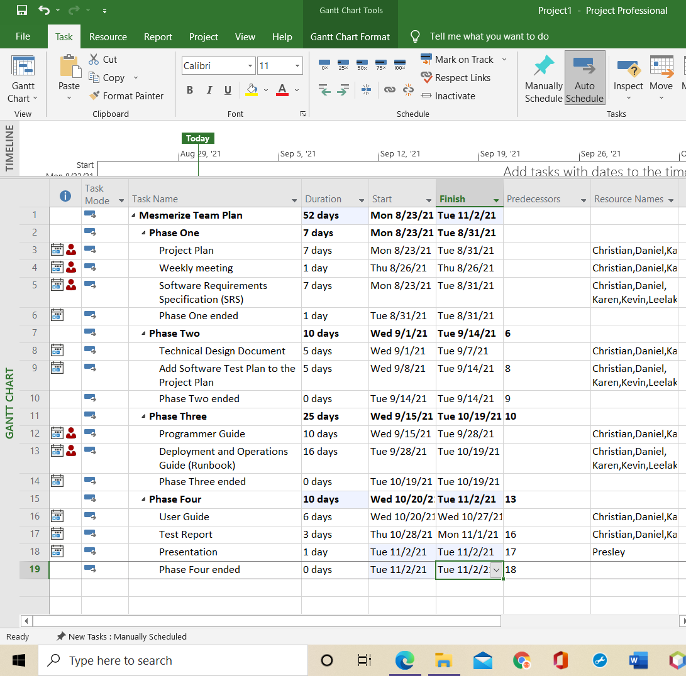

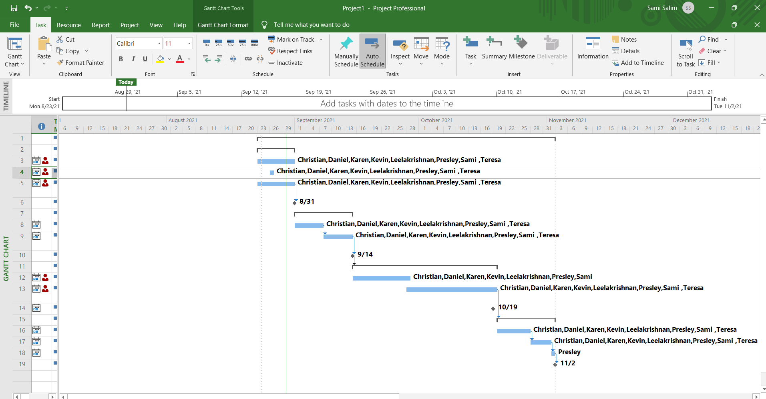

## 6.2 References

Atlassian. (n.d.). Agile tools for software teams. In *Jira Software*. Retrieved from <https://www.atlassian.com/software/jira/agile>

Baars, W. (2006). *Project management handbook*. Hague, Netherlands: Data Archiving and Networked Services. Retrieved from <https://learn.umgc.edu/d2l/le/content/609389/viewContent/22442926/View>

Baileys, A., Benavides, R., Cushing, B., Dunning, M., Mesfin, E., & Puschinsky, T. (2021, June 19). Project plan: Harkify. *University of Maryland Global Campus*.

Brown, M. (2020, March 24). Capstone project guide. In *SWEN 670*. Retrieved from <https://learn.umgc.edu/d2l/le/content/609389/viewContent/22442920/View>

Cherry, K. (2021, April 25). What is short-term memory?. In *Verywell Mind*. Retrieved from <https://www.verywellmind.com/what-is-short-term-memory-2795348>

Developers. (2021, August 26). Everything you need to build on Android. In *Android Studio*. Retrieved from <https://developer.android.com/studio/features>

Famudehin, A., Broggin, C., Ahmed, C., Olshansky, M., Drammeh, M., Ballo, N., & Kelly, S. (2021, July 24). Project Plan: Memory enhancer application. *University of Maryland Global Campus*.

Gisclard-Biondi, H. (2021). The Risk Management Lifecycle Explained: 5 Steps to Managing Risks. *Appvizer.* Retrieved from <https://www.appvizer.com/magazine/operations/project-management/risk-management-lifecycle>

Hello world. (2020, July 24). In *GitHub Guides*. Retrieved from <https://guides.github.com/activities/hello-world/>

Le, M., Jena, D., Johnson, A., Aboagye, P. A., Kimbi, D., & Sevilla, D. (2021, August 6). Project plan: Mnemosyne, Disability Mobile Application. *University of Maryland Global Campus*.

Rae, M. (2020, October 26). What is Adobe XD and what is it used for?. In *Adobe.com*. Retrieved from <https://www.adobe.com/products/xd/learn/get-started/what-is-adobe-xd-used-for.html>

Small, G. W. (2002, June 22). What we need to know about age related memory loss. *BMJ*, *324*(7352), 1502-1505. Retrieved from <https://www.ncbi.nlm.nih.gov/pmc/articles/PMC1123445/>

SWEN 670 9040 Software Engineering Project (2218). (n.d.). In *University of Maryland Global Campus*. Retrieved from <https://learn.umgc.edu/d2l/home/609389>

Szeja, R. (2021, March 26). Is Flutter a programming language?. In *Netguru*. Retrieved from <https://www.netguru.com/blog/is-flutter-a-programming-language>

Weir, M. (2020, November 18). What is Microsoft Teams? Here's what you need to know about the workplace communication

tool. In *Insider*. Retrieved from <https://www.businessinsider.com/what-is-microsoft-teams>

Yahnke, K. (2018). How to Use a Risk Assessment Matrix. *i-Sight.* Retrieved from <https://i-sight.com/resources/risk-assessment-matrix/>