University of Maryland Global Campus

Presented By:
Team A: Reshawna Sampson, Barry Gartrell, Ananya Srinivasan, Stanley De Jesus, Sheena Johnpeter, Arnold Detoito
DEPLOYMENT AND OPERATIONS GUIDE
(Runbook)
USPS Informed Delivery App- Visually Impaired

Table of Contents
1. Introduction 3
1.1 Purpose 3
1.2 Intended Audience 3
1.3 Technical Project Stakeholders 3
1.4 Definitions, Acronyms, and Abbreviations 4
2. Mobile Application 5
2.1 Features, Packages, Plugins- 5
2.1.1 Features 5
2.1.2 Packages 6
2.1.3 Plugins 7
3. Software Installation 9
3.1 Android Studio Installation 10
3.2 Flutter and Dart System Requirements 10
3.3 Dart and Flutter Plug-ins 11
3.4 Android Emulator 14
3.5 Visual Studio Code – Mac Install 21
3.6 Dart and Flutter Plug-ins 23
3.7 Xcode (iOS) 24
3.8 Flutter and Dart SDKs 24
3.9 GitHub Desktop setup 30
4. Prepare the Mobile Application for Use 30
4.1 Google Cloud Vision API setup 30
4.2 Google ML Kit Barcode Scanning Plugin setup 39
4.3 USPS Address Validation API setup 41
4.4 Cloning GitHub repository 44
4.5 Run the Flutter application 47
5. Testing the Mobile Application 50
5.1 Testing Objective 50
5.1.1 Unit tests 50
5.1.1.1 Google Cloud Vision 50
5.1.1.2 Digest Email Parsing 52
5.1.1.3 USPS Address Verification 53
5.1.1.4 QR Code/Barcode Scanning 54
6. Troubleshooting 55
6.1 Issues configuring Flutter or Dart SDKs 55
6.2 Emulator not responding 55
6.3 Dependency Errors 57
6.4 Known Issues and Solutions 60
6.4.1 Google Vision Service Account - Violation of Google Cloud User Agreement 60
7. Appendices 64
7.1 References 64

Revision Number | Date | Description | Approved By
1.0 | 7/28/22 | Initial Document | Reshawna Sampson (PM)
1.0 | 8/9/22 | Revised | Reshawna Sampson (PM)

Introduction
Installing and deploying the USPS Informed Delivery Vision Assistance Application is covered in depth in this Team Arch’s Deployment and Operation Guide (Runbook). Additionally, the documentation provides step-by-step instructions that show how the whole team members – including the Project Manager, Developers, Business Analysts, and Testers worked on, completed/accomplished, and implemented the entire application as a class during Summer 2022 at the University of Maryland Global Campus (UMGC). In addition to this document, there are a suite of documents that include the Project Plan, Software Requirements Specification, Technical Design Document, and Programmer’s Guide that can be used in conjunction with this document.
  - Purpose
The Deployment and Operation Guide (Runbook) is intended to lay out the process required for installing and deploying the USPS Informed Delivery Vision Assistance Application to a user’s device, as well as to provide illustrations of those actions. This document assists in outlining each step needed to complete a successful installation.
  - Intended Audience
Software developers, technical stakeholders, and future programmers who are interested in installing or deploying the application are the intended audience for this Runbook guide. This document’s goal is to give instructions that any user may easily follow by thoroughly outlining each stage of the installation procedure. Users may learn more about Flutter in depth by taking the “Flutter Crash Course for Beginners 2021 - Build a Flutter App with Google's Flutter & Dart” course offered by Academind on YouTube.

  - Technical Project Stakeholders
The table below shows the technical project stakeholders for the USPS Informed Delivery Vision Assistance Application:
Table 1
Project Stakeholders

Name | Role
Dr. Mir Assadullah | Professor
Roy Gordon | Project Mentor
Robert Wilson | Project Mentor
Bereket Kelemu | Overall Project Manager
Reshawna Sampson | Team Arch’s Project Manager
Stanley De Jesus | Lead Developer
Barry Gartrell | Developer
Arnold Detoito | Developer/Tester
Ananya Srinivasan | Developer/Business Analyst
Sheena Johnpeter | Business Analyst/ Tester

  - Definitions, Acronyms, and Abbreviations
The table below shows the most used acronyms/abbreviations and their definitions:
Table 2
All Acronyms and Abbreviations
Acronyms and Abbreviations | Definitions
PM | Project Manager
BA | Business Analyst
UI | User Interface
OS | Operating System
iOS | iPhone Operating System
API | Application Program Interface
VM | Virtual Machine
CE | Code Editor
GCP | Google Cloud Services Platform
HI | Hardware Interface
IDE | Integrated Development Environment
SI | Software Interface
UML | Unified Modeling Language
UMGC | University of Maryland Global Campus
QR | Quick Response

Mobile Application
  - Features, Packages, Plugins-
    - Features
- Simplicity: The USPS Informed Delivery Vision Assistance Application’s user interface (UI) is well-organized, user-friendly layout, and simple to use.
- Flexibility: Compatible with Android and iOS operating systems.
- Android and iOS Devices Support: Offering mobile applications that are cross-platform or multi-platform is one of the finest ways to attract customers. With this feature, users will have flexibility in when and how they can access the program.
- Security: Provides users the security they need to deal with storing sensitive and personal data.
- Login: Logins will be available for Visually Impaired users, allowing them to choose which features they user has access to.
- Search Options: Ensures that the application allows users to search for the information they have entered.
- Audible feature: From the informed delivery daily digest, the application audibly reads the following:
- Logos
- Type or read the handwritten text to find the sender and recipient information
- Reads Quick Response (QR) codes or barcodes on mail pieces. In addition, it also encourages users to visit those websites for more information while they are using the application.
- Voice Command Feature: It is trained to recognize the user’s voice. When a new USPS delivery digest email is received, the application is programmed to alert the user and offer voice command action choices.
- Mic button Feature: It will recognize the user’s voice and distinct phrases, which will cause the program to do tasks.
- Scan an image feature: Through the phone’s camera, this feature is programmed to scan a piece of mail and read the contents aloud.
    - Packages
Both the Flutter and Dart ecosystems allow the usage of common packages made by other programmers, allowing for the quick creation of applications without having to start from scratch. Programmers may quickly develop an application using resources offered by other programmers with the aid of Flutter packages. These packages are available on pub.dev, where developers often make their work downloadable. On this page, individuals can find a lot of packages and dependencies that work with and may be utilized with Flutter.
Installing a Package Dependency Into an App:
Depend on it:
- Open the pubspec.yaml file from within the application and add css_colors: under dependencies.
Install it:
- From the terminal: Run flutter pub get. OR
- From Android Studio/IntellJ: At the top of pubspec.yaml, select packages to open the action ribbon.
- From VS Code: Click “Get Packages” located on the right side of the action ribbon at the top of pubspec.yaml.
Import it
- In the Dart code, add a similar import statement.
Stop and restart the application, if necessary
- Platform-specific code (Kotlin/Java for Android, Swift/Objective-C for iOS) that is included in a package must be included into your application.
- A complete restart of the application might be necessary to prevent problems like MissingPluginExecption while using the package because hot reload and hot restart only update the Dart code.
Note: An easy reference of these processes may be found under the Installing tab on every package page on pub.dev.
The main Google ML Kit packages utilized by the USPS Informed Delivery Vision Assistance Application are listed in the table below:
Note: Refer https://github.com/bharat-biradar/Google-Ml-Kit-plugin/tree/master/packages/google_mlkit_barcode_scanning for a complete list of ML Kit Barcode Scanning packages.

2.1.3 Plugins
Depending on the platform being utilized, the installation steps for the Flutter and Dart plugins differ:
macOS Installation:
For macOS, utilize the guidelines listed below:
- Start Android Studio first
- Launch the plugin option by selecting “Plugins” in Android Studio (Android Studio >Preferences>Plugins).
- After choosing the Flutter plugin, select Install.
- To install the Dart plugin, select Yes when prompted.
- Select Restart when requested.
Windows Installation
For Windows, utilize the guidelines listed below:
- Open plugin preferences.
- Search for the necessary plugin.
- Read and “Apply” the privacy notice.
- Select the “OK” button.
- To make modifications take effect when installation is finished, select “Restart.”
Table 3
Plug-ins, Packages and Descriptions
Packages | Description
Google_ml_kit | A Flutter plugin to use all APIs from Google’s standalone ML Kit for mobile platforms.
Google_mlkit_barcode_scanning | A Flutter plugin to use Google’s ML Kit Barcode Scanning to read data encoded using most standard barcode formats.
Global_configuration | A Flutter package for managing different configurations by merging them together and making them available everywhere inside the app via a singleton.
http | A Flutter package that contains a set of high-level functions and classes that make it easy to consume HTTP resources. It's multi-platform, and supports mobile, desktop, and browser.
image_gallery_saver | A Flutter plugin project for saving images to the gallery, iOS needs to add the following keys to your Info.plist file.
image_picker | A Flutter plugin for iOS and Android for picking images from the image library and taking new pictures with the camera.
permission_handler | A Flutter plugin that provides support for a cross-platform (iOS, Android) API to request permissions and check their status.
json_annotation | A Flutter plugin for defining the annotations used by json_serializable to create code for JSON serialization and deserialization.
path_provider | A Flutter plugin for finding commonly used locations on the filesystem. Supports Android, iOS, Linux, macOS, and Windows. Not all methods are supported on all platforms.
googleapis | A Flutter library that provides support for accessing Google APIs described through the API discovery service.
googleapis_auth | A Flutter package that provides support for obtaining OAuth2 credentials to access Google APIs.
enough_mail | A Flutter library that provides support for IMAP, POP3 and SMTP for email developers.

Software Installation
The user will be guided by the instructions while they set up the development environment on Windows and macOS. This section will outline the core procedures to assist the user in selecting the appropriate tools. Please visit the official websites for each of the systems mentioned below for detailed step-by-step instructions.
  - Android Studio Installation
Download and Installation:
- Step 1: Download the most recent version of Android Studio for your operating system from https://developer.android.com/studio.
Figure 1
Android Studio Installation
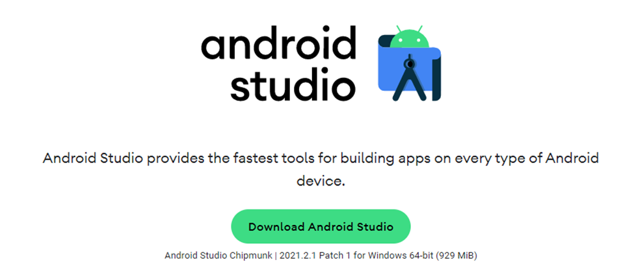
- Step 2: Follow the official steps for your Operating System at https://developer.android.com/studio/install to install Android Studio on your computer.
- Step 3: Following a successful installation of Android Studio, you may proceed to install the additional tools needed to launch Android Studio, including Flutter, Dart, and the Android Emulator.

  - Flutter and Dart System Requirements

The following list names the system requirements needed for the development environment for Windows and MacOS.
Windows:
- Operating system: Windows 10 or later (64-bit), x86-64 based.
- Disk space: 1.64 GB.
- Tools: Windows PowerShell 5.0 or newer OR Git for Windows 2.x OR command Prompt.
MacOS:
- Operating system: macOS.
- Disk space: 2.8 GB.
- Tools: git is used for flutter installation and upgrade. It is recommended to install Xcode that has git.
  - Dart and Flutter Plug-ins

This section details instructions for installing Flutter and Dart Plug-ins on Android Studios.
Step 1: With a blank project open, navigate to File Settings
Figure 2
File Tab
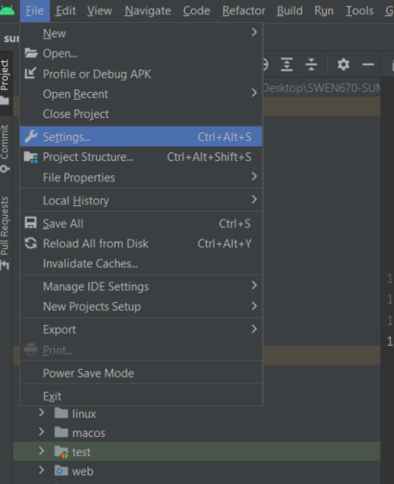

Step 2: On the Settings screen navigate to the Plug-ins tab.
Figure 3
Settings Plug-ins tab
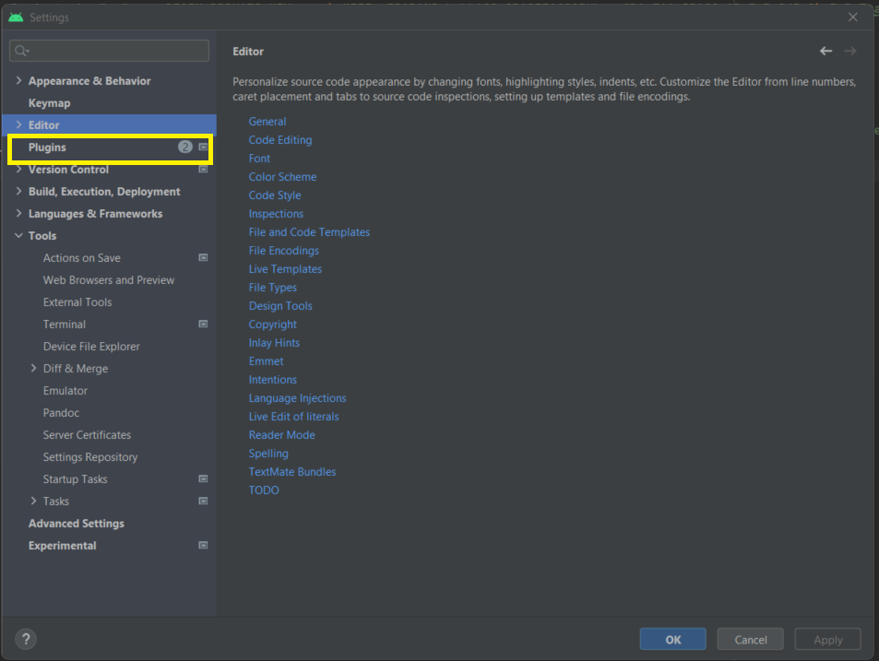

Step 3: On the Plug-ins screen, in the search bar type in flutter and choose the first one. Then click the install green button on the right to install the plug-in.
Figure 4
Install Flutter Plug-in
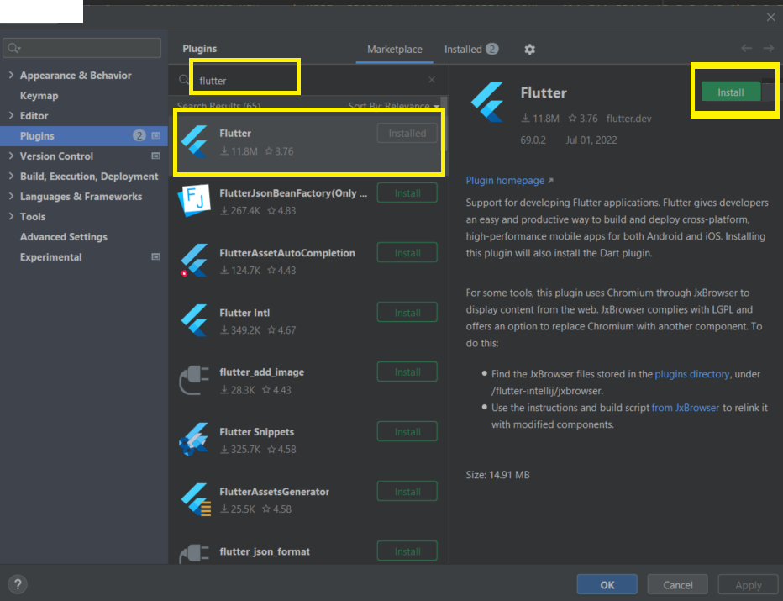

Step 4: After the Flutter plugin is installed, if you are not prompted to install Dart plugin, search “dart” in the search bar and install the first one.
Figure 5
Install Dart Plug-in
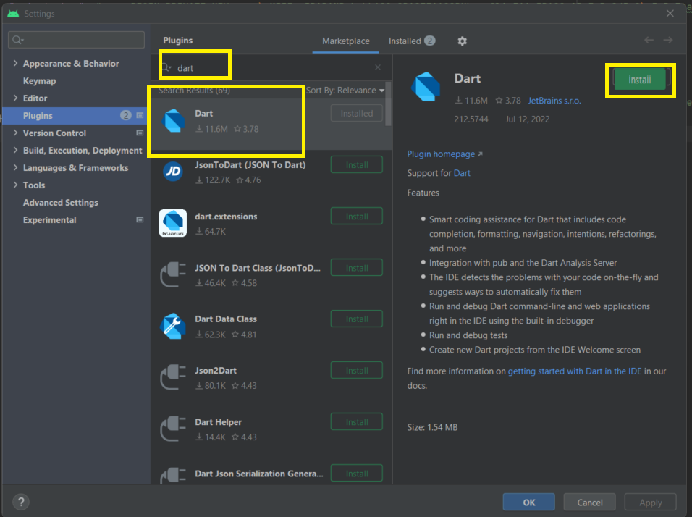
After both have been installed, click “OK” on the bottom right. Close and reopen Android Studios.
  - Android Emulator
Setting up Android Emulator
To launch the Android Emulator, follow the below steps
Step 1: On your computer, enable VM acceleration.
Step 2: On the Android Studio main screen, select “Tools”, then “Device Manager” in the dropdown.

Figure 6
Tools Tab
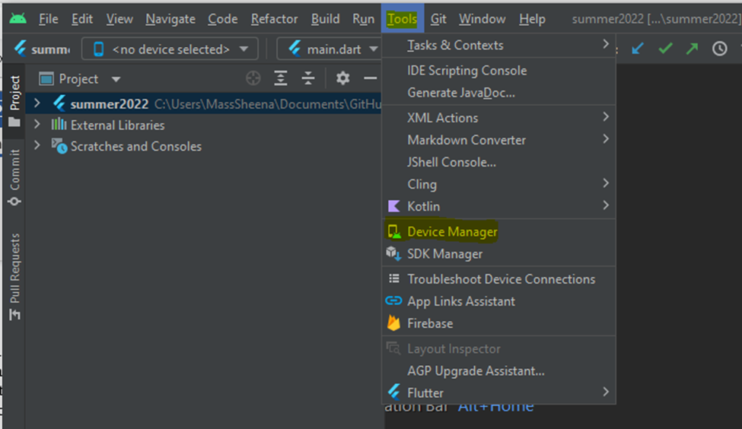

Step 3: Select “Create Device.”
Figure 7
Device Manager – Create a Device
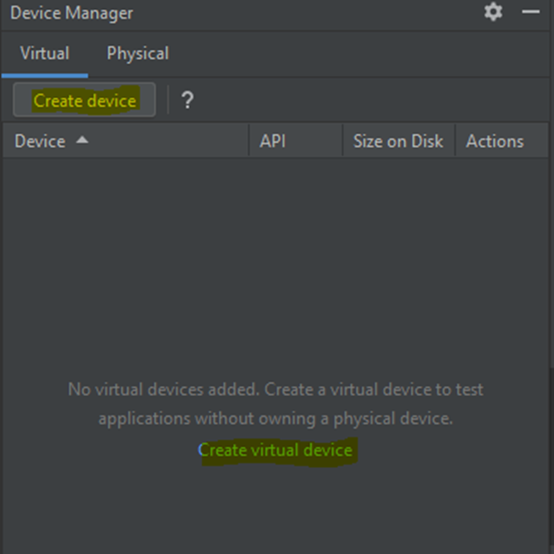

Please note:
- In older versions of Android Studio, select Android Studio >Tools> Android>AVD Manager and select Create Virtual Device (only while in an Android project is the Android submenu visible).
- Choose Configure>AVD Manager and select Create Virtual Device if you do not have a project open.

Step 4: Select Hardware and choose “Next.”
Figure 8
Choose Device Settings and Type
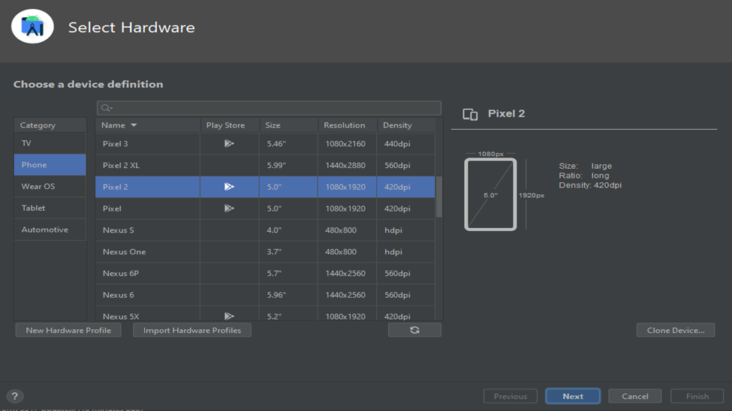

Step 5: Choose a system image for the Android version you would like to emulate and select “Next.” Recommendation: X86_64 image.

Figure 9
Choose Android API Level
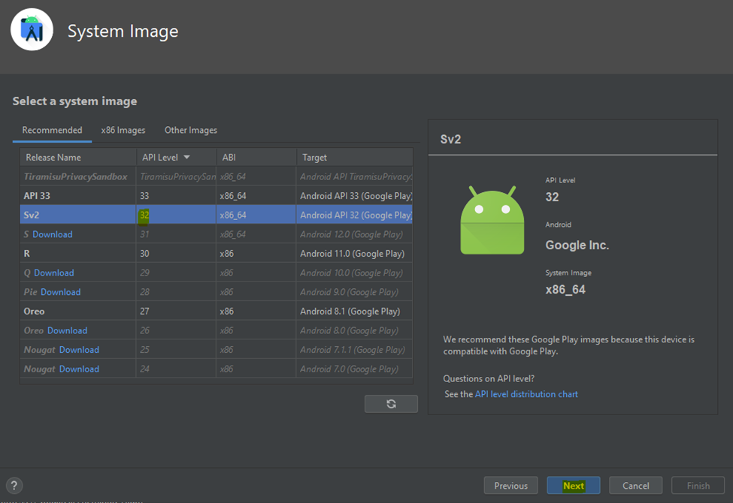

Step 6: Select “Finish” after making sure the Android Virtual Device Configuration is accurate.
Figure 10
Finish Creating Device Emulator
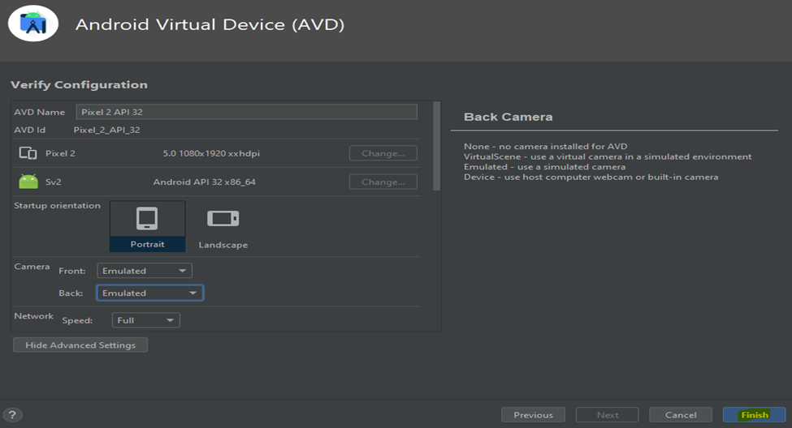
Step 7: In Android Virtual Device Manager, Select the “Launch this AVD in the emulator” option.
Figure 11
Launch the Emulator
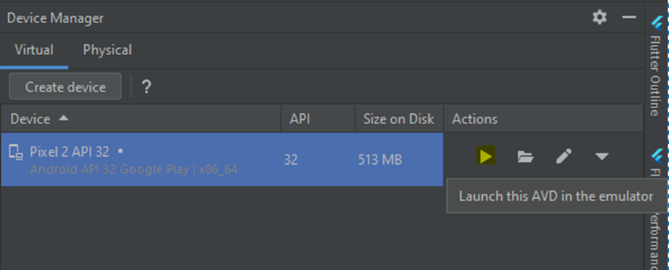

Step 8: The emulator starts up and shows the standard canvas for the device and the Operating System version you have chosen.
Figure 12
New Emulator
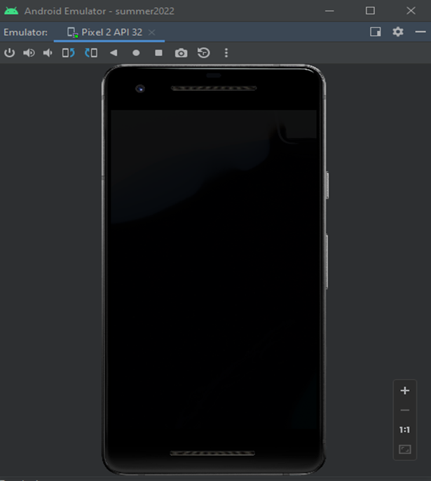

  - Visual Studio Code – Mac Install

This section covers the installation of the Visual Studio Code on Mac.

- Go to the Visual Studio Code homepage, https://code.visualstudio.com, and click on the "Download Mac Universal" button to download the latest version. By default, the download file will be saved in the "Downloads" folder in the Finder app on the Mac.

Figure 13
Visual Studio Installation

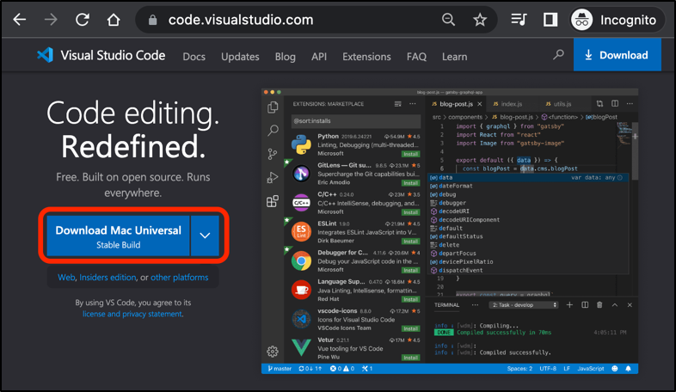

- Locate the downloaded Visual Studio Code zip file on the Mac and double-click to extract the archive content.

Figure 14
Download Zip Location

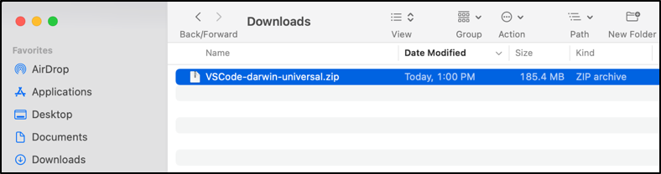

- Drag and drop the "Visual Studio Code.app" to the "Applications" folder to make it available in the Mac Launchpad.

Figure 15
Drag and drop the Download

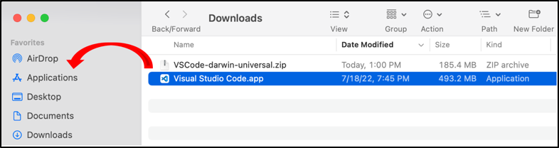

- The Visual Studio Code is now installed and set up on the Mac. To open the Visual Studio Code from the "Applications" folder, double-click on the "Visual Studio Code.app" icon.

Figure 16
Visual Studio App

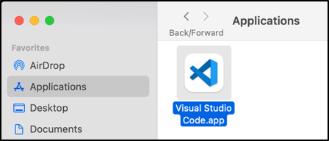

  - Dart and Flutter Plug-ins
1. On VS Code, click on the “extensions” icon on the left
Figure 17
Visual Studio Code Side Bar
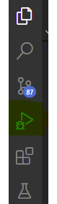

2. VS code will open a screen with an extension marketspace window.
3. On search, look for dart and flutter. They are both from Dart Code.

Figure 18
Dart Plug-in
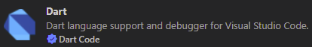

Figure 19
Flutter Plug-in
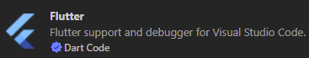

4. Click the install button on the details window for each
Figure 20
Install
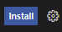

3.7 Xcode (iOS)

To develop a Flutter application in an iOS platform, the Xcode integrated development environment must be installed on the user’s Mac.

- Install the latest version of Xcode. The easiest way is to download Xcode from the App Store. From the App Store, search "Xcode" and click the "Get" button to install Xcode to the user’s Mac.

Figure 21
XCode Install
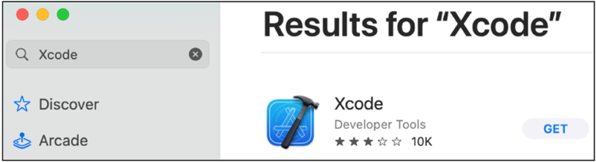

- Configure the Xcode command-line tools to use the newly installed version of Xcode by running the following from the Terminal or command line interface.

$ sudo xcode-select --switch /Applications/Xcode.app/Contents/Developer
$ sudo xcodebuild -runFirstLaunch

This is the correct path for most cases when the user wants to use the latest version of Xcode. If the user needs to use a different version, specify that path instead.

- Run the following in a Terminal window or command line interface to sign the Xcode license agreement.

$ sudo xcodebuild -license

  - Flutter and Dart SDKs

Install Flutter
- Download the following installation bundle to get the latest stable release of the Flutter SDK
- Extract the zip file and place the contained flutter in the desired installation location for the Flutter SDK.
  - Avoid file locations that will have special characters and/or spaces.
- To run flutter commands with the windows console you will need to update your computer’s path value.
  - From the Start search bar, enter ‘env’ and select Edit environment variables for your account.
Figure 22
Search for Environment Settings
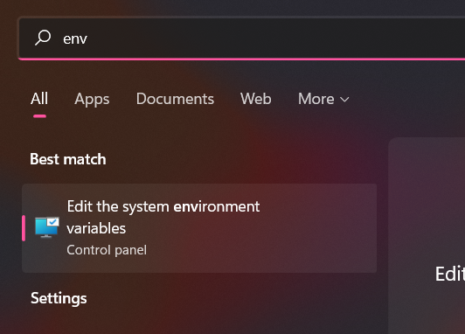

Figure 23
System Properties – Environment Variables
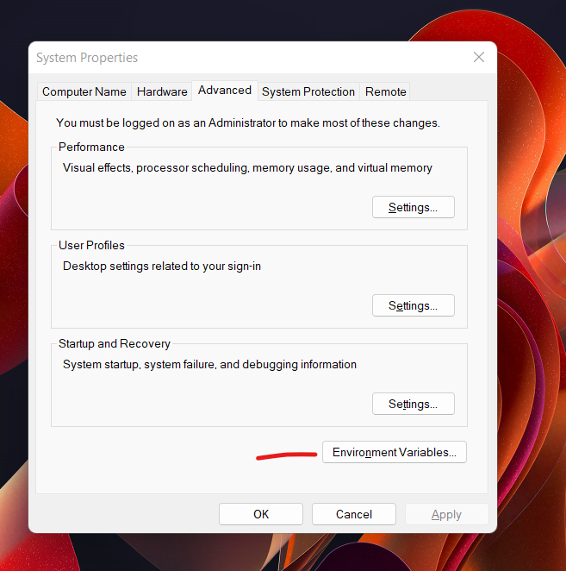

  - Under User, variables check if there is an entry called Path.
    - If the entry exists, append the full path to flutter\bin using, as a separator from existing values.
    - If the entry doesn’t exist, create a new user variable named Path with the full path to flutter\bin as its value.

Figure 24
Environment Variables
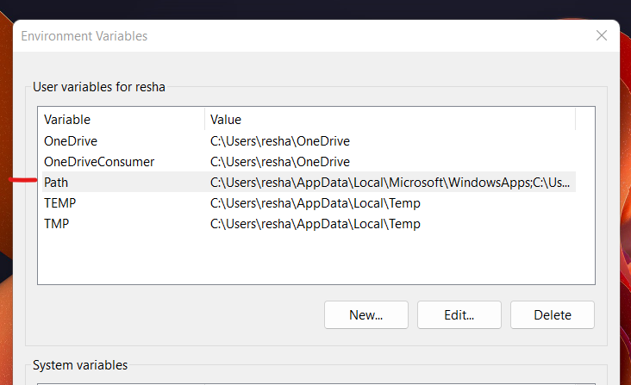

- To verify that flutter is completely installed run “flutter doctor” from the command line.
Figure 24
Run flutter doctor in Command Prompt
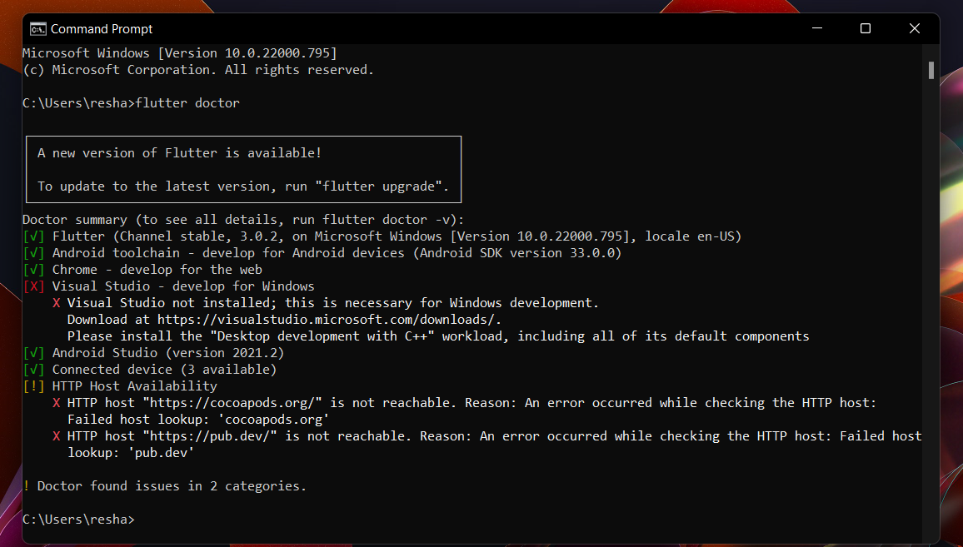
Install Dart
- To install Dart you will need to download the Dart SDK from here.
- Once downloaded extract the SDK to a folder similar to the Flutter SDK.
- Once extracted, you will need to add the Dart SDK to your computer’s route value like with Flutter.
Once both are installed you will need to make sure that Flutter and Dart plugins are enabled on your Android studio.

Figure 25
Dart Plug-in Installation
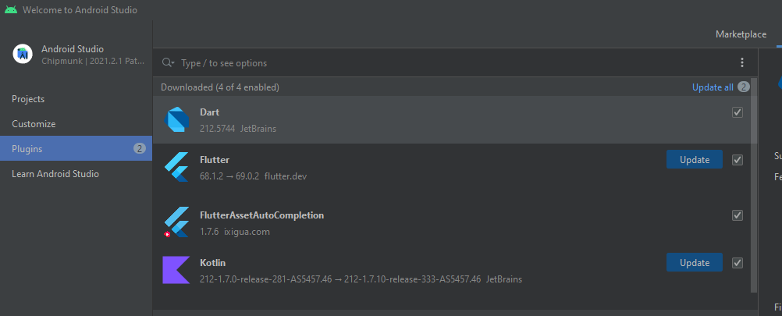
Once those are enabled you will need to path your Android Studio to the Dart and Flutter SDKs under settings.
Figure 26
Path to Flutter SDK
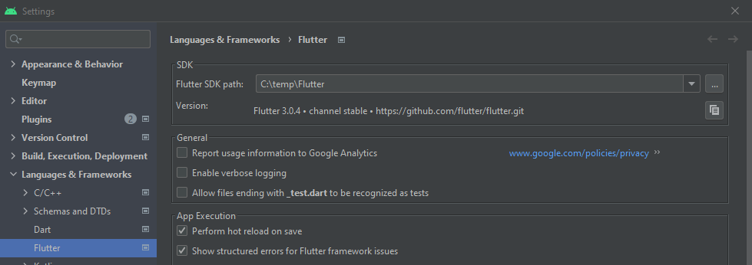

Figure 27
Path to Dart SDK
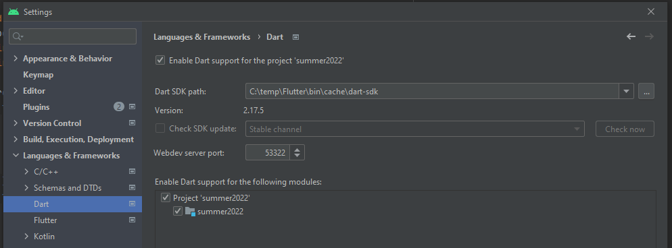
  - GitHub Desktop setup

- Install Git from here.
- Download and install GitHub Desktop from here.
- Sign in or create an account that is associated with your GitHub repo.
- Clone down your repo to a file path where you want to store the application.

Prepare the Mobile Application for Use
  - Google Cloud Vision API setup
- Go to console.cloud.google.com.
- On the top left, click the down array right next to the Google Cloud Platform.
Figure 28
Google Cloud Platform
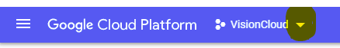

- Click on new project on the top right of the new window. Add a project name and click create
  - For Project name, use Vision
Figure 29
Creating a new project
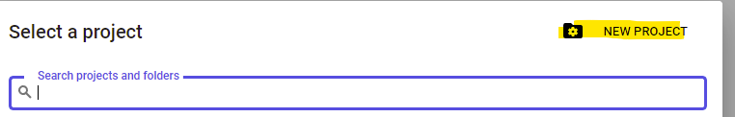
- It will take a minute for it to be created. You can see the progress under notifications. Once complete, select the project. You can also select it via figure 31.
Figure 30
Project Selection 1
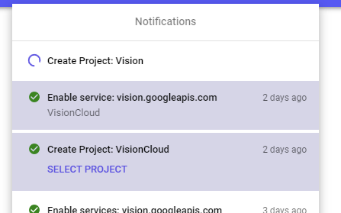
Figure 31
Project Selection 2
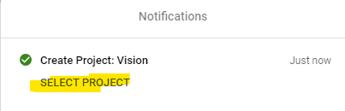
- Next go to Navigation Menu on the top right -> APIs & Services -> Enabled API & Services.
- On the top left, you should see Enable APIs and Service. Click on it.
Figure 32
Enable APIs and Services
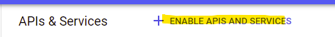
- Use the search to look for “Cloud Vision API”, click on it and hit enable. It will bring you to the API/Service Detail Window.
- Once done, you will need credentials to use with your project. In the service detail window, there will be a button for credentials on the left navigation window. (You can also go to the Navigation Menu button on the top left -> APIs and Services -> Credentials).
Figure 33
Credentials
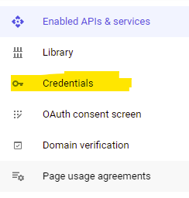
- Under the credentials window, click on Create Credentials -> Service Account.
Figure 34
Create Credentials
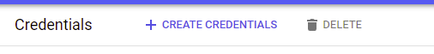

Figure 35
Select Service account
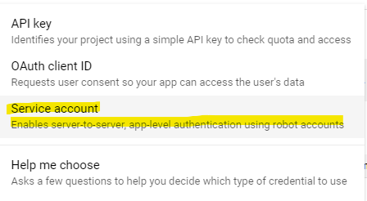
- For Step one, insert a Service Account name and click “Create and Continue”.
  - For Service Account name, insert “Vision”.
Figure 36
Enter Service Account Details
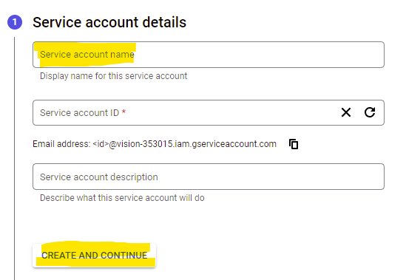
- Step 2 is to create a role. For simplicity, select “Owner”. This will be revisited later once everything is working and we need to lock things down. Now click next.
Figure 37
Grant Permissions
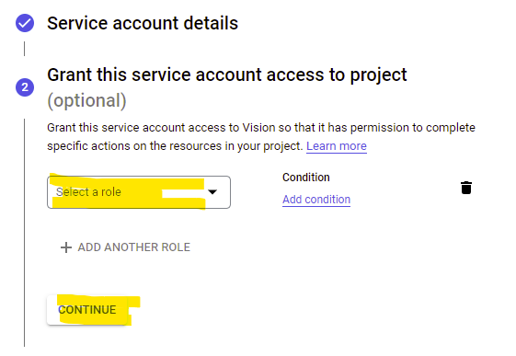
Figure 38
Choose Owner for Role Permissions
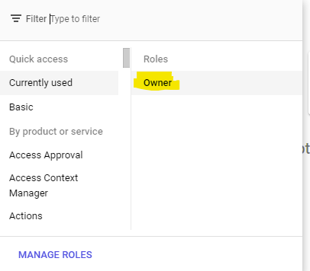

- Step 3 will be skipped. Click on “Done
Figure 39
Done
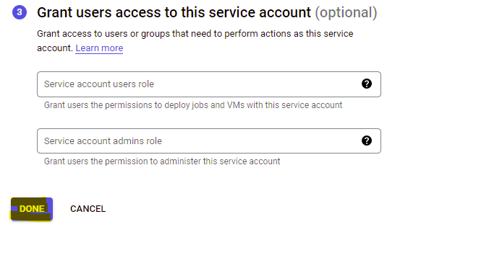
- Now that your role has been established, under Service Accounts, click the email address.
Figure 40
Service Accounts created
Click on Keys at the top, then the “Add Key” Button -> Create New Key.

Figure 41
Create New Key
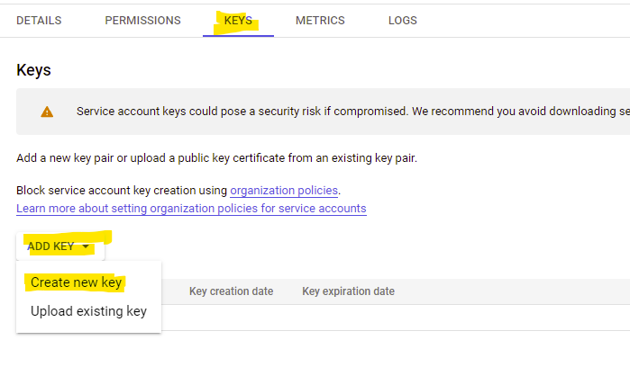
- Click on json and then create. IT will automatically download the json file to your computer. Make sure to change the name of the file to “credentials.json”.

Figure 42
Create private key credentials json file
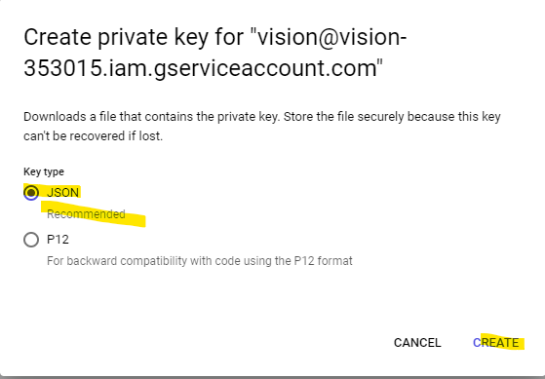

15. Enable Billing - Go to menu and billing.

Figure 43
Enabling Billing
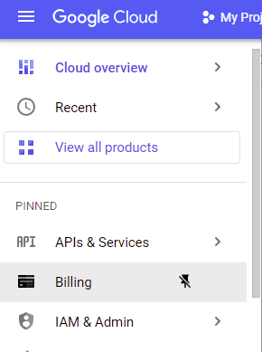

- It will open the billing page. Click on Link a Billing Account.
Figure 44
Link a Billing Account

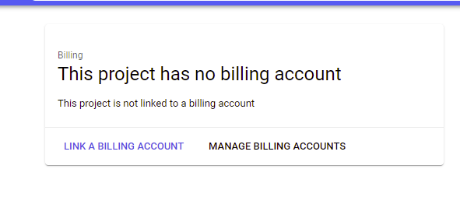

- Follow the prompt until it brings you back to the original screen.
- You are now good to go to use Google Cloud Vision API.
  - Google ML Kit Barcode Scanning Plugin setup

This section will detail the process of setting up the Google ML Kit Barcode Scanning Plugin. While the entire ML Kit package (google_ml_kit) can be downloaded as an umbrella plugin for Flutter application development, each API within the package can be installed as a separate plugin for use. The Barcode Scanning API plugin name is google_ml_kit_barcode_scanning.

Figure 45

Google ML Kit Plugin on pub.dev

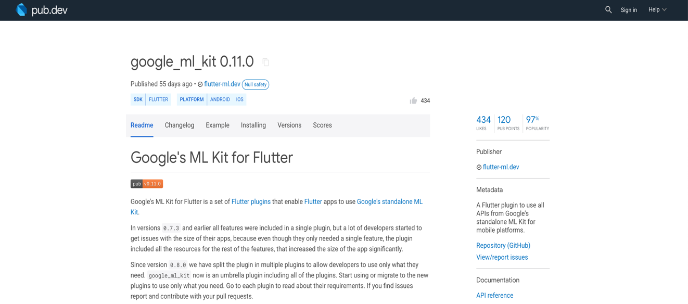

To install the plugin, the developer must have the Flutter SDK installed on their system and a Flutter application to run. Please refer to section 3.4 of the document for a detailed installation of the Flutter SDK.

To install Flutter SDK: https://docs.flutter.dev/get-started/install

To create a new Flutter application: https://docs.flutter.dev/get-started/test-drive?tab=androidstudio

The minimum Android SDK version required to use ML Kit Barcode Scanning is Version 21. Ensure that you have this SDK version or higher. Also, you may need to update the build.gradle file under android/app folder in the defaultConfig section with the minSdkVersion to ensure that the plugin runs successfully.

Figure 46

MinSDKVersion

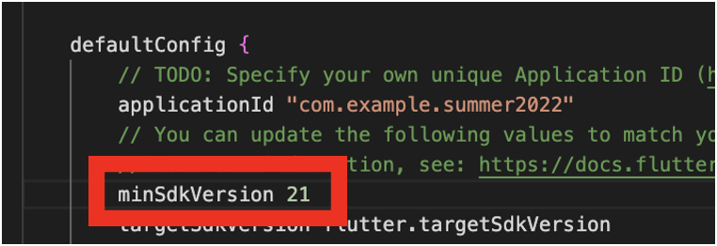

To install the google_ml_kit_barcode_scanning plugin:

- In the command line interface (CLI) of your choice, navigate to the Flutter project directory if you are not in it already
- Run the command:

flutter pub add google_ml_kit_barcode_scanning

which will add a dependency for the plugin in your project’s pubspec.yaml file.

Figure 47

Dependency in pubspec.yaml

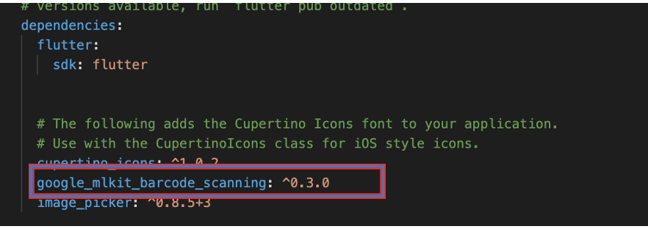

To use the plugin in your Dart code:

- Once the dependency is added to the pubspec.yaml file, the plugin can be utilized in your Dart code for the application. The following import should be added to the Dart file before any classes are declared:

import 'package:google_mlkit_barcode_scanning/google_mlkit_barcode_scanning.dart';

  - USPS Address Validation API setup

This section will detail the process of registering an account with the USPS Web Tools API Portal. The following image illustrates the website https://www.usps.com/business/web-tools-apis/ landing page.
Figure 48
USPS Web Tools API Page
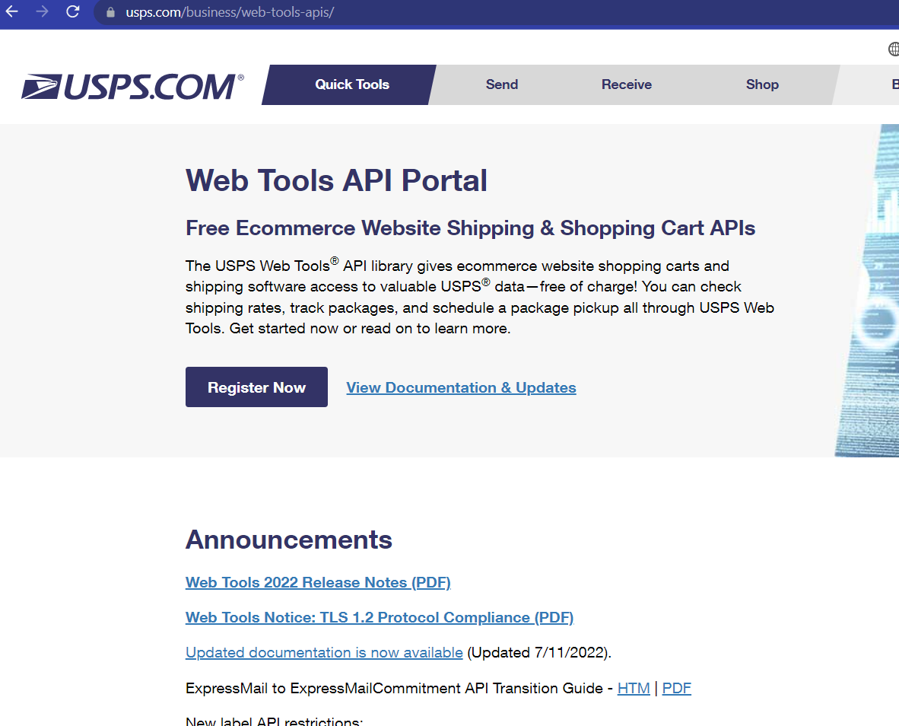
USPS requires an account to be registered with their portal to have access to any of their APIs.
Click the “Register Now” button and it will redirect to a registration form. The following image illustrates the form needed to register for a valid account.
Figure 49
Registration Form for USPS Web Tools
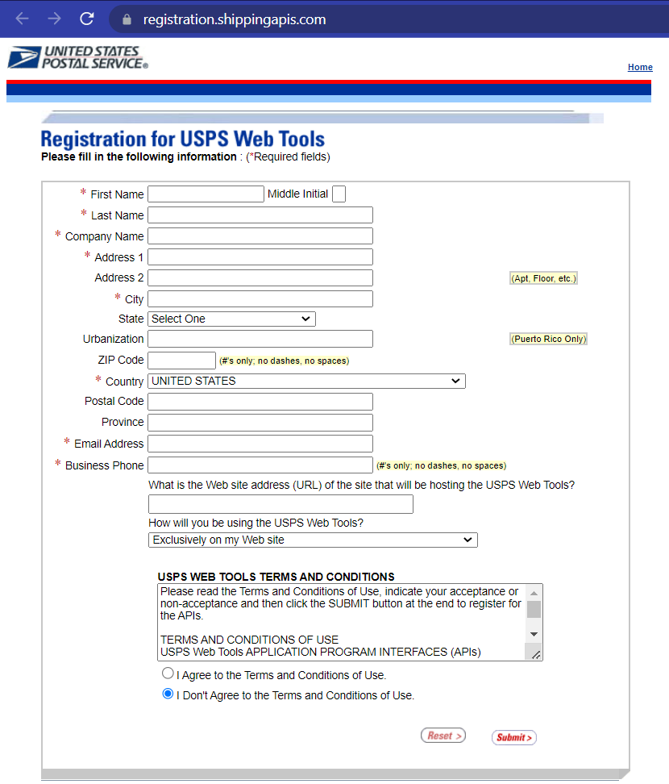
After filling out the form with the necessary information and submitting it, email notification of the registration will be sent to the email used to create the account.
This email will include information about the username and password needed to connect to their APIs and documentation for developers on the implementation of the APIs. The following images illustrate an example of the email notice.
Figure 50
Email Notice of Registration being complete
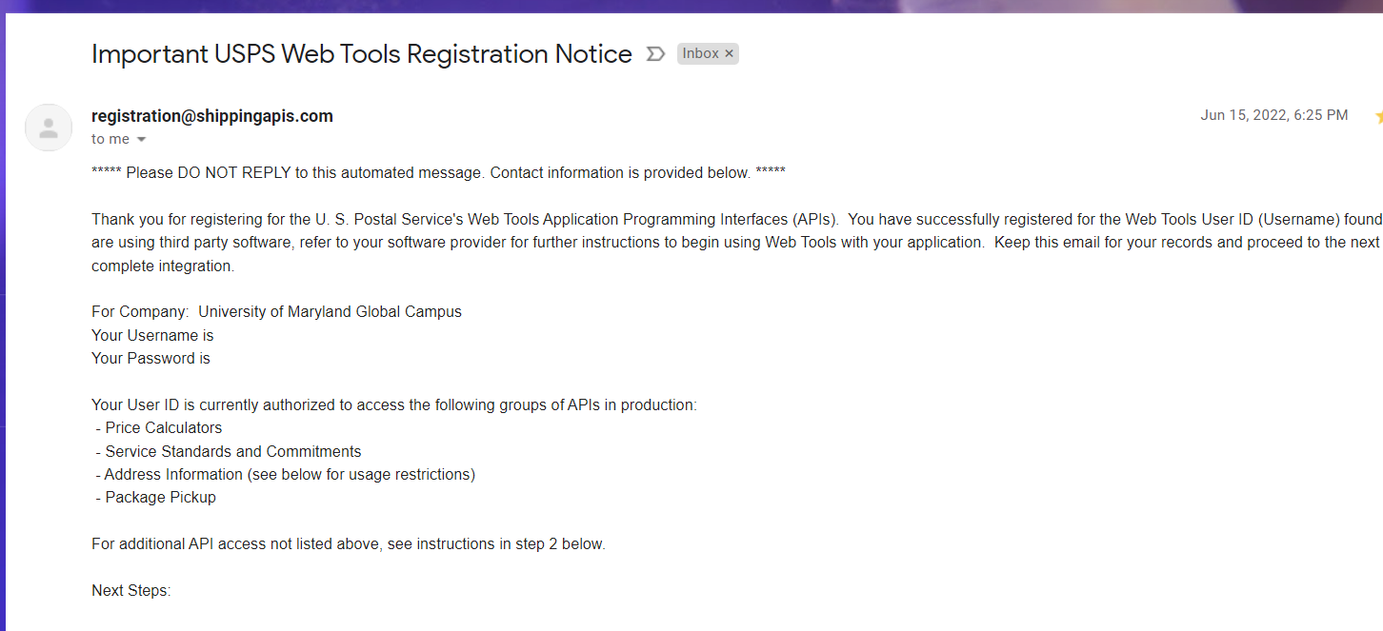

Figure 51
Email Notice of Registration
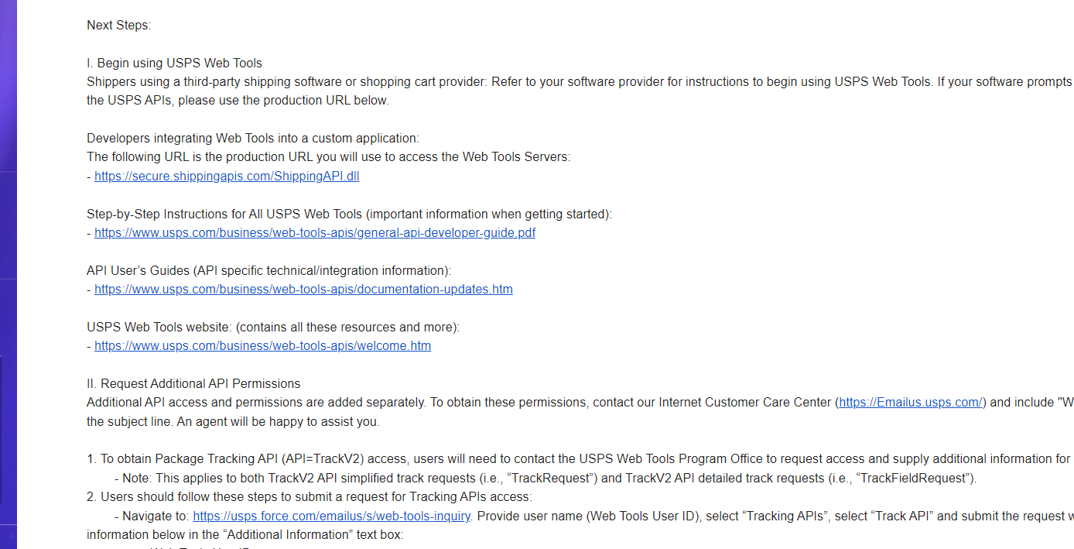
  - Cloning GitHub repository

This section gives step instructions on how to clone the repository from GitHub using GitHub Desktop.

Step 1: Open the GitHub Desktop app. Click the file and then choose “Clone repository”.

Figure 52
Clone a Repository from GitHub Desktop

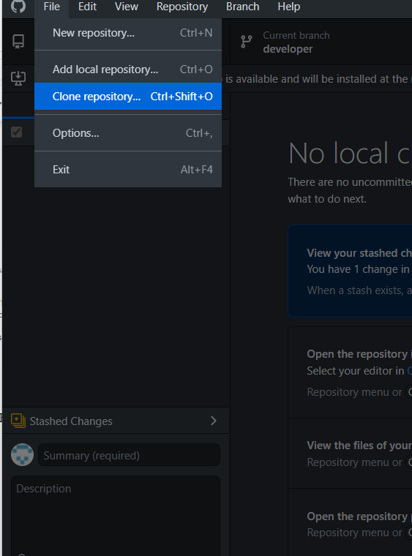

Step 2: The following image shows the clone repository screen. The screen shows the repository that is available to be cloned. Click on the umgc-summer22 repository to be cloned, choose the file location to clone it to, and click clone.

Figure 53
Choose the Repo to Clone

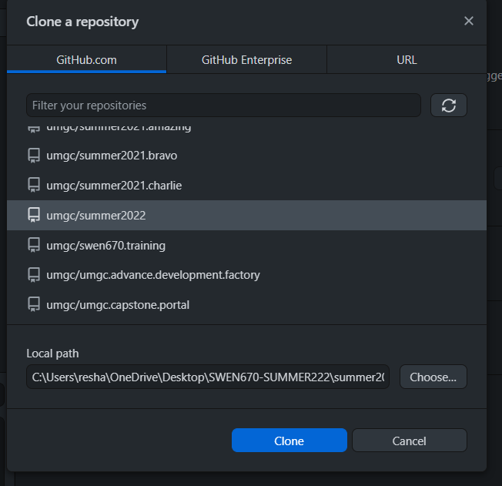

Step 3: After the cloning process is done, open Android Studio if that is your IDE of choice, and it will automatically sync with the developer branch. The developer branch is the default branch. The following images illustrate the default branch on the GitHub Desktop app and on Android Studios.

Figure 54
Cloned Repository
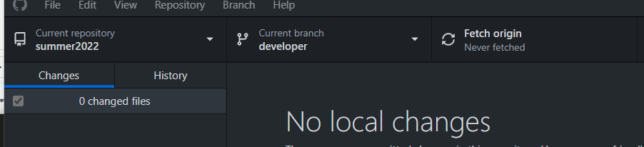

Figure 56
Developer Branch
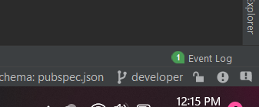

  - Run the Flutter application
To run the Flutter application: on Android Studios IDE
Step 1: Click on no device dropdown and choose open android emulator. An android phone emulator should load.
Figure 57
Connection to an Android Emulator Device
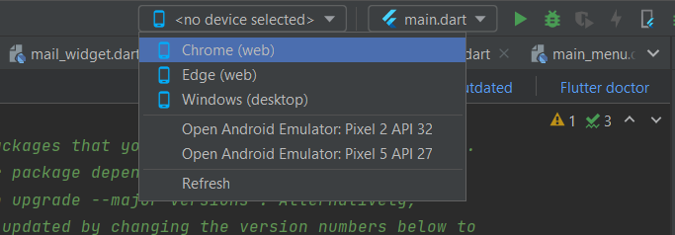

Figure 58
Android Emulated Device
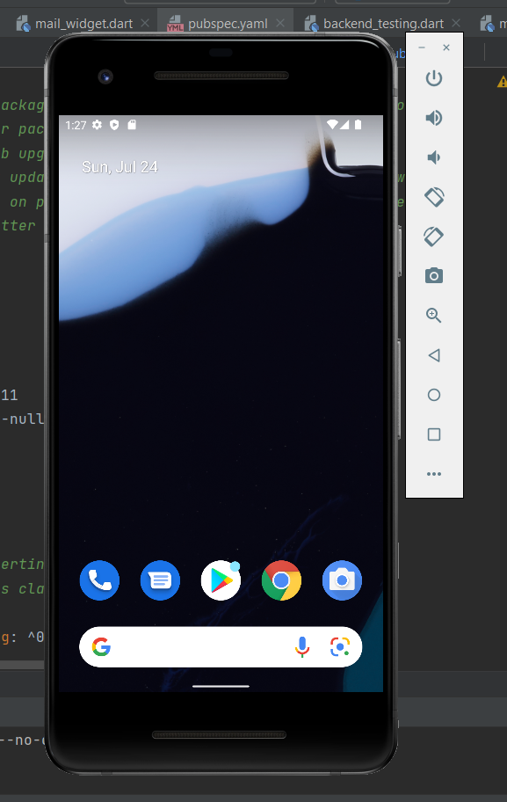

Step 2: click “Run” the green arrow.
Figure 59
Run the Application
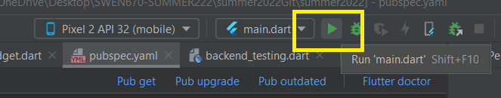
After step 3, the Futter application will begin building and the app should display on the android phone emulator. As depicted in the following image.

Figure 60
USPS Informed Delivery Visual Assistance App
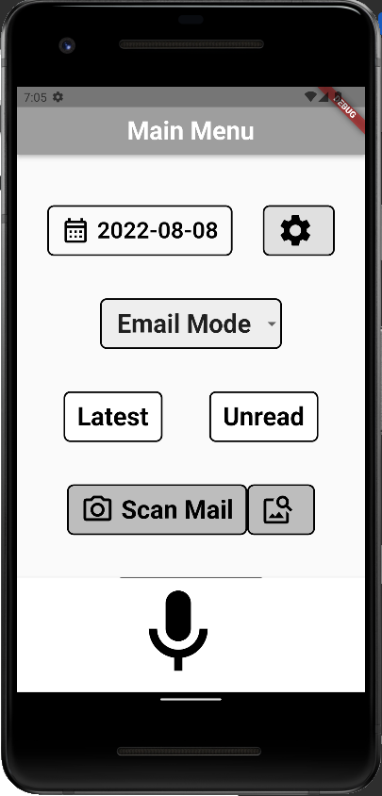

Testing the Mobile Application
  - Testing Objective
    - Unit tests

5.1.1.1 Google Cloud Vision

Table 4
Google Cloud Vision Tests

Test | iPhone | Android
The Application can access the credentials.json file in the assets folder.
Success case: The application does not return an error.
The application receives text results for processed mailpiece
Success case: The application is able to access a stored mailpiece, send it to vision to be process and return the result as a AddressObject. The result using mail.test.01.jpg under the assets folder should match the expected object results.
The Application sends mailpiece to detect logos.
Success case: The application sends image to be processed by google vision using logo detector option and receive its outcome. The result using mail.test.01.jpg under the assets folder should match the expected object results.
The Application uses the vision search function.
Success case: The application uses the search function and returns the outcome as a MailResponse object. The object contains both addresses and logos found. The result using mail.test.01.jpg under the assets folder should match the expected object results.
The Application uses the search function illegible image.
Success: The List Objects within MailResponse (Address and logo) will both have a length of zero.

5.1.1.2 Digest Email Parsing

Due to the nature of IMAP, it is not possible to unit test this without running the application.

Table 4
Digest Email Parsing tests

Functional Test | iPhone | Android
The application must connect to the user’s email.

Success case: The application is able to create an IMAP client with the user’s credentials.
The application must retrieve the user’s USPS Daily Digest.

Success case: The application is able to find and fetch the desired email using the IMAP client.
The application must parse the information of the Daily Digest Email.

Success case: The application is able to parse the information into an object to be consumed by the UI.

5.1.1.3 USPS Address Verification
Table 6
USPS Address Verification Tests

Unit Test | iPhone | Android
The application must accept an address string.

Success case: The application is able to take a formatted address string.

The application must create an XML for the USPS Web API.

Success case: The application is able to create an XML for a given address.
The application must connect to the USPS Web API.

Success case: The application is able to verify the status of the USPS Web API.

The application must determine if an address has been verified.

Success case: The application determines if the address is verified based on the response from the USPS Web API.

5.1.1.4 QR Code/Barcode Scanning
Table 7
QR code/Barcode Scanning Tests

Unit Test | iPhone | Android
Scanner must recognize QR Code

Success case: There is one parsed QR code in the list
Scanner must not recognize QR Code

Success case: There are no parsed barcodes in the list
Scanner must recognize barcode

Success case: There is one parsed barcode in the list

    - Integration tests
Table 8
Integration Test

Functional Test | iPhone | Android
The application will open the Digest Page with the digest of the specified date.

Troubleshooting
  - Issues configuring Flutter or Dart SDKs

If the IDE being used says it cannot detect the dart or flutter SDKs, it might need to be remapped to the location they were downloaded to. Usually, you can know if this issue occurred if the project won’t build and the main.dart file is not recognized. The following steps shows how to remap the SDKs.

Click “File” then “Settings” to remap the SDKS. Then rerun flutter clean in the terminal. The following image shows the settings dialog where you can select the path to the Dart or Flutter SDK.

Figure 61
Settings Dart SDK Path

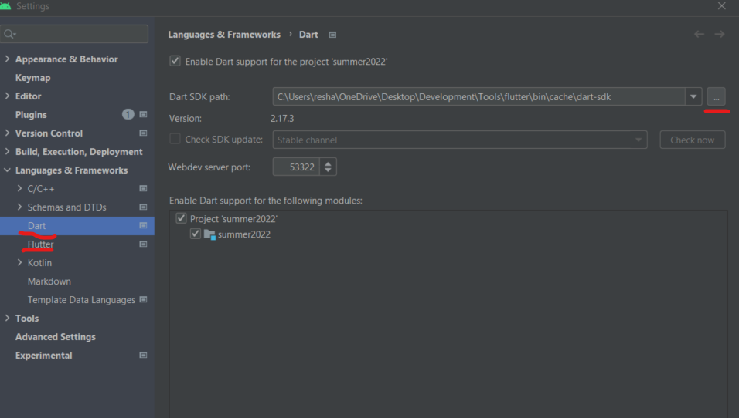

  - Emulator not responding

In the case of an Android emulator not responding, it is encouraged to close the running app and the emulator first. If the user is using Android Studio as the IDE of their choice, they should navigate to the Device Manager screen and select the action menu for the device being used. From the action menu, the user should select “Cold Boot Now” to clear the device's RAM and restart the device.
Figure 62
Android Studio Virtual Devices Manager

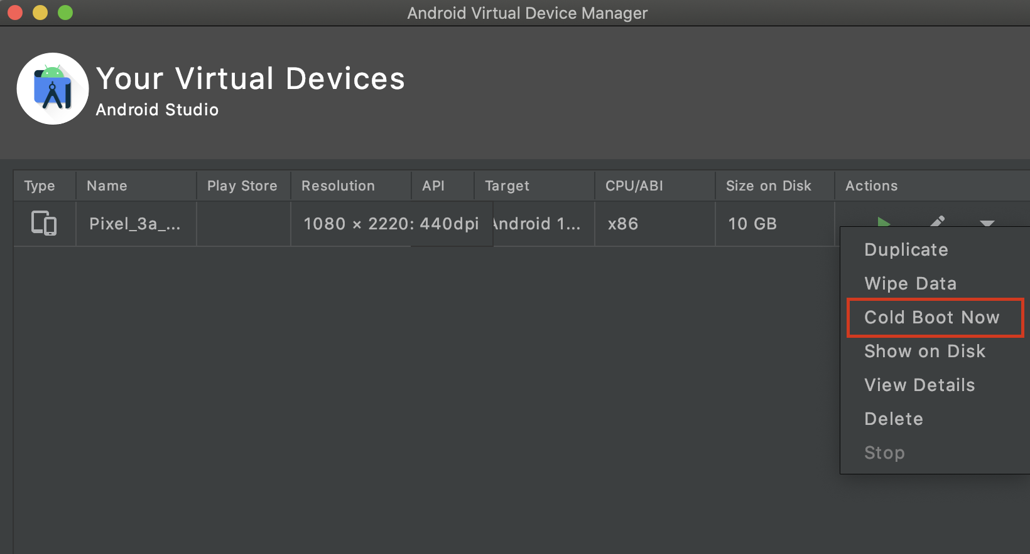

For users running the app in Visual Studio, the user can cold boot the device by selecting the device menu from the bottom toolbar.

Figure 63
Visual Studio Device Menu Button

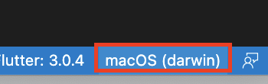

This button will launch a menu at the top of the IDE, which displays all the emulators and devices from which the user can run the application. To cold boot an emulator, please select the device that has “(cold boot)” next to its name.

Figure 64
Cold Boot Option

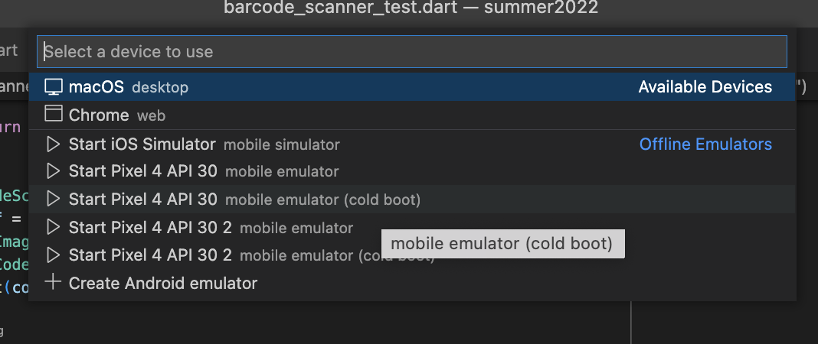

For users who are running an iPhone emulator through Xcode, it is recommended to first check if there are any issues with the build. The user should navigate to the “View” menu and under the “Navigators” option should “Show Issue Navigator” option. If no issues are visible with the build, then the user should close the emulator window and try to relaunch the device emulator again. If the issue persists, navigate to the “Device” menu and then select the “Erase All Content and Settings” option.
  - Dependency Errors
When a developer encounters errors with dependencies being changed this is generally due to changes in the pubspec.yaml file where packages and resources are organized. To remedy this issue a developer will need to run “flutter pub get” in the terminal to get the packages associated with the entries in the pubspec.yaml file.

Figure 65
Run flutter pub get
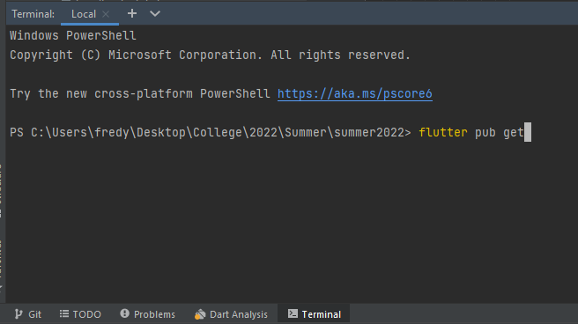
If the issue persists the developer should run a “flutter clean” and then “flutter pub get” to try to resolve the issue.

Figure 66
Run flutter clean
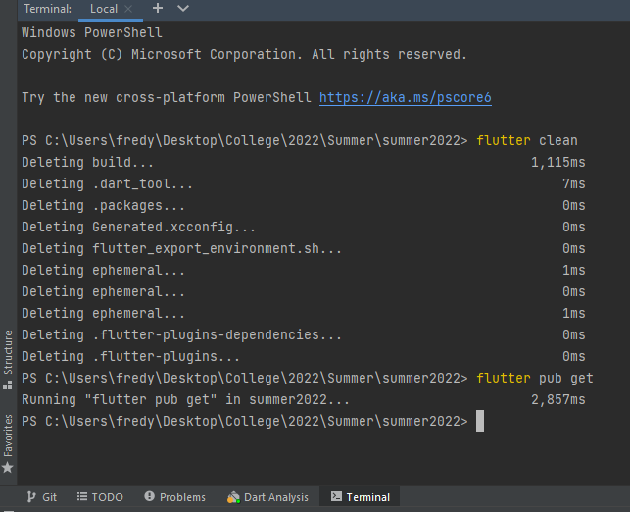
If neither resolves the issue the developer will need to run the “flutter pub cache repair” from the command line and then the “flutter pub get” command.

Figure 67
Run flutter pub cache repair
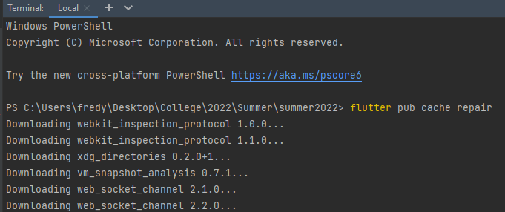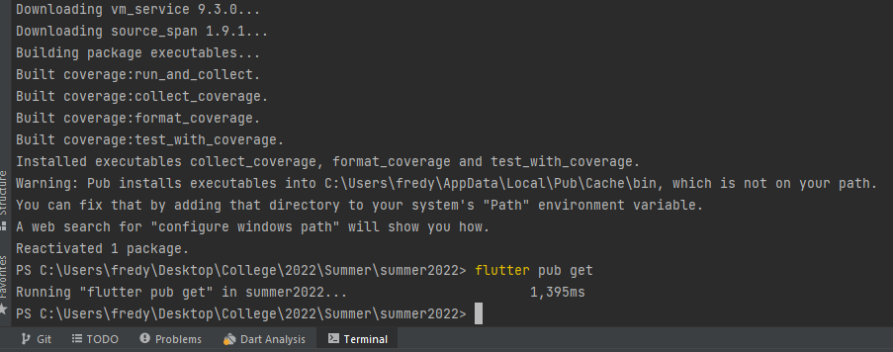

  - Known Issues and Solutions
    - Google Vision Service Account - Violation of Google Cloud User Agreement
An issue that presented itself while developing was the suspension of the service account used to make connections to Google Vision API. Google assumes that it is one person per service account per IP address that will be making connections. For the purpose of this project this is fine. However, once the code was pushed to the developer branch and more developers were using one account credential, it got suspended. Some solutions to combat this include using Google OAuth 2.0 and to create an API Server to store the credentials on.

Solution 1: Google OAuth 2.0
Creating an OAuth credential is needed in order to make calls to Google APIs.
Go to Credentials page on the Google Cloud Console and click on create credentials. This will show options to select which credentials to create. Select eh OAuth client ID option and follow the instructions The image bellow shows this step.
Figure 68
GCP Credentials Page
.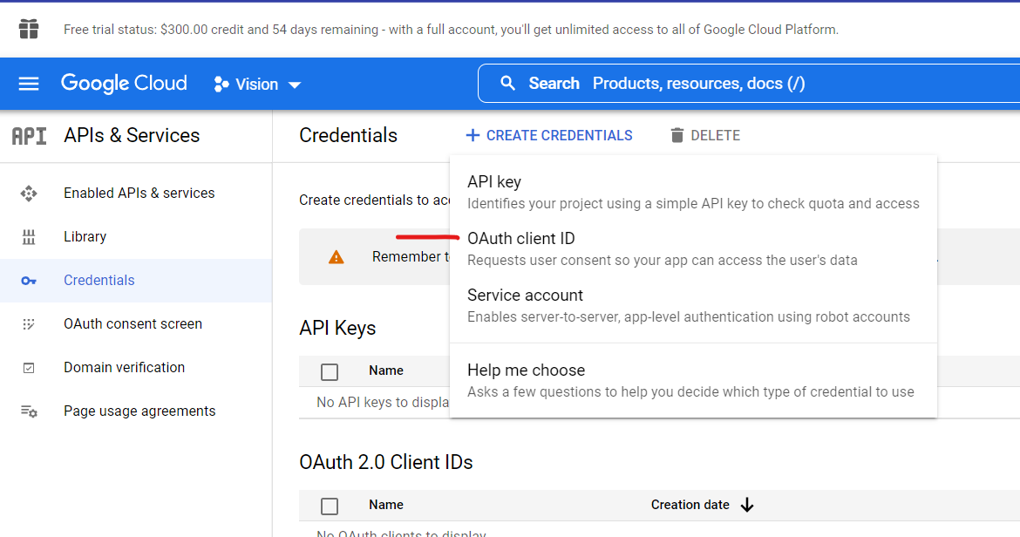

The following steps are used to make the connection calls to the Google APIs once a OAuth credential is created.
- Request Token - oAuth client ID and client secret.
- user redirected to Consent page to grant access to private data.
- Authorization code - sent by Google for user to use service.
- Use auth code for token.
- Token Response (access/refresh) is provided to user.
- Token is used to call Google API.

The image bellow depicts a high-level illustration of this process. More information can be found OAuth 2.0 for Mobile & Desktop Apps | Google Identity | Google Developers

Figure 69
UML of the OAuth 2.0

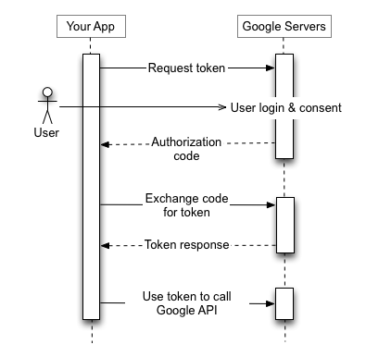
Solution 2: API Server
Another solution is to create an API Server to interact with Google Vision. On this server the service account credentials can be added and be used to interface with cloud services. This would be linked to one IP address, therefore preventing the violation of the Google Cloud User Agreement. The following image shows a high-level illustration of this process.

Figure 70
UML of using the API Server
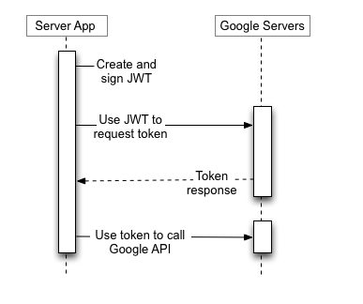

Appendices
  - References
MacOS install. Flutter. (n.d.). Retrieved July 12, 2022, from https://docs.flutter.dev/get-started/install/macos
Web tools API portal. USPS. (n.d.). Retrieved July 12, 2022, from https://www.usps.com/business/web-tools-apis/
Windows install. Flutter. (n.d.). Retrieved July 12, 2022, from https://docs.flutter.dev/get-started/install/windows
B. (n.d.). Google-Ml-Kit-plugin/pubspec.yaml at master · bharat-biradar/Google-Ml-Kit-plugin. GitHub. Retrieved July 27, 2022, from https://github.com/bharat-biradar/Google-Ml-Kit-plugin/blob/master/packages/google_mlkit_translation/pubspec.yaml

Academind. (2019, July 10). Flutter Crash Course for Beginners 2021 - Build a Flutter App with Google’s Flutter & Dart. YouTube. Retrieved July 27, 2022, from https://www.youtube.com/watch?v=x0uinJvhNxI&t=2407s

css_colors | Flutter Package. (n.d.). Dart Packages. Retrieved July 27, 2022, from https://pub.dev/packages/css_colors/install

Windows install (n.d.) Flutter, Retrieved July 26, 2022, from https://docs.flutter.dev/get-started/install/windows

Get the Dark SDK (n.d.) Dart, Retrieved Jult 26, 2022, from https://dart.dev/get-dart

Google. (n.d.). OAuth 2.0 for Mobile & Desktop Apps | google identity | google developers. Google. Retrieved July 28, 2022, from https://developers.google.com/identity/protocols/oauth2/native-app
MacOS install. Flutter. (n.d.). Retrieved July 28, 2022, from https://docs.flutter.dev/get-started/install/macos
Purdue Writing Lab. (n.d.). APA tables and figures // Purdue Writing Lab. Purdue Writing Lab. Retrieved July 29, 2022, from https://owl.purdue.edu/owl/research_and_citation/apa_style/apa_formatting_and_style_guide/apa_tables_and_figures.html

