Municipality Permit ChatBot

UMGC City Application

Version 1.0

Test Report

Prepared by:
Rusty Baker
Sepribo Taylor-Harry
Subhash Gandhi Vallala
Joshua Piersol
Matthew Slaymaker
Nathaniel Muesing

SWEN 670
University of Maryland Global Campus

TABLE OF CONTENTS

Document Version History 3
Introduction 4
Purpose 4
Overview of Tests Results 5
Tests Summary 5
Detailed Test Results 5
City Official (CO) Subsystem Tests: 6
City Official Subsystem: Account Registration 6
City Official Subsystem: Specify Zoning 7
City Official Subsystem: Add Permit Type 8
City Official Subsystem: Add Permit URL 9
City Official Subsystem: Add Regulation Type 10
City Official Subsystem: Add Regulation URL 11
City Official Subsystem: Delete Regulation URL 12
City Official Subsystem: Delete Permit 13
City Official Subsystem: Registration Error Handling 14
City Official Subsystem: Add User Error Handling 14
City Official Subsystem: Add Zone Error Handling 15
City Official Subsystem: Add Permit Error Handling 16
City Official Subsystem: Add Regulation Error Handling 17
City Official Subsystem: Add Zone Listed/Removal from Zone Menu 18

Document Version History
Date | Version | Author | Description
08/03/2020 | 1.0 | Matt Slaymaker (Test Lead) & Nathaniel Muesing (Software lead & Test Team) | Initial Release

Introduction
The Municipality Permit Chatbot System (MPCS) consists of a chatbot application that city residents will interact with, as well as a downloadable component that allows city officials to customize the offerings of the chatbot.
The system is composed of two primary subsystems, the City Resident Chatbot and the City Official Interface. The purpose of the City Resident Chatbot subsystem is to facilitate access to the features by residents, while the City Official Interface is to facilitate access to the features of the system by city officials.
MPCS is a software application that assists end-users in navigating the local city website (e.g., Pasadena) by answering questions and providing information when inquired. Questions provided by the end-user are administered via a popup website chatbox. The chatbot convincingly acknowledges and interfaces with the end-user comparable to a human customer representative by determining whether to provide a direct answer or reference search results from within the website. Furthermore, the chatbot is linked to other applications within the website to provide accurate information to the end-user. The Chatbot System (CS) will also contain options that will be customizable by its Stakeholders (e.g., City Officials) through a downloadable client.

Purpose
The purpose of this document is to outline the results of the expected tests as detailed in the User Acceptance Test Plan for this project.

Overview of Tests Results

Tests Summary
This report summarizes the testing results carried out during Milestone 4 of the project (07/20/20-8/4/20).

Below are the results of these tests summarized as; tests executed, passed, and failed,
# Tests Executed | # Tests Passed | # Tests Failed
14 | 14 | 0

Detailed Test Results
For each executed test, this document contains:
- Test identification
- Test title
- Expected Output
- Actual Output
- Passed or Failed

City Official (CO) Subsystem Tests:

City Official Subsystem: Account Registration

Test ID | CO Case 1
Title | City Official Subsystem: Account Registration
Expected Output | Registration information entered. Notification of successful registration when “Register” button pushed. Login Screen displayed. User added to user menu.
Actual Output | 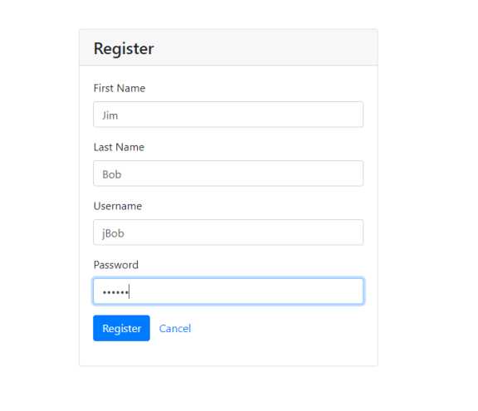  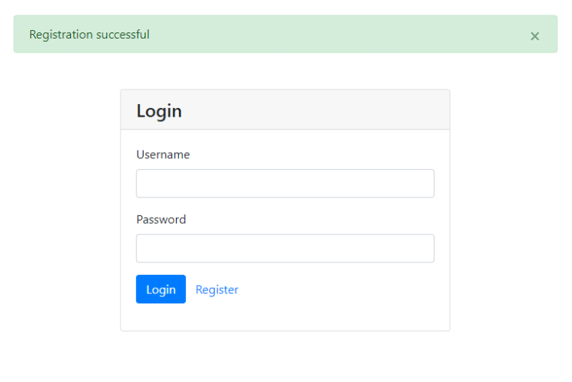  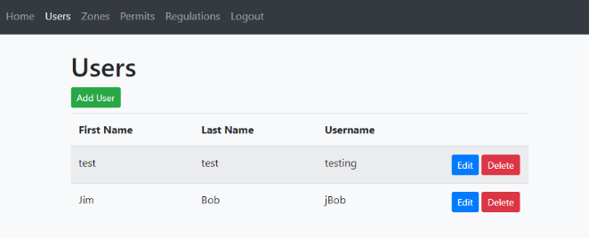
Result | PASSED

City Official Subsystem: Specify Zoning

Test ID | CO Case 2
Title | City Official Subsystem: Specify zoning
Expected Output | Zone tab selected, add zone window API launched. Zone information entered into fields. Appropriate Zone searchable and linked to correct information via the Watson API.
Actual Output | 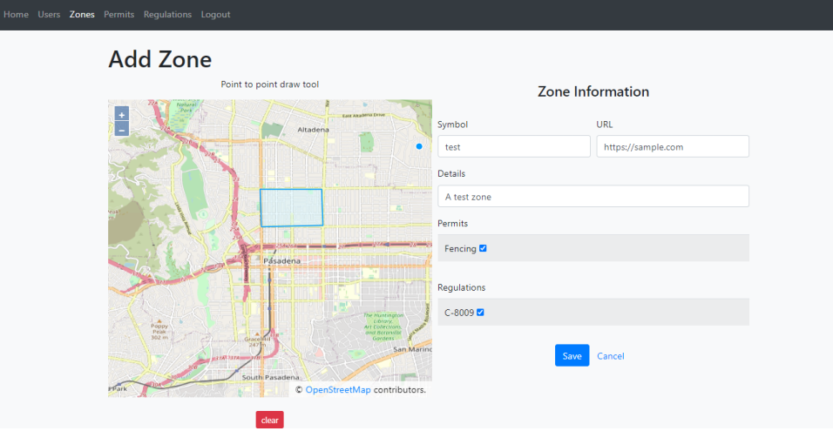  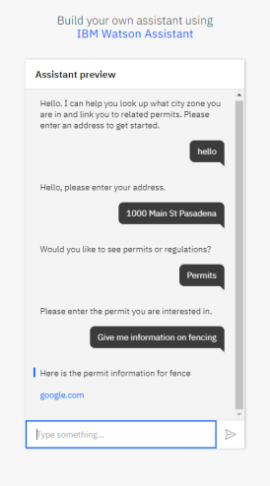
Result | PASSED

City Official Subsystem: Add Permit Type

Test ID | CO Case 3
Title | City Official Subsystem: Add permit type
Expected Output | Type information added to code and keyword fields, active permit screen shows the correct information.
Actual Output | 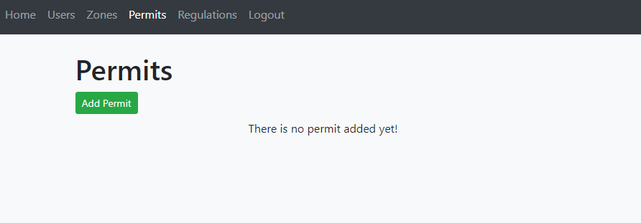  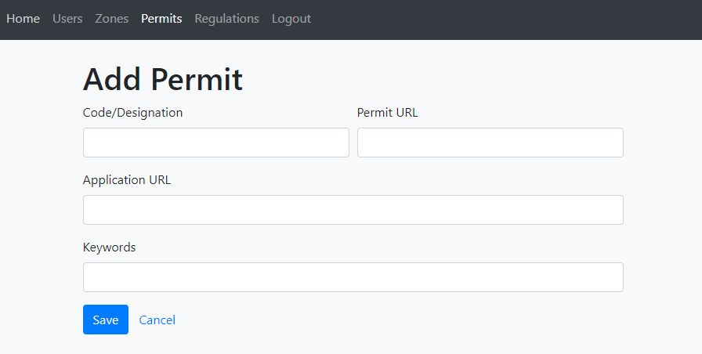  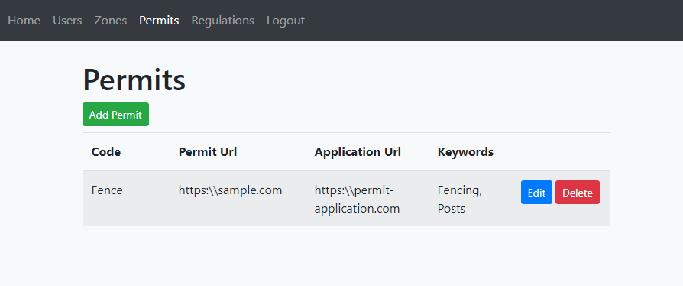
Result | PASSED

City Official Subsystem: Add Permit URL

Test ID | CO Case 4
Title | City Official Subsystem: Add Permit URL
Expected Output | Permit URL entered in the “Permit URL” field, active permit screen shows correct information.
Actual Output |     
Result | PASSED

City Official Subsystem: Add Regulation Type

Test ID | CO Case 5
Title | City Official Subsystem: Add regulation type
Expected Output | Add regulation button pressed, add regulation window activated. Regulation type entered into Code/designation field. Regulation window activated when saved with newly added regulation displaying correct type information.
Actual Output | 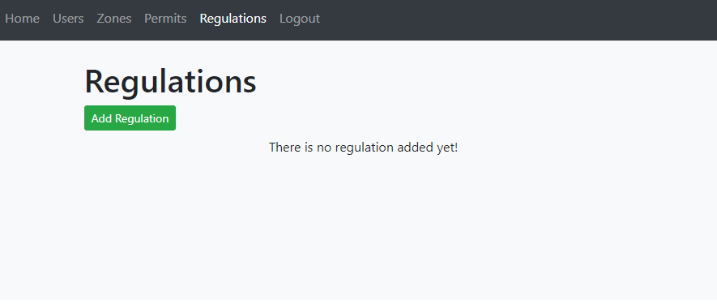  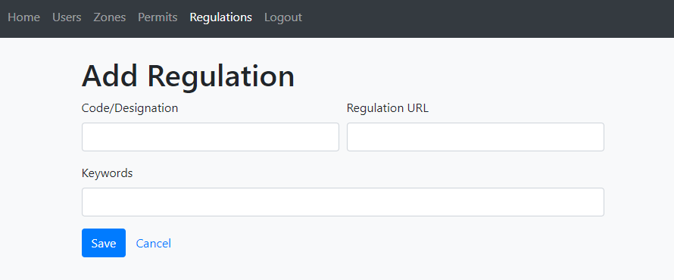  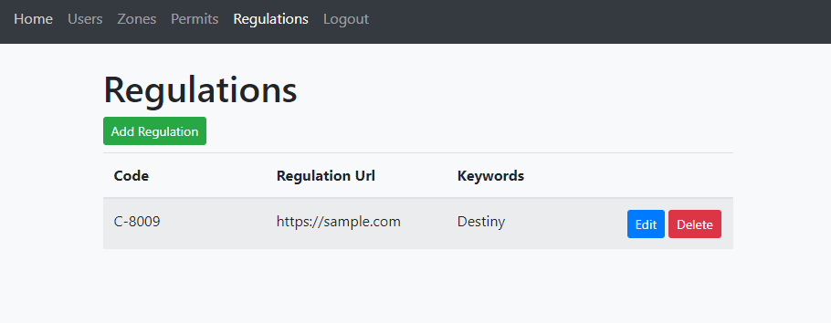
Result | PASSED

City Official Subsystem: Add Regulation URL

Test ID | CO Case 6
Title | City Official Subsystem: Add regulation URL
Expected Output | Add regulation button pressed, add regulation window activated. Regulation URL entered into Code/designation field. Regulation window activated when saved with newly added regulation displaying correct URL information.
Actual Output |     
Result | PASSED

City Official Subsystem: Delete Regulation URL

Test ID | CO Case 6
Title | City Official Subsystem: Delete Regulation
Expected Output | Delete button pressed on regulation screen, warning prompted, “OK” button pressed to finalize deletion. Regulation screen updated with regulation removed.
Actual Output | 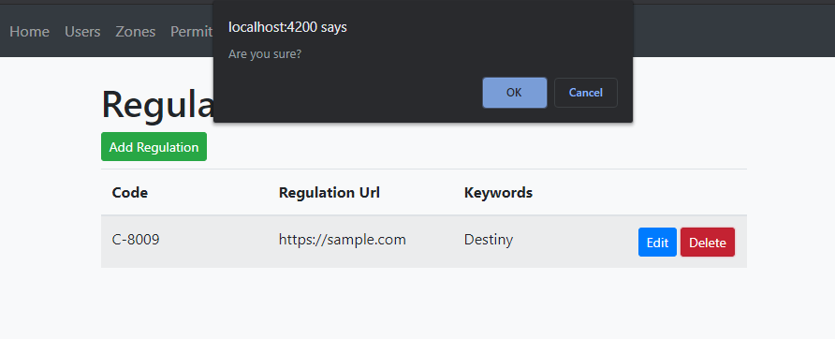  
Result | PASSED

City Official Subsystem: Delete Permit

Test ID | CO Case 8
Title | City Official Subsystem: Delete Permit
Expected Output | Delete button pressed on permit screen, warning prompted, “OK” button pressed to finalize deletion. Permit screen updated with Permit removed.
Actual Output | 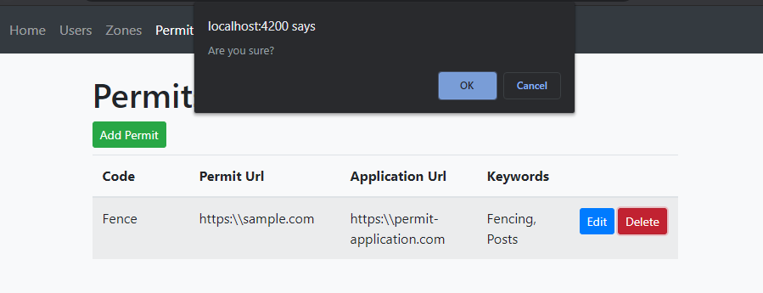
Result | PASSED

City Official Subsystem: Registration Error Handling

Test ID | CO Case 9
Title | City Official Subsystem: Registration Error Handling
Expected Output | Registration declined, error UI presented when incorrect information or null provided.
Actual Output | 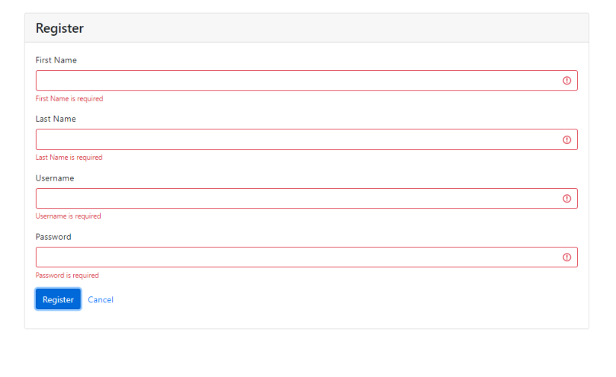
Result | PASSED

City Official Subsystem: Add User Error Handling

Test ID | CO Case 10
Title | City Official Subsystem: Add User Error Handling
Expected Output | Add User declined, error UI presented when incorrect information or null provided.
Actual Output | 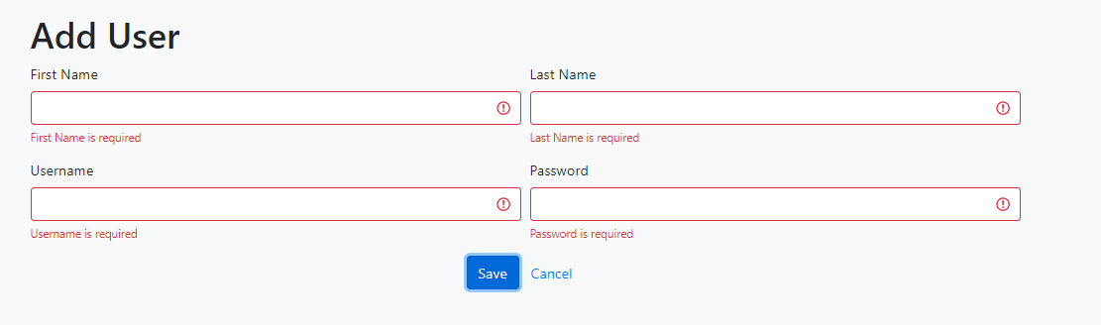
Result | PASSED

City Official Subsystem: Add Zone Error Handling

Test ID | CO Case 11
Title | City Official Subsystem: Add Zone Error Handling
Expected Output | Add Zone declined, error UI presented when incorrect information or null provided.
Actual Output | 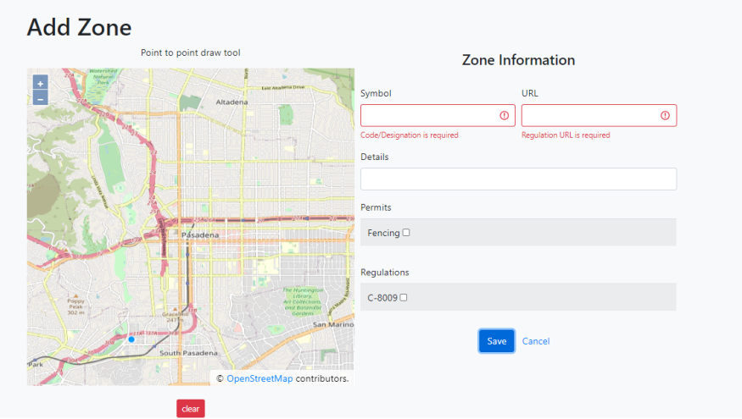
Result | PASSED

City Official Subsystem: Add Permit Error Handling

Test ID | CO Case 12
Title | City Official Subsystem: Add Permit Error Handling
Expected Output | Add Permit declined, error UI presented when incorrect information or null provided.
Actual Output | 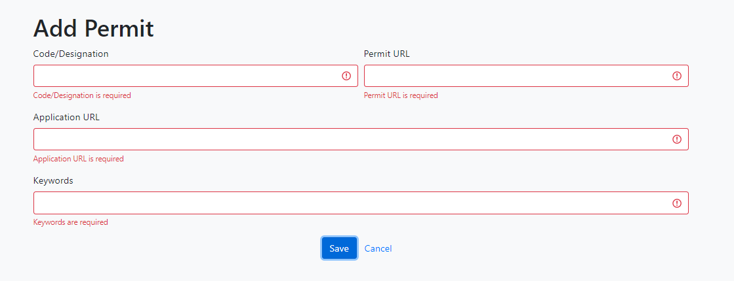
Result | PASSED

City Official Subsystem: Add Regulation Error Handling

Test ID | CO Case 13
Title | City Official Subsystem: Add Regulation Error Handling
Expected Output | Add Regulation declined, error UI presented when incorrect information or null provided.
Actual Output | 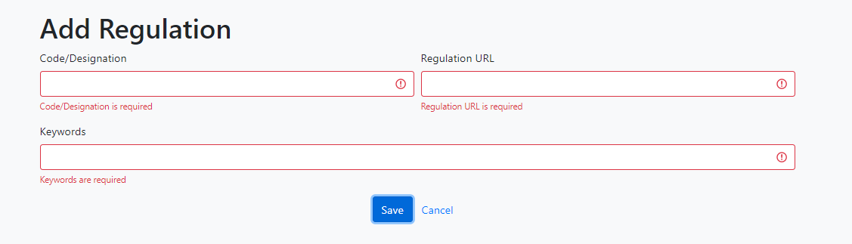
Result | PASSED

City Official Subsystem: Add Zone Listed/Removal from Zone Menu

Test ID | CO Case 14
Title | City Official Subsystem: Zone Listed/Removal from Zone Menu
Expected Output | After Zone added, viewable in Zone menu.
Actual Output | 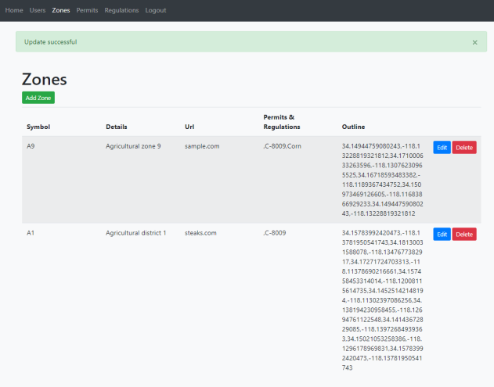
Result | PASSED

