University of Maryland Global Campus
User Guide
USPS Informed Delivery Visual Assistance App
Presented By
Reshawna Sampson, Barry Gartrell, Stanley De Jesus,
Arnold Detoito, Sheena Johnpeter, Ananya Srinivasan

Table of Contents

1. Introduction 3
2. Overview 3
3. Abbreviations, Acronyms, Definitions 3
4. Hardware Specifications 3
5. Software Specifications 4
6. Screens 4
6.1. Log-in 4
6.2. Main Menu 5
6.2.1. Digest Mode 5
6.2.2. Email Mode 6
6.3. Digest Email Details 7
6.4. Other Email Details 8
6.5. Settings 9
7. Launching the Application 10
7.1. Permissions 10
8. Step-by-step Guide 13
8.1. Log-in 13
8.2. Main menu 14
8.2.1. Digest Mode 18
8.2.2. Email Mode 22
8.4. Digest Email Details 25
8.5. Other Email Details 33
8.6. Settings 40
9. Troubleshooting 44
9.1 Application crashes unexpectedly. 44
9.2 Application is not recording speech or not audibly reading. 44

Revision Number | Date | Description | Approved by
1.0 | 8/9/22 | Initial Document | Reshawna Sampson (PM)

1. Introduction

This user guide document describes the functions and operation procedures of the USPS informed delivery mobile application developed by the Team Arch and B. Its goal is to facilitate the usage of the application, and as such, its target audience is the end-user of the application.

2. Overview
The USPS Informed Delivery Vision Assistance Mobile application has been developed to help people who are visually impaired/blind know what is in their mailboxes. Furthermore, this cross-platform mobile application has been designed to notify visually impaired people when a daily digest email comes, offer an audio explanation of their Informed Delivery Daily Digest emails, and transmit photos of mails via a user-friendly mobile application. Those who are blind or visually impaired will benefit from the speech recognition technology utilized in this mobile application. All the specifications provided by the project’s stakeholders were followed in the development of this application. Core functionalities such as “Date picker”, “Settings Button”, “Email Mode or Digest Mode picker”, “Latest button”, “Scan mail with camera button/get image from gallery button”, and “Listening/Stopping button” are included in the list of requirements. Both Team Arch and Team B will be responsible for releasing the application onto the Google Play and App Store when development is complete. This User Guide for the USPS Informed Delivery Mobile application will be posted online for the benefit of both existing and potential users.

3. Abbreviations, Acronyms, Definitions
CE – Code Editor
GCP – Google Cloud Services Platform
HI – Hardware Interface
IDE - Integrated Development Environment
iOS – iPhone Operating System
SI – Software Interface
SRS – Software Requirements Specification
UML - Unified Modeling Language
QR - Quick Response
ML – Machine Learning

4. Hardware Specifications
The USPS Informed Delivery Visual Assistance App was designed to be used on mobile devices only. The user must have an Android device or an iOS platform device in order to use this app. This application is not compatible with website, web app, iPad or TV.

5. Software Specifications
The minimum Android OS version needed to run the application is Android 5.0 (also known as Lollipop) with API Level 21. However, Android 12 with API Levels 31 or above is the preferred Android OS version for the application.
The minimum iOS version for the application to run is Version 11.0, while the preferred version is Version 15.6.

6. Screens
The USPS Informed Delivery Visual Assistance App has a total of five screens. The log-in screen, the main menu, the daily digest email details, the other emails details, and the settings. This section will show each screen and its identifying features on the screen.

6.1. Log-in
This is the main “Log-in” screen at the start. The screen requires users’ unique “Email Address” and a valid “Password” to log in.
Figure 1  Sign-in Screen  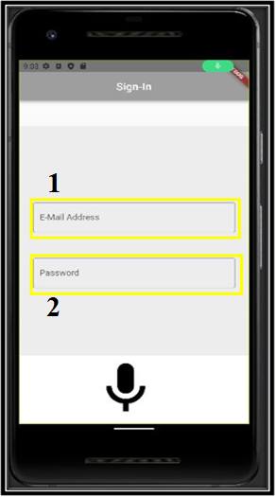 | Sign-in Screen:  - E-Mail Address  - Password

6.2. Main Menu
The main menu consists of two sub screens: the main screen for Email Mode and Digest Mode. The following figures numbers and describes the elements on each main menu mode.

6.2.1. Digest Mode
The Digest Mode Screen is a sub-screen on the main menu screen. It is used to retrieve the USPS Informed Delivery Email from the user’s email.

Figure 2  Main Menu – Digest Mode  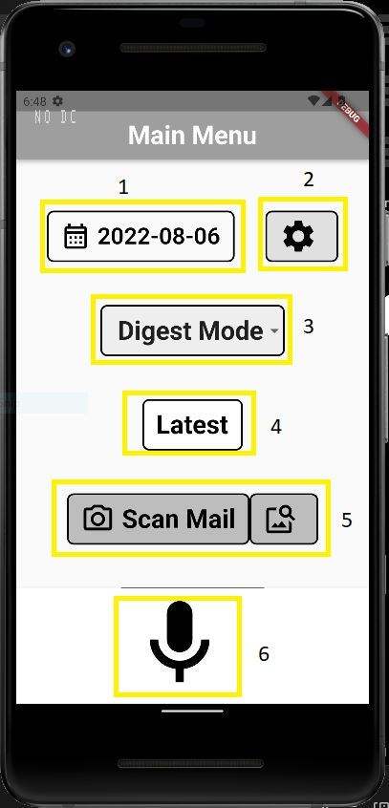 | - Date picker  - Settings Button  - Email Mode or Digest Mode picker  - Latest button  - Scan mail with camera button/get image from gallery button  - Listening/Stopping button

6.2.2. Email Mode
The Email Mode screen is a sub-screen on the main menu screen. It is used to retrieve all emails in the user’s email mailbox.
Figure 3  Main Menu - Email Mode  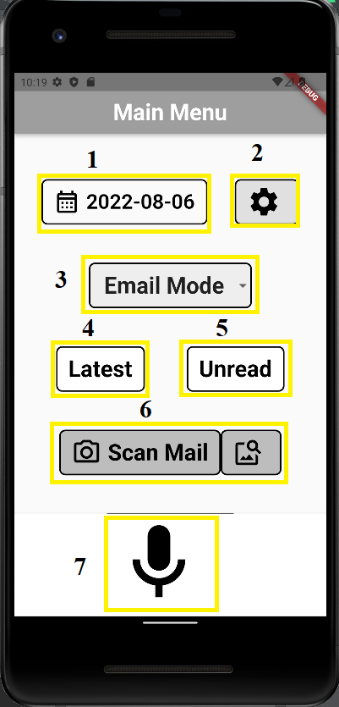 | - Date picker  - Settings Button  - Email Mode or Digest Mode picker  - Latest button  - Unread button  - Scan mail with camera button/get image from gallery button  - Listening/Stopping button

6.3. Digest Email Details
The Digest Email Details screen lets the users view or listen to the USPS Informed Delivery Daily Digest email details such as the sender's name, sender's address, sender's address validated, recipient's name, recipient's address, recipient's address validated and logo. On this screen, users can also tap the buttons as described below. Alternatively, the users can use the voice commands by saying specific words or phrases as described in the digest page help tutorial.
Figure 4  Digest Email Details Screen  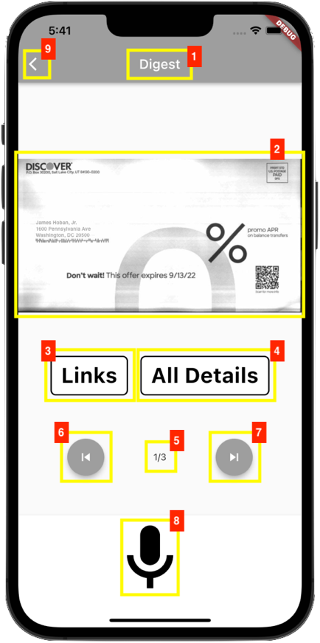 | - Daily digest page name  - Daily digest scanned mail piece  - Links button to go to the hyperlinks dialog page and audibly read the current daily digest email hyperlinks.  - All Details button to audibly read the daily digest email details.  - Daily digest scanned mail piece(s) viewed/listened to and number of mail piece(s) counter  - Previous button to go to the previous daily digest email  - Next button to go to the next daily digest email  - Microphone button to control voice command and double tap to stop audio  - Back button to go back to the main screen

6.4. Other Email Details
The Other Email Details screen lets the users view or listen to the other email details such as the subject, sender, recipient, and text. On this screen, users can also tap the buttons as described below. Alternatively, the users can use the voice commands by saying specific words or phrases as described in the email page help tutorial.
Figure 5  Other Email Details Screen - Email Mode  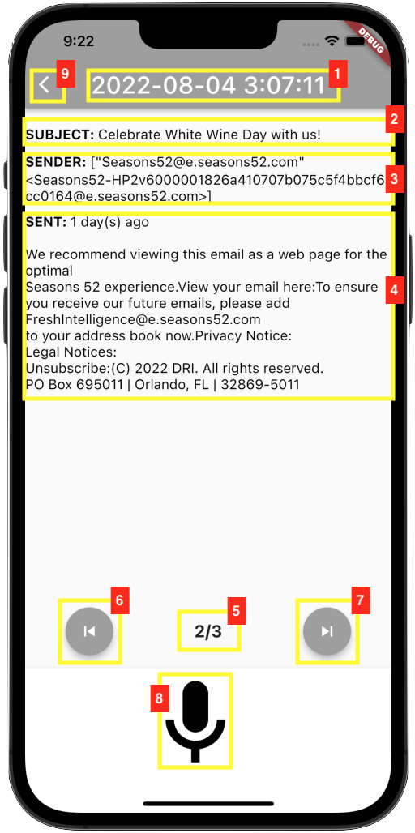 | - Email received date/timestamp  - Email subject line  - Email sender's name  - Email other details  - Email viewed/listened to and number of email(s) counter  - Previous button to go to the previous email  - Next button to go to the next email  - Microphone button to control voice command and double tap to stop audio  - Back button to go back to the main screen

6.5. Settings
The Settings screen allows the user to toggle the application settings to their preference. Based on these preferences, the application will only read out the details of the user’s choice.

Figure 6  Settings – Envelope Details  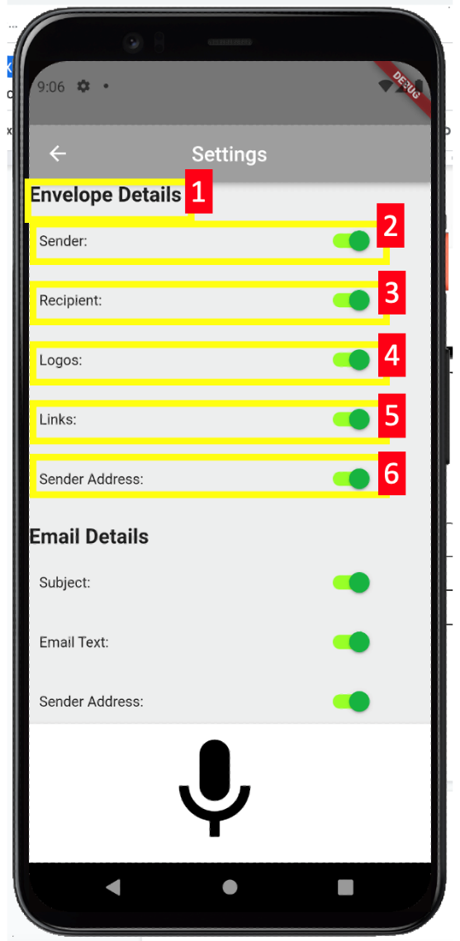 | - Envelope Details Section - header text for the section  - Sender - enable/disable the mail senders’ details from the Daily Digest readout  - Recipient - enable/disable the mail recipients from the Daily Digest readout  - Logos - enable/disable the mails logos from the Daily Digest readout  - Links - enable/disable the mails affiliated links from the Daily Digest readout  - Sender Address - enable/disable the mail sender’s address in the Daily Digest readout
Figure 7  Settings - Email Details  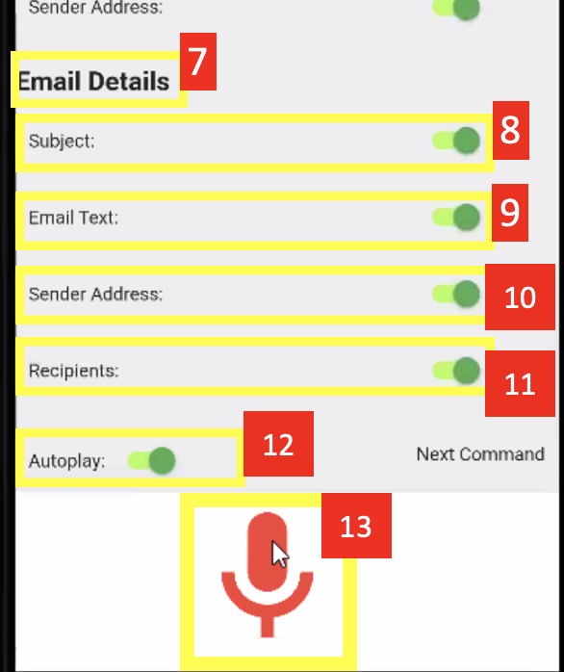 | - Email Details Section - header text for the section  - Subject - enable/disable the email subject from the readout  - Email Text - enable/disable the email text in the readout  - Sender Address - enable/disable the email sender’s address from the readout  - Recipients - enable/disable the email recipient in the text from the readout  - Autoplay - enables/disables autoplay of readouts  Microphone button - used for voice commands

7. Launching the Application
The USPS Informed Delivery Visual Assistance App can be launched by tapping the application icon (see image below) from the user's devices.
Figure 8
App Logo (Sample)
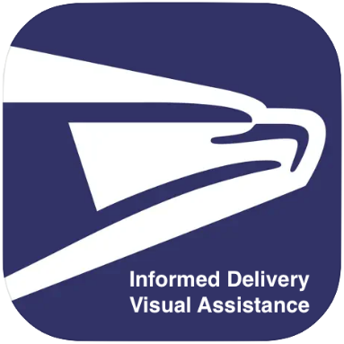

7.1. Permissions
Speech Recognition Permission
The first time the application is launched, the user will need to explicitly grant permission to use the speech recognition. The user can also turn on or off the speech recognition permission setting directly in the iOS device's Settings app, under the "Privacy" section.

Figure 9
Speech Recognition Permission
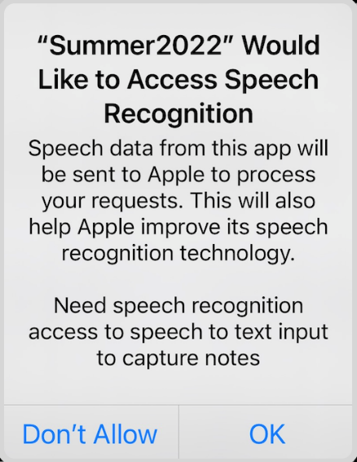

Microphone Permission
The first time the application is launched, the user will need to explicitly grant permission to use the microphone. The user can also turn on or off the microphone permission setting directly in the iOS device's Settings app, under the "Privacy" section.

Figure 10
Microphone Permission
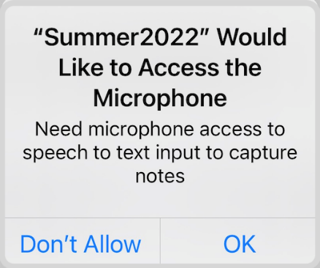

Camera Permission
The first time the application is launched, the user will need to explicitly grant permission to use the camera. The user can also turn on or off the camera permission setting directly in the iOS device's Settings app, under the "Privacy" section.

Figure 11
Camera Permission
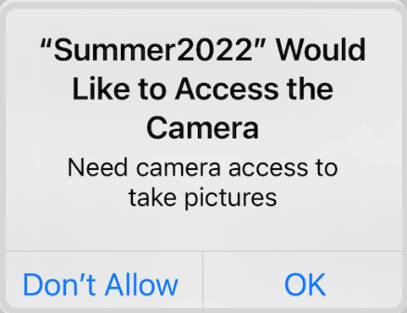

Photo Gallery Permission
The first time the application is launched, the user will need to explicitly grant permission to use the photo gallery. The user can also turn on or off the photo library permission setting directly in the iOS device's Settings app, under the "Privacy" section.

Figure 12
Photo Gallery Permission
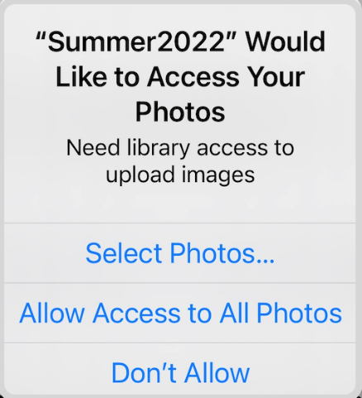

- Step-by-step Guide
The following are step by step guides on how to use the USPS Informed Delivery Visual Assistance App.

8.1. Log-in
Table 1
Logging in
Log-in Main Screen  Figure 13  Logging In  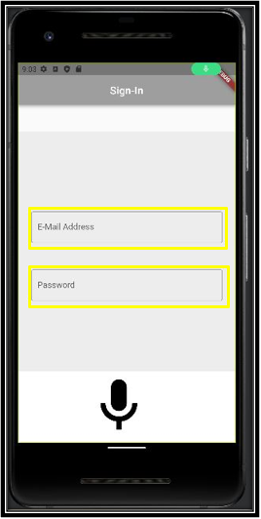 | - This is the main “Log-in” screen at the start.  - Users will be able to register for the application through the system in order to log in.  - Both a unique email address and a password are required.  - An email address and a password must be entered if a user wishes to log in.  - Those who are completely blind might require assistance from someone to complete this phase.  - If using a Gmail email account, an “app password” must be generated in order to use the app.  - To allow IMAP to process your email, go the Google Gmail Settings See all settings Forwarding and POP/IMAP Enable IMAP.  - To generate an app password Google Click on name on top right Manage your google Account Security Note* Make sure two-step verification is enable Signing into Google App passwords follow steps to generate.

8.2. Main menu

Table 2
Settings/Scan Mail/Sign Out
Screen: Main Menu | Settings
Figure 14  Settings Button  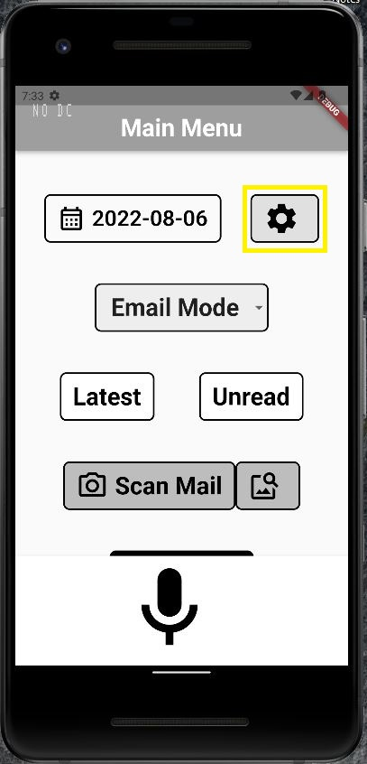 | This button allows user to access their settings. This button can be accessed two ways.  - Press the settings button and the application will navigate to the Settings Page.  - Press and hold the Microphone button and say “Settings.” The application will then navigate to the settings page. See figure 15.
Figure 15  Settings Screen  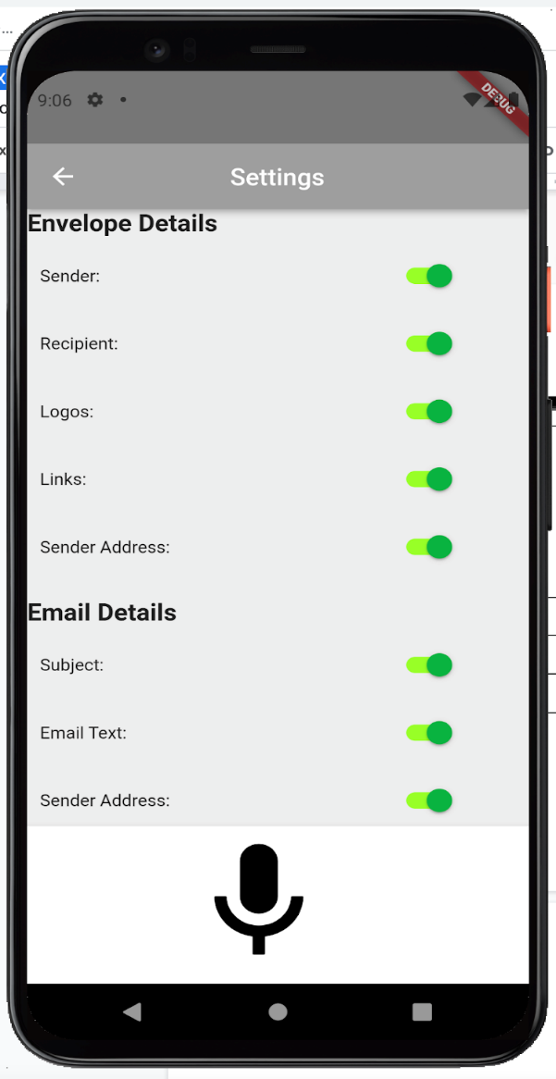 | Settings Screen
Screen: | Scan Mail
Figure 16  Scan Mail/Gallery Buttons  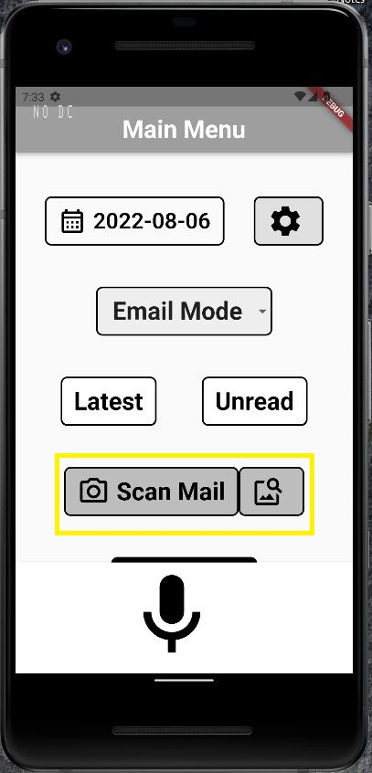 | This set of buttons allows users to Scan Mail pieces. Each button functions differently but has the same result.  - The Scan Mail button will open the user’s camera and allow them to take a picture to be scanned for mail information. The information is then read aloud to the user.  - The Gallery button to the right of the Scan Mail button will open the user’s image gallery and allow them to select an image to process for mail information. The information is then read aloud to the user.
Screen: Main Menu | Sign out
Figure 17  Sign out Button  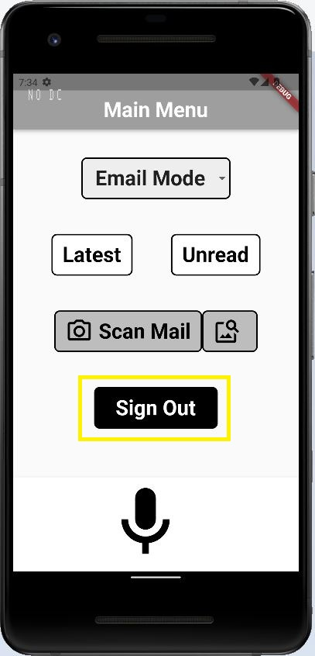 | This button allows the user to sign out of their account.  - Scroll the page down to show the Sign Out button.  - Press the Sign Out button to have the user sign out and it will then navigate to the Sign In page.

8.2.1. Digest Mode

Table 3
Digest Mode
Screen Digest Mode/Main Menu | Listening/Stop Button
Figure 18  Listening/Stop Mic Button  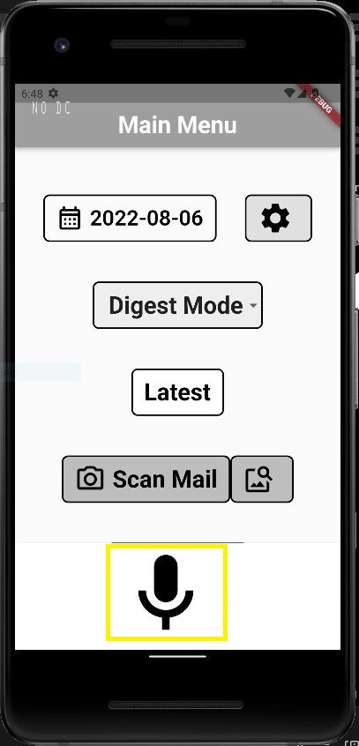 | - To stop an audio from playing, double tap the microphone button on the bottom of the screen.  - To say a command, press and hold on the microphone button. Upon release of the press the command will happen,
Screen Digest Mode/Main Menu | Latest Button
Figure 19  Latest Button  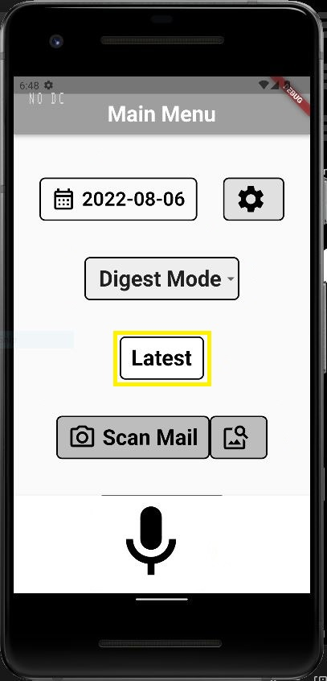 | This button retrieves the latest USPS Informed Delivery Daily Digest Email. There are two ways to use this button.  - Press and hold the microphone button, then say, “Latest Digest” and release the press. It will then navigate to the Digest Page and begin reading the mail pieces available  - Press the Latest button and it will then navigate to the Digest Page and begin reading the mail pieces available.
Screen Digest Mode/Main Menu | Date Picker
Figure 20  Date Picker  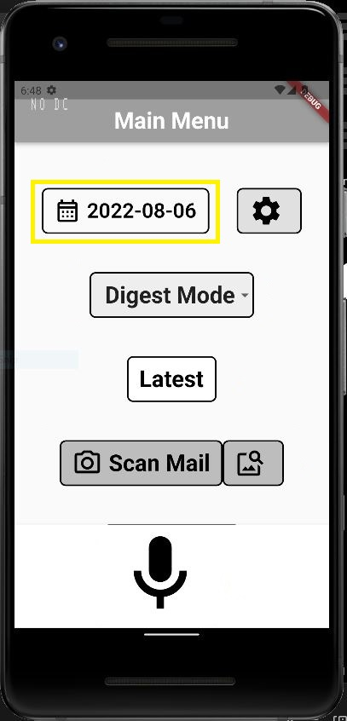 | This button allows the user to access older USPS Informed Delivery Daily Digest Emails. There are two ways to use this button.  - Press and hold the microphone button, then say “Digest Date” followed by the date and then release the button. It will navigate to the Digest Page and begin reading the available information.  - By pressing the Date button, the user will be prompted with a modal to select the date. See figure 21.
Figure 21  Date Picker Calendar  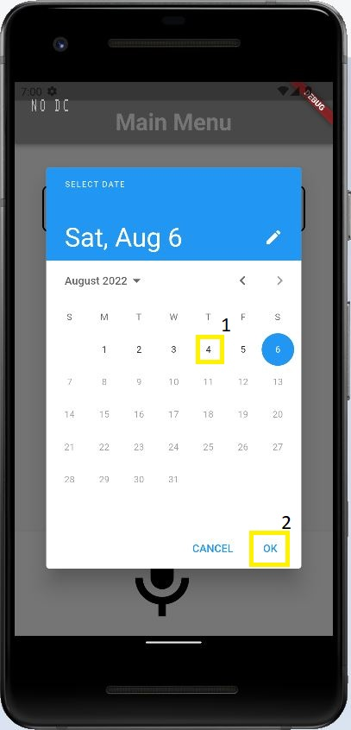 | - From this page the user can then select the desired date and then press the OK button and it will navigate to the Digest Page and begin reading the available information.

8.2.2. Email Mode

Table 4
Email Mode
Screen: Email Mode/Main Menu | Listening/Stop button
Figure 22  Listening/Stop Mic Button  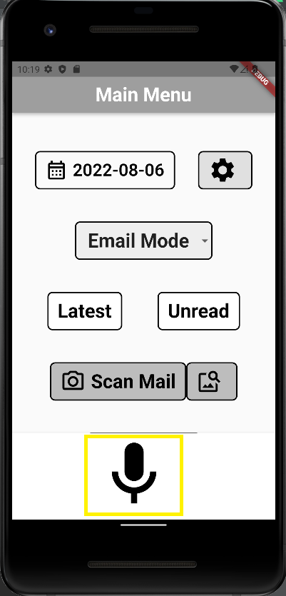 | - To stop an audio from playing, double tap the microphone button on the button of the screen.  - To say a command, press and hold on the microphone button. Upon release of the press the command will happen,

Table 5
Latest Button
Screen: Email Mode/Main Menu | Latest button
Figure 23  Latest Button  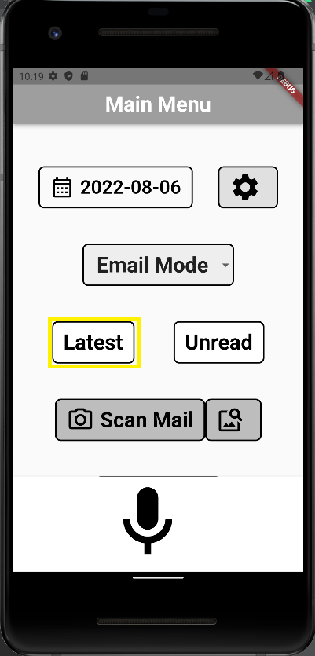 | This button retrieves all emails for the current date. There are two ways to use this button.  - Press and hold the microphone button, then say, “Latest Email” and release the press. It will navigate to the Email Mode details screen that will audibly read the emails for the current date.  - Press the Latest button and it will navigate to Email Mode details screen that will audibly read the emails for the current date.

Table 6
Unread Button
Screen: Email Mode/Main Menu | Unread button
Figure 24  Unread Button  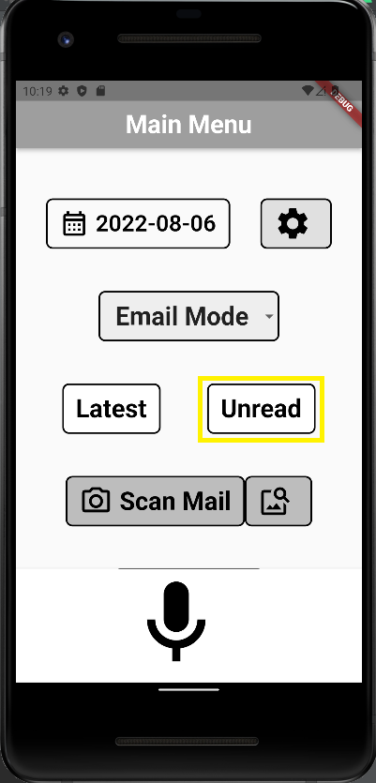 | The unread button retrieves all email that the user has not read. However, once it is read on the app it is not marked as read. Like the latest button, this button has two ways to use it.  - Press and hold the microphone button, then say, “Unread Email” and release the press. It will navigate to the Email Mode details screen that will audibly read the unread emails for the current date.  - Press the Unread button and it will navigate to Email Mode details screen that will audibly read the unread emails for the current date.

Table 7
Date Picker
Screen: Email Mode/Main Menu | Date Picker
Figure 25  Date Picker Calendar   | To check emails for a specific date, the date picker can be used.  - Choose the date.  - Click OK.  It will navigate to the Email Page and begin reading the available information.

8.4. Digest Email Details
To view or listen to the USPS Informed Delivery Daily Digest email details or navigate from one page to another, follow the steps shown in Figures 1-7 below.

Table 8
Digest Email details
Screen: Listening to the current daily digest email details.
Figure 26  All Details Button  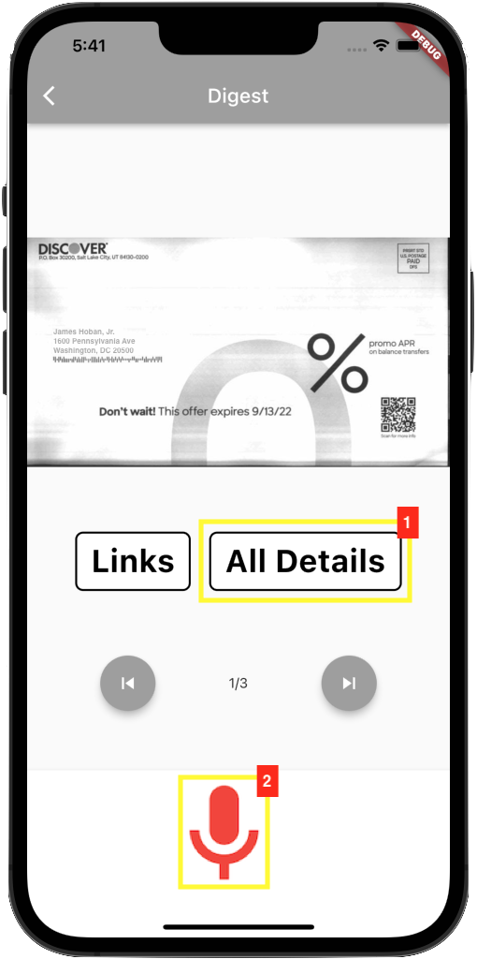 | - Press the “All Details” button to audibly read the current daily digest email details, or;  - Press and hold the microphone button until it turns red, then say “Details” or other voice commands below and release the press to audibly read the current daily digest email details.  - Say “Sender name” to audibly read the sender's name for the current digest.  - Say “Recipient name” to audibly read the recipient's name for the current digest.  - Say “Sender address” to audibly read the sender's address for the current digest.  - Say “Recipient address” to audibly read the recipient address for the current digest.  - Say “Sender validated” to audibly read if the sender's address for the current digest was validated.  - Say “Recipient validated” to audibly read if the recipient's address for the current digest was validated.  - Say “Logo” to audibly read the logos for the current digest.

Table 9
Links
Screen: Viewing or listening to the current daily digest email hyperlinks.
Figure 27  Links Button  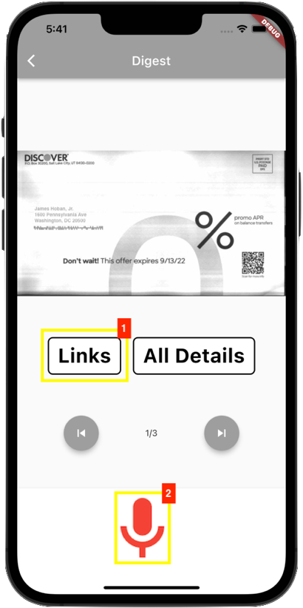 | - Press the “Links” button to go to the hyperlinks dialog page and audibly read the current daily digest email hyperlinks, or;  - Press and hold the microphone button until it turns red, then say “Hyperlinks” and release the press to go to the hyperlinks dialog page (Figure 28) and audibly read the current daily digest email hyperlinks.
Figure 28  Hyperlinks Dialog  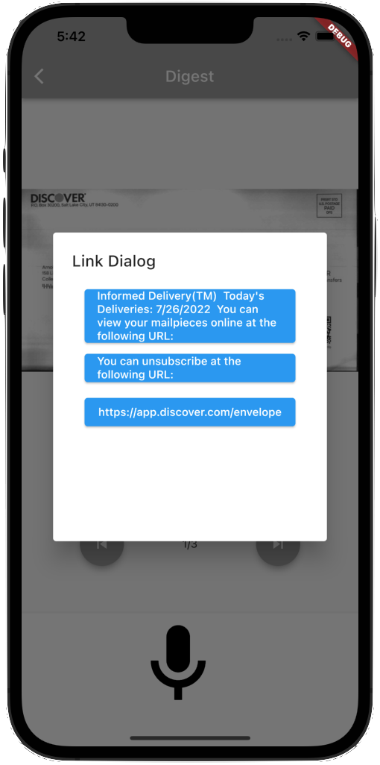 | This is the current daily digest email hyperlink dialog page.  Tap outside the link dialog box to go back to the current daily digest email page.

Table 10
Stopping Audio
Screen: Stopping the current daily digest email details audio from playing.
Figure 29  Double Tap to Stop Audio  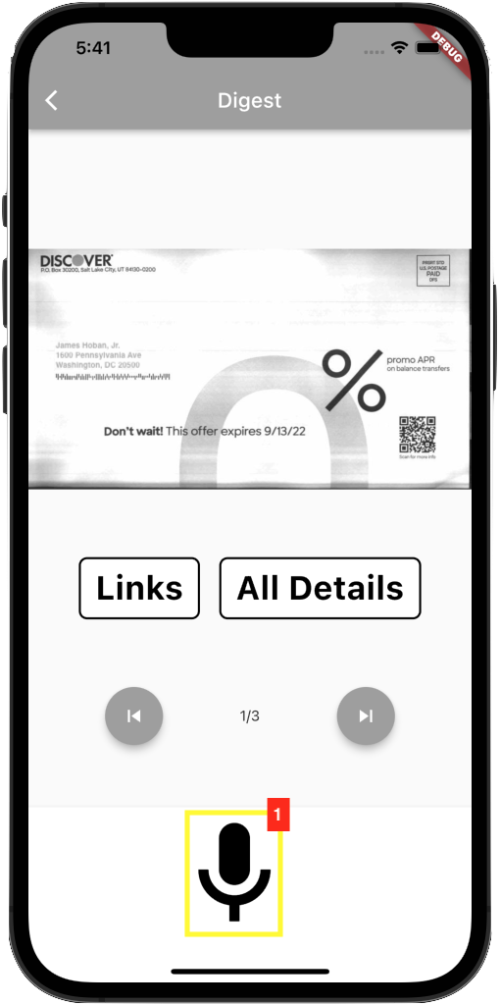 | - Double tap on the microphone button to stop the current daily digest email details audio from playing.

Table 11
Previous Command
Screen: Viewing or listening to the previous daily digest email details.
Figure 30  Previous Button  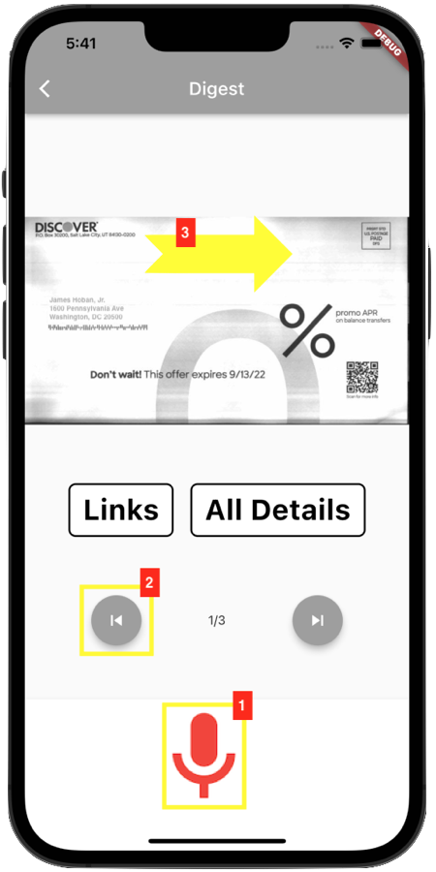 | - Press and hold the microphone button until it turns red, then say “Previous” and release the press to go the previous page and audibly read the previous daily digest email details, or;  - Press the previous button to go the previous page and audibly read the previous daily digest email details, or;  - Swipe right to go to the previous and audibly read the previous daily digest email details.

Table 12
Next Command
Screen: Viewing or listening to the next daily digest email details.
Figure 31  Next Button  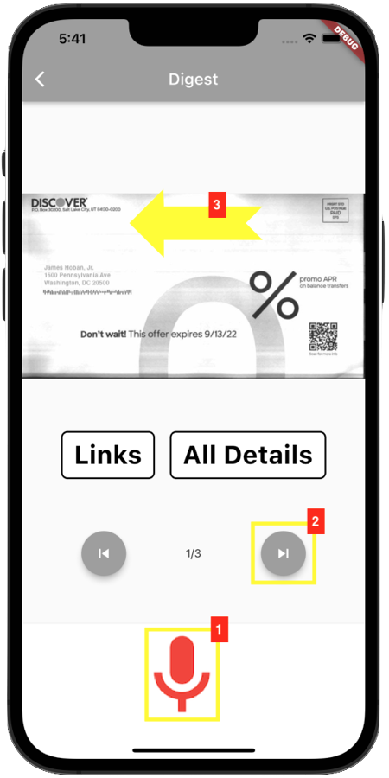 | - Press and hold the microphone button until it turns red, then say “Next” and release the press to go the next page and audibly read the next daily digest email details, or.  - Press the next button to go the next page and audibly read the next daily digest email details, or.  - Swipe left to go the next and audibly read the next daily digest email details.

Table 13
Help Command
Command: Listening to the digest help commands.
Figure 32  Press and hold to say "Help" Command  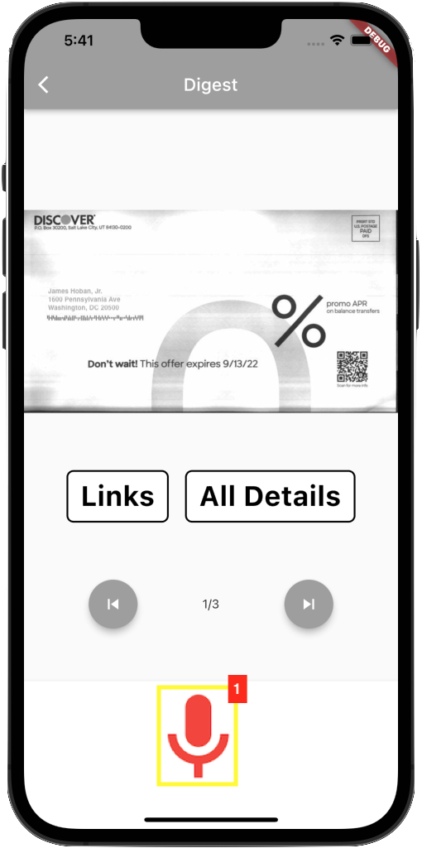 | - Press and hold the microphone button until it turns red, then say “Help” and release the press to listen to the digest help commands.

Table 14
Back Command
Command: Returning to the main screen.
Figure 33  Press and hold to say "Back" Command  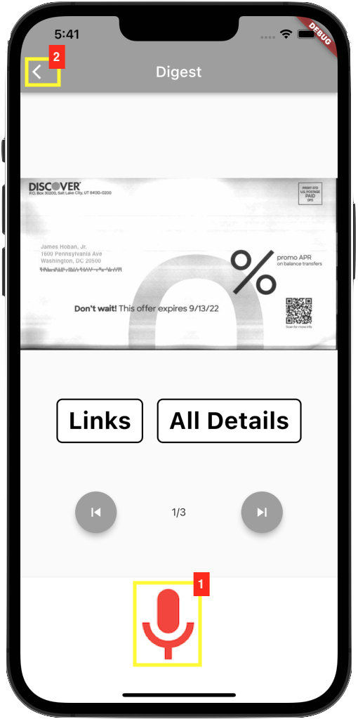 | - Press and hold the microphone button until it turns red, then say “Back” and release the press to go the main screen, or;  - Press the back button to go to the main screen.

8.5. Other Email Details
To view or listen to the other email details or navigate from one page to another, follow the steps shown in Figures 34-39 below.

Table 15
Email Details Commands
Screen: Listening to the current other email details.
Figure 34  Email details Commands  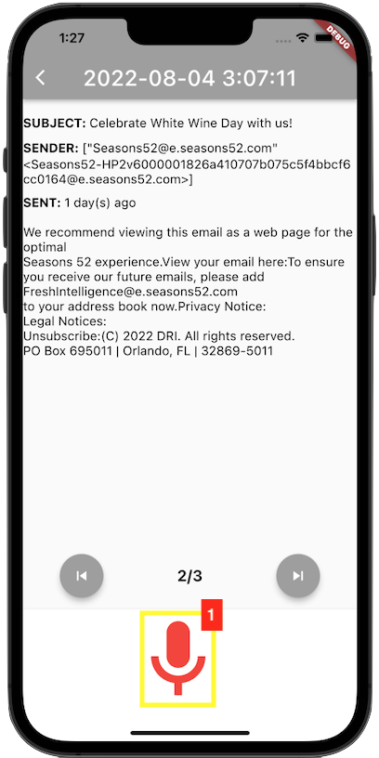 | - Press and hold the microphone button until it turns red, then say “Details” or other voice commands below and release the press to audibly read the current other email details.  - Say “Subject” to audibly read the email subject line.  - Say “Sender name” to audibly read the email sender's name.  - Say “Recipient name” to audibly read the email recipient's name.  - Say “Text” to audibly read the email text.

Table 16
Stop command
Command: Stopping the current other email details audio from playing.
Figure 35  "Stop" Command  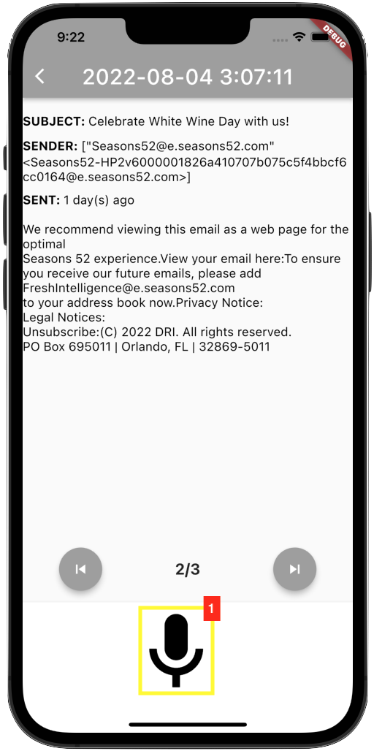 | - Double tap on the microphone button to stop the current other email details audio from playing.

Table 17
Previous Swipe/Command/Button
Screen: Viewing or listening to the previous other email details.
Figure 36  Previous Swipe/Command/Button  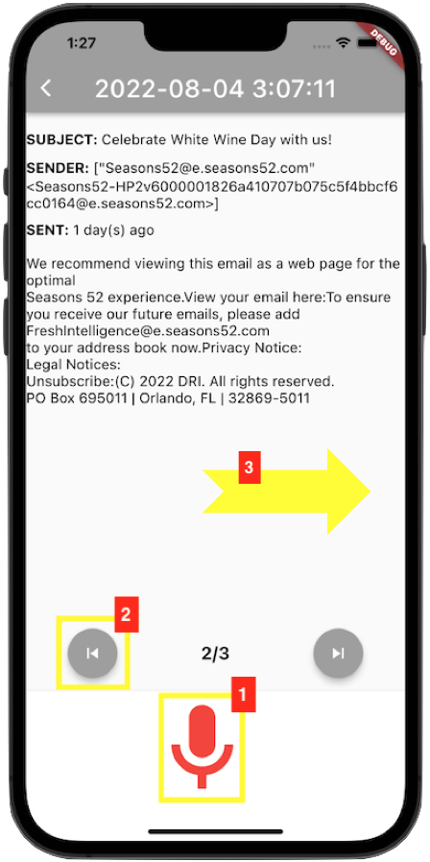 | - Press and hold the microphone button until it turns red, then say “Previous” and release the press to go the previous page and audibly read the previous other email details, or;  - Press the previous button to go the previous page and audibly read the previous other email details, or;  - Swipe right to go to the previous and audibly read the previous other email details.

Table 18
Next Swipe/Command/Button
Screen: Viewing or listening to the next other email details.
Figure 37  Next Swipe/Command/Button  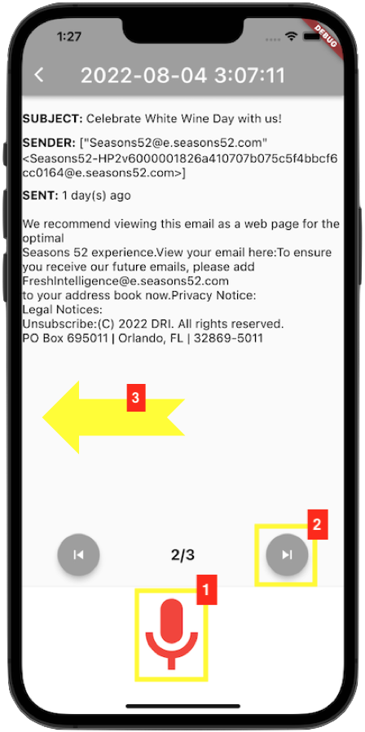 | - Press and hold the microphone button until it turns red, then say “Next” and release the press to go the next page and audibly read the next other email details, or;  - Press the next button to go the next page and audibly read the next other email details, or;  - Swipe left to go the next and audibly read the next other email details.

Table 19
Help Command
Command: Listening to the email help commands.
Figure 38  "Help" Command  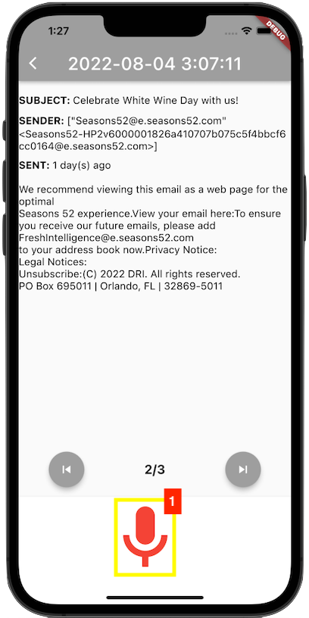 | - Press and hold the microphone button until it turns red, then say “Help” and release the press to listen to the email help commands.

Table 20
Back Command
Command: Returning to the main screen.
Figure 39  "Back" Command/Button  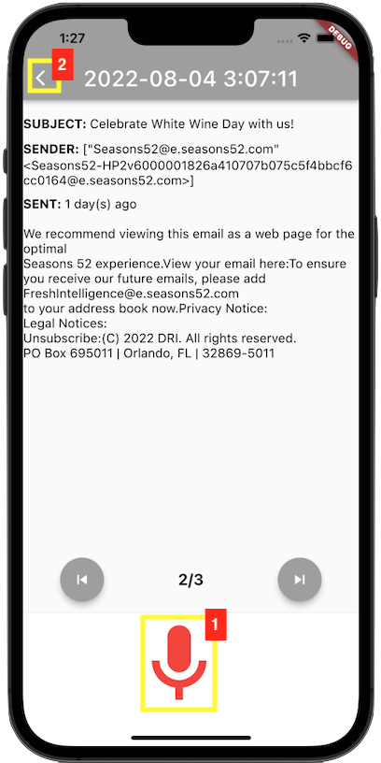 | - Press and hold the microphone button until it turns red, then say “Back” and release the press to go the main screen, or;  - Press the back button to go to the main screen.

8.6. Settings
The following table and figures depict and shows the guide to using the settings screen.
Table 21
Settings Menu
Screen: Settings Menu | Menu
Figure 40  Settings Screen   | To reach the menu, the user has either clicked the “Settings” icon on the main menu or used the “Settings” voice command with the microphone button  The Settings menu allows the user to customize their experience with the application, by enabling or disabling details for the readout of their Daily Digest mail pieces and general emails. The two main sections of the menu are:  - Envelope Details  - Email Details
Screen: Settings Menu | Envelope Details
Figure 41  Envelope Details  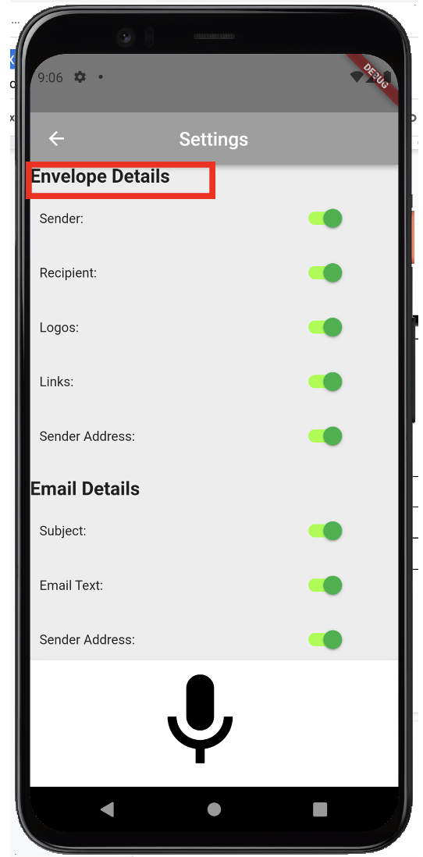 | The Envelope Details section groups the settings for mail piece data read from USPS Daily Digest emails. Attributes include:  - Sender: States the sender’s name  - Recipient: States the recipient’s name  - Logos: States the logos on the mail piece  - Links: States the links available from the mail piece  - Sender Address: States the sender’s address  Each attribute can be enabled or disabled using a material design switch component. The switch is green and toggled to the right, if the attribute is enabled. Otherwise, the switch is gray and toggled to the left.
Screen: Settings Menu | Email Details
Figure 42  Email Details  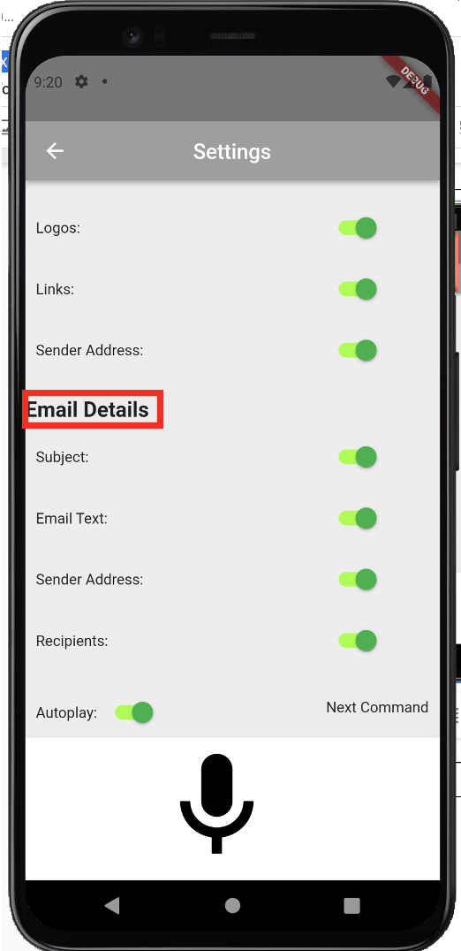 | The Email Details section groups the settings for emails read by the application. Attributes include:  - Subject: States the subject line of the email  - Email Text: States the email body  - Sender Address: States the sender’s email address  - Recipients: States the recipients of the email  - Autoplay: Reads the emails for the given date consecutively (if enabled)  Each attribute can be enabled or disabled using a material design switch component. The switch is green and toggled to the right, if the attribute is enabled. Otherwise, the switch is gray and toggled to the left.
Screen: Settings Menu | Disable Attribute
Figure 43  Subject Off Command  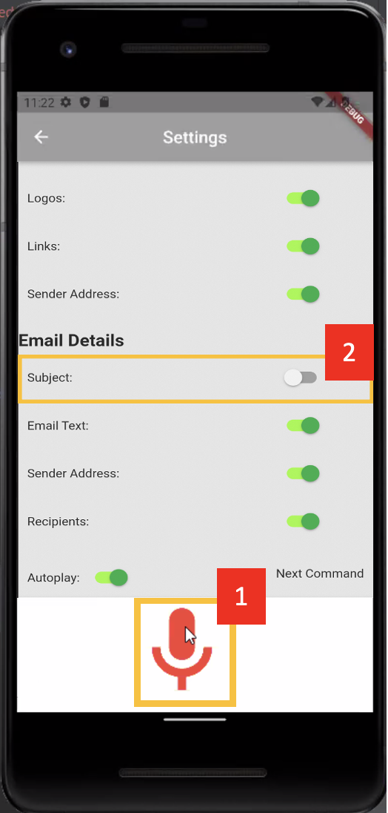 | To disable an attribute, state the name of the attribute, followed by the word “off.” Attributes in the Email Details section, except Autoplay, should be preceded by the word “email.”  For instance, to disable the Subject:  - Press and hold the microphone button until it turns red, then say, “Email Subject Off” and release the press to automatically toggle the Subject to a disabled state. Or.  - Toggle the switch for the Subject attribute, so that it is gray and toggled to the left
Screen: Settings Menu | Enable Attribute
Figure 44  Subject On Command  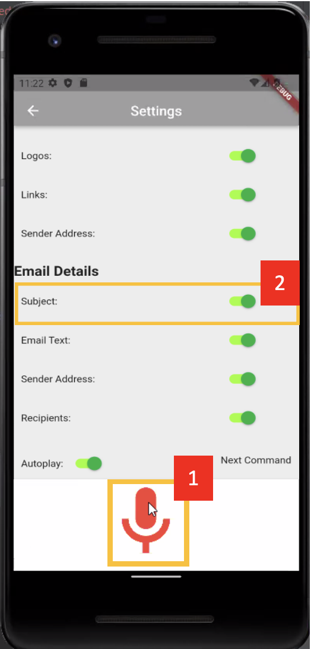 | To enable an attribute, state the name of the attribute, followed by the word “on.” Attributes in the Email Details section, except Autoplay, should be preceded by the word “email.”  For instance, to enable the Subject:  - Press and hold the microphone button until it turns red, then say, “Email Subject On” and release the press to automatically toggle the Subject to an enabled state. Or.  - Toggle the switch for the Subject attribute, so that it is green and toggled to the right

9. Troubleshooting
This section is to help with issues that may occur while using the app.

9.1 Application crashes unexpectedly.

Force stops the app by clearing it from the device recently used APPs. then restart the app.

9.2 Application is not recording speech or not audibly reading.

Check to make sure permissions to use speech recognition and the device mic was granted. This differs per device, iOS, or Android. If using the emulator, clear the data on the emulator, and restart the application.

