Software Requirements Specifications
Usps imformed delivery app – visually impaired
Presented by: Team Arch: Reshawna Sampson, Barry Gartrell, Sheena Johnpeter, Stanley De Jesus, Ananya Srinivasan, Arnold Detoito
2022

Table of Contents
1. Introduction 3
1.1 Purpose 3
1.2 Product Scope 3
1.3 Intended Audience 4
1.4 Acronyms and Definitions 4
2. Overall Description 5
2.1 Product Perspective 5
2.2 Product Features 5
2.3 User Classes and Characteristics 6
2.4 Operating Environment 6
2.5 Design and Implementation Constraints 6
2.6 User Documentation 7
2.7 Assumptions and Dependencies 7
3. System Features 8
3.1 Gets the images from the Informed Delivery daily digest, and runs image processing software on it to detect the sender’s logos, typed text, or handwritten text to recognize the sender and recipient’s information to read it audibly to the user. 8
3.2 Scans an image of a mail through the phone camera and read aloud the contents of the scanned piece. 8
3.3 Read any QR codes or barcodes on the mail pieces and offer the user to visit those websites. 8
4. 9External Interface Requirements 9
4.1 Application Programming Interfaces 9
4.2 Software Interfaces (SWI) 9
5. System Features/Modules 11
5.1 Daily Digest Reader 11
5.2 Sender/Recipient Information Scan Reader 11
5.3 Image Scan Reader 12
5.4 QR code / Barcode Reader 12
6. Use Cases for User/System Interface………………………………………………………13
6.1.1 Use Case Name: Main Window “Play Latest” Button 13
6.1.2 Use Case Name: Main Window “Camera” Button 15
6.2 UML Diagram 15
7. Nonfunctional Requirements 17
7.1 Performance 17
7.2 Security 17
7.3 Quality 18
7.4 1Maintainability 18
8 References 18

Revision History
Date | Version | Reason | Approved By
6/1/2022 | 1.0 | Initial Document | Reshawna Sampson (Project Manager)
6/16/2022 | 1.1 | Added Milestone 1 feedback | Reshawna Sampson (Project Manager)
6/25/2022 | 1.2 | Added feedback from Milestone 2 and the updated UI images. | Reshawna Sampson  (Project Manager)
7/29/2022 | 1.3 | Updated UI and APA format for tables and images | Reshawna Sampson (Project Manager)

Introduction

1.1 Purpose
The purpose of this Software Requirements Specification (SRS) document is to describe the requirements that have been committed for the initial release of the USPS Informed Delivery mobile application. Informed Delivery is a service that allows USPS consumers to view images of their mail and receive tracking updates for their incoming packages in a daily email format. To make the service more accessible for visually impaired consumers, USPS intends to create a mobile application that would read the user’s Informed Delivery Daily Digest email from their inbox or mail piece image from their phone camera and provide pertinent information to the user. Features for this application were divided among two project teams: Team A and Team One. This SRS document will provide the requirements that are to be implemented and validated by Team A.

Product Scope
The scope of Team A’s implementation for the USPS Informed Delivery application revolves around three main requirements:

SRS-01: The application receives mail piece images from the Informed Delivery Daily Digest emails in the user’s inbox, runs image processing software on the image to detect sender’s logos, typed text, or handwritten text, to determine the sender and recipient’s information, and reads this information audibly to the user.

SRS-02: The application scans an image of a mail piece through the user’s phone camera, recognizes text from mail piece using image processing software, and reads aloud the contents of the scanned piece.

SRS-03: The application reads any QR codes or barcodes on the mail pieces and offers the user to visit those websites.

Further sections of this document will classify these requirements into functional and nonfunctional requirements and elaborate on the product features corresponding to these requirements.

Intended Audience
The intended audience of this SRS document is the development team, Team A. which consists of business analysts, developers, testers, and a project manager. This document provides the scope of requirements along with their descriptions, corresponding features, and their classification as functional, non-functional, or external interface requirements. The project team will refer to this document throughout the software development lifecycle, to ensure that the application implementation aligns with the outlined requirements. More specifically, the project manager and developers are expected to review the document in its entirety, while other members of the team would benefit from reviewing specific sections. An application tester, for instance, can get a better understanding of the system features they need to test by reviewing the System Features section of the SRS.

Acronyms and Definitions
CE – Code Editor
GCP – Google Cloud Services Platform
HI – Hardware Interface
IDE - Integrated Development Environment
iOS – iPhone Operating System
SI – Software Interface
SRS – Software Requirements Specification
UML - Unified Modeling Language
QR - Quick Response
ML – Machine Learning

Overall Description

Product Perspective
One of the challenges that the visually impaired individuals face is dealing with vision loss or poor vision. In everyday life, people with disabilities confront a variety of challenges. In the United States, over 12 million people aged 40 and up suffer from vision impairment (CDC.com). While smartphones are useful in everyday life, it may be difficult or impossible for visually challenged people to utilize them.

The major goal of Team A is to develop the USPS Informed Delivery Mobile application, a cross-platform mobile application that will inform visually impaired individuals about what is in their mailboxes. Additionally, the mobile application will notify visually impaired individuals when a daily digest email arrives, provide an audio explanation of their Informed Delivery Daily Digest emails, and deliver images of mails via a user-friendly mobile application in order to meet the demands.

Product Features
The main focus of the USPS Informed Delivery Mobile Application will be on the following five core product features:

- Recognize the sender’s and recipient’s information: The application shall be able to scan an image from the user’s email in order to recognize and read out the sender’s and recipient’s information to the user.

- Recognize written content: The application shall be able to recognize written material by scanning an image from the user’s email and reading it out to the user.

- Recognize handwritten content: The application shall be able to recognize handwritten material by scanning an image from the user’s email and reading it out to the user.

- Scans an image of a mail: The application shall be capable of scanning an image of an email using the user’s phone camera and reading the text aloud to the user.

- Reads QR codes/Barcodes: The application shall be able to read QR codes or barcodes and redirect users to the website.

User Classes and Characteristics
User: A visually impaired individual who receives help through the USPS Informed Delivery Mobile Application is referred to as a “User.” Users in this group may not be familiar with smartphones; as a result, the UI/UX design should be able to demonstrate how simple it is to understand and use for the first-time user. From any window, the user may utilize the voice command button (mic button) to communicate verbally. The user may also obtain help on the functions by pressing the help button. All of these will be considered in the design.

Project Manager/Business Analyst/Developers/Testers: Users that aim to update and maintain the system include project manager, business analysts, developers, and testers.

Operating Environment
The following are the United States Postal Service® (USPS) Informed Delivery application's operating environment considerations.

OE-1: The United States Postal Service® (USPS) Informed Delivery application shall be designed to ne compatible with Apple iOS and Google Android operating systems.

Design and Implementation Constraints
The following are the United States Postal Service® (USPS) Informed Delivery application's design and implementation constraints.

IC-1: The United States Postal Service® (USPS) Informed Delivery application shall be compatible with Apple iOS and Google Android operating systems.

IC-2: The United States Postal Service® (USPS) Informed Delivery application shall be implemented in Dart programming language using Flutter framework.

User Documentation
The following are the United States Postal Service® (USPS) Informed Delivery application's user documentations.

UD-1: The United States Postal Service® (USPS) Informed Delivery application shall provide an audible help feature that describes all application functionalities.

UD-2: The United States Postal Service® (USPS) Informed Delivery application shall provide first time end user an audible tutorial to setup the account access to the application.

UD-3: The United States Postal Service® (USPS) Informed Delivery application shall provide a document describing all features and functionalities of the app.

Assumptions and Dependencies
The following are the United States Postal Service® (USPS) Informed Delivery application's assumptions and dependencies:

AS-1: The United States Postal Service® (USPS) Informed Delivery application must be downloadable 24 hours a day and 7 days a week from Apple Store or Google Play Store.

AS-2: The end user must be an owner of compatible Apple and/or Android devices.

AS-3: The end user must be connected to the Internet to be able to use the application functionalities.

DE-1: The operation of the United States Postal Service® (USPS) Informed Delivery application depends on complete integration of the end user’s email boxes.

System Features
The following are sections of the major system features of the USPS Informed Delivery App.

Gets the images from the Informed Delivery daily digest, and runs image processing software on it to detect the sender’s logos, typed text, or handwritten text to recognize the sender and recipient’s information to read it audibly to the user.
Assuming that the user has given the app permission to access their email and speaker, this functionality allows the user to audibly hear a brief overview of the mail that is going to be in their mailbox.

Scans an image of a mail through the phone camera and read aloud the contents of the scanned piece.
Assuming that the user has given the app permission to access their camera and speaker, this functionality allows the user to use their camera to scan any mail piece and have the contest audibly read to them.

Read any QR codes or barcodes on the mail pieces and offer the user to visit those websites.
Assuming that the user has given the app permission to access their camera and speaker, this functionality allows the user to use their camera to scan QR codes or barcodes on mail pieces and be audibly asked if they would like to visit the websites linked to the QR codes or barcode.

External Interface Requirements

Application Programming Interfaces
The application will be interfacing with Google's Cloud Services Platform (GCP). There are four services API suites that we will be connecting to. These are Cloud Vision, Cloud Storage, Google Maps, Speech-to Text.
API-1: The Cloud Vision perform image content analysis feature to integrate image labeling, face, logo, landmark detection, and optical character recognition (OCR).
API-2: Cloud Storage provides access to highly durable data storage. It will used as a data placeholder that will be processed by Cloud Vision.,
API-3: Google Map is used to confirm whether the address on mail is accurate.
API-4: Speech-to-Text is used to convert audio content to text.
Cloud solutions are used because of their Machine Learning capability, which provides more accurate information than their mobile stand-alone versions.

4.2 Software Interfaces (SWI)
SWI-1: The system shall be developed as an Android and iOS mobile application, which will be installed on smartphones running on the following Android operating systems: Android 7.0 Nougat, Android 8.0 Oreo, Android 9.0 Pie, Android 10, Android 11, Android 12, iOS10, iOS11, and iOS12.

SWI-2: The system will interface with the open-source Flutter framework, Dart plugins, and libraries.

SWI-3: The system with interface with GCP "Speech-to-Text." to more accurately convert speech to text.

SWI-4: The system will not use a database.

SWI-5: The Android Studio integrated development environment (IDE), and Visual Studio Code Editor (CE) will be used to develop the application. Both environments interoperate well with the Flutter framework and Dart language development.

SWI-6: The Android emulator will be used to test the application on a virtual smartphone, enabling faster development and testing. Additionally, the Android emulator allows testing with different screen sizes and Android operating system versions.

SWI-7: A GitHub repository will be used to manage the application codebase, change versioning, builds, and releases.

SWI-8: The systems will interface with Google Cloud Storage to temporarily store content that will be analyzed by Google Vision.

SWI-9: The system will interface will communicate to the user using the Flutter_TTS package to convert text to speech.

4.3 Communication Interfaces

CI-1: The application shall interface using the smartphone's microphone to capture the user spoken words and translate them into action phrases.

CI-2: The application shall interface with the smartphone's speakers to communicate assisting audio messages to the user

CI-3: The system shall interface with the smartphone network modules to establish an internet connection.

CI-4: The system shall interface with the Google Vision API to scan image to text.

CI-5: The system shall interface with the USPS Address Validation API to validate the addresses.

CI-6: The system shall interface with Google ML Kit to scan and process QR codes and barcodes.

5 System Features/Modules

5.1 Daily Digest Reader
5.1.1 Description and Priority
This feature is used when the user request that their Informed Delivery Daily Digest is read out to them. The application will scan the email and then give an audio response to the user. Priority: High.
5.1.2 Stimulus/Response Sequences
Stimulus: The user selects the option to have their daily digest read to them.
Response: The system compiles the information from the daily digest and audibly reads the information.
Stimulus: The user audibly selects the option to have their daily digest read to them.
Response: The system compiles the information from the daily digest and audibly reads the information.
5.1.3 Functional Requirements
REQ-1.1: When the user selects the option to have their daily digest read to them, the system shall compile the information from the daily digest and audibly read the information.
REQ-1.2: When the user audibly selects the option to have their daily digest read to them, the system shall compile the information from the daily digest and audibly read the information.
REQ-1.3: When the system compiles the information it will check against the other reader functionality. In these cases, the system will provide itself with the stimulus for these functions.

5.2 Sender/Recipient Information Scan Reader
5.2.1 Description and Priority
This feature will allow the application to read the sender/recipient information from a scan of a piece of mail. This scan can either come from the user directly or from the Daily Digest Email. Priority: High.

5.2.2 Stimulus/Response Sequences
Stimulus: The user provides a scan of a piece of mail.
Response: The System produces the information to be read audibly by the system.
5.2.3 Functional Requirements
REQ-2.1: When the user provides a scan of a piece of mail, the system shall produce the information to be read audibly by the system.
REQ-2.2: If the scan is coming from the user’s camera and the read is invalid the user will be audibly notified.

5.3 Image Scan Reader
5.3.1 Description and Priority
This feature will allow the application to read image scans for information about company logos or other information. The scan can come from either the user or the Daily Digest Email. Priority: High
5.3.2 Stimulus/Response Sequences
Stimulus: The user provides a scan of an image.
Response: The System produces information to be read audibly to the user.
5.3.3 Functional Requirements
REQ-3.1: When the user provides a scan of an image, the system shall produce information to be read audibly to the user.
REQ-3.2: If the scan is coming from the user’s camera and the read is invalid the user will be audibly notified.

5.4 QR code / Barcode Reader
5.4.1 Description and Priority
This feature will allow the application to read QR codes or Barcodes scans. Once read the user will be prompted if they want to navigate to the website associated with the QR code/Barcode. These scans can come from either the User or the Daily Digest Email. Priority: High

5.4.2 Stimulus/Response Sequences
Stimulus: The user provides a scan of a QR code.
Response: The system will prompt the user with the option to navigate to the website associated with the QR code.
Stimulus: The user provides a scan of a Barcode.
Response: The system will prompt the user with the option to navigate to the website associated with the Barcode.
5.4.3 Functional Requirements
REQ-4.1: When the user provides a scan of a QR code, the system will prompt the user with the option to navigate to the website associated with the QR code.
REQ-4.2: When the user provides a scan of a Barcode, the system will prompt the user with the option to navigate to the website associated with the Barcode.
REQ-4.3: If the scan is coming from the user’s camera and the read is invalid the user will be audibly notified.

- Use Cases for User/System Interface

  - User Interface Overview
The features will initially be developed as standalone applications called widgets. These widgets will then be integrated and modified to interface with Team B's User Interface. The user interface will consist of buttons and icons to input information for transport to GCP for processing.

6.1.1 Use Case Name: Main Window “Unread Mail” Or “Latest Mail” Buttons

Summary: The actor clicks on the “Unread Mail” or “Latest Mail” Button on the main window.
Preconditions: The user must be on the main window screen
Triggers: The actor clicks on the “Play Latest” button

Basic course of events (Main Window “Latest” Button scenario):

Table 1
Digest Mode
Actor | System | Screen
1. The actor clicks the “Latest” button or presses and hold the mic and say “Latest Digest” on the main window or the user says “digest date July 15 2022”. |  | 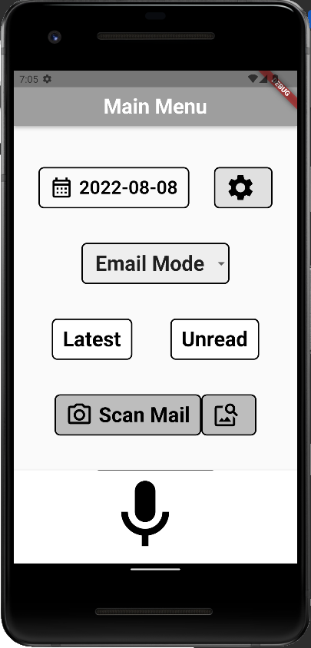
 | 2. The system locates the latest email.  3. After loading the email, it sends it to GCP features for processing to check for any artifacts (QR code, logos, etc.).  4. Once it receives results, it will send the result to GCP to be read and convert the outcome to voice.  5. The application will audibly tell the user about the email context, such as the sender and recipient contact information. | 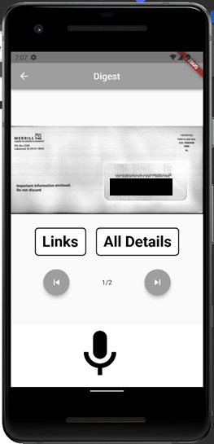

6.1.2 Use Case Name: Main Window “Scan Mail” Button

Summary: The actor clicks on the “Camera” button on the main window.
Preconditions: The user must be on the main window or menu screens
Triggers: The actor clicks on the “Inbox” Button.
Basic course of events (Main Window “Camera” Button scenario):

Table 2
Scan Mail
Actor | System | Screen
1. The actor clicks the scan mail button on the main window. |  | 
 | 2. The system turns on the camera screen.
3. The user will scan the mail per the general mail guidance (sender – top left and recipient – top right)
4. The system will send the picture to GCP for image to text processing.

5. The system then sends the results for processing to GCP OCR to audibly inform the user of who is the sender and recipient of the mail.

  - UML Diagram

The UML diagram is used to visualize the planned internal architecture of the USPS Informed Delivery App GCP data flow.

Figure 1
UML of USPS Informed Delivery Visual Assistance App
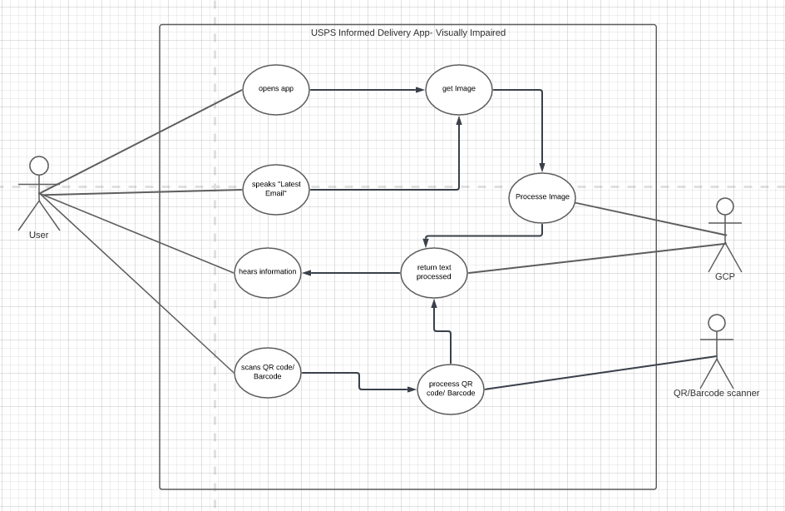
    - Design Architecture of the GCP Dataflow

The architectural design in figure 2 and the sequence diagram in figure 3 depicts the back-end components of the USPS Informed Delivery App. It also shows the flow of data from retrieving the data to the output of the returned data.

Figure 2
Architecture Design of the GCP
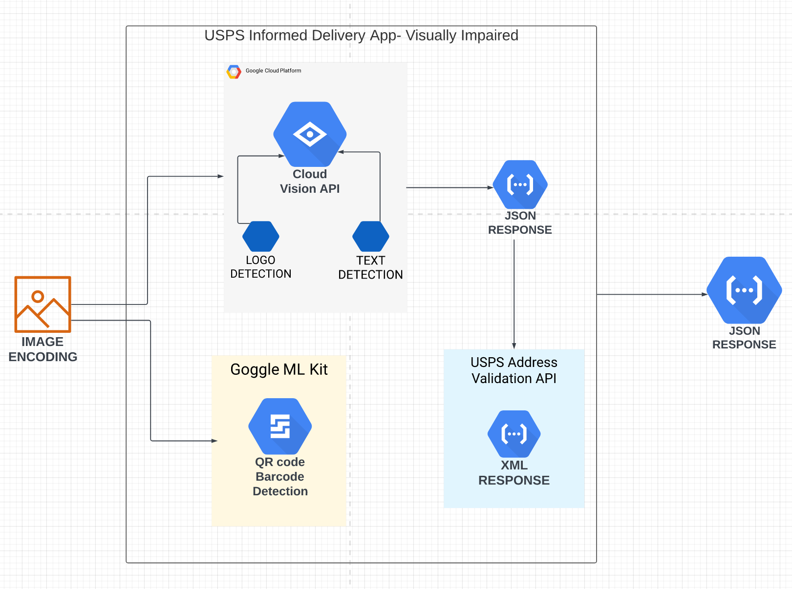

The following image shows a sequence diagram to further illustrate the GVP Vision.

Figure 3
Sequence Diagram
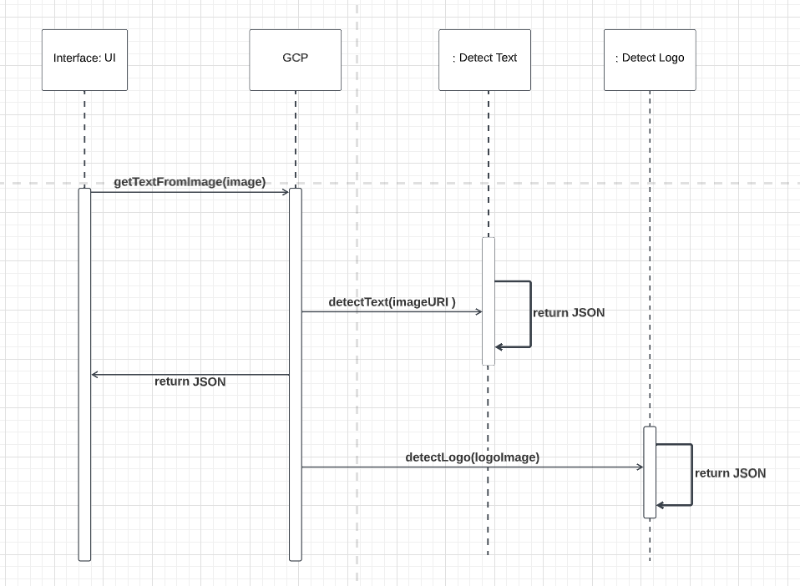

7. Nonfunctional Requirements

7.1 Performance
NF-1.1: UI responses to user interaction shall not exceed 2-3 seconds.

7.2 Security
NF-2.1 All incoming data related to user email shall be encrypted by POP3 or IMAP protocols.

NF-2.2 The application shall not store or share any of the recorded voice to limit the risk of sharing Personal Identifiable Information (PII).

NF- 2.3 The Application shall only be available on official Apple and Google Play stores

7.3 Quality
NF-:3.1 The system shall comply with 508 specifications to ensure that it is easy to use by individuals with a visual disability.

7.4 Maintainability
NF-4.1: There shall be comprehensive documents that shall capture the business and technical requirements of the system.

NF-4.2: Documents shall be revisited and updated periodically before proposed changes are made to the system.

8 References
Amazing. (2021, July 2). Memory Enhancer Application - Software Requirements Specification. Retrieved from https://umgc-cappms.azurewebsites.net/download/b1497111-ddf1-4b9a-ac5d-71d2021f811f----SoftwareRequirementsSpecification_TeamAmazing_v1_1.pdf

Fast Facts of Common Eye Disorders | CDC. (n.d.). CDC. Retrieved May 31, 2022, from https://www.cdc.gov/visionhealth/basics/ced/fastfacts.htm#:%7E:text=Approximately%2012%20million%20people%2040,due%20to%20uncorrected%20refractive%20error.
Purdue Writing Lab. (n.d.). APA tables and figures // Purdue Writing Lab. Purdue Writing Lab. Retrieved July 29, 2022, from https://owl.purdue.edu/owl/research_and_citation/apa_style/apa_formatting_and_style_guide/apa_tables_and_figures.html

