​


Test Report
Memory Magic App

Project name: Memory Magic Application

Date: November 2, 2021

Project Manager: Presley Muwan

Phase: Design & Implementation

Revision History
Version Number | Date | Description | Approved By
1.0 | 11/02/2021 | Test Report | Presley Muwan

Table of Contents
Introduction 4
1.1 Purpose 4
1.2 Application Overview 4
1.3 Technical Project Stakeholders 4
Types of Testing 5
2.1 Unit Testing 5
2.2 Integration Testing 5
2.3 User Acceptance Testing 5
Items Not Tested 5
User Acceptance testing 6
4.1 NLU Interaction 6
4.2 Access Permissions to device resources 7
4.3 Activate and deactivate listening mode 9
4.4 Type in notes 10
4.5 Transcribe notes 11
4.6 Edit and Delete notes 13
4.7 Onboarding 14
4.8 Support for multiple languages 15
4.9 Notifications 16
4.10 Display Events on Calendar 18
4.11 Display Events on Checklist 19
4.12 Change Theme Settings 21
4.13 Change General Settings 22
4.14 Search notes 23
4.15 Help 25
Unit Testing 26
Defects Identified 26
Exit Criteria 26
Appendices 26
7.1 Credits & Contributions 26

Introduction

1.1 Purpose
The purpose of this test report is to document the testing strategy and results for the Memory Magic Application. The types of testing completed, items not tested, and results of tested features are also featured in this report.

1.2 Application Overview
The Memory Magic application was developed for the UMGC Software Engineering Project Fall 2021 term application team. The requirements for the project were presented by Dr. Mir Assaduallah, and further developed on suggestions by team as well as subject matter experts.
The purpose of the application is to provide an application in which the user can make notes to remind them of various activities. The application can also be used to create a calendar of events, and checklist of activities. Notifications can also be used within the application. In addition to English, this application supports several other languages, including Spanish, Chinese, Arabic, and Portuguese.

1.3 Technical Project Stakeholders
Table 1 shows the project stakeholders for the Memory Magic App:
Table 1
Project Stakeholders
Name | Role
Dr. Mir Assadullah | Stakeholder (Project Owner)
Roy Gordon | Stakeholder (Project Advisor)
Presley Muwan | Project Manager
Teresa Balbi | Business Analyst
Karen Crumb | Lead Developer
Daniel Avery | Developer
Sami Salim | Developer
Christian Cruz Jimenez | Tester
Kevin Bell | UI/UX Designer

Types of Testing
To thoroughly test the application, team Mesmerize members did various types of testing. The types performed are as follows:

2.1 Unit Testing
Unit tests were written and executed by development team members. The code coverage expected by the unit testing is 80% as directed by the DevSecOps Team.

2.2 Integration Testing
Integration testing was performed for the integration of Team Tongue Twisters NLU application. The purpose of this testing was to confirm that the NLU was returning the proper response to spoken transcriptions from the Memory Magic application.

2.3 User Acceptance Testing
Functional tests were performed by team members to determine that the application was working as expected and that they met the predetermined requirements of the project. If any issues or errors were found, they were reported to the development team.

Items Not Tested
The NLU software was tested by Team Tongue Twisters and was out of scope for this application. The encryption feature was not directly tested through user acceptance testing other than confirming notes were saved correctly.

User Acceptance testing
The following sections show the User Acceptance Testing completed by team Mesmerize.

4.1 NLU Interaction
Table 2 shows the NLU Interaction test:
Table 2
NLU Interaction
Test Name: | NLU Interaction
Test Type: | User Acceptance Testing, Integration testing (Memory Magic app and NLU)
Test Date: | 10/26/2021
Test Conductor: | Karen Crumb
Software Version: | Android Studio Artic Fox 2020.3.1 Patch 1
Emulator Version: | Android Pixel 5 API 29
Steps: | - In application, click the Microphone Icon  - Speak a key phrase such as Make Appointment
Expected Result: | Application should ask for more information, such as date and time of appointment, and ask to create a note.
Issues: | None
Status: | passed
Screen Capture: | 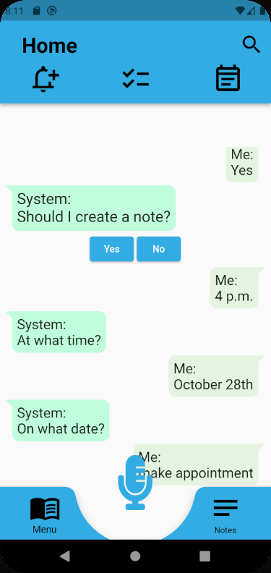

4.2 Access Permissions to device resources
Table 3 shows the access permissions test:
Table 3
Access Permissions
Test Name: | Access Permissions to device resources
Test Type: | User Acceptance Testing
Test Date: | 10/26/2021
Test Conductor: | Karen Crumb
Software Version: | Android Studio Artic Fox 2020.3.1 Patch 1
Emulator Version: | Android Pixel 5 API 29
Steps: | - Using new or wiped emulator, open the application.  - Go through onboarding language.  - On Permission screen, answer Yes to Do we have permission to access your microphone and resources?
Expected Result: | Application should ask permission to record audio and to use resources.
Issues: | None
Status: | Passed
Screen Capture: | 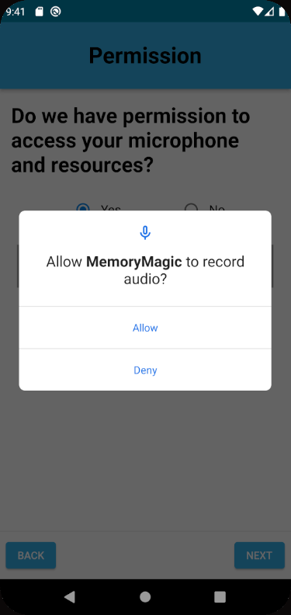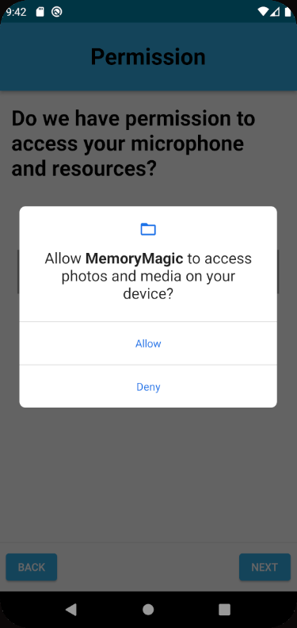

4.3 Activate and deactivate listening mode
Table 4 shows the activate/deactivate listening mode test:
Table 4
Activate/Deactivate Listening Mode
Test Name: | Activate and deactivate listening mode
Test Type: | User Acceptance Testing
Test Date: | 10/27/2021
Test Conductor: | Karen Crumb
Software Version: | Android Studio Artic Fox 2020.3.1 Patch 1
Emulator Version: | Android Pixel 5 API 29
Steps: | - In application click microphone icon and speak.  - Click microphone again.
Expected Result: | The first click should turn microphone on and the application should be able to listen. The second click should turn the microphone off.
Issues: | None
Status: | passed
Screenshot: | 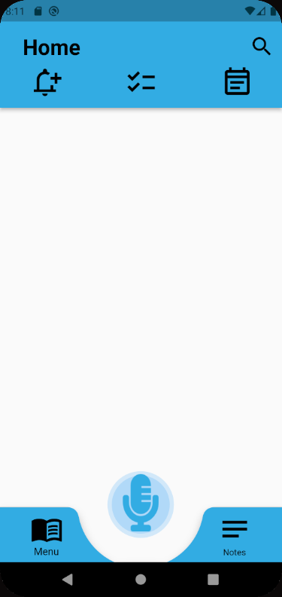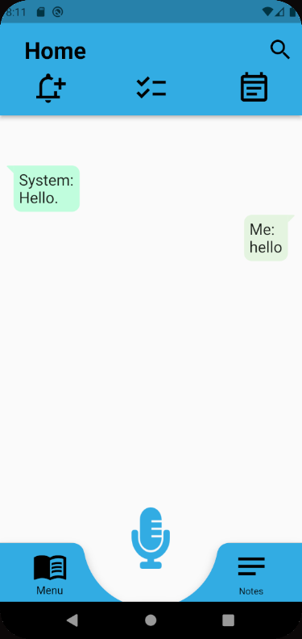  Microphone is activated

4.4 Type in notes
Table 5 shows the type notes test:
Table 5
Type Notes
Test Name: | Type notes
Test Type: | User Acceptance Testing
Test Date: | 10/29/2021
Test Conductor: | Karen Crumb
Software Version: | Android Studio Artic Fox 2020.3.1 Patch 1
Emulator Version: | Android Pixel 5 API 29
Steps: | - In App click the notes button.  - In Notes screen, click the Add Notes button (+ button).  - Enter the note text. Also enter the Make this a daily activity checkbox if it is a daily activity, and date and time if it is an event.  - Click Save Note.
Expected Result: | The note should be saved.
Issues: | If a time is entered and the note is saved and reopened, the time is 0:00.
Status: | Found issue
Screenshot: | 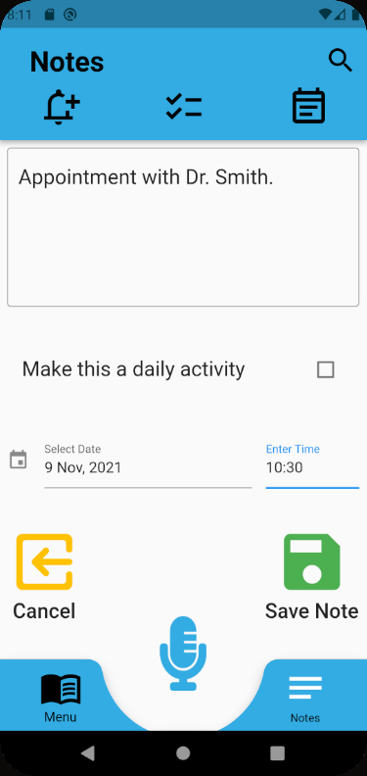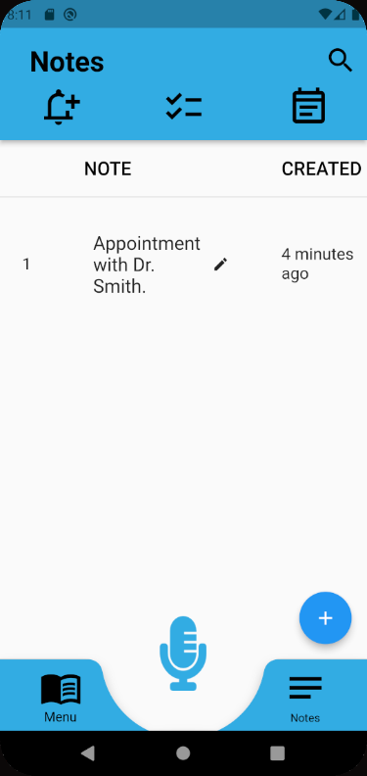

4.5 Transcribe notes
Table 6 shows the transcribe notes test:
Table 6
Transcribe Notes
Test Name: | Transcribe notes
Test Type: | User Acceptance Testing
Test Date: | 10/30/2021
Test Conductor: | Karen Crumb
Software Version: | Android Studio Artic Fox 2020.3.1 Patch 1
Emulator Version: | Android Pixel 5 API 29
Steps: | - In application click microphone icon.  - When microphone activates speak phrase such as Make Appointment.  - Application will either ask for additional information or ask to save note, yes or no.  - Click yes to save note.
Expected Result: | The application will listen to and transcribe the speech, and ask to create a note.
Issues: | None
Status: | passed
Screenshot: | 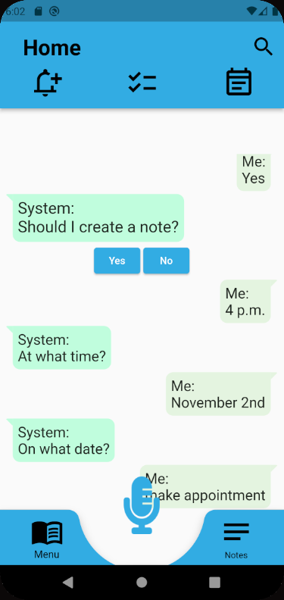

4.6 Edit and Delete notes
Table 7 shows the edit/delete notes test:
Table 7
Edit/Delete Notes
Test Name: | Edit and Delete Notes
Test Type: | User Acceptance Testing
Test Date: | 10/30/2021
Test Conductor: | Karen Crumb
Software Version: | Android Studio Artic Fox 2020.3.1 Patch 1
Emulator Version: | Android Pixel 5 API 29
Steps: | - In application, click Notes Icon.  - In Notes screen, click on note text.  - To Edit, make any changes in text box and click Save Note.  - Click Delete Note to delete the note.
Expected Result: | If edited, the note will change. Delete the note will be deleted. Clicking Cancel will go back to the Notes screen.
Issues: | If a time was entered and the note saved, or if the time was entered, when you look at the note again, the time is 0:00
Status: | Has issue
Screenshot: | 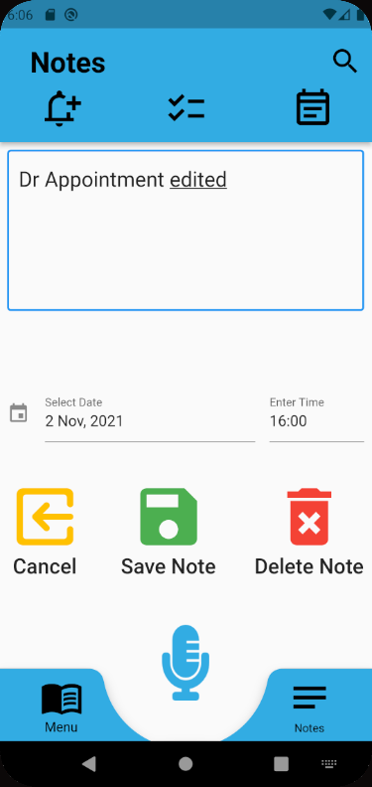

4.7 Onboarding
Table 8 shows the onboarding test:
Table 8
Onboarding
Test Name: | Onboarding
Test Type: | User Acceptance Testing
Test Date: | 10/26/2021
Test Conductor: | Karen Crumb
Software Version: | Android Studio Artic Fox 2020.3.1 Patch 1
Emulator Version: | Android Pixel 5 API 29
Steps: | - In new or wiped emulator, open the application.  - The Choose Language screen should open with the default language English.  - The permissions screen should open, if the option is Yes, it should ask for microphone and resource permissions.
Expected Result: | User should be onboarded, if the application is opened in the same emulator, it should not ask for onboarding steps again.
Issues: | None
Status: | passed
Screenshot: | 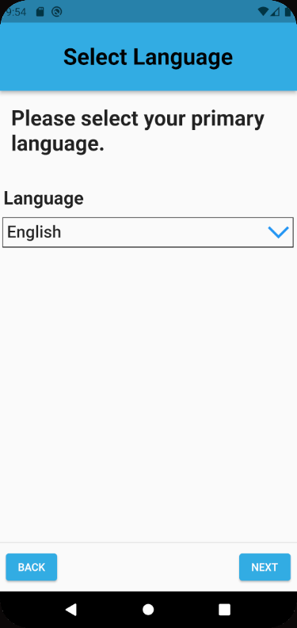

4.8 Support for multiple languages
Table 9 shows the support for multiple languages test:
Table 9
Multiple Languages Support
Test Name: | Support for multiple languages
Test Type: | User Acceptance Testing
Test Date: | 10/30/2021
Test Conductor: | Karen Crumb and other Team Mesmerize members
Software Version: | Android Studio Artic Fox 2020.3.1 Patch 1
Emulator Version: | Android Pixel 5 API 29
Steps: | - In application, click on Menu then Settings and find the Language dropdown (or during Onboarding go to the Language dropdown).  - In Language dropdown change language (Default is English).  - Click Save.
Expected Result: | The application text will change to the appropriate language.
Issues: | None found. Team members with knowledge of languages confirmed the translations are correct.
Status: | passed
Screen Capture | Shows application after changing language to Spanish and clicking Save.  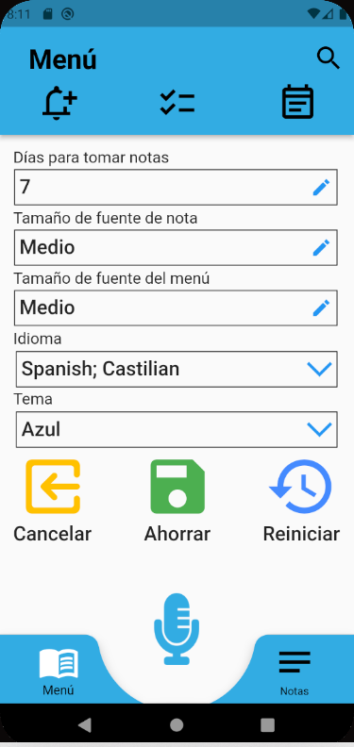

4.9 Notifications
Table 10 shows the notifications test:
Table 10
Notifications
Test Name: | Notifications
Test Type: | User Acceptance Testing
Test Date: | 10/30/2021
Test Conductor: | Karen Crumb
Software Version: | Android Studio Artic Fox 2020.3.1 Patch 1
Emulator Version: | Android Pixel 5 API 29
Steps: | - In application, click Notifications  - Turn on some of the notifications
Expected Result: | A notification will pop up within a few minutes.
Issues: | None
Status: | Passed, working as expected.
Screen Capture | 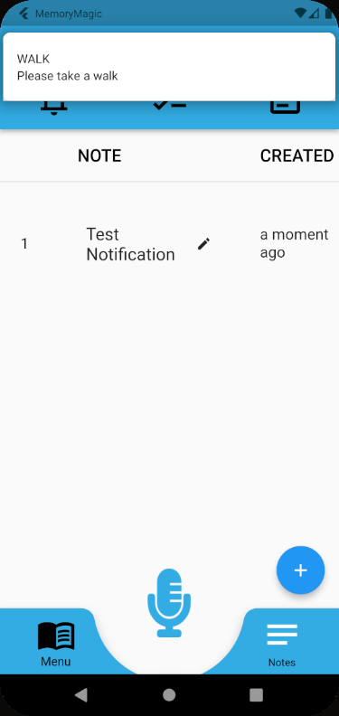

4.10 Display Events on Calendar
Table 11 shows the display events on calendar test:
Table 11
Display Events on Calendar
Test Name: | Display Events on Calendar
Test Type: | User Acceptance Testing
Test Date: | 10/30/2021
Test Conductor: | Karen Crumb
Software Version: | Android Studio Artic Fox 2020.3.1 Patch 1
Emulator Version: | Android Pixel 5 API 29
Steps: | - Confirm there are already notes with dates added to application. If there are not add some.  - Click the Calendar Icon and go to the date of the event in the calendar.  - Click on date with event.
Expected Result: | There should be a black dot under any date that has an event. Clicking the date will show the text of the note and time of event.
Issues: | None
Status: | passed
Screenshot: | 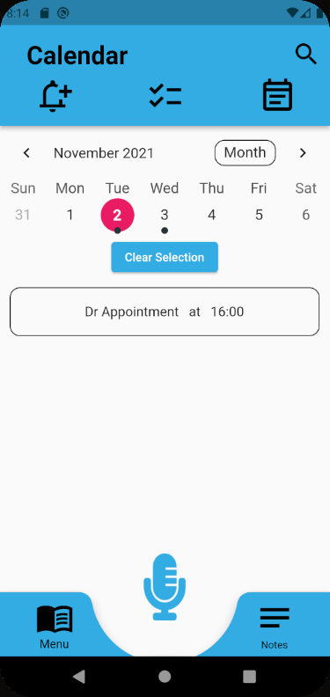

4.11 Display Events on Checklist
Table 12 shows the display events on checklist test:
Table 12
Display Events on Checklist
Test Name: | Display Events on Checklist
Test Type: | User Acceptance Testing
Test Date: | 10/30/2021
Test Conductor: | Karen Crumb
Software Version: | Android Studio Artic Fox 2020.3.1 Patch 1
Emulator Version: | Android Pixel 5 API 29
Steps: | - Create a note with Make this a daily activity checked.  - Click the Checkbox icon.
Expected Result: | The text of any notes with the Make this a daily activity should appear with a checkbox, you can click the checkbox to check them off.
Issues: | none
Status: | passed
Screenshot: | 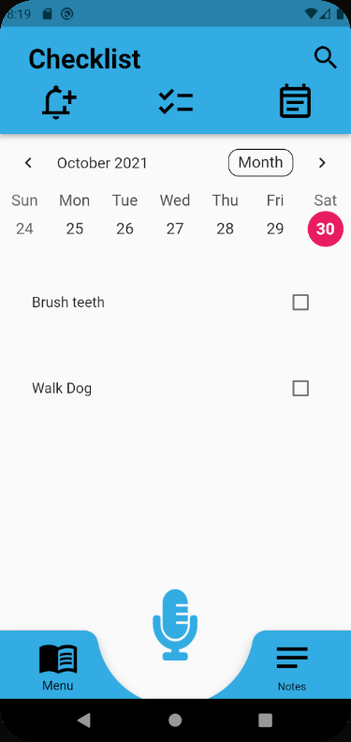

4.12 Change Theme Settings
Table 13 shows the change theme settings test:
Table 13
Change Theme Settings
Test Name: | Change Theme Settings
Test Type: | User Acceptance Testing
Test Date: | 10/30/2021
Test Conductor: | Karen Crumb
Software Version: | Android Studio Artic Fox 2020.3.1 Patch 1
Emulator Version: | Android Pixel 5 API 29
Steps: | - In application, go to Menu.  - Click Settings.  - Find Theme dropdown, and select different theme  - Click save.
Expected Result: | Theme should change to selection.
Issues: | None
Status: | passed
Screenshot: | 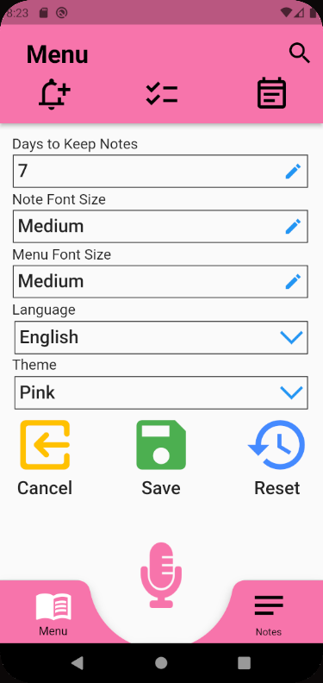

4.13 Change General Settings
Table 14 shows the change general settings test:
Table 14
Change General Settings
Test Name: | Change General Settings
Test Type: | User Acceptance Testing
Test Date: | 10/30/2021
Test Conductor: | Karen Crumb
Software Version: | Android Studio Artic Fox 2020.3.1 Patch 1
Emulator Version: | Android Pixel 5 API 29
Steps: | - Go to Settings page  - Change Font size settings and days to keep notes  - Click Save
Expected Result: | Change in settings will save
Issues: | None found
Status: | passed
Screen Capture: | 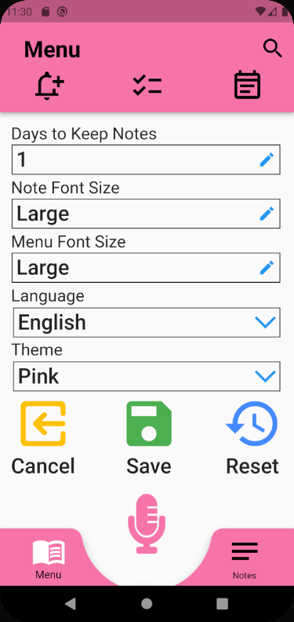

4.14 Search notes
Table 15 shows the search notes test:
Table 15
Search Notes
Test Name: | Search Notes
Test Type: | User Acceptance Testing
Test Date: | 10/31/2021
Test Conductor: | Karen Crumb
Software Version: | Android Studio Artic Fox 2020.3.1 Patch 1
Emulator Version: | Android Pixel 5 API 29
Steps: | - In application, click Search on top of screen.  - Enter search criteria to search notes
Expected Result: | If there is a note containing the search criteria, it should appear in the search results.
Issues: | None
Status: | passed
Screenshot: | 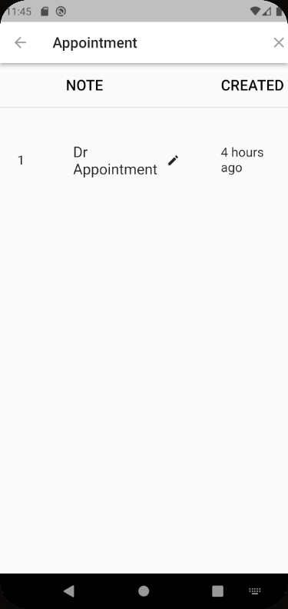

4.15 Help
Table 16 shows the help test:
Table 16
Help
Test Name: | Help
Test Type: | User Acceptance Testing
Test Date:
Test Conductor: | Karen Crumb
Software Version: | Android Studio Artic Fox 2020.3.1 Patch 1
Emulator Version: | Android Pixel 5 API 29
Steps:
Expected Result:
Issues:
Status: | Feature not yet developed.

Unit Testing
The following unit tests were specified in the original requirements document and are listed here with its related status. In some cases, if a feature was not implemented due to time or technical restraints, the unit test was not constructed. In that case, such was documented below.
Unit Test Construction Status
General Tests:
- Application Opens Up
Success case: Wait for the “Speak” button to appear which means that the application has successfully opened.
- From any page, click Calendar
Success case: Wait for anticipated elements to appear.
- From any page, click on Settings
Success case: Wait for anticipated elements to appear.
- From any page, click on Notes
Success case: Wait for anticipated elements to appear.
- From any page, click on Home
Success case: Wait for anticipated elements to appear.
- From any page, click on Bell
Success case: Wait for anticipated elements to appear.
- From any page, click on Mic
Success case: Wait for anticipated elements to appear.
Home Screen:
- Click on “Speak”
Success case: Mic screen will appear.
- Click on “Text”
Success case: Enter a note by text screen will appear.
Mic Screen:
- Click on “Press to Record (Mic)”
Success case: Speak dialog appears.
Menu Screen:
- Click on sync to cloud
Success case: Enter state for enabling sync to cloud.
- Click on trigger
Success case: Wait for anticipated elements to appear.
- Click on general setting
Success case: Wait for anticipated elements to appear.
- Click on help
Success case: Wait for anticipated elements to appear.
Note Screen:
- Search for note – no results
Success case: No results appear.
- Search for a note - results
Success case: Searched for note will appear.
- Modify text after search note
Success case: Note is updated.
- Click on “Add A Note”
Success case: Wait for anticipated elements to appear.
Delete a Note Screen
- Click on Delete Note
Success case: Note is deleted from datastore.
- Click on Cancel
Edit a note Screen
- Click on Save Changes
Success case: Note is saved in datastore.
- Click on Cancel Changes
Success case: Note is not saved in datastore.
Trigger Screen
- Change all inputs and save
Success case: Triggers are saved in datastore.
- Change all inputs and cancel
Success case: Triggers are not saved in datastore.
Sync to Cloud Screen
- Mock login to google cloud
Success case: After mock response, user is linked to google cloud
General Setting Screen
- days to keep notes and save
Success case: Settings are updated for the user
- Change font size notes
Success case: Settings are updated for the user
- Change font size menu
Success case: Settings are updated for the user
- Change language from English to Arabic
Success case: Settings are updated for the user
- Change language from English to Arabic back to English, then save
Success case: Settings are updated for the user
Security Setting Screen
- Setup fingerprint
Success case: Settings are updated for the user
- Reset fingerprint
Success case: Settings are updated for the user
- Press Cancel Button
Success case: State is unchanged
Calendar Screen
- Click a calendar event
Success case: Wait for anticipated elements to appear.

Defects Identified
A defect was found in user acceptance testing in which if the notes are edited or type notes are saved, the time does not save correctly and saves as 00:00 instead of the entered time. This defect is a low severity as it does not affect the overall function of the application, and time is not a required field.

Exit Criteria
The exit criteria for the completion of testing are the following:
- That all user acceptance testing has been completed and any issues are reported to the development team for correction.
- That all unit testing is performed with 80% coverage.
- Any issues found in testing are documented.
- No other test cases are determined as necessary by the team.

Appendices

7.1 Credits & Contributions
Below are the members that contributed or will contribute to the development of this application in alphabetical order by last name:
- Aboagye, Prince Antwi
- Ahmed, Christian
- Avery, Daniel
- Baileys, Alec
- Balbi, Teresa
- Ballo, Nicholas
- Bell, Kevin
- Benavides, Raul
- Broggin, Chauntika
- Cabrales, Andreas
- Chari, Firehiwot
- Crumb, Karen
- Cruz Jimenez, Christian
- Cushing, Benjamin
- Drammeh, Mod
- Dunning, Maddison
- Endashw, Eskedar
- Famudehin, Ayodeji
- Girma, Endalkachew
- Gordon, Roy
- Jena, Debashis
- Johnson, Austin
- Johnson, Rebecca
- Kalfus, Joseph
- Kelly, Shawn
- Kimbi, Didimus
- Le, Michael
- Lockhart, Johnny
- Mesfin, Elshaday
- Monfort, Michelle
- Muwan, Presley
- Okonkwo, Obinna
- Olshansky, Mitchell
- Puschinsky, Tyler
- Rohn, Andrew
- Salim, Sami
- Setiawan, Matthew
- Sevilla, Damion
- Soeurt, Jeroen
- Subramanian, Leela
- Webster, Malik
- Wilson, Robert
- Worku, Addisu
- Dr. Mir Mohammed Assadullah

