Presented by Team Mesmerize
Presley Muwan, Karen Crumb, Kevin Bell, Teresa Balbi, Sami Salim, Daniel Avery & Christian Cruz Jimenez
UMGC SWEN 670
User guide
MEMORY MAGIC APP
Project name: Memory Magic Application

Date: November 2, 2021

Project Manager: Presley Muwan

Phase: Design & Implementation

Revision History
Revision Number | Date | Description | Approved By
1.0 | 11/02/2021 | Initial Release | Presley Muwan

Table of Contents
Introduction 5
1.1 Purpose 5
1.2 Overview 5
1.3 References 5
Software Description 7
2.1 Features 7
2.1.1 Simplicity 8
2.1.2 Android Device Support 8
2.1.3 iOS Device Support 8
2.1.4 NLU Interaction 8
2.1.5 Notification 8
2.1.6 Internationalization 8
2.1.7 Speech-To-Text Transcribe 8
2.1.8 Note Management 8
Software & Hardware Specifications 8
Application Page 9
4.1 Memory Magic Splash 9
4.2 Onboarding Select Language Screen 10
4.3 Onboarding Permission Screen 13
4.4 Onboarding Introduction Screen 17
4.5 Onboarding Home Screen 18
4.6 Home Screen 19
4.7 Notes Screen 21
4.8 Checklist Screen 26
4.9 Notifications Screen 27
4.10 Menu Screen 29
4.11 Settings Screen 30
4.12 Help Screen 36
4.13 Language Translated Screens 37
Troubleshooting 43
5.1 Help with Memory Magic App 43
5.2 Application is Not recording 44
5.2.1 Android 44
5.2.2 iOS 45
5.3 Application Stops Responding/Closes Unexpectedly/Will Not Open 45
5.3.1 Android 45
5.3.2 iOS 45
5.4 User Cannot Find a Specific Note 46
5.5 Trigger Words Not Working 47
5.6.1 Android 48
5.6.2 iOS 50
Appendices 51
6.1 Credits & Contributions 51

Introduction

1.1 Purpose
The purpose of this User Guide document is to provide guidance for the Memory Magic App. This guide will assist users navigate the application and aids with features, functionality, and troubleshooting.

1.2 Overview
The Memory Magic App has been developed and implemented based on the requirements needed. The requirements list includes core functionalities such as NLU interaction, resource-permission, TTS and speech-to-text transcribe, note management, internationalization/multilingual, onboarding, and notifications. Upon completion of development, the DSO team will be responsible for the deployment of the application on iOS and GooglePlay. This User Guide is intended for current and future users of the Memory Magic App and will be available online for further guidance of the Memory Magic App.

1.3 References
Cascella, M., & Khalili, Y. A. (2021). Short Term Memory Impairment. Treasure Island, FL: StatPearls Publishing LLC. Retrieved from https://www.ncbi.nlm.nih.gov/books/NBK545136/
Cast your Android audio from the Google home app. (n.d.). In Chromecast built-in help. Retrieved from https://support.google.com/chromecastbuiltin/answer/6279392?hl=en
Close an app on your iPhone or iPod touch. (n.d.). In Support Apple. Retrieved from https://support.apple.com/en-us/HT201330
Faris, S. (2020, June 14). How to change the microphone settings on an iPhone. In Techwalla. Retrieved from https://www.techwalla.com/articles/how-to-change-the-microphone-settings-on-an-iphone
India tech Bureau. (2020, December 20). Why do my apps keep crashing on Android, How to fix it. In Business Insider. Retrieved from https://www.businessinsider.in/tech/apps/news/how-do-you-fix-an-app-that-keeps-crashing-on-android/articleshow/72110840.cms
How to check the storage on your iPhone, iPad, and iPod touch. (n.d.). In Support Apple. Retrieved from https://support.apple.com/en-us/HT201656#:~:text=Use%20your%20device%20to%20check,of%20storage%20each%20one%20uses.
1.4 Definitions, Acronyms, and Abbreviations
Table 1 shows the most used acronyms/abbreviations and their definitions:
Table 1
Acronyms, Abbreviations, and Definitions
Acronyms and Abbreviations | Definitions
DSO | DevSecOps
STML | Short Term Memory Loss
UI | User Interface
NLP | Natural Language Processing
NLU | Natural Language Understanding
OS | Operating System
LEO | UMGC online platform class
iOS | iPhone operating system
Flutter CLI | Flutter Command Line Tool
API | Application Program Interface
TTS | Text to Speech
UMGC | University of Maryland Global Campus
VM | Virtual Machine
AVD | Android Virtual Device
APK | Android Application Package
IDE | Integrated Development Environment
SDK | Software Development Kit

Software Description
The Memory Magic App was developed to assist people with STML with daily note-taking and reminders for various events. The impairment of STM involves forgetting information to which the subject has been recently exposed (Cascella & Khalili, 2021).
The Memory Magic App is intended to help this population by supporting the user on keeping notes and reminders utilizing speech/voice recognition by levering the mobile phone capabilities and external services. Onboarding will be provided to the user the first time the application is accessed to provide guidance for the Memory Magic App’s features and functionalities.

2.1 Features

2.1.1 Simplicity
The Memory Magic App is easy to navigate and keep user engaged. Clear, uncluttered screens, no ambiguity that leads to an easier and improved user experience.

2.1.2 Android Device Support
The Memory Magic App is a multi-platform application, and it is compatible with Android OS.

2.1.3 iOS Device Support
The Memory Magic App is a multi-platform application, and it is compatible with iOS.

2.1.4 NLU Interaction
The Memory Magic App integrates with an amazon Lex Natural Language Understanding system.

2.1.5 Notification
The Memory Magic App provides the user relevant and personalized notifications.

2.1.6 Internationalization
The Memory Magic App supports multiple languages out of the box and may be extended to add more support later.

2.1.7 Speech-To-Text Transcribe
The Memory Magic App can transcribe user voice to text in multiple languages.

2.1.8 Note Management
The Memory Magic App provides users the ability to create, delete, edit, and search notes.

Software & Hardware Specifications
The Memory Magic App is only available for mobile environment (smartphones). To run the Memory Magic App, the user’s development environment must meet these minimum software requirements:
- Android OS version: 11
- iOS version: 14

Application Page
The Memory Magic application starts with a splash screen and onboarding screens to setup your preferences. The main screens that show all the functionality of the application are the home, menu, notes, checklist, and calendar screens. If needed, Settings can be accessed from the menu screen for the user to edit. A help screen can also be accessed from the menu screen to provide videos to help the user navigate the application. The notifications screen can be accessed using the icon at the top-left of the toolbar. Below, each screen is shown along with detailed descriptions of their functions.

4.1 Memory Magic Splash
The Memory Magic splash screen, as shown on Figure 1, is a 6-second animation of the Memory Magic logo that appears when the application is first open. It will lead to the screens that will assist the user with onboarding.
Figure 1
Memory Magic Splash Screen
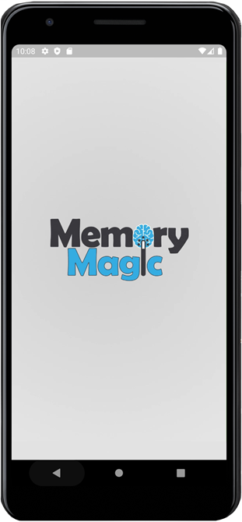

4.2 Onboarding Select Language Screen
The first screen after the splash introduction is the select language screen which begins the onboarding process. This allows the user to select the preferred language by clicking the dropdown button, as shown on Figure 2. After selecting the language, the user can proceed to the next screen by selecting the next button.
Figure 2
Onboarding Select Language Screen
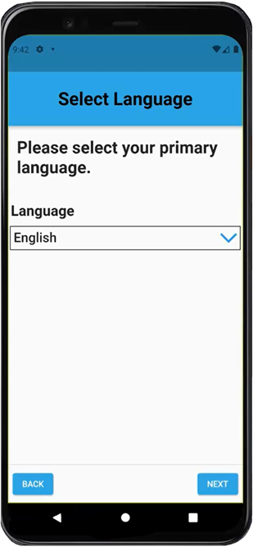
When the user clicks the dropdown button on the select language screen, the user is able to change the default language, as shown on Figure 3. These languages are English, Spanish (Castilian), Portuguese, Chinese, and Arabic; English is the default language.

Figure 3
Expended Onboarding Select Language Screen
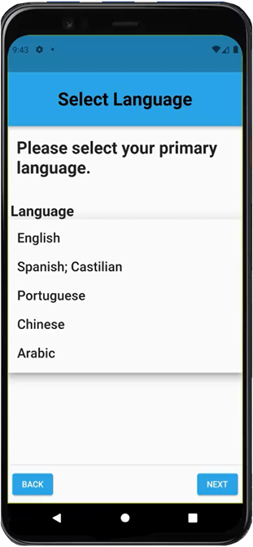
When the user selects a different language on the select language screen, the text will be translated on the screen, as shown on Figure 4. Below, the language has been changed to Chinese which will be reflected throughout the entire application.
Figure 4
Translated Onboarding Select Language Screen
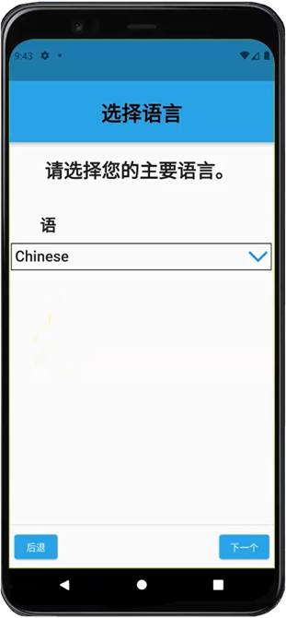

4.3 Onboarding Permission Screen
If the user does not allow the application to access the microphone, the user will see the warning message “features will be limited without allowing access to your microphone”, as shown on Figure 5, and the user can press the next button and proceed with restrictions.
Figure 5
Onboarding Permission Screen - No
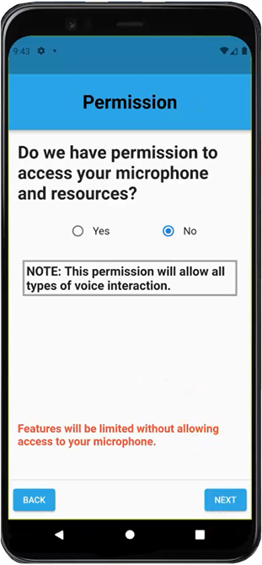
If the user allows the application to access the microphone, the “features will be limited without allowing access to your microphone” message will disappear, as shown on Figure 6, and the user can press the next button and proceed without restrictions.
Figure 6
Onboarding Permission Screen - Yes
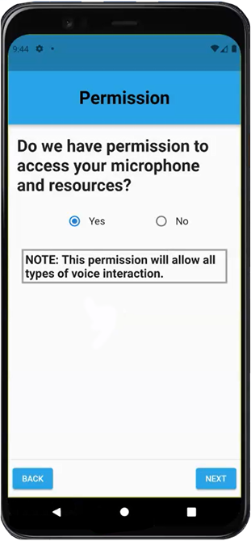
When the user selects “YES,” and clicks the next button to proceed to the next screen, a window will appear, as shown on Figure 7, asking the user to allow/deny access to record audio. The user can either allow or deny.
Figure 7
Onboarding Audio Permission Screen
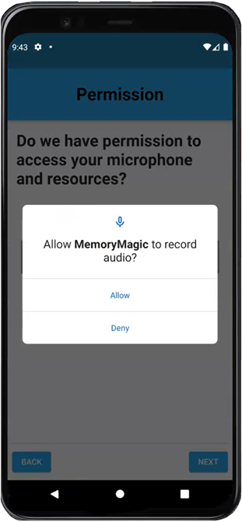
Next, the user will be asked to allow access to photos and media on the device. The user can either allow or deny access, as shown on Figure 8.
Figure 8
Onboarding Photo Permission Screen
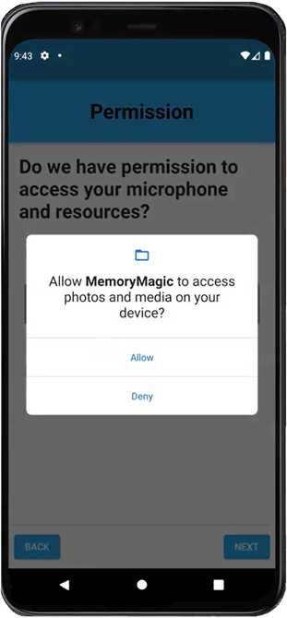

4.4 Onboarding Introduction Screen
The onboarding introduction screen has several videos that will give the user a comprehensive overview/walkthrough of how to use the application, as shown on Figure 9.
Figure 9
Onboarding Introduction Screen
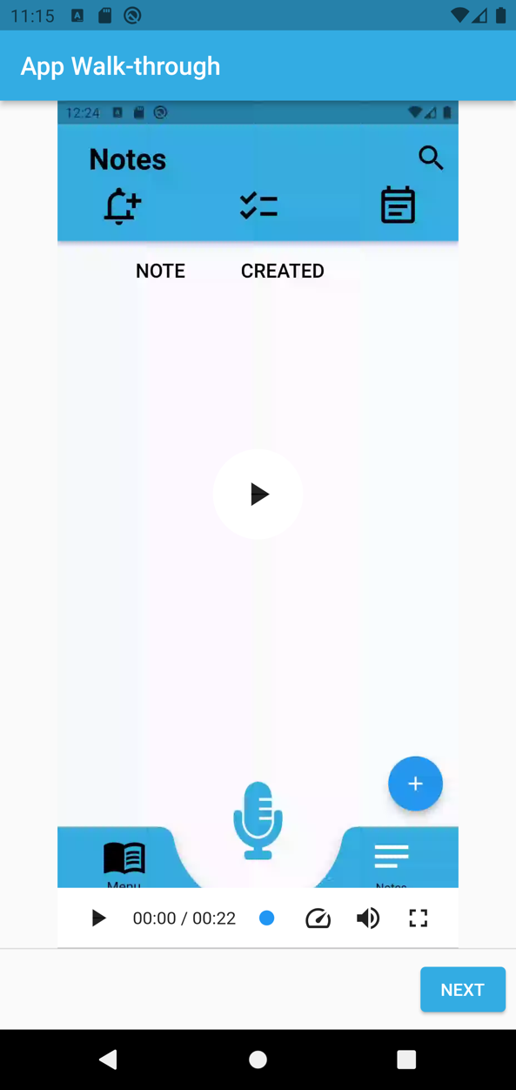

4.5 Onboarding Home Screen
The last onboarding screen is the onboarding home screen, as shown on Figure 10. This screen asks the user’s preference to create notes: speaking into the microphone, or texting the note with the keypad. If the user did not allow the application access to the device’s microphone, the speak option will not work.
Figure 10
Onboarding Home Screen
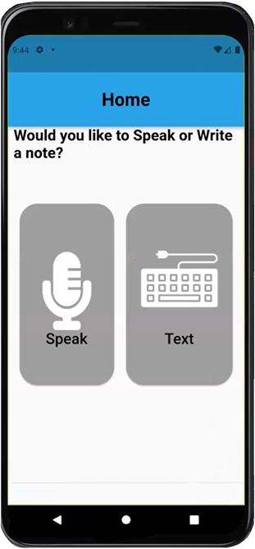

4.6 Home Screen
Onboarding is complete and Figure 11 shows the official home screen. There is a microphone at the bottom of the screen that the user can press to record a note. The top navigation icons (from left to right) are the notifications screen, checklist, and calendar. The bottom navigation (from left to right) is the access the menu and notes screens.
Figure 11
Home Screen
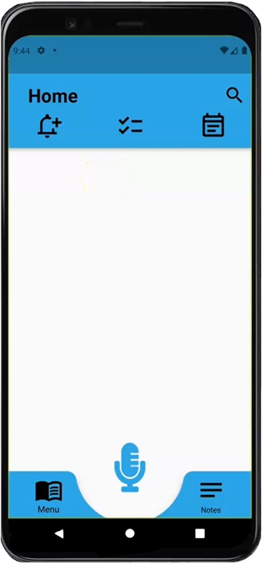
When the user speaks into the microphone, the system will respond asking for specific information about the note being created, as shown on Figure 12.
Figure 12
Home Screen Record with Microphone
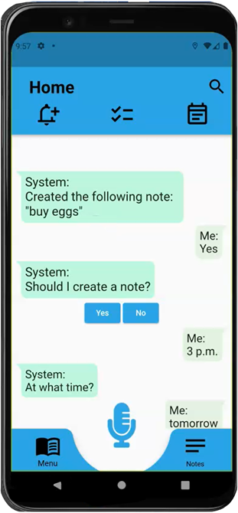

4.7 Notes Screen
When the note is recorded, it can be viewed in the notes screen, as shown on Figure 13. The user can view the notes screen by selecting the notes icon on the bottom-right of the screen. Figure 13 shows what the note says and when it was created. The plus icon at the bottom-right allows the user to add a new note using your keyboard.
Figure 13
Notes Screen
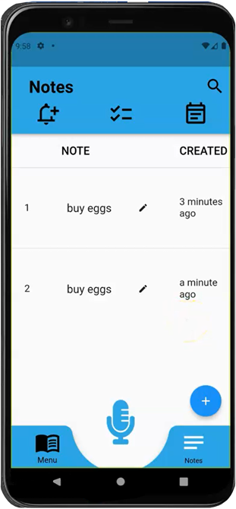
When the user clicks a note, the system allows the user to edit the note by text and edit the date and time, as shown on Figure 14. At the bottom of the screen (left to right), the user can cancel any updates to the note, save, or delete the note completely.
Figure 14
Selected Note in Notes Screen
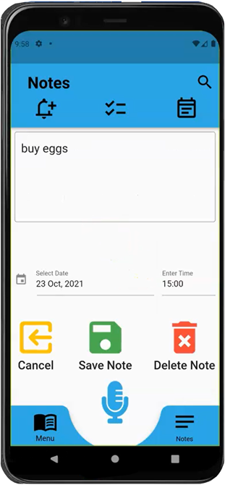
In the add note by text screen, as shown on Figure 15, the user can write a note in the text box using the keypad. The user can also select the checkbox to make the note a daily activity.
Figure 15
Text Note in Notes Screen
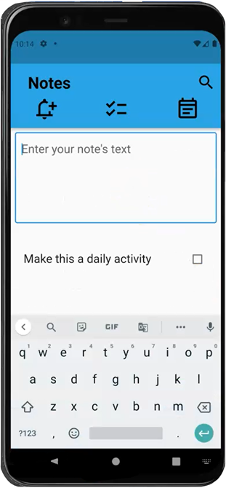
The user can also enter the start date and time in the edit notes screen, as shown on Figure 16. Lastly, the user can either decide to cancel the edits made to the note by pressing the cancel button on the bottom-left of the screen, or save the note by pressing the save note button on the bottom-right of the screen.
Figure 16
Complete Text Note in Notes Screen
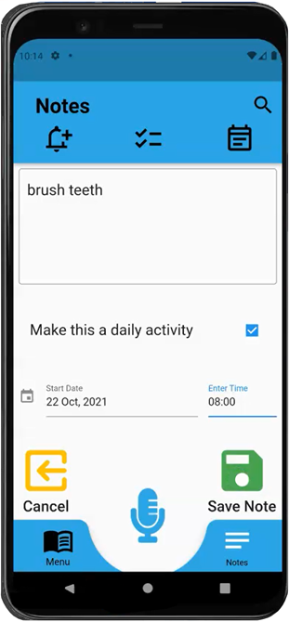
When a note is saved, as shown on Figure 17, the new note appears at the bottom of the list of notes as well as a green notification at the bottom of the screen informing the user that the note was saved.
Figure 17
Saved Text Note in Notes Screen
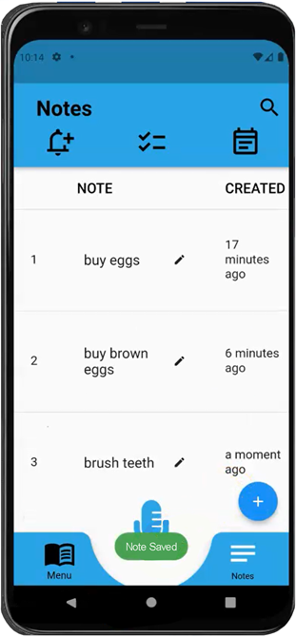

4.8 Checklist Screen
The checklist screen, as shown on Figure 18, allows the user to see events/activities for the day, and check them off when the activity/event has been accomplished/completed.
Figure 18
Checklist Screen
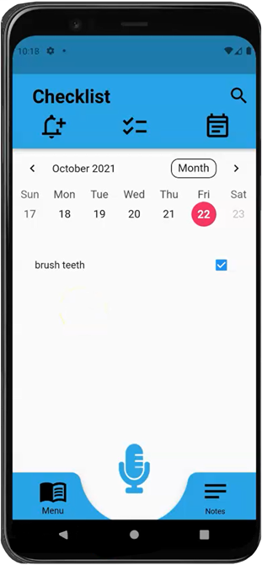

4.9 Notifications Screen
The notifications screen, as shown on Figure 19, shows notifications for notes and activities.
Figure 19
Notifications Screen Off
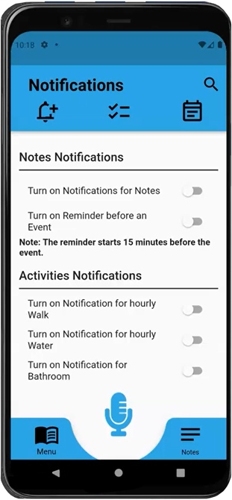
The notifications can be turned on and off, as shown on Figure 20.
Figure 20
Notifications Screen On
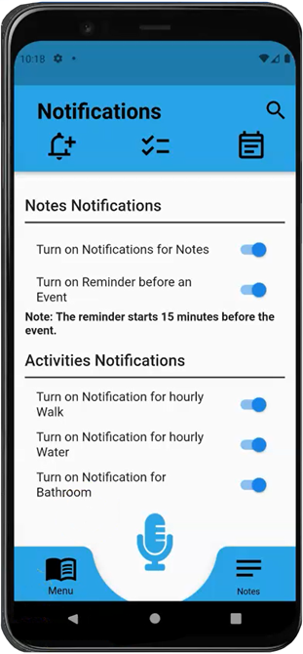

4.10 Menu Screen
The menu screen, as shown on Figure 21, is where the user can access most of the functions of the application, which include the tool bars. The body of the screen has four buttons that allow the user to sync to cloud (top-left), access trigger words (top-right), view settings (bottom-left), and view help options (bottom-right).
Figure 21
Menu Screen
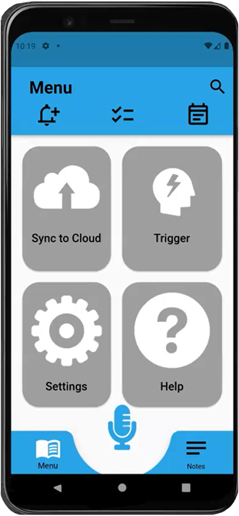

4.11 Settings Screen
The settings screen, as shown on Figure 22, is the screen where the user can change default settings such as notes expiration, note font size, menu font size, language, and theme color. The user can cancel and save settings by pressing the cancel (bottom-left) or save (bottom-center) buttons. The reset button (bottom-right) will return the settings to their default state.
Figure 22
Settings Screen
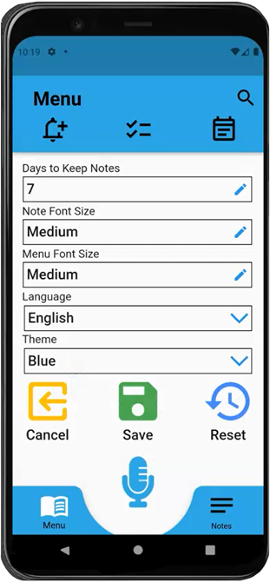
The alternate theme color for the application is pink, as shown on Figure 23. This can be changed by using the theme dropdown button.
Figure 23
Settings Screen with Pink Theme
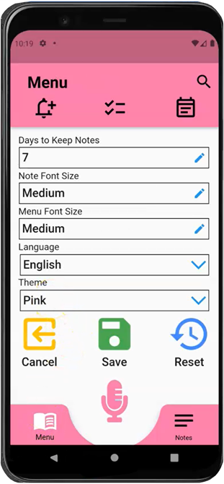
Like the onboarding screens, the settings screen, as shown on Figure 24, has the options to select a different language using the dropdown button.
Figure 24
Settings Screen Language Selection
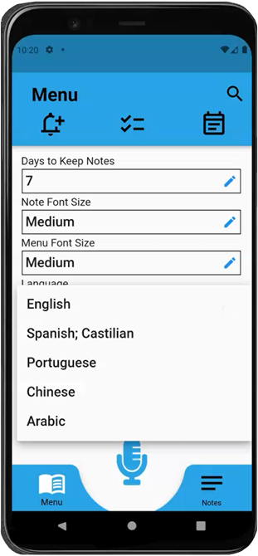
When language settings are changed, all the text on the screen is translated to the chosen language, as shown on Figure 25. The microphone will now recognize the updated language when the user speaks.
Figure 25
Settings Screen Language Change
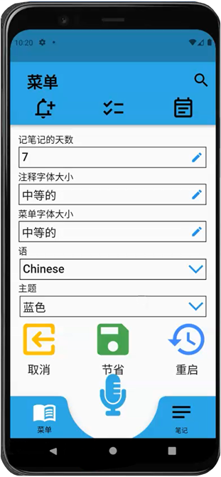
The menu font size can be changed to accommodate the user’s vision. The default menu font size is medium, but it can be changed to small or large. Figure 26 shows the large menu font size.
Figure 26
Settings Screen Menu Font Size
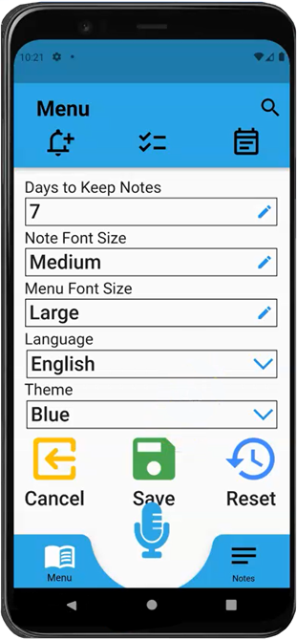
The days to keep notes has a default setting of seven days but it can be changed, as shown on Figure 27.
Figure 27
Settings Screen Change
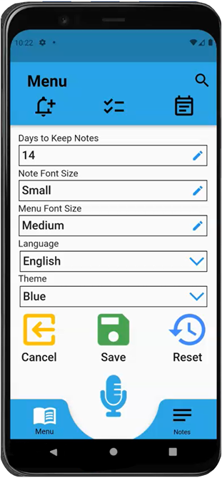

4.12 Help Screen
The help screen, as shown on Figure 28, shows buttons with a play icon. When pressed, the user is directed to a tutorial video explaining how to use certain features of the application.
Figure 28
Help Screen
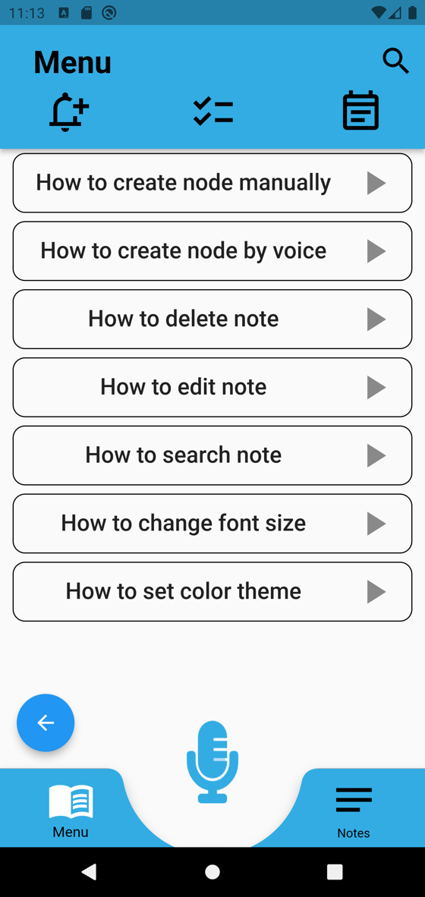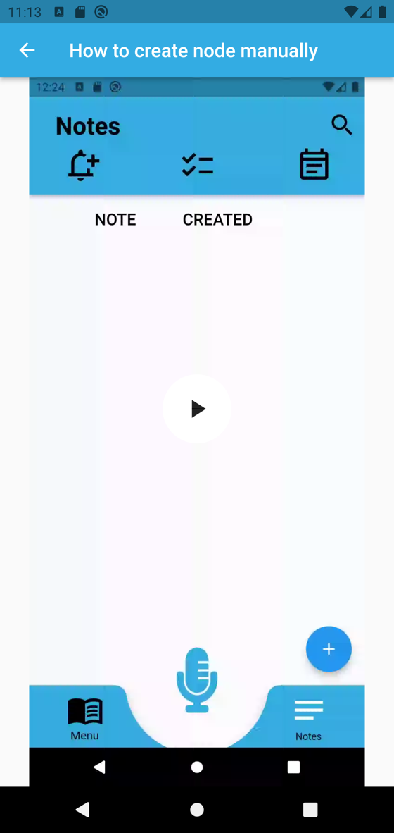

4.13 Language Translated Screens
When language settings are changed in the settings screen, as shown on Figure 29, it is reflected throughout the entire application. Below, all of the text has been changed to Spanish (Castilian).
Figure 29
Settings Screen Language Change (Spanish)
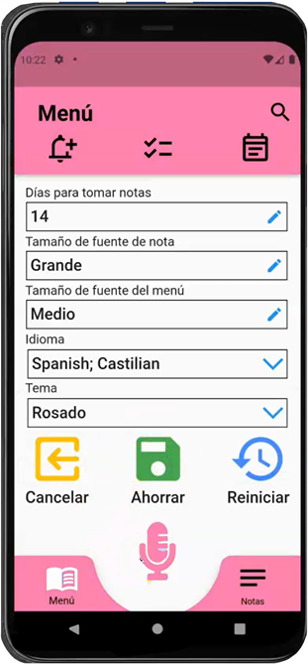
A previous note is not translated automatically but it can be edited in the text box, as shown on Figure 30. All the other functions on the notes screen will be translated.
Figure 30
Note Screen Font Size Increase
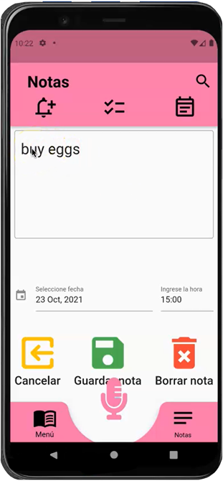
The checklist screen, as shown on Figure 31, is translated based on language selection from the settings screen.
Figure 31
Checklist Screen Translated
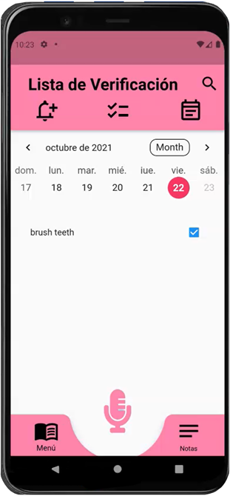
The calendar screen, as shown on Figure 32, is translated based on language selection from the settings screen. Any previous notes highlighted in the calendar will not be translated automatically and will need to be edited or rerecorded.
Figure 32
Calendar Screen Translated
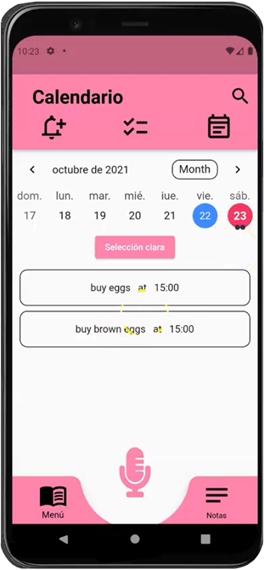
When a new note is being recorded using the home screen microphone, as shown on Figure 33, the conversation with the system will appear on the home screen in the language selected.
Figure 33
Home Screen Translated
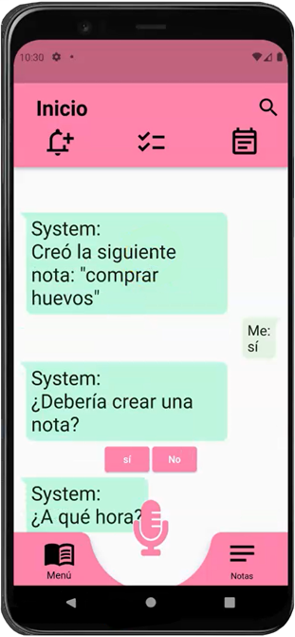
When a new note has been recorded and saved, the notes screen, as shown on Figure 34, will reflect the new note in the updated language from the settings screen. Previous notes will reflect the language that they were originally recorded.
Figure 34
Note Screen Translated
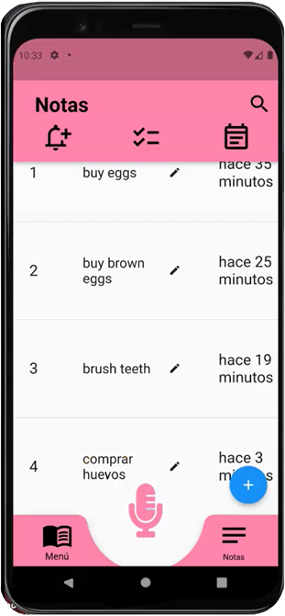

Troubleshooting
This section will guide the user to solve some of the most common issues when using the Memory Magic App. Some of the troubleshooting steps provided in this section could be different depending on the OS and/or versions being used.

5.1 Help with Memory Magic App
If the user needs help with the basic functionalities of the Memory Magic App, please visit the Help section in the application. This section will guide the user on how to use the different features in the app. To open the Help sections please follow the below steps:
- Open the Memory Magic App go to the Menu open the Help section, as shown on Figure 34.
*Some features of the help section are still under development and more videos are expected to be added in the future.
Figure 34
Memory Magic Help Section
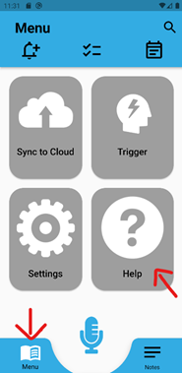

5.2 Application is Not recording

5.2.1 Android
To turn on microphone permissions:
- On your Android device, tap Settings .
- Scroll down and tap Apps Google Play Services Permissions.
- Look for "Microphone" and slide the slider On .

5.2.2 iOS
To enable microphone access:
- On the device: go to Settings Privacy Microphone.
- Find the Memory Magic App Toggle the switch to the right.
*The switch turns green when the microphone is enabled for the app and gray when it is off.

5.3 Application Stops Responding/Closes Unexpectedly/Will Not Open

5.3.1 Android
“Force stop” the Memory Magic App:
- On the device: go to Settings Apps select Memory Magic App
- Tap on the Memory Magic App tap on ‘Force stop’.

5.3.2 iOS
“Force stop” the Memory Magic App:
- From the Home Screen, swipe up from the bottom of the screen and pause in the middle of the screen.
- Swipe right or left to find the Memory Magic App.
- Swipe up on the app's preview to close the Memory Magic App.

5.4 User Cannot Find a Specific Note
If the user is having issues finding a specific note, using the search function on Memory Magic could be an easy solution, as shown on Figure 35.
- On the Memory Magic App go to the Search Bar at the top right of the screen.
- On the search bar type a “keyword” contained on the notes to find a specific note.
Figure 35
Search Bar
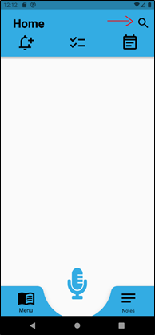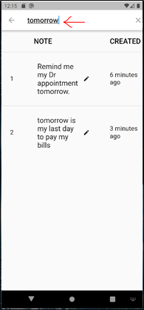

5.5 Trigger Words Not Working
If trigger words are not working as expected the user might need to verify the setting on the Memory Magic App. If the trigger words are not correct, try to change them for the preferred word.
To change trigger words on the Memory Magic App:
- Go to Menu Trigger.
5.6 Application is Not Saving Notes

5.6.1 Android
Check storage for the Memory Magic App:
- On the device: Applications Long Press (1 second) the Memory Magic App logo App info - as shown on Figure 36.
Figure 36
Applications
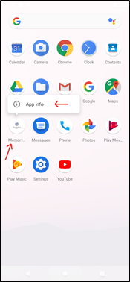

- On the App info screen: Permissions StorageAllowed section – as shown on Figure 37.
Figure 37
App Permissions
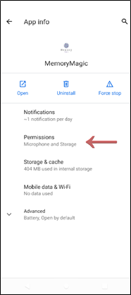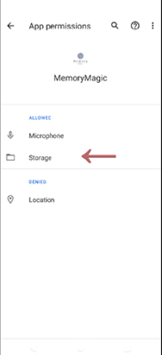

5.6.2 iOS
Check storage for the Memory Magic App:
- On the device: go to Settings General Storage.
- In the detailed view the user can:
- Offload the app, which frees up storage used by the app, but keeps its documents and data.
- Delete the app, which removes the app and its related data.

Appendices

6.1 Credits & Contributions
Below are the members that contributed or will contribute to the development of this application in alphabetical order by last name:
- Aboagye, Prince Antwi
- Ahmed, Christian
- Avery, Daniel
- Baileys, Alec
- Balbi, Teresa
- Ballo, Nicholas
- Bell, Kevin
- Benavides, Raul
- Broggin, Chauntika
- Cabrales, Andreas
- Chari, Firehiwot
- Crumb, Karen
- Cruz Jimenez, Christian
- Cushing, Benjamin
- Drammeh, Mod
- Dunning, Maddison
- Endashw, Eskedar
- Famudehin, Ayodeji
- Girma, Endalkachew
- Gordon, Roy
- Jena, Debashis
- Johnson, Austin
- Johnson, Rebecca
- Kalfus, Joseph
- Kelly, Shawn
- Kimbi, Didimus
- Le, Michael
- Lockhart, Johnny
- Mesfin, Elshaday
- Monfort, Michelle
- Muwan, Presley
- Okonkwo, Obinna
- Olshansky, Mitchell
- Puschinsky, Tyler
- Rohn, Andrew
- Salim, Sami
- Setiawan, Matthew
- Sevilla, Damion
- Soeurt, Jeroen
- Subramanian, Leela
- Webster, Malik
- Wilson, Robert
- Worku, Addisu
- Dr. Mir Mohammed Assadullah

