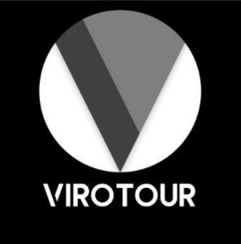
User’s Guide

University of Maryland Global Campus
SWEN 670 : Team A
Spring Semester
Version 1.0
April 4, 2023
Document History
Version | Issue Date | Changes
0.1 | 3/29/2023 | Initial Version
1.0 | 4/4/2023 | Milestone 4 Submission

Contents
1. Introduction 5
1.1. Overview 5
1.2. Intended Audience 5
1.3. Technical Project Stakeholders 5
1.4. Project Documents 6
1.5. References 6
1.6. Definitions, Acronyms, and Abbreviations 6
1.7. Hardware Requirements 7
2. Operating Systems required 7
3. Network Requirements 7
4. Getting Started 7
4.1. Launching the Application 7
4.2. Permissions 8
5. Application Screens 9
5.1. Tour List/User Home Screen 10
5.2. Tour Detail 11
5.3. Edit Tour 12
5.4. Hamburger Menu 13
5.5. Wheel Menu 14
5.6. Create Tour 15
5.7. Search Tour 16
5.8. Search Hotspots 17
5.9. Glow Effect 18
5.10. VR View 19
5.11. Theme Selection Dropdown 21
6. Step-by-step Guide 22
6.1. How to View a Tour 22
6.2. How to Create a Tour 24
6.3. How to Edit a Tour 25
6.4. How to Search Tours 26
6.5. Searching for Hotspots 27
6.6. How to Delete a Tour 28
6.7. How to Change the Application Theme 29
6.8. How to Apply Glow Effect 30
6.9. How to View Tour Using VR Viewer 31
7. Troubleshooting 31

Introduction

Overview
The purpose of this document is to provide technical guidance on how to use the ViroTour application. Users will learn:
- How to launch and run the application.
- The technical software and hardware requirements that are needed to run the ViroTour Application.
- Various application features and their work within the ViroTour application.
- Troubleshooting any issues that may arise during the use of the application.

Intended Audience
The intended audience of the ViroTour user’s guide is anyone who will be using the application, including end-users who will be interacting with the virtual tours created using the application, as well as content creators or administrators who will be responsible for creating, managing, and publishing the tours. The user's guide provides clear and concise instructions on how to use the application and its various features, as well as any relevant best practices or tips for getting the most out of the tool.

Technical Project Stakeholders
The technical stakeholders of the project are listed below:
Stakeholder Name | Project Role
Dr. Mir Assadullah | Client/Professor
Roy Gordon | Project Mentor
Robert Wilson | User Guide Mentor
Khoa Nguyen | Project Manager (PM)
Jacob Lynn | Product Owner (PO) / Test Manager
Viet Nguyen | Lead Developer (Dev Lead)
Tilahun Abreha | Business Analyst (BA)
Fedor Menchukov | Software Engineer (Dev)
Jude Ibe | Software Engineer (Dev)
Nicholas Platt | Software Engineer (Dev)
Samson Alemneh | Software Engineer (Dev)
Jeffrey Welch | Software Engineer (Dev)
Shawn Kagwa | Software Engineer (Dev)
Christian Dovel | Software Engineer (Dev)
Table 1.3 - Technical Project Stakeholders

Project Documents
The following documents were created during the development lifecycles of the ViroTour application.
Document | Version | Date
Project Management Plan (PMP) | 3.0 | 4/04/2023
Software Requirements Specification (SRS) | 3.0 | 4/04/2023
Technical Design Document (TDD) | 2.0 | 4/04/2023
Software Test Plan (STP) | 2.0 | 4/04/2023
Programmers Guide (PG) | 2.0 | 4/04/2023
Deployment and Operations (DepOps) | 2.0 | 4/04/2023
User Guide (UG) | 1.0 | 4/04/2023
Test Report (TR) | 1.0 | 4/04/2023
Table 1.4 - Project Documents

References
Assadullah, M. (2023). Software Engineering Project. Retrieved from: https://learn.umgc.edu/d2l/home/732302

Definitions, Acronyms, and Abbreviations
  - BA - Business Analyst
  - DepOps - Deployment and Operations
  - Hotspots - transition points, as in points that indicate a direction of a new image
  - iOS - iPhone Operating System
  - PM - Project Manager
  - PO – Product Owner
  - RAM – Random Access Memory
  - SWE - Software Engineer
  - UMGC – University of Maryland Global Campus
  - URL - Uniform Resource Locators
  - VR – Virtual Reality

Hardware Requirements
The minimum hardware requirements for the ViroTour Application are:
- Processor: PIII 800 or higher.
- RAM: 512 MB or higher, 1024 MB would be recommended.
- Display resolution of 800 x 600 or higher, 256-colors or more, 1024 x 768 would be recommended. Network card would be needed.

Operating Systems required
- At minimum MacOS v.10 is required, but the application will run best on Version 11 or higher. s
- At minimum Android v.10 is required but 13 or higher is recommended.
- At minimum Microsoft Windows v.7 is required, but version 10 or higher is recommended. x64 architecture
- At minimum IOS 11 is required, but 13 is or higher is recommended.
Web Browsers required
- Google Chrome v.10.0 or higher
- Mozilla Firefox v.110 and higher
- Safari v.4 or higher

Network Requirements
A 10mbps or higher internet speed.

Getting Started

Launching the Application
The ViroTour application can be launched from a mobile device by tapping or clicking the ViroTour icon from the device’s application launch menu for both iOS and Android devices. The application can also be accessed via the web by going to a domain name (TBD) on Google Chrome web browser. The ViroTour application icon displays the unique logo of ViroTour.

Figure 4.1a - ViroTour Logo

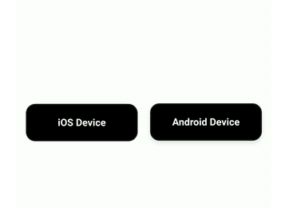
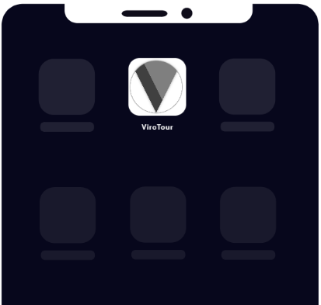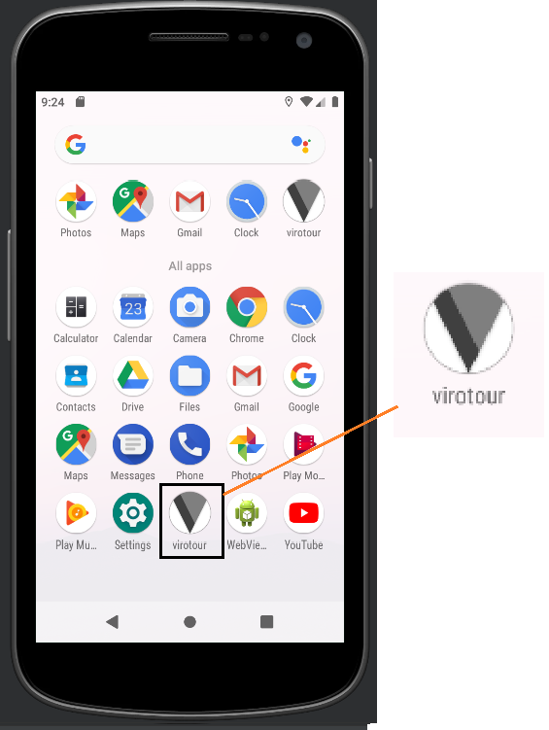
Figure 4.1b - ViroTour Application can be launched from the application launch menu

Permissions
When the ViroTour application is launched for the first time, users need to grant permission to use the photo gallery. This permission can be disabled anytime by going to phone settings and application permissions.
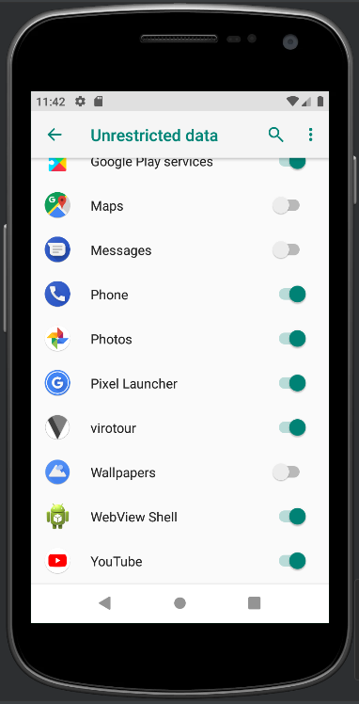
Figure 4.2 - Enable/Disable permission

Application Screens
The virtual tour application, ViroTour has a number of screens that make up the application and host different functionalities that users need in order to utilize the application as intended. These screens include Tour List, Tour Detail, Edit Tour, Create Tour, Search, Hamburger Menu, Wheel Menu, Glow Effect, VR View, Switch App Theme.
This section presents the features and functionalities of these screens with supporting labeled screenshots.

Tour List/User Home Screen
When the application starts the “Tour List” page is the page that users view first. From the tour list page, users can navigate to any section of the application as needed.
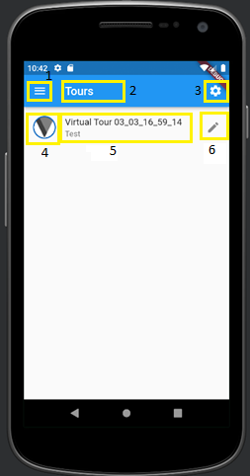  Figure 5.1 - Tour List Screen | - Hamburger Menu  - Screen Heading  - Wheel Menu button  - Logo  - Tour name and Description  - Edit Tour Button

Tour Detail
Tour detail screen where the selected tour is displayed and navigated. The Tour detail screen is equipped with controls that are needed to navigate a tour. Users can zoom in, zoom out, pan, switch to full screen mode, use the navigation hotspots to navigate the tour, get information from information hotspots.
Once in the full screen mode, the user can either make use of the same button to exit full screen mode or press the “Esc” key from keyboard. The mouse wheel can also be used to zoom in and zoom out in place of the on-screen buttons.
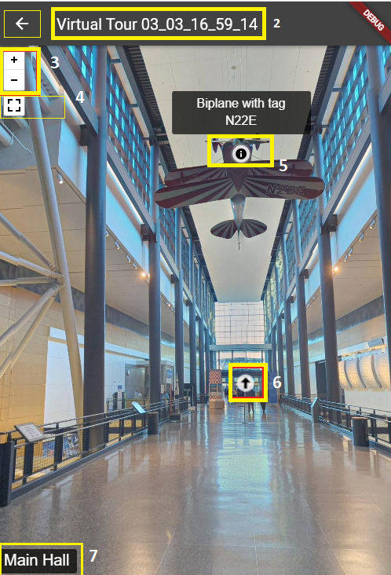 | 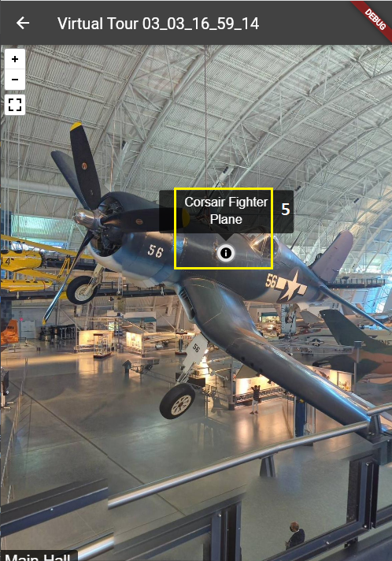
Figure 5.2 - Tour Detail Screens
  - Back arrow to get to the previous screen
  - Screen Heading
  - Zoom in and Zoom out buttons
  - Full Screen Button
  - Information Hotspot
  - Navigation Hotspot
  - Current Location

Edit Tour
The edit button against the tour from the Tour List page can be used to navigate to the Edit Tour screen. On this screen users can edit the tour name and description, and use the buttons to save, cancel or delete as needed.
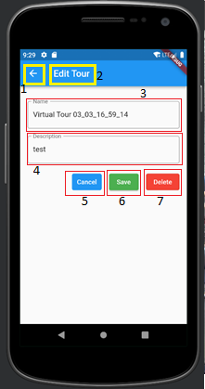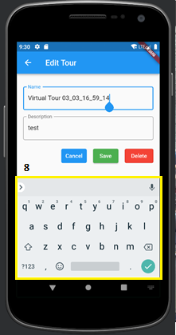  Figure 5.3 - Edit Tour Screen | - Back arrow  - Screen Heading  - Tour name  - Tour description  - Cancel button  - Save button  - Delete button  - keyboard to input characters

Hamburger Menu
The Hamburger Menu is displayed on the top left of screens of the application. When selected the Hamburger Menu displays list of options to choose from which include “View Tour” to display list of tours, “Create Tour” to create a new tour, “Search Tours” to search for a specific tour and “Search Hotspots” to search hotspots that match the search criteria.
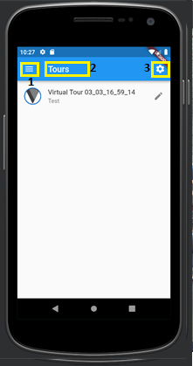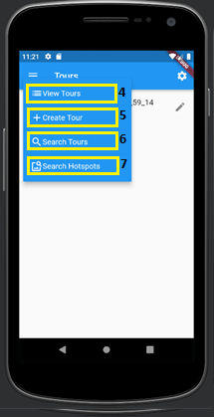  Figure 5.4 - Hamburger Menu | - Hamburger Menu  - Screen Heading  - Wheel Menu  - Menu item 1 View Tours  - Menu item 2 Create Tour  - Menu item 3 Search Tours  - Menu item 4 Search Hotspots

Wheel Menu
The Wheel Menu is displayed on the top right side of the screens of the application. The wheel menu, when selected displays the dropdown for system theme, button for Glow Effect and Share tour.
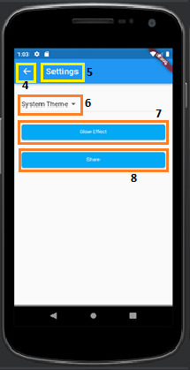
Figure 5.5 - Wheel Menu

  - Hamburger Menu
  - Screen Heading
  - Wheel Menu
  - Back arrow to get back to the previous screen
  - Settings
  - Theme Types
  - Glow Effect
  - Share View

Create Tour
Create tour is one of the menu items in the Hamburger menu, when selected, it redirects users to the create tour screen. On the Create Tour screen, tour name and description can be entered, and pictures can also be selected for a new tour. The cancel and save buttons can be used to save the new tour cancel as needed.
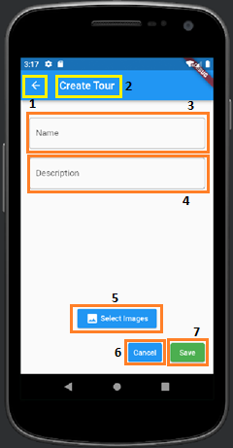  Figure 5.6 - Create Tour | - Back arrow to get back to the previous screen  - Page heading  - Name for new Tour  - Description for new Tour  - Select Image button  - Cancel button  - Save button

Search Tour
The Search Tours feature is located in the Hamburger menu. This functionality is used to search for tours related to the search parameter. The search result is displayed in a list which users can select and view tour details.

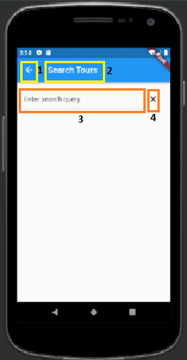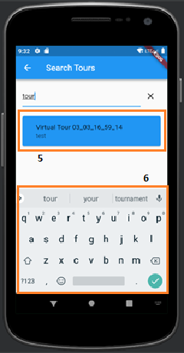  Figure 5.7 - Search Tours – Enter search query (left), search result (right) | - Back arrow to get back to previous screen  - Screen name  - Search query input box  - Button to cancel search  - Search Tours result  - keyboard to input characters

Search Hotspots
The Search Hotspots is also located in the Hamburger menu. The hotspot search is used to enter a search query to locate specific hotspots. The hotspot search result is displayed in the form of a list which users can select and view tour details.
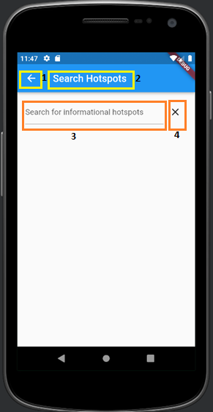 | 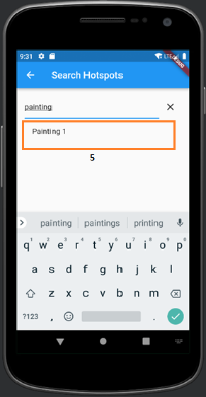
Figure 5.8 - Search Hotspots Enter search query (left), search result (right)

  - Back arrow to get back to previous screen
  - Screen name
  - Search query input box
  - Cancel search button
  - Informational Hotspots Search result

Glow Effect
The Glow Effect functionality is located under the Wheel Menu and it is used to adjust the lighting of a selected picture in a tour. Sliding the button on the slider from left to right increases the lighting and from right to left decreases the lighting.
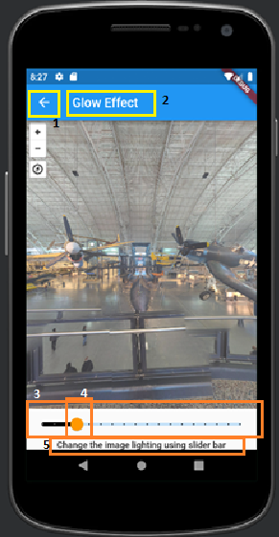 | - Back arow get back to previous screen  - Screen heading  - Glow Effect slider  - Glow Effect button  - Label
Figure 5.9 - Glow Effect

VR View
The VR view feature allows users to experience viewing the tour using a VR viewer. The VR View is activated by clicking on the ‘Toggle VR’ button from the tour detail screen. Users can also switch between the view options from Google Cardboard VR View to VR Stereo View using Toggle VR button.
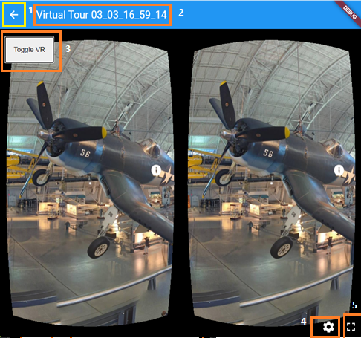  Figure 5.10a - Google Cardboard VR View | - Back arow  - Tour Name  - Toggle button  - Settings button  - Full Screen button

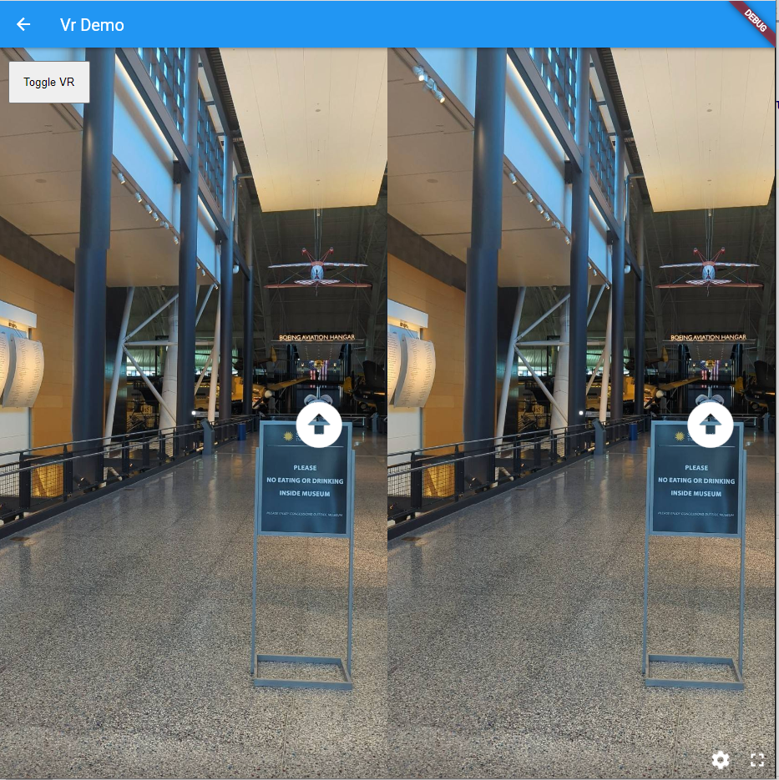
Figure 5.10b - VR Stereo View
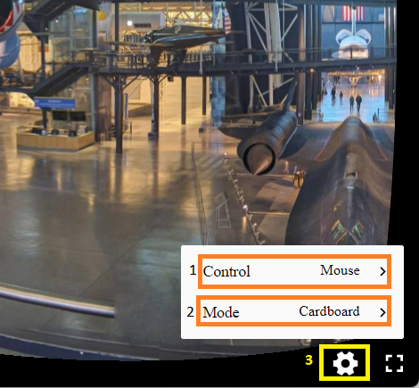 | - Control Options  - Mode switch  - Settings button
Figure 5.10c - VR View Controls

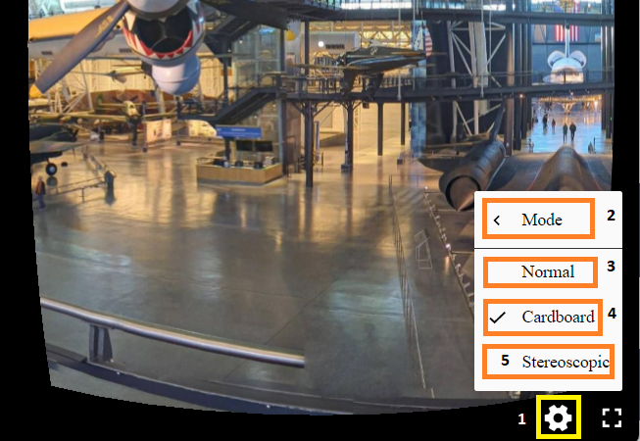 | - Settings button  - Mode Options  - Normal Mode  - Cardboard Mode  - Stereoscopic Mode
Figure 5.10d - VR View Controls

Theme Selection Dropdown
The Theme selection dropdown is used to change the theme of the application as needed. The Theme Selection dropdown is located under the wheel menu. From the dropdown, users can select from the options System Theme, Light Theme and Dark Theme.
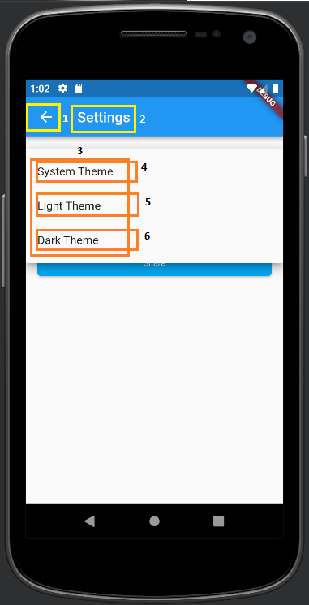 | 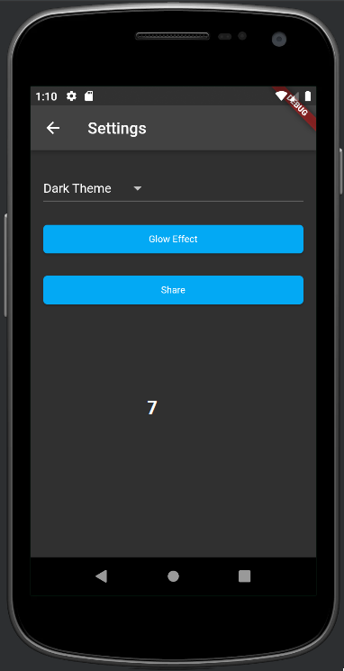 | 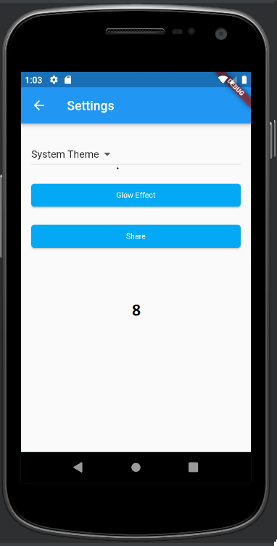
Figure 5.11 - Theme Selection drop down items(left), Dark mode (center), Light mode (right)

  - Back arrow
  - Screen Heading
  - Theme selection dropdown items
  - Item 1 - System Theme
  - Item 1 – Light Theme
  - Item 1 - Dark Theme
  - Dark mode
  - Light mode

Step-by-step Guide

How to View a Tour
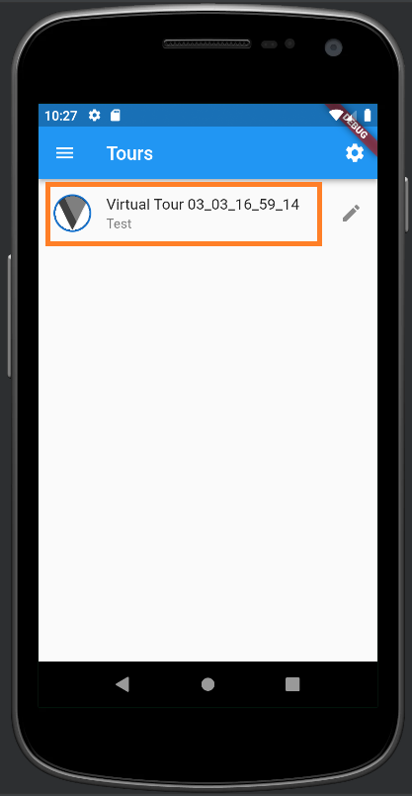 | 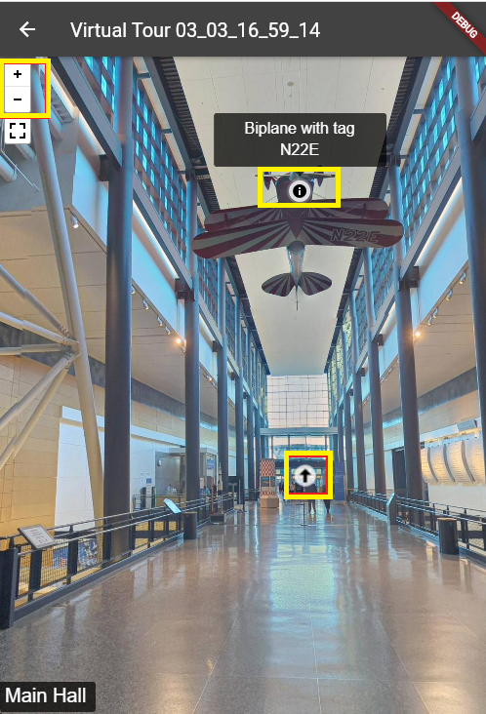
Figure 6.1 - View Tour
    - Open the application by clicking on the ViroTour icon.
    - The Home-screen includes a list of recorded tours.
    - Click on any tour to open it. A tour opens by loading panoramic images that give a 360-degree view of the virtual space.
    - To have a 360-degree view, one can make a swipe gesture on a mobile device or click and drag on an image when running the application on a web, Windows or MacOS based device. A 360-degree view can be autoplay that shows the whole view frame by frame without stopping or can be done by the user who can use the click and drag to move the view in whatever direction they want.
    - To move from one panoramic view /image to another, transition points are placed within the view that assist in doing this. Transition points enable a user to move from one location to another in a virtual space. Information hotspots are used within a view to display additional information related to objects within the tour.
    - The user can zoom and pan at any image location. To zoom the user can use the pinch gesture on the mobile application or use the onscreen zoom bar to zoom in and out.

How to Create a Tour
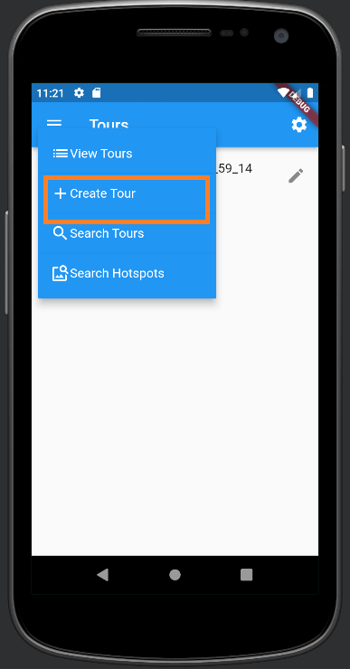 | 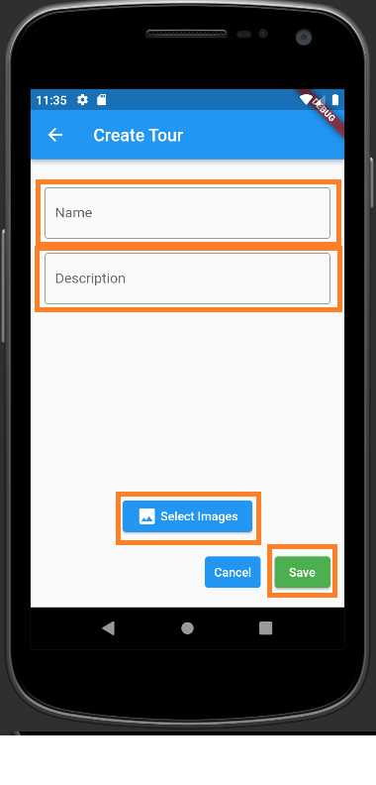
Figure 6.2 - Create Tour
- Click on the hamburger menu to open a dropdown list of menu options.
- Select the create tour option to open the create tour screen.
- Fill in the name and the description in the input fields.
- Upload tour images using the select images button.
- Click save to upload to create a tour or cancel to cancel the create tour process.

How to Edit a Tour
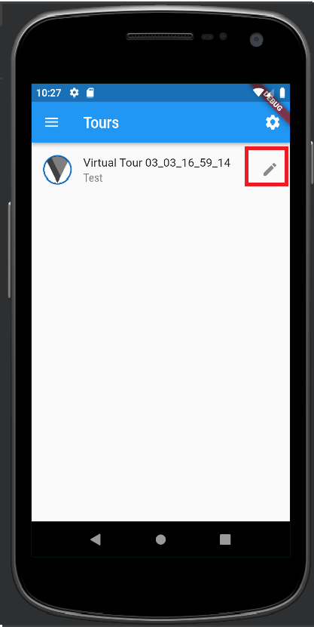 | 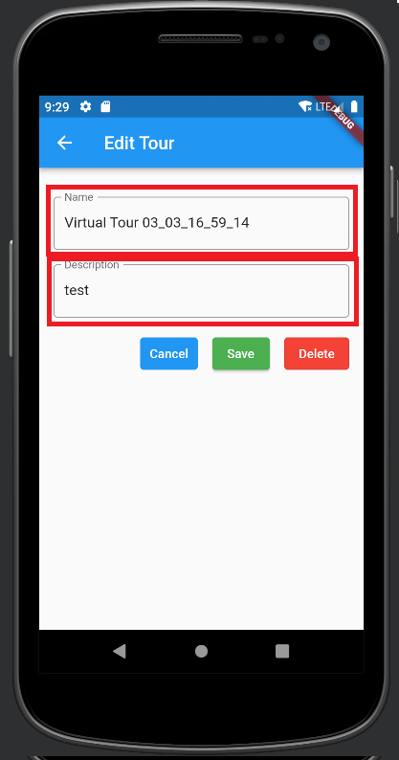
Figure 6.3 - Edit Tour
- The process of editing a tour consists of changing associated descriptive information (name and description) of a tour. Open the ViroTour Application. This should open a view with a list of all tours on the home-screen
- Navigate to the tour that you want to edit and click on the edit icon which should open the tour information in edit mode (text fields that allow information to be changed).
- Update the required fields and click save to update the information.

How to Search Tours
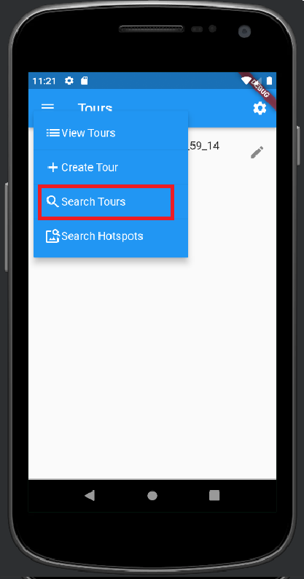 | 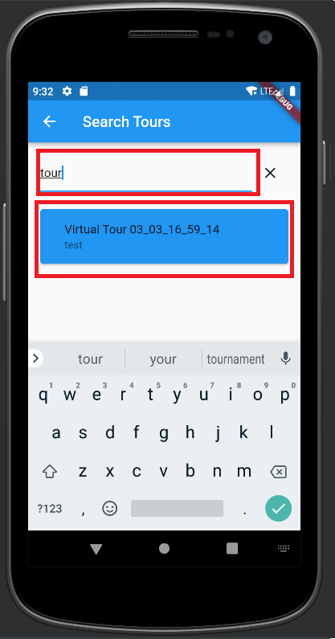
Figure 6.4 - Search Tour
  - Click on the hamburger menu to open a dropdown list of menu options.
  - Select the Search Tours option to open the search tour screen.
  - Type in the search text and press enter.
  - The list of tours that match the search text will be displayed in a list

Searching for Hotspots
A virtual space or tour may contain text, it is possible to find locations or images that contain the text.
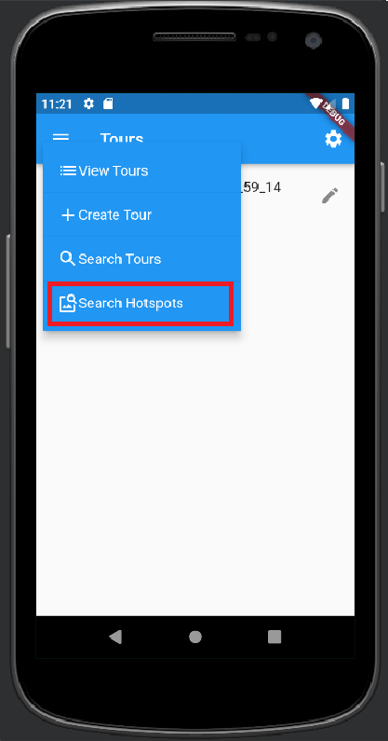 | 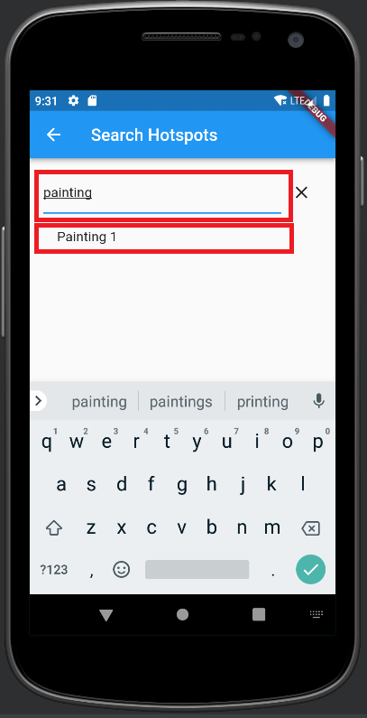
Figure 6.5 - Search Hotspots
- Click on the hamburger menu to open a dropdown list of menu options.
- Select the Search Hotspots option to open the search hotspots screen.
- Type in the search text and press enter.
- The list of Hotspots containing the search text will be displayed in a list

How to Delete a Tour
Deleting a tour is done through the tour edit page.
 | 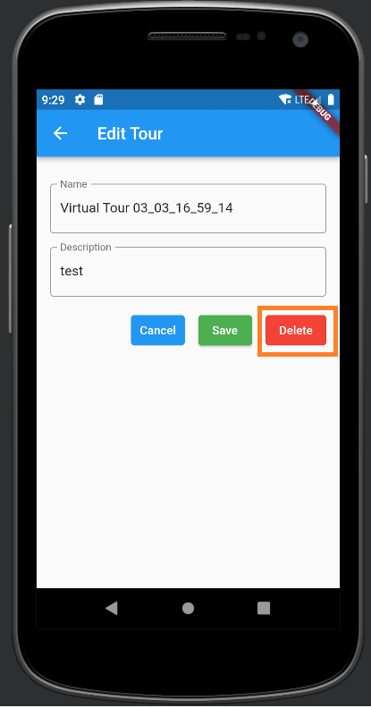
Figure 6.6 - Delete Hotspot
- Navigate to the tour list page.
- Click the edit symbol to the right of the tour you would like to delete. A new page will be opened showing the name and description of the selected tour.
- Click the red “Delete” button. A pop-up will be shown for the user to verify that they would like to delete the tour.
- Select “Delete”.
- A message will display any necessary information that was received from the server upon deletion of the tour.

How to Change the Application Theme
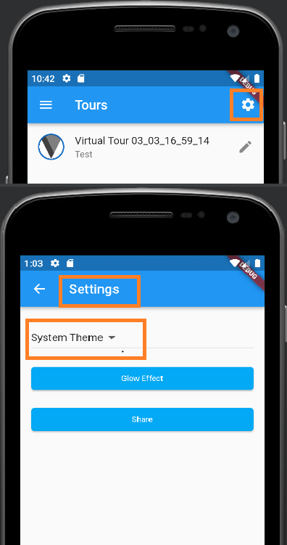 | 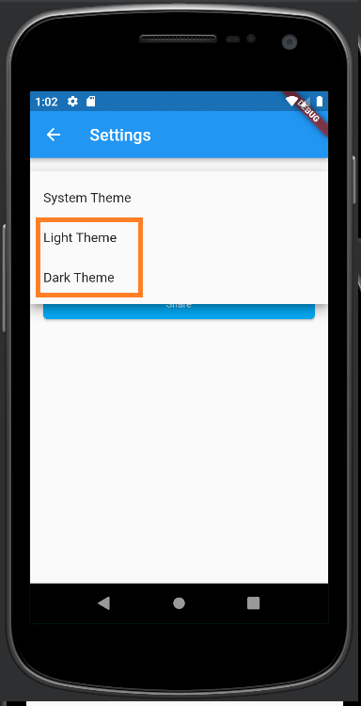
Figure 6.7 - Change Theme
- Open the Settings screen by choosing Wheel Menu
- From the System Theme Dropdown Select ‘Light Theme’ or ‘Dark Theme’ as needed

How to Apply Glow Effect
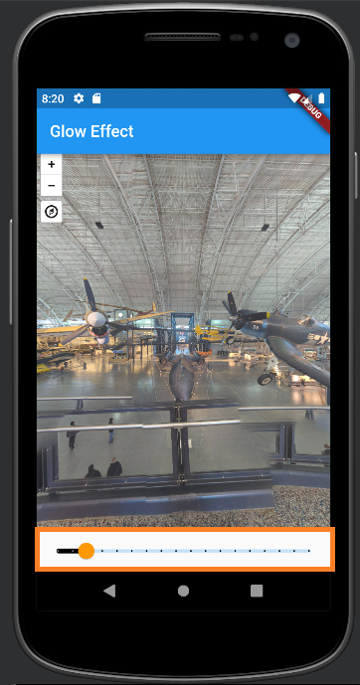 | Glow Effect is a standalone feature  - Slide the button on the glow effect bar from left to right to increase lighting  - Slide the button on the glow effect bar from right to left to decrease lighting

Figure 6.8 - Glow Effect

How to View Tour Using VR Viewer
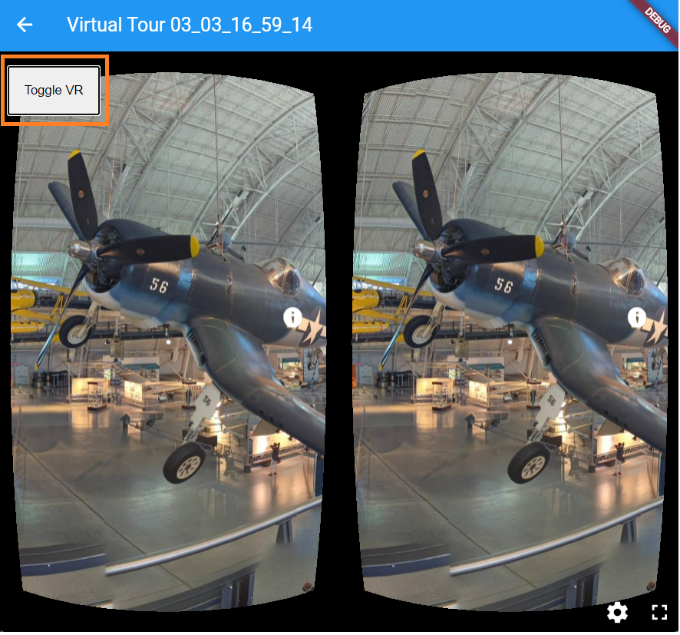 | VR View is a standalone feature.  - Open a tour in tour detail view  - Select the ‘Toggle VR’ button at the top left of the tour detail screen to change the view to VR (Google Cardboard VR)  - Select the same button gain to switch from Google Cardboard VR to VR Stereo  - Selecting the ‘Toggle VR’ button for a third time, will return the view to normal view.
Figure 6.9 - VR View

Troubleshooting
  - Restart the application: If the application is not working as expected, try closing it and reopening it. This can often resolve minor issues and restore normal functionality.
  - Clear cache and data: If the application is still not working properly after restarting it, try clearing the cache and data. This will remove any temporary files and settings that may be causing issues.
    - Android: go to Settings > Apps > ViroTour > Storage > Clear cache / Clear data.
    - IOS: go to Settings > General > iPhone Storage > ViroTour > Offload App / Delete App
    - Web browsers: clear the cache and cookies from the browser settings.
  - Check internet connection: If ViroTour is not working properly on the web, check the internet connection. A slow or unstable connection can cause the application to perform poorly or not load at all.
  - Update the application: Make sure that you are using the latest version of ViroTour. Developers often release updates to fix bugs and improve performance, so keeping the application up to date can help prevent issues.
  - Check for device compatibility: Make sure that your device is compatible with ViroTour. Check the application's system requirements and ensure that your device meets them. If your device is not compatible, the application may not work properly or at all.
  - Contact support: If the issue persists after trying the above steps, contact ViroTour's support team for further assistance. Be sure to provide as much detail as possible about the issue, including any error messages or unusual behavior that you have noticed.

