Software Requirements Specification
for
For NASA Maestro HUD
Version 4
April 26, 2020

Prepared by Laura Tamshen

Team Members
Ali Alnaqeeb
Laura Tamshen
Ryan Cohan
Matthew Elliott
Jonathan Johnson
Table of Contents
Table of Contents ii
Revision History iii
1. Introduction 1
1.1 Purpose 1
1.2 Document Conventions 1
1.3 Intended Audience and Reading Suggestions 1
1.4 Product Scope 2
1.5 References 2
2. Overall Description 2
2.1 Product Perspective 2
2.2 Product Features 3
2.3 User Classes and Characteristics 3
2.4 Operating Environment 3
2.5 Design and Implementation Constraints 3
2.6 User Documentation 3
2.7 Assumptions and Dependencies 3
3. System Features 3
4. External Interface Requirements 3
4.1 User Interfaces Overview 3
4.2 Hardware Interfaces 4
4.3 Software Interfaces 4
5. System Features/Modules 4
5.1 Display Steps in HUD 4
5.2 Voice Commands 4
5.3 Use-Case Model survey 5
5.4 Use-Case Reports 6
5.5 Unit Tests 9
6. UML Diagrams 11
7. Agile Backlog and Sprint Report 12
7.1 Sprint 1 Backlog Report 12
7.2 Sprint 2 Backlog Report 12
7.3 Sprint 3 Backlog Report 13
7.4 Sprint 4 Backlog Report 13
7.5 Sprint 5 Backlog Report 14
7.6 Sprint 6 Backlog Report 14
8. Supporting Information 14

Revision History
Name | Date | Reason For Changes | Version
Laura Tamshen | 02/21/2020 | Initial Version | 1.0
Laura Tamshen | 02/24/2020 | Update Use Cases | 1.1
Laura Tamshen | 03/15/2020 | Use different SRS template | 1.2
Ali Alnaqeeb | 03/17/2020 | Update formatting and added content | 1.3
Ali Alnaqeeb | 03/21/2020 | Update all document to correspond with project plan, and SDD, fix formatting issues. | 2
Ali Alnaqeeb | 03/25/2020 | Udpated Procedure and role steps in product scope | 2.1
Ali Alnaqeeb | 04/05/2020 | Added UML diagram and updated backlog | 3
Laura Tamshen | 04/11/2020 | Added Unit Test information | 3.9
Ali Alnaqeeb | 04/24/2020 | Updated document with sprint reports and unit tests example | 4

Introduction

Purpose
This Software Requirements Specification (SRS) describes the functional for the NASA Maestro HUD project. The first requirement of this project which is the display of the HUD is the highest priority. Next priority is navigating through the steps through the use of voice commands. This document will be utilized by the stakeholders to ensure that the NASA Maestro application has been built according to specifications. This document also features Use Cases that clarify the requirements of the application.

Document Conventions
Features are listed by priority.
Definitions and Abbreviations:
HUD | Heads Up Display
EVA | Extravehicular Activity

Intended Audience and Reading Suggestions
The intended audience for this document is the NASA HUD Team 2 including the stakeholders and Project Manager. The team will also use information in this document to create tasks on the product backlog therefore developers and testers may want to pay special attention to the requirements and use case sections. The stakeholders are:
- UMGC Team
- Two DevOps engineers who will provide our Developers assistance with development tools and infrastructure
- Two product owners - James Montalvo and Kristopher Field
- Project manager Roy Gordon
- The astronauts and operators who will be using the NASA Maestro HUD software
- Dr. Assaduallah who is the professor for our class

Product Scope
The software to be created will allow a single actors instruction set for a given EVA procedure to be displayed on a Heads-Up device. The software will also be controlled by a set of voice commands. The software is Proof of Concept. The following requirements were elicited:

- Launch the Maestro application
- Load a list of procedures for the user to select from using voice command Maestro select procedure (number)
- After selecting a procedure, user will be presented with a list of associated roles to select from using voice command Maestro select role (number)
- The system displays the first step of the first task, as well as any images, associated with the selected procedure
- User can navigate through the procedure with the following voice commands:
  - Maestro Select Procedure (procedure number) – selects the supplied procedure number
  - Maestro Select Role (role number) – selects the supplied role number and displays the first associated task step
  - Maestro Next Step – shows the next step in the task
  - Maestro Previous Step – shows the previous step in the task
  - Maestro Go Home – navigates back to the landing page where the user can select a new procedure
  - Maestro Show Image (image number) – enlarges the selected image number
  - Maestro Back to Step – exits the current, enlarged image and returns to the step
  - Maestro Next Image Page – shows the next set of images; does not change task step
  - Maestro Previous Image Page – shows the previous set of images; does not change the task step
  - Maestro Toggle Checkbox (checkbox number) – toggles the selected checkbox to either selected or unselected
  - Maestro Help – brings up the help screen listing all voice commands
- When the user advances past the last page of steps for the final task associated with a procedure, the UI should display a screen with the message “Procedure Complete”. After 5 seconds, the UI should be redirected to the procedure selection screen
- All this information is displayed in a small 4” display located in the astronaut helmet

References
F., Kris (2011). STS-134 Flight Supplement. Retrieved March 17, 2020, from
https://www.nasa.gov/centers/johnson/pdf/539922main_EVA_134_F_A.pdf

Overall Description

Product Perspective
The project is essential for fulfillment of the UMGC Spring 2020 SWEN-670 Software Engineering Project. Maestro currently renders procedure data in many file types (HTML, DOCX, specific XML types) as well as different formats (EVA format, IVA format, etc.). This project adds to the existing Maestro application. A new format is to be added for a Heads-Up Display (HUD) which would display only one actor’s steps for a given EVA procedure on a four-inch screen inside of the astronaut’s helmet. Voice commands will be accepted allowing the user to display a selected set of instructions as well as displaying next and previous steps and images.

Product Features
- Display EVA procedure steps in the HUD.
- Use voice commands to navigate through steps.

User Classes and Characteristics
- Astronauts performing procedures.
- Ground control.

Operating Environment
The software will operate in the 4-inch HUD located in the astronaut’s helmet.

Design and Implementation Constraints
The steps and associated images must all display in a four-inch screen.

User Documentation
A User Manual, Developer’s Guide and Runbook will be produced by the end of the project.

Assumptions and Dependencies
No defects in the Maestro software will impact development of the application.

System Features
- Display Steps in HUD
- Voice Commands

External Interface Requirements

User Interfaces Overview
The user interface will be voice controlled. The voice commands that will control this software are “Maestro next step” and “Maestro previous step” as well as “Maestro show image [image number]” to enlarge. The user of the software will be able to select which actor he/she will be acting as, which - since procedures are a compilation of many different steps for many different actors – dictates which steps will be displayed on the HUD. Note that further information regarding the user interface is documented in the Software Design Specification.

Hardware Interfaces
The hardware will be a four-inch HUD located inside the astronaut’s helmet.

Software Interfaces
The NASA Maestro software user interface is currently in progress. Please refer to section 5.2 of the software design document to see a mock up overview of the system.

System Features/Modules

Display Steps in HUD
5.1.1 Description and Priority
Create a basic format showing one actor's steps which can be displayed on a small (~4") display. Priority 1.
5.1.2 Stimulus/Response Sequences
See Section 5.4 Use Cases.
5.1.3 Functional Requirements
  - Create a basic format showing one actor’s steps which can be displayed on a small (~4") display.
  - As the screen resolution is currently unknown, development will be for a 4-inch display like a cell phone.
  - The display device will be located in the astronaut’s helmet and must therefore be able to be read at a close distance. Therefore, larger text is preferable.
  - Between one and five steps will fit on a page. However, it was decided that one step will display per page. A step may not cross a page boundary.
  - Steps may have reference to images which will display on the HUD as well.
  - Warnings can apply to one step, set of steps, or all steps and must also be displayed.
  - Each page shows navigation help.

Voice Commands
5.2.1 Description and Priority
Make the HUD respond to voice commands. This is Priority 2.

5.2.2 Stimulus/Response Sequences
See Section 5.4 Use Cases.

5.2.3 Functional Requirements
8. Commands “Maestro select procedure”, “Maestro select actor”, "Maestro next step(s)","Maestro previous step(s)", “Maestro show image [image number]”, “Maestro close image” will update the display as appropriate. Commands are triggered with the word “Maestro”. (e.g. “Maestro next step”).
9. Steps may have reference to images which will display upon voice command also.
10. A voice command allowing the actor to select which set of steps to display before beginning the procedure is available.

Use-Case Model survey
There are thirteen Use Cases that make up the requirements for this system. Below is a summary. Detailed information is located in section 5.4.
ID | Use Case | Description
UC-01 | Select Procedure | The actor selects which procedure to run.
UC-02 | Select Which Actors Steps to Display | Since there may be several actors per procedure, the actor selects which to display.
UC-03 | Step has a Warning | A step may have a warning associated with it. If so, the warning displays with the step.
UC-04 | Warning exists for entire procedure | The entire procedure may have a warning associated with it. If so, the warning displays for the entire procedure.
UC-05 | Warning exists for set of steps | A warning may exist for a set of steps in the procedure. If so, display the warning only for the set of steps.
UC-06 | Images exist for a step | Steps may have associated images. If so, display the images with the steps.
UC-07 | Long Steps are not broken over pages | A step may not be broken over a page.
UC-08 | Voice Command to Select Procedure | A voice command may be used to select the procedure.
UC-09 | Voice Command to Select Actor | A voice command may be used to select the actor of a procedure.
UC-10 | Voice Command to Select Next Step(s) | A voice command may be used to display the next step in a procedure.
UC-11 | Voice Command to Select Previous Step(s) | A voice command may be used to display the previous step in a procedure.
UC-12 | Voice Command to View Images | A voice command may be used to view images associated with step(s).
UC-13 | Each Page Shows Navigation Help | Each page will display information regarding navigation between steps, images, etc.

Use-Case Reports
Use Case UC-01: Select Procedure

Basic course of events (Scenario):
Preconditions: None

Actor | System | Notes
The actor selects the procedure. | The system selects the procedure and displays the Select Actor screen.

Use Case UC-02: Select Which Actors Steps to Display

Basic course of events (Scenario):
Preconditions: Use case Select Procedure has been executed.

Actor | System | Notes
The actor selects which set of steps to display for a procedure. | The system displays the initial step(s) for the selected procedure for the correct actor on the HUD in a way that is readable to the actor.

Use Case UC-03: Step has a Warning

Basic course of events (Scenario):
Preconditions: Use cases Select Procedure and Select Which Actors Steps to Display have been executed.

Actor | System | Notes
The actor views a step that has an associated warning. | The system displays the warning on the HUD.

Use Case UC-04: Warning exists for entire procedure

Basic course of events (Scenario):
Preconditions: Use cases Select Procedure and Select Which Actors Steps to Display have been executed.

Actor | System | Notes
The actor selects a procedure that has a warning for the entire procedure. | The system displays the warning on each page of steps.

Use Case UC-05: Warning exists for set of steps

Basic course of events (Scenario):
Preconditions: Use cases Select Procedure and Select Which Actors Steps to Display have been executed.

Actor | System | Notes
The actor selects a step that begins a series of steps with warnings. | The system displays the warning on each page of steps.

Use Case UC-06: Images exist for a step

Basic course of events (Scenario):
Preconditions: Use cases Select Procedure and Select Which Actors Steps to Display have been executed.

Actor | System | Notes
The actor views a step that has one or more associated images. | The system displays the associated images. If there is more than one image for the step, the system allows the actor to see all images.

Use Case UC-07: Long Steps are not broken over pages

Basic course of events (Scenario):
Preconditions: Use cases Select Procedure and Select Which Actors Steps to Display have been executed.

Actor | System | Notes
The actor views a long set of steps. | The system displays steps such that none are broken up over pages.

Use Case UC-08: Voice Command to Select Procedure

Basic course of events (Scenario):
Preconditions: None

Actor | System | Notes
The actor verbally selects a procedure. (e.g. “Maestro select procedure 1”) | The system responds to the voice command by displaying the select actor screen.

Use Case UC-09: Voice Command to Select Actor

Basic course of events (Scenario):
Preconditions: Use case Voice Command to Select Procedure has been executed.

Actor | System | Notes
The actor verbally selects an actor. (e.g. “Maestro select actor 1”) | The system responds to the voice command by displaying the steps for the selected actor.

Use Case UC-10: Voice Command to Select Next Step(s)

Basic course of events (Scenario):
Preconditions: Use case Voice Command to Select Procedure and Voice Command to Select Actor have been executed.

Actor | System | Notes
The actor verbally selects the next step. (e.g. “Maestro next step”) | The system displays the next step(s) in the selected procedure for the selected actor.

Use Case UC-11: Voice Command to Select Previous Step(s)

Basic course of events (Scenario):
Preconditions: Use case Voice Command to Select Procedure and Voice Command to Select Actor have been executed.

Actor | System | Notes
The actor verbally selects the previous step. (e.g. “Maestro previous step”) | The system displays the previous step(s) in the selected procedure for the selected actor.

Use Case UC-12: Voice Command to View Images

Basic course of events (Scenario):
Preconditions: Use case Voice Command to Select Procedure and Voice Command to Select Actor have been executed.

Actor | System | Notes
The actor verbally asks to view images associated with the steps. (e.g. “Maestro show images”) | The system displays the images associated with the selected step.

Use Case UC-13: Each Page Shows Navigation Help

Basic course of events (Scenario):
Preconditions: Use case Voice Command to Select Procedure and Voice Command to Select Actor have been executed.

Actor | System | Notes
The actor navigates through the steps of the procedure. | Each page displays navigation help.

5.5 Unit Tests
Unit tests are written using Mocha/Chai and verify correct responses from each endpoint. The following tests have been implemented FilesController.js, RolesController.js, TasksController.js and can be located here: https://github.com/umgc/nasa.hud/tree/master/backend/test

Below is an example of how the unit tests were written:
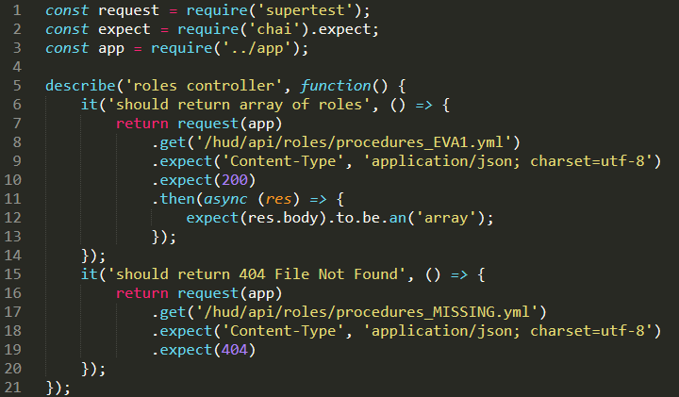

UML Diagrams
UML stands for Unified Modeling Language (UML). UML is a general-purpose, developmental, modeling language in the field of software engineering that is intended to provide a standard way to visualize the design of a system. Below is the UML Diagram for the NASA HUD application.

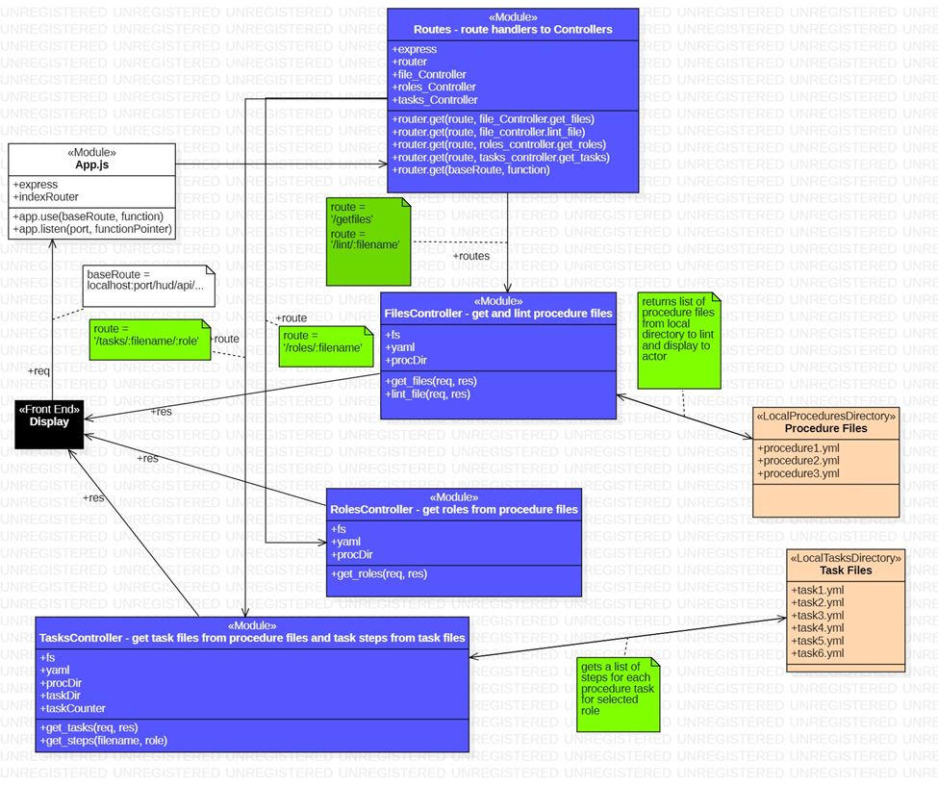

Agile Backlog and Sprint Report

Sprint 1 Backlog Report

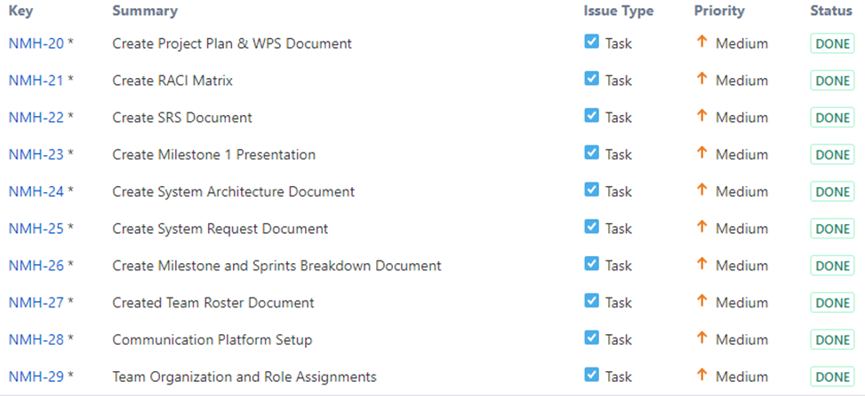

Sprint 2 Backlog Report

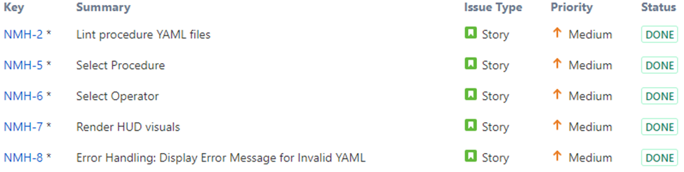

Sprint 3 Backlog Report

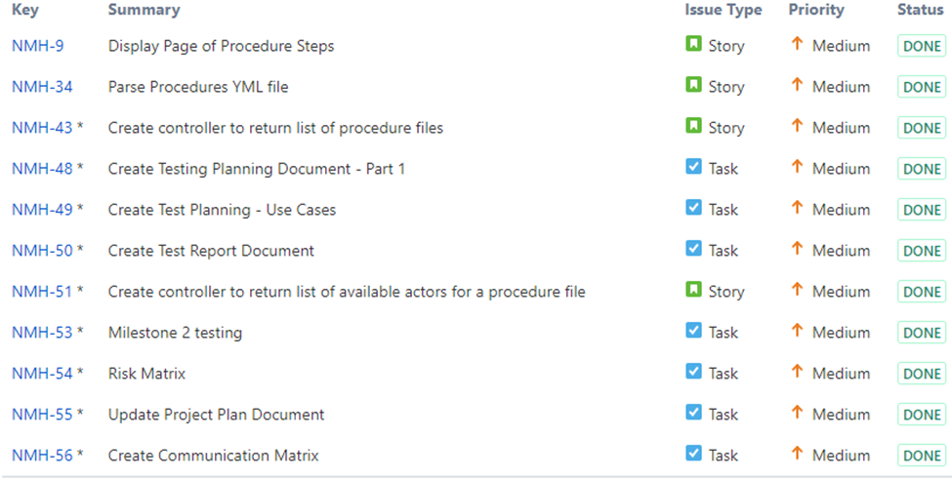

Sprint 4 Backlog Report

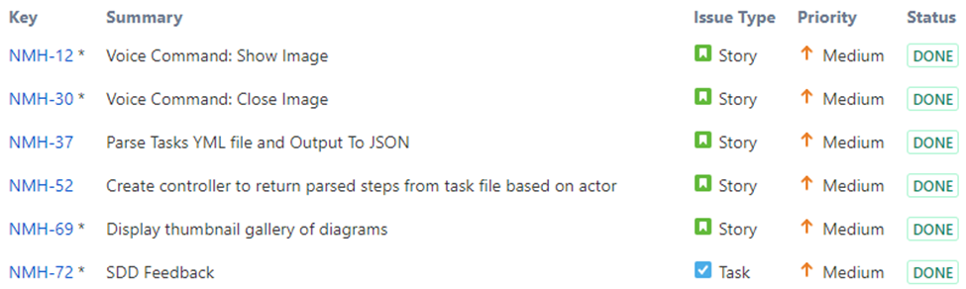

Sprint 5 Backlog Report

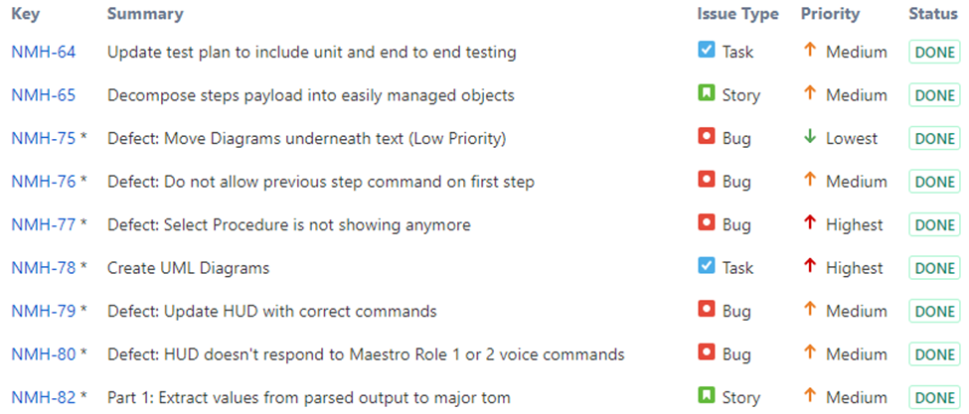

Sprint 6 Backlog Report

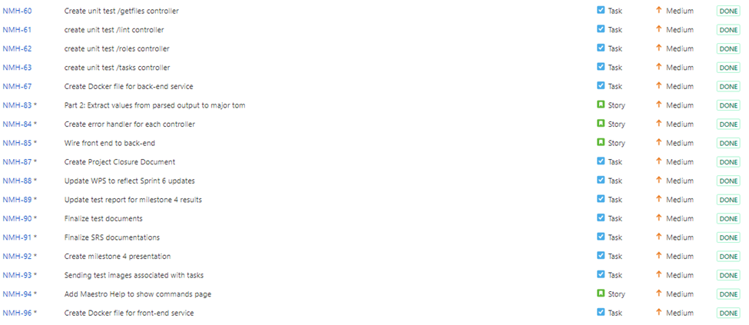

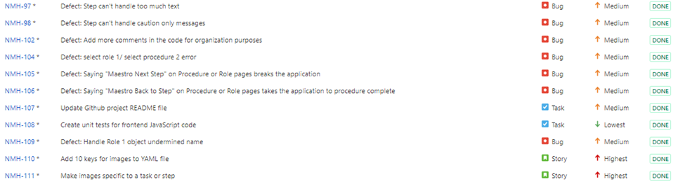

Supporting Information
N/A

