An Introduction into EEG recording of visually evoked responses

Ursula M. Goldstein

Freie Universität in Berlin

Abstract

In this report we focused on a good introduction for students to study the effects of EEG data preprocessing on visually evoked potentials. For this purpose we used a checkerboard paradigm already known to evoke a ERP , specifically the P100. The P100 is demonstrated through modulating stimuli contrast. The analysis included different variations for rereferncing, high and low-pass filter cut-offs and artifact detection and rejection. Results showed a positive ERP at around 100 ms post-stimulus on the electrodes PO8 and O2.Variations for high-filter cut-off and artifact detection were not as noticeable as the variations for low-filter and re-referencing. Overall data were good for introduction to ERP preprocessing.

*Keywords:* EEG, contrast, visually evoked responses, checkerboard, P100

An Introduction into EEG recording of visually evoked responses

An event-related potential is an electrical potential, recorded through EEG, associated with a specific sensory, cognitive, or motor event (Luck, 2005). In this study we focused on one of the sensory event-related potentials called visually evoked potentials. Visually evoked potentials have three distinct peaks, the N70, P100 and N140 (Ostwald, 2010). Here we focus on the P100 which is known to have a onset latency of 60-90ms with a peak latency of 100-130 ms (post-stimulus). This potential can be evoked through a checkerboard stimulation, further explained in the methods, since it is dependent on the stimulus contrast. Ostwald and colleagues have demonstrated that the checkerboard stimulation evoked the P100 component and is modulated by stimulus contrast . Therefore this study is a good introduction for students to study the effects of EEG data preprocessing on visually evoked potentials.

Event-related potentials also depend on the specific data processing . Keil and colleagues (2014) describe in their report guidelines for recording and processing the importance of preprocessing parameters. Preprocessing is a procedure that transforms the data into a form that is appropriate for more generic computations and can eliminate artifacts. There are several aspects of preprocessing, in this report we will focus on rereferencing, high-pass and low-pass filter cut-offs, artifact rejection and correction. Rereferencing uses either one specific electrode or average reference to reference the data. High-pass and low-pass filter cut-offs differ to eachother in that high-pass filer cut-offs eliminate very low frequencies and low-pass filters very high. Artifact detection and correction involves identifying artifact either produced by the subject or other equipment, and correcting the influence of an artifact. All of these parameters have to be considered before starting processing the data.

In this report the data were preprocessed with default setting set by the instructor and included different variations. The default included, average rereferencing, a high-pass filter cut -off of 0.1 Hz, low-pass cut-off of 40 Hz and no artifact detection. For rereferencing the variations included to the electrode TP10 or no rereferncing. The high-pass filter varied from 1 Hz or 2 Hz compared to the low-pass filter including 20 Hz or 10 Hz. Finally an Peak-to-peak threshold-based artifact detection and rejection with a threshold of 50 μV was included. In order to implement the above, the default data processing strategy was realized using a Matlab function. In a second step, parameters of this function were adapted such that separate functions performed the data processing variations.

**Method**

**Participants**

This study was comprised of a single subject (female), single session EEG data using

a BrainProducts active-electrode set-up as installed at the Center for Adaptive Rationality, Max-Planck Institute for Human Development, Berlin using a basic visual stimulation paradigm as reported in Ostwald et al. (2010).

**Materials**

The experimental paradigm is presented to the participant using the custom Matlab function ChecherBoard_EEG.m which uses functionality of “PsychToolBox-3” a Matlab toolbox for neurocognitive stimulation available from http://psychtoolbox.org/. The function CheckerBoard.m implements one data acquisition session of the checkerboard (CB) experiment as reported in Ostwald et al (2010). It creates the stimuli and trial presentation sequence (“design”) for the session, along with presenting the stimuli and a fixation change detection task. Moreover, it sends markers to the EEG recording system (Vision Recording) for post-hoc EEG recording partitioning. The function records all significant events into a log cell array with time stamps and event identifiers as well as a separate array of observer responses for easy behavioural analysis. Figure 1 depicts and overview of the design. The stimuli are full hemifield checkerboards of reversing phase. The checkerboards are presented to the left visual hemifield, filling the entire projection screen left of the midline. Checkerboards, i.e. sums of orthogonal square wave gratings, can be described by at least the following physical properties: contrast and spatial frequency, which will be discussed below. Markers are sent from the stimulation PC via the parallel port to the EEG recording system (Vision Recorder) using the PC’s parallel port. CheckerBoard_EEG.m addresses the parallel port using Matlab’s data acquisition toolbox (details can be found in http://www.mathworks.com/help/pdf_doc/ daq/daqug.pdf ). All major events are recorded as a marker in the EEG trace. Table 3 gives an overview of the markers and their corresponding events.

**Design**

The objective of the experiment is to record EEG data of a human observer being presented with checkerboards of two different contrasts. The checkerboards are presented with phase reversal at a frequency of 2 Hz every XXX seconds, with fixation breaks between individual stimulus presentations. During the fixation breaks, the observer is engaged in a fixation change task, to engage her attention, i.e. the observer is asked to press a button, whenever the fixation cross changes from a plus sign to the letter x. The main emphasis of the experiment rests on the response of visual cortex to checkerboard stimulation, while the fixation change task is only meant to engage the observer in some activity, while maintaining fixation.

In the checkerboard experiment, there are several pseudo-randomly chosen variables per trial which are shown in table 2. On the start of each trial a checkerboard of either high or low contrast is displayed, followed after 500 ms by its phase reversal, which is again presented for 500 ms. After this, the fixation cross is displayed for 500 ms. If the trial is a target trial, the fixation-cross “+” sign will next assume its “x” state or remain in the “+” state, each for the duration of 500 ms, and finally remain in the “+” state for another 1000 ms. Each trial, including presentation of the checkerboard reversal and the inter-stimulus onset time thus lasts 1000 ms (checkerboard presentations) + 1000 ms (fixation cross change or none) + 1000 ms = 3000 ms.

**Stimulus Contrast**

The contrast of the presented checkerboards is an experimental parameter with two levels, low and high contrast. Luminance contrast as a measure of perceived lightness or brightness is commonly defined as Michelson contrast, given by

𝐶 = (𝐿𝑚𝑎𝑥 − 𝐿𝑚𝑖𝑛)/(𝐿𝑚𝑎𝑥 + 𝐿𝑚𝑖𝑛) (1)

where 𝐿𝑚𝑎𝑥and 𝐿𝑚𝑖𝑛 are the maximum and minimum “luminances” of the foreground and background colors, respectively. Essentially, the luminance quantities in (1) can be interpreted in three different ways: First, as the “driving luminance” 𝐿𝑑, which is calculated as a weighted sum of the gamma-corrected RGB values of the display, second as the emitted luminance (𝐿𝑒), which is the luminance of light emitted from the display surface, and third as the perceived luminance (𝐿𝑝), which is the luminance of the total light that enters the eye. 𝐿𝑝 is the quantity that matters for calculating stimulus contrast, but only 𝐿𝑑 is readily controlled in the experimental stimulation protocol. Hence assuming optimal gamma-correction and optimal viewing conditions, the luminance values for the checkerboards can be obtained by inspecting 𝐿𝑑, the driving luminance.

Table 1 displays the driving luminance values for the different stimuli presented in the experiment.

**Spatial Frequency**

The spatial frequency of both stimulus levels is identical. From the literature, it seems that a spatial frequency of 2 cycles per degree of visual angle (cpd) is optimal for generating “good” evoked responses in addition to strong gamma range frequency activation. To obtain a spatial frequency of 2 cycles per degree visual angle tileSideLength was set to 10. For recording event-related potential in the set-up at the MPI for Human Development, this setting was reused.

**Data Analysis**

Data analysis included default setting on the first function that were then varied for the function that followed with variations. Default settings included converting the data as continuous from the native BrainProducts format to the SPM12 format. Re-referencing of the data was kept at average reference. A Butterworth filter was used for high-pass filtering on the converted data, with a cut-off frequency of 0.1 Hz. Low-pass filtering also included a Butterworth filter but with a cut-off frequency of 40 Hz. The data was then epoched with a time window of -100 to 500 ms and a baseline-correction. There was no artifact correction or rejection. Finally the data was then averaged using standard averaging.

For further analysis, the following variations were performed, where all remaining setting should correspond to the mentioned default settings. Re-referncing variation included none and data re-referencing to electrode TP10. High-pass filter variations contained 1 Hz and 2 Hz variation. Low-pass filter variations were compromised of 20 Hz and 10 Hz. Finally artifact detection included Peak-to-peak threshold-based artifact detection and rejection with a threshold of 50 μV. The data were then presented for the electrodes PO8 and O2 as seen in all of the figures.

**Results**

A Matlab .m-file function that evaluates basic aspects of the participants’ EEG data in the experimental paradigm was created in the program Matlab. The participants' data were received in .eeg, .dat, .vhdr and .vmrk files, where the 04 denoted the participant number and the LI denoted the first two letters of the name and HOV the first three letters of the last name. All the figures show high contrast(HC) and low contrast(LC) graphs. Figure 2 depicts the rereferencing variation compared to average reference. As expected there is a positive ERP at 100 ms (P100) and the no rereferencing condition has the highest peak compared to rereferencing to TP10 with the lowest amplitude. Figure 3 also shows a P100 wave but with the high-pass filter cut-offs variation. The different Hz variation are very close to each other on the graph and the HC and LC are more separated. Figure 4 depicts again a P100 this time with low-filter cut-offs. The HC conditions have a higher amplitude compared to LC, but overall the graphs have a equal distance to each other and are not clustered up. P100 is again seen in Figure 5 this time with the variation of artifact rejection. The graphs HC and LC are more seperate from each other, but the two variations of artifact rejection are close to each other. The results are discussed further in the discussion.

**Discussion**

As seen in the results , with the re-referencing variations, TP10 has a low peak because there should not be a significant ERP at the electrode itself , therefore re-referencing to a low creates a lower peak overall. For average re-referencing the peak is a bit lower than no recording since it averages it out to all of them compared to none. The high-filter cut-offs for 0.1, 1 and 2 don't show a lot of difference. The only noticeable difference is between the high and low contrasts. But overall Figure 2 demonstrates a very smooth graph since it doesn't let low frequencies pass as much the low-pass filter cut-offs. The low-pass filter cut-offs graph is very uneven since it lets low frequencies pass. The difference between the variations is noticeable, the cut-off of 40 Hz has the highest peak, since it has the highest cut-off for frequencies. Finally the artifact variation compared to no artifact correction does not demonstrate a noticeable difference, this might be due to using an algorithm to detect artifacts. One could try inspecting the data manually and see if there are really almost no artifacts.

In conclusion the aim of the report was to introduce students to study the effects of EEG data preprocessing on visually evoked potentials. The data were good for an introduction since there was a noticeable ERP at 100 ms and the variations demonstrated some differences to each other.

References

Keil, A., Debener, S., Gratton, G., Junghöfer, M., Kappenman, E.S., Luck, S.J., Luu, P., Miller, G.A., & Yee, C.M. (2014). Committee report: Publication guidelines and recommendation for studies using electroencephalography and magnetoencephalography. *Psychophysiology, 51,* 1-21. doi: 10.1111/psyp.12147

Luck, S. J. (2005). *An Introduction to the Event-Related Potential Technique* (pp. 1-124).

Ostwald, D., Porcaro, C., & Bagshaw, A.P. (2010). An information theoretic approach to EEG-fMRI integration of visually evoked responses. *NeuroImage, 49,* 498-516.

doi : 10.1016/j.neuroimage.2009.07.038



*Figure 1.* (A) Experimental Factor Checkerboard contrast with two levels, low and high.

(B) Single Trisal Design and EEG markers

Table 1

*Driving luminances of the visual stimuli employed*

|  |  |  |  |  |  |  |
| --- | --- | --- | --- | --- | --- | --- |
|  | HC Phase | LC Phase | HC Antiphase | LC Antiphase | Fixation Plus | Fixation X |
| Mean Dl | 127.28 | 127.28 | 127.78 | 127.78 | 127.03 | 127.03 |
| STD Dl | 63.66 | 15.67 | 63.67 | 15.67 | 1.49 | 1.50 |
| MI Contrast | 1.00 | 0.25 | 1.00 | 0.25 | 0.22 | 0.22 |

Table 2

*Randomly determines trial properties*

|  |  |  |
| --- | --- | --- |
| **Variable** | **Values** | **Sampling Distribution** |
| Condition | 1 or 2 | Random permutation of the same number of repeats per condition |
| Target Trial | 0 or 1 | Random permutation of zeros (trials-targets) and as many ones as target per run determined by the target-trial ratio of 1/3 |

Table 3

*EEG marker coding*

|  |  |
| --- | --- |
| **Marker** | **Corresponding Event** |
| **S1/S2** | Onset of the first checkerboard presentation on a given trial, S1 indicating condition 1 = high contrast, S2 indicating condition 2 = low contrast |
| **S11/12** | Onset of the second checkerboard presentation on a given trial, always follows S1 or S2 by 500 ms. S11: high contrast reversal, S12 low contrast reversal |
| **S3** | Onset of the post-stimulus fixation cross presentation on trials, onset of fixation blocks at the beginning and end of each recording session |
| **S4** | Onset of the fixation cross X presentation on target trials |
| **S5** | Button press. Can occur at any time. |
| **S6** | Onset of the fixation cross plus sign after presentation of the fixation change. |

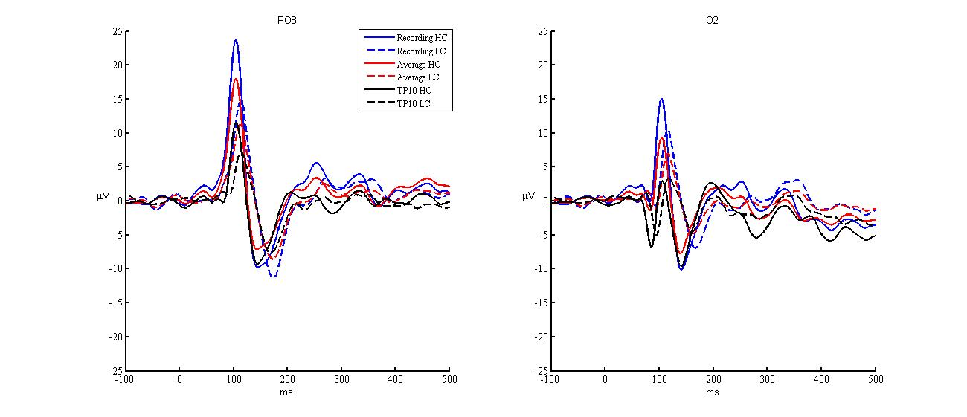

*Figure 2.* No re-referencing, average reference, and re-referencing of the data to electrode TP10 compared to each other.

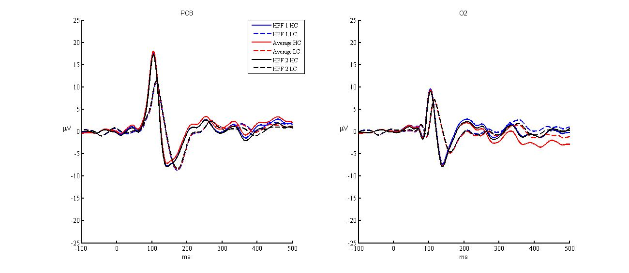

*Figure 3.* High-pass filter cut-offs of 1 Hz, 2 Hz, and 0.1 Hz compared to each other.

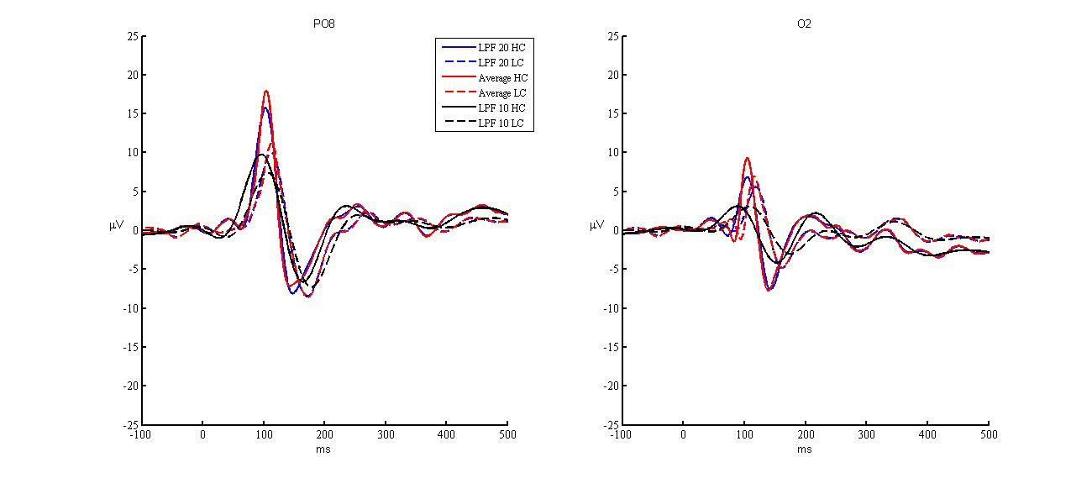

*Figure 4.* Low-pass filter cut-offs of 10 Hz, 20 Hz, and 40 Hz compared to each other.

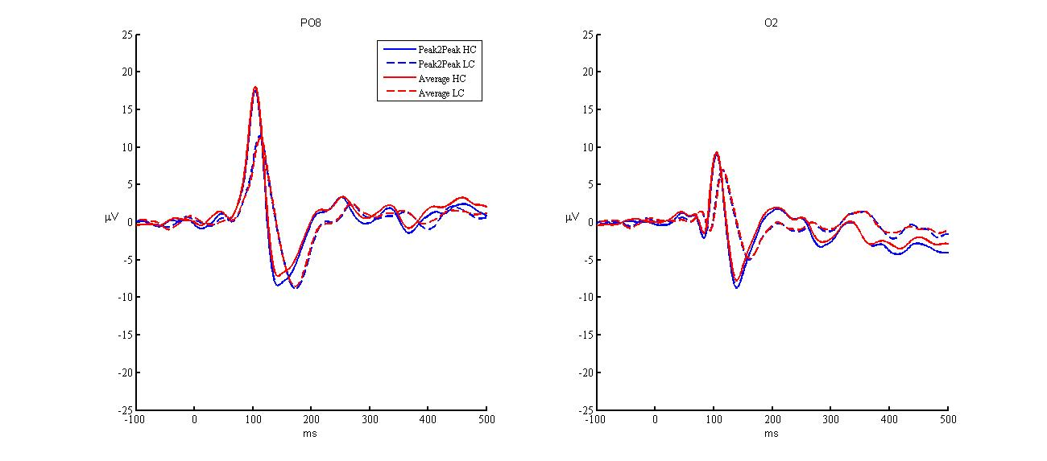

*Figure 5.* Peak-to-peak threshold-based artifact detection and rejection with a threshold of 50 μV compared to no artifact detection or rejection.