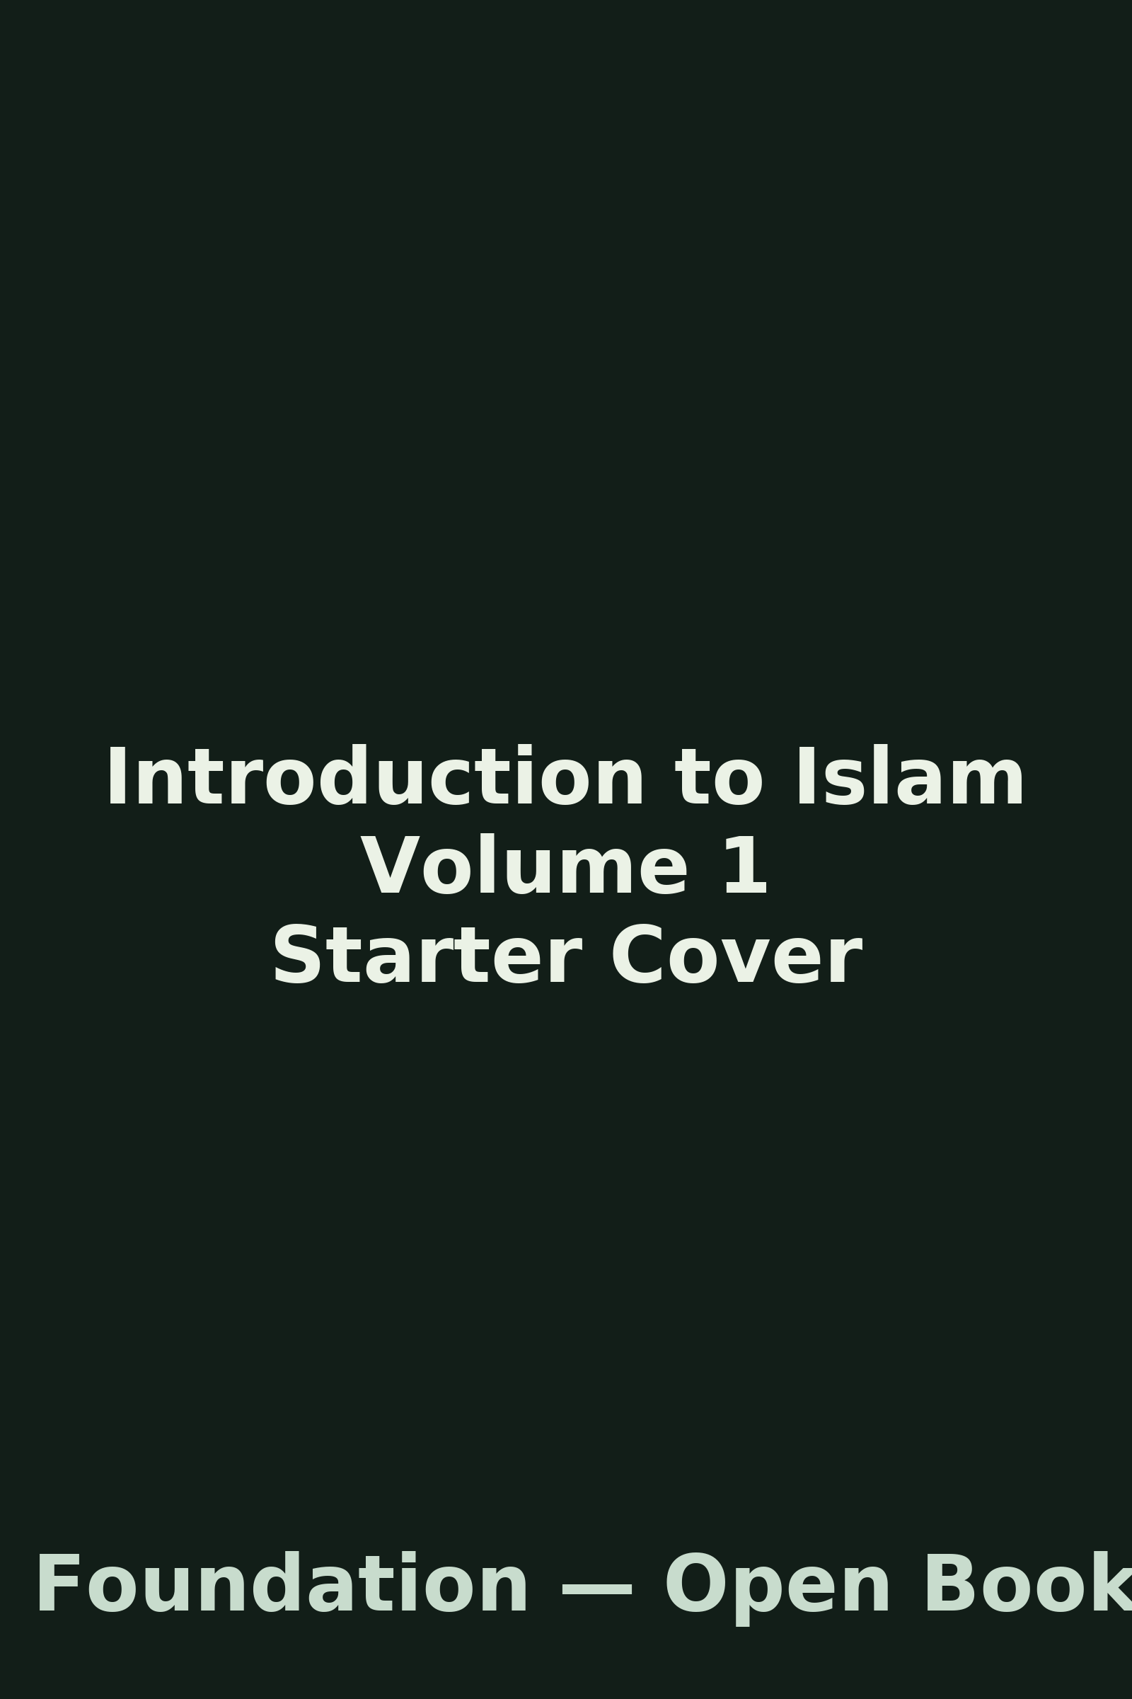

# hello

## Contents

* Foreword: My Chapter Title
* Foreword: volume2-introduction
* Foreword: volume1-introduction
* hello
* README
* ch00 prelude
* ch01 git GitHub basics

## Foreword: My Chapter Title

## Big picture

* You (or any contributor) put files in **raw_docs/<volume-slug>/**.
* The **Ingest bot** (GitHub Actions) mirrors or converts them into **content/volumes/<volume-slug>/**.
* The output is normalized Markdown (front-matter, title, code fence languages, etc.) and ready to review/publish.

## Folder layout

raw_docs/ # Drop-zone for uploads (md, docx, pdf), one folder per volume  
content/volumes/ # Bot-populated Markdown output (auto-numbered chapters)  
chapters/ # (Legacy/authoring) Existing Volume 0 authoring  
docs/ # Website pages (MkDocs)  
.github/ # CI workflows, issue templates, policies  
tools/ # Helper scripts for scaffolding volumes  
```text  
  
---  
  
## Contribute in 3 minutes  
  
1. **Pick a volume slug** (lowercase, hyphens): e.g., `volume-0`, `introduction-to-islam`, `bits-to-banking`   
2. **Upload your file(s)** into `raw_docs/<slug>/` as **`.md`**, **`.docx`**, or **`.pdf`**.   
 - Optional cover image: **`bookcover_<book_title>.png`** (or `.jpg`)   
3. **Commit to `main`** (or open a PR).   
4. Bot converts/copies into `content/volumes/<slug>/` and auto-numbers new chapters: `ch01-…`, `ch02-…`  
  
### Examples  
```text  
raw_docs/volume-0/intro.md  
raw_docs/introduction-to-islam/history.docx  
raw_docs/bits-to-banking/bookcover_Bits_to_Banking.png  
```text  
  
---  
  
## What the bot does (exactly)  
  
1. **Markdown passthrough**   
 Copies `.md` to `content/volumes/<slug>/` (and lists them for auto-numbering).  
2. **DOCX → Markdown**   
 Uses Pandoc to produce GitHub-Flavored Markdown; extracts embedded images to `content/volumes/<slug>/images/<basename>/`.  
3. **PDF → DOCX → Markdown (best-effort)**   
 Converts text-based PDFs via LibreOffice → DOCX → Markdown. Scanned/image-only PDFs become images and may need manual edits.  
4. **Book cover standardization**   
 Files named `bookcover_<book_title>.(png|jpg|jpeg)` are saved as `content/volumes/<slug>/images/cover.png`.  
5. **Auto-numbering (new files only)**   
 Fresh files from this run are renamed to `chNN-<slug>.md` to keep chapters ordered. Existing files are not renamed.  
6. **Normalization**   
 Adds YAML front-matter if missing (title, volume, status, dates), ensures a top-level `# Title`, and fixes bare code fences to `text`.  
  
### Guards & hygiene  
- Skips junk/temp files (e.g., `~$docx`, `.tmp`, `.DS_Store`, `Thumbs.db`).  
- Warns (does not fail) on uppercase or spaces in filenames—use **lowercase-hyphenated** names.  
- Skips very large files with a **warning** (Markdown >2MB, DOCX >20MB, PDF >40MB, images >10MB).  
  
---  
  
## File conventions (quick rules)  
  
- **Filenames:** `lowercase-hyphenated.md` (e.g., `risk-management.md`)   
- **One H1 per chapter:**   
 ```markdown  
 # My Chapter Title

* **Code fences** specify a language:
* print("hello")
* Use text if unsure.

## Start a new volume (optional helpers)

### Windows (PowerShell)

# From the repo root  
. ools  
ew-volume.ps1 introduction-to-islam  
```text  
  
### macOS/Linux (Bash)  
```bash  
# From the repo root  
bash tools/new-volume.sh introduction-to-islam  
```text  
  
This creates:  
```text  
raw_docs/<slug>/  
content/volumes/<slug>/images/  
content/volumes/<slug>/ch00-<slug>.md (placeholder)  
```text  
  
---  
  
## Maintainer review flow (what happens after the bot)  
  
1. You push to `main` (or open a PR).   
2. The bot writes normalized Markdown into `content/volumes/<slug>/`.   
3. Maintainer reviews and curates the chapters.   
4. Docs site/build pipelines pick up the content for publishing.  
  
---  
  
## Troubleshooting  
  
- **Nothing happened**: Make sure you committed into `raw_docs/<slug>/` and the file isn’t too large. Check Actions → *Ingest* logs.   
- **Weird formatting**: For DOCX/PDF conversions, open the produced `.md` in `content/volumes/<slug>/` and adjust manually.   
- **Filename warnings**: Rename to lowercase-hyphenated; commit again.   
- **Cover image not found**: Ensure filename starts with `bookcover_` and is `.png`/`.jpg` in the same `raw_docs/<slug>/` folder.  
  
---  
  
## Suggested volumes  
  
- **Volume 0:** `volume-0` — project introduction (this file).  
- **Volume 1:** `introduction-to-islam` — foundations, history, core concepts.  
- **Volume 2:** `bits-to-banking` — computing → OS → programming → security → finance.  
  
Happy writing! ✨  
  
  
  
## Foreword: volume2-introduction  
  
  
## Who this is for  
  
- Beginners who want a clear, practical route from zero to building useful things.   
- Engineers from other fields who want a **finance-tech** overview.   
- Contributors who can add examples, diagrams, labs, or case studies.  
  
---  
  
## Learning outcomes  
  
By the end you will be able to:  
  
- Explain how data becomes meaning: **bits → bytes → files → processes**.   
- Use the command line and write small programs to automate tasks.   
- Model and query data in **relational databases**.   
- Understand core **networking** and **security** ideas.   
- Read and discuss **banking/treasury** workflows with the right vocabulary.   
  
---  
  
## Suggested outline  
  
- **ch01 — Bits & Binary:** Representation, integers, text, endianness.   
- **ch02 — Operating Systems primer:** Processes, memory, filesystems, permissions.   
- **ch03 — Programming basics:** Variables, control flow, functions, modules, tests.   
- **ch04 — Data modeling & SQL:** Tables, keys, normalization, joins, transactions.   
- **ch05 — Networking:** TCP/IP, HTTP, tools, client–server mini-labs.   
- **ch06 — Security essentials:** Hashing, crypto at a high level, auth, threat basics.   
- **ch07 — Finance foundations:** Money flows, accounts, ledgers, payments rails.   
- **ch08 — Market data & pricing:** Instruments, quotes, risk-at-a-glance.   
- **ch09 — Treasury systems overview:** Positions, cash, risk, settlement; where **Calypso/TMS** fits.   
- **ch10 — Mini projects:** ETL a CSV into a DB; simple pricing/reporting script; mock “ops” day.  
  
This outline will evolve with contributions and reviewer feedback.  
  
---  
  
## Contributing to this volume  
  
1. Create or use the folder:  
 ```text  
 raw_docs/bits-to-banking/

1. Add chapters as **.md**, **.docx**, or **.pdf**.
   * Optional cover image: bookcover_Bits_to_Banking.png
2. Commit to **main** (or open a PR). The **Ingest** bot will:
   * Convert/copy to content/volumes/bits-to-banking/
   * Auto-number new chapters (ch01-...)
   * Normalize Markdown (front-matter, title, code fences)

If your file is very large (PDF > 40MB, DOCX > 20MB, MD > 2MB), it will be **skipped** with a warning in the Action logs.

## Getting hands-on (starter tasks)

* Reproduce a binary-to-decimal conversion with a short script.
* Write a CLI that reads a CSV and prints summary stats.
* Spin up a local database and run three non-trivial joins.
* Use a packet capture tool to observe a simple HTTP request.
* Sketch a money movement from account A → B and identify risks.

We’ll refine these into end-to-end labs as the volume grows.

## Next steps

Pick a chapter (e.g., **Bits & Binary**) and start drafting under raw_docs/bits-to-banking/.  
Include small, runnable examples and short exercises.

## Foreword: volume1-introduction

## Who this is for

* Curious readers with **no prior background**.
* Educators, parents, and learners looking for **clear definitions** and **primary-source pointers**.
* Contributors who want to help with **editing, translation notes, or adding references**.

We aim for **accuracy**, **neutrality**, and **respect** for diverse Muslim communities and scholarly traditions.

## What this volume covers

* A beginner-friendly **overview of Islam**: key beliefs and practices.
* Concise context for **history**, **sources**, and **schools of thought**.
* Clear definitions for common terms and a short **glossary**.
* Signposts to primary sources and widely used translations.

This is **not** a replacement for scholarly study; it is an introduction that points to deeper resources.

## How to use this volume

* Read sequentially or dip into sections you need.
* Use the **glossary** when you encounter new terms.
* Follow the **Further Reading** notes at the end of chapters.

If you notice unclear phrasing or missing context, please contribute a correction (see **Contributing** below).

## Sources and methodology (at a glance)

* **Primary sources**: the Qur'an and the Sunnah (the teachings and practices attributed to the Prophet Muhammad, recorded in hadith literature).
* **Secondary sources**: classical and modern scholarship, commentaries (tafsir), legal theory (usul al‑fiqh), and history.
* When citing English translations, we note that **word choices vary**; contributors may suggest improvements and add references.
* We avoid sectarian polemics; where scholarly views diverge, we **describe multiple perspectives** clearly.

## Key terms at a glance

* **Allah** — Arabic for God; used by Arabic‑speaking Muslims and non‑Muslims alike.
* **Qur'an** — central scripture of Islam.
* **Sunnah** — the prophetic example; teachings/practices reported in hadith.
* **Hadith** — reports about what the Prophet said, did, or approved; collected with chains of transmission.
* **Sharia** — the broad path or way; ethical‑legal framework derived from sources.
* **Fiqh** — jurisprudence; the human understanding and application of the law.
* **Ummah** — the global community of Muslims.
* **Mosque (Masjid)** — place of worship.
* **Five Pillars** — declaration of faith, prayer, almsgiving, fasting in Ramadan, and pilgrimage (Hajj).

These brief definitions are for orientation; later chapters expand them with sources and examples.

## Suggested outline for this volume

* **ch01 — Orientation:** What this book covers and how to read it.
* **ch02 — The Qur'an:** Structure, themes, translations, recitation.
* **ch03 — The Sunnah and Hadith:** Collections, authentication, usage.
* **ch04 — Core Beliefs:** God, prophethood, revelation, afterlife.
* **ch05 — Practices:** Prayer, charity, fasting, pilgrimage.
* **ch06 — Ethics and Law:** Sharia, fiqh, objectives (maqasid), diversity of opinion.
* **ch07 — History (very brief):** Early community, spread, languages, scholarship.
* **ch08 — Contemporary topics:** Community life, education, and common questions.
* **ch09 — Glossary & study tips:** How to keep learning.
* **ch10 — Further reading:** Translations, introductions, beginner courses.

This outline is a **starting point**; contributors can suggest reordering or new sections.

## Contributing (for this volume)

1. Create or use the folder:

* raw_docs/introduction-to-islam/

1. Add your chapter as **.md**, **.docx**, or **.pdf**.
   * Optional cover image named like: bookcover_Introduction_to_Islam.png
2. Commit to **main** (or open a PR). The **Ingest** bot will:
   * Convert or copy to content/volumes/introduction-to-islam/
   * Auto‑number new chapters (ch01‑..., ch02‑...)
   * Normalize Markdown (front‑matter, title, code fences)

If your file is very large (PDF > 40MB, DOCX > 20MB, MD > 2MB), the bot will **skip it** and print a warning in the Action logs.

## A short glossary (starter)

* **Aqidah** — creed or beliefs.
* **Tafsir** — exegesis/commentary on the Qur'an.
* **Madhhab** — legal school (e.g., Hanafi, Maliki, Shafi'i, Hanbali).
* **Imam** — leader of prayer; also used for senior scholars in history.
* **Maqasid al‑Sharia** — higher objectives of the law (e.g., protection of faith, life, intellect, family, property).

### Next

Propose a **chapter you want to write** (e.g., “The Qur'an: an overview”) and add it under raw_docs/introduction-to-islam/.  
We’ll grow this volume together with clear, sourced, respectful chapters.

## hello

﻿# Hello from raw_docs

## README

﻿# raw_docs (drop zone)

Put uploads here. Accepted formats (for now): **.md**, **.docx**, **.pdf** Optional cover image: bookcover_<book_title>.png

Recommended structure (we’ll wire automation next step):

* raw_docs/<volume-slug>/your_chapter.docx
* raw_docs/<volume-slug>/bookcover_<book_title>.png

Examples:

* raw_docs/generalist-ai/intro.docx
* raw_docs/starting-a-business/bookcover_Starting_Your_Own_Business.png

## ch00 prelude

﻿# Prelude — Recap & Setup (placeholder)

This chapter has moved to the new content system. For current content, see: content/v001_islam_blueprint_for_life/.

## ch01 git GitHub basics

﻿# Git & GitHub Basics (placeholder)

This chapter has moved to the new content system. For current content, see: content/v001_islam_blueprint_for_life/.