BLACKJACK STRATEGY SIMULATION
DATA SCIENCE REPORT

Date: 12 June
Author: Umid Ganbarov, Computer Engineering student

In this project, I built a simulation engine in Python that models repeated blackjack gameplay under controlled rule variations, allowing systematic testing of different decision and betting strategies. The engine generates full shoe-based gameplay, where cards are shuffled, dealt and resolved according to standard blackjack rules, including dealer logic (hit until 17) and player decision policies. Note that in this project, I sometimes used AI for ideas, most of the codes are written by me. I used AI for grammar fixing part of the report, since it does not affect our main purpose – Data Science. You can get codes of plots in the file “Plot_Codes.py”.
I want to start with my data collection. I ran simulations for 1176 different game styles. Adding that for 26.000 users with this combination we get number round 30 million Shoes. And each shoe takes around 80 hands, so total 2.5 Billion Blackjack hands were simulated. I ran computer for straight 9 hours of compiling as it shows that the data is well-simulated. Now it's time for the actual Data Science.

TEST 1 -- Does card counting actually work?
My first question was simple: does counting cards make a real difference? I split the data into two groups - counting on vs counting off - and compared their average win rates. The result was honestly shocking. I tested it with this plot below:
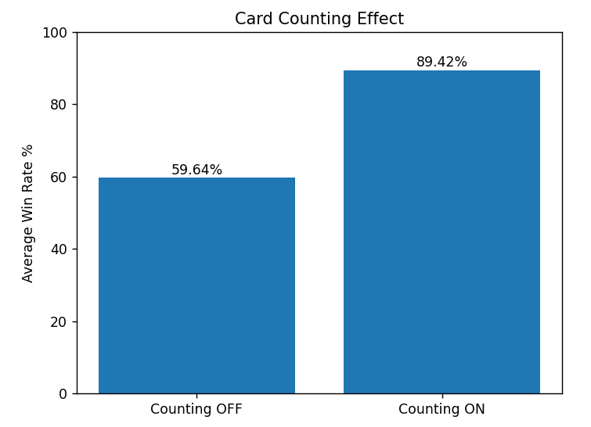
There is a huge difference - card counting increases win rate by around 30%. That's not a small edge; that's a completely different game.

TEST 2 -- Which gameplay strategy is the best?
I have strategies from random (literally random hit/stand) to stand14-stand19 (stand when your hand total hits X, hit otherwise). Let's see which one performs best on average across all configurations:
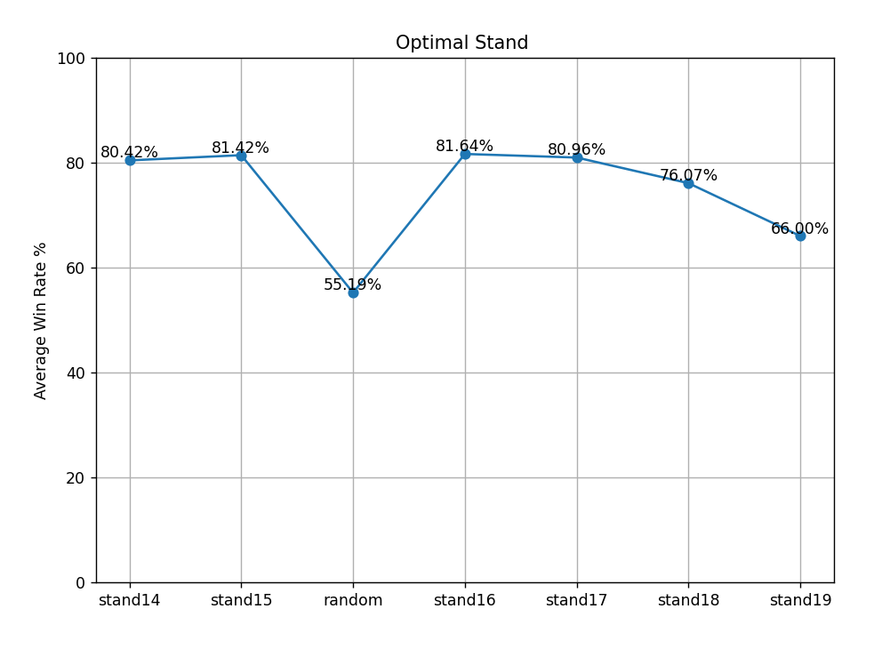
Clearly stand16 is the winner. There's a peak and it drops off on both sides. After this point, I'll use stand16 as the base strategy for all other tests. Now lets zoom in how much does card counting help specifically with stand16?
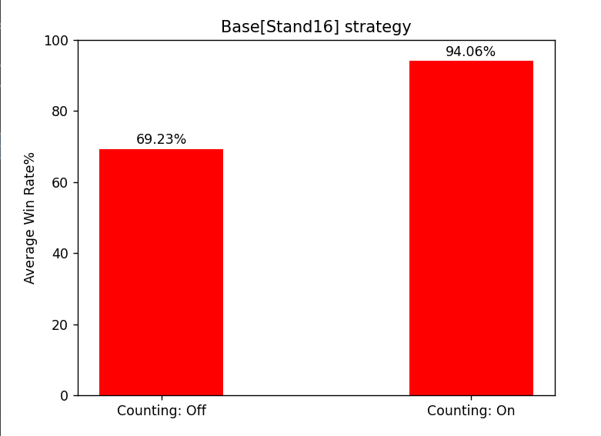
The difference here ~24% is smaller than the overall test, but the absolute win rate with counting hits around 94%, which is genuinely impressive for a game that's designed for the casino to win.

TEST 3 — Does starting balance actually matter?
I searched on internet and found that most of the daily gamblers start with $100-$1000 initial balance. Let’s see in general that if starting balances affect our win rates, if so among them, which is the best for my base cases: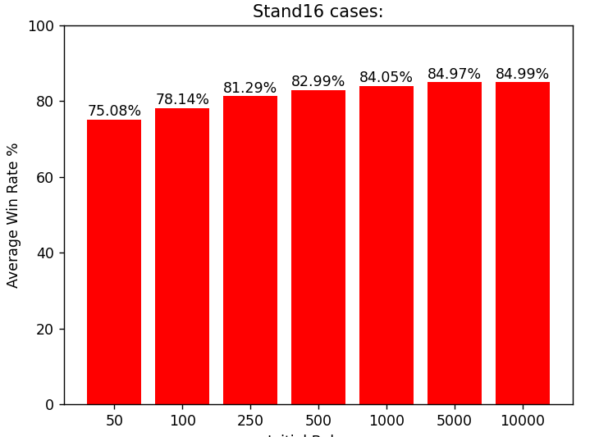
On the surface "more money = less risk" sounds obvious, but it's more complicated. If I start with $10,000 and bet $5 flat, losing a few hands barely touches my win rate. The loss is tiny next to the balance. Flat bets become misleading at high balances. Percentage-based and Martingale bets are a more honest comparison. Lets use few of them:
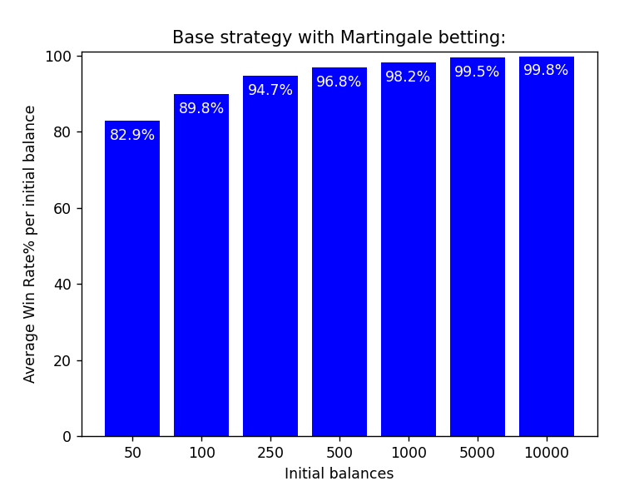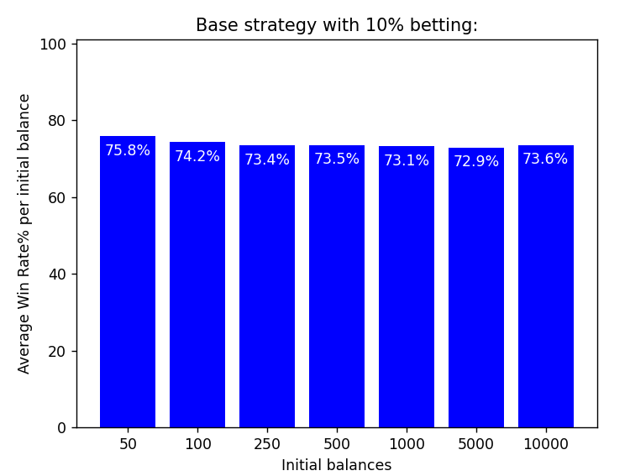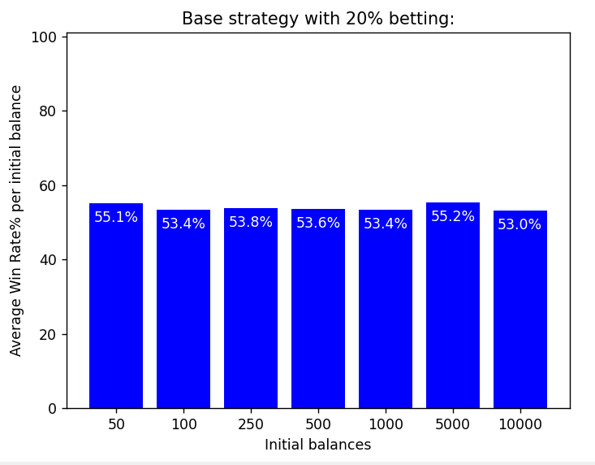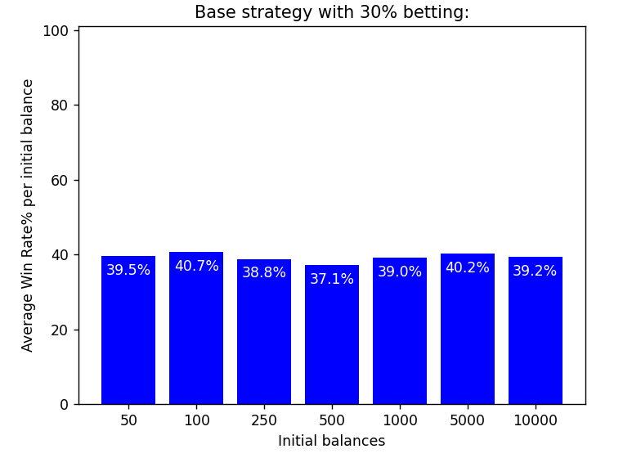
Wow, I did not expect these results. Martingale shows the same upward curve as balance increases. With percentage betting, win rates actually go down as the percentage gets higher, and the three cases eventually equalize. From these stats, Martingale really works in gambling :D

TEST 4 -- Risk analysis: Who actually goes broke?
We talked a lot about win rates, but what about actual risk? My dataset has a "brokes" column showing how many out of 26,000 players hit $0 and got eliminated. Let's see broke_rate% split by strategy and by betting type:

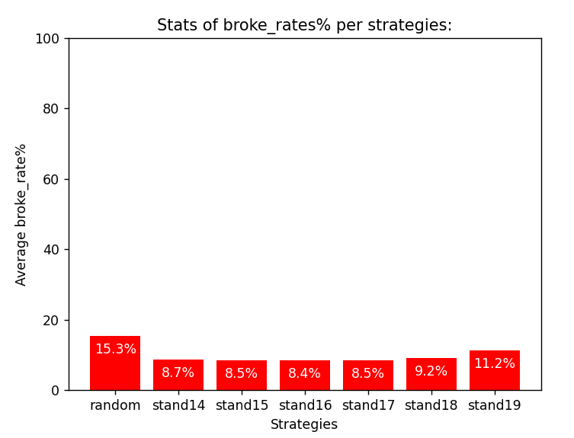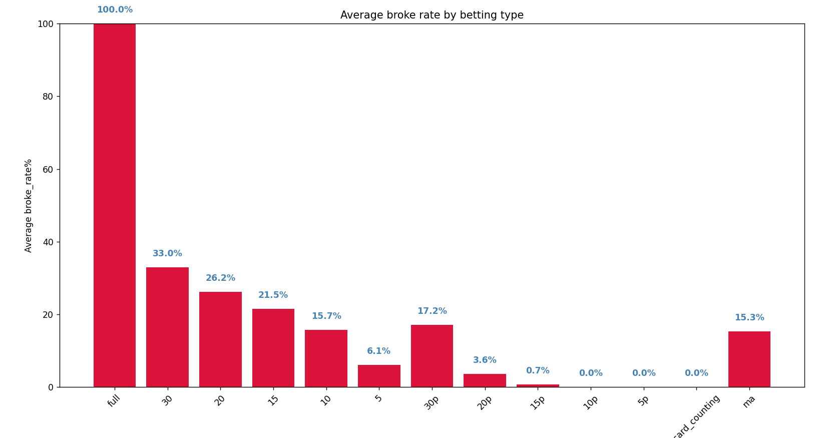
Results are interesting, in plot 1,of course random is the riskiest and after stand18 it risk increases by little. However in plot 2 in this simulation, card counting reduces observed bankroll risk under current betting rules and shoe length. And never put all eggs in one basket. Important note: this is not about losing money in general. A player can lose 80% of their balance and NOT appear here, only total bankruptcy counts

TEST 5 -- Best configuration per starting balance
What is the single best combo of strategy + betting + counting for each possible starting balance? Let me find the winner for each one:
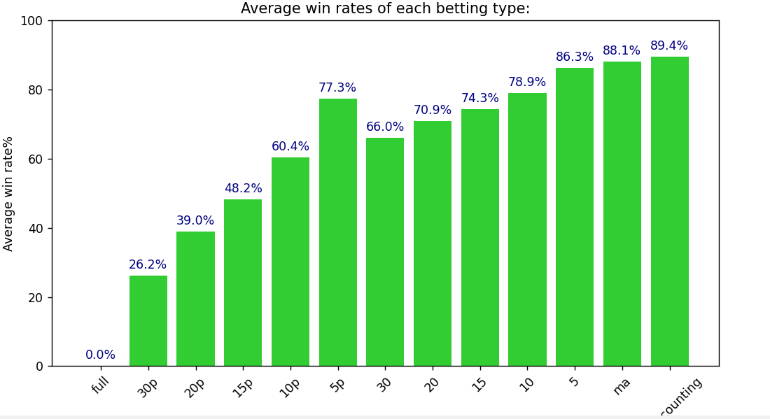
As in Tests 1,2; this case shows a clear pattern. Martingale works better than others and counting cards really benefit.

TEST 6 -- Fixed vs percentage vs Martingale: deep dive
Now I wondered more about win rates. Actually, win rates based on final balances does not show always the best strategy, as I mentioned in the previous about bet5 and 10.000 initial balance. Even if users lose most of their hands, average win rate is still >90%. To show here is a plot:
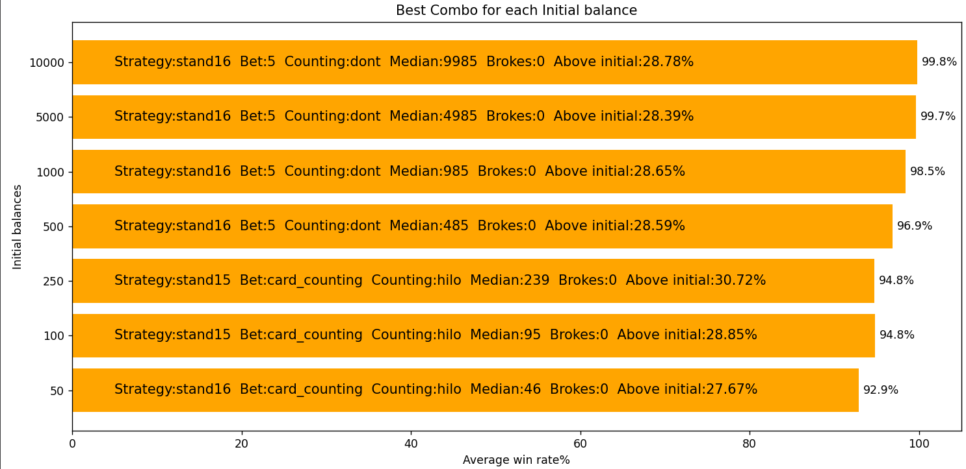
Before win rates, look at strategies. They are mostly about stand 15/16 so proves my previous stats. Medians are also around 91% of initial balances. No broke and average rate of users who gained more than they put is around 28%. From my perspective, for a gambling game it is not really bad.
After a point, in this case - 500, flat bets are “misleading” stats. Now lets look at a similar plot where I deducted fixed bets:
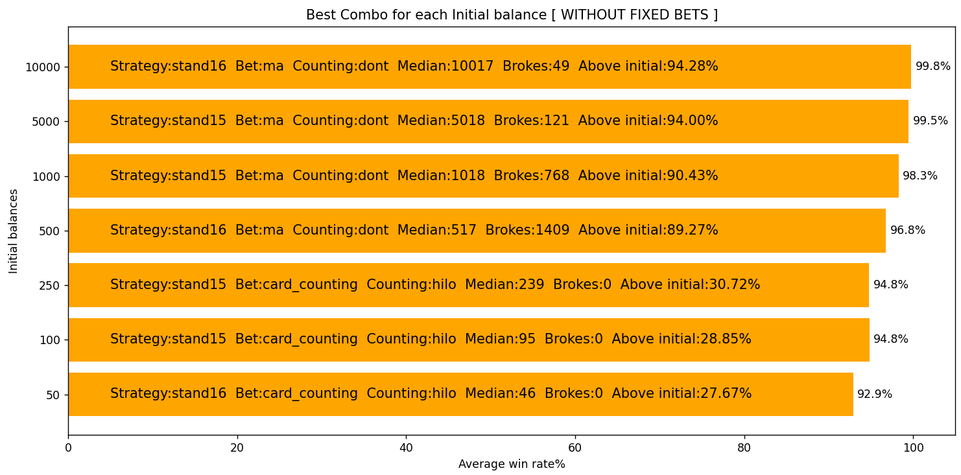
And stats did not change much in terms of win rate. I will talk about it later. Medians are actually more than initial in >=500 cases so there is a separation here I could not find why. And we see this difference pattern also in Brokes where >=500 has non-zero values and more money makes less risk of becoming broke, too. But shocking thing is that after >=500 bridge, Above initial skyrockets. It is very very good since they all are about more than 90%. As I said, out win rate pattern still gets more when initial balance increases and I found its “why”. See, martingale strategy works in my code as: If won bet 1, else bet 2x of previous bet. Bet 1 makes it risking less so it has more rate. When I deducted Martingale strategy:
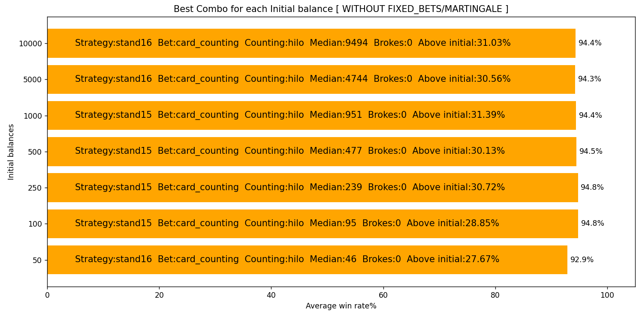
See, because there is literally no flat bets, their win rates are near. What is valuable here is that betting a share of your balance is does not make you completely broke. For >=500 cases we do not see a bridge and Above initial rates are close for every case. However, starting with more money still is a bit better. Medians are also nearly same percentage.
Overall, for Test 6, the best strategy for Blackjack gambling is stand15 and card counting. Specifically, Martingale works if user has more money and do not want to lose much money with this strategy.

TEST 7 -- Hand win rate vs balance win rate with loses
I always talked about win rate in terms of balance because it matters in real life more than just how many times you won. User can lose 10 times but if it bets huge in 11th hand, it can get more money than initially. Lets look at combos generally and to get which top 7 strategy combos wins you most hands:
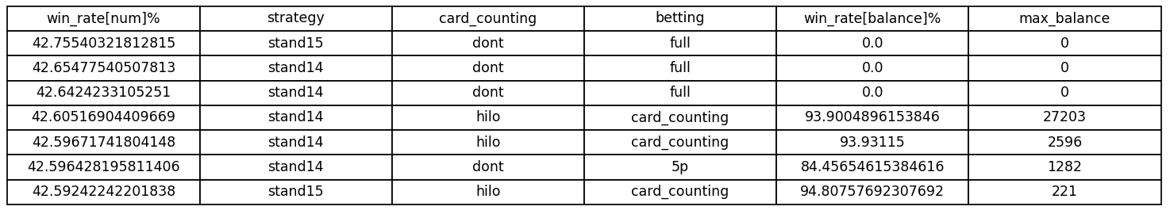
Users can win lots of hands yet gain literally nothing which proves my point. Actually stand14 shines here. It makes users win more number of hands while in previous tests, it is shown that it is a bad strategy for rates in terms of balance.
Talking about wins, why not loses?:
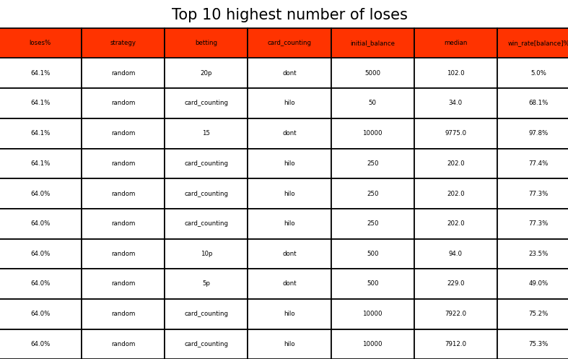
This table says everything. Random is the worst. And look at row 3 - users lost 64% of their hands but kept 97% of their money. That's a strange situation. The reason is bet15 when users do win, users win big. Hand count is almost irrelevant. Bet sizing is everything.

TEST 8 -- What is the absolute maximum you can win?
Some people may consider themselves really luck and ask “What is the strategy that gives you a lot of money?” High risk high reward. Now I have a parameter called max_balance. It gets values from a list where final balances of a user for every strategy stored and chooses maximum value. I have 26k users here. Lets see what strategy gives biggest balance in terms of percentage:
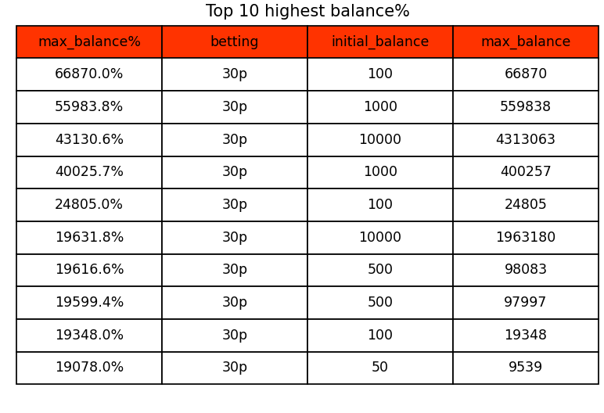
Oh my God. Data tells us that somebody started with $100, finished with more than $66,870. Considering all of them are 30% betting, we can consider for my simulation, it is the most reward given option. To get that much money like in this case, is really hard. The thing is I simulated more than 2.500.000.000 hands, so like in real life somebody hits jackpot. How about highest money ever taken? I expect it with initial balance $10.000. Data says:
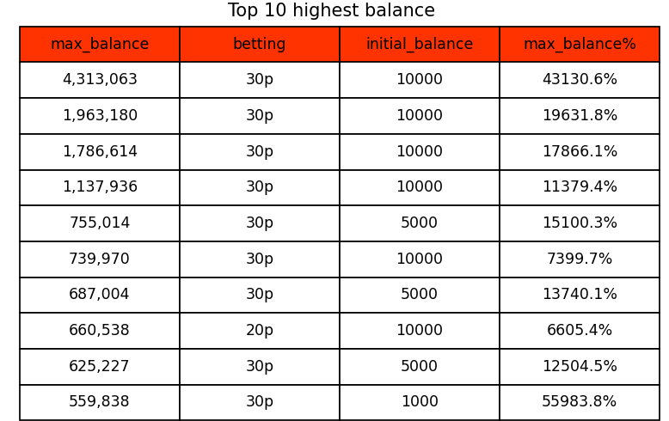
The 1st here is the 3rd in plot1. Somebody put 10k and gained 4.3 Million $. My expectation was true, 60% / top 4 of entire list has 10k as initial balance. One difference can be noted as we see a 20% betting here.

CONCLUSION:
This project showed how simulation and data science can be combined to analyze a real-world probability game like blackjack. By building a blackjack engine from scratch and simulating billions of hands across many different strategies, I was able to compare gameplay decisions, betting systems, bankroll sizes and card-counting methods using actual data instead of assumptions. The results showed that hand win rate alone does not determine success; bankroll management and betting strategy matter just as much. Some strategies won fewer hands but preserved money better, while others created high-risk, high-reward outcomes.
Overall, this project helped me practice simulation design, data structures and algorithms, large-scale data collection, statistical thinking, visualization and interpretation of results. It also showed me how powerful Data Science can be when combined with programming and experimentation.

Thanks for reading if you did. Means me a lot :)

