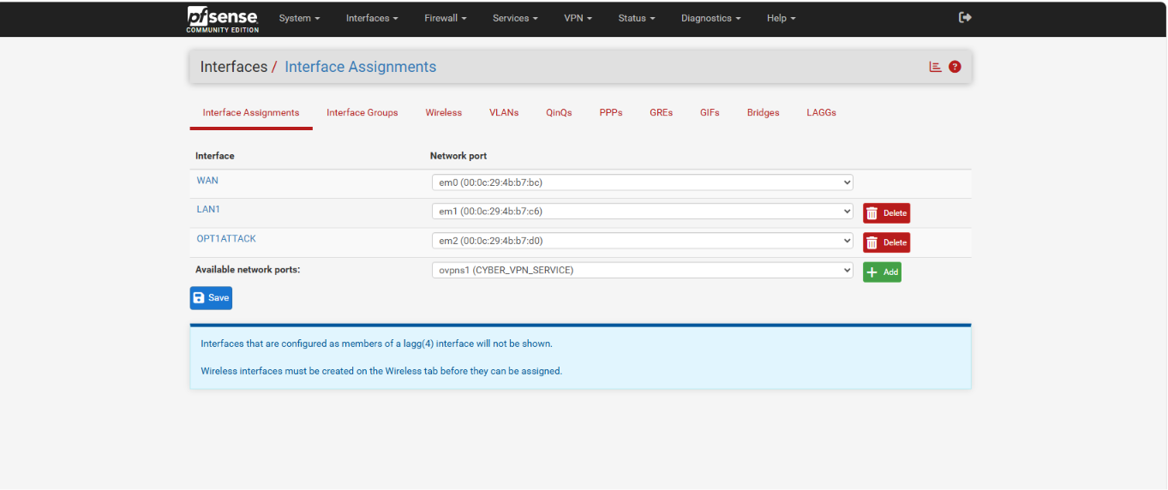
Technical Description: As the core of the laboratory environment, three main network interfaces have been configured on the pfSense firewall for network segmentation and traffic management. This configuration ensures the accurate mapping of physical network cards to virtual machines (VMs).
Configuration Details:
- WAN (em0): Designed for internet access and external traffic management.
- LAN1 (em1): The internal network (192.168.10.0/24) hosting the victim machine (Windows) and the monitoring server (ELK).
- OPT1ATTACK (em2): An isolated "Attack" network (192.168.20.0/24) housing the attacker machine (Kali Linux). This segmentation forces attack traffic to route directly through the firewall and the Suricata IPS, enabling effective security monitoring.

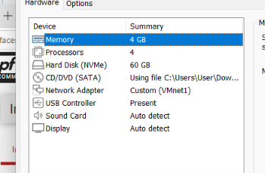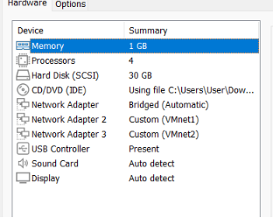
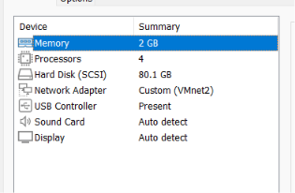
Technical Description: To ensure optimal performance of the machines within the laboratory environment and the proper operation of security tools (specifically ELK and IPS), appropriate hardware resources have been allocated to each virtual machine. The configuration was implemented within the VMware environment using "Custom (VMnet)" settings, which ensures network isolation and secure routing.
Maşın | RAM | Prosessor | Şəbəkə Adaptoru
Windows (Qurban) | 4 GB | 4 | VMnet1 (LAN)
pfSense (Firewall) | 1 GB | 4 | Bridged + VMnet1 + VMnet2
Kali Linux (Hücumçu) | 2 GB | 4 | VMnet2 (OPT1/Attack)

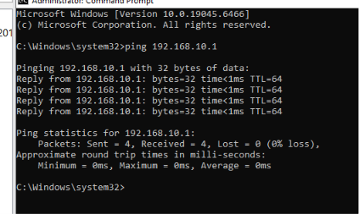
Technical Description: A ping test was conducted to verify proper connectivity between the machines deployed in the virtual laboratory environment. This test confirms that the network configuration parameters—including IP addresses, subnet masks, and default gateways—were applied successfully.
Test Details:
- Target: A ping request was sent from the Windows machine to the pfSense firewall's LAN interface (192.168.10.1).
- Result: All 4 sent packets were successfully received (0% loss). This demonstrates a stable connection between the Windows machine and pfSense, confirming that the network gateway is functioning correctly.
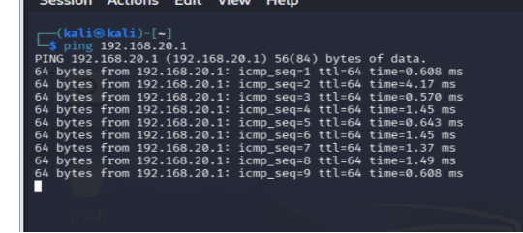

Technical Description: Within the laboratory's security architecture, the attacker machine (Kali Linux) is positioned on the "OPT1" interface. To verify that this interface is functioning properly and that routing is active, the ping 192.168.20.1 command was executed from the Kali terminal.
Test Details:
- Target: A ping request was sent from the Kali Linux machine to the pfSense firewall's OPT1 interface (192.168.20.1).
- Result: Requests received consistent responses. The very low round-trip latency (time values between 0.5 ms and 1.5 ms) indicates zero network delay within the virtual environment and confirms a high-quality connection.
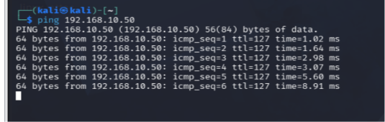
Technical Description: In the laboratory's security architecture, the attacker machine (Kali - 192.168.20.50) and the victim machine (Windows - 192.168.10.50) reside on different subnets. This test confirms that pfSense permits traffic flow from the attack network (OPT1) to the internal network (LAN) and that cross-subnet routing is correctly configured.
Test Details:
- Attack Path: A ping request was sent from the Kali Linux machine to the Windows victim machine (192.168.10.50).
- Result: Successful responses were received. A TTL (Time-to-Live) value of 127 indicates that the traffic passed through a single routing hop (via pfSense).
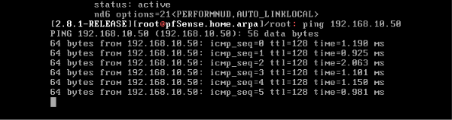
Technical Description: Within the laboratory's network infrastructure, a ping test was executed from the pfSense console to verify direct connectivity between the pfSense firewall itself and the target machine on the internal network (Windows - 192.168.10.50). This test demonstrates that the firewall's internal interfaces and routing table are properly configured.
Test Details:
- Target: A ping request was sent from the pfSense firewall system to the Windows machine (192.168.10.50).
- Result: Requests received successful responses. The low round-trip latency (time values ranging between 0.9 ms and 2.0 ms) indicates a high-speed, stable connection between the firewall and the target system.
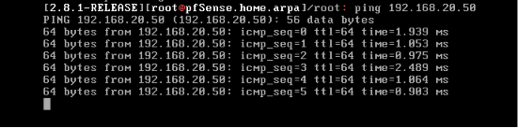
Technical Description: To verify that the firewall has full administrative control and visibility across all segments within the laboratory's security architecture, a ping request was issued from the pfSense console to the Kali Linux machine (192.168.20.50).
Test Details:
- Target: A request was sent from the pfSense firewall system to the Kali Linux machine (192.168.20.50).
- Result: Requests achieved a 100% success rate. The stability of the round-trip latency (time values between 0.9 ms and 2.4 ms) indicates that there are no network delays or routing issues between the firewall and the attacker machine.
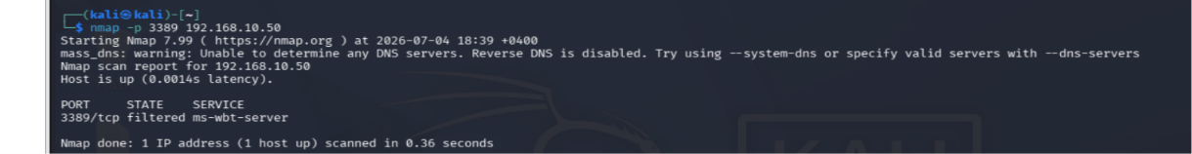
Technical Description: The status of the RDP (Remote Desktop Protocol - port 3389) port was checked from the Kali Linux attacker machine against the victim Windows machine (192.168.10.50) using the command nmap -p 3389 192.168.10.50. This test was conducted to evaluate how the pfSense firewall processes requests originating from the attack network.
Test Details:
- Attack Tool: Nmap (Network Mapper).
- Target Port: 3389/TCP (RDP).
- Result: The scan returned a status of 3389/tcp filtered.
Technical Analysis: The "filtered" status is crucial: it indicates that security policies (Firewall Rules) or the Suricata IPS active on pfSense are blocking or silently dropping incoming packets on this port. This proves that the firewall successfully prevents the attacker machine from directly reaching the target.
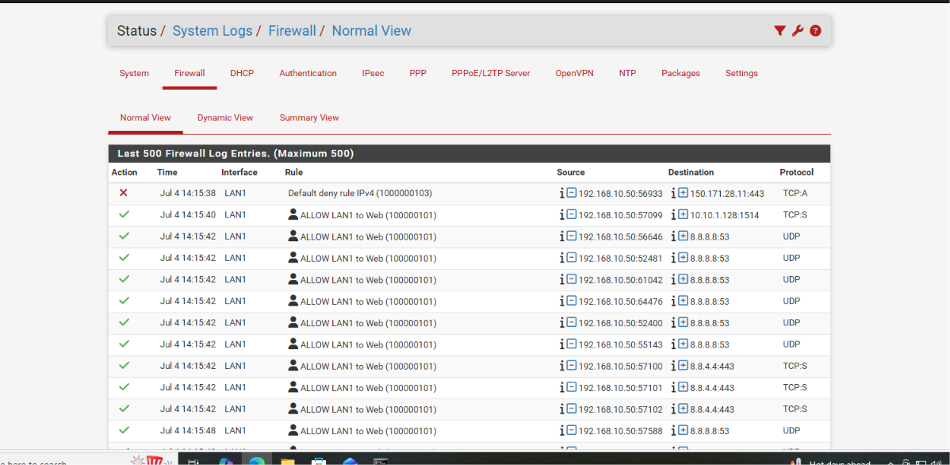
Technical Description: The Suricata system was enabled on pfSense to perform Deep Packet Inspection (DPI) on network traffic. In this phase, the target interfaces for Suricata monitoring were designated, and the "Enable" settings required for intrusion detection (IDS) and automated blocking (IPS) were configured.
Configuration Details:
- Interface Selection: Suricata was activated on the WAN or OPT1 interfaces where attack traffic originates and requires continuous monitoring.
- IPS Mode: The system was configured in "Block Offenders" mode. Upon detecting real-time threats, it automatically appends the offending IP address to the firewall's Block List.
- Logging: Logging was enabled in EVE JSON format, facilitating downstream log shipping to the ELK stack via Logstash.
Result: This configuration establishes the laboratory's defensive capabilities. Any suspicious network activity—such as port scans or exploitation attempts launched from Kali Linux—will now be detected, logged, and automatically blocked by Suricata.
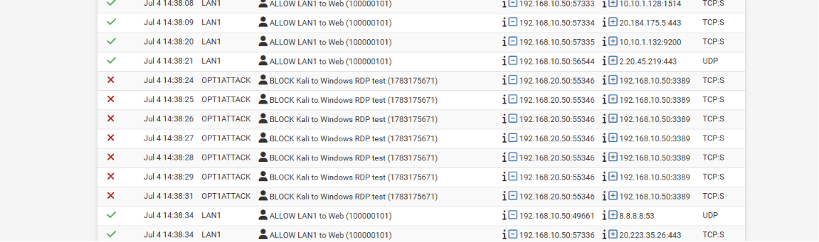
Technical Description: To operate effectively, Suricata relies on a database containing thousands of security rules. In this setup, specific categories were selected to enable the system to detect distinct types of cyber attacks.
Configuration Details:
- Enabled Categories: Key categories such as emerging-attack-response.rules, emerging-exploit.rules, and emerging-malware.rules are selected in the ruleset. This ensures the system can detect both known exploits and malicious software (malware) activity.
- Management: Utilizing the "Enable" function applies these categories to inspect network traffic in real time. This allows pfSense to operate not merely as a traditional firewall, but as an intelligent Intrusion Detection System (IDS).
Result: The configuration completed at this stage establishes the depth of the lab environment's threat detection capabilities. The system is now equipped not only to identify unauthorized access, but also to detect and block active malware and exploit activity across the network.
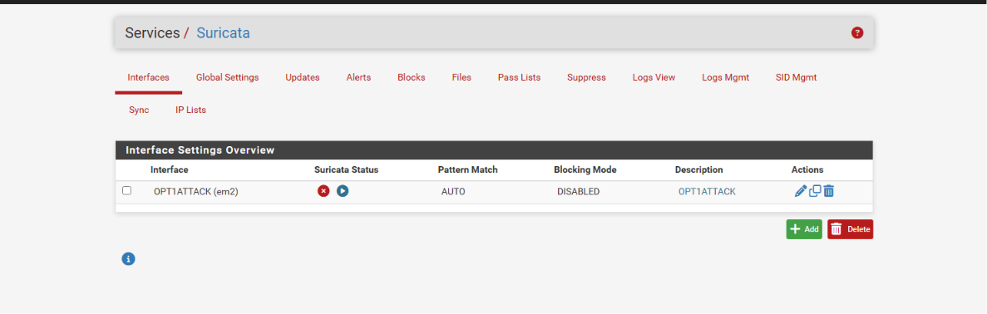
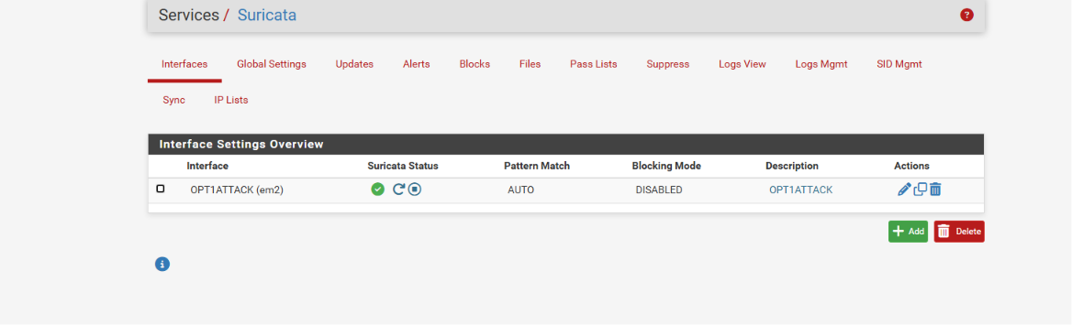
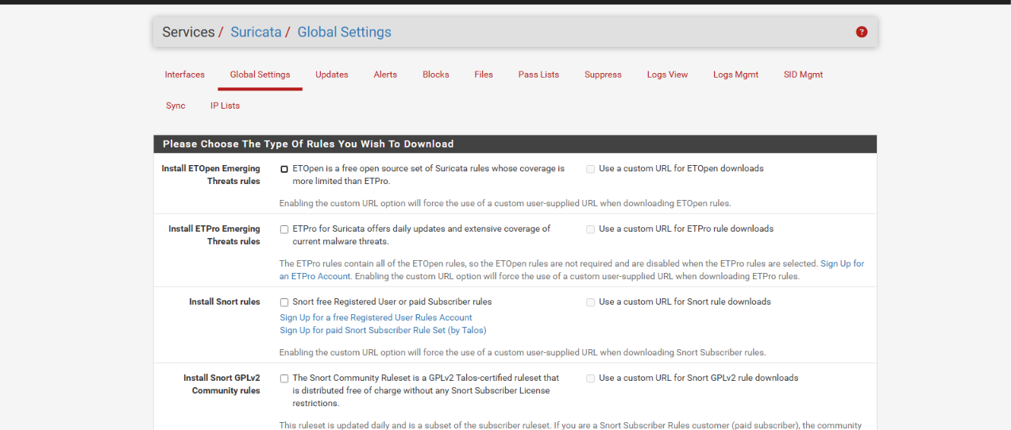
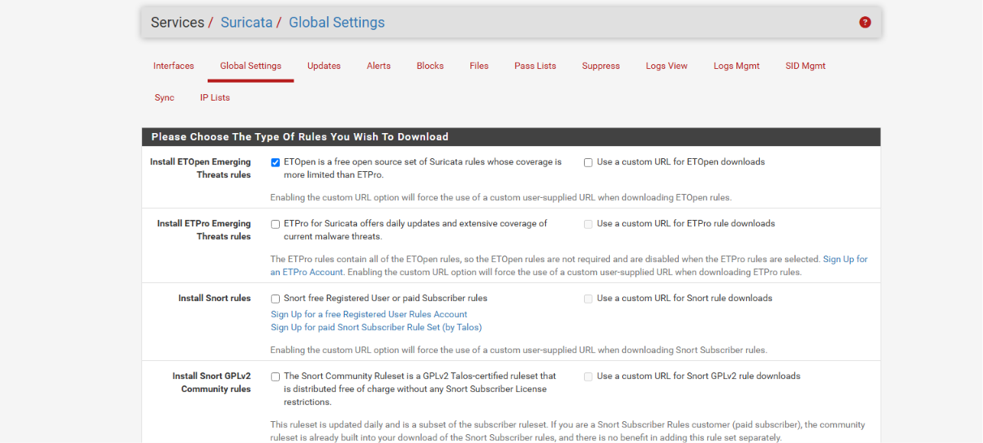
Technical Description: Real-time Deep Packet Inspection (DPI) was applied to the lab environment's network traffic using the Suricata IPS system. These screenshots confirm that the system successfully generated "Alerts" upon detecting suspicious operations (such as ICMP requests and port scanning attempts) executed by the attacker (Kali Linux).
Analysis:
- Detected Activities: Suricata logs the attacker's network actions within the "Alert" view based on specific signature rules.
- Management Details: Each alert precisely displays the attack type, source IP (Kali - 192.168.20.50), destination IP (Windows - 192.168.10.50), and exact timestamp of the event.
Result: This stage establishes the "Visibility" layer of your laboratory architecture. As a security analyst, you can now observe the specific signature rules Suricata uses to inspect and catch attacks, as well as how these logs are structured for downstream analysis.
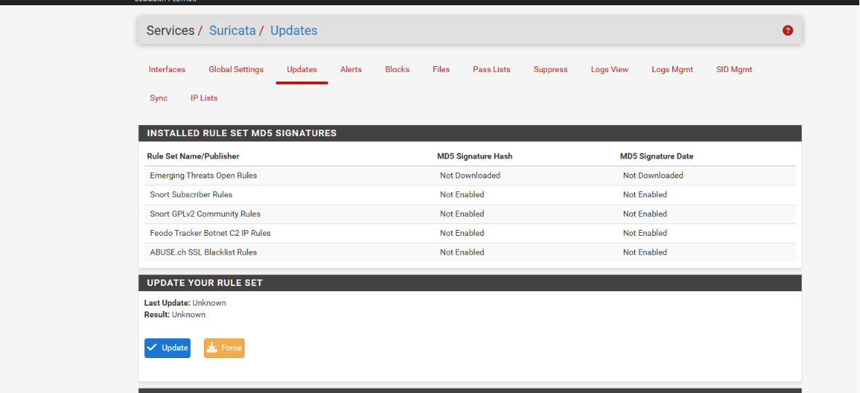
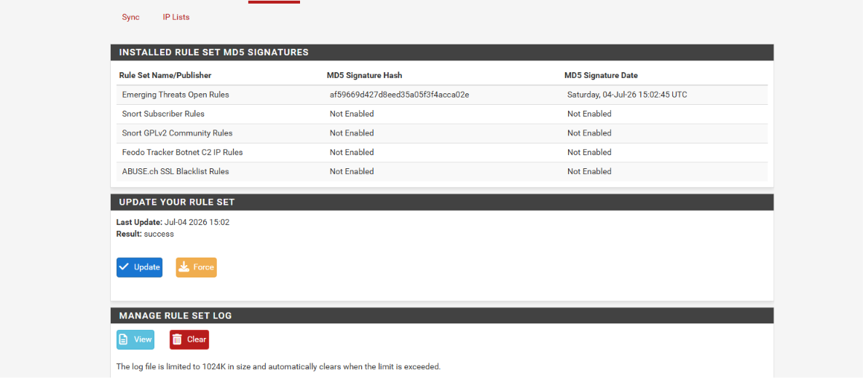
Technical Description: The effectiveness of Suricata is directly tied to the Rule Sets it utilizes. The "Updates" section ensures that the system stays immune to newly discovered global threats.
Configuration & Functionality:
- Automated Updates: The system automatically checks for and downloads updates from Emerging Threats (ET) and other threat intelligence databases. This ensures that your lab maintains a level of readiness against zero-day vulnerabilities.
- Version Control: The update timestamp and version for each rule set are logged within this view. This allows administrators to verify the freshness of the active signature database.
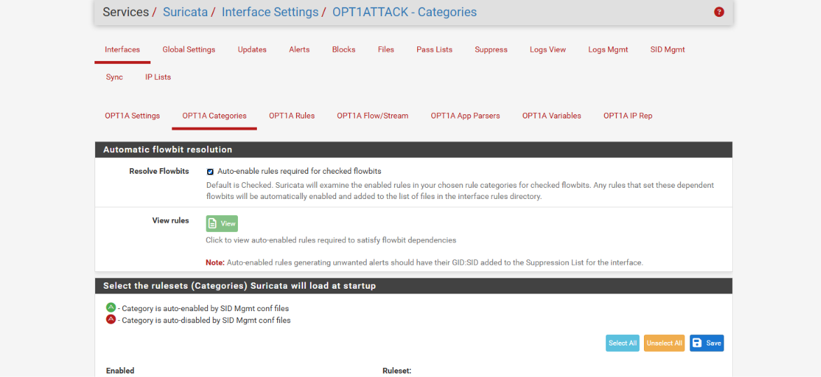

Automatic Flowbit Resolution
- Function: The "Auto-enable rules required for checked flowbits" option is enabled.
- Purpose: This setting is essential for Suricata's proper operation. If a selected rule depends on state tracking from another rule (a flowbit), Suricata will automatically enable the prerequisite dependent rules. This ensures accurate identification and tracking of multi-stage network session flows necessary for those rules to trigger effectively.
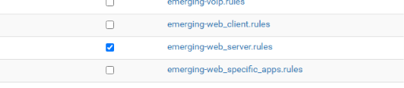
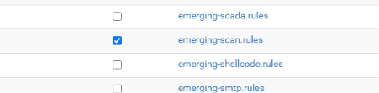
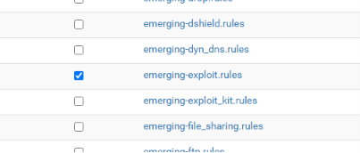
Analysis of Selected Rule Sets The rules currently active are as follows:
- emerging-web_server.rules: Used to detect attacks targeting web servers (e.g., injection, cross-site scripting).
- emerging-scan.rules: Detects threat actors performing network reconnaissance and port scans (e.g., Nmap scans).
- emerging-exploit.rules: Designed to detect or block attacks attempting to leverage known software vulnerabilities.
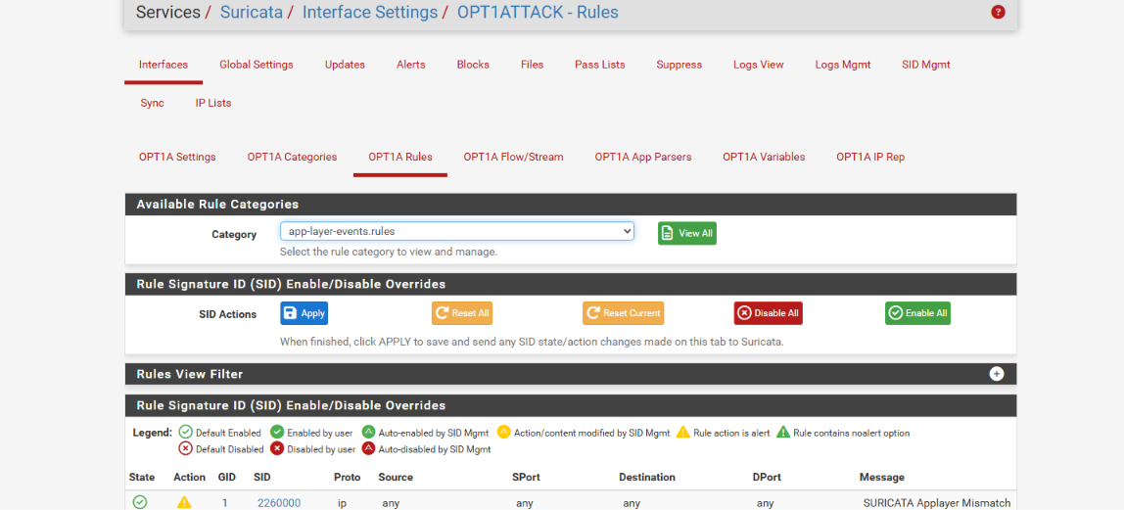
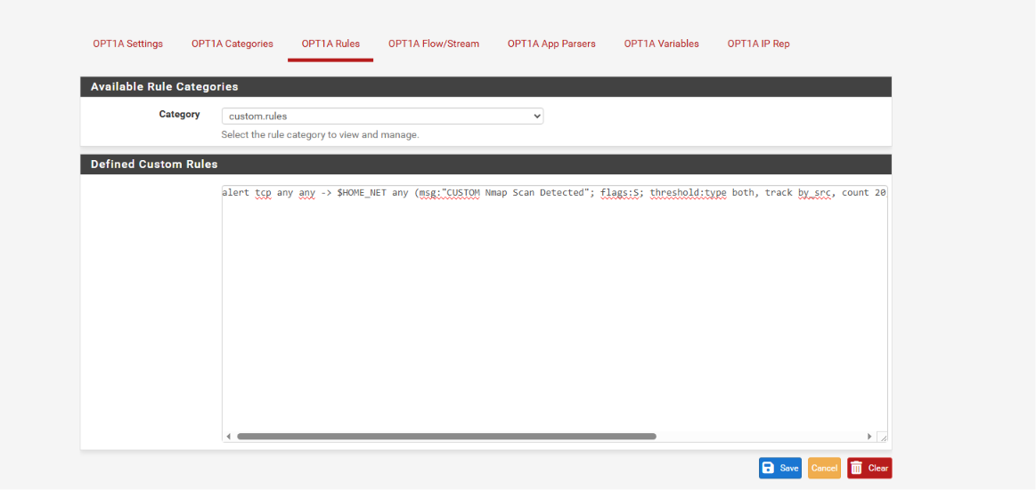
Rule Management (OPT1A Rules):
- You are currently viewing the app-layer-events.rules category. Buttons such as Enable All and Disable All are available to manage or toggle the state (enabled/disabled) of each rule.
- SID (Signature ID) Management is utilized to toggle specific attack signatures into "alert" mode or disable them entirely.
Custom Rule Creation (custom.rules):
- A notable custom rule has been implemented:
alert tcp any any -> $HOME_NET any (msg:"CUSTOM Nmap Scan Detected"; flags:S; threshold:type both, track by_src, count 20, seconds 10;)
- Purpose of the Rule: This rule is designed to trigger an alert ("CUSTOM Nmap Scan Detected") if 20 or more TCP connection attempts with the SYN flag (flags:S) are detected from the same source IP (by_src) within a 10-second window.
- This is a classic and highly effective approach for detecting network reconnaissance attempts.
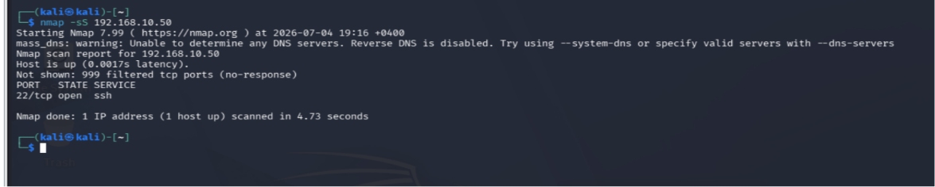
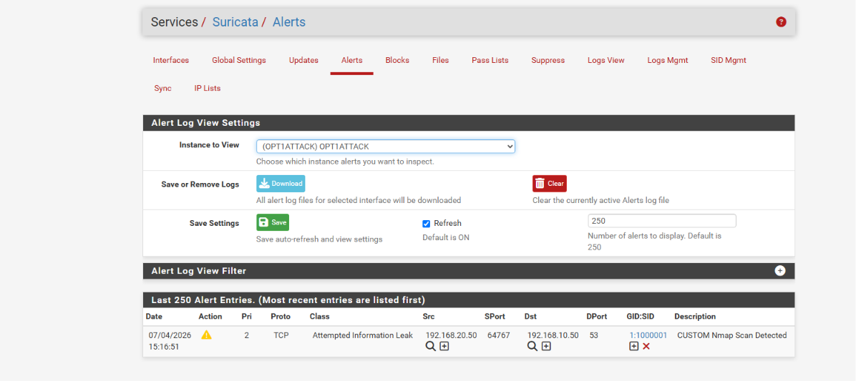
Testing Process To verify system effectiveness, a SYN scan was executed from the Kali Linux attacker machine (192.168.20.50) against the target host (192.168.10.50) using the command nmap -sS. This step simulates network reconnaissance activity performed by a potential threat actor.
Detected Threat This activity was immediately identified by our custom rule. Details of the alert logged by the Suricata IDS/IPS system are as follows:
- Event: "CUSTOM Nmap Scan Detected"
- Classification: Logged as "Attempted Information Leak"
- Source: 192.168.20.50
- Destination: 192.168.10.50
- GID:SID: 1:1000001
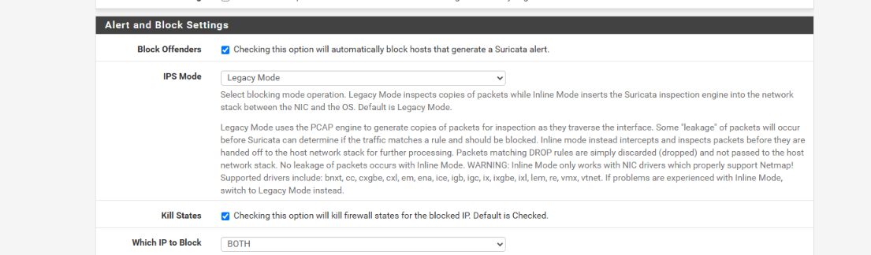
Enabling the Blocking Mechanism
- Block Offenders: This feature is enabled, ensuring that any source IP address involved in an attack or suspicious activity detected by Suricata is automatically blocked by the system.
- Kill States: This setting is active, ensuring that all active firewall state table connections belonging to the blocked IP address are terminated immediately.
IPS Operating Mode Selection The system currently operates in Legacy Mode.
- Operating Principle: This mode inspects packet copies mirrored from the traffic stream.
- Characteristics: A slight delay ("leakage") may occur between packet inspection and the action to block.
- Alternative: Provided the underlying network interface drivers (NIC drivers) support it, transitioning to Inline Mode in the future will provide higher security, as packets are intercepted and inspected before reaching their destination without packet leakage.
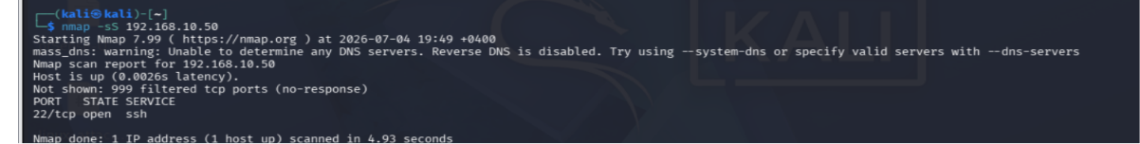
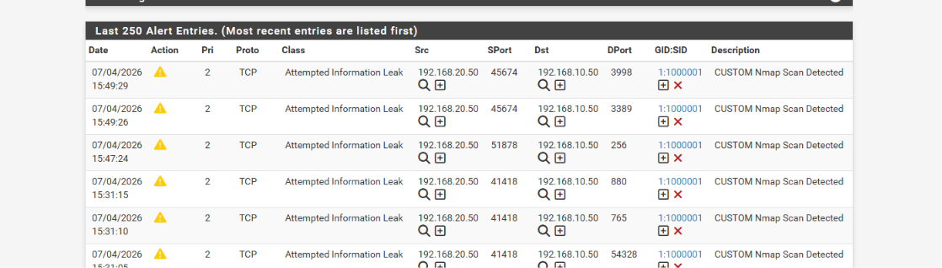
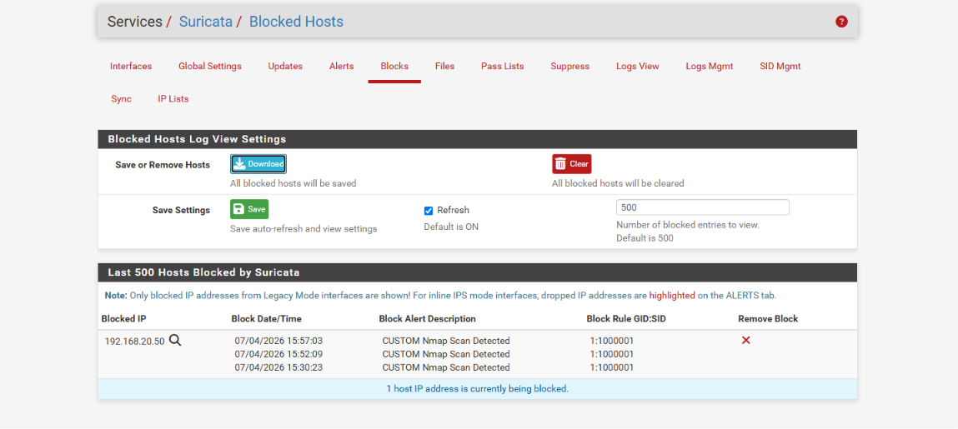
Testing Process and Incident Detection
- Activity: An nmap -sS scan was executed from the Kali Linux machine (192.168.20.50) against the target network (192.168.10.50).
- Detection: The Suricata IDS/IPS system immediately detected this activity and logged it under the Alerts section as "CUSTOM Nmap Scan Detected" (GID:SID 1:1000001).
The system is currently actively blocking 1 attacker IP address.
This test confirms that:
- IDS/IPS Effectiveness: The deployed defense layer not only detects network reconnaissance but also automatically blocks it.
- Defensive Response: The system demonstrates the capability to neutralize threats automatically without requiring manual intervention.
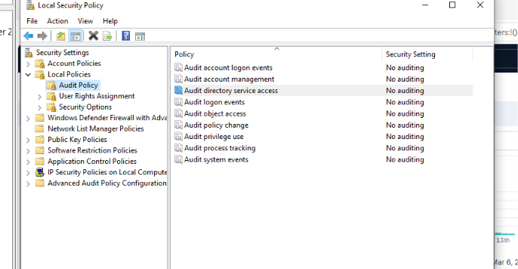
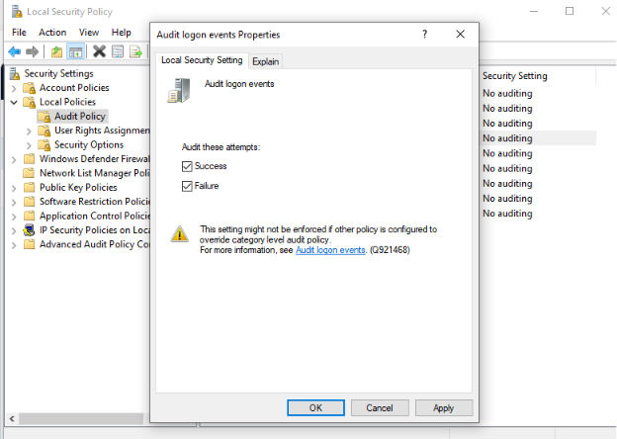
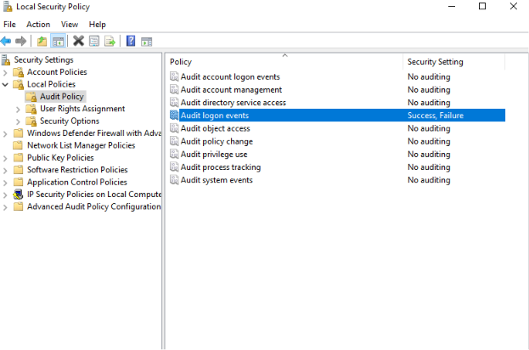
Technical Description: To enhance the security monitoring capabilities of the laboratory environment, auditing policies within the Local Security Policy were updated:
- Audit Policy Adjustment: The "Audit logon events" policy was initially set to "No auditing".
- Logon Tracking Configuration: Options to record both "Success" and "Failure" logon attempts were enabled within the "Audit logon events" properties.
- Final Configuration: Following the applied changes, the state of the "Audit logon events" policy was successfully set to "Success, Failure".
These modifications ensure continuous tracking of authentication attempts on the system, significantly improving the detection of potential security incidents.
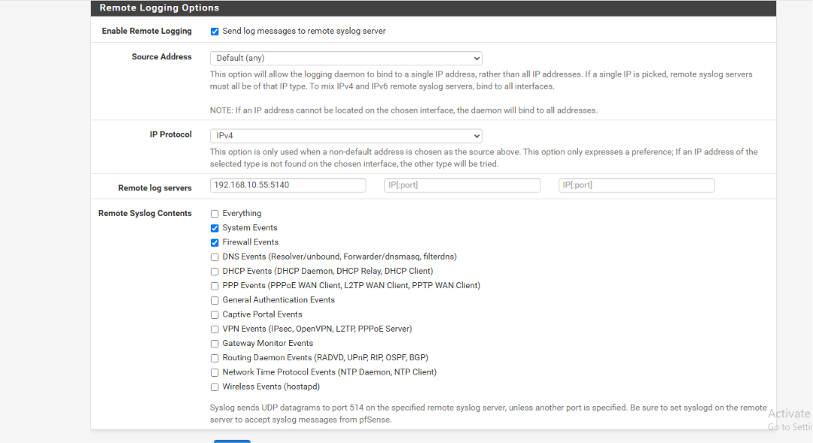
Configuration Parameters
- Enabling: The "Enable Remote Logging" option is activated to forward log messages to a remote destination.
- Remote Server Address: IP address 192.168.10.55 and port 5140 are defined as the target destination server for log transmission.
- Protocol: IPv4 is selected as the communications protocol.
Log Content Selection The following security events (Remote Syslog Contents) were selected for centralized monitoring:
- System Events: Logging of system-level events and operational status.
- Firewall Events: Tracking of network traffic and security rule enforcement on the firewall.
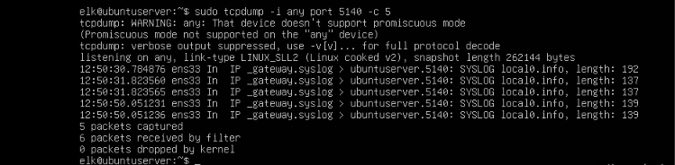
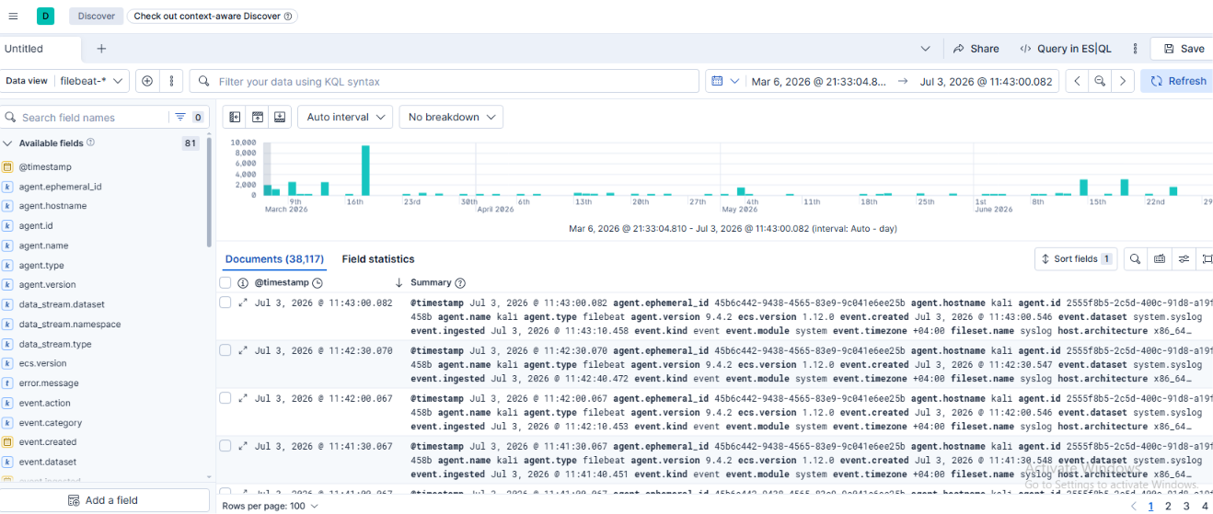
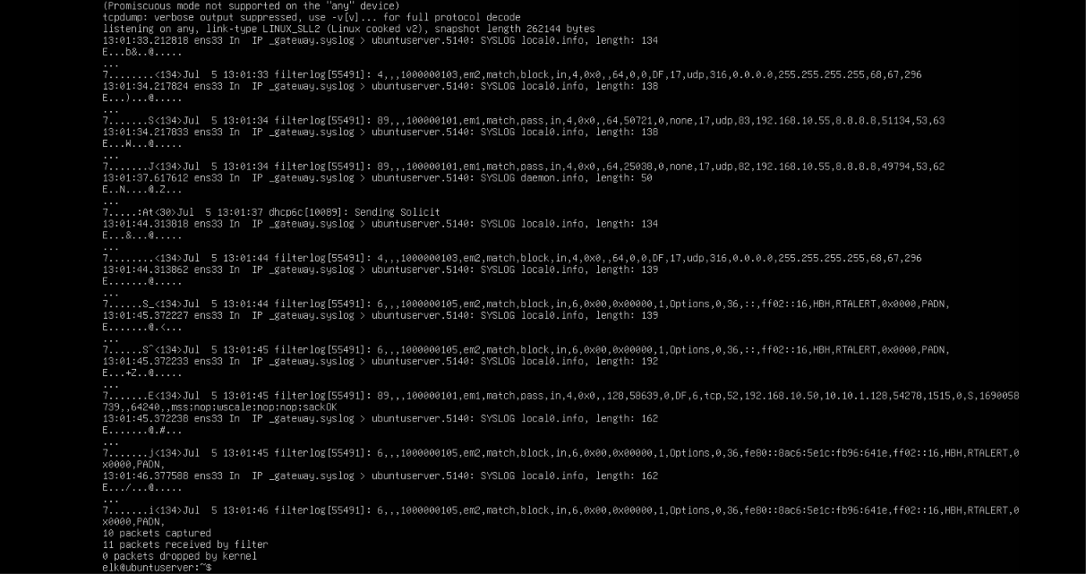
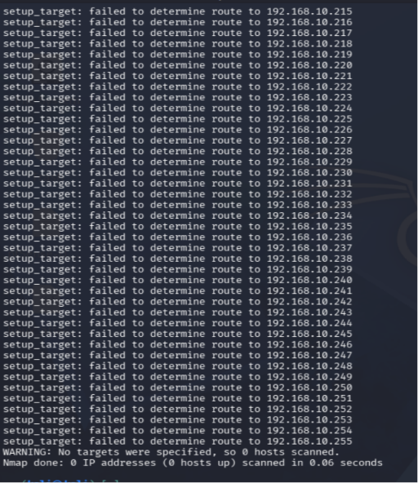
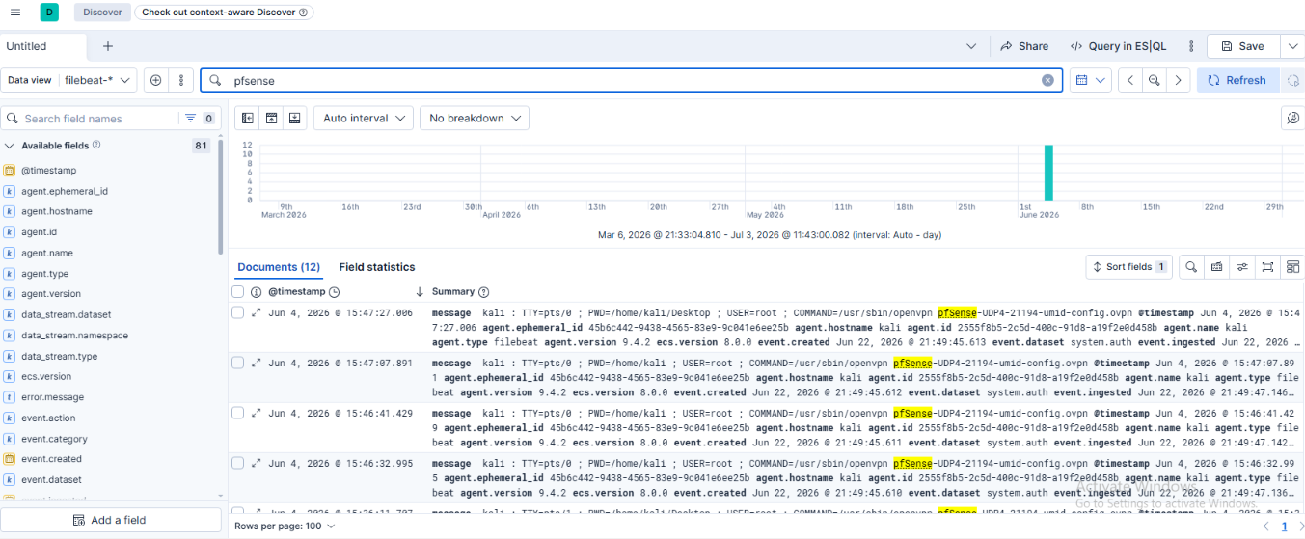
Log Centralization and Forwarding It has been confirmed that syslog data forwarded from the pfSense firewall is successfully transmitted and received:
- Packet Capture: Inspection on port 5140 using tcpdump shows SYSLOG packets arriving from _gateway at the ubuntuserver (ELK server).
- Log Contents: Received packets reflect firewall events, including the enforcement of match,block and match,pass rules.
ELK Stack Visibility Collected data has been centrally visualized within the Kibana interface:
- Data Indexing: Over 38,117 documents have been indexed under the filebeat-* pattern.
- Monitoring: The Kibana Discover view provides clear visibility into pfSense events, including VPN configurations and system logon logs.
Network Scanning Activity
- Kali Linux Scan Tests: During verification performed with Nmap, applied blocking rules from previous steps caused host route determination to fail, resulting in 0 hosts scanned. This re-confirms the effectiveness of our IPS/Firewall configurations in mitigating attack vectors.
A complete Blue Team ecosystem is currently operational in our network:
- Monitoring: pfSense logs are continuously forwarded to the central server.
- Analysis: Logs are indexed via the ELK Stack and visualized in Kibana.
- Defense: Applied firewall policies successfully detect and block suspicious scanning attempts.
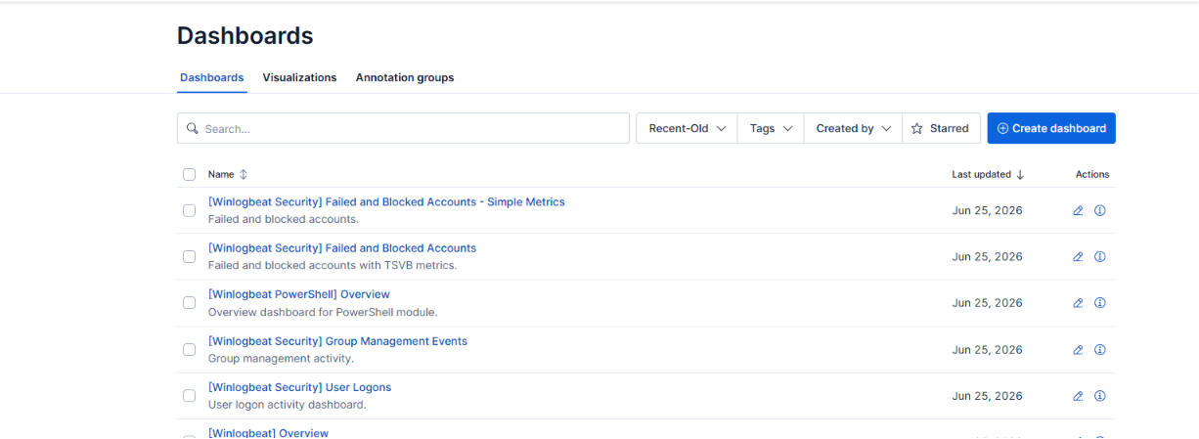
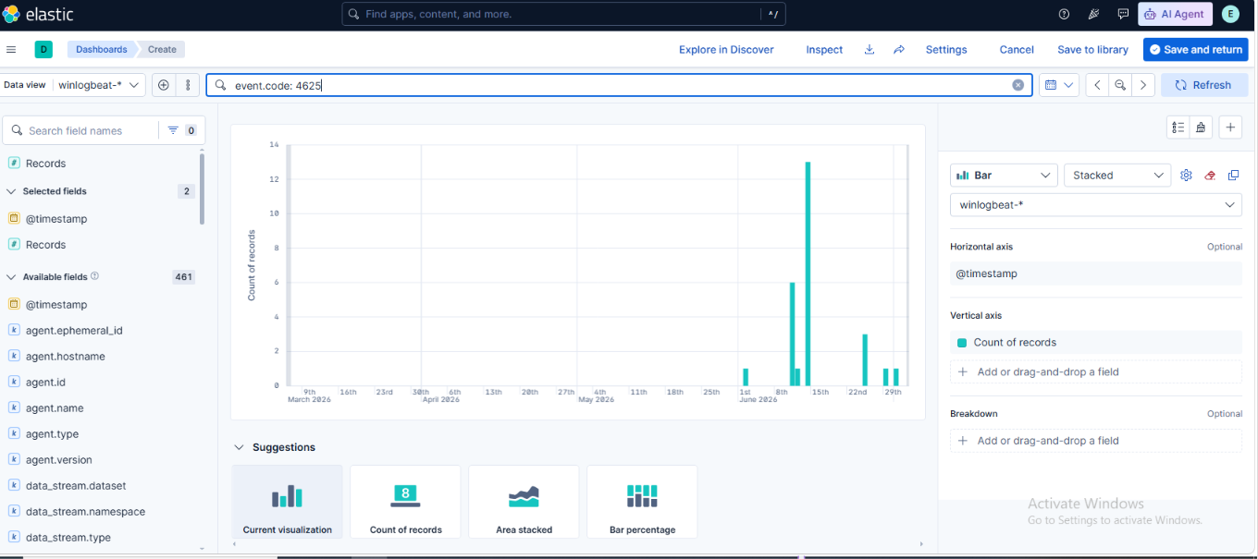
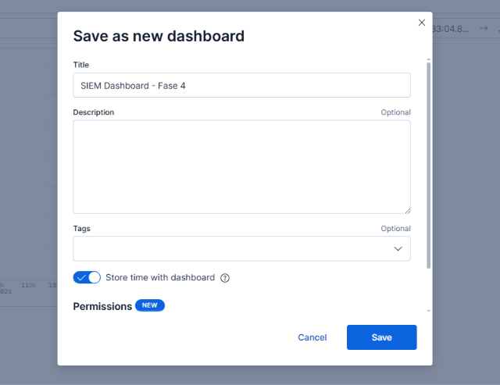
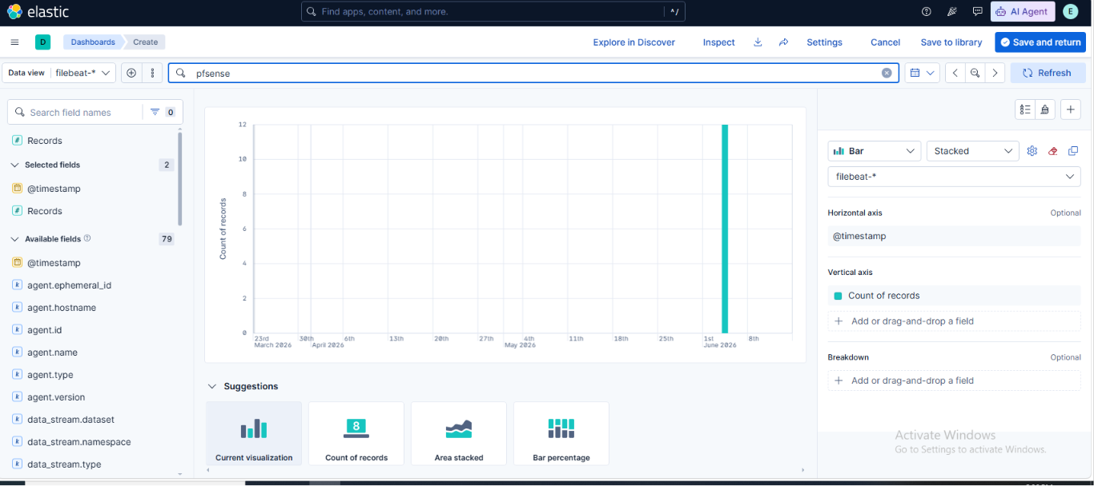
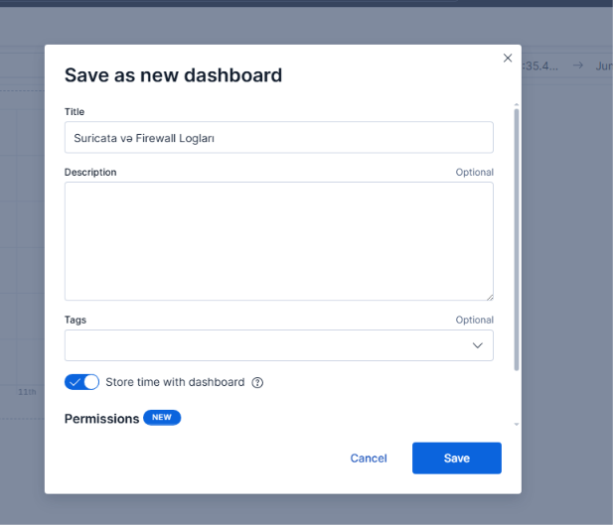
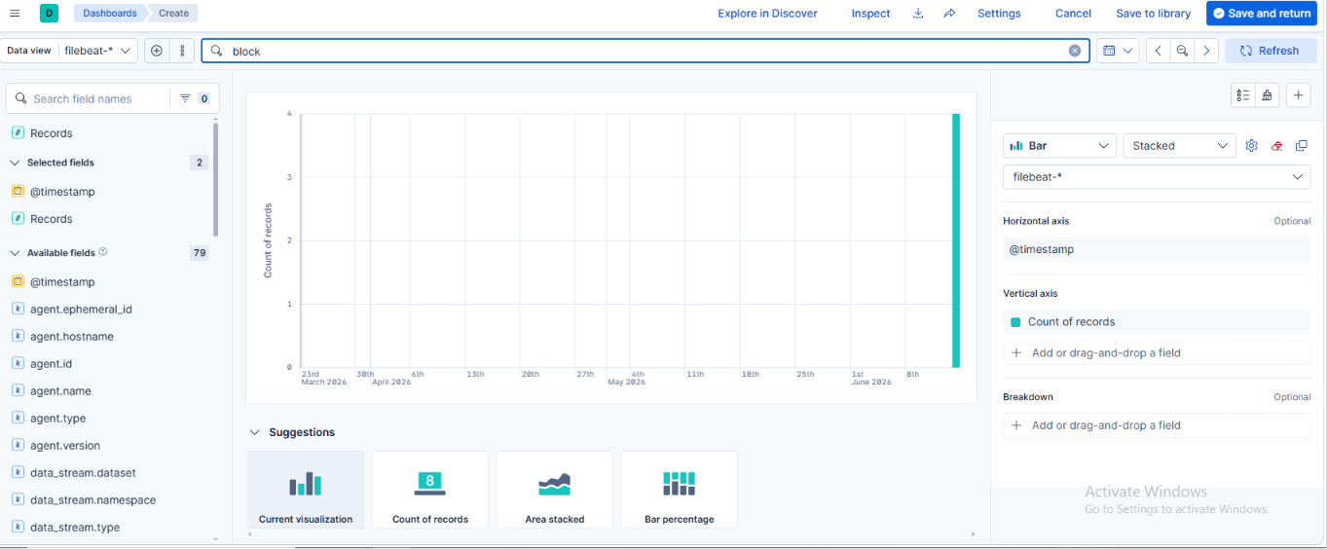
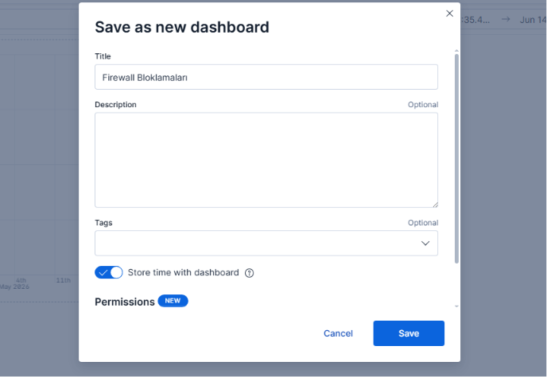
SIEM Dashboard - Phase 4: Designed for monitoring overall SIEM (Security Information and Event Management) events.
Suricata and Firewall Logs: Dedicated to the centralized monitoring of network-level security logs (Suricata and Firewall).
Firewall Blocks: Tailored specifically for tracking and analyzing traffic dropped or blocked by the firewall.
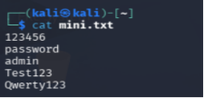
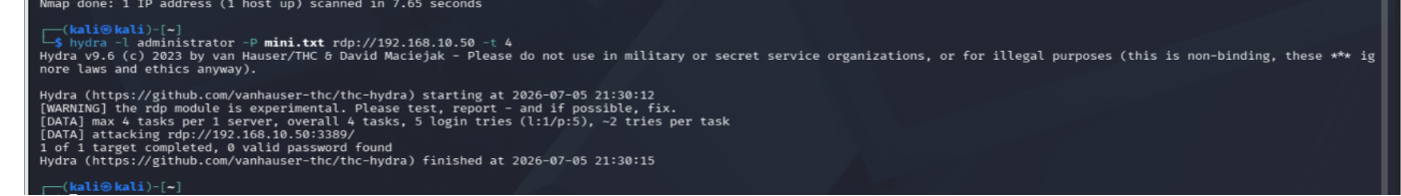
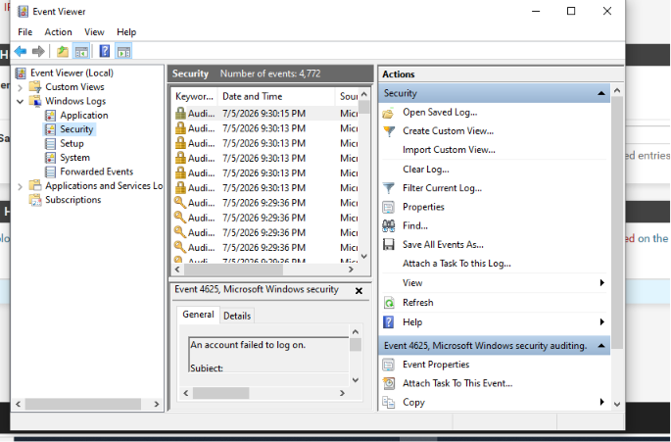
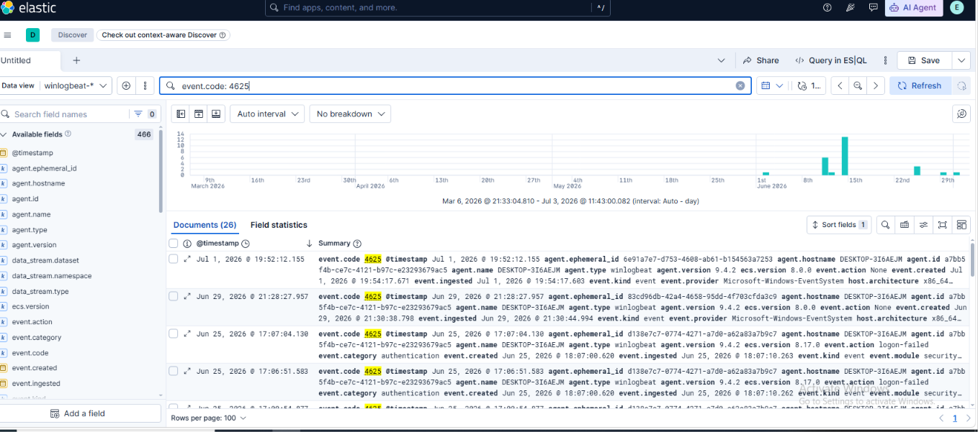
Attack Execution (Kali Linux)
- Password List Preparation: First, a mini.txt wordlist was created using the echo command, populated with a few weak passwords.
- Attack Launch: Using the hydra tool, a brute-force attack was executed against the RDP service on 192.168.10.50 targeting the administrator user using 4 parallel tasks.
Event Monitoring (Windows and Elastic Stack)
- Event Viewer (Windows): Failed logon attempts generated during the attack were recorded in the Security logs of the target system under Event ID 4625 (An account failed to log on).
- Elastic Stack Analysis: Within Kibana, the executed attack attempts were centrally monitored on the winlogbeat-* Data View by applying the event.code: 4625 filter.
- Although the attack resulted in failure, the tools and methodology employed fully simulate real-world brute-force attack scenarios.
- The immediate visibility of Event 4625 records in both Windows Event Logs and the Elastic environment confirms that the SIEM system's monitoring and detection capabilities are correctly configured.
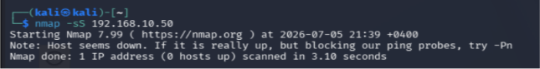
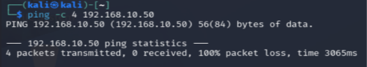
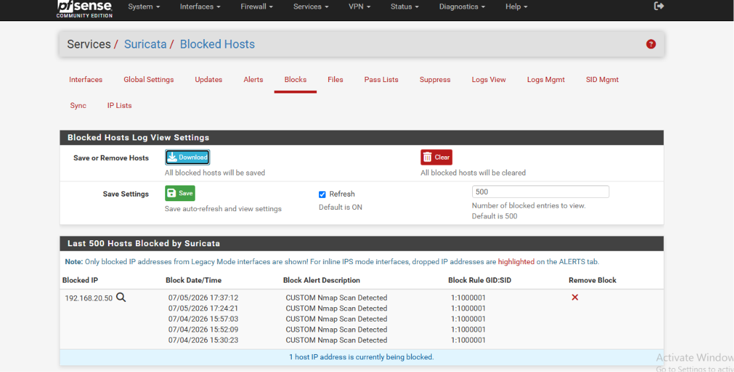

Event: Nmap scanning attempts targeting 192.168.10.50 were detected by Suricata running on pfSense.
Observation: IP address 192.168.20.50 (the scanning host) was blocked based on the "CUSTOM Nmap Scan Detected" rule (GID:SID 1:10000001).
Result: Execution of ping and nmap -sS commands resulted in 100% packet loss and a "Host seems down" message, proving that the IPS successfully blocked the scanning traffic.
Defensive Mechanism: Suricata rapidly identified unauthorized network reconnaissance activity (Nmap scans) and dynamically added the offending IP address to the block list.

Cihaz/İnterfeys | IP Ünvanı
Ubuntu Server (ens33) | 192.168.10.55/24
Kali Linux (eth0) | 192.168.20.50/24
Windows (Ethernet 2) | 192.168.10.50
pfSense (WAN - em0) | 192.168.1.69/24
pfSense (LAN - em1) | 192.168.10.1/24
pfSense (OPT1/ATTACK - em2) | 192.168.20.1/24

