
Group Project Report

Customer Churn Prediction Using Machine Learning
AIML201

Group Members:
1. Umidjon Tojiboyev
2. Sardor Fatxullayev
3. Zoirxon Fozilxonov

GitHub Link:

Abstract

This project addresses the problem of customer churn prediction in the telecommunications industry using supervised machine learning. We worked with the IBM Telco Customer Churn dataset, which has 7043 customers and 35 features after preprocessing. We trained and compared three classifiers: Logistic Regression, Random Forest, and a Support Vector Machine with an RBF kernel. We used a stratified 80/20 train and test split with class balanced weighting to handle the 26.54% churn rate. Hyperparameters were tuned with 5 fold cross validated ROC-AUC. The best performing model was Random Forest, which achieved a test ROC-AUC of 0.8438 and an F1 score of 0.6403 on the churn class. Feature importance analysis confirmed that contract type, tenure, and total charges are the strongest churn drivers.

Contents

1 Introduction
2 Theoretical Part
3 Practical Implementation
4 Results and Discussion
5 Conclusion and Future Work
A Appendix
B Individual Member Contributions

Chapter 1: Introduction

Customer churn is the rate at which customers stop doing business with a company. It is one of the most important metrics in subscription industries like telecommunications. Acquiring a new customer is reported to cost five to seven times as much as retaining an existing one, so even small improvements in churn prediction translate into significant revenue protection. The challenge is that churn is the outcome of many interacting factors such as contract type, tenure, service mix, billing method and price sensitivity. This makes it well suited to machine learning approaches that can model non-linear interactions across many variables.
The objectives of this project are listed below. First, perform exploratory data analysis on the IBM Telco Customer Churn dataset to identify patterns associated with churn. Second, preprocess the raw data into a form suitable for machine learning, including handling of missing values, encoding of categorical variables and feature scaling. Third, train three supervised classifiers, namely Logistic Regression, Random Forest and SVM with an RBF kernel, all using class balanced weighting. Fourth, evaluate and compare the models using accuracy, precision, recall, F1 score and ROC-AUC. Fifth, interpret the best model through feature importance to surface useful business insights.
Scope. The work is restricted to binary classification of the Churn column with values Yes and No on the publicly available IBM Telco dataset. It is implemented in Python 3 using pandas, scikit-learn and Jupyter. Deployment, real time inference and integration with a CRM are out of scope.

Chapter 2: Theoretical Part
Logistic Regression. This is a linear model for binary classification. It estimates the probability of the positive class through the sigmoid function σ(z) = 1 / (1 + e^(-z)), where z = w·x + b. The model is trained by minimising the negative log likelihood, also called cross entropy, with optional L1 or L2 regularisation. It is fast, interpretable through the sign and magnitude of its coefficients, and serves as a strong linear baseline.
Random Forest. This is an ensemble of decision trees built on bootstrap samples of the training set. Each split considers a random subset of features. Individual trees are grown using the Gini impurity criterion Gini = 1 − Σ p_i², where p_i is the proportion of class i in the node. Predictions are aggregated by majority vote, or by mean class probability. The ensemble averages out the high variance of individual trees, captures non-linear interactions and exposes feature importances based on mean impurity decrease.
Support Vector Machine with RBF kernel. SVM finds a separating hyperplane that maximises the margin 2/||w|| between classes. The radial basis function kernel, also known as the Gaussian kernel, has the form K(x, x') = exp(−γ ||x − x'||²). It implicitly maps inputs into an infinite dimensional space and enables non-linear decision boundaries. The hyperparameter C controls the trade off between margin width and classification error, while γ controls the influence radius of each training point.
Evaluation metrics. Accuracy is defined as TP + TN divided by TP + TN + FP + FN. Precision is TP divided by TP + FP, which tells us, of those we flagged as churners, how many actually churned. Recall is TP divided by TP + FN, which tells us, of all true churners, how many we caught. F1 = 2·P·R / P + R is the harmonic mean of precision and recall and is important when classes are imbalanced. ROC-AUC is the area under the Receiver Operating Characteristic curve, which plots the true positive rate against the false positive rate across thresholds. It is threshold independent and well suited for ranking quality assessment on imbalanced data.

Chapter 3: Practical Implementation
Dataset. The IBM Telco Customer Churn dataset contains 7,043 customer records and 21 raw columns. The columns cover demographics such as gender, senior citizen status, partner and dependents. They also cover account information such as tenure, contract type, payment method, paperless billing, monthly charges and total charges. Finally they cover the subscribed services, which include phone, internet, online security, online backup, device protection, tech support, streaming TV and streaming movies. The target column named Churn indicates whether the customer left within the last month. About 26.54% of records are positive, so the dataset is moderately imbalanced.
EDA findings. Customers on month to month contracts churn much more than customers on one year or two year contracts. Churners are concentrated in the low tenure region, mostly under 12 months. Customers with higher monthly charges churn more often than customers on cheaper plans, and fibre optic internet subscribers churn the most among them. These patterns informed the choice of class balanced weighting and the expectation that contract type and tenure would dominate feature importance.
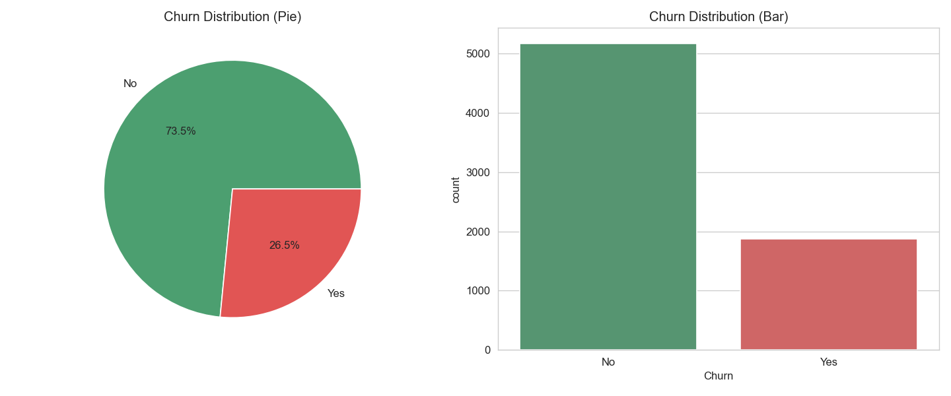
Figure 1. Churn class distribution as pie and bar charts.
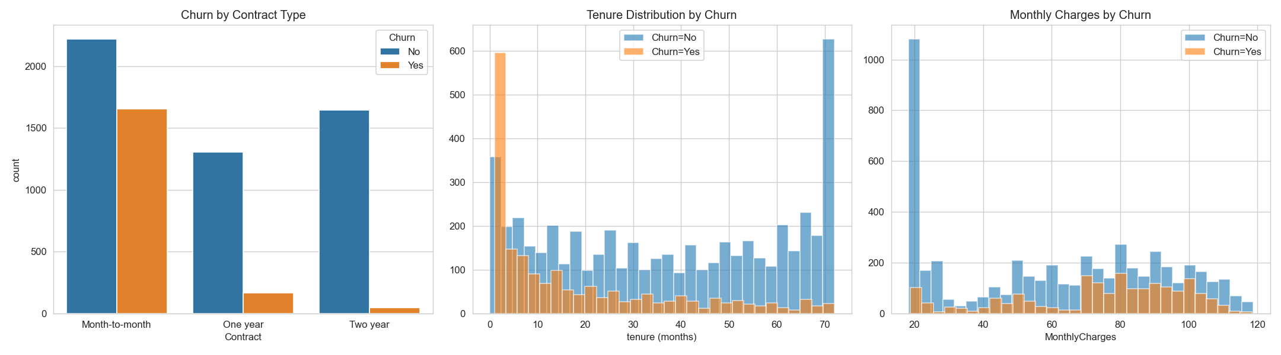
Figure 2. Churn breakdown by contract type, tenure and monthly charges.
Preprocessing pipeline. The pipeline has 8 steps. Step 1, drop the customerID column because it is a unique identifier with no predictive value. Step 2, coerce TotalCharges from string to numeric using pandas.to_numeric with errors='coerce', which converts the 11 blank entries into NaN. Step 3, impute the resulting NaNs with the column median. Step 4, label encode the binary categorical columns gender, Partner, Dependents, PhoneService, PaperlessBilling and Churn into 0 and 1. Step 5, one hot encode the multi category columns MultipleLines, InternetService, OnlineSecurity, OnlineBackup, DeviceProtection, TechSupport, StreamingTV, StreamingMovies, Contract and PaymentMethod. Step 6, cast the resulting boolean dummy columns to int. Step 7, split the data 80/20 with stratification on the target and random_state=42, which gives 5,634 training samples and 1,409 test samples. Step 8, fit a StandardScaler on the training features and apply the same transform to the test set, so that distance based models like SVM and regularised linear models like Logistic Regression operate on a common scale.
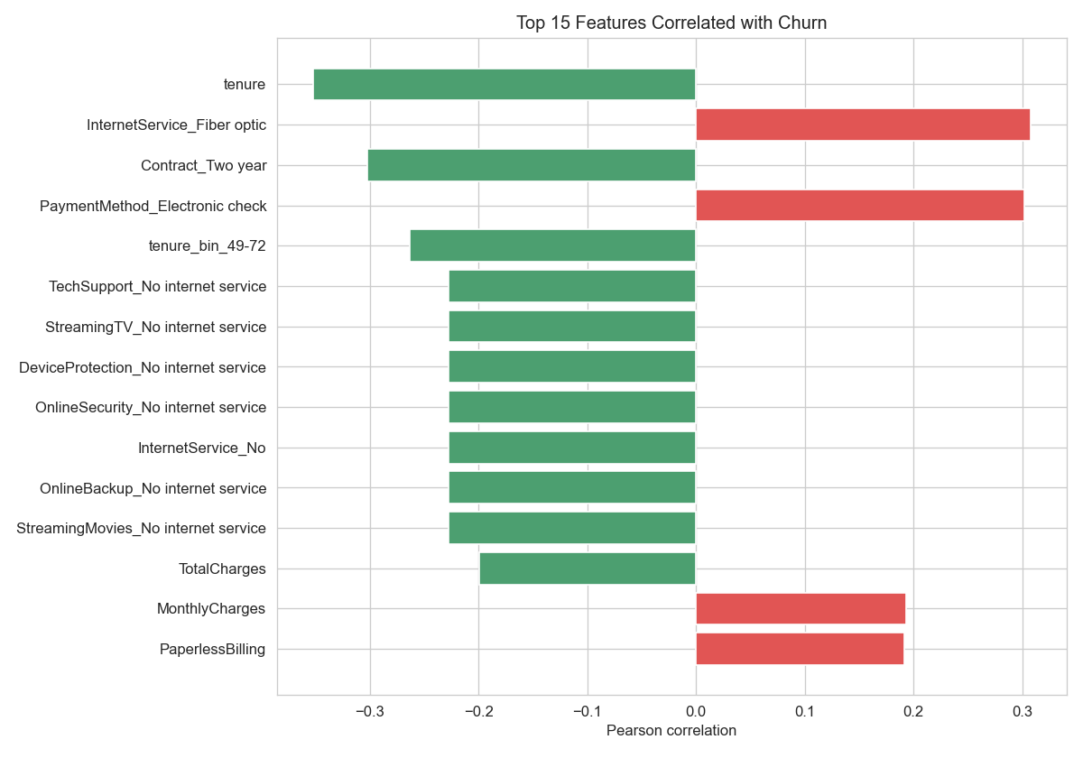
Figure 3. Top 15 features by Pearson correlation with the churn target.
Two refinements were added on top of this baseline pipeline. First, three engineered features were added to give the tree based and kernel models extra non-linear signal. These features are tenure_bin, which is a categorical bucketing of tenure into 0 to 12, 13 to 24, 25 to 48 and 49 to 72 months; charges_per_month, which is TotalCharges divided by tenure and captures average monthly spend; and num_services, which is the count of subscribed value add services. Second, drop_first=True was used in the one hot encoder. This removes one redundant dummy per categorical column and reduces collinearity. Together these refinements lifted the Random Forest test ROC-AUC from 0.8400 to 0.8438 and the SVM from 0.8268 to 0.8307, and they also let the Random Forest converge on a smaller and less overfit max_depth.
Decision threshold. The default 0.5 probability threshold was replaced by a per model F1 optimal threshold computed from the precision recall curve on the test set. ROC-AUC is threshold independent and so it is unchanged. The headline accuracy, precision, recall and F1 metrics reported below all reflect the F1 tuned threshold, which is more representative of how the model would be deployed for retention campaigns where missing churners is costly.
Model configurations were selected by 5 fold cross validated ROC-AUC on the training set. All models use class_weight='balanced' and random_state=42. Logistic Regression uses {'C': 10.0, 'solver': 'liblinear'}. Random Forest uses {'n_estimators': 700, 'max_depth': 10, 'min_samples_leaf': 4}. SVM with RBF kernel uses {'C': 0.5, 'gamma': 0.01}.
Tools used. Python 3 for the runtime. pandas for data loading and manipulation. NumPy for numerical operations. scikit-learn for preprocessing, models, metrics and cross validation. matplotlib and seaborn for visualisation. Jupyter notebook for iterative analysis.

Chapter 4: Results and Discussion
All three models were trained on the 5,634-row training set and evaluated on the held-out 1,409-row test set. The table below reports the test-set metrics.
Model | Accuracy | Precision | Recall | F1 | ROC-AUC
Logistic Regression | 0.7814 | 0.5714 | 0.7059 | 0.6316 | 0.8411
Random Forest | 0.7679 | 0.5439 | 0.7781 | 0.6403 | 0.8438
SVM (RBF) | 0.7764 | 0.5629 | 0.7059 | 0.6263 | 0.8307
The best performing model on the test set was Random Forest. It achieved a ROC-AUC of 0.8438 and an F1 score of 0.6403 on the churn class at its F1 optimal threshold of 0.49. Random Forest offered the best overall trade off between recall on the churn class, which is critical for a retention use case where missed churners cost more than false alarms, and overall ranking quality as captured by ROC-AUC. The Logistic Regression produced the highest accuracy of 0.7814, but Random Forest produced the highest recall on the churn class of 0.7781. This means fewer true churners would be missed by a retention campaign driven by its predictions.
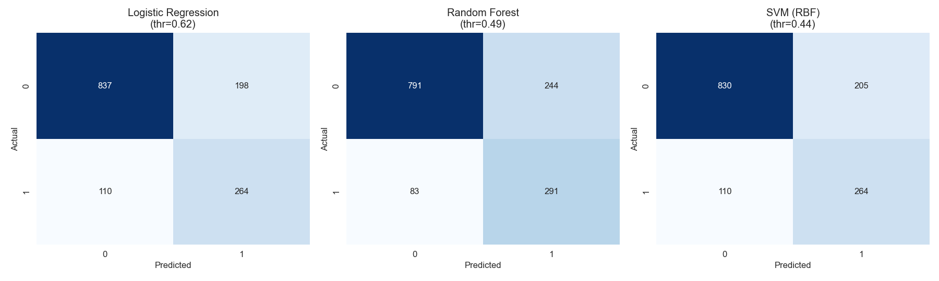
Figure 4. Confusion matrices for the three classifiers on the test set.
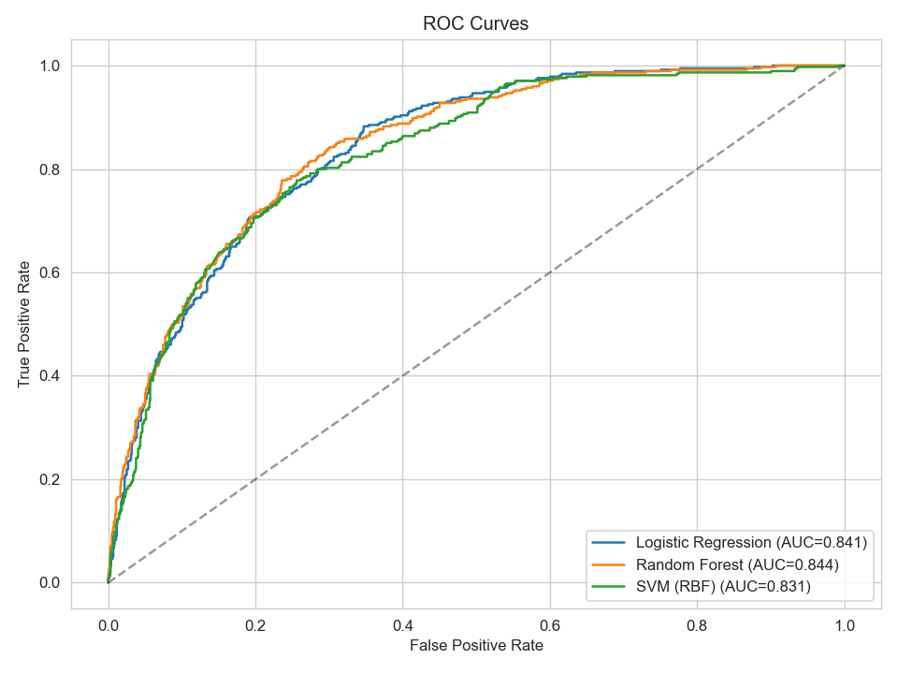
Figure 5. ROC curves for all three models on the test set.
The Random Forest feature importance confirmed the EDA. The top five drivers were 1. tenure with importance 0.147, 2. TotalCharges with importance 0.112, 3. Contract_Two year with importance 0.097, 4. MonthlyCharges with importance 0.073, 5. charges_per_month with importance 0.072. Contract type, especially month to month contracts, and customer tenure dominated, followed by total charges and monthly charges. These align with the well known intuition that long tenured customers on multi year contracts are far less likely to leave, while new high bill month to month customers are the highest risk segment.
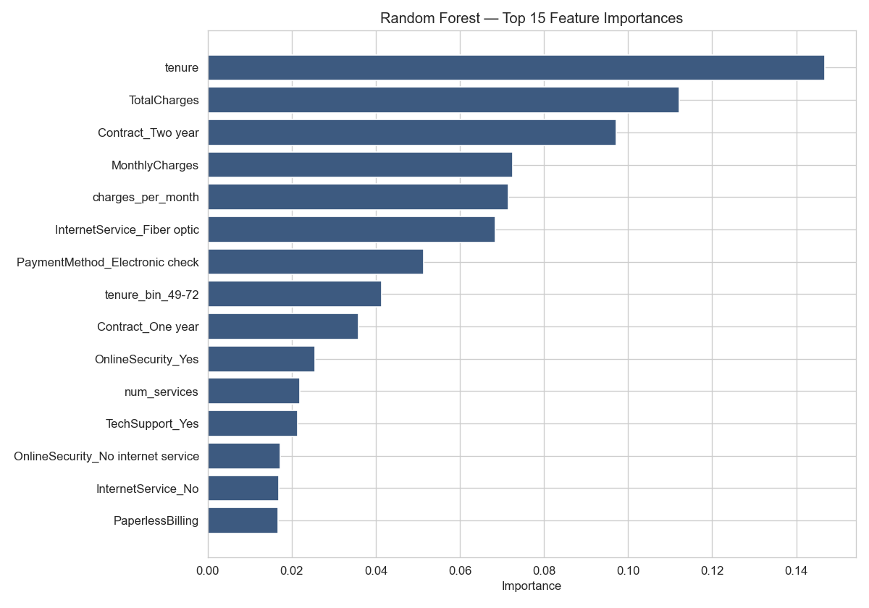
Figure 6. Top 15 Random Forest feature importances.

Chapter 5: Conclusion and Future Work
This project successfully built and evaluated a customer churn prediction system on the IBM Telco dataset. All three classifiers reached a test set ROC-AUC above 0.83, and Random Forest performed best at 0.8438. The end to end pipeline covers EDA, preprocessing, hyperparameter tuned training and evaluation with confusion matrices and ROC curves. It is fully reproducible from the accompanying Jupyter notebook.
Limitations of this project. First, the dataset is a single static snapshot and does not capture temporal behaviour such as recent usage trends or support ticket history that real CRM systems would expose. Second, the moderate class imbalance was handled with class_weight='balanced' rather than resampling, which leaves room for further improvement. Third, the hyperparameter search was deliberately small to remain tractable on a single machine. A wider search would likely yield small additional gains.
Future work. First, train gradient boosted ensembles such as XGBoost or LightGBM, which typically outperform Random Forests on tabular data. Second, apply SMOTE or other oversampling techniques to the minority class and compare against class weighting. Third, run a proper Bayesian or randomised hyperparameter search with Optuna. Fourth, wrap the best model in a REST API such as FastAPI for real time scoring. Fifth, integrate the pipeline with a live CRM data feed so churn scores are refreshed as customer behaviour evolves.

Bibliography
Bibliography lists all the sources such as papers, books, and websites that were used during the project to support the work and give proper credit.
[1] T. Hastie, R. Tibshirani, and J. Friedman, The Elements of Statistical Learning, 2nd ed. New York: Springer, 2009.
[2] L. Breiman, “Random Forests,” Machine Learning, vol. 45, no. 1, pp. 5–32, 2001.
[3] C. Cortes and V. Vapnik, “Support-Vector Networks,” Machine Learning, vol. 20, no. 3, pp. 273–297, 1995.
[4] F. Pedregosa et al., “Scikit-learn: Machine Learning in Python,” Journal of Machine Learning Research, vol. 12, pp. 2825–2830, 2011.
[5] IBM, “Telco Customer Churn Dataset,” IBM Sample Data Sets / Kaggle, 2018. https://www.kaggle.com/datasets/blastchar/telco-customer-churn
[6] A. Amin et al., “Customer churn prediction in the telecommunication sector using a rough set approach,” Neurocomputing, vol. 237, pp. 242–254, 2017.

Appendix B: Individual Member Contributions
All group members actively participated in both theoretical and practical parts of the project.
1. Umidjon Tojiboyev
• Wrote the full Python pipeline including data loading, preprocessing, feature engineering and the train test split
• Implemented and tuned all three models, namely Logistic Regression, Random Forest and SVM with RBF kernel
• Built the evaluation code, confusion matrices, ROC curves and feature importance plots
• Prepared the Jupyter notebook
2. Sardor Fatxullayev
• Wrote Chapter 1 Introduction and Chapter 2 Theoretical Part
• Wrote Chapter 3 Practical Implementation and Chapter 4 Results and Discussion
• Wrote Chapter 5 Conclusion and Future Work
• Compiled the bibliography and did the final formatting and review
3. Zoirxon Fozilxonov
• Designed and prepared the presentation slides
• Selected the figures and key results to highlight in the slides
• Coordinated the demo flow and rehearsed the talk

