Draft of the Complete E-R Diagram

We used Mermaid to create the Entity-Relationship diagram for this problem. This is our rough diagram (page 2). Due to software limitations, the attributes of relationships are presented in page 3 separately (You can also see it in OneNote). Some additional constraints that we could not show in the diagram are described on page 4. In case, any of the diagram don’t show up due to formal limitations, please use the following links:

[Draft of E-R Diagram Link Vector Image](https://mermaid.ink/svg/pako:eNqdVU1v2kAQ_Ssjn1opRg6FVLKaXEJVVZQIKc0hki_LeoAV9q6zuyZFwH_vrD_ADls1ig-WvTNvPt4bj_cBVykGcRCGYSKtsBnG8ON5BqObKJHVIeqJYCvN8kQCXTPMF6j39Yu7hLS4Qg15ZXgo3R3mUzh7bJnma6Y_DaPPsJQsRzhfSfBUgFUwjMD5MG5RmyTog9m6BmcfAbvM1wQu1kpiU97T1IFxsBrAmMDXwy8wGsPN10ELPiayfrhXpTa49zfDM2bMQ1XTfOphhP2ZM20FFwWTti15VhoLC4Rvt0RxcInipdYobQ_ZRfWjdiOkzFbsGEv2Sf1yaUWZNrYuke3p3Rl9wcVvzYT0am9rS8Nun41_qf9e8T6s-rsUv2jyF24x87SYufOfk15ry0wxp2su5GNBDAq56kh1d9vTt3VOheGqrOehq-s48hEuDfUnlPST3lq9xJ_8lGUZwBvBz4mHURT5xqgTvxoHr6J2V2Ad8F6jA6Yqp1mAV2HXUChjxCLDystctPf9pRRFTrPuaU5YzNuufNM0otwpGq5F4Qqk_JP2bYtQTcxSUe9rBGzT-L62l5K5tbfrk9KR7lTtnPENW3lWARS1pVoEvvHgytj_x68XKxxVGKp9s3cghqJ0SQzR160CjocwPLRuMaWQlmg3vQ8VDodOrBgsMr5uAzXpGpfOpMW0tzZvvJpsJ8FiWCit1avH61B_QVQ5VR1cBTlqGoiUfjEVc0lAkuS0W2J6TJneOB6O5MdKqx53kgex1SVeBWXh5rD59dSHx7-YUQMZ)

[Draft of E-R Diagram With Relationship Attributes in OneNote](https://1drv.ms/o/s!AuyKDFNwj9rvgZJJK7TFYDkpbSm5vQ?e=Rv3KqM)

In addition to this, please note this is the draft of E-R Diagram. Entities and relationships may not yet contain foreign keys. These specifics will be present when the E-R Diagram is converted to a relation database schema during the logical dataset design.

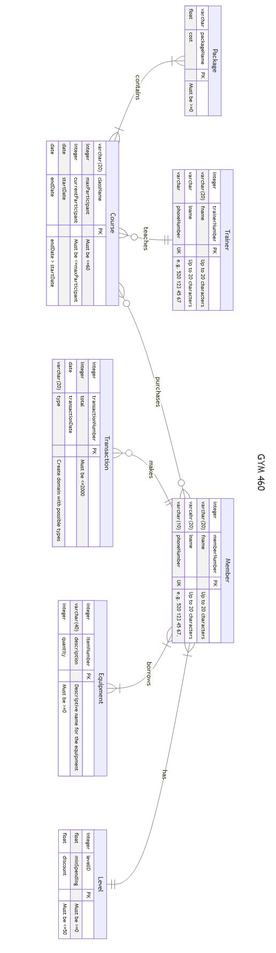

Relationship Attributes

teaches

purchases

borrows

Additional Constraints

1.Deletion of a member. All equipment borrowed by the members should be returned. If the total of transaction amounts for the use is <0, do not allow the deletion of the member. Remove the user from the enrolled course and update the number of active participants in those courses.

2.Deletion of a course. If the course does not end and has members, notify users (best to do programmatically.).

3.If a course package is modified, this should not impact members.

4.Only a user with admin credentials should be able to delete, update, and insert a course package, equipment, and courses. Only administrators can view information about all members, schedules, and trainers.