--module-path “C:\Users\S A K H I\Desktop\javafx-sdk-20.0.2\lib”--add-modules javafx.controls,javafx.fxml

**Code side ============DB side**

**DB setup============= DB formation**

**DB model============collection banega**

**Schema==============document banega.**

Nodejs:

Nodejs is a javascript runtime environment. Which is built on the v8 engine that allows us to make the server from javascript.

**Ex:**

Nodejs is the collection of v8 engine code that is taken from chrome v8 engine code written in C++ we wrapped that code with javascript so this collection is called is Nodejs. Our js code is accepted by js wrapper and on the basis of C++ code it make the server for us.

So we called that in the core we have the C++ code which makes the server environment for us.

Note:

Javascript cannot make the server itself.

**Middle Ware:**

Middle-Ware is the function that we use when we want to execute some piece of code before the get request has been fulfilled.

It is used when we want to send the message when anyone send the request to us for any particular route.

**Ex:**

App.use(function(req,res,next){

res.send(“Helllo world ”);

Next();

})

**22-SW-01**

File which setup the whole Program:

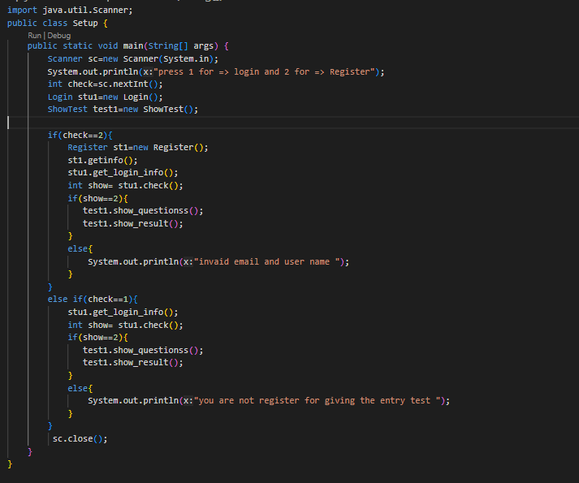

**Registration page:** which save the student data in txt file 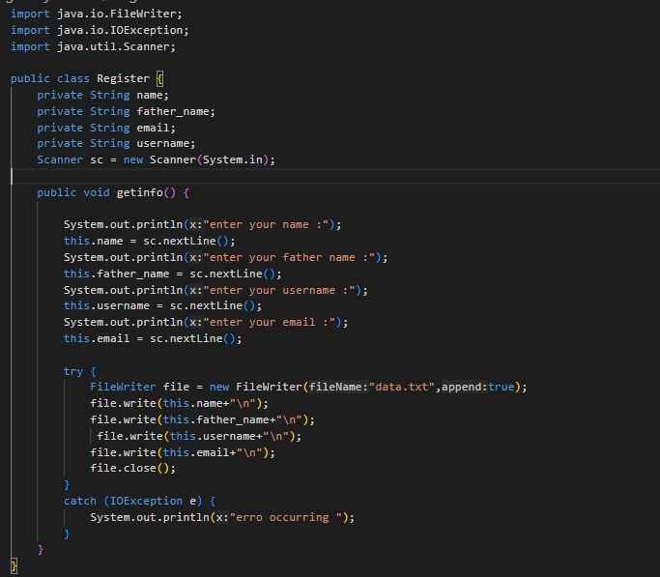

**Login page:** which login the student account which is al-ready registered

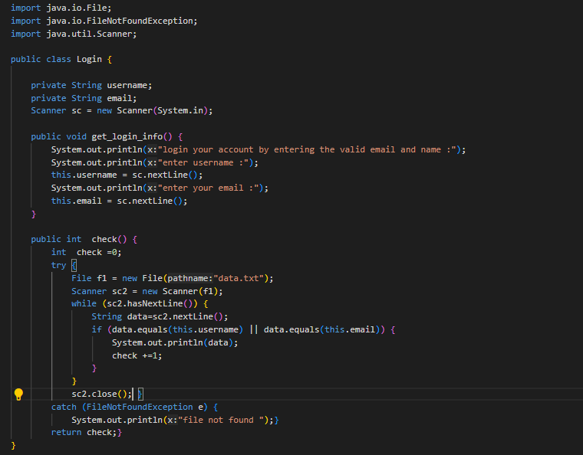

**Show questions :** page which show the questions and their result

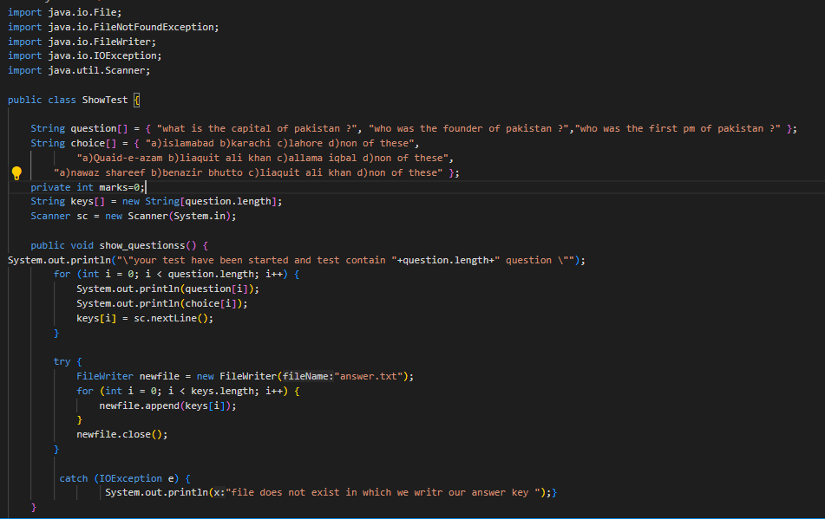

**Console result:** if student is already registered

Then it can give the test.

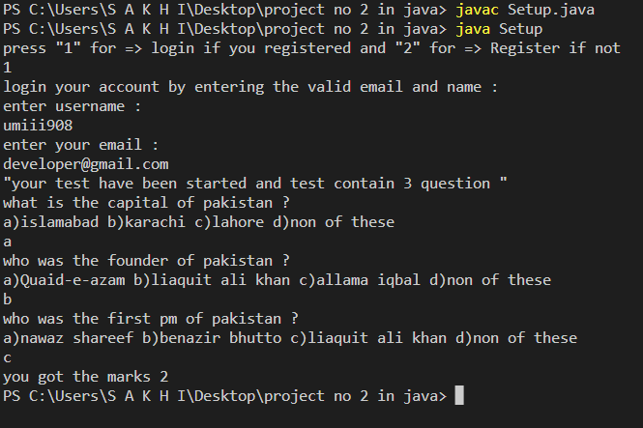

**If student is not Registered and trying to login**

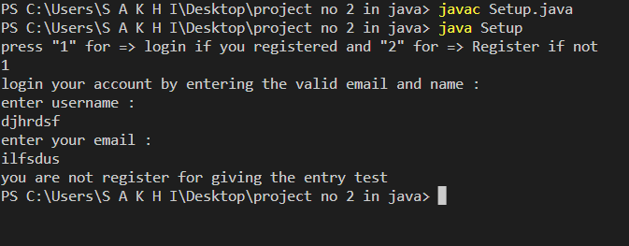

**Registering the student for entry test and the give the test**

