Experiencia 3.1
Questão 3.0
Utilize o ssh-audit para efetuar um teste ao servidor algo.paranoidjasmine.com, i.e.

Ao fazer uso do comando python ssh-audit.py algo.paranoidjasmine.com, é possível efetuar um teste ao servidor algo.paranoidjasmine.com, como mostra a figura abaixo.
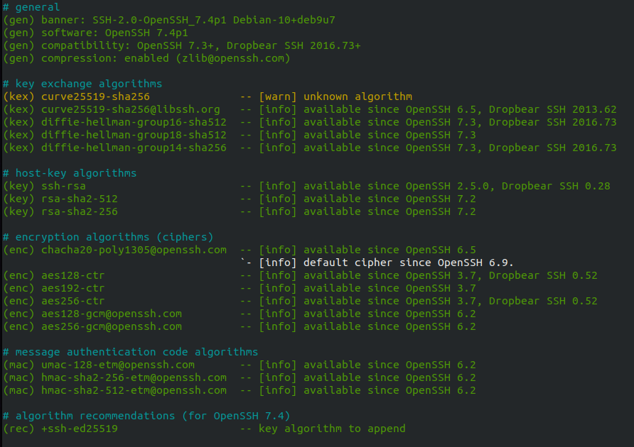
Figura . - Teste ao servidor algo.paranoidjasmine.com

Questão 3.1.1
Anexe os resultados SSH à tua resposta.

Após fazer registo no shodan, realizamos diversas pesquisas de algumas empresas cotadas na NASDAQ de modo a nos facilitar a pesquisa por servidores ssh na porta 22.

Empresa 1:
python ssh-audit.py 146.152.205.96
# general
(gen) banner: SSH-2.0-OpenSSH_8.0
(gen) software: OpenSSH 8.0
(gen) compatibility: OpenSSH 7.3+, Dropbear SSH 2016.73+
(gen) compression: enabled (zlib@openssh.com)

# key exchange algorithms
(kex) curve25519-sha256 -- [warn] unknown algorithm
(kex) curve25519-sha256@libssh.org -- [info] available since OpenSSH 6.5, Dropbear SSH 2013.62
(kex) ecdh-sha2-nistp256 -- [fail] using weak elliptic curves
`- [info] available since OpenSSH 5.7, Dropbear SSH 2013.62
(kex) ecdh-sha2-nistp384 -- [fail] using weak elliptic curves
`- [info] available since OpenSSH 5.7, Dropbear SSH 2013.62
(kex) ecdh-sha2-nistp521 -- [fail] using weak elliptic curves
`- [info] available since OpenSSH 5.7, Dropbear SSH 2013.62
(kex) diffie-hellman-group-exchange-sha256 -- [warn] using custom size modulus (possibly weak)
`- [info] available since OpenSSH 4.4
(kex) diffie-hellman-group16-sha512 -- [info] available since OpenSSH 7.3, Dropbear SSH 2016.73
(kex) diffie-hellman-group18-sha512 -- [info] available since OpenSSH 7.3
(kex) diffie-hellman-group14-sha256 -- [info] available since OpenSSH 7.3, Dropbear SSH 2016.73
(kex) diffie-hellman-group14-sha1 -- [warn] using weak hashing algorithm
`- [info] available since OpenSSH 3.9, Dropbear SSH 0.53

# host-key algorithms
(key) rsa-sha2-512 -- [info] available since OpenSSH 7.2
(key) rsa-sha2-256 -- [info] available since OpenSSH 7.2
(key) ssh-rsa -- [info] available since OpenSSH 2.5.0, Dropbear SSH 0.28
(key) ecdsa-sha2-nistp521 -- [fail] using weak elliptic curves
`- [warn] using weak random number generator could reveal the key
`- [info] available since OpenSSH 5.7, Dropbear SSH 2013.62
(key) ssh-ed25519 -- [info] available since OpenSSH 6.5

# encryption algorithms (ciphers)
(enc) chacha20-poly1305@openssh.com -- [info] available since OpenSSH 6.5
`- [info] default cipher since OpenSSH 6.9.
(enc) aes256-gcm@openssh.com -- [info] available since OpenSSH 6.2
(enc) aes128-gcm@openssh.com -- [info] available since OpenSSH 6.2
(enc) aes256-ctr -- [info] available since OpenSSH 3.7, Dropbear SSH 0.52
(enc) aes192-ctr -- [info] available since OpenSSH 3.7
(enc) aes128-ctr -- [info] available since OpenSSH 3.7, Dropbear SSH 0.52

# message authentication code algorithms
(mac) umac-64-etm@openssh.com -- [warn] using small 64-bit tag size
`- [info] available since OpenSSH 6.2
(mac) umac-128-etm@openssh.com -- [info] available since OpenSSH 6.2
(mac) hmac-sha2-256-etm@openssh.com -- [info] available since OpenSSH 6.2
(mac) hmac-sha2-512-etm@openssh.com -- [info] available since OpenSSH 6.2
(mac) hmac-sha1-etm@openssh.com -- [warn] using weak hashing algorithm
`- [info] available since OpenSSH 6.2
(mac) umac-64@openssh.com -- [warn] using encrypt-and-MAC mode
`- [warn] using small 64-bit tag size
`- [info] available since OpenSSH 4.7
(mac) umac-128@openssh.com -- [warn] using encrypt-and-MAC mode
`- [info] available since OpenSSH 6.2
(mac) hmac-sha2-256 -- [warn] using encrypt-and-MAC mode
`- [info] available since OpenSSH 5.9, Dropbear SSH 2013.56
(mac) hmac-sha2-512 -- [warn] using encrypt-and-MAC mode
`- [info] available since OpenSSH 5.9, Dropbear SSH 2013.56
(mac) hmac-sha1 -- [warn] using encrypt-and-MAC mode
`- [warn] using weak hashing algorithm
`- [info] available since OpenSSH 2.1.0, Dropbear SSH 0.28

# algorithm recommendations (for OpenSSH 8.0)
(rec) -ecdh-sha2-nistp521 -- kex algorithm to remove
(rec) -ecdh-sha2-nistp384 -- kex algorithm to remove
(rec) -diffie-hellman-group14-sha1 -- kex algorithm to remove
(rec) -ecdh-sha2-nistp256 -- kex algorithm to remove
(rec) -diffie-hellman-group-exchange-sha256 -- kex algorithm to remove
(rec) -ecdsa-sha2-nistp521 -- key algorithm to remove
(rec) -hmac-sha2-512 -- mac algorithm to remove
(rec) -umac-128@openssh.com -- mac algorithm to remove
(rec) -hmac-sha2-256 -- mac algorithm to remove
(rec) -umac-64@openssh.com -- mac algorithm to remove
(rec) -hmac-sha1 -- mac algorithm to remove
(rec) -hmac-sha1-etm@openssh.com -- mac algorithm to remove
(rec) -umac-64-etm@openssh.com -- mac algorithm to remove
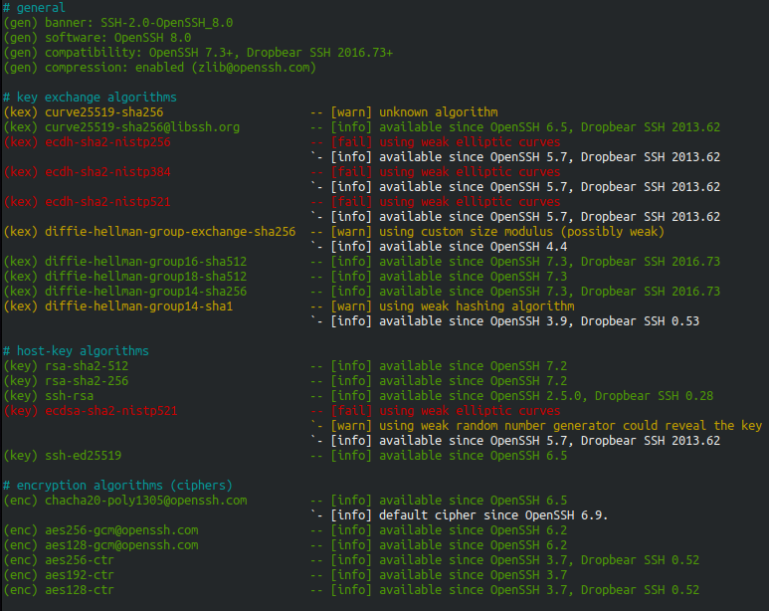
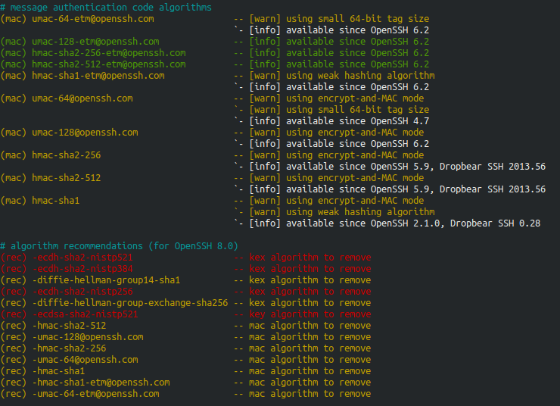
Empresa 2:
# general
(gen) banner: SSH-2.0-prontosftp
(gen) compatibility: OpenSSH 5.9-6.6, Dropbear SSH 2013.62+ (some functionality from 0.52)
(gen) compression: disabled

# key exchange algorithms
(kex) ecdh-sha2-nistp256 -- [fail] using weak elliptic curves
`- [info] available since OpenSSH 5.7, Dropbear SSH 2013.62
(kex) ecdh-sha2-nistp384 -- [fail] using weak elliptic curves
`- [info] available since OpenSSH 5.7, Dropbear SSH 2013.62
(kex) ecdh-sha2-nistp521 -- [fail] using weak elliptic curves
`- [info] available since OpenSSH 5.7, Dropbear SSH 2013.62
(kex) diffie-hellman-group14-sha1 -- [warn] using weak hashing algorithm
`- [info] available since OpenSSH 3.9, Dropbear SSH 0.53
(kex) diffie-hellman-group1-sha1 -- [fail] removed (in server) since OpenSSH 6.7, unsafe algorithm
`- [fail] disabled (in client) since OpenSSH 7.0, logjam attack
`- [warn] using small 1024-bit modulus
`- [warn] using weak hashing algorithm
`- [info] available since OpenSSH 2.3.0, Dropbear SSH 0.28

# host-key algorithms
(key) ssh-rsa -- [info] available since OpenSSH 2.5.0, Dropbear SSH 0.28

# encryption algorithms (ciphers)
(enc) aes128-ctr -- [info] available since OpenSSH 3.7, Dropbear SSH 0.52
(enc) aes192-ctr -- [info] available since OpenSSH 3.7
(enc) aes256-ctr -- [info] available since OpenSSH 3.7, Dropbear SSH 0.52
(enc) aes128-cbc -- [fail] removed (in server) since OpenSSH 6.7, unsafe algorithm
`- [warn] using weak cipher mode
`- [info] available since OpenSSH 2.3.0, Dropbear SSH 0.28
(enc) aes192-cbc -- [fail] removed (in server) since OpenSSH 6.7, unsafe algorithm
`- [warn] using weak cipher mode
`- [info] available since OpenSSH 2.3.0
(enc) aes256-cbc -- [fail] removed (in server) since OpenSSH 6.7, unsafe algorithm
`- [warn] using weak cipher mode
`- [info] available since OpenSSH 2.3.0, Dropbear SSH 0.47
(enc) blowfish-cbc -- [fail] removed (in server) since OpenSSH 6.7, unsafe algorithm
`- [fail] disabled since Dropbear SSH 0.53
`- [warn] disabled (in client) since OpenSSH 7.2, legacy algorithm
`- [warn] using weak cipher mode
`- [warn] using small 64-bit block size
`- [info] available since OpenSSH 1.2.2, Dropbear SSH 0.28
(enc) 3des-cbc -- [fail] removed (in server) since OpenSSH 6.7, unsafe algorithm
`- [warn] using weak cipher
`- [warn] using weak cipher mode
`- [warn] using small 64-bit block size
`- [info] available since OpenSSH 1.2.2, Dropbear SSH 0.28

# message authentication code algorithms
(mac) hmac-sha2-256 -- [warn] using encrypt-and-MAC mode
`- [info] available since OpenSSH 5.9, Dropbear SSH 2013.56
(mac) hmac-sha2-512 -- [warn] using encrypt-and-MAC mode
`- [info] available since OpenSSH 5.9, Dropbear SSH 2013.56
(mac) hmac-sha1 -- [warn] using encrypt-and-MAC mode
`- [warn] using weak hashing algorithm
`- [info] available since OpenSSH 2.1.0, Dropbear SSH 0.28
(mac) hmac-md5 -- [fail] removed (in server) since OpenSSH 6.7, unsafe algorithm
`- [warn] disabled (in client) since OpenSSH 7.2, legacy algorithm
`- [warn] using encrypt-and-MAC mode
`- [warn] using weak hashing algorithm
`- [info] available since OpenSSH 2.1.0, Dropbear SSH 0.28
(mac) hmac-sha1-96 -- [fail] removed (in server) since OpenSSH 6.7, unsafe algorithm
`- [warn] disabled (in client) since OpenSSH 7.2, legacy algorithm
`- [warn] using encrypt-and-MAC mode
`- [warn] using weak hashing algorithm
`- [info] available since OpenSSH 2.5.0, Dropbear SSH 0.47
(mac) hmac-md5-96 -- [fail] removed (in server) since OpenSSH 6.7, unsafe algorithm
`- [warn] disabled (in client) since OpenSSH 7.2, legacy algorithm
`- [warn] using encrypt-and-MAC mode
`- [warn] using weak hashing algorithm
`- [info] available since OpenSSH 2.5.0

# algorithm recommendations (for OpenSSH 5.9)
(rec) -ecdh-sha2-nistp521 -- kex algorithm to remove
(rec) -ecdh-sha2-nistp384 -- kex algorithm to remove
(rec) -diffie-hellman-group1-sha1 -- kex algorithm to remove
(rec) -ecdh-sha2-nistp256 -- kex algorithm to remove
(rec) -aes192-cbc -- enc algorithm to remove
(rec) -aes128-cbc -- enc algorithm to remove
(rec) -blowfish-cbc -- enc algorithm to remove
(rec) -3des-cbc -- enc algorithm to remove
(rec) -aes256-cbc -- enc algorithm to remove
(rec) -hmac-sha1 -- mac algorithm to remove
(rec) -hmac-md5-96 -- mac algorithm to remove
(rec) -hmac-sha1-96 -- mac algorithm to remove
(rec) -hmac-md5 -- mac algorithm to remove

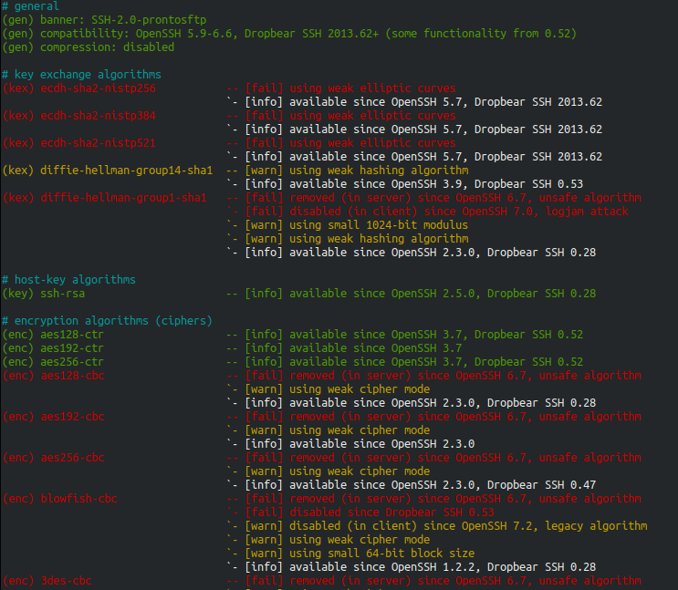
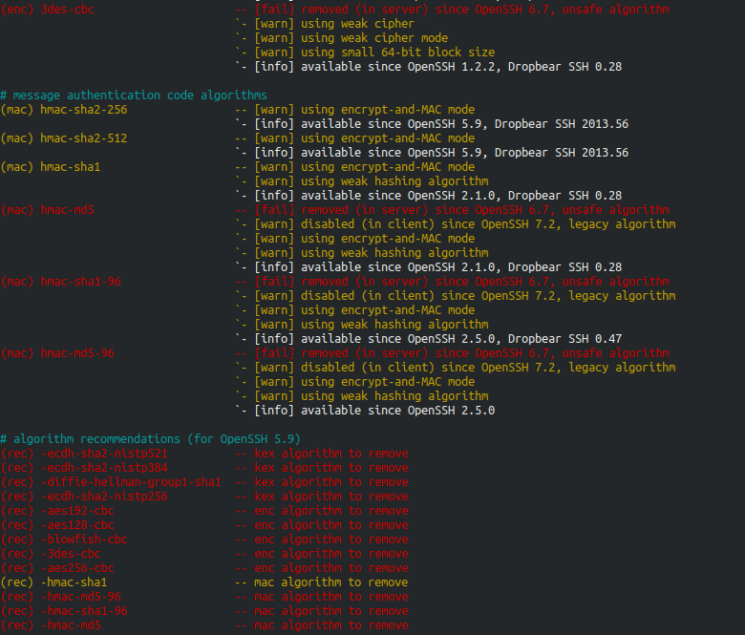

Intel Corporation
146.152.205.96
Versão: SSH-2.0
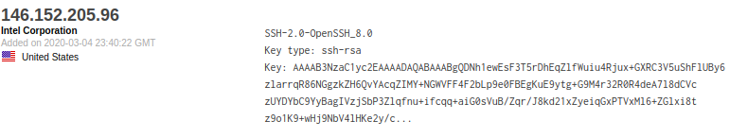
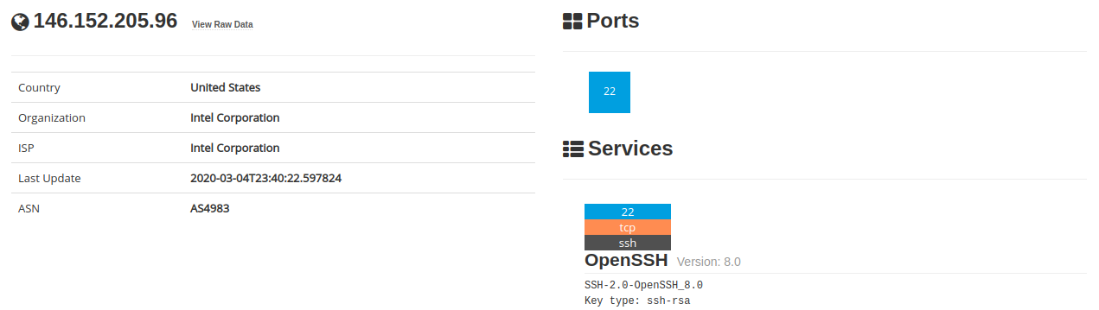

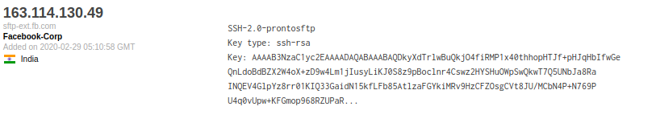
Facebook-Corp
163.113.130.49
Versão: SSH-2.0
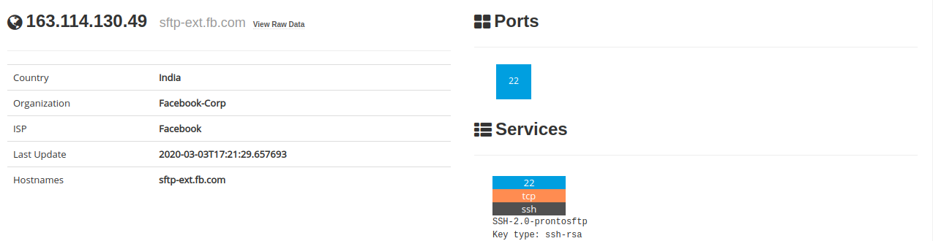

Empresa 3
# general
(gen) banner: SSH-2.0-OpenSSH_7.4
(gen) software: OpenSSH 7.4
(gen) compatibility: OpenSSH 7.3+ (some functionality from 6.6), Dropbear SSH 2016.73+ (some functionality from 0.52)
(gen) compression: enabled (zlib@openssh.com)

# key exchange algorithms
(kex) curve25519-sha256 -- [warn] unknown algorithm
(kex) curve25519-sha256@libssh.org -- [info] available since OpenSSH 6.5, Dropbear SSH 2013.62
(kex) ecdh-sha2-nistp256 -- [fail] using weak elliptic curves
`- [info] available since OpenSSH 5.7, Dropbear SSH 2013.62
(kex) ecdh-sha2-nistp384 -- [fail] using weak elliptic curves
`- [info] available since OpenSSH 5.7, Dropbear SSH 2013.62
(kex) ecdh-sha2-nistp521 -- [fail] using weak elliptic curves
`- [info] available since OpenSSH 5.7, Dropbear SSH 2013.62
(kex) diffie-hellman-group-exchange-sha256 -- [warn] using custom size modulus (possibly weak)
`- [info] available since OpenSSH 4.4
(kex) diffie-hellman-group16-sha512 -- [info] available since OpenSSH 7.3, Dropbear SSH 2016.73
(kex) diffie-hellman-group18-sha512 -- [info] available since OpenSSH 7.3
(kex) diffie-hellman-group-exchange-sha1 -- [fail] removed (in server) since OpenSSH 6.7, unsafe algorithm
`- [warn] using weak hashing algorithm
`- [info] available since OpenSSH 2.3.0
(kex) diffie-hellman-group14-sha256 -- [info] available since OpenSSH 7.3, Dropbear SSH 2016.73
(kex) diffie-hellman-group14-sha1 -- [warn] using weak hashing algorithm
`- [info] available since OpenSSH 3.9, Dropbear SSH 0.53
(kex) diffie-hellman-group1-sha1 -- [fail] removed (in server) since OpenSSH 6.7, unsafe algorithm
`- [fail] disabled (in client) since OpenSSH 7.0, logjam attack
`- [warn] using small 1024-bit modulus
`- [warn] using weak hashing algorithm
`- [info] available since OpenSSH 2.3.0, Dropbear SSH 0.28

# host-key algorithms
(key) ssh-rsa -- [info] available since OpenSSH 2.5.0, Dropbear SSH 0.28
(key) rsa-sha2-512 -- [info] available since OpenSSH 7.2
(key) rsa-sha2-256 -- [info] available since OpenSSH 7.2
(key) ecdsa-sha2-nistp256 -- [fail] using weak elliptic curves
`- [warn] using weak random number generator could reveal the key
`- [info] available since OpenSSH 5.7, Dropbear SSH 2013.62
(key) ssh-ed25519 -- [info] available since OpenSSH 6.5

# encryption algorithms (ciphers)
(enc) chacha20-poly1305@openssh.com -- [info] available since OpenSSH 6.5
`- [info] default cipher since OpenSSH 6.9.
(enc) aes128-ctr -- [info] available since OpenSSH 3.7, Dropbear SSH 0.52
(enc) aes192-ctr -- [info] available since OpenSSH 3.7
(enc) aes256-ctr -- [info] available since OpenSSH 3.7, Dropbear SSH 0.52
(enc) aes128-gcm@openssh.com -- [info] available since OpenSSH 6.2
(enc) aes256-gcm@openssh.com -- [info] available since OpenSSH 6.2
(enc) aes128-cbc -- [fail] removed (in server) since OpenSSH 6.7, unsafe algorithm
`- [warn] using weak cipher mode
`- [info] available since OpenSSH 2.3.0, Dropbear SSH 0.28
(enc) aes192-cbc -- [fail] removed (in server) since OpenSSH 6.7, unsafe algorithm
`- [warn] using weak cipher mode
`- [info] available since OpenSSH 2.3.0
(enc) aes256-cbc -- [fail] removed (in server) since OpenSSH 6.7, unsafe algorithm
`- [warn] using weak cipher mode
`- [info] available since OpenSSH 2.3.0, Dropbear SSH 0.47
(enc) blowfish-cbc -- [fail] removed (in server) since OpenSSH 6.7, unsafe algorithm
`- [fail] disabled since Dropbear SSH 0.53
`- [warn] disabled (in client) since OpenSSH 7.2, legacy algorithm
`- [warn] using weak cipher mode
`- [warn] using small 64-bit block size
`- [info] available since OpenSSH 1.2.2, Dropbear SSH 0.28
(enc) cast128-cbc -- [fail] removed (in server) since OpenSSH 6.7, unsafe algorithm
`- [warn] disabled (in client) since OpenSSH 7.2, legacy algorithm
`- [warn] using weak cipher mode
`- [warn] using small 64-bit block size
`- [info] available since OpenSSH 2.1.0
(enc) 3des-cbc -- [fail] removed (in server) since OpenSSH 6.7, unsafe algorithm
`- [warn] using weak cipher
`- [warn] using weak cipher mode
`- [warn] using small 64-bit block size
`- [info] available since OpenSSH 1.2.2, Dropbear SSH 0.28

# message authentication code algorithms
(mac) umac-64-etm@openssh.com -- [warn] using small 64-bit tag size
`- [info] available since OpenSSH 6.2
(mac) umac-128-etm@openssh.com -- [info] available since OpenSSH 6.2
(mac) hmac-sha2-256-etm@openssh.com -- [info] available since OpenSSH 6.2
(mac) hmac-sha2-512-etm@openssh.com -- [info] available since OpenSSH 6.2
(mac) hmac-sha1-etm@openssh.com -- [warn] using weak hashing algorithm
`- [info] available since OpenSSH 6.2
(mac) umac-64@openssh.com -- [warn] using encrypt-and-MAC mode
`- [warn] using small 64-bit tag size
`- [info] available since OpenSSH 4.7
(mac) umac-128@openssh.com -- [warn] using encrypt-and-MAC mode
`- [info] available since OpenSSH 6.2
(mac) hmac-sha2-256 -- [warn] using encrypt-and-MAC mode
`- [info] available since OpenSSH 5.9, Dropbear SSH 2013.56
(mac) hmac-sha2-512 -- [warn] using encrypt-and-MAC mode
`- [info] available since OpenSSH 5.9, Dropbear SSH 2013.56
(mac) hmac-sha1 -- [warn] using encrypt-and-MAC mode
`- [warn] using weak hashing algorithm
`- [info] available since OpenSSH 2.1.0, Dropbear SSH 0.28

# algorithm recommendations (for OpenSSH 7.4)
(rec) -diffie-hellman-group14-sha1 -- kex algorithm to remove
(rec) -ecdh-sha2-nistp256 -- kex algorithm to remove
(rec) -diffie-hellman-group-exchange-sha256 -- kex algorithm to remove
(rec) -diffie-hellman-group1-sha1 -- kex algorithm to remove
(rec) -diffie-hellman-group-exchange-sha1 -- kex algorithm to remove
(rec) -ecdh-sha2-nistp521 -- kex algorithm to remove
(rec) -ecdh-sha2-nistp384 -- kex algorithm to remove
(rec) -ecdsa-sha2-nistp256 -- key algorithm to remove
(rec) -blowfish-cbc -- enc algorithm to remove
(rec) -3des-cbc -- enc algorithm to remove
(rec) -aes256-cbc -- enc algorithm to remove
(rec) -cast128-cbc -- enc algorithm to remove
(rec) -aes192-cbc -- enc algorithm to remove
(rec) -aes128-cbc -- enc algorithm to remove
(rec) -hmac-sha2-512 -- mac algorithm to remove
(rec) -umac-128@openssh.com -- mac algorithm to remove
(rec) -hmac-sha2-256 -- mac algorithm to remove
(rec) -umac-64@openssh.com -- mac algorithm to remove
(rec) -hmac-sha1 -- mac algorithm to remove
(rec) -hmac-sha1-etm@openssh.com -- mac algorithm to remove
(rec) -umac-64-etm@openssh.com -- mac algorithm to remove

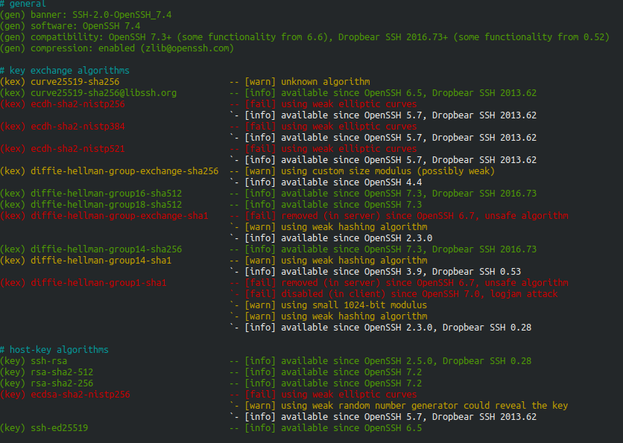

Questão 3.1.2
Indique o software e versão utilizada pelos servidores ssh.

Como é possível observar nas imagens acima, o software e versão utilizada pelos servidores ssh são:
Empresa 1:
146.152.205.96 – Intel Corporation
Software: OpenSSH
Versão: 8.0

Empresa 2:
193.164.17.134 – Apple Tecnologies LLC
Software: OpenSSH
Versão: 7.4

Questão 3.1.3
Através de uma busca por CVE no NVD(National vulnerability DataBase) e recorrendo ao próprio shodan podemos concluir que a versão 7.4 possui já duas vulnerabilidades descobertas e publicadas enquanto que a versão 8.0 ainda não possui quaisquer vulnerabilidades publicadas. Os CVE’s das vulnerabilidades podem ser observadas na imagem abaixo.
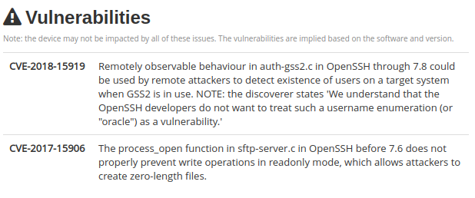
Figura. - Vulnerabilidades encontradas – Apple Tecnologies LLC

Questão 3.1.4

E qual tem a vulnerabilidade mais grave (de acordo com o CVSS score identificado no CVE details)?

A vulnerabilidade com o CVE-2018-15919 é considerada mais grave dentro das enumeradas, esta possui um CVSS score na versão 3.x de 5.3(Medium) e na versão 2.0 um apontuaçao semelhante de 5.0(Medium), enquanto que a outra é apenas considerada baixa em termo de gravidade, com uma pontuaçao de 3.0.

Questão 3.1.5
Para efeitos práticos, a vulnerabilidade indicada no ponto anterior é grave? Porquê?

Resposta
A vulnerabilidade em questão é considerada grave, pois esta pode permitir que um invasor/atacante aproveite a vulnerabilidade de enumeração de usuario, permitindo o recolher contas de usuarios validos, o que pode ajudar no uso de um ataque de força bruta. Mas felizmente esta vulnerabilidade foi corrigida nas versoes superiores a esta.

