әл-Фараби атындағы қазақ ұлттық университеті



Зертханалық жұмыс № 2

**Пән: Сетевые технологии**

**Тақырыбы: VLAN технологиясы**

Тексерген: Маликова Ф. У.

Орындаған: Якуфуцзян Азати

Тобы: ВТиПО

# An aggregate of Network Technology's homework

An aggregate of Network Technology's homework. Thanks for the help of [Маликова Ф.У.](http://www.kaznu.kz/) Full article and related source code can be found at [Github](https://github.com/yaakovazat/network-technology)

Some related sources:

* [Markdown](https://github.com/adam-p/markdown-here/wiki/Markdown-Cheatshe)
* [Cisco Network Academy](https://www.netacad.com/)
* [Cisco Paket Tracer](https://www.netacad.com/courses/packet-tracer-download/)

## Telnet configuratin on Cisco Packet Tracer

A virtual LAN (VLAN) is any broadcast domain that is partitioned and isolated in a computer network at the data link layer (OSI layer 2).[1][2] LAN is the abbreviation for local area network and in this context virtual refers to a physical object recreated and altered by additional logic. VLANs work by applying tags to network packets and handling these tags in networking systems – creating the appearance and functionality of network traffic that is physically on a single network but acts as if it is split between separate networks. In this way, VLANs can keep network applications separate despite being connected to the same physical network, and without requiring multiple sets of cabling and networking devices to be deployed.

VLAN (аббр. от англ. Virtual Local Area Network) — логическая («виртуальная») локальная компьютерная сеть, представляет собой группу хостов с общим набором требований, которые взаимодействуют так, как если бы они были подключены к широковещательному домену, независимо от их физического местонахождения. VLAN имеет те же свойства, что и физическая локальная сеть, но позволяет конечным станциям группироваться вместе, даже если они не находятся в одной физической сети. Такая реорганизация может быть сделана на основе программного обеспечения вместо физического перемещения устройств.

VLAN--Виртуальдық локальдық желі (VLAN ағылш. Virtual Local Area Network).

**The basic topology of Telnet network testing is as follows:**

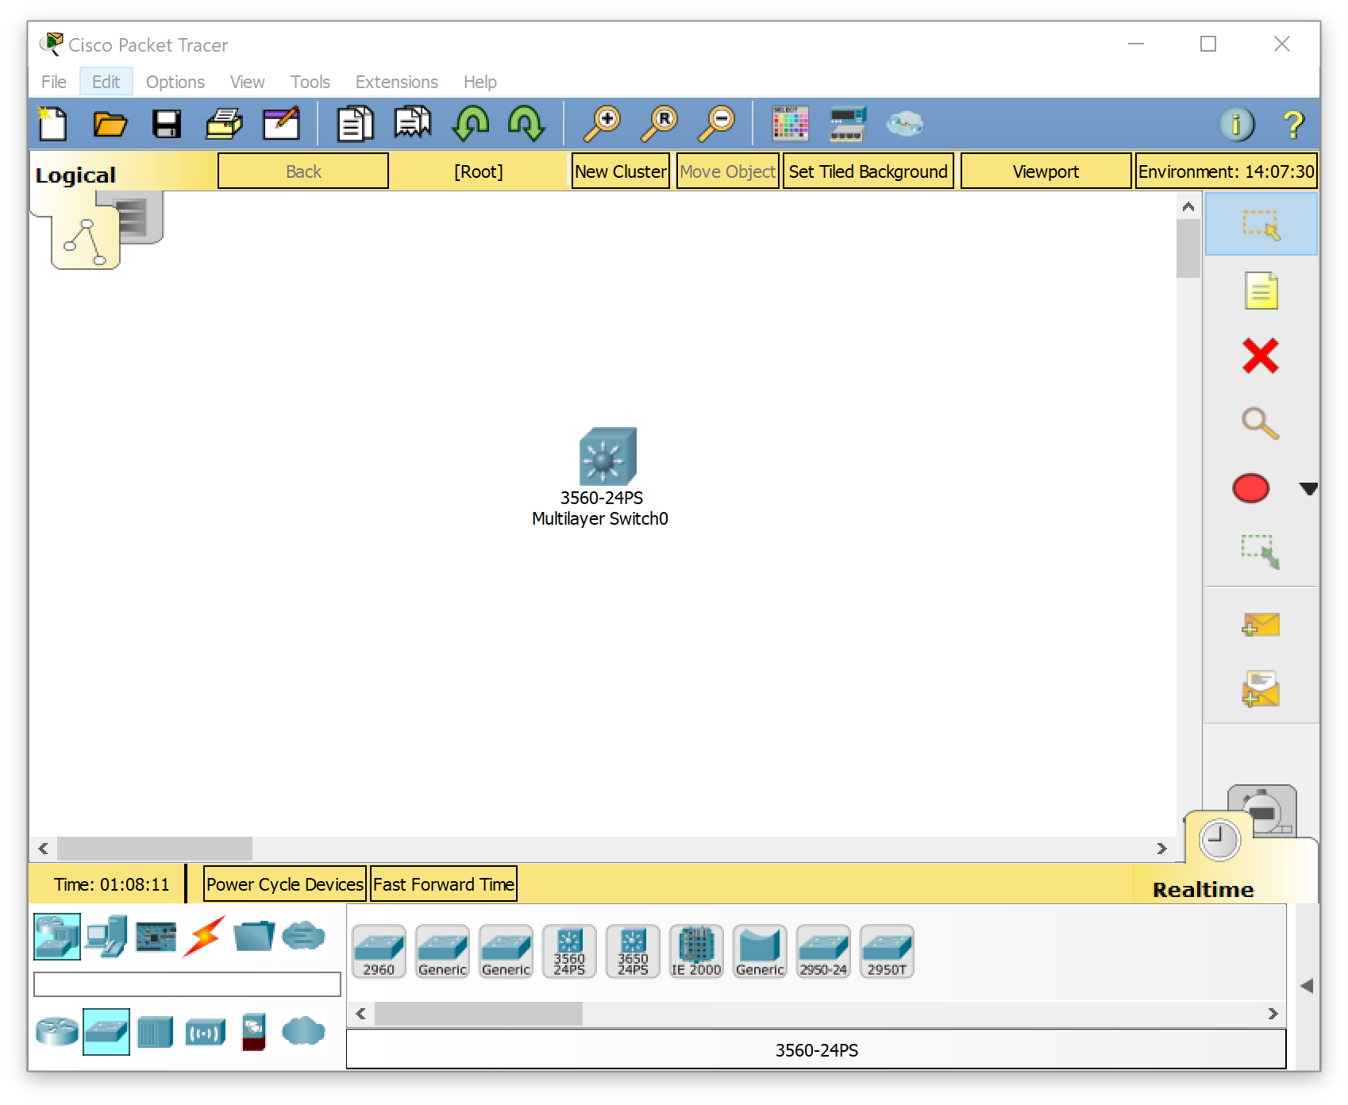

1. We use one c3560 cisco switcher

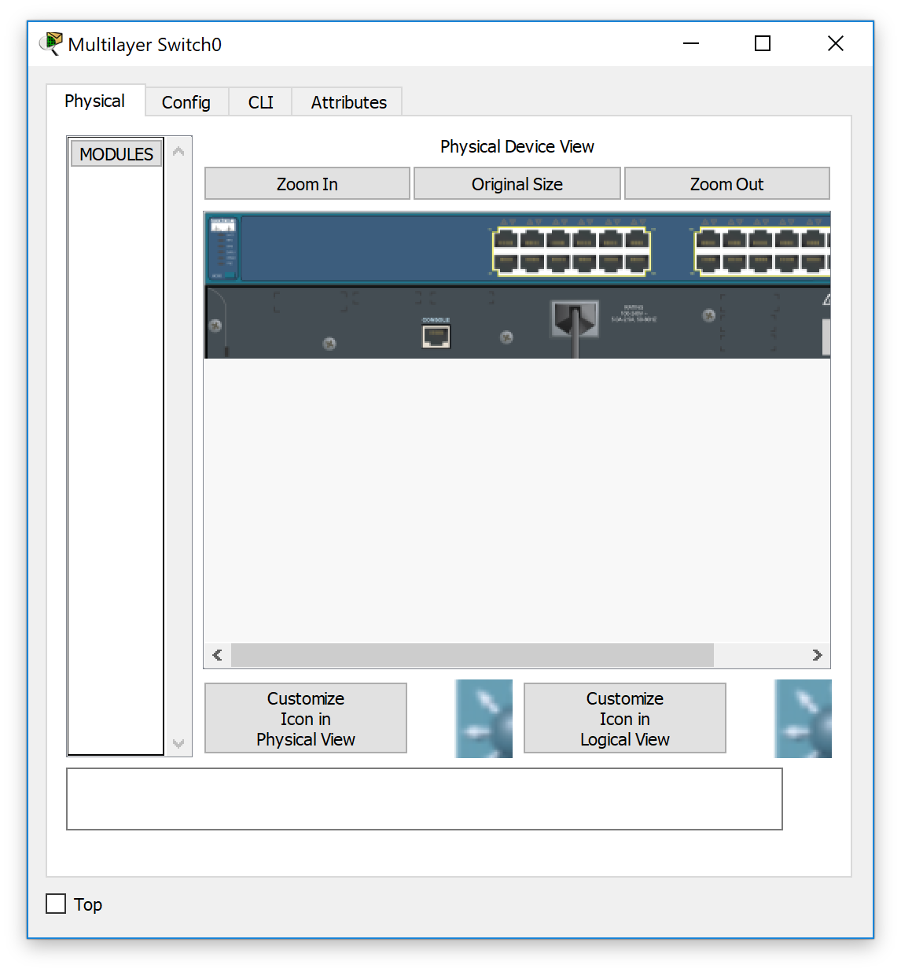

1. Enter ``enable`` and enter the super configuration mode of switcher.

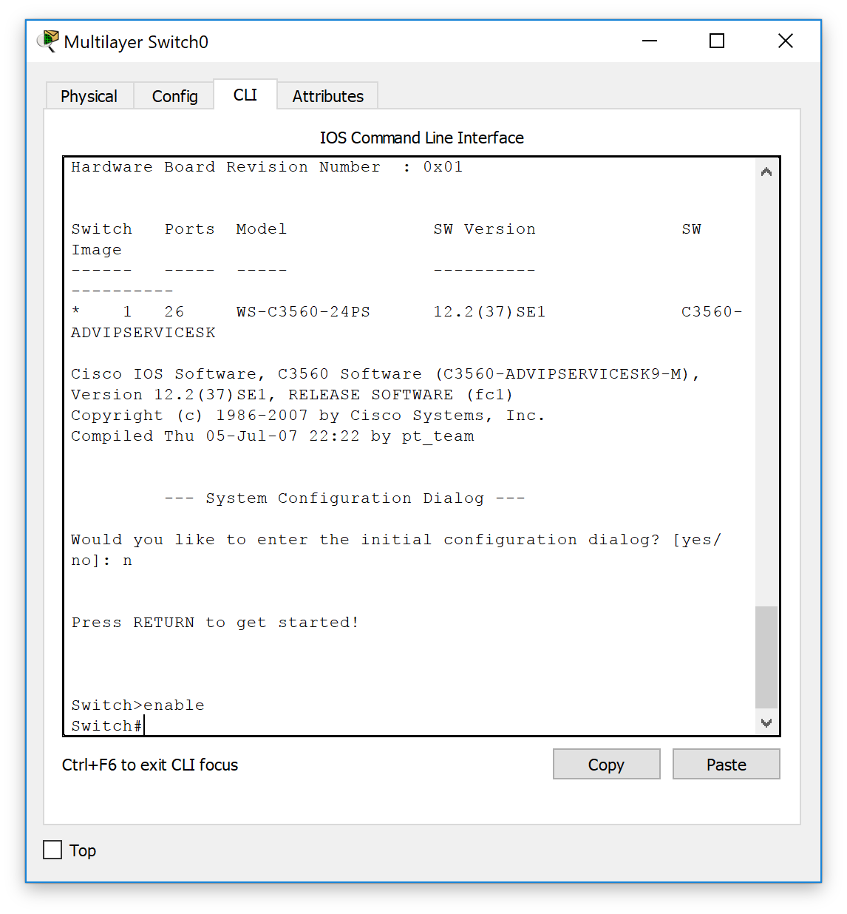

1. Enter `` vlan `` configuration mode with the code `` vlan database ``
2. 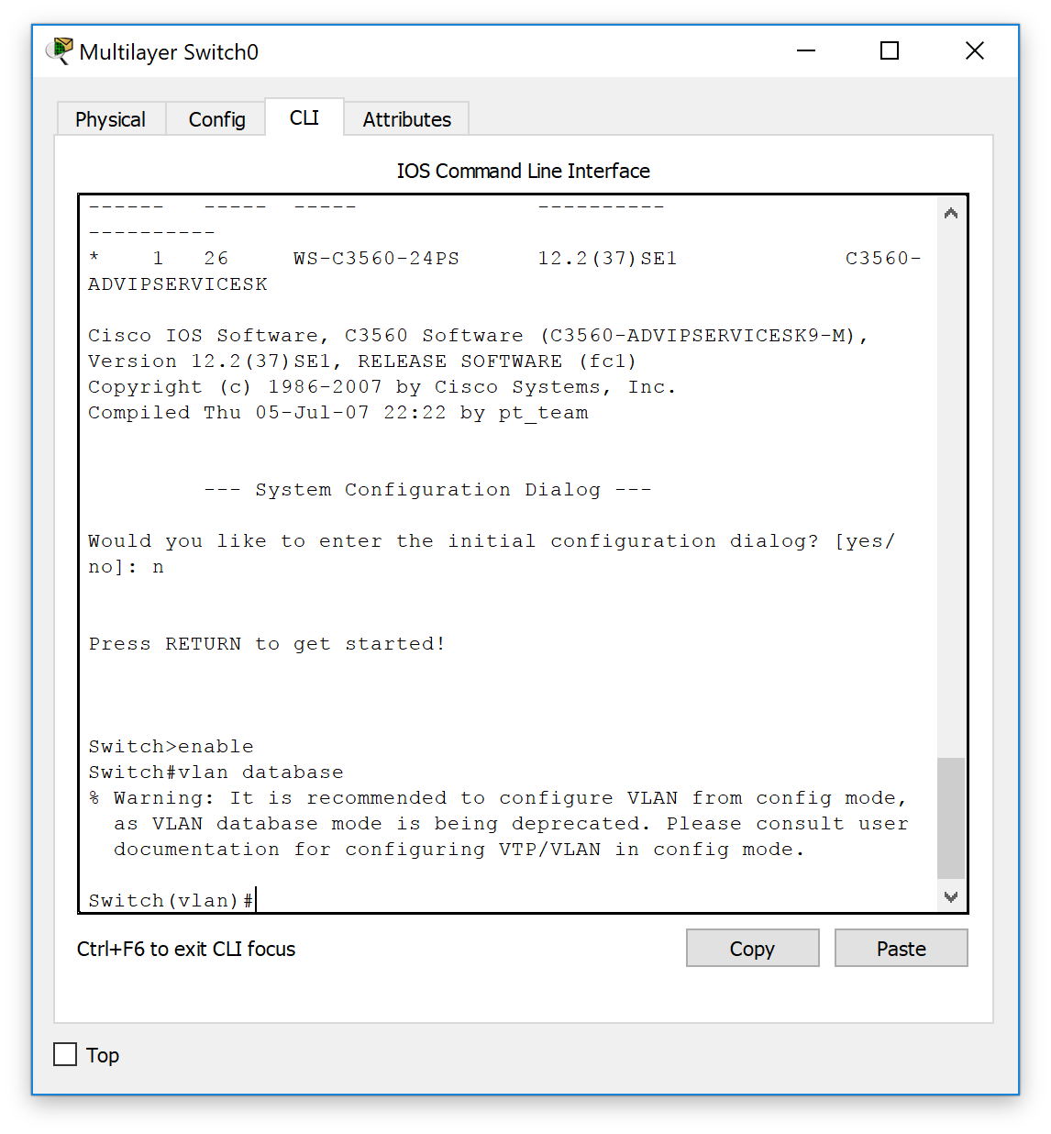
3. Enter ``?`` to see other configuration options

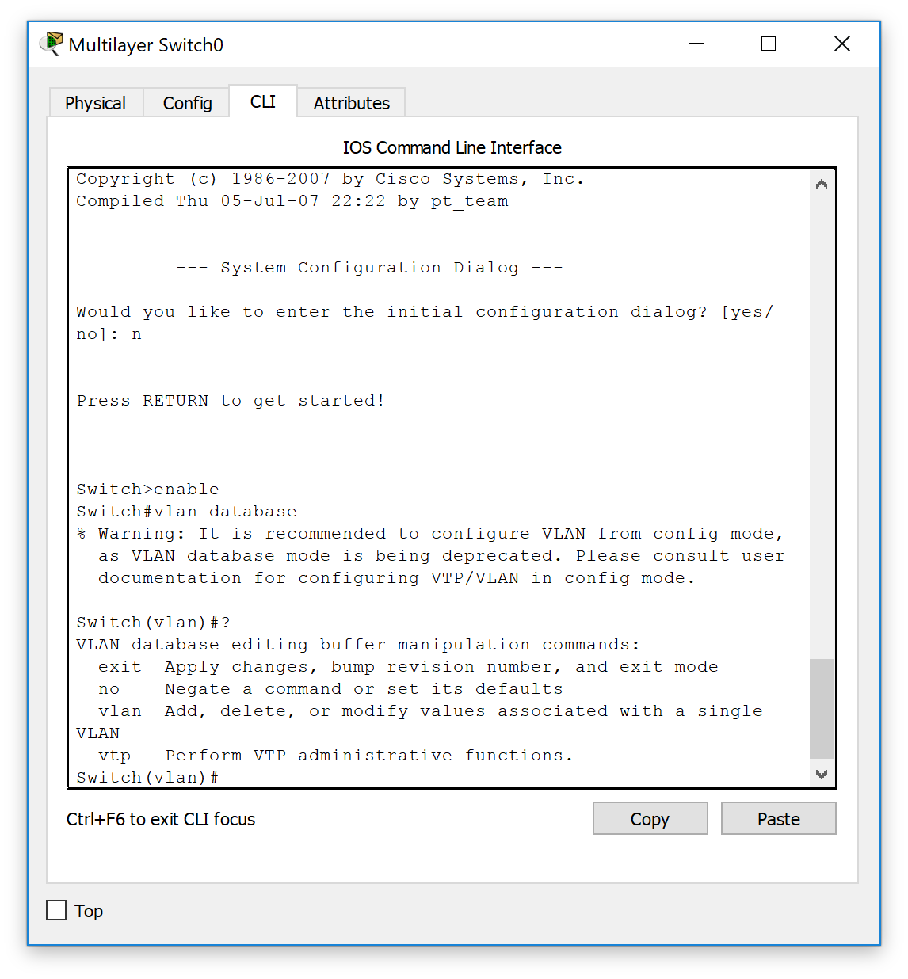

1. Add one vlan to switcher with using the code ``vlan 300``

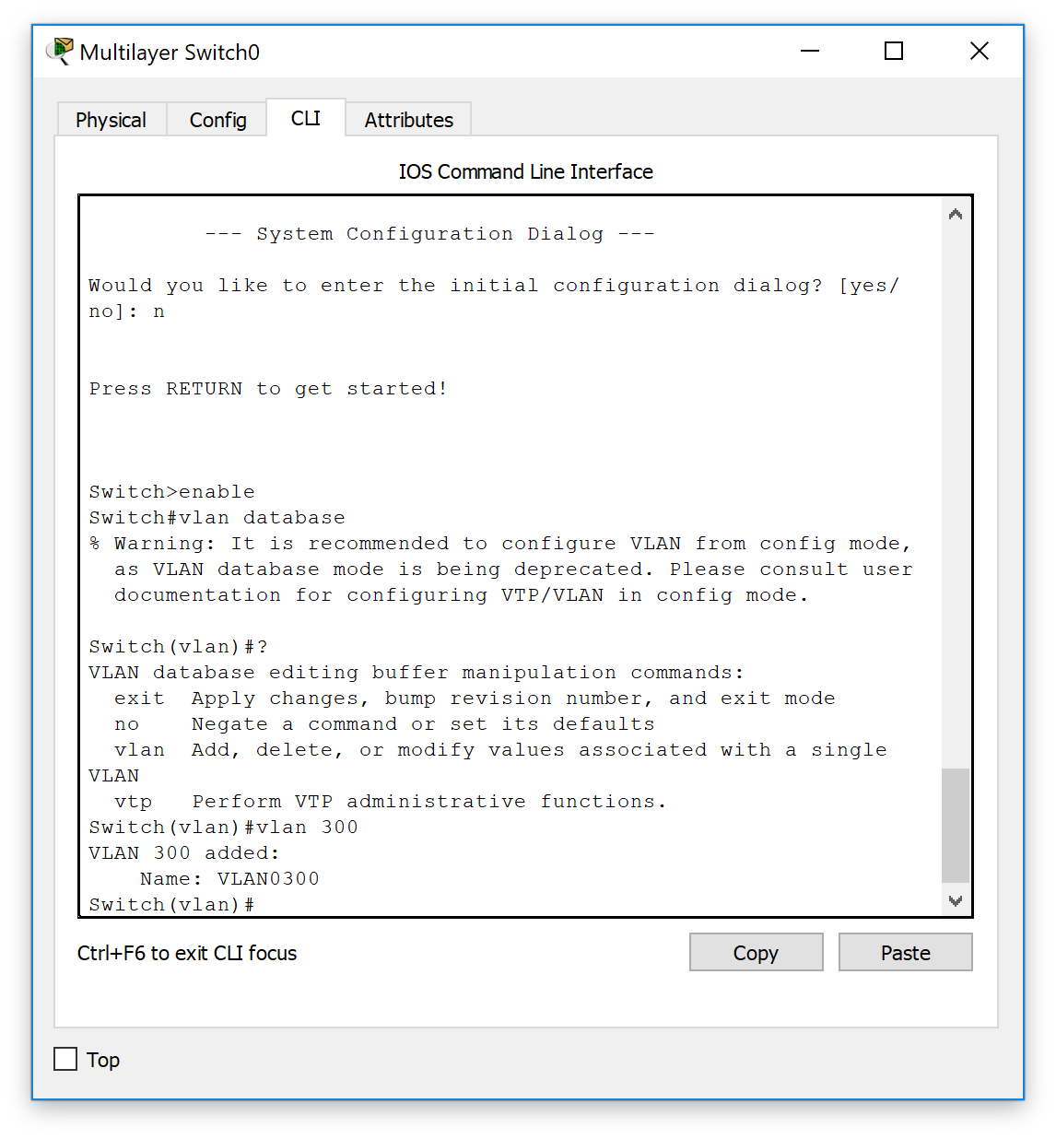

1. Enter ``show vlan``to see all vlan informations

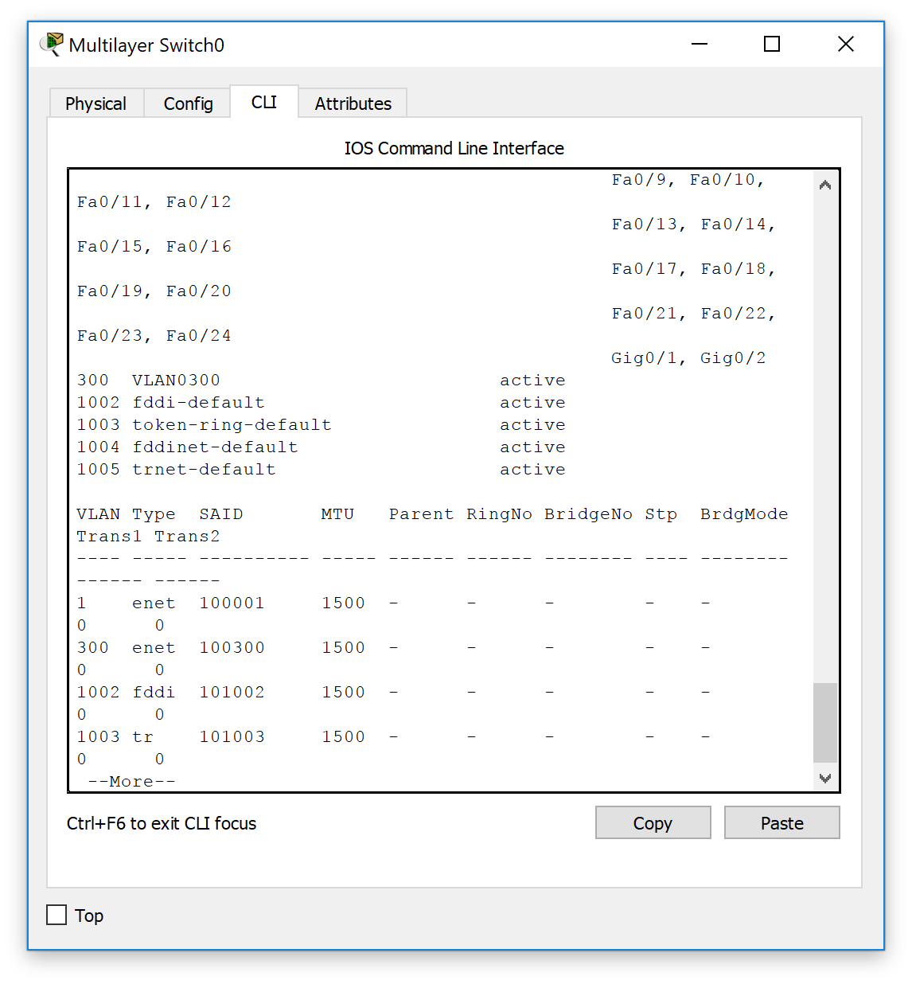

1. Set ``f0/1``to access and set ``f0/1``blongs to vlan 300

Switch#config

Configuring from terminal, memory, or network [terminal]?

Enter configuration commands, one per line. End with CNTL/Z.

Switch(config)#int f0/1

Switch(config-if)#switchport mode access

Switch(config-if)#switchport access vlan 300

Switch(config-if)#no shutdown

Switch(config-if)#exit

Switch(config)#

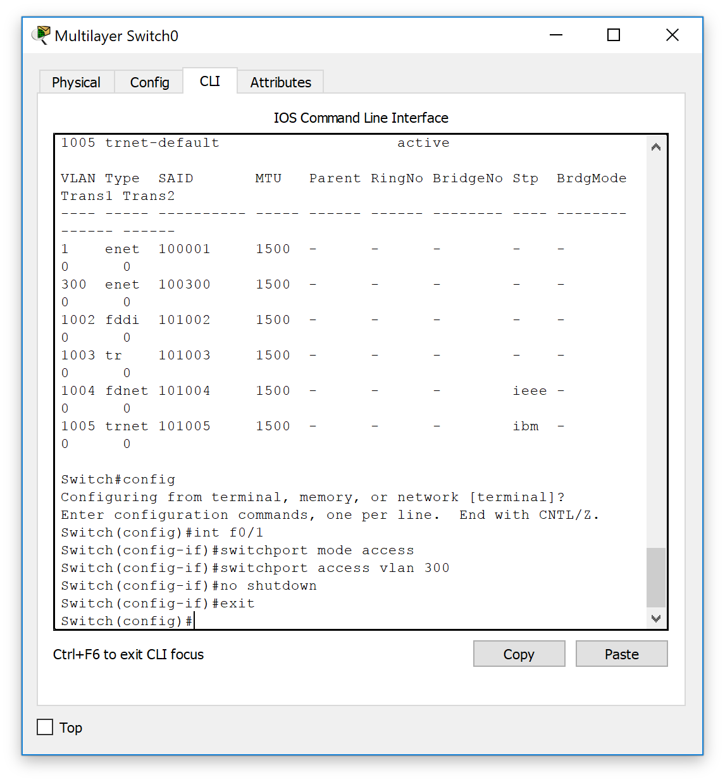

1. Enter code ``show vlan `` to verify results

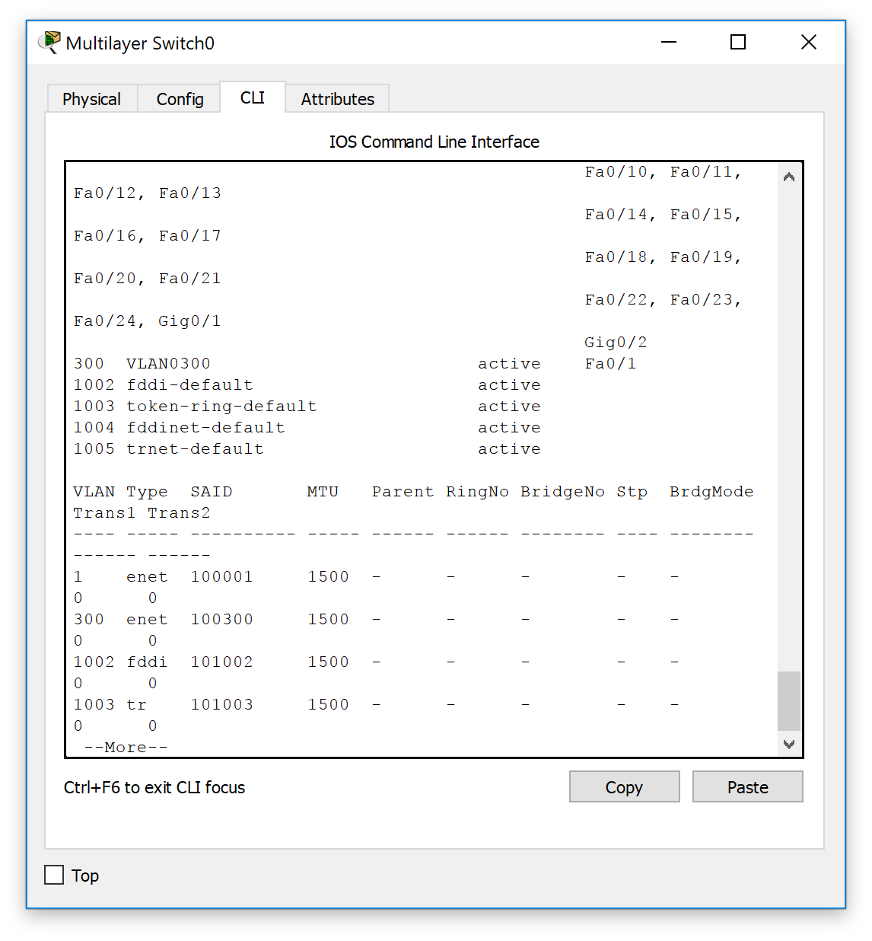

1. Configure ip address of vlan 300

Switch#config

Configuring from terminal, memory, or network [terminal]?

Enter configuration commands, one per line. End with CNTL/Z.

Switch(config)#int vlan 300

Switch(config-if)#

%LINK-5-CHANGED: Interface Vlan300, changed state to up

Switch(config-if)#int vlan 300

Switch(config-if)#int vlan 300

Switch(config-if)#ip address 10.10.10.254 255.255.255.0

Switch(config-if)#

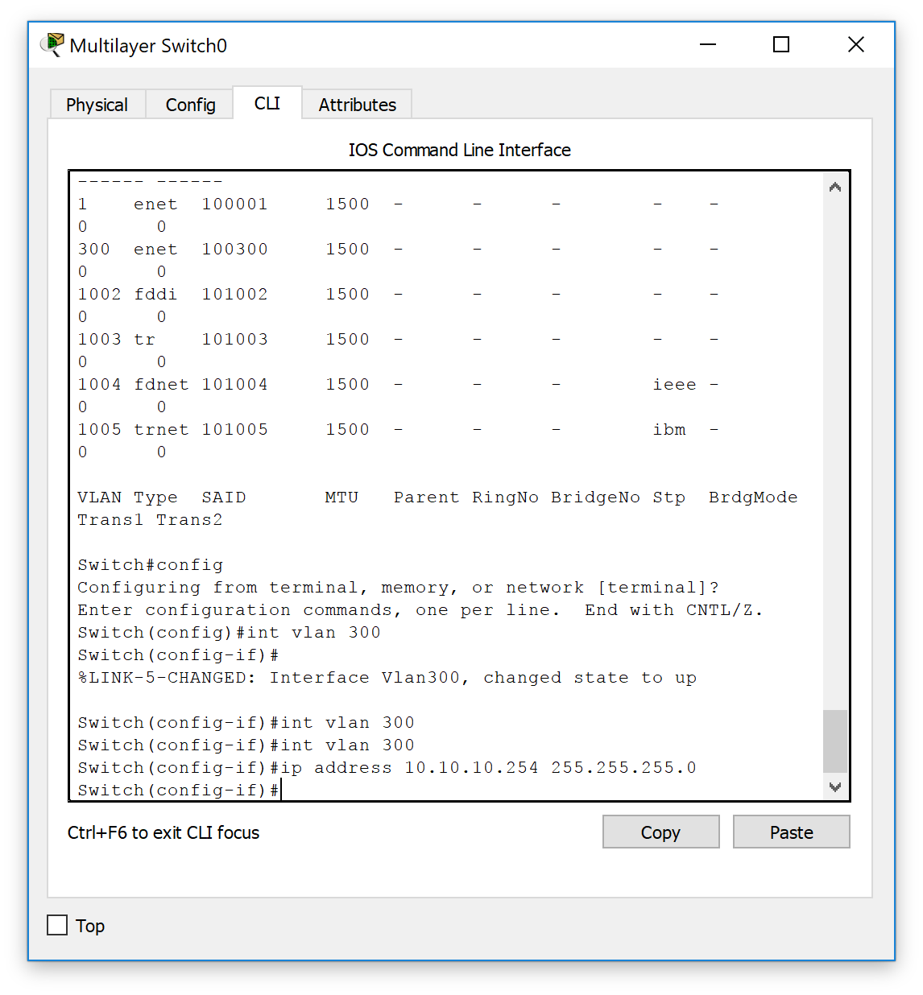

1. Verify the final results :

VLAN results :

interface FastEthernet0/1

switchport access vlan 300

switchport mode access

switchport nonegotiate

!

interface FastEthernet0/2

!

interface FastEthernet0/3

!

interface FastEthernet0/4

!

interface FastEthernet0/5

!

interface FastEthernet0/6

!

interface FastEthernet0/7

!

interface FastEthernet0/8

--More--

