әл-Фараби атындағы қазақ ұлттық университеті



Зертханалық жұмыс № 3

**Пән: Сетевые технологии**

**Тақырыбы: Статикалық маршрутизация**

Тексерген: Маликова Ф. У.

Орындаған: Якуфуцзян Азати

Тобы: ВТиПО

# An aggregate of Network Technology's homework

An aggregate of Network Technology's homework. Thanks for the help of [Маликова Ф.У.](http://www.kaznu.kz/) Full article and related source code can be found at [Github](https://github.com/yaakovazat/network-technology)

Some related sources:

* [Markdown](https://github.com/adam-p/markdown-here/wiki/Markdown-Cheatshe)
* [Cisco Network Academy](https://www.netacad.com/)
* [Cisco Paket Tracer](https://www.netacad.com/courses/packet-tracer-download/)

## Статикалық маршрутизация configuratin on Cisco Packet Trace

**The basic topology of Telnet network testing is as follows:**

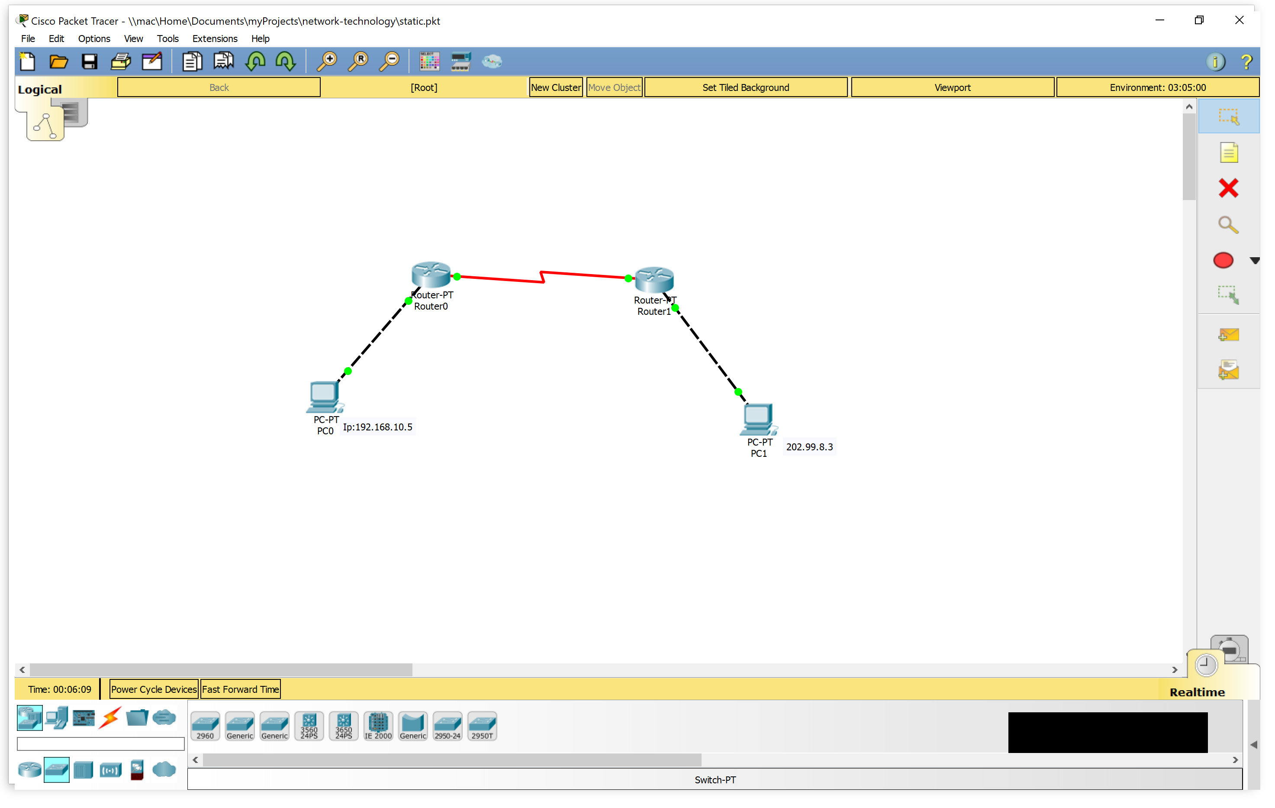

1. Link Router 1 to PC 1 with R1’s f0/0 port

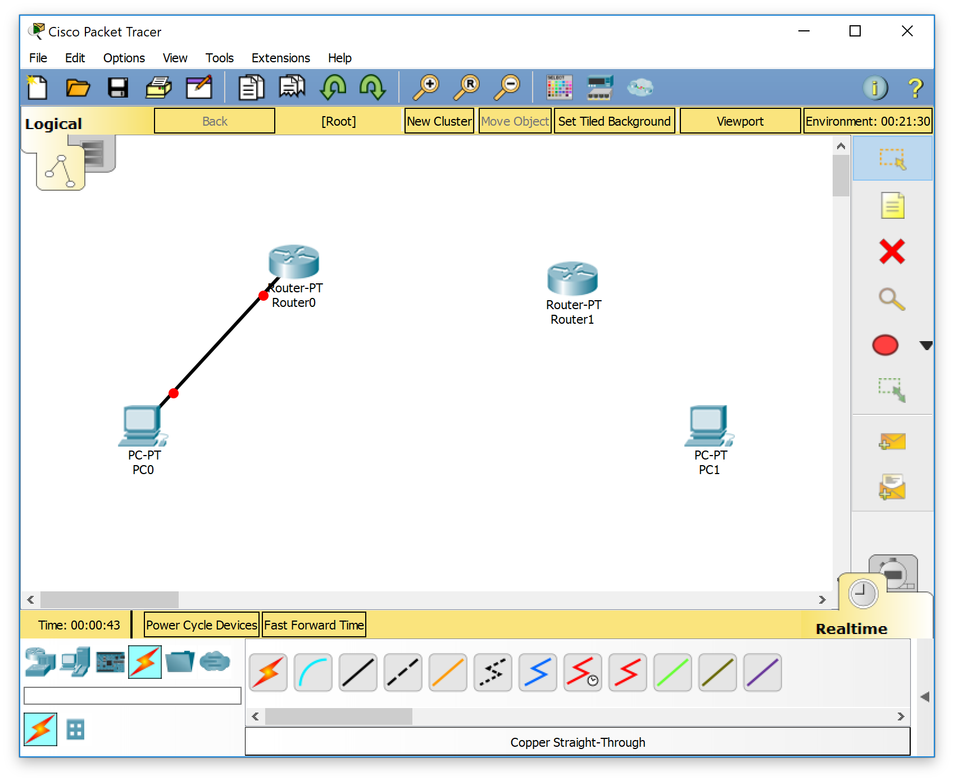

1. Link Router 1 and Router 2 with serial DTE on Cisco packet tracer

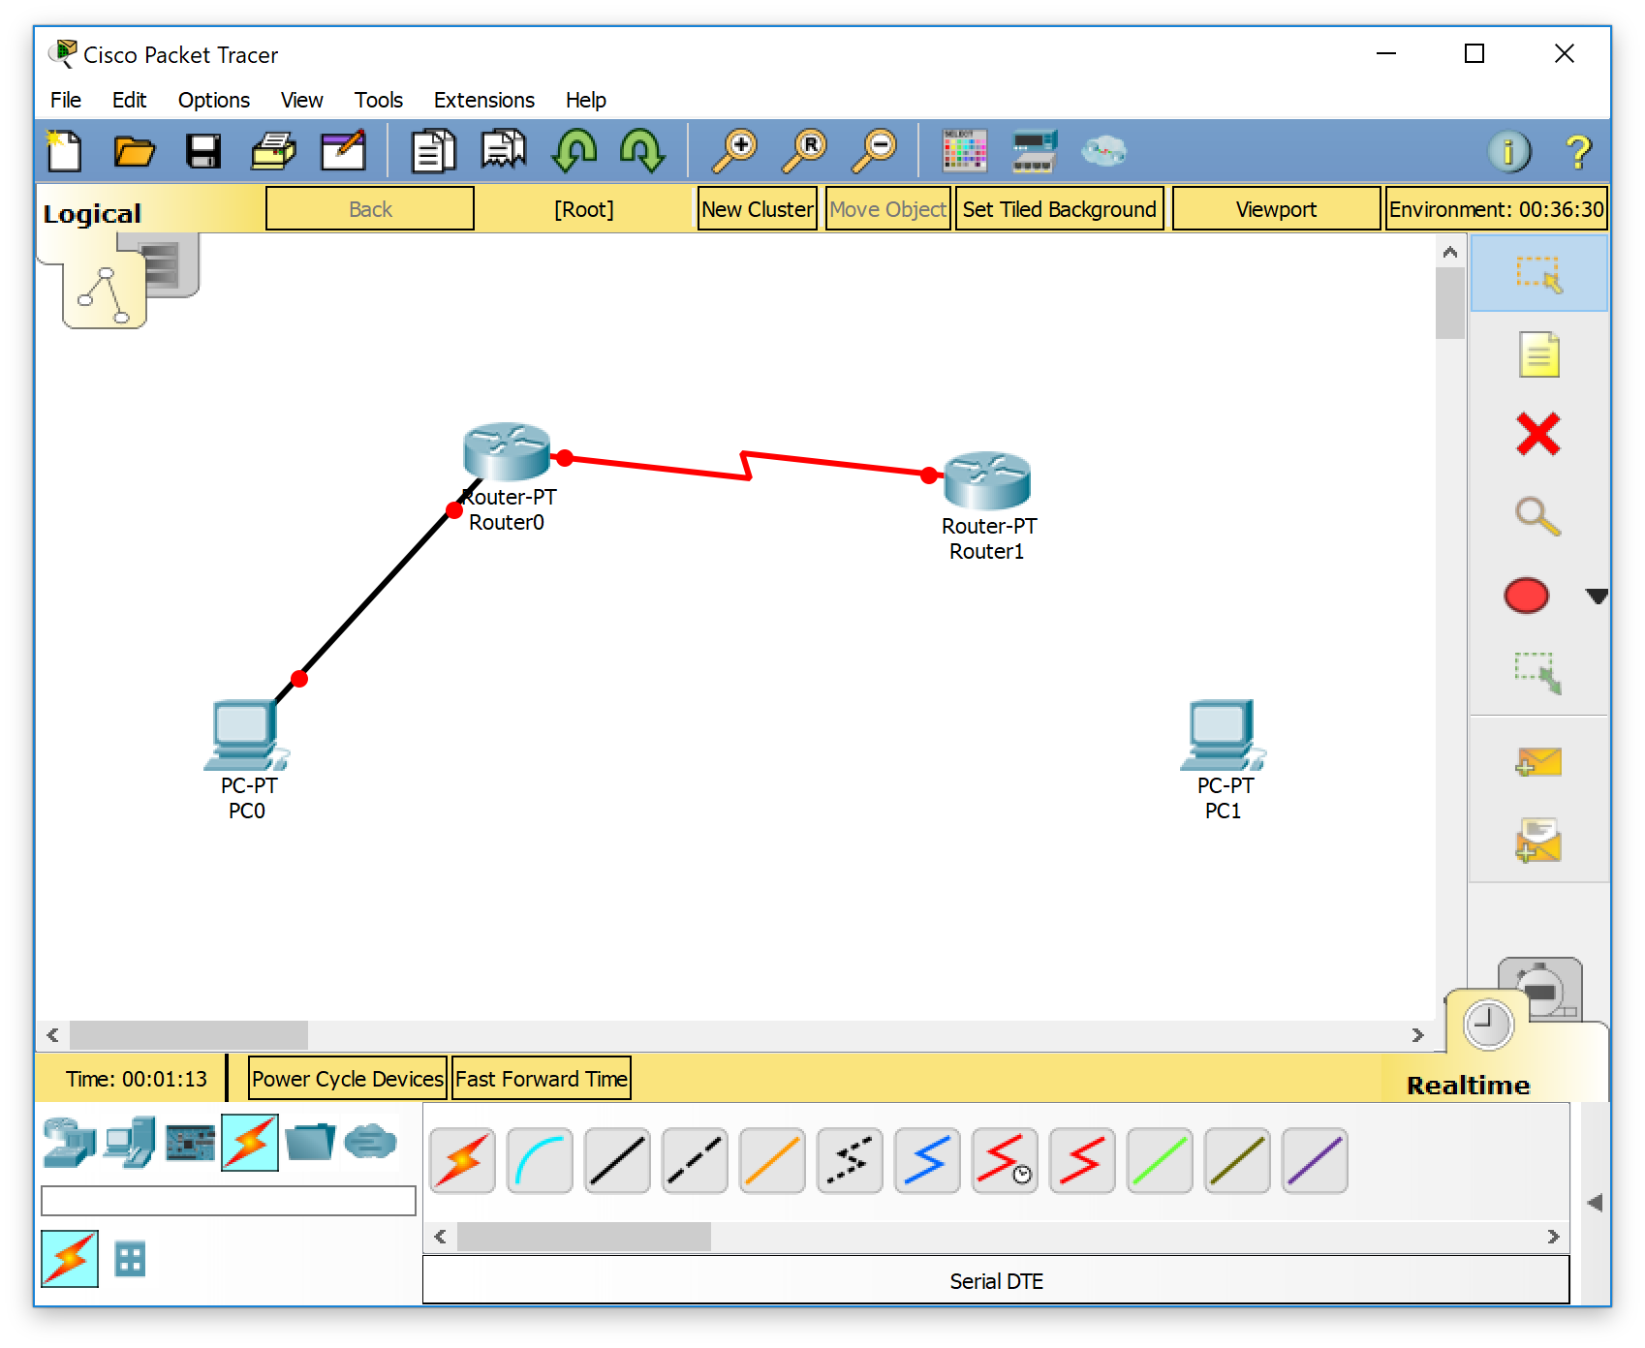

1. Link Router 2 to PC2 with f0/0 port of R2

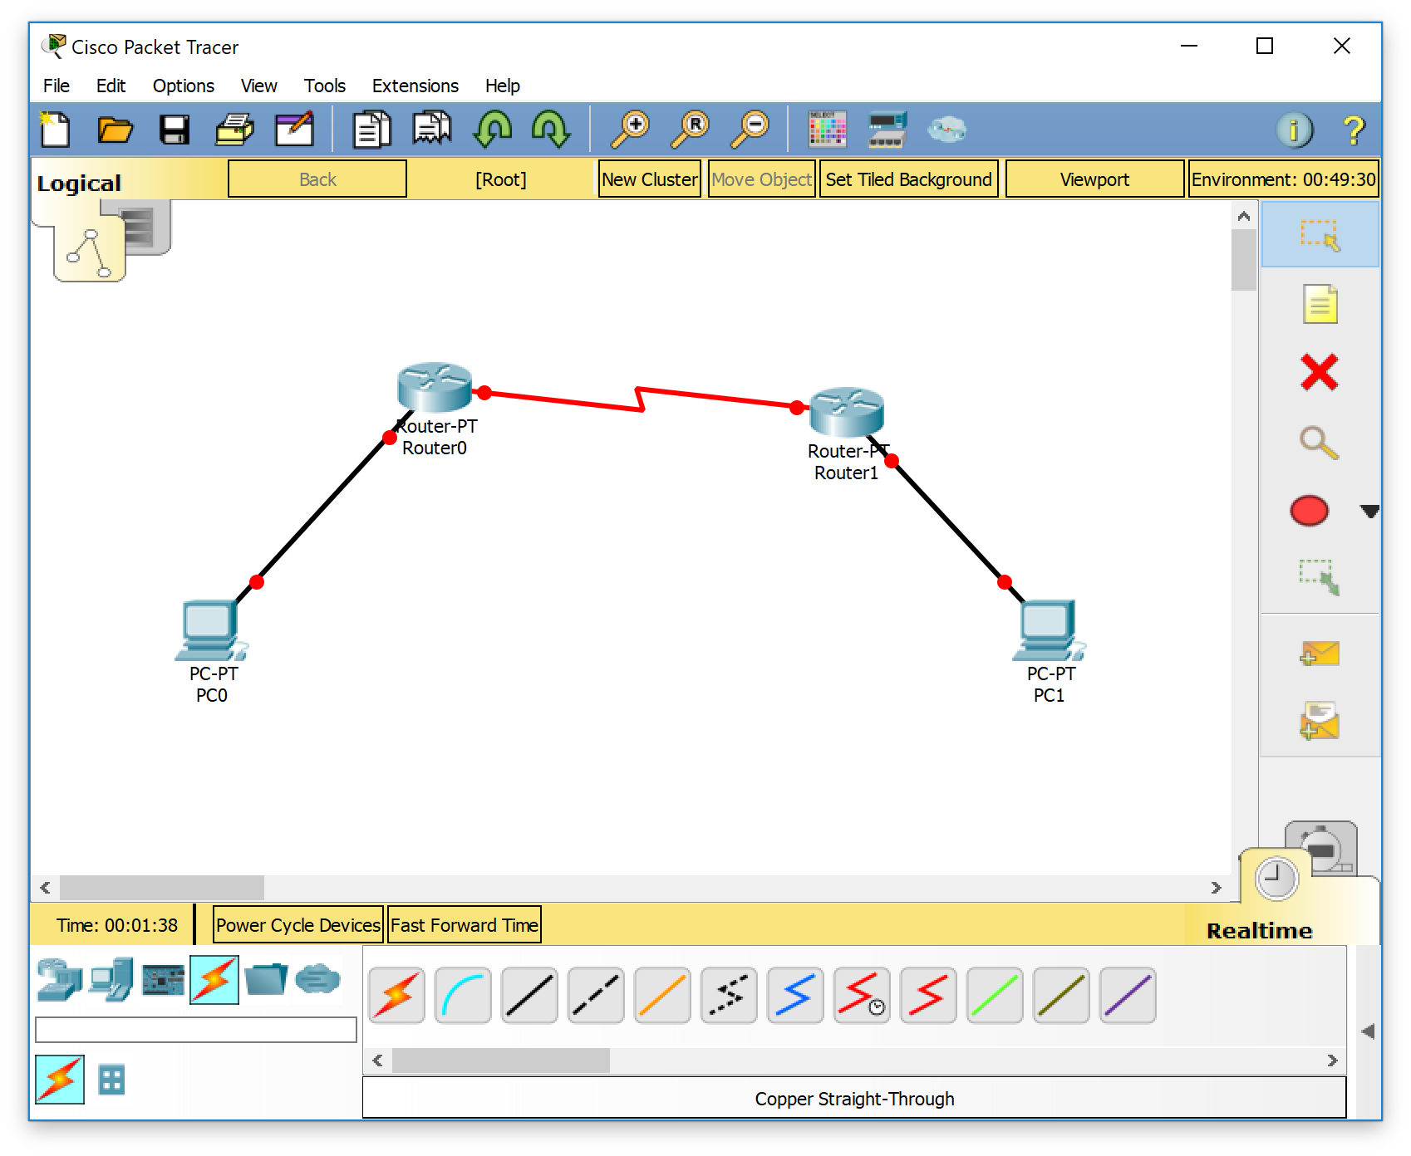

1. Set PC1 and PC2 computers’ IP configuration

For PC1 : static :

IP address: 192.168.10.5

Sub :255.255.255.0

Gateway :192.168.10.1

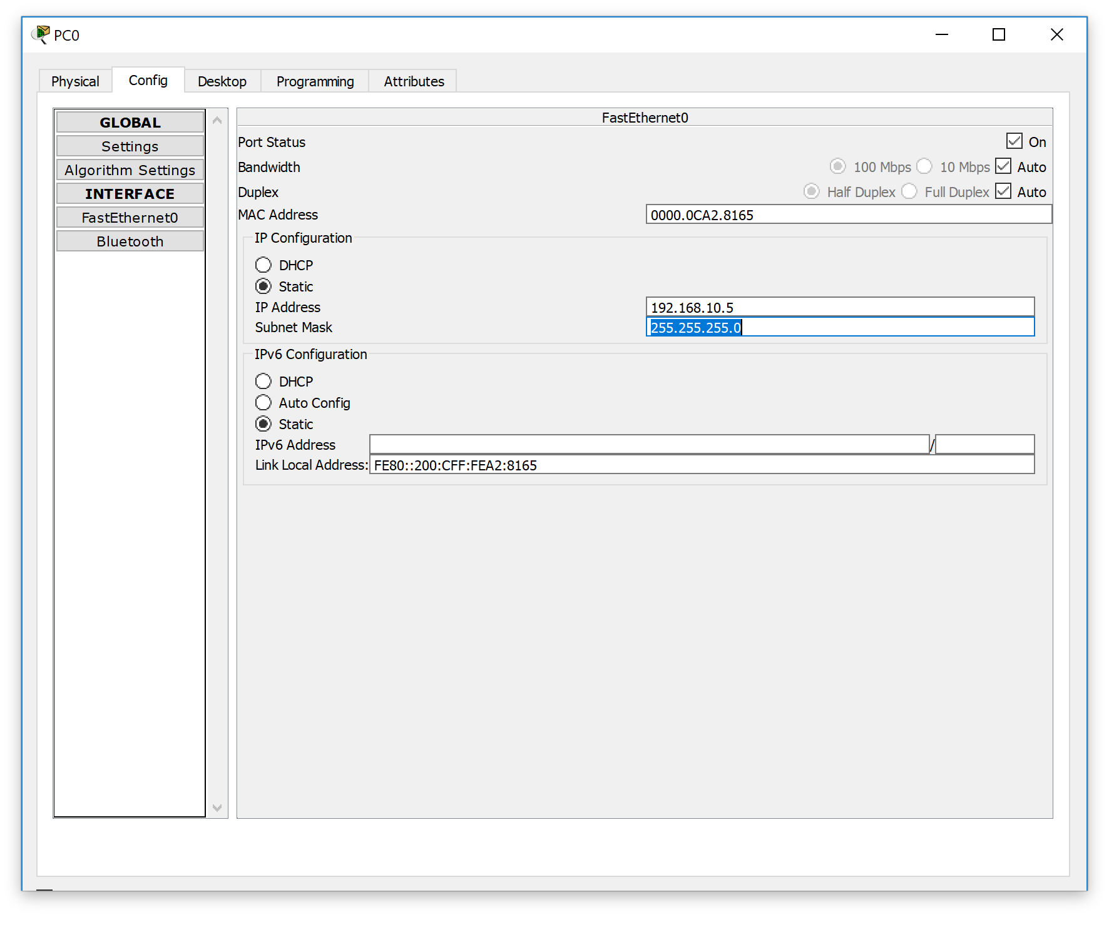

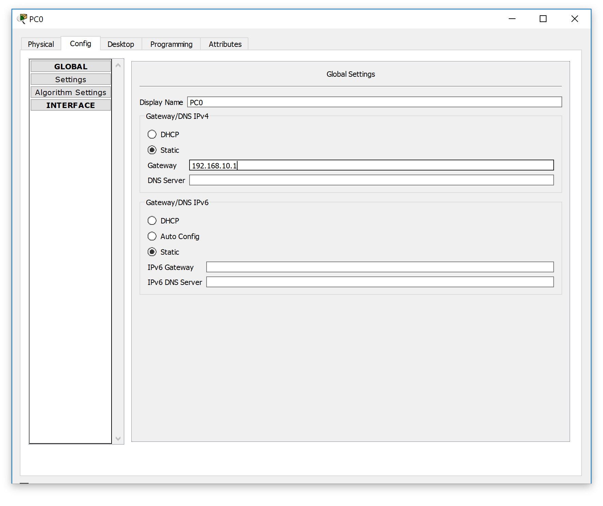

For PC 2 ,static :

IP address :202.99.8.3

Sub :255.255.255.0

Gateway :202.99.8.1

DNS :0.0.0.0

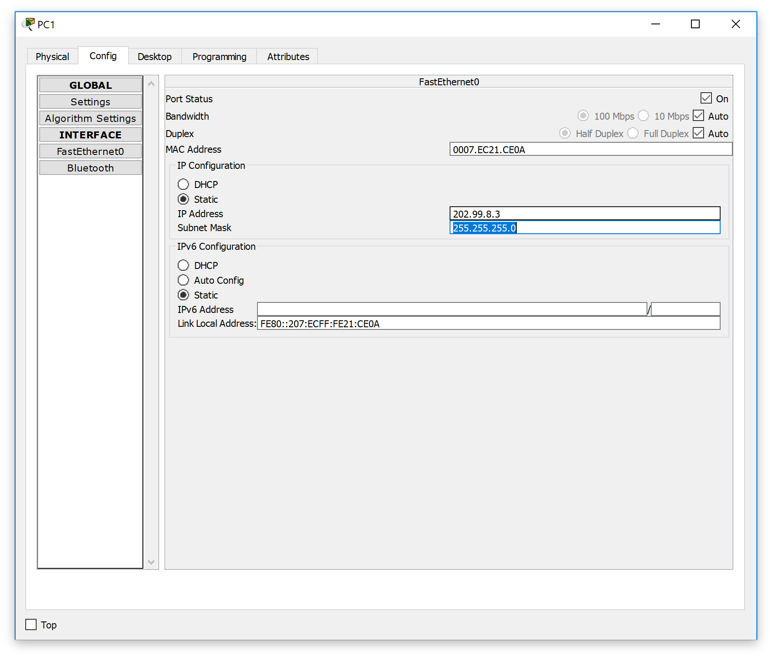

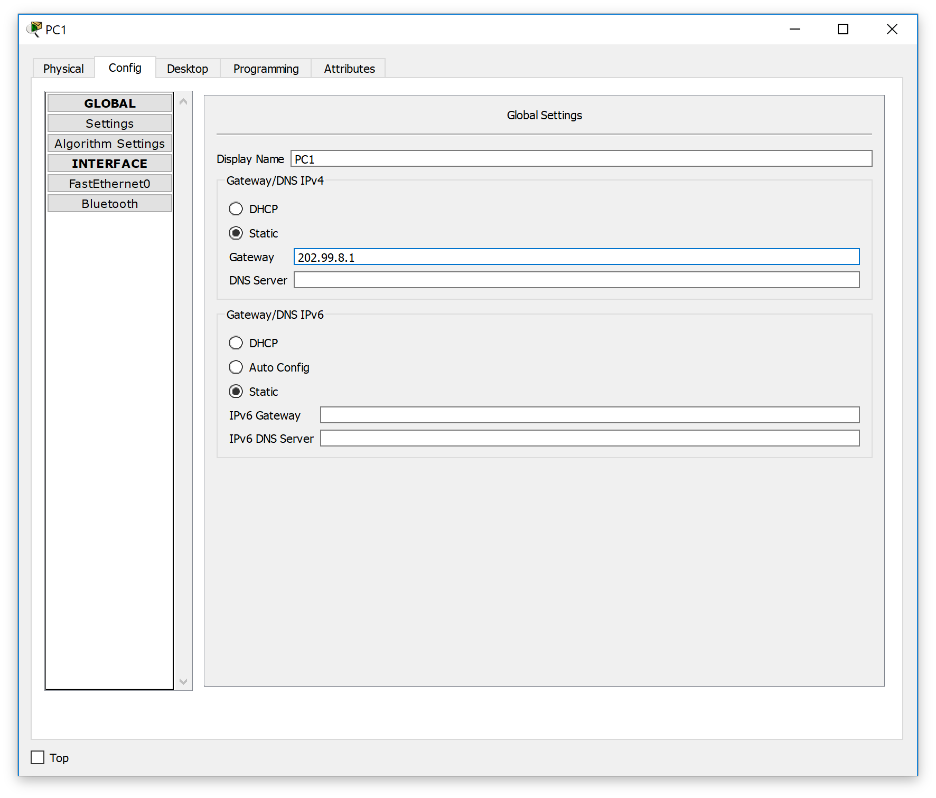

1. Configure Router 1’s f0/0 port as:

Ip add :192.168.10.1

Sub :255.255.255.0

```Router>enable

Router#

Router#configure terminal

Enter configuration commands, one per line. End with CNTL/Z.

Router(config)#

Router(config)#

Router(config)#

Router(config)#enable

% Incomplete command.

Router(config)#interface f0/0

Router(config-if)#ip address 192.168.10.1 255.255.255.0

Router(config-if)#no shutdown

Router(config-if)#

%LINK-5-CHANGED: Interface FastEthernet0/0, changed state to up

Router(config-if)#

Router#

%SYS-5-CONFIG_I: Configured from console by console

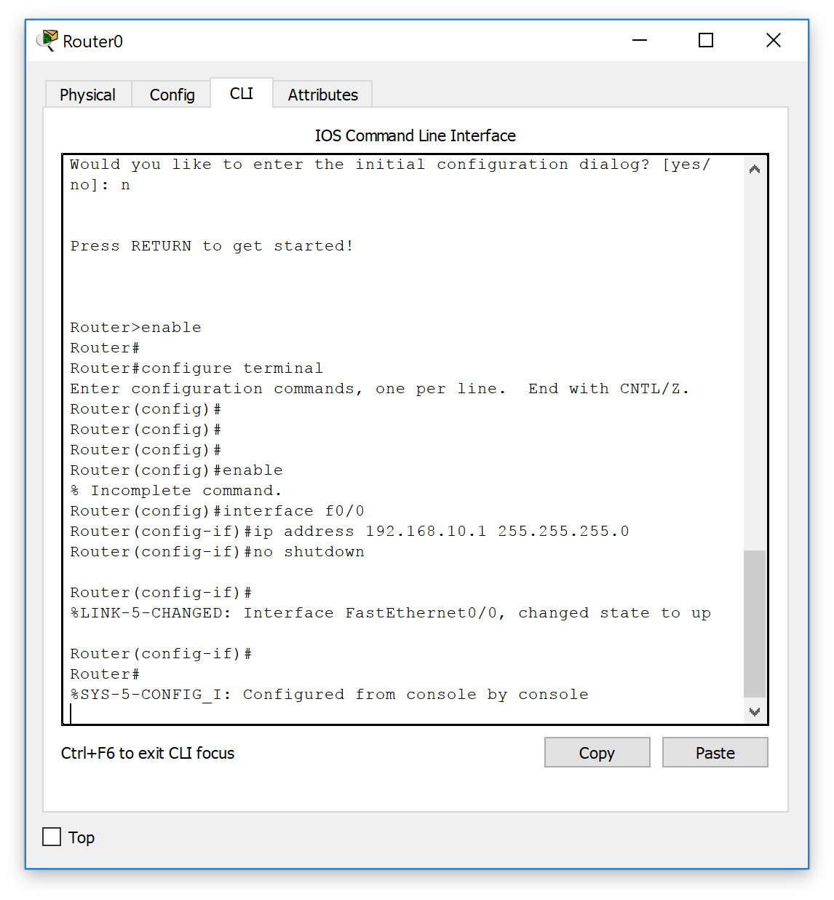

1. Configure s2/0 port on Router 1 as :

Ip add :172.16.2.1

Sub :255.255.255.0

````Router>enable

Router#

Router#configure terminal

Enter configuration commands, one per line. End with CNTL/Z.

Router(config)#

Router(config)#

Router(config)#

Router(config)#enable

% Incomplete command.

Router(config)#interface f0/0

Router(config-if)#ip address 192.168.10.1 255.255.255.0

Router(config-if)#no shutdown

Router(config-if)#

%LINK-5-CHANGED: Interface FastEthernet0/0, changed state to up

Router(config-if)#

Router#

%SYS-5-CONFIG_I: Configured from console by console

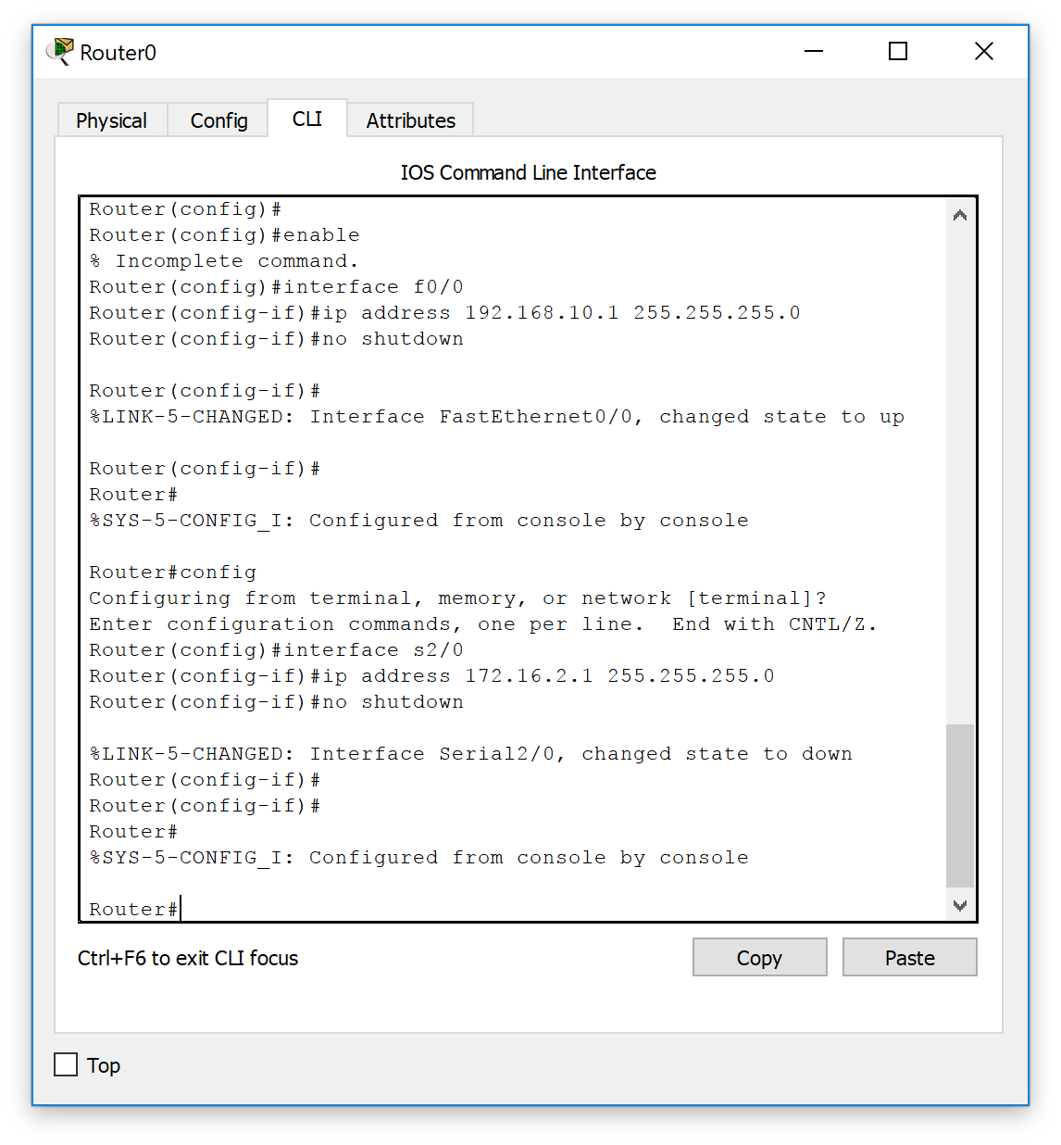

1. Configure Router 1’s clockwork as follow :

Router#

%SYS-5-CONFIG_I: Configured from console by console

Router#config

Configuring from terminal, memory, or network [terminal]?

Enter configuration commands, one per line. End with CNTL/Z.

Router(config)#interface serial 2/0

Router(config-if)#clock rate 64000

This command applies only to DCE interfaces

Router(config-if)#

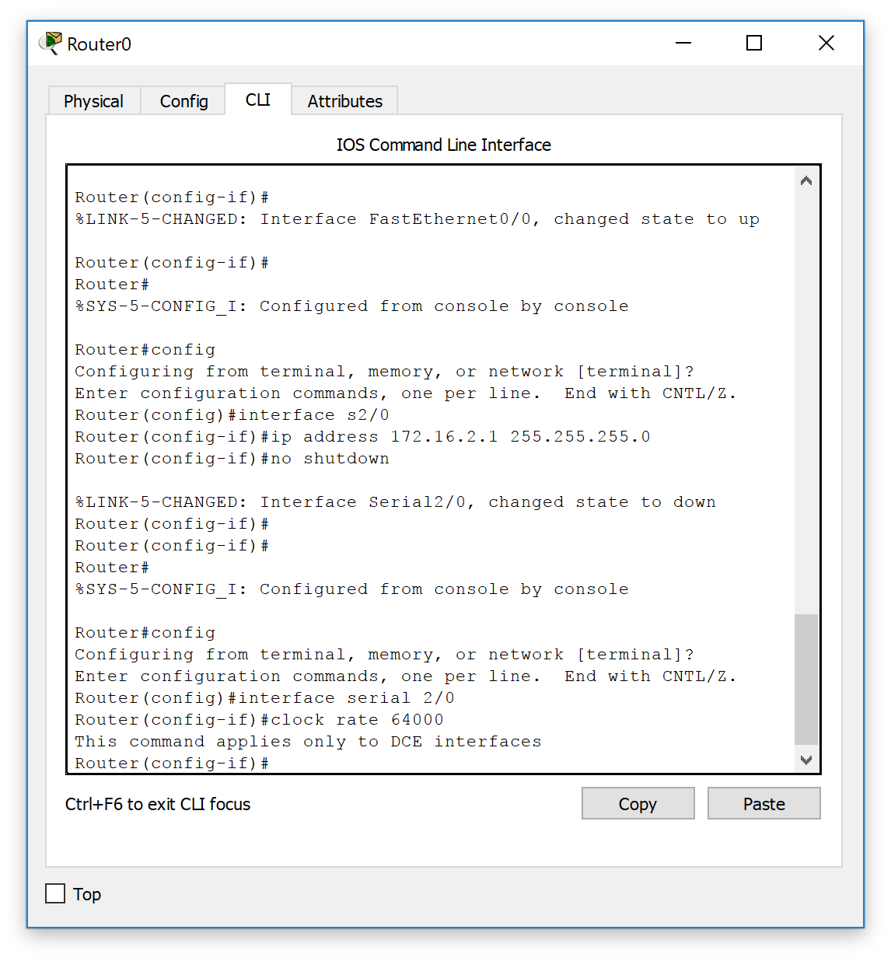

1. Configure R2 with the same :

R2#conf t

Enter configuration commands, one per line.  End with CNTL/Z.

R2(config)#router rip

R2(config-router)#ver 2

R2(config-router)#no auto-summary

R2(config-router)#net 2.0.0.0

R2(config-router)#net 202.96.1.0

1. Configure static :

R1#conf t

Enter configuration commands, one per line.  End with CNTL/Z.

R1(config)#ip nat inside source static 192.168.1.1 202.96.1.3

//配置静态NAT 映射

R1(config)#ip nat inside source static 192.168.1.2 202.96.1.4

R1(config)#int s0/0/0

R1(config-if)#ip nat outside

//配置NAT 外部接口

R1(config-if)#int f0/0

R1(config-if)#ip nat outside

1. Configure and verify

Now we can werify the work by ping with PC2 ‘s cmd command

