INTRODUCTION

TITLE PAGE OF REPORT

Course Number and Name:
Introduction to Programming

Report : Shipping Calculator | Date Report Submitted:  11/25/2022

Problem Statement (Requirements)

The purpose of the program calculates shipping cost and as an input, requesting package weight in kg and distance to destination in miles and calculate the shipping cost based on given parameters and display the result in the main window. There are parameters to calculate shipping cost based on item weight and distance and there are certain limitation on given parameters.

- Weight must be in between 1-20 kg
- Weight less than 2kg , rate is 0.01
- Weight more than 2kg and less than 6kg, rate is 0.015
- Weight more than 6kg and less than 10kg, rate is 0.020
- Weight more than 10kg and less than 20kg, rate is 0.025
- Distance must be in between 10-3000 miles
- Calculation: multiply rate with distance.

Analysis
  - Input
Input Value(s) | Input method | Input string (if applicable)
weight | Obtained from user, windows form
distance | Obtained from user, windows form
shippingRate | Predefined

  - Output
Output Value(s) | Output method | Output string (if applicable)
ShippingCost | Calculated | Displayed on the shipping charge label in program window
Caption | Calculated | Information message for error handling

  - Variables
Variable | Datatype | Usage Description
weight | double | User input
distance | double | User input
shippingRate | double | Predefined parameters based in user inputs
ShippingCost | double | Calculated value based on rate and distance
Caption | string | Information message for error handling

Design
  - Algorithm Description
Export Resolution is limited in free edition of miro drawing utility, please click on link below to see flowchart in high quality.
https://miro.com/welcomeonboard/d0UwN0xxa01hU1JJRUlyekM4U2Fjc3RSUGpxNFEwZ1RlUk9WSXZVUTU0VEk4S0NjZGJrTU45TERDZXlNdm5aSnwzNDU4NzY0NTIxODQzOTI3MDk1fDI=?share_link_id=403473245427
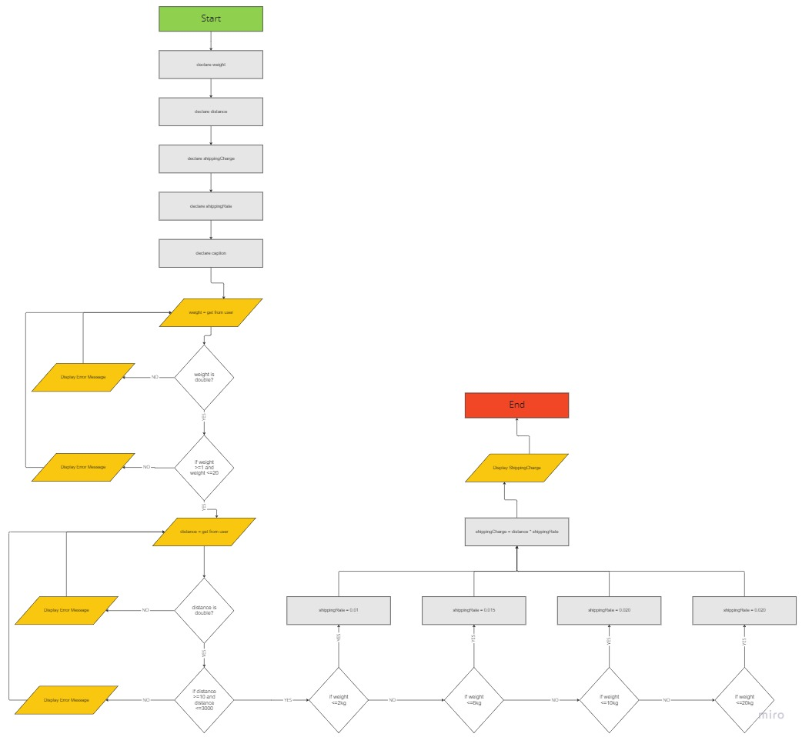

  - Error Indications

Program will catch empty inputs, out of limitations for distance and weight input fields and display an error message to indicate problem to the user.
Error condition | Action
Weight input value is not double | Show messageBox indicating the problem and request valid input
Distance input value is not double | Show messageBox indicating the problem and request valid input
Weight not between 1-20 | Show messageBox indicating thre problem and request valid input
Distance not between 10-3000 | Show messageBox indicating thre problem and request valid input

Implementation

  - Code Listings

using System;
using System.Collections.Generic;
using System.ComponentModel;
using System.Data;
using System.Drawing;
using System.Linq;
using System.Text;
using System.Threading.Tasks;
using System.Windows.Forms;

namespace ShippingCalc
{
public partial class frmShippingCalc : Form
{
public frmShippingCalc()
{
InitializeComponent();
}

private void btnCalculate_Click(object sender, EventArgs e)
{
/*
Umit Tas
Assignment3 , 11/21/2022
*/

//DECLARATIONS
double weight;
double distance;
double shippingCharge;
double shippingRate;
string caption=""; //Error handling messagebox title
MessageBoxIcon MessageIcon = MessageBoxIcon.Error; //Changing icon in error handling

try
{
//DATA VALIDATION & INITIALIZATION
if (!double.TryParse(txtWeight.Text, out weight))
{
caption = "Invalid Data: Weight";
MessageIcon = MessageBoxIcon.Error;
throw new Exception("Please enter Valid number in Weight input field!");
}
else
{
//CONTROL WEIGHT DATA LIMIT BETWEEN 1-20
if (weight.CompareTo(1) < 0 || weight.CompareTo(20) > 0)
{
caption = "Data Limit: Weight";
MessageIcon = MessageBoxIcon.Warning;
txtWeight.Focus();
txtWeight.SelectAll();
throw new Exception("Weight must be in between 1 - 20 kg.");
}
}

if (!double.TryParse(txtDistance.Text, out distance))
{
caption = "Invalid Data: Distance";
MessageIcon = MessageBoxIcon.Error;
throw new Exception("Please enter Valid number in distance input field!");
}
else
{
if (distance.CompareTo(10) < 0 || distance.CompareTo(3000) > 0)
{
caption = "Data Limit: Distance";
MessageIcon = MessageBoxIcon.Warning;
txtDistance.Focus();
txtDistance.SelectAll();
throw new Exception("Distance must be in between 10 - 3000 miles.");
}
}

//CONDITIONAL PARAMETERS FOR SHIPPING CHARGE
if (weight.CompareTo(2) <= 0) //if weight is less than 2kg, rate is 0.01
{
shippingRate = 0.01;
}
else if (weight.CompareTo(6) <= 0) //if weight is less than 6 kg, rate is 0.015
{
shippingRate = 0.015;
}else if (weight.CompareTo(10) <= 0) //if weight is less than 10 kg, rate is 0.020
{
shippingRate = 0.02;
}
else if (weight.CompareTo(20) <= 0) //if weight is less than 20 kg, rate is 0.025
{
shippingRate = 0.025;
}
else //In case if weight limit change, we need to alert user and keep max. rate.
{
shippingRate = 0.025;
caption = "Warning : Shipping Rate";
MessageIcon = MessageBoxIcon.Warning;
throw new Exception("Shipping Rate out of shipping weight limit");
}

//FINAL CALCULATION
shippingCharge = distance * shippingRate;

//DISPLAY ON SCREEN WITH PROPER FORMATTING
lblShippingCharge.Text = String.Concat("$",string.Format("{0:0.##}",shippingCharge));

}catch(Exception ex)
{
MessageBox.Show(ex.Message, caption,MessageBoxButtons.OK, MessageIcon);
}

}
}
}

  - Compilation

There is no special instruction to compile application. Opening project in Visual Studio will be enough for compile.
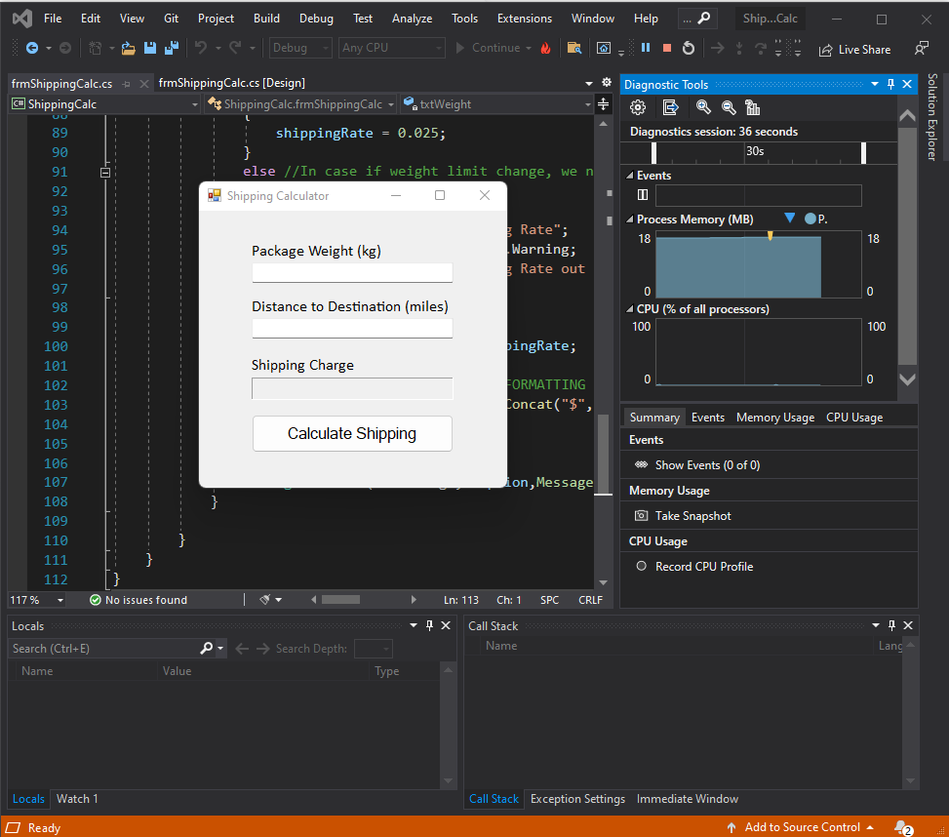

Testing

  - Test Description

Name | 1. Negative - Verify empty weight input field
Objective | Input empty value in weight column
Steps | 1. Open application  2. keep empty weight input field  3. enter number 10 into distance input field  4. Click "Calculate Shipping button"  5. Visually confirm error message
Formula
Result | Error message will appear with text "Please enter Valid number in Weight input field!"
Name | 2. Negative - Verify empty distance input field
Objective | Input empty value in distance column
Steps | 1. Open application  2. keep empty distance input field  3. enter number 1 into weight input field  4. Click "Calculate Shipping button"  5. Visually confirm error message
Formula
Result | Error message will appear with text "Please enter Valid number in distance input field!"
Name | 3. Negative - Verify upper limit weight input field
Objective | out of limit value in weight column
Steps | 1. Open application  2. enter value: 21 in weight input field  3. enter number:10 into distance input field  4. Click "Calculate Shipping button"  5. Visually confirm error message
Formula
Result | Error message will appear with text "Weight must be in between 1 - 20 kg."
Name | 4. Negative - Verify lower limit weight input field
Objective | out of limit value in weight column
Steps | 1. Open application  2. enter value: 0.99 in weight input field  3. enter number:10 into distance input field  4. Click "Calculate Shipping button"  5. Visually confirm error message
Formula
Result | Error message will appear with text "Weight must be in between 1 - 20 kg."
Name | 5. Negative - Verify upper limit distance input field
Objective | out of limit value in distance column
Steps | 1. Open application  2. enter value: 5 in weight input field  3. enter number:3001 into distance input field  4. Click "Calculate Shipping button"  5. Visually confirm error message
Formula
Result | Error message will appear with text "Distance must be in between 10 - 3000 miles."
Name | 6. Negative - Verify lower limit distance input field
Objective | out of limit value in distance column
Steps | 1. Open application  2. enter value: 5 in weight input field  3. enter number:9 into distance input field  4. Click "Calculate Shipping button"  5. Visually confirm error message
Formula
Result | Error message will appear with text "Distance must be in between 10 - 3000 miles."
Name | 7. Negative - Verify alphanumeric value in weight input field
Objective | alphanumeric value in weight input field
Steps | 1. Open application  2. enter value: "testingTheNumericValue" in weight input field  3. enter number:10 into distance input field  4. Click "Calculate Shipping button"  5. Visually confirm error message
Formula
Result | Error message will appear with text ""Please enter Valid number in Weight input field!""
Name | 8. Negative - Verify alphanumeric value in distance input field
Objective | alphanumeric value in distance input field
Steps | 1. Open application  2. enter value: "testingTheNumericValueInDistance" in distance input field  3. enter number:1 into weight input field  4. Click "Calculate Shipping button"  5. Visually confirm error message
Formula
Result | Error message will appear with text "Please enter Valid number in distance input field!"
Name | 9. Positive - Verify calculation tier1 rate
Objective | calculation value for tier1 rate
Steps | 1. Open application  2. enter value: 1.5 in weight input field  3. enter number:100 into distance input field  4. Click "Calculate Shipping button"  5. Visually confirm calculated value
Formula | 0.01 * 100 = $1
Result | Shipping charge will display $1
Name | 10. Positive - Verify calculation tier2 rate
Objective | calculation value for tier1 rate
Steps | 1. Open application  2. enter value: 5 in weight input field  3. enter number:200 into distance input field  4. Click "Calculate Shipping button"  5. Visually confirm calculated value
Formula | 0.015 * 200 = $3
Result | Shipping charge will display $3
Name | 11. Positive - Verify calculation tier3 rate
Objective | calculation value for tier1 rate
Steps | 1. Open application  2. enter value: 8 in weight input field  3. enter number:750 into distance input field  4. Click "Calculate Shipping button"  5. Visually confirm calculated value
Formula | 0.02 * 750 = $15
Result | Shipping charge will display $15
Name | 12. Positive - Verify calculation tier4 rate
Objective | calculation value for tier1 rate
Steps | 1. Open application  2. enter value: 15 in weight input field  3. enter number:2000 into distance input field  4. Click "Calculate Shipping button"  5. Visually confirm calculated value
Formula | 0.025 * 2000 = $50
Result | Shipping charge will display $50

  - Test Results

- Negative - Verify empty weight input field, Passed
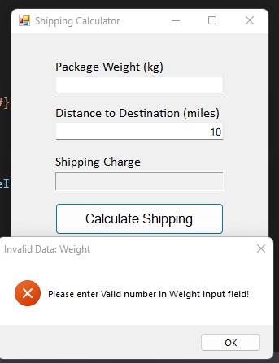

- Negative - Verify empty distance input field, Passed
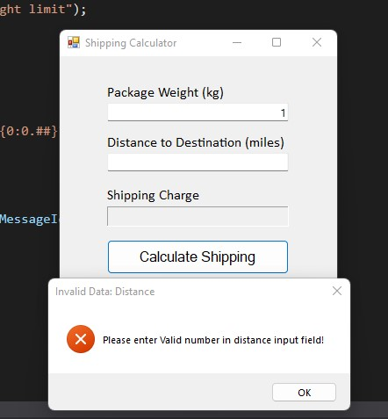

- Negative - Verify upper limit weight input field, Passed
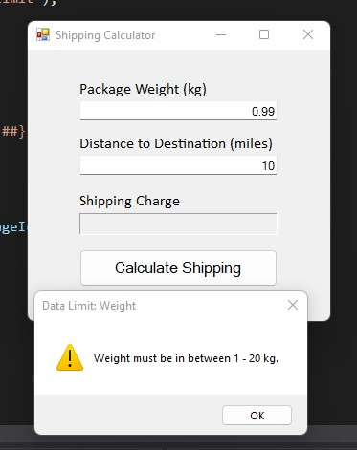

- Negative - Verify lower limit weight input field, Passed

- Negative - Verify upper limit distance input field, Passed
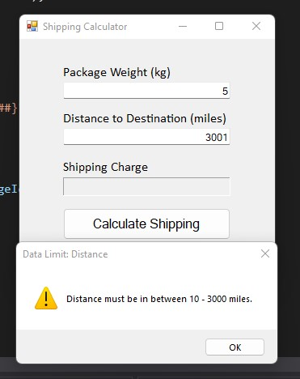

- Negative - Verify lower limit distance input field, Passed
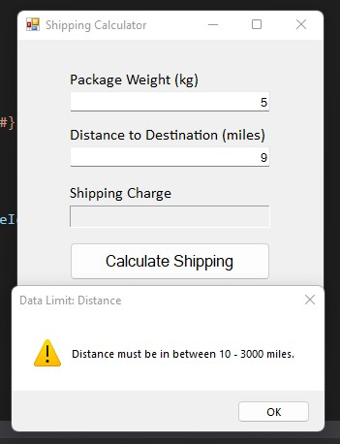

- Negative - Verify alphanumeric value in weight input field, Passed
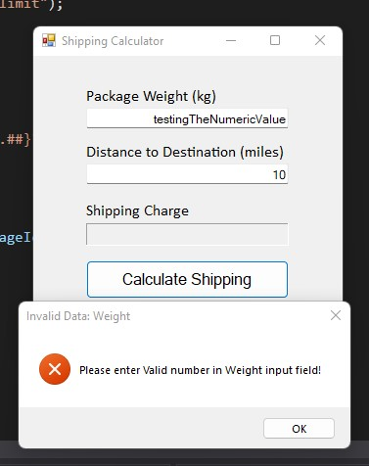

- Negative - Verify alphanumeric value in distance input field, Passed
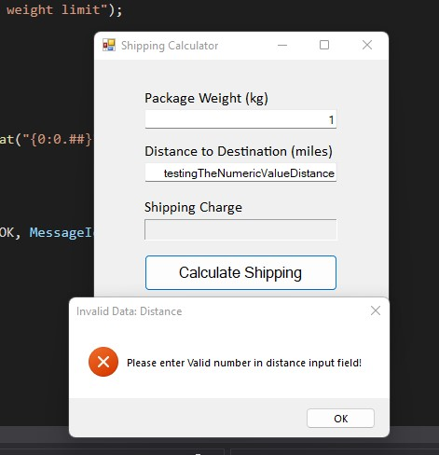

- Positive - Verify calculation tier1 rate, Passed
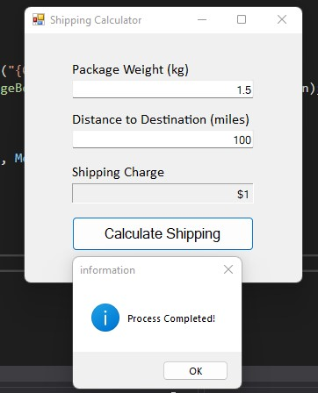

- Positive - Verify calculation tier2 rate, Passed
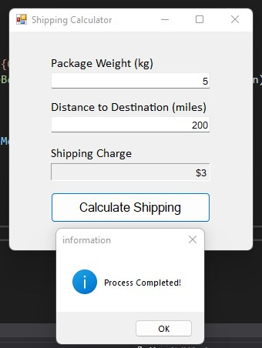

- Positive - Verify calculation tier3 rate, Passed
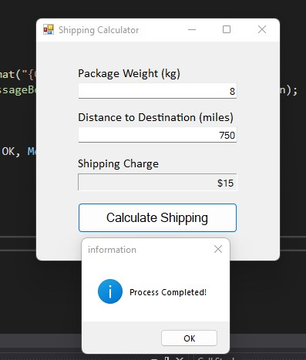

- Positive - Verify calculation tier4 rate, Passed
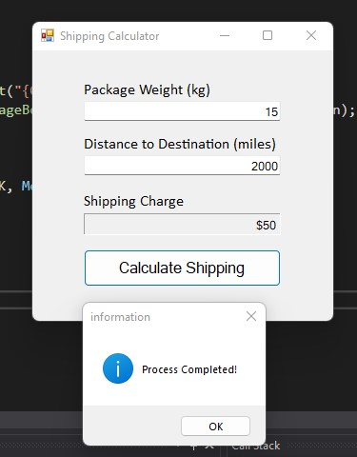

  - Known Bugs

- After trying Positive case testing, switching to the negative test case; shipping charge information field needs to be clear. This was the defect.
- Distance limit warning not focusing back and selecting all textbox field
- Weight invalid value warning not focusing back and selecting all textbox field
- After valid calculation, there should be information message indicate process is completed.

- Final Thoughts
  - Possible Improvements

After completion of valid test, switching to negative tests, shipping charge field needs to be clear.

  - Your thoughts

I feel I’m writing better test cases on given programs and I can find inconsistencies in the code while creating test cases. I did error handling test cases in this lab and did not feel any difficulties.

