|  |  |  |  |
| --- | --- | --- | --- |
| **CS102** | **Spring 2018/19** | Project Group | 1E |
| Instructor: | **David Davenport** |
| Assistant: | Mustafa Duymuş |

|  |  |  |
| --- | --- | --- |
| **Criteria** | **TA/Grader** | **Instructor** |
| Presentation |  |  |
|  |  |  |
|  |  |  |
|  |  |  |
| Overall |  |  |

~ UNeed ~

fıstıkçı_şahap

Ümit Başaran - Murat Angın - Can Alpay Yiğit Erkal - Emre Yıldız - Ayberk Yılmaz - Elham Amin

|  |
| --- |
| UI Design Report  ( V2 )  8 April 2019 |

# Introduction

UNeed is a shopping application especially focus on second hand items such as books and course materials for university students. Our purpose is making a great connection between customer and seller so as to make the life easier for university students.

UNeed application is based on Android system and hence we designed our user interface on Android Studio with XML. Our main purpose is creating a user-friendly interface for our application based on material design. We try to reduce the complexity of menu options in order to prevent difficulties that user might face. In order to save loading time, login and registration screens are based on a tab-style layout and filter and search options are pop-up style. In filter and sorting part, user can filter items based on title, category and price range. This filter option enables users to find what they want more efficiently. After selecting material user can contact with seller in a private chat room that provided by our message system.

# Table Of Contents

3.1 Application

3.2 Similar Programs

3.3 Outlines / Design

3.3.1 Login Screen

3.3.2 Register Screen

3.3.3 Home Screen

3.3.4 Marketplace

3.3.5 Item Adding

3.3.6 Item View

3.3.7 Chat

4 Summary

5 References

# Details

## Application

After opening the application, the student will have to either log-in or sign-up. For signing-up they have to use their university mails [for Bilkent students: ug.bilkent.edu.tr] of their universities, in order to declare they are student. In log-in page, student enter the nickname and enter password [1]. After login, users will have several options: Buying or selling second hand course related materials, giving or taking private lessons. After selecting an item in the list user can contact with seller by chat platform [2]. And also, user can look for campus information such as food menu and bus schedule.

## Similar Programs

In login page we imitate STARS application [1] and develop it by implementing registration option. In home page there are options which are features of UNeed such as marketplace and messages that users can navigate between them. In the marketplace option, we were inspired from Letgo application’s features like sorting and filtering. To create a connection with seller and customer there is a private chat system.[2]

## Outlines/Design

### 3.3.1 Login Screen

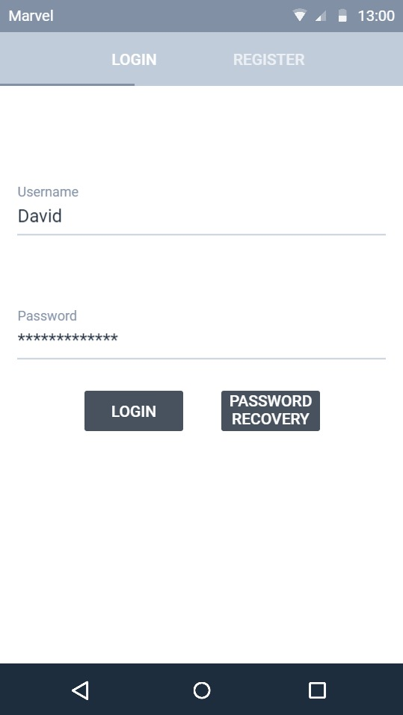

Figure 1 will be the first page that user will encounter when they open the application. In that page showed in Figure 1, user firstly choose whether register or log-in. In log-in section, user enters the username and previously specified password. If user forget their password, they can click password recovery button in order to get a new password. Password recovery button will send code to the users email and user can change their password using this code.

**Figure 1**

**3.3.2 Register Screen**

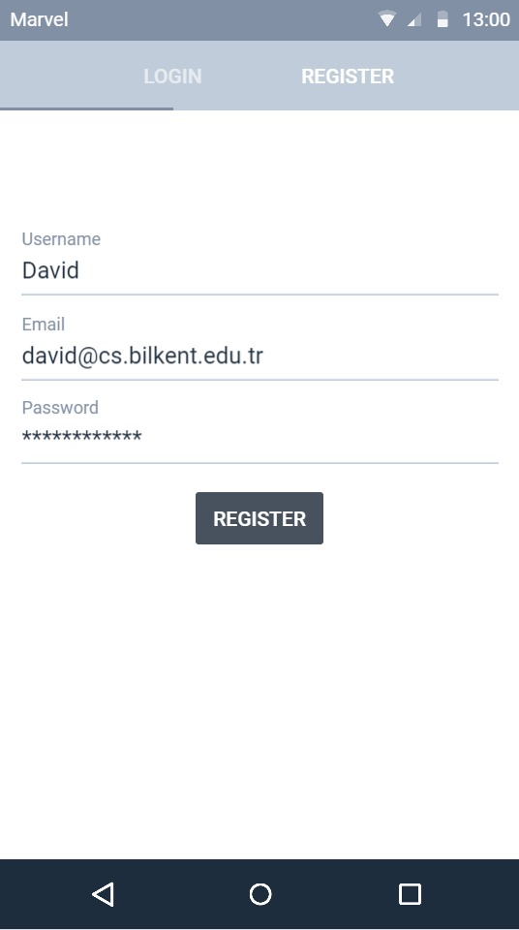

As it seen in Figure 2 for opening a new account, user has to specify a new username, program will compare the chosen username with database in order to avoid from getting same usernames. Secondly, to verify the user that they are legit, they have to enter their allocated university email (in that case Bilkent mail). If users forget their password, they will receive a recovery code to change their password through this email. Finally, they have to allocate password to enter their account and application.

**Figure 2**

### 3.3.3 Home Screen

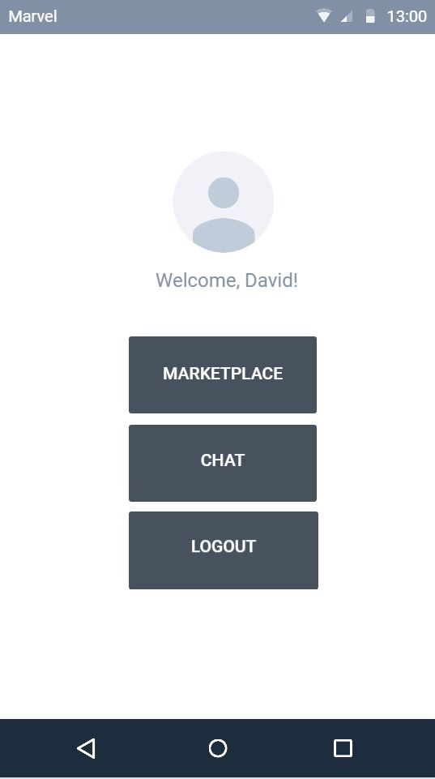

As it seen in Figure 3 our home screen contains 3 button which are named marketplace, chat and logout. When users clicked “Marketplace” button, users can reach the marketplace which items can be sold and bought. When the “Chat” button is pressed, users can see their message box. With logout button, users can end their session.

**Figure 3**

**3.3.4 Marketplace**

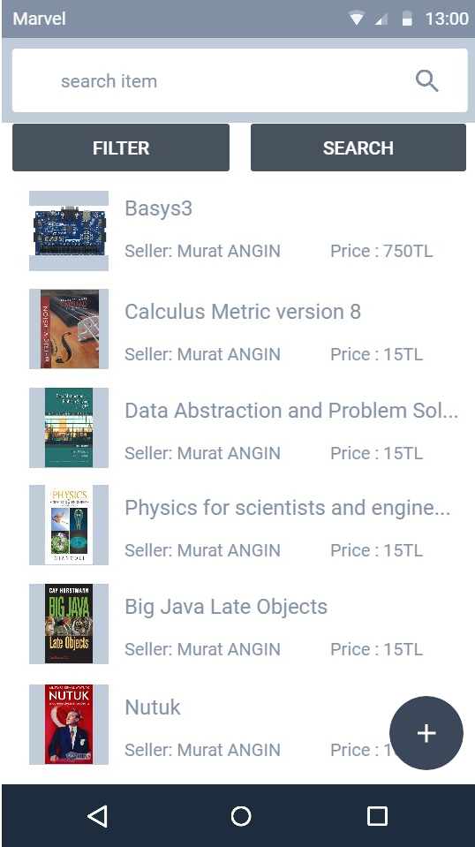

Items are shown in Figure 4 with their pictures, descriptions, price, category and title. User can search, filter and sort items in marketplace. After selecting an item, user can open a chat screen and contact with the seller easily. If user want to add an item for selling, there is a button at the right bottom corner to open adding item page.

**Figure 4**

**3.3.5 Item Adding Section**

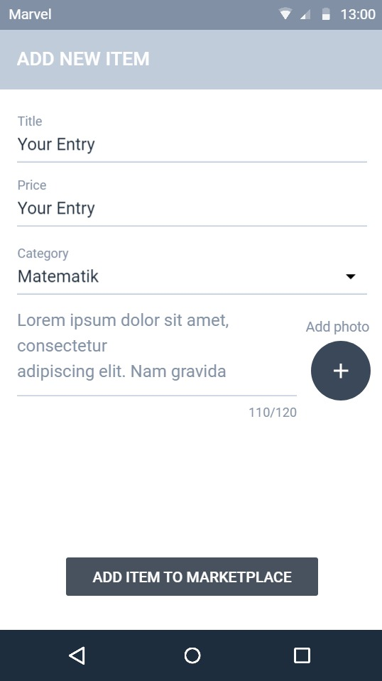

When user open the item adding section, there are lots of properties for item as it seen in Figure 5 such as title, price, category, description and photo that seller have to fill. There is a limit in description section for the purpose of avoiding floods and junk descriptions. After filling the blanks, seller can add the item to the marketplace by pressing “Add item to marketplace” button.

**Figure 5**

**3.3.6 Item View**

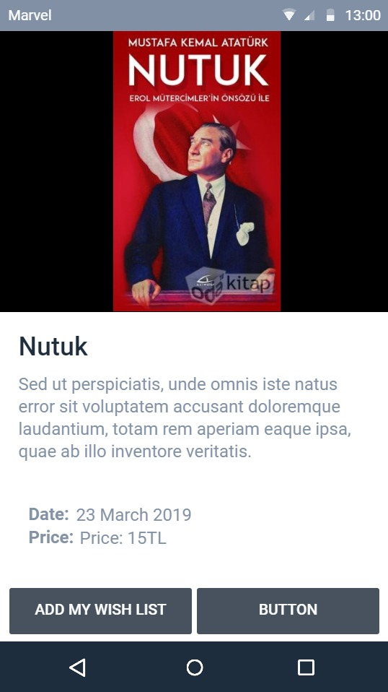

As it seen in Figure 6, when the user selected an item from marketplace, application shows the details of selected item such as its photo, price, description, listing date, and buttons for adding Wishlist and making contact with seller.

**Figure 6**

**2.3.7 Chat**

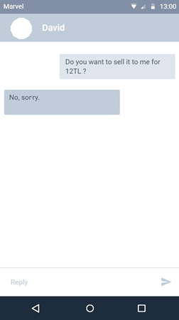

Chat part enables seller and buyer to contact each other. The heading displays the seller’s name and also, we have a small picture of the seller. Screen’s left-hand side shows the messages from seller and the right-hand side shows the buyer’s messages. At the bottom, we have a message box that the user can write message and send button to send this message.

**Figure 7**

# Summary & Conclusions

Our main purpose is meet the students’ needs in a convenient, basic and efficient way. As it can be seen in screenshots of our application’s user interfaces, we have simple and handy system for users. Our project has basically 7 parts. These are:

* **Login Screen:** The first page that user will encounter when they open the application to login.
* **Register Screen:** In order to open a new account with their university email.
* **Home Screen:** After login screen, user encounters with home screen that contains three buttons called marketplace, chat and logout.
* **Marketplace:** The place where user can see products with their pictures, descriptions, price, category and title.
* **Item Adding Section:** In order to add new product to marketplace, user need to enter data of the intended information which are as title, price, category, description and photo.
* **Item View:** When the user selected an item from marketplace, application shows the details of selected item in the item view page.
* **Chat:** Chat part enables seller and buyer to contact each other to trade.

Under the “*Details”* part of our GUI report, we explained parts of our project more detailed.

***“What u need is UNeed!”***



# *References*

**[1] Mobiversite Yazılım. (2015). Bilkent STARS (1.9.7) [Mobile Application Software]. Rerieved From < https://play.google.com/store/apps/details?id=mobiversite.bilkentstars >**

**[2] Ambatana Holdings. (2015). Letgo (2.7.5) [Mobile Application Software]. Retrieved From < https://play.google.com/store/apps/details?id=com.abtnprojects.ambatana >**