CS102 | Spring 2018/19 | Project  Group | 1E
Instructor: | David Davenport | Project  Group | 1E
Assistant: | Mustafa Duymuş | Project  Group | 1E

~ UNeed ~
Criteria | TA/Grader | Instructor
Presentation
Overall

fıstıkçı_şahap
Murat ANGIN, Can ALPAY, Ümit BAŞARAN, Ayberk YILMAZ, Elham AMİN, Emre YILDIZ, Yiğit ERKAL

Detail Design
(v1.0)

Introduction

UNeed is a shopping application especially focus on second hand items such as books and course materials for university students. Our purpose is making a great connection between customer and seller so as to make the life easier for university students.
In this report, we will show the details of UNeed application such as UML diagrams, class hierarchies.



Details

The real work goes here! Replace section titles with something relevant to your report.

System Overview

The program is based on mobile phones with Android. There is a website which has RESTful API and database. When user wants to take action, a connection is established between database and app by RESTful API.

Tools that we will use:

- MySQL for the database
- PHP for back-end development
- Java for Android application
- JSON for pull data from website with http-GET request
- PhpMyAdmin for managing MySQL database

Core Design Details

2.2.1 Network
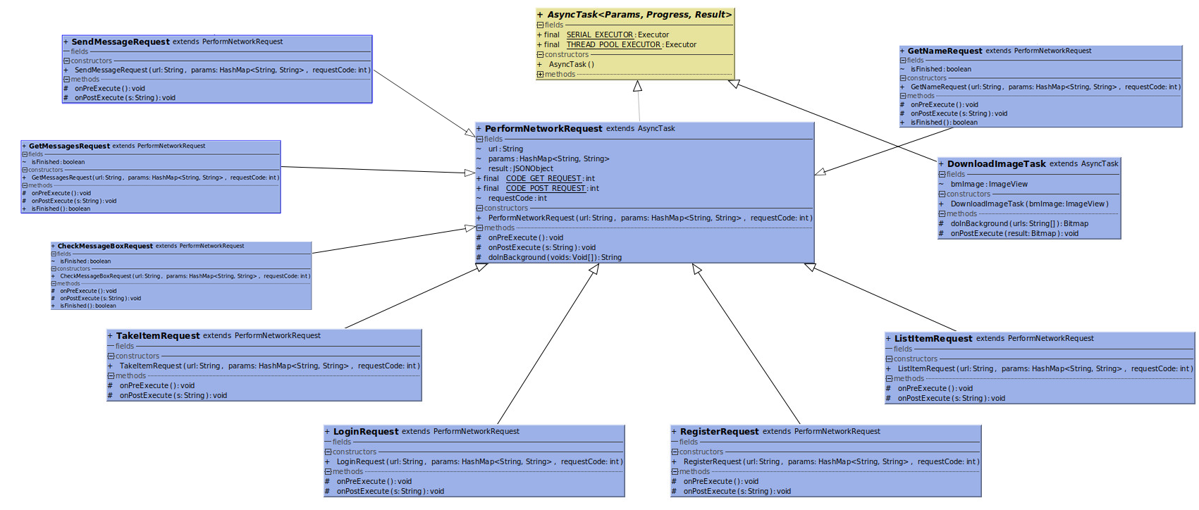

Figure-1

- PerformNetworkRequest extends AsyncTask<Param, Progress, Result>
  - The main and fundamental request class for performing network processes.
- DownloadImageTask extends AsyncTask<Param, Progress, Result>
  - Download item images from database.

- TakeItemRequest extends PerformNetworkRequest
  - A specific network class for taking item properties from database.
- LoginRequest extends PerformNetworkRequest
  - This class undertakes the login process between database and application.
- RegisterRequest extends PerformNetworkRequest
  - This class undertakes the register process between database and application.
- ListItemRequest extends PerformNetworkRequest
  - This class takes all items from database and adds this items in a list in MarketActivity.
- CheckMessageBoxRequest extends PerformNetworkRequest
  - This class possess the people that user had been talking to.
- SendMessageRequest extends PerformNetworkRequest
  - This class adds new message to the database (as a String).
- GetMessageRequest extends PerformNetworkRequest
  - This class pulls messages from database and shows to the user.

- GetNameRequest extends PerformNetworkRequest
  - This class gets the usernames from database whom the people in the message box.

2.2.2 API
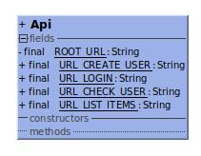
Figure-2

- In the future if the website (database) changes, the modification will be much simple and easier. Because of that the class holds the final properties of API calls.

2.2.3 Activities

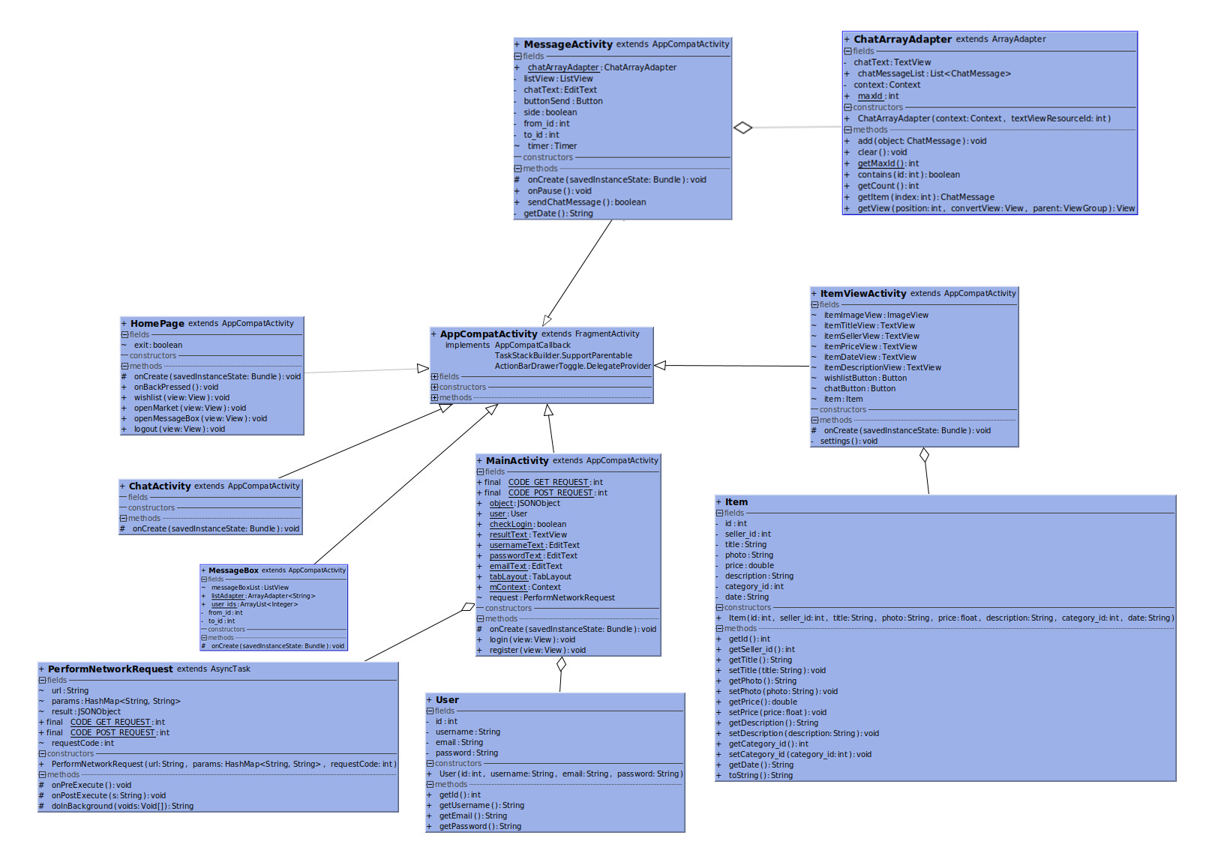
Figure-3

- AppCombatActivity extends FragmentActivity
  - This class is a default activity class that is provided by Android Studio. This class will be automatically extended by Android Studio when a new activity created.

- MainActivity extends AppCombatActivity
  - This class is controller for login and register page. It checks the elements whether enter correctly or not (username, password). For register side, it compares user’s enters (which are username, password and email) with database whether they already existed or not.

  - MainActivity has_a User
    - User class contains properities such as userID, username and password.
    - When user logins the application MainActivity class creates an instance of User.
- MessageBox extends AppCombatActivity
  - This class holds the chat history that user made between other users.

- HomePage extends AppCompatActivity
  - This class creates a main menu which contains buttons to guide user.

- ChatActivity extends AppCombatActivity
  - Create a user interface when user want to contact with the seller.

- ChatMessage
  - This class creates an object for messages.
  - Properties are:
    - Boolean left (whether messages are on the left side or right side, to distinguish seller and buyer)
    - Int id (Message id, every message has a unique id on database)
    - String message
    - String date (date and time)
    - Int from_id (sender)
    - Int to_id (receiver)

- MessageActivity extends AppCompatActivity
  - This class creates a chat room between seller and buyer.
  - MessageActivity has_a ChatArrayAdapter
    - ChatArrayAdapter extends ArrayAdapter
      - This class holds the previous messages between the users and shows them when either ne of them enters the chatroom.

- ItemViewActivity extends AppCompatActivity
  - This class illustrates the item, its description, photo of it, price, seller and adding date to the marketplace.
  - ItemViewActivity has_a Item
    - Item class contains properities such as id, sellerid, title, photo, price, description, categoryid and date.

- SortActivity extends AppCompatActivity
  - This class presents options in order to sort market items by price, adding date or alphabetical.

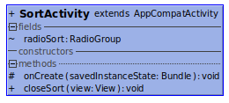
Figure-4

- FilterActivity extends AppCompatActivity
  - This class presents filter options to user, price or lesson (such as MBG110).

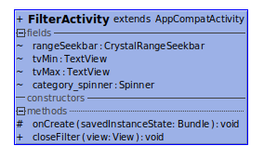
Figure-5
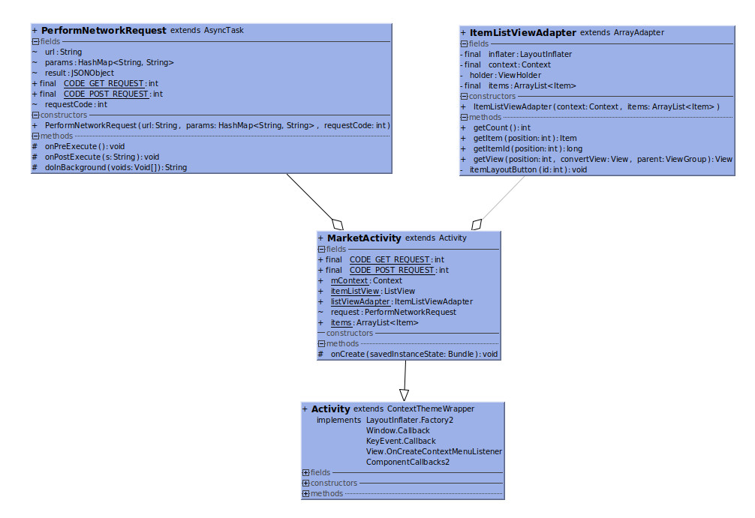
Figure-6
- MarketActivity extends Activity
  - This class basically provides a marketplace to user.
  - Class contains itemListView.
  - MarketPlace has_a ItemListViewAdapter
    - This class controls the itemListView.

Task Assignment

Murat Angın & Emre Yıldız – Database and Network Part
Can Alpay – Main Activity
Ümit Başaran – ItemViewActivity, MarketPlace Part
Elham Amin – Home Page, User and Item classes
Ayberk Yılmaz – General Design
Yiğit Erkal – Chat Part

