AYDIN ADNAN MENDERES UNIVERSITY

SOFTWARE ENGINEERING MIDTERM PROJECT
PROJECT TEAM İNFO SHEET
INTRODUCE OF OUR TEAM;
Team Name: BBZ Software
Team Members: Ümit Zafer Karakuş,
Mevlüt Batuhan Saar,
Baran Yıldız.
Stengths Of Our Team:
- We are a strong team in terms of teamwork,
- We are a strong team in terms of communication,
- We focus on goals and results in our team,
- Everyone contributes their fair share in our team,
- We respect team members and projects,
- We produce creative solutions to problems,
- We have produced projects as a team before, we have high team harmony and we know each other's working methods.

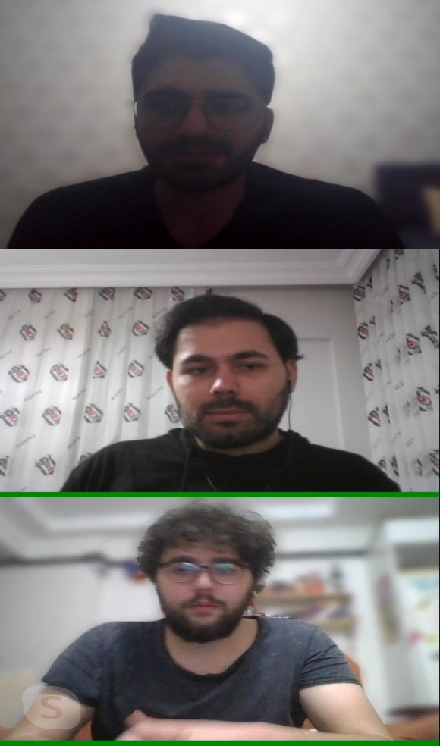

INTRODUCE TEAM MEMBERS;
- Ümit Zafer Karakuş, I was born in 1997, Gaziantep. I am a student of Computer Science Engineering department in Aydın Adnan Menderes University. I am a 4th grade student. I did my first internship at Bellsoft Software Company. My job at the company was to do web design and software coding. I developed myself on C# and Java while doing projects. Except for the company, I learned C, Python and PHP with the projects we did at school. My biggest goal is to have a software company and I want to bring this company to a level that can represent our country.

- Mevlüt Batuhan Saar. I was born in 1998, Kayseri. I am a student of Computer Science Engineering department in Aydın Adnan Menderes University. I am a fourth grade student. I worked as an IT staff at MSC company in my first internship. My job in this internship was to meet the demands of the units and respond to the needs. Apart from that, I gained experience in C, python and database management with the projects and assignments I did at school. My future goal is to have my own game development company and turn it into a global company.

- Baran Yıldız, I am Computer Engineering student at Adnan Menderes University. I am 3rd grade. I did my first internship at BITES - Defence & Aerospace Technologies in 2018. In my first internship, we made a project to be used in-house with consulting engineers. We used Microsoft SQL, ASP.NET Core 2.1, JavaScript, HTML, Bootstrap technologies in the project. I mostly worked in the front-end part of the project. But I also fixed the errors and deficiencies in the back-end part. I did my second internship at the Youth and Sports Ministry in 2019. I gained theoretical knowledge in this internship. In this internship, I learned about Information security, IDS, IPS and Attack Prevention, DDoS Attack, Load Balancing, Web Filtering and Mail Filtering, VoIP, Virtualization, Data Encryption, Data Mining.

** Contact team member is Ümit Zafer Karakuş.

OUR FİRST VİRTUAL MEETING:

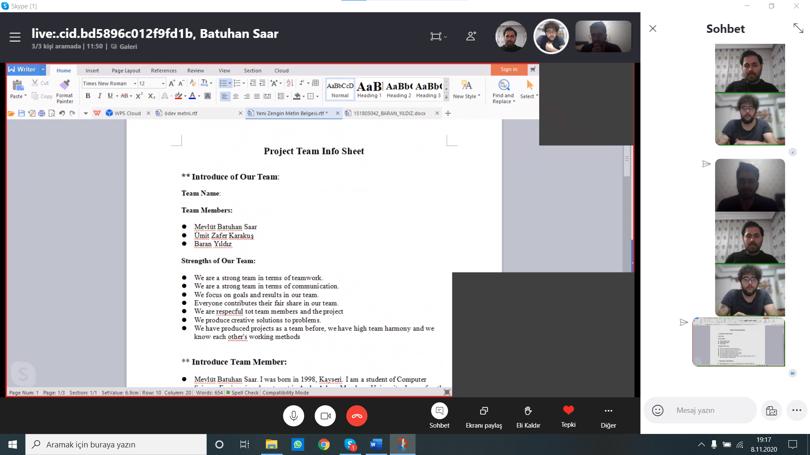

TEAM AGREEMENT:
- Metods Of Communication:
  - Ümit Zafer Karakuş Email: 161805020@stu.adu.edu.tr
  - Mevlüt Batuhan Saar Email: 161805030@stu.adu.edu.tr
  - Baran Yıldız Email: 151805042@stu.adu.edu.tr
  - Ümit Zafer Karakuş Phone: 0505-542-6120
  - Mevlüt Batuhan Saar Phone: 0541-582-2270
  - Baran Yıldız Phone: 0537-826-8593
- Communation Response Time:
  - Phone: No more than 1 hour
  - Other: No more than 1 day
- Meeting Attendance:
  - 2 days per week mandatory meeting
- Running Meeting:
  - There will always be online calls with skype
  - Each group member will take note
- Meeting Preparation:
  - Each group member based on his post for that week. It is present at the meeting time with the work and documents it prepares.
- Version Control:
  - Each group member will notify the other group member about their work and the problems they encounter at 18:00.
  - The division of labor will be shared according to the skills of the group members after the meetings.
- Submitting Assignments:
  - Assignments will be sent weekly by Ümit Zafer Karakuş.
  - At the last meeting of the week, each group member will examine the assignment.
- Contingency Planning:
  - The departing team member will be notified to the instructor, and the remaining members will work harder to fill in for the departing group member.

GITHUB ACCOUNTS:
** https://github.com/zaferkrkss
** https://github.com/m-batuhans
** https://github.com/brnnyildiz

