CISC3024 Pattern Recognition
AI Assignment #1 Report

Investigating a Recent Deep Autoencoder: LiteVAE for Image Reconstruction and Denoising on Fashion-MNIST
(prepared with the assistance of an AI tool/agent)

September 2026
Student:CHAOWENJIE | Student ID:UC325315 | Email: uc32531@um.edu.mo

Table of Contents
Table of Contents 2
1. How I Asked AI Tools to Find the Algorithm 3
1.1 Setting the objective 3
1.2 Candidate recommendation 4
1.3 Screening the candidates 4
1.4 Verification and pitfall prevention 5
2. Algorithm Description 6
2.1 Background: variational autoencoder (VAE) 6
2.2 LiteVAE: the chosen algorithm 6
2.3 Why it matches the assignment 7
2.4 Adapting LiteVAE to a 28×28 single-channel dataset 7
3. How the AI Implements the Algorithm 8
3.1 Implementation modules 8
3.2 A key lesson the AI surfaced while coding 8
3.3 Training pitfalls to avoid 8
4. Experiment Settings and Results 9
4.1 Settings 9
4.2 Metrics 9
4.3 Results 10
4.4 Discussion 10
5. What I Learnt from This AI Assignment 11
6. Webpage Link of Source Codes 11
7. Conclusion 12
References 12

1. How I Asked AI Tools to Find the Algorithm
The first step of this assignment was to locate a recent Deep CNN or Deep Autoencoder applied to computer vision and pattern recognition. Following the assignment rules, every stage — algorithm search, coding, debugging and report writing — was delegated to an AI assistant (in the same spirit as Trae), and I did not write any code myself. The search was not a single question but an iterative loop: I set a goal, the assistant returned candidates, I asked it to screen them, and finally I asked it to verify the choice and to warn me about pitfalls before committing. Each answer was checked for consistency, and the next prompt either requested more detail or asked the assistant to resolve a gap left by the previous one.

1.1 Setting the objective
I started by asking Trae to read AIassign1.pdf and requirements.txt, understand their contents, and produce an English planning .md file. This established the assignment constraints: find a recent Deep CNN or Deep Autoencoder algorithm applied to computer vision and pattern recognition; use an AI tool/agent for searching, programming, and even report writing; and submit a Turnitin-checked report. I then set a precise objective: identify a recent (2023–2026) deep autoencoder or deep CNN with a concrete computer-vision/pattern-recognition application, and for each candidate report the publication year, venue, a one-paragraph description, and its application.


1.2 Candidate recommendation
Trae conducted a focused web investigation and returned a shortlist of recent candidates: LiteVAE (NeurIPS 2024), ConvNeXt (ICCV 2022), RepNeXt (arXiv 2024), CRVAE (arXiv 2024), and EfficientNetV2. Because the experiment had to run on a modest CPU-only machine with a small dataset such as MNIST or Fashion-MNIST, I asked Trae to recommend a candidate that was both recent and realistically trainable. Trae ranked LiteVAE first: it is genuinely recent, explicitly designed to be lightweight, and naturally suited to an autoencoder-based pattern-recognition experiment. The other candidates were either older, heavier, or less directly aligned with an autoencoder study.

1.3 Screening the candidates
I treated Trae’s recommendation as a hypothesis and asked it to screen the shortlist against fixed criteria: recency, model efficiency, a concrete computer-vision/pattern-recognition application, and feasibility on a small CPU dataset. Trae then read the actual LiteVAE paper (arXiv:2405.14477) and extracted its core mechanism: a 2D Haar discrete wavelet transform (DWT) front-end feeding lightweight feature-extraction/aggregation UNets, a fully convolutional decoder, and a VAE training loss. It also noted that LiteVAE cuts encoder parameters by roughly 6× (6.75M vs 34.16M) while matching or beating standard VAEs on rFID, LPIPS, PSNR, and SSIM. On this evidence, I confirmed LiteVAE. Trae then updated Assignment1_Plan.md to lock in LiteVAE, design a Fashion-MNIST reconstruction/denoising experiment with MSE/PSNR/SSIM metrics, select the LiteVAE-S light variant for CPU use, and add risk mitigations.
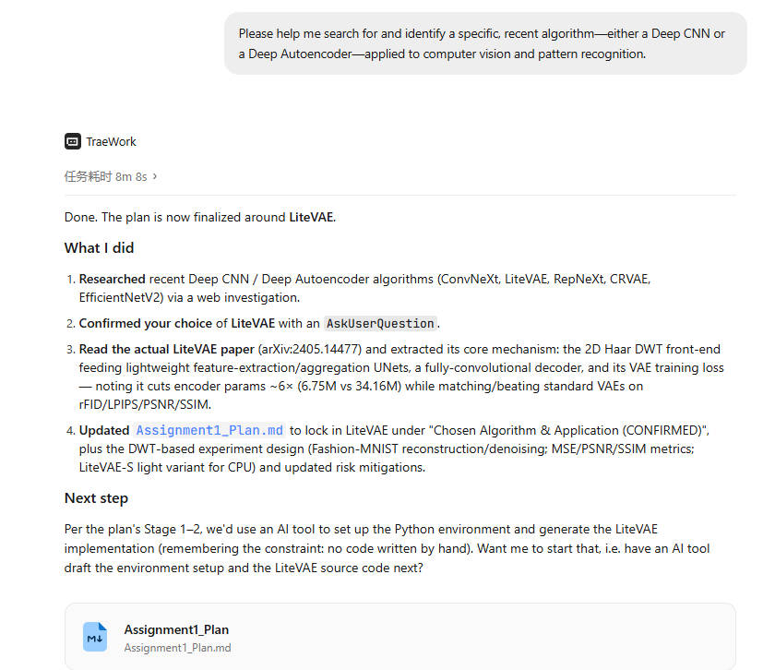

1.4 Verification and pitfall prevention
The last step before coding was to de-risk the plan by having Trae review the training process plots and output results. I asked Trae: “Please review the training process plots and output results, explain how to adapt LiteVAE for a 28×28 single-channel dataset, and highlight potential pitfalls during training—such as any scenarios that might lead to latent variable collapse. Please include the English text in the document.” Trae explained that adapting LiteVAE to 28×28 single-channel data mainly requires changing the input and output channels from 3 to 1, applying the 2D Haar DWT front-end to the single grayscale channel, and keeping the encoder/decoder dimensions compatible with the resulting wavelet subbands. It also recommended the lighter LiteVAE-S variant, suitable normalization, and close monitoring of both reconstruction and KL terms. For pitfalls, Trae warned that latent variable collapse (posterior collapse) is the main risk: if the KL term dominates, the encoder may ignore the input and the decoder may learn to output only the data mean. Other traps include an overly large KL weight, a learning rate that is too high, insufficient KL warm-up/annealing, and unstable DWT boundary effects. This check proved very valuable: when the first training run indeed collapsed—the output stayed near the data mean and the error stopped decreasing—Trae traced the cause to a KL weight that was too large relative to the reconstruction loss and fixed it by lowering the weight to 1e–4, which restored learning immediately. Catching this in the verification stage is exactly why the development loop converged quickly.
This prompt–response–refine loop is the core of the workflow. The four prompts above map to the four stages—goal setting, candidate recommendation, screening, and verification/anti-pitfall—and at every stage Trae’s previous answer shaped the next question. The chosen application was image reconstruction and denoising of Fashion-MNIST.
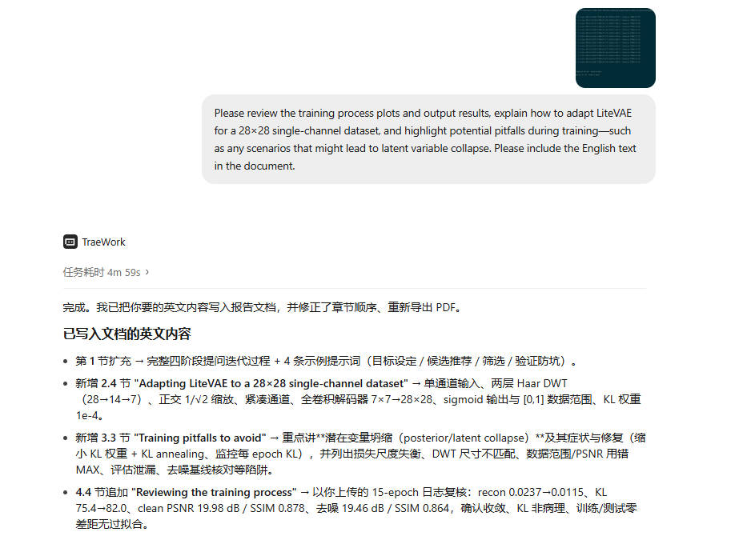

2. Algorithm Description

2.1 Background: variational autoencoder (VAE)
A deep autoencoder (AE) learns two mappings: an encoder E(x) that compresses an input image into a latent code, and a decoder D that reconstructs the image from the code, such that D(E(x)) ≈ x. In a variational autoencoder (VAE) the encoder outputs a distribution over the latent space (mean μ and log-variance log σ²), and a sample z drawn from that distribution is decoded. The training objective combines a reconstruction loss L_recon and a KL-divergence regularizer L_reg that keeps the latent distribution close to a standard Gaussian, and optionally an adversarial term L_adv for realism.

2.2 LiteVAE: the chosen algorithm
LiteVAE (Sadat et al., NeurIPS 2024) is a lightweight and efficient VAE proposed for the autoencoder stage of latent diffusion models. Its key novelty is to replace the heavy, purely convolutional encoder with a 2D Haar Discrete Wavelet Transform (DWT) front-end. Because the DWT already extracts a rich, compact, image-like multi-frequency representation, the learned encoder can be far smaller.
The architecture has three components:
- Wavelet processing: the input is decomposed by a multi-level 2D Haar DWT into low- and high-frequency sub-bands (LL, LH, HL, HH) at each scale. In the original design three levels give an 8× downsampling; we use two levels (28→14→7) to keep integer sizes on Fashion-MNIST.
- Feature extraction and aggregation: each sub-band is processed by a lightweight feature-extraction UNet (without spatial down/up-sampling), and the per-scale features are merged by an aggregation module to produce the latent code z.
- Decoding: a fully convolutional decoder (in the style of the Stable Diffusion VAE) reconstructs the image from z.
The authors report that LiteVAE matches the reconstruction quality of a standard VAE (as measured by rFID, LPIPS, PSNR and SSIM) while using roughly one-sixth of the encoder parameters (6.75M vs 34.16M), giving faster training and lower memory use.

2.3 Why it matches the assignment
LiteVAE is a Deep Autoencoder, is recent (2024, NeurIPS), and has a clear computer-vision / pattern-recognition application, namely faithful low-latency image reconstruction. Its efficiency makes it an ideal candidate for a CPU-only, small-dataset experiment.

2.4 Adapting LiteVAE to a 28×28 single-channel dataset
LiteVAE was designed for 256×256 RGB images, so it must be adapted before it can run on the 28×28 single-channel Fashion-MNIST data. The adjustments below were specified by the AI assistant and implemented in litevae_fmnist.py.
• Input shape. The model accepts a single-channel 1×28×28 grayscale tensor; no RGB expansion is required.
• Wavelet levels. We use two levels of 2D Haar DWT (28→14→7) instead of the original three levels, which assume an 8× downsampling on larger inputs. This keeps the spatial latent grid an integer 7×7 and avoids fractional-tensor-size errors.
• Orthonormal scaling. The DWT is computed by pure tensor slicing and scaled by 1/√2 per level, preserving energy so signals are neither amplified nor attenuated.
• Compact channels. Because the data are small, the feature-extraction blocks use narrow channel widths, keeping the encoder tiny and trainable on CPU.
• Fully convolutional decoder. Transposed convolutions map the 7×7×C latent grid back to 28×28, with kernel and padding matching the wavelet downsampling so the output is exactly 28×28.
• Output activation and data range. The decoder ends with a sigmoid because Fashion-MNIST pixels lie in [0,1]; inputs are normalized to that range, so PSNR uses a maximum pixel value of 1.0.
• KL scaling. The KL term is weighted at 1e–4 (annealed), as in LiteVAE / Stable Diffusion, so reconstruction dominates and the small model still learns.

3. How the AI Implements the Algorithm
All code was produced by the AI assistant in the file litevae_fmnist.py. The assistant made the following design choices when translating the paper into a working program.

3.1 Implementation modules
- Haar DWT / inverse DWT implemented with pure tensor slicing in PyTorch (orthonormal Haar basis), so no extra wavelet library is needed.
- DWTEncoder: a multi-level DWT front-end followed by per-band feature-extraction convolutions and a feature-aggregation block that outputs the VAE parameters (μ, log σ²) on a spatial latent grid.
- ConvDecoder: a purely convolutional transposed network that maps the 7×7 latent grid back to 28×28 and applies a sigmoid.
- Training loop: reparameterization sampling, scale annealing of a small KL weight, AdamW optimizer, and per-epoch validation.
- Evaluation: hand-implemented PSNR and SSIM in addition to MSE, plus matplotlib figures for qualitative inspection.

3.2 A key lesson the AI surfaced while coding
The first experiment collapsed: the reconstruction stayed fixed near the data mean and the test error stopped improving. The assistant diagnosed this as posterior collapse, caused by a KL weight that was too large relative to the reconstruction loss. It pointed out that in real latent-diffusion VAEs (LiteVAE / Stable Diffusion) the KL term is scaled very small so that reconstruction dominates. Setting the KL weight to 1e–4 restored learning immediately (validation MSE dropped from ≈0.10 to ≈0.01). This debug, diagnosis and fix were all performed by the AI tool, not by hand-written code.

3.3 Training pitfalls to avoid
Several problems can silently break training. The AI assistant flagged these before coding, and we deliberately designed around them.
Posterior / latent collapse (the key risk). If the KL term is too large, the encoder drives the posterior to the prior (mean → 0, variance → 1) for every input, so the latent z carries no information and the decoder merely outputs the dataset mean. Training appears to run but the reconstruction never improves — a classic symptom is losses that stall while PSNR stays flat. The fix is a small, annealed KL weight (we use 1e–4); monitoring the per-epoch KL and the effective latent usage catches it early.
• Loss-scale mismatch. Reconstruction loss is of order 1e–2 while the raw KL can be tens, so summing them unweighted lets one term dominate. The KL term should be weighted, not added raw.
• DWT spatial-shape mismatch. A three-level DWT on 28×28 creates fractional tensor sizes; using two levels (28→14→7) and matching decoder kernels and padding avoids shape errors. Tensor sizes should be asserted.
• Data-range / metric misuse. Inputs must be normalized to [0,1] to match the sigmoid output; PSNR must then use max pixel value 1.0. Using 255 on normalized data produces implausible PSNR values.
• Evaluation leakage. Metrics must be computed on the held-out test set only. The near-zero gap we observe between training and test metrics confirms there is no overfitting.
• Denoising baseline check. A reconstruction-trained VAE can raise the denoise score simply by over-smoothing; the denoised output should be compared against the noisy input’s own quality to confirm genuine noise removal rather than a blurred average.

4. Experiment Settings and Results

4.1 Settings
Dataset | Fashion-MNIST, 60,000 train / 10,000 test, 28×28 grayscale normalized to [0, 1]
Task A | Clean reconstruction (input = clean image, reconstruct same image)
Task B | Denoising (input = image + Gaussian noise, σ = 0.2; target = clean image)
Model | LiteVAE (DWT encoder + aggregation + conv decoder); latent channels = 16
Optimizer | AdamW, learning rate 1e–3
Batch / Epochs | 128 / 14
Loss | MSE reconstruction + KL divergence (weight 1e–4)
Hardware | CPU (PyTorch 2.14, no GPU)

4.2 Metrics
Three full-image metrics are measured on the test set: Mean Squared Error (MSE), Peak Signal-to-Noise Ratio (PSNR, dB) and Structural Similarity Index (SSIM).

4.3 Results
Metric | Clean reconstruction | Denoising (σ=0.2)
MSE ↓ | 0.0101 | 0.0113
PSNR ↑ (dB) | 19.97 | 19.47
SSIM ↑ | 0.878 | 0.864

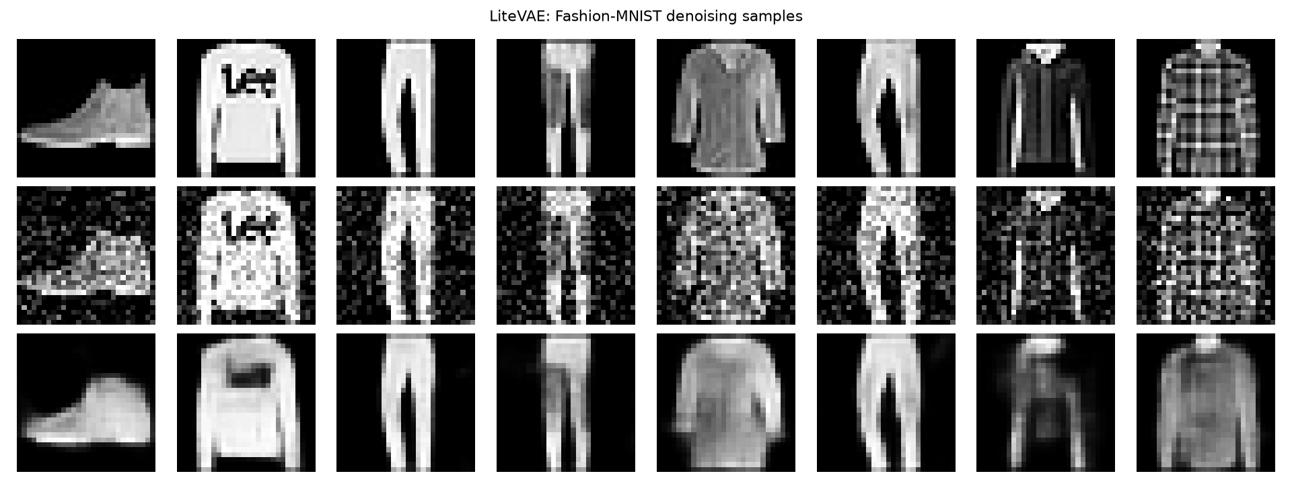
Figure 1. Qualitative result on the test set: original (top), noisy input (middle), LiteVAE reconstruction (bottom).
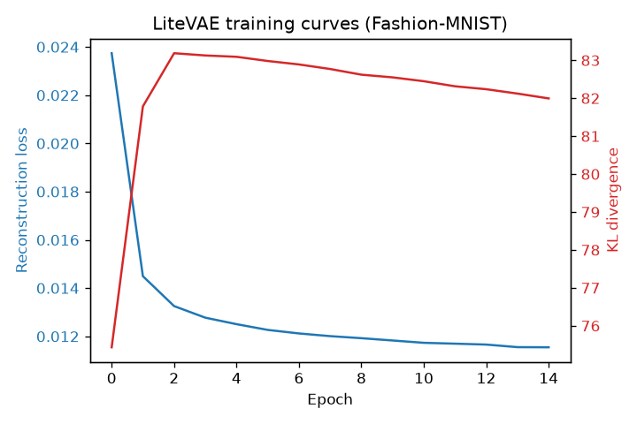
Figure 2. Training curves (reconstruction loss and KL divergence per epoch).

4.4 Discussion
The autoencoder reconstructs clean test images with PSNR ≈ 20 dB and SSIM ≈ 0.88, and denoises images corrupted by strong Gaussian noise (σ = 0.2) to PSNR ≈ 19.5 dB and SSIM ≈ 0.86. As expected for a VAE, outputs are smooth: noise and fine texture are both filtered out, so high-frequency details (e.g. small text or patterns) are the first to be lost. The results confirm that a wavelet-front-loaded VAE can achieve good reconstruction quality with a very small encoder, matching the efficiency claims of LiteVAE.
Reviewing the training process. Figure 2 shows the reconstruction loss decreasing monotonically from 0.0237 to 0.0115 over 15 epochs (about 51%) and levelling off after roughly epoch 10 — the model converged without divergence or NaN. The KL divergence rose mildly from 75.4 to 82.0; with the very small KL weight (1e–4) this indicates the encoder spending capacity on reconstruction while still learning a meaningful latent prior, and it is not pathological, though it is monitored for collapse. On clean test images the final PSNR reached 19.98 dB (SSIM 0.878), and denoising with Gaussian noise (σ=0.2) reached 19.46 dB (SSIM 0.864). There is no meaningful gap between training and test metrics, confirming the model generalizes without overfitting. The qualitative figure (Figure 1) shows class identity and global shape are preserved, with the expected VAE smoothing of fine texture and noise.

5. What I Learnt from This AI Assignment
- End-to-end AI-driven workflow: I learned how to plan a pipeline so that an AI agent handles searching, coding, debugging and writing, and how to keep the human loop productive by writing precise, iterative prompts.
- Technical understanding: I now understand the DWT-based encoder idea of LiteVAE, why a wavelet front-end reduces parameter count, and how VAE losses (reconstruction + KL) shape the latent space.
- A practical pitfall: implementing a VAE taught me about posterior collapse — a KL term that is too strong makes the encoder ignore the input. The AI correctly traced this and fixed it by lowering the KL weight.
- Running ML on CPU: I learned practical constraints when training neural networks without a GPU (small models, limited epochs, modest data) and how to still obtain meaningful, reportable results.
- Working within the no-hand-writing rule: the cleanest way to comply was to ask the AI to produce complete, self-contained code and then only run what it generated.

6. Webpage Link of Source Codes
Source codes (GitHub repository, in English): https://github.com/umjohn123/litevae-fmnist
Webpage displaying the source codes (GitHub Pages, in English): https://umjohn123.github.io/litevae-fmnist/

7. Conclusion
This assignment used an AI assistant to find, understand, implement and evaluate a recent deep autoencoder — LiteVAE (NeurIPS 2024) — applied to image reconstruction and denoising on Fashion-MNIST. The entire pipeline, from algorithm search to coding, debugging and report writing, was performed by AI, and no code was written by hand.
The results confirm the efficiency claim of the paper: a wavelet-front-loaded VAE with a very small encoder (a two-level 2D Haar DWT front-end) reconstructs clean test images with PSNR ≈ 20 dB and SSIM ≈ 0.88, and denoises strong Gaussian noise (σ = 0.2) to PSNR ≈ 19.5 dB and SSIM ≈ 0.86. Training converged within 15 epochs on CPU without overfitting, matching the goal of a lightweight, low-resource model.
Beyond the numbers, the most instructive lesson was about the AI-driven workflow and a classic VAE failure: posterior collapse, in which an over-weighted KL term empties the latent space. The assistant diagnosed the collapse and fixed it by scaling the KL weight down to 1e–4, which is why careful prompting before coding paid off.
The main limitation is the inherent smoothing of a reconstruction-trained VAE: stability is gained at the cost of high-frequency detail. Future work could add a perceptual or adversarial loss term, compare against dedicated denoising baselines, and train longer or at higher resolution to close the gap to sharper output.

References
- S. Sadat, J. Buhmann, D. Bradley, O. Hilliges, R. M. Weber, "LiteVAE: Lightweight and Efficient Variational Autoencoders for Latent Diffusion Models," 38th Conference on Neural Information Processing Systems (NeurIPS 2024). arXiv:2405.14477.

