Commerce Bank Web Application

Group 9

April 25, 2020

Team Members
Michael Cu
Mao Zheng
Joshua Daniels
Toni Tan

Contents
Contents 2
1 Introduction 3
2 Quick Start Guide 3
3 System Requirements 3
4 Main Scenarios of Use 3

Introduction
The Commerce Bank Web Application offers customers to check and view their bank transactions and intuitive manner. Customers can also set notification alert base on their personal needs.

Quick Start Guide
- Go to Commerce Bank Web Application web link inside any web browser.

System Requirements
The Commerce Bank Web Application should be accessed through a web browser via any laptop, desktop or mobile device.

Main Scenarios of Use

View Recent Transactions
  - After Log in, transaction page will be the first screen shows up since it is set by default
  - User can click on the “Transactions” button on the top right corner of the screen inside navigation bar
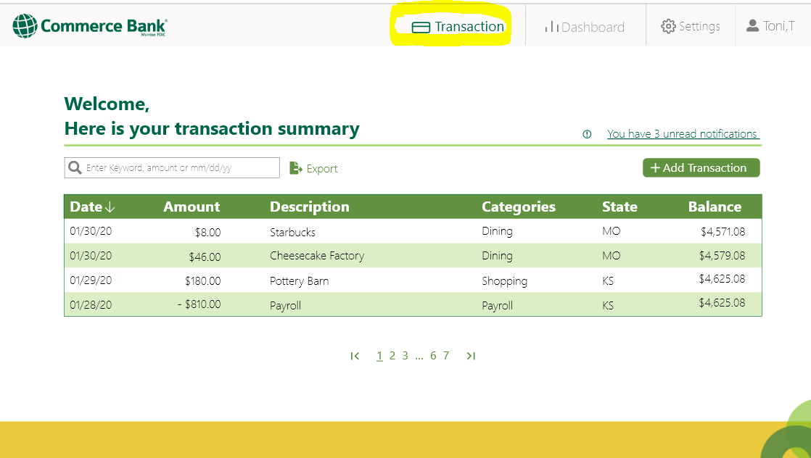

Export and Adding Transactions
    - User click on “Export”, It will automatically export a excel spreadsheet for transactions
    - User click on “Add Transaction”. New screen will show up for user to add transaction manually.

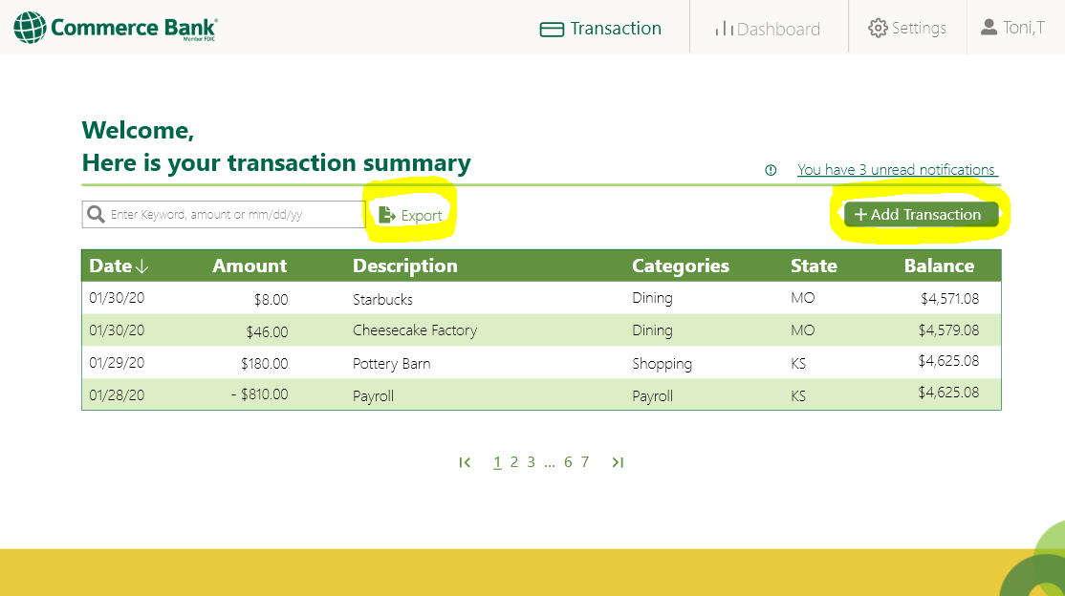
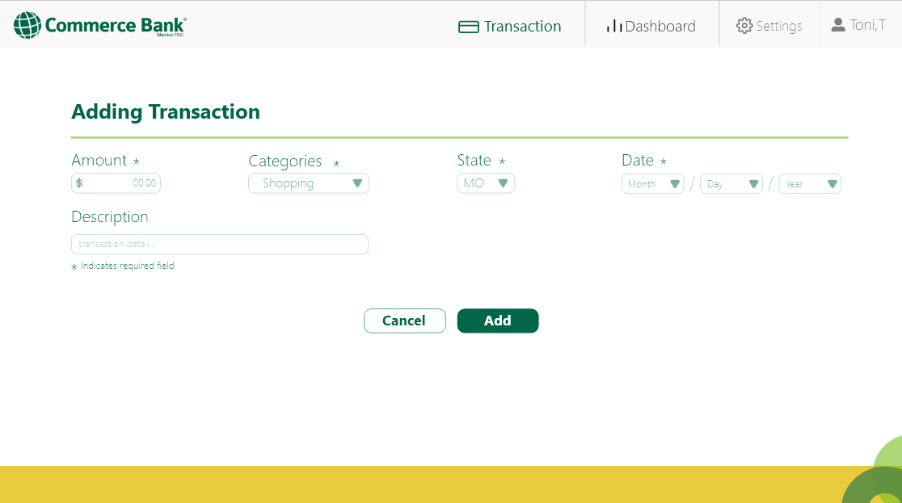

Transactions Dashboard
      - User click on the “Dashboard” button on the top right corner of the screen inside navigation bar.
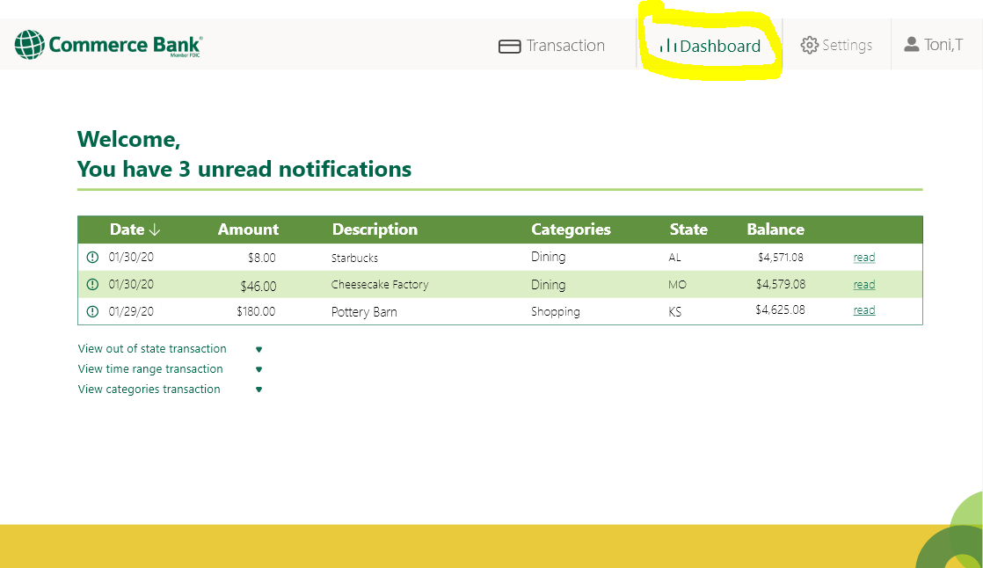

Setting
        - User click on the “Setting” button on the top right corner of the screen inside navigation bar
        - Click on button right by the “Text” and “Mail” to turn on/off notification received type
        - Select state, categories or time range, click on the plus sign right next to it. It will create an alert.
        - Click on trashcan icon to delete the alert.
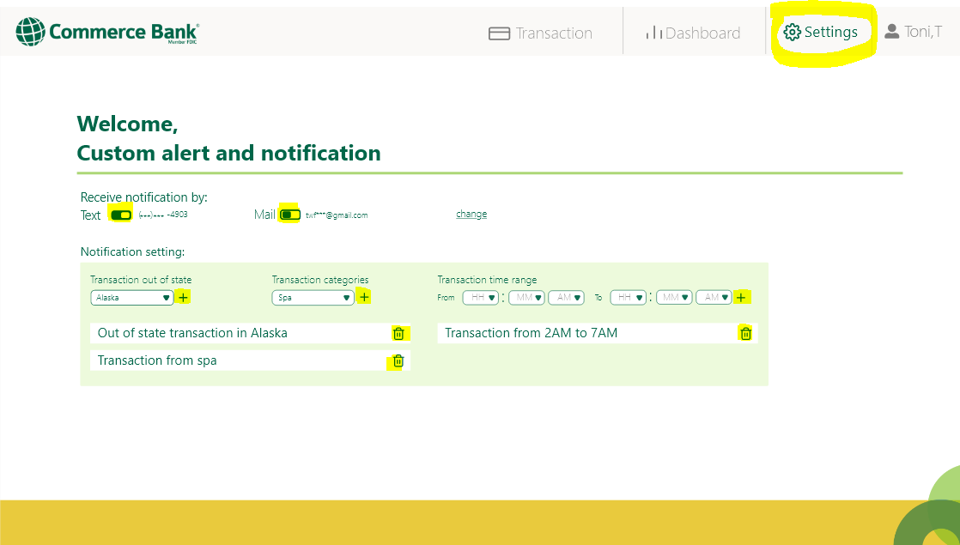
        - Click on “change” to change email adress and phone number
