CS5590VC Lab 2 Assignment

Create a web app using javascript, css, jquery, google weather and location using jsfiddle environment.

I have used the google location API and javascript to create a simple web application which uses the google locational services to find the route from Kansas city to any other city which you like.

The web application looks like this.

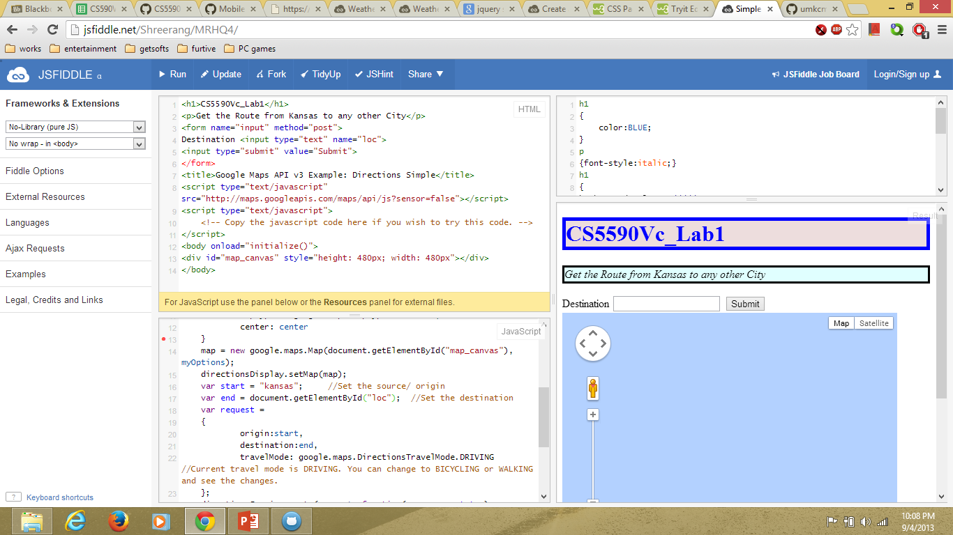

Here in the Destination box we enter the desired location to be routed from the Kansas city as the default starting point set is Kansas city.

We enter the ohio city in the destination box and we get the route as follows.

