Media Computing Project
Python 3 blackjack game

Jose Flores, Andrew Long
Computer Science
University of Massachusetts Lowell
Lowell, MA United States of America

Abstract—A Python 3 blackjack terminal simulator with a pyGame generated user interface which was done in lieu of completing any other assignment or exams with the intent of fulfilling the requirements for COMP 1000 Media Computing under professor Byung Kim for the Fall 2016 semester.
Keywords—Python 3, pyGame, GUI, blackjack, Media Computing

Project Expectations

Changes to original guidelines
- Documentation shall not be found on the gh-pages branch of the blackjack repository of the uml-cm-f16 organization or the projects Github webpage. Instead it shall be found within the component classes Ref. [2] [3]

Installation

Dependency Installation
- Download and install Python 3 for your system Ref. [5].

- Download and install Ref. [6].

Source Code Installation
- With a terminal client clone the project repository
git clone https://github.com/uml-cm-f16/blackjack.git

- Navigate into the project directory:
cd blackjack

- With terminal run the command:
python ./setup.py install

Operation

Running the terminal program
- [Optional] To test the code base with terminal run:
python ./terminal.py

Running the GUI program
- [Optional] To test the code base with terminal run:
python ./gui.py

Code management
- To unit test the code base with terminal run:
python ./setup.py test

- To update the Git repository with terminal run:
python ./setup.py save {message}
where {message} is your Git commit message

Code Base
At the root of the project directory are three python files and one directory. They python files are the project landing points.

setup.py

This is the project setup file and can install dependencies, unit test the code base, and update the Git repository. The following are the commands it can take.
python ./setup.py install
  - Installs the application dependencies:
    - pip – Package installer
    - pygame – Graphical User Interface (GUI) framework
    - pytest – Unit test framework
    - pylint – Code format linter
python ./setup.py test
  - Runs and auto discovers the unit tests.
python ./setup.py save {message}
  - Updates the Git master branch with changes

simulator.py
The simulator runs a terminal blackjack game for play between one human player and a computerized dealer. The terminal game shows the cards in play, the player score, and the probability to bust on next hit. This game follows the rules as described in the bicycle cards webpage Ref [4].
python ./terminal.py
  - Runs the terminal simulator

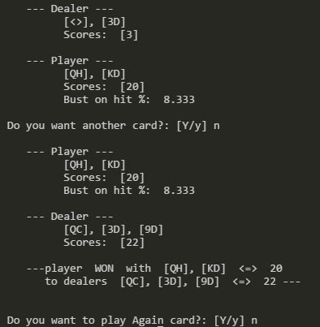
Fig1 Terminal simulator screenshot.

gui.py

The GUI application runs in a windowed environment of 1000px wide and 800px high. It updates the screen on a looping interval. The GUI like the simulator, whom share the same logic, create a blackjack game environment for play between one human player and a computerized dealer. The terminal game shows the cards in play, the player score, and the probability to bust on next hit. This game follows the rules as described in the bicycle cards webpage Ref [4].
python ./gui.py
  - Runs the windowed GUI simulator

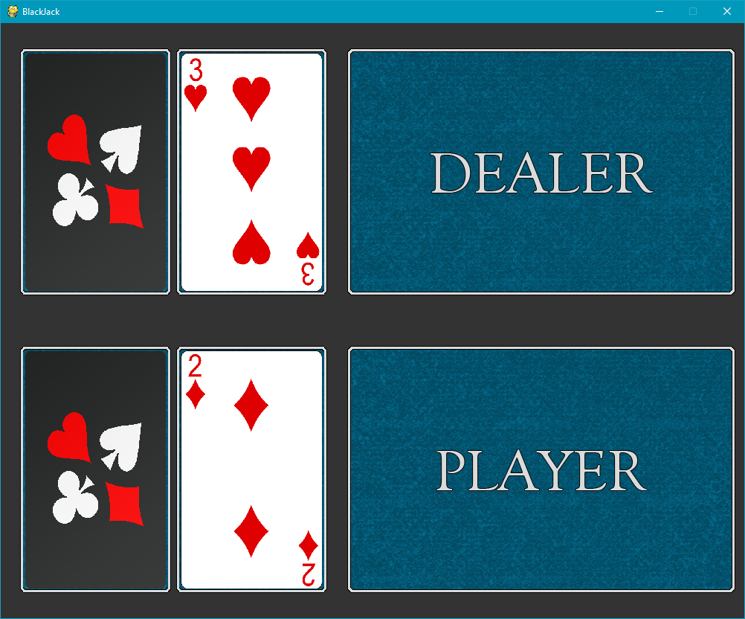
Fig 2. Gui application screen shot, after initial deal.

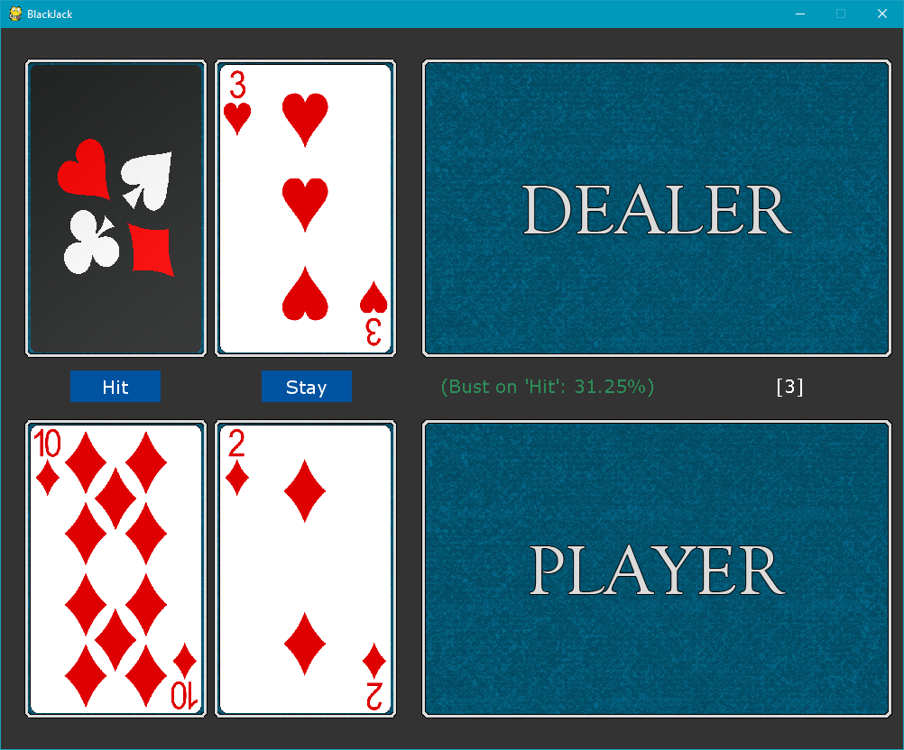
Fig 3. Gui application screen shot, at the players turn.

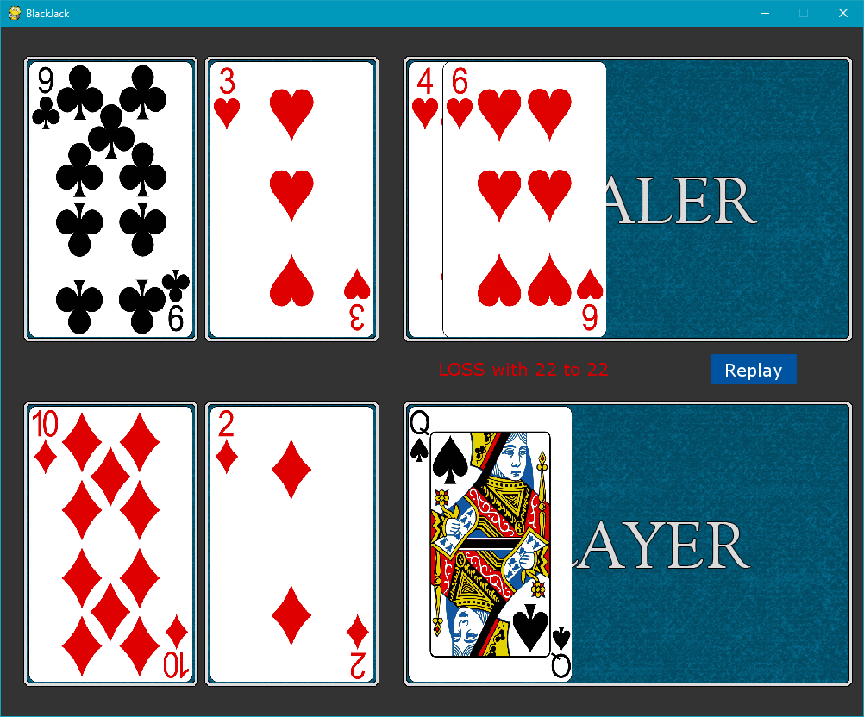
Fig 4. Gui application screen shot, after the dealers turn.

App/

The application directory contains four sub directories. With the remainder of our files. Thy are organized as follows.
- doc – The application documents, such as the proposal and reports.
- img – Holds all the images, and psd files that were used to generate them.
- src - The application classes
- test – The unit test files

Code Authors
- Ownership
Task | Description | Owner
setup.py | Python script to install dependencies, test source, and deploy to Git repository. | J
gui.py | The GUI program launcher. | A
terminal.py | The terminal application launcher. | J
app/src/logic/card.py | A card class. | J
app/test/test_card.py | Unit tests for the card class. | J
app/src/logic/deck.py | A deck class of 52 cards. | J
app/test/test_deck.py | Unit tests for the deck class. | J
app/src/logic/hand.py | A hand of cards class. | J
app/test/test_hand.py | Unit tests for the hand class. | J
app/src/logic/player.py | Extends Hand by giving player actions. | J
app/test/test_player.py | Unit tests for the player class. | J
app/src/logic/dealer.py | Extends Player by giving deck handling actions. | J
app/test/test_dealer.py | Unit tests for the dealer class. | J
app/src/logic/blackjack.py | Extends Dealer by adding blackjack rules | J
app/test/test_blackjack.py | Unit tests for the blackjack class. | J
app/src/pygame/engine.py | The UI game interface | B
img/* | Card, buttons, background, etc. | A
UI design | Determine layout, calculate positions for buttons graphics and probability display. | A
UI proof of concept | Create a window, add UI elements, and input elements. Test inputs and output functionality. | A
UI game flow | Make sure game actions can be implemented. Such as adding a card, and folding for both the dealer and player | A
UI/ Sim integration | Integrate UI to call simulator | B
Game testing | Test completed application for functionality and usability. | B

References
- https://github.com/uml-cm-f16/blackjack.
- https://github.com/uml-cm-f16/blackjack/tree/gh-pages
- https://uml-cm-f16.github.io/blackjack/
- http:// www.bicyclecards.com/how-to-play/blackjack/
- https://www.python.org/downloads/
- https://git-scm.com/downloads

