**Battery Drain : Battery Saver Application – Battery Doctor.**

Team Members:

1. Manoj Reddy Dumpa

2. Kavya Kumar Vallurupalli

3. Rohan Girase

4.Omkar Salunke

<http://www.cmcm.com/en-us/battery-doctor/> : Link to the app description

This application aims at optimizing the battery usage of phones to extend the battery life. It has many features and tries to analyze the phone usage and optimize the battery. It has modes which allow different stages of charging and provides battery management tips.

Think ALoud Tasks :

Task 1: Go to a battery saving mode and choose a mode.

The user was told to go to different modes of the battery application and chose a mode. They were also asked to see the different options in the modes.

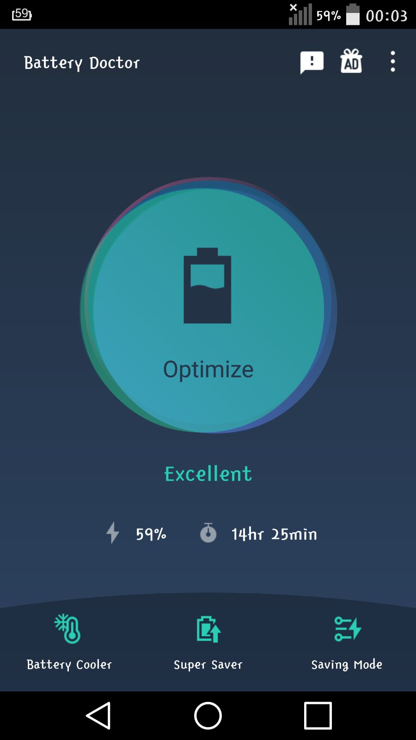 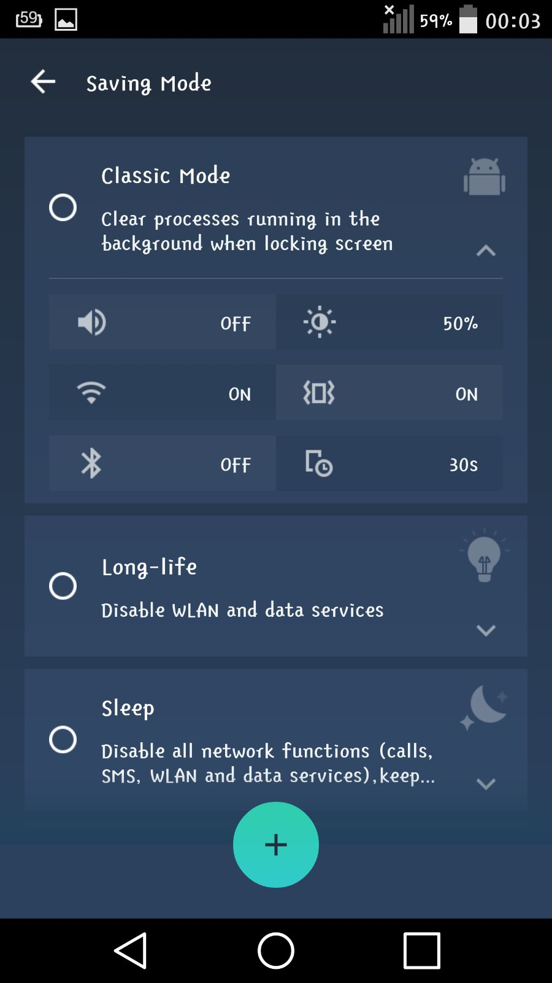

Task 2: Go through battery details and go through super saver and optimize the battery usage.

The users where asked to look at the battery details and see the super saver options.

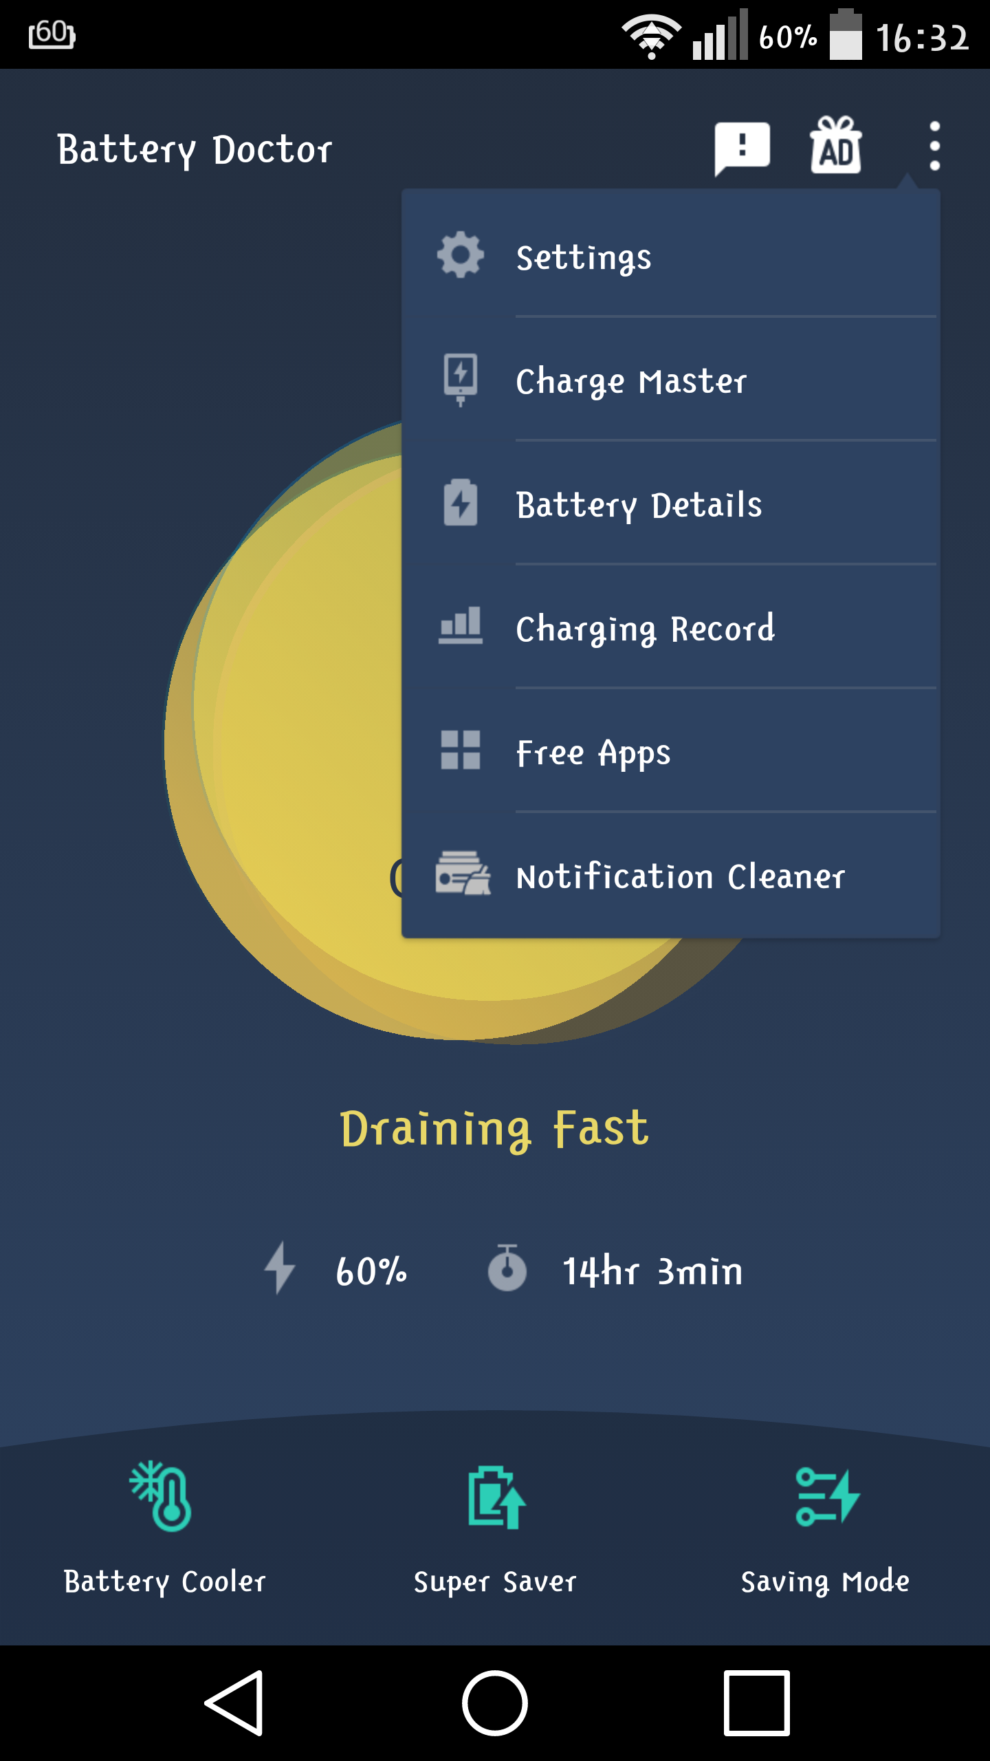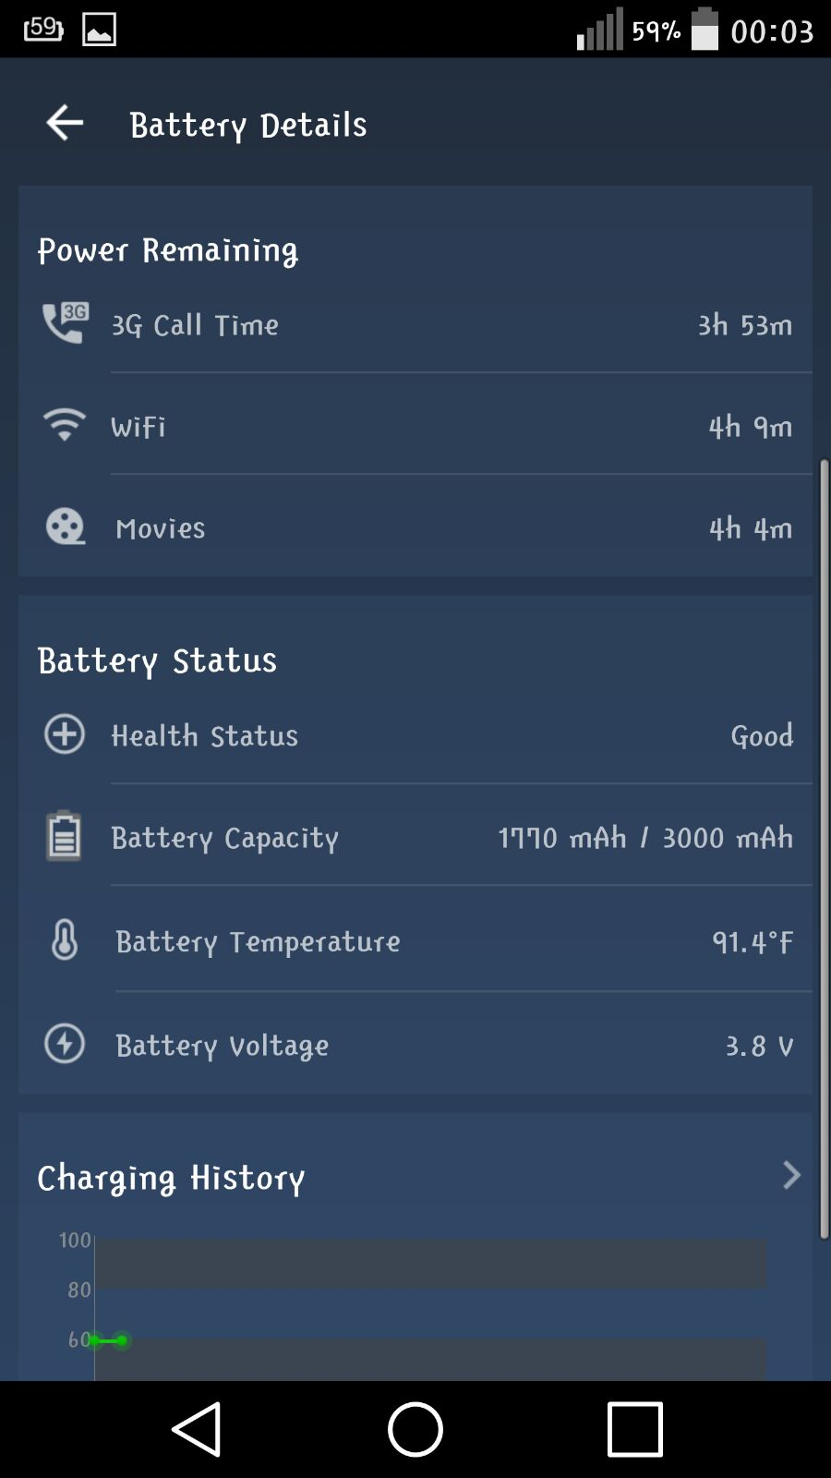

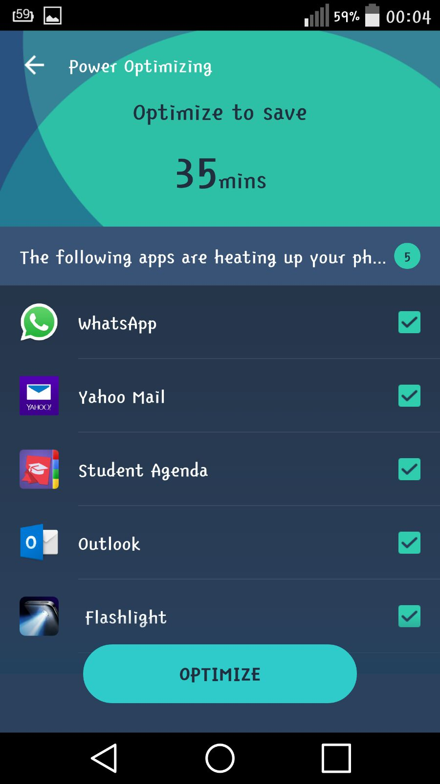

Task 3: Go to battery cooler and cool down the battery.

The users were asked to play around with the battery cooler and check to see what they felt about it.

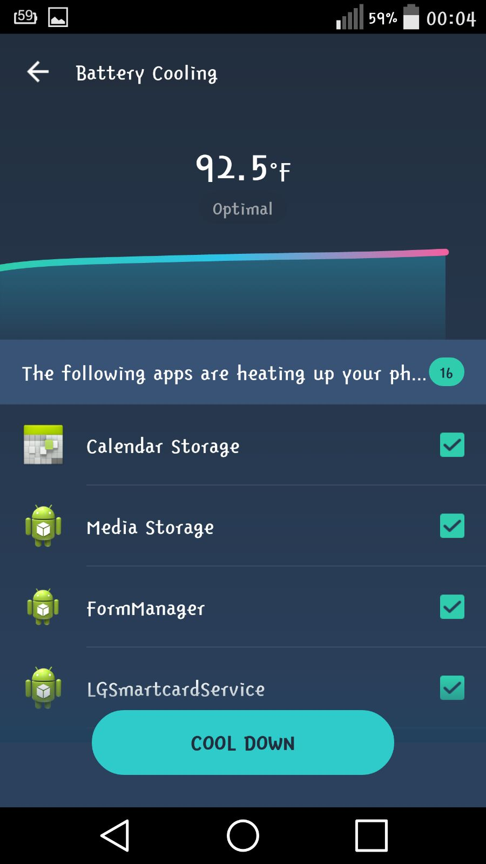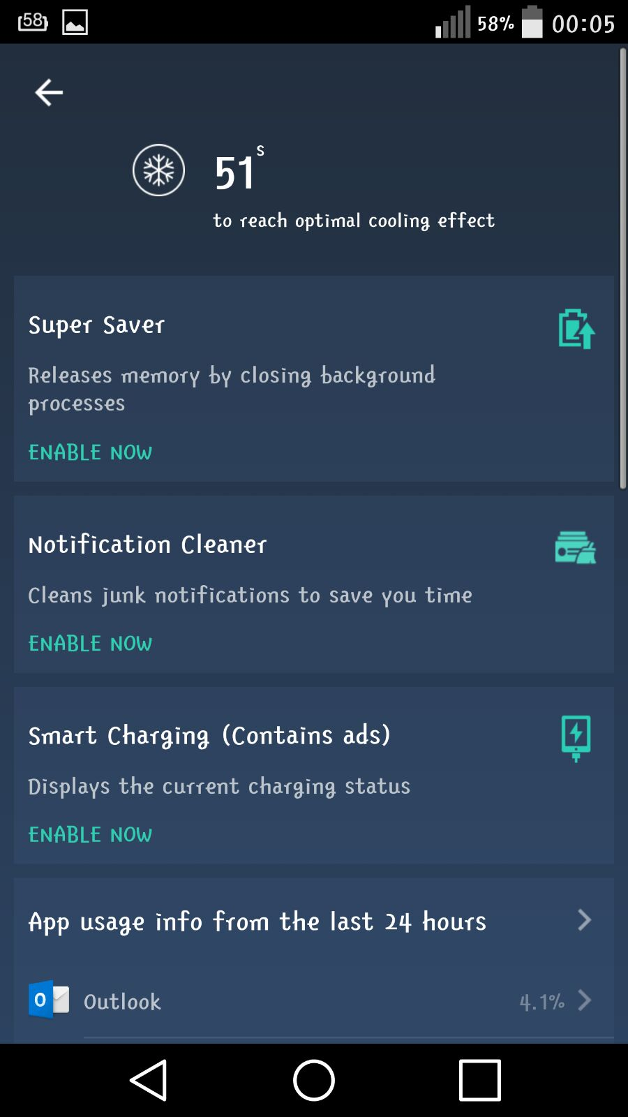

Tasks Think Aloud Responses:

Participant-1

1) Selected Long life Battery saving mode. It disables WLAN and data services. It is easy to find and choose.

2) Battery details was easy to find in the 3 dots tab. Super saver was present on the main page of the app. Optimizing battery was pretty easy with just the push of a button.

3) Battery cooler was also present on the main app page and one press cooled the battery down.

Participant-2

1) The option is clearly visible at the bottom of screen. On clicking got 4 options to choose and mentioned details about mode using icons. It was easy to choose based on our interest.

2) It was also easy to find and clearly shows the details of apps that are using the battery and how long it stays. The super saver was at bottom of the screen and has one click solution to optimize

3) The battery cooler is easy to find and shows the temperature of battery and has option to cool down.

Participant-3

1) Nice UI, can be made easy using colors to define saving modes like blue for classic and red for sleep or maximum saving mode.

2) Too much battery details. need quick remarks on purpose of each option at least the super saver option. displayed in primary window.

3) The option was good and easy to be done.

Participant-4

1) the battery saving option was right there and I chose the long life mode.

2) the battery details give the idea of the phones battery life including the estimated power remaining, battery usage by applications, battery status, and charging history. besides, the super saver quickly runs though the phone and gives all the running applications which we can optimize based on the need.

3) the battery cooler option gives the current temperature and also provides the list of applications that may be the cause of the over heating and can be optimized to improve the temperature.

Participant-5

1) I like the UI. Lots of options to choose according to my need.

2) The super saver mode is really good. It puts all the unnecessary apps to sleep and also shows the apps that run in the background like social media and messenger apps which drains the battery life. With this I can choose which app can be stopped from running in the background.

3) This feature saves the performance of the battery from losing charge unnecessarily by running apps that consume charge continuously in the background (like calender, android system programs). This feature is useful when my mobile gets heated up by excessive usage.

Participant-6

1) Default modes are not customizable. New modes can be created.

2) Has shortcut on home page but shortcut is not easy to decipher. Extra details of the battery given. Super saver mode doesn't consume time.

3) Battery cooler is easy to use and provides good details . But is seems to be same as the super saver mode.

Participant-7

1) Lot of options to choose from and categories are well defined.

2) I found it easily and a good battery analysis. Super saver helps to control battery usage. It shows all the apps in the phone that is using more battery.

3) More features than the default battery mode. Allows me to optimize my battery temperature and usage.

Participant-8

1) I went to app and found the saving mode on the home page. It was easy to find and has options to choose between various modes. I chose the classic mode.

2) At first had little difficulty in finding the battery details option. It has many details that are useful to analyze my battery usage. Super saver was on hope page. It scans all apps and shows all the apps that are needed to be optimized

3) Battery cooler shows the phone temperature and also the apps that are heating up the phone. Has one click solution to cool down the phone.

Participant-9

1) The UI is simple and easy. The options are clearly visible. Finished first task by choosing the mode that I wanted.

2) Battery details has all info about the battery usage and also charge history. Super saver was easy to locate and also has one click solution on home page to optimize the apps to save the battery life.

3) This is a good feature that can stop phones from over heating. The option was on main page of app.

Participant-10

1) Went to app clicked on saving mode. I liked to create my own saving mode which was easy to do.

2) Battery details is easy to find in menu. It also has a shortcut but not clearly stated. Was very useful feature. Also clicked on super saver option it scans all apps and optimizes those to save battery life.

3) Battery cooler is useful for me as I have problem of my phone heating up. The app is very useful and smooth.

Participant Survey:

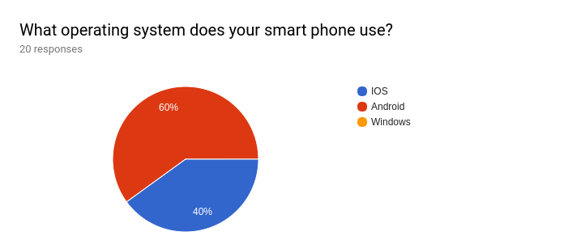

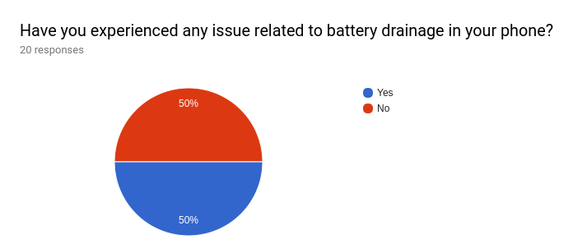

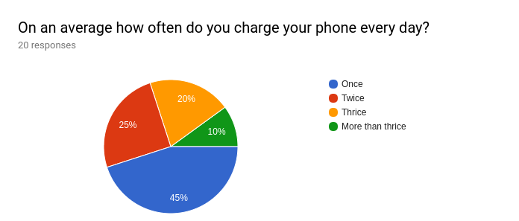

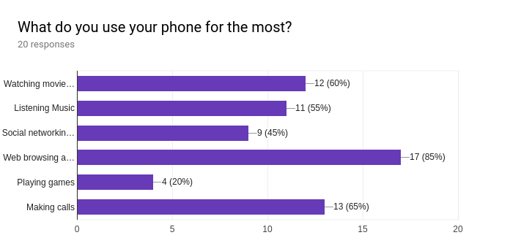

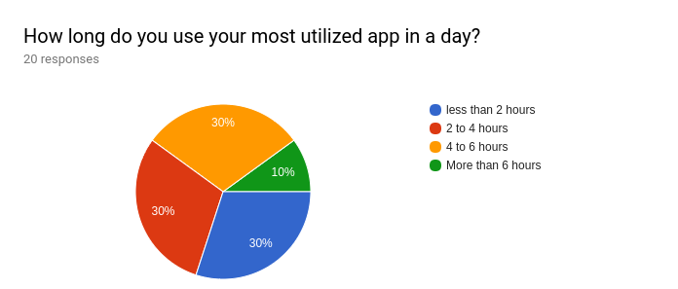

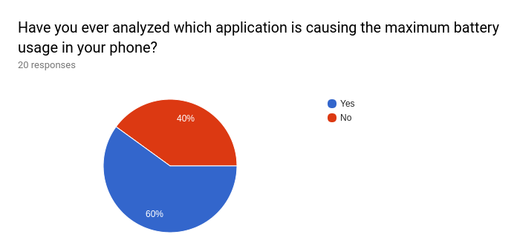

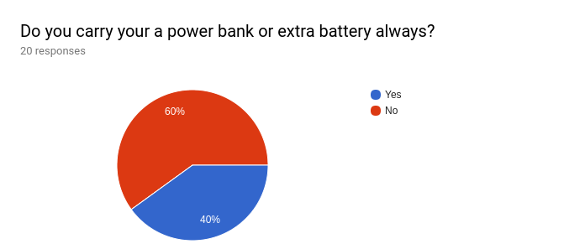

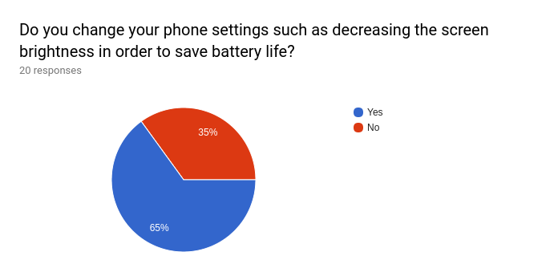

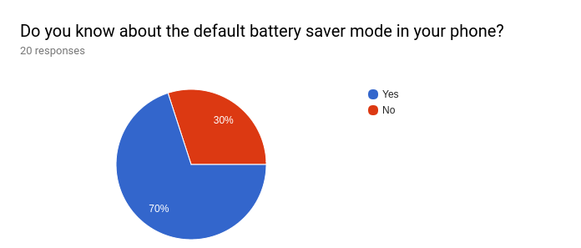

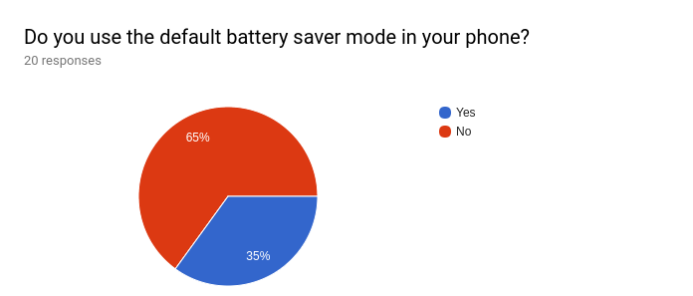

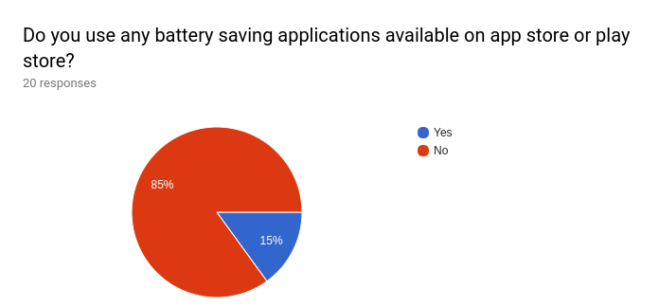

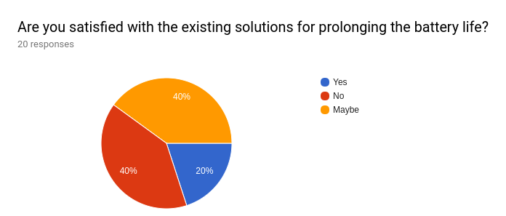

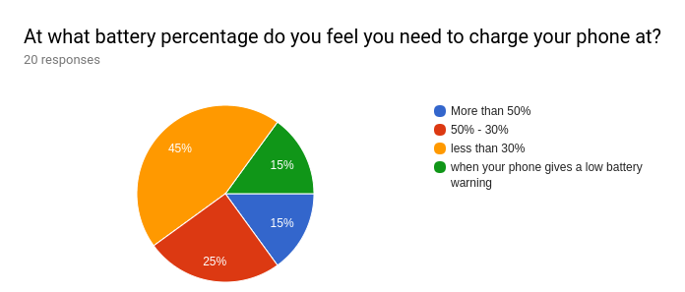

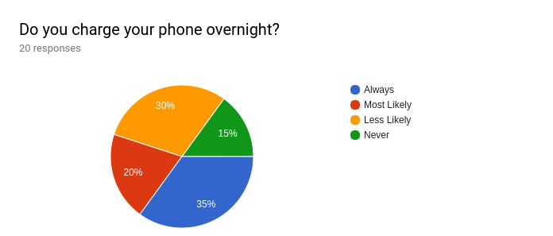

SUS Survey:

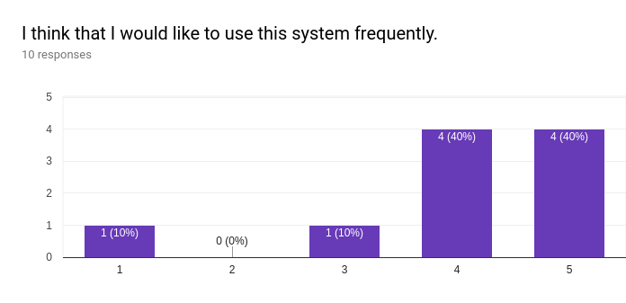

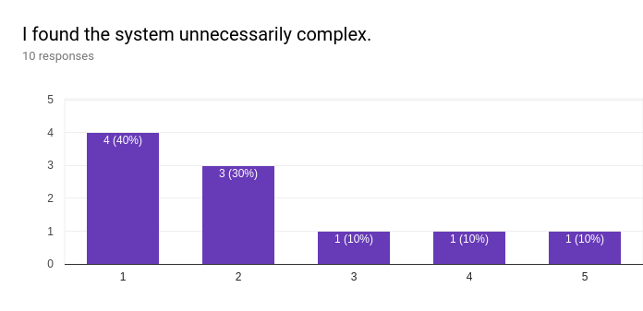

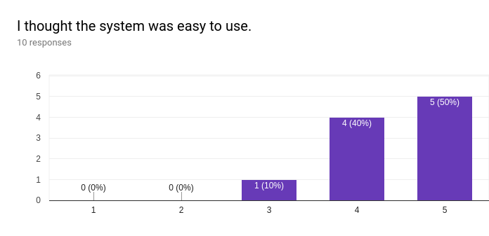

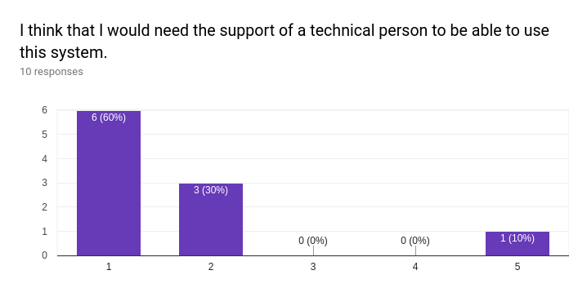

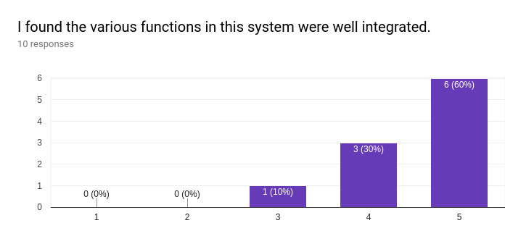

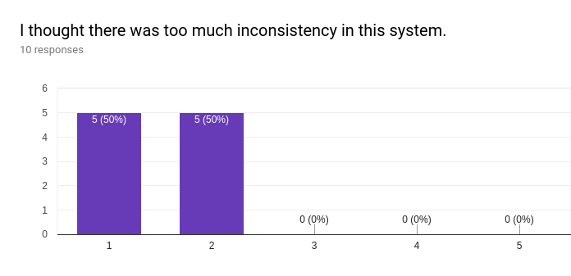

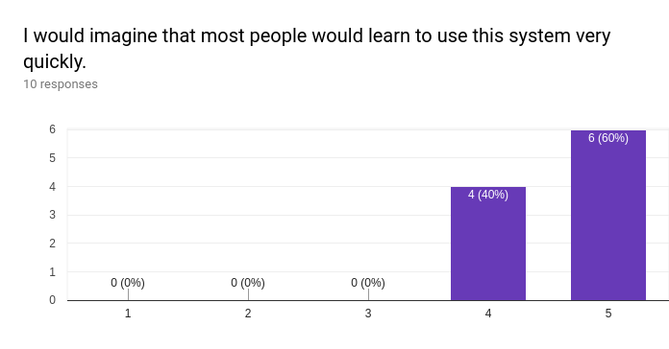

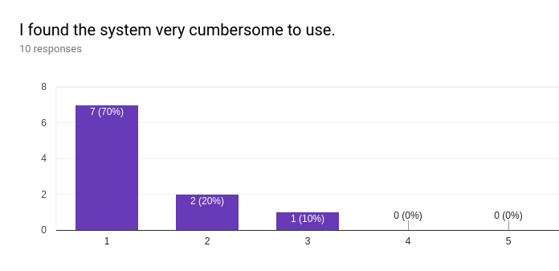

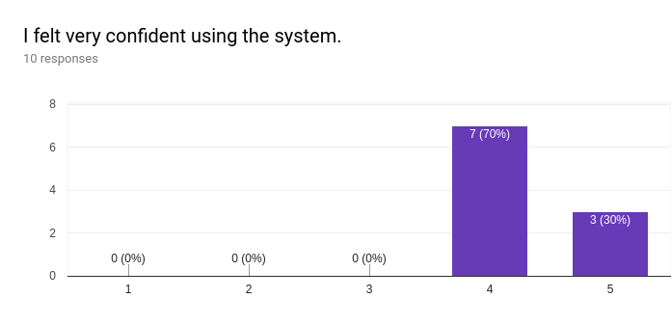

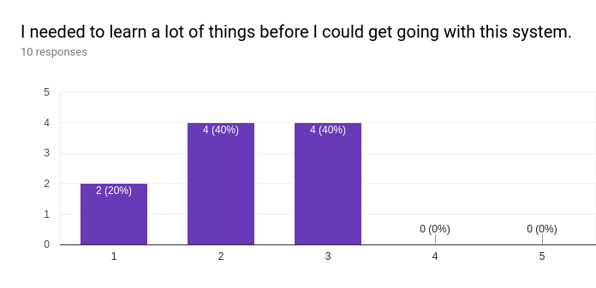

Interview Questions:

1. Do the user interface is easy to use and simple looking?

2. Does this application solves the problem?

3. Are the tasks are fair enough to learn about the application?

4. How much percent are you willing to use this application?

5. Do you think of any changes that can be done in application to be more user friendly?

Interview Response summary:

1. All the participants found the application user friendly and appreciated the simple UI.

2. Many participants thought that the application can solve the problem of battery issues with the phone.

3. The tasks covered the major functionalities of the application. So participants became comfortable with application after finishing think aloud tasks.

4. About 90% of participants are willing to use this application.

5. Almost all of the application has only few colors making the UI more appealing.