**VMWare Horizon Browser Access**

1. Go to <https://vlabs.uml.edu>
2. Select “**VMware Horizon HTML Access**”

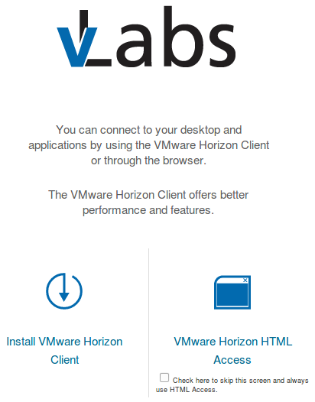

1. Log in with your username (student email address) and password

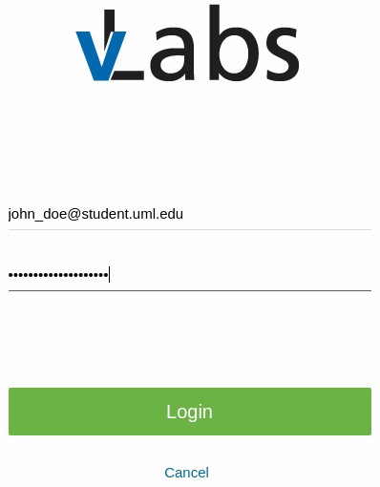

1. Select “**Computer Science**”

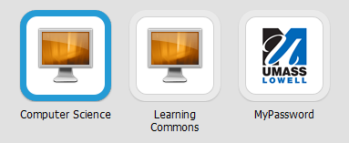

1. You will be taken to a screen displaying the date and time. Swipe upward with your mouse (or merely wait for several seconds).
2. The desktop will load. You are all set! ROS has been preinstalled, as well as ViM, Emacs, and the other tools you need to start programming.
3. ***Note****: make sure you power off the virtual machine, as well as log out of VLabs before closing your browser.*

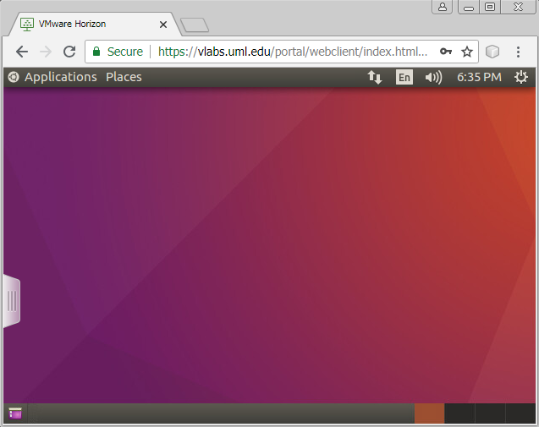

**Installing the VMware Horizon Client**

1. Go to <https://vlabs.uml.edu>
2. Select “**Install VMware Horizon Client**”
3. Select and download the binary installer for your operating system
4. Press the “**Read More**” button. This displays the MD5, SHA1, and SHA256 checksums.

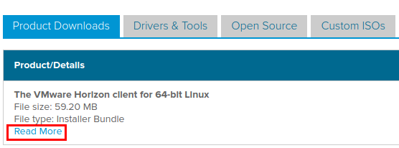

1. Verify the MD5 and/or SHA checksum(s)

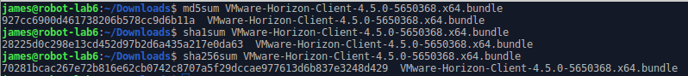

1. Run the installer and follow its instructions. You should be all set!

