E:\Git>git clone <https://wackerow@bitbucket.org/wackerow/ucmis.m2t.git>

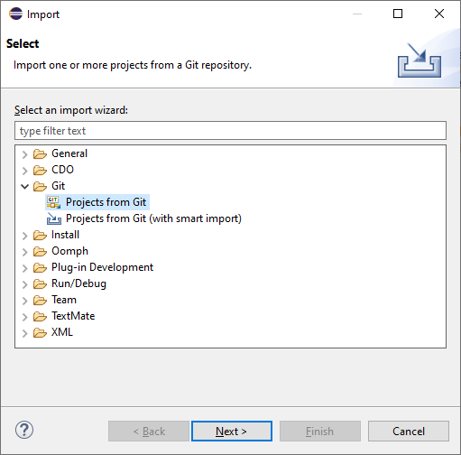

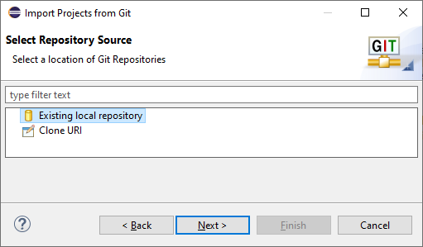

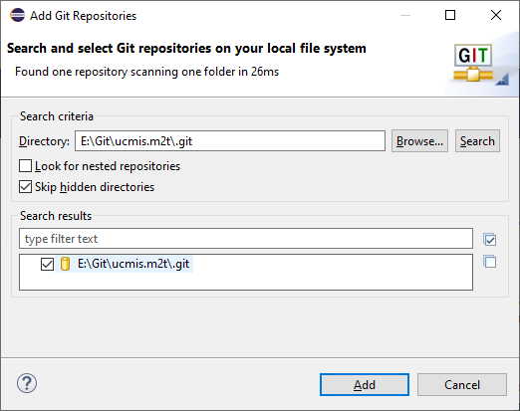

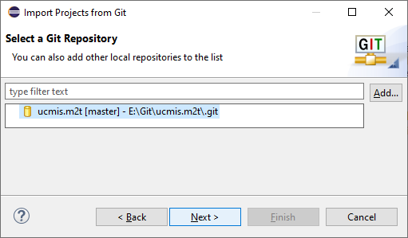

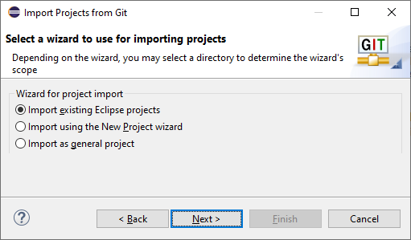

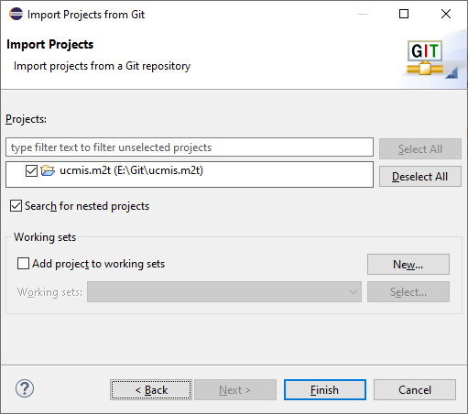

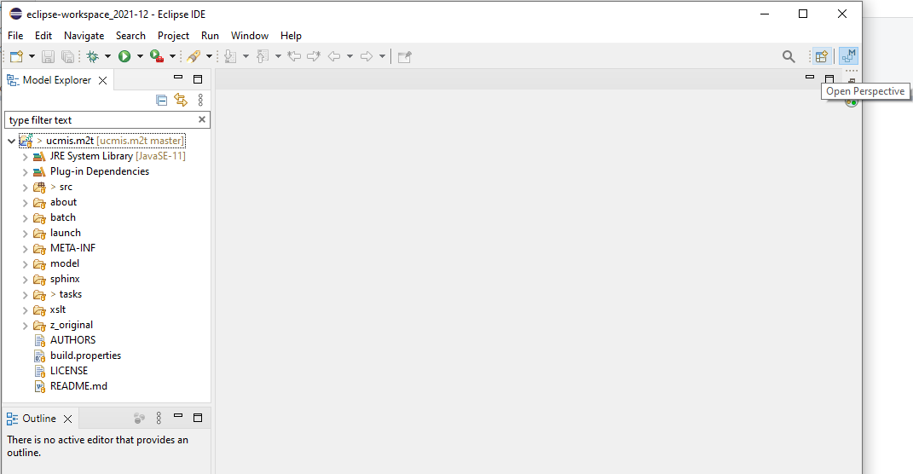

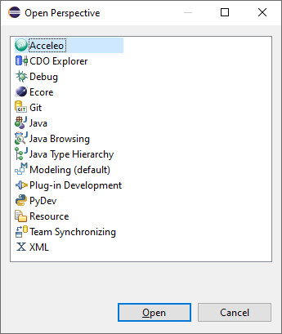

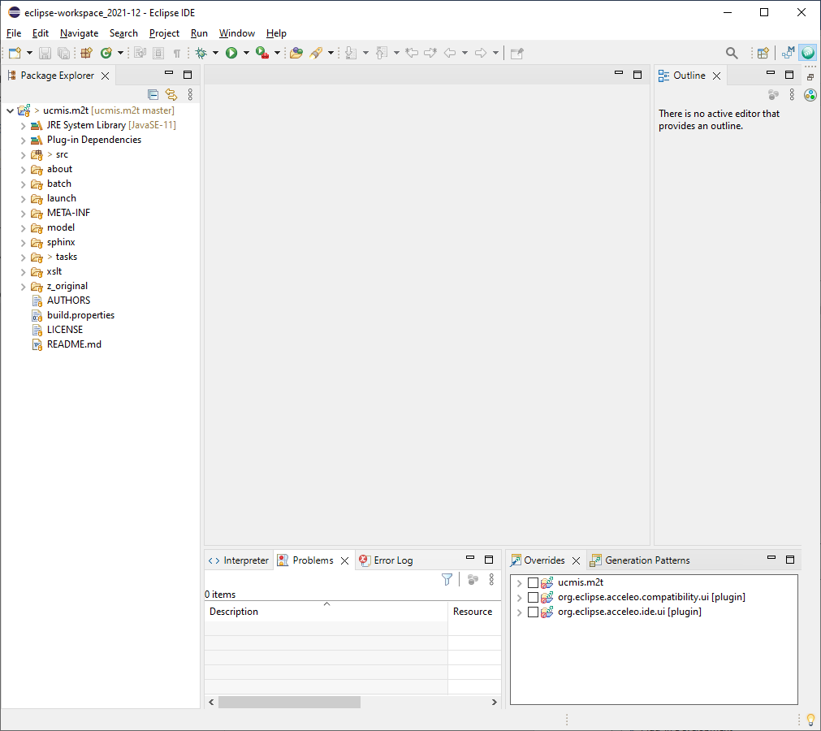

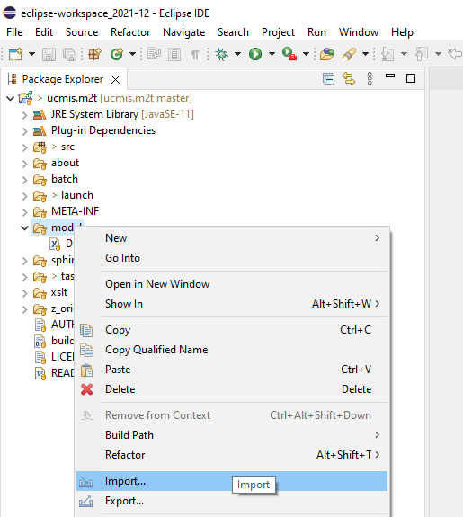

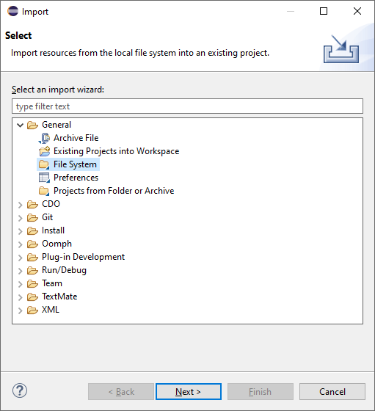

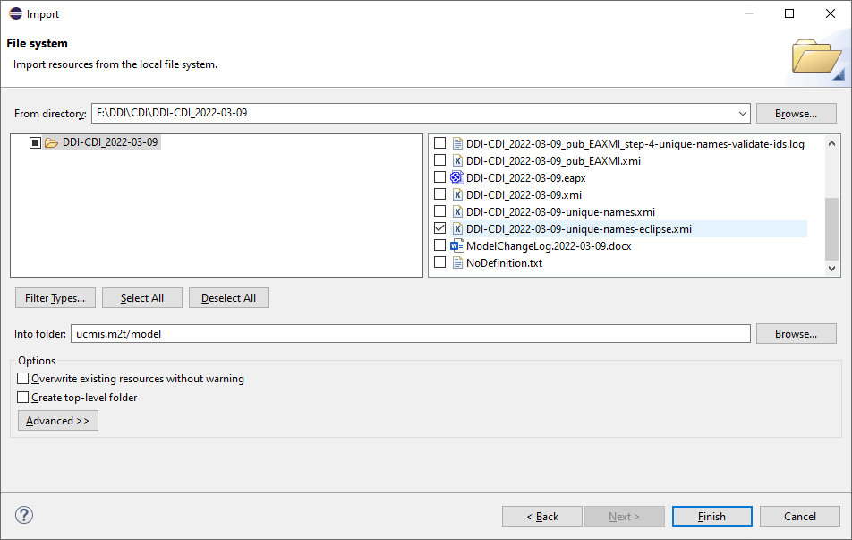

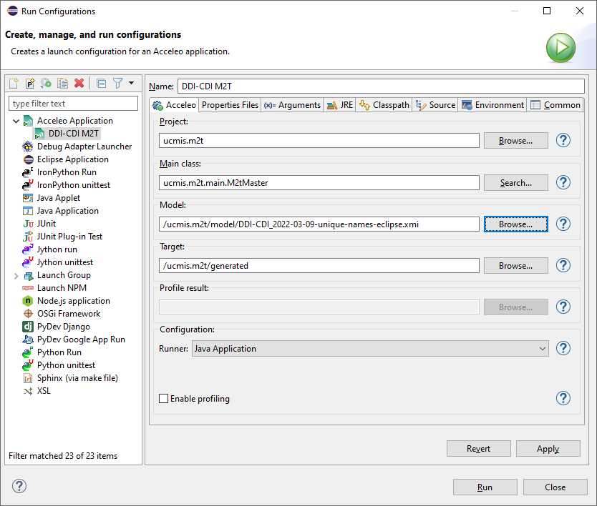

Windows > Show View > Other > Git > Git Staging

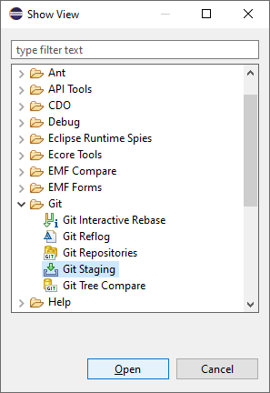

Drag ‘Git Staging’ to left bottom corner of main window.

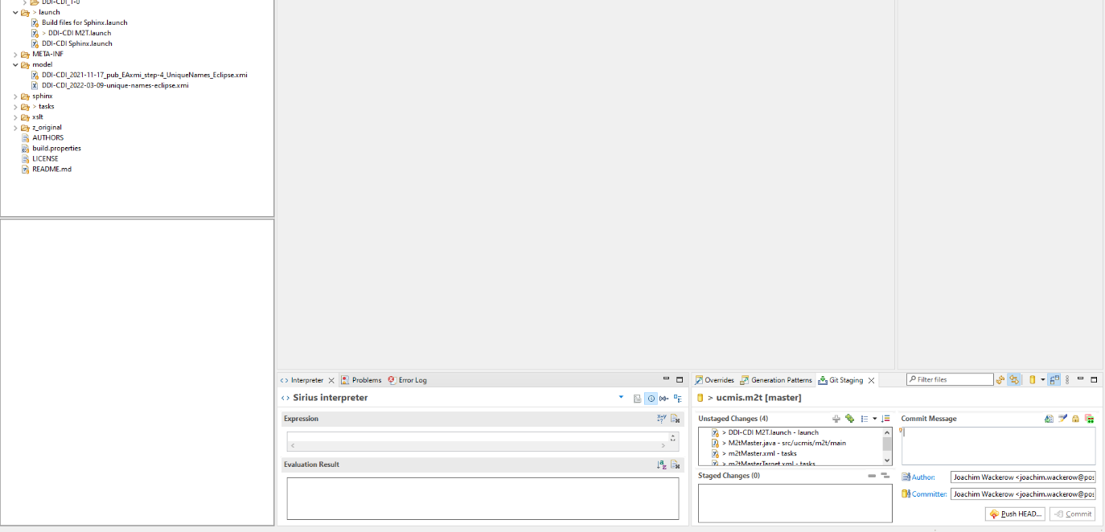

Git staging

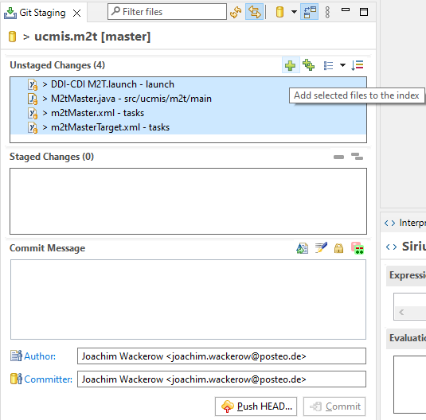

Git commit and push

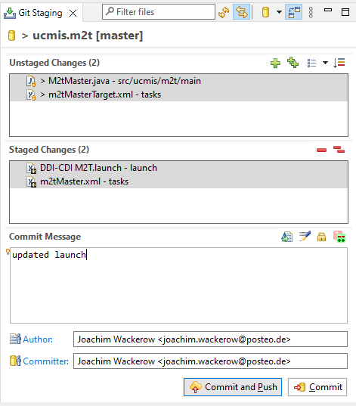

Graphviz: windows_10_cmake_Release_graphviz-install-3.0.0-win64.exe

python-3.10.2-amd64.exe

Installation of Python and extensions as administrator

Python 3, for all users, add to PATH

python.exe -m pip install --upgrade pip

pip install sphinx

pip install sphinxcontrib-contentui

pip install sphinxcontrib.plantuml

pip install sphinx_panels

pip install sphinx_rtd_theme

PlanUML put

C:\Programs\PlantUML\plantuml-1.2022.2.jar

Restart Eclipse (Python can then be found in PATH)

Sometimes this error occurs:

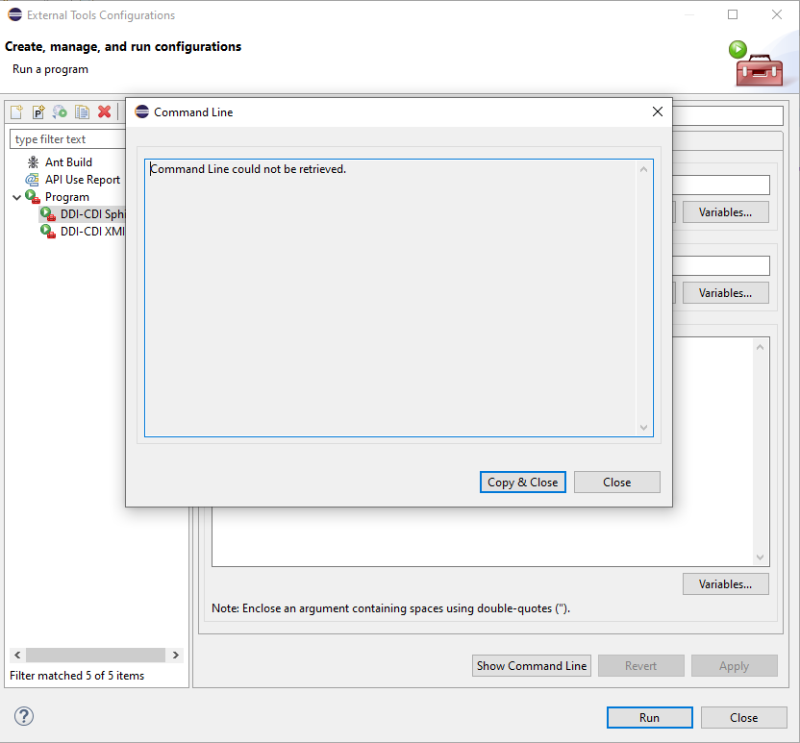

Solution: click on project root in package explorer and try again.