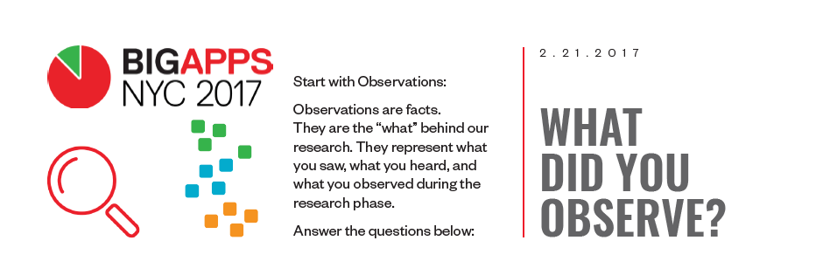

## What did you **see?**

We saw a space on market for an application/service which would help you plan your path in urban areas depending on your limit condition such as surface, time or frequency of traffic. We expected this could be useful especially for people with disabilities, people doing sports which needs a special surface or just people who walks to work of shops who want a change.

## What did you learn in your interview and research process?

* Most people are mostly satisfied with currently availed application for their normal life.
* People could use a different approach with path finding in foreign cities.
* People with disabilities do not have enough information around their surroundings to make their movement easier
* People could use better surface based navigation for their sport track planning
* People in general do not want to be tracked
* The most common wearable device is mobile phone and the second smart is smart watch
* Most people in US we interviewed are using cars to go to work
* Most people in CZ we interview are using public transport to go to work
* 60% of interviewed people would participate in a small walking competitions with prices

## What surprised you during your research?

* People are not seeking for new ways of transport for their daily needs
* People do not want to share their data to help other people for free
* People are overwhelmed with all the application around
* We saw an interest to combine city navigation with trip advising
* Steep incline can be a big problem for people with disabilities

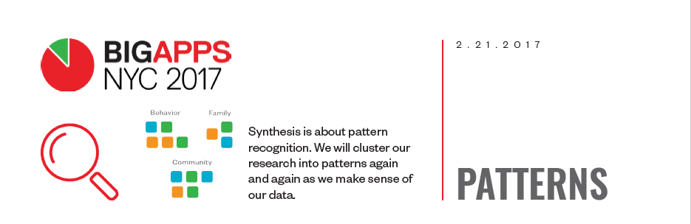

## What has been consistent across your research (interviews, observations, secondary research, primary research)?

* We interviewed only people under age 35, because we identify them as most potential to use new applications and wear wearable devices for crowd mining
* They were from the US or the Czech Republic
* Everybody visits a place regularly every day in distance between 2 km and 10 km from his home
* Nobody walks more than 8000 steps every day

## What are the 3 commonalities you have learned about the user group you’re researching?

* To get to a place of their work or school they are using the same path every day
* Majority thinks that current market offer is suffusion
* We should be focused at minorities

## If you could synthesize the above questions into 5-6 “buckets,” what would they be?

## Start simple! It’s OK to have a bucket that says “family” or “transportation”. We’ll get more specific later.

* Urban path finding
* A lot of concurrent services
* Minorities
* Path discovering
* Sport usage

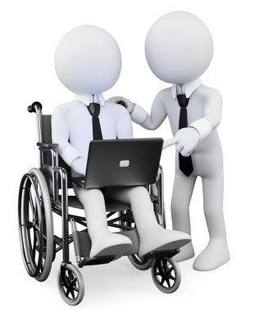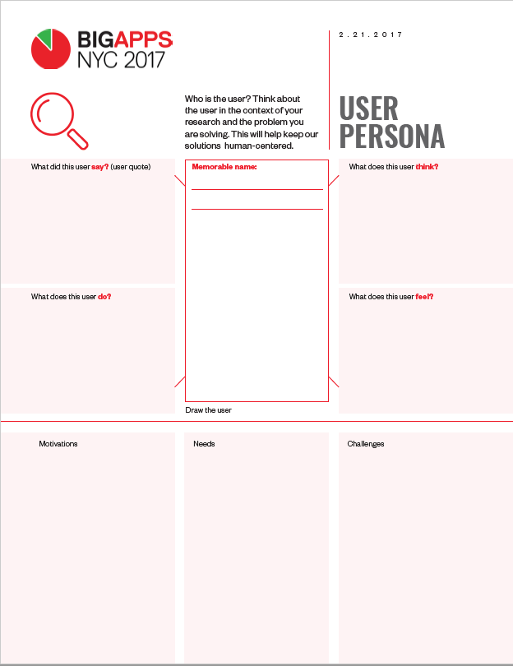

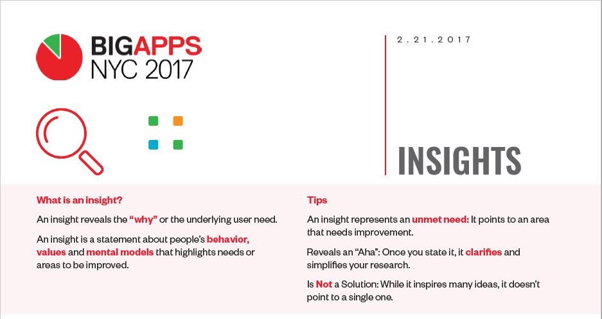

Greg **needs** a planner for his roller-skate trips **because** he likes taking new tracks, but not every route is suitable for roller skaters

**Insight:** There is not sufficient support for different sport track planning

**Quote or Story that informs insight:** Greg put his roller skates on and since did not have a plan, he just hit the road in general direction. He was skating on a long street with no sideways and unfortunately after couple hundreds of meters the surface changed from asphalt to paved road. There was no way to go around do he had to head back and find a different way.

Martin **needs** information about his neighborhood **because** he is handicapped and sometimes struggles to move around with his wheelchair

**Insight:** People with disabilities could use more intel about possible obstacles for them.

**Quote or Story that informs insight:** Martin wanted to go to a shop for some supplies, but the pedestrian zone on the shortest path was under reconstruction, so he had to go around three block. Later he admitted he would rather to skip this and had just pasta with ketchup and buy supplies the other day.

Tomas **would like to be** rewarded for walking **because he** heard about imaginary money you can be gaining when you are walking.

**Insight:** People would walk more if they t=know they can get something in reward.

**Quote or Story that informs insight:** Martin saw an ad which promised users they can get kind of bitcoins for walked kilometers. At the moment, he did not trust it, but he is still thinking about it.