**Future Mobility Sensing technology**

is a personal activity tool designed to support travel survey.

Structure:

3 major components

1. Logger (smartphone or dedicated device)
2. Backend system with real time data analysis
3. Web interface

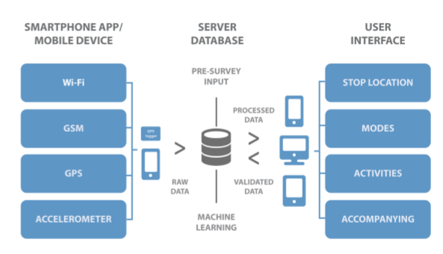

The important part of this technology is the construction of the participant’s travel diaries, which are used to understand the travel behavior and preferences, and develop and calibrate their planning model. FMS is an automated travel survey; the recruiter invites the potential participant to install the App on the smartphone or carry a dedicated logger. The participant is expected to periodically access and update information’s.

** Participants in a survey is rewarded by a nominal incentive

**How the App Works**:

Is designed to collect location, accelerometer data and some other information on a continuous basis.

The aim is to capture all trip data, stops with short duration but of importance to transportation modeling. Besides all this the app is also responsible for keeping a background process alive and for uploading the data to the backend in chunks. The backend server receives and stores the data and turns the raw data, in real time, into a trip information using machine learning algorithms.

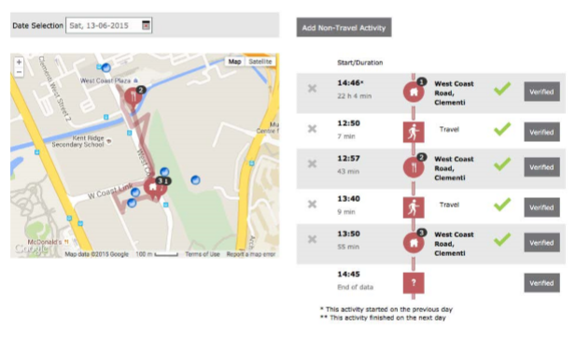

**Comparison with traditional survey**

The benefits of FMS

* Observer detailed routes
* Activities
* Walking trips
* Multi-day data

The challenges for designing, implementing and running such a technology depends on the production level numbers.

**Challenges and lessons learned**

* Number of participant’s effectively completing the survey is very small.
* A lot of training is required for the recruiters and more importantly, able to transmit the same to the participant’s.

To address all these issues, they designed a Flyer and a simple video tutorial, created a help-line and also extended the FMS with a remote desktop support tool.

* Major concern was: Battery Consumption

**User interface**

The main contact point was the FMS activity diary interface. The design was more focused on a “quantifying self” than a “filling a survey”.

More care was taken on design: Fonts, Icons, item locations, simplicity, attractive feedback, minimal number of clicks.

The most challenging task for a user was to added a new stop and delete stops. (they had to correct/change the algorithm).

**Conclusions**

Lessons learned from FMS:

* Improve battery performance
* Data quality
* More straightforward validation process
* Use other sensors to improve intelligence, may be use IWatch, pebble or other wearable devices.

The ultimate goal is to improve/increase the user experience together with data quality and quantity.