**DroneNet**

The primary paper chosen by us for our review is “Extending Cell Tower Coverage through Drones” written by Ashutosh Dhekne, Mahanth Gowda and Romit Roy Choudhury from University of Illinois Urbana Champaign. The paper specifies about a product called as DroneNet that can be used to provide temporary wireless internet access with the help of Drones.

The paper starts by saying the increase in network traffic and the pressure of communication channels to transmit such huge amounts of data. This results in users receiving a lowered quality of service from the service providers as there are huge loads of data that is being transmitted every second. The problem aggravates in skyscrapers due to their tall structure and the normal data tower that cannot transmit the data to such high structures. The paper also speaks about political rallies, social events and social occasions that result in sudden increase in consumption of data and natural disasters that destroy the network infrastructure that results in loss of data connectivity. To overcome this issue, the students of UIUC came up with a concept where we can use drones in dense urban regions and at places where there is sudden increase in data consumption to use Wifi equipped drones to keep the network traffic stable. Thereby using drones as elastic extenders of cell towers.

The paper also discusses similarity with the concept of Cloud computing as clouds are aggregation components where clients usually use only a fraction of its resources and this way, it can provide powerful resources to any client at a fast pace. It displays the benefits of a drone based internet service provider as there would be few users who consume majority of data at a time. Hence, a limited set of drones is enough to cater to their needs. This way, it’s a win-win for all the clients providing a better Quality of Service.

The paper illustrates the use of drones with the help of a figure, Here the drones are connected to a cell tower with a 4G/LTE link. It also describes the problem of the location at which to hover the drones. If the drones hover very much ear to the ground, the drone would provide better network quality, however, it results in multipath and shadowing effects. Also, there is less area that is covered (Line Of Sight) if the drones are near to the ground. However, if the drone is too far away from the ground, it will result in better area coverage, but lesser network quality due to the distance between user and the drone. It also speaks about lateral movements as the left and right most drones in the picture provides coverage to one of the clients but not the other. Therefore, a combination of lateral and vertical movements can bring the drones to a position that maximizes the efficiency. This is one of the goals of the paper.

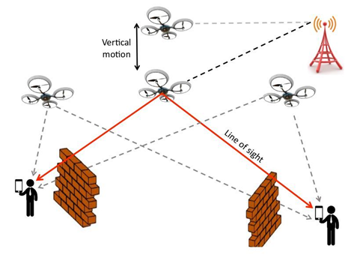

To predict the movement, we cannot use a brute force approach to find an optimal location by flying the drone over the area and using SNR measurements as the area might comprise of large blocks. Also, hovering the drone over a centroid of clients is also deemed unsuitable. Therefore, the paper speaks about the use of RF ray tracing to model dominant structures in the area and simulate how the signals would bounce and scatter from the drone to different clients. Thereby yielding a coarse-grained solution. If client positions or traffic changes substantially, the drone re-computes the ray tracing results and finds a new hovering location.

The paper also discussed about the prototype which uses an Octocopter carrying an Almond WiFi AP continuously transmitting packets to clients. The octocopter flew in a raster scan of an area of 50 * 68m at three different heights: 15,30 and 45m. The RF rays were traced using Remcom Wireless insite.The DroneNet resulted in a throughput gain of 44% with 10% full measurement overhead.

However, couple of questions arise, such as:

How to sustain battery for longer time on the drones?

The paper suggests that drones be used under extreme conditions. However, advancements in battery may provide better benefits out of the drone.

How practical is obtaining a terrain model?

The paper does not rely on material of the terrain and uses public data provided by Google warehouse

How compelling are the gains?

16-18dB of SNR gain is possible from drone mobility.

Are the gains emerging from moving closer to clients?

The drones need not go closer to clients, depending upon ray trace, they can be positioned to provide optimal throughput

Why not use Femtocells or WiFi Hotspots?

A drone on the other hand can fly higher and offer much higher coverage. The drone’s motion allows on-demand mitigation of dead zones and hotspots.

System Design:

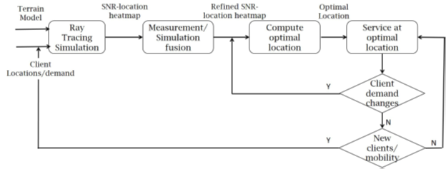

Ray Tracing:

Using ray tracing simulations, *DroneNet* predicts SNR heatmap without undergoing the overhead of empirical measurements.

Fusion of ray tracing and measurements

*SNR gain* of a candidate position for drone hovering is defined as the difference between the measured SNR of that position and the median of measured SNRs of all candidate positions. The top 10 percentile high SNR drone positions from ray-tracing predictions to plot a CDF of their SNR gain and this is used as the optimal hovering location.

Evaluation:

Components used in the experiment was a X8 quadcopter, an Almond WiFi AP powered by a Lithium-Polymer battery with the transmission frequency set at 2.437GHz (20MHz bandwidth) and transmission power of 28dBm. An android phone was used for collecting information about packet transmission.7 Raspberry Pis were used as clients with the University of Illinois campus.

The Pis were connected with an Atheors WiFi dongle and packets were transmitted as 400 packets per second. This data was collected from the clients from which SNR was computed.

Conclusion:

The demand for stable cellular networks is on the rise. This paper discusses about the extending cell towers to mitigate connectivity issues.